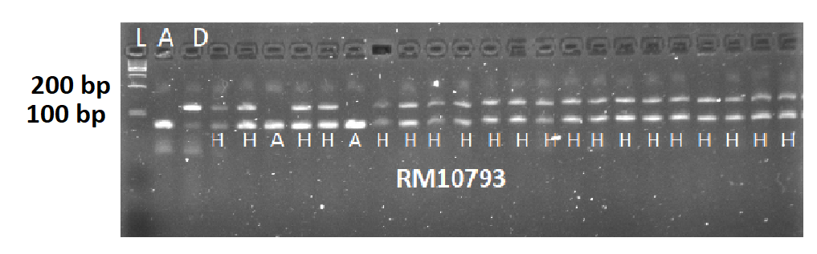
Figure 1: Genotyping and foreground selection of F₁ plants derived from cross between Putra-1 and Binadhan-10 through linked markers RM10793 for Saltol salinity tolerance and RM212 for blast resistance. Electrophoresis running on 3% metaphor agarose gel stained with 10 μl of gel view in a 100 ml TBE Buffer. L=100bp DNA Ladder, A=Putra-1, D=Binadhan-10, H=heterozygous.

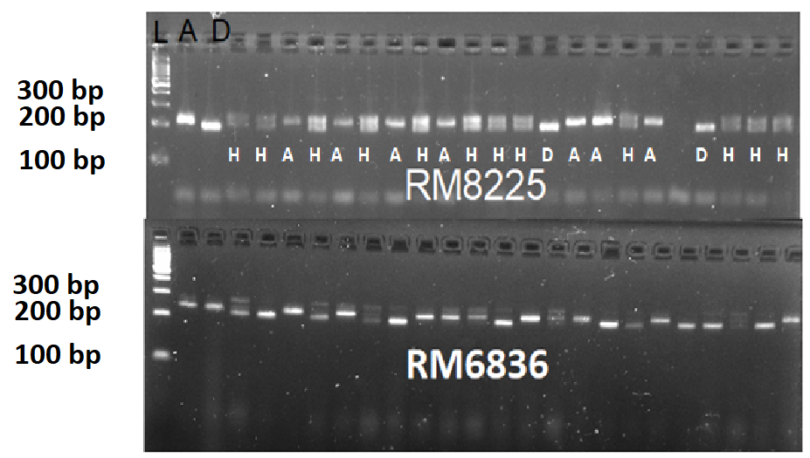

Figure 2: Genotyping and foreground selection of F₁ plants derived from cross between Putra-1 and Binadhan-10 through linked markers RM8225 and RM6836 for blast resistance. Electrophoresis running on 3% metaphor agarose gel stained with 10 μl of gel view in a 100 ml TBE Buffer. L=100bp DNA Ladder, A=Putra-1, D=Binadhan-10, H=Heterozygous.

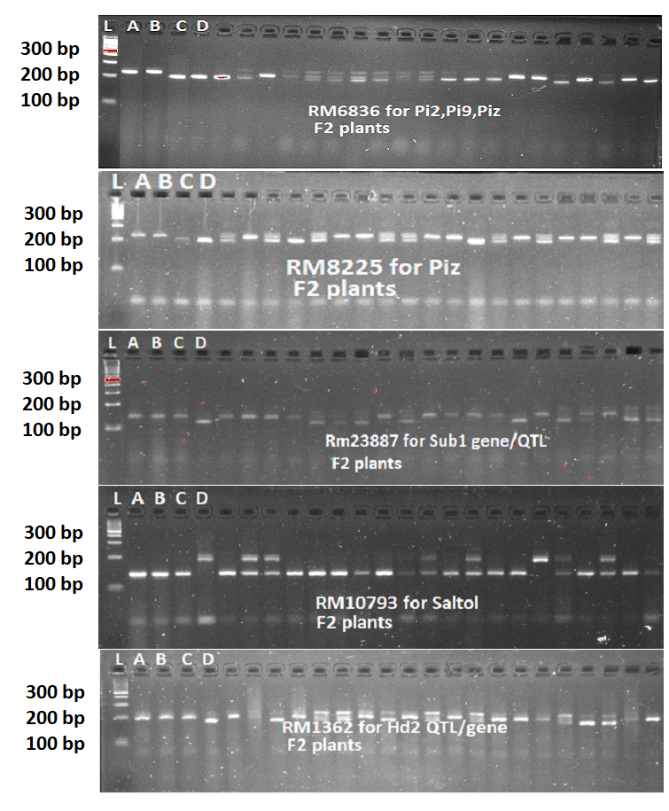

Figure 3: Genotyping with foreground marker assisted selection of RM6836 (Pi2, Pi9, Piz gene linked markers), RM8225 (Piz gene linked markers), RM23887 (Sub1 gene/QTL linked marker), RM10793 (Saltol QTL/gene linked marker) and RM1362 (Hd2 QTL/gene linked markers) in the F₂ generation of rice derived from double crosses A stands for Putra-1, B stands for Putra-2, C stands for MR297, and D stands for the Binadhan-10, double band, which represents heterozygous individuals, L= 100 bp ladder.

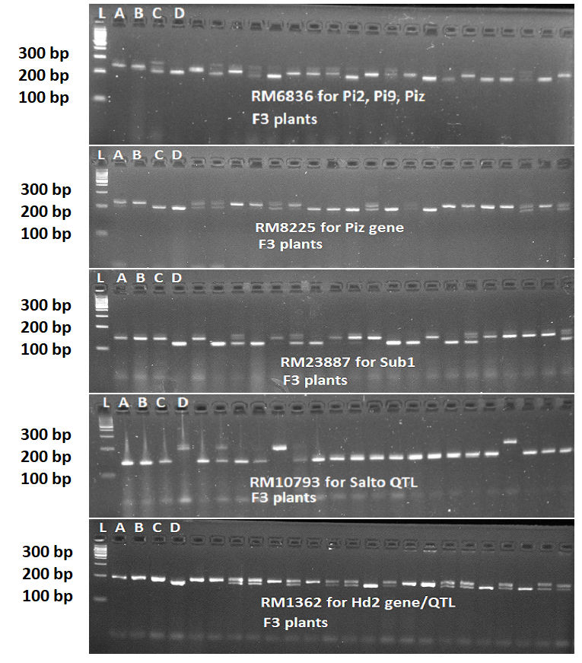
Figure 4: Genotyping with foreground marker assisted selection of RM6836 (Pi2, Pi9, Piz gene linked markers), RM8225 (Piz gene linked markers), RM23887 (Sub1 gene/QTL linked marker), RM10793 (Saltol QTL/gene linked marker) and RM1362 (Hd2 QTL/gene linked markers) in the F₂ generation of rice derived from double crosses A stands for Putra-1, B stands for Putra-2, C stands for MR297, and D stands for the Binadhan-10, double band, which represents heterozygous individuals, L = 100 bp ladder.

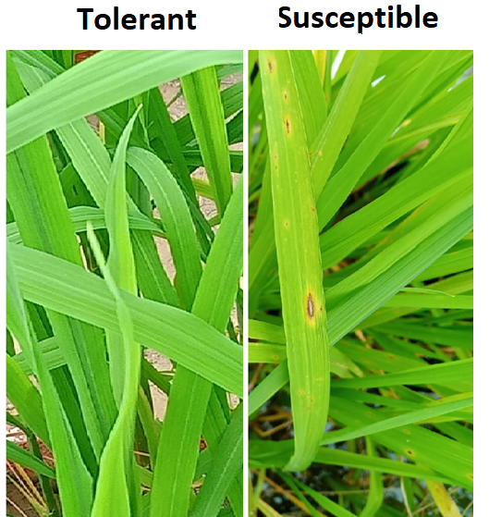
Figure 5: Symptom of susceptible and tolerant varieties for blast resistance under artificial conditions

