Supplementary information

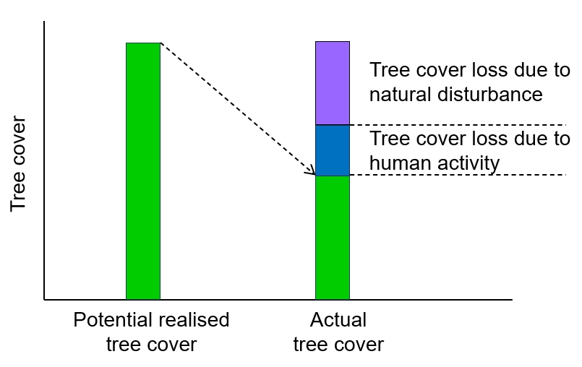
Extended Data Fig. 1 | Conceptual illustration of the relationship between potential realized tree cover and actual tree cover (or baseline tree cover). The potential realized tree cover is predicted by a model trained on samples derived from intact forests (delineated by satellite observations)²⁵, and is assumed to be achieved under favorable environmental conditions where no distinct losses in tree cover were observed in the intact forests. However, the actual forest tree cover in the remaining areas is generally achievable under prevailing environmental conditions that include both widespread natural (e.g., wildfire, insects, heatwave and drought driven distinct losses in tree cover) and anthropogenic disturbances (e.g., timber harvest) that likely lead to distinct losses in tree cover. In this study, the potential for tree cover restoration (PRTC) was calculated from the remaining increases in tree cover (positive signs) calculated from the differences between potential realized tree cover and baseline tree cover². As a result, the degraded (or loss) tree cover relative to potential realized tree cover was attributed to distinct natural and anthropogenic disturbances and was considered as PRTC in this study. Note that the intact forests however may still suffer very “low-intensity” of natural or anthropogenic disturbances²⁵ but didn’t cause any distinct losses in tree cover and was thereby neglected in the analysis.

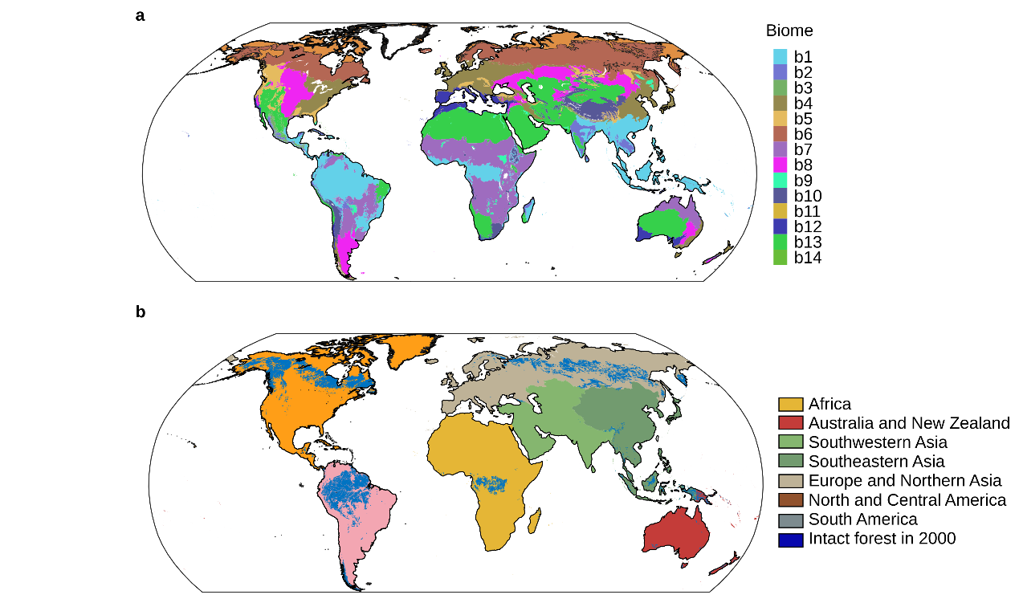
Extended Data Fig. 2 | (a) Terrestrial ecoregions defined by ref ⁶⁵. b1, tropical and subtropical moist broadleaf forests; b2, tropical and subtropical dry broadleaf forests; b3, tropical and subtropical coniferous forests; b4, temperate broadleaf and mixed forests; b5, temperate coniferous forests; b6, boreal forests/taiga; b7, tropical and subtropical grasslands, savannas, and shrublands; b8, temperate grasslands, savannas, and shrublands; b9, flooded grasslands and savannas; b10, montane grasslands and shrublands; b11, tundra; b12, Mediterranean forests, woodlands, and scrub; b13, deserts and xeric shrublands; b14 mangroves. (b) Geographic regions referring to ref ⁶⁰ and the intact forest boundary referring to ref ²⁵ for analysis.

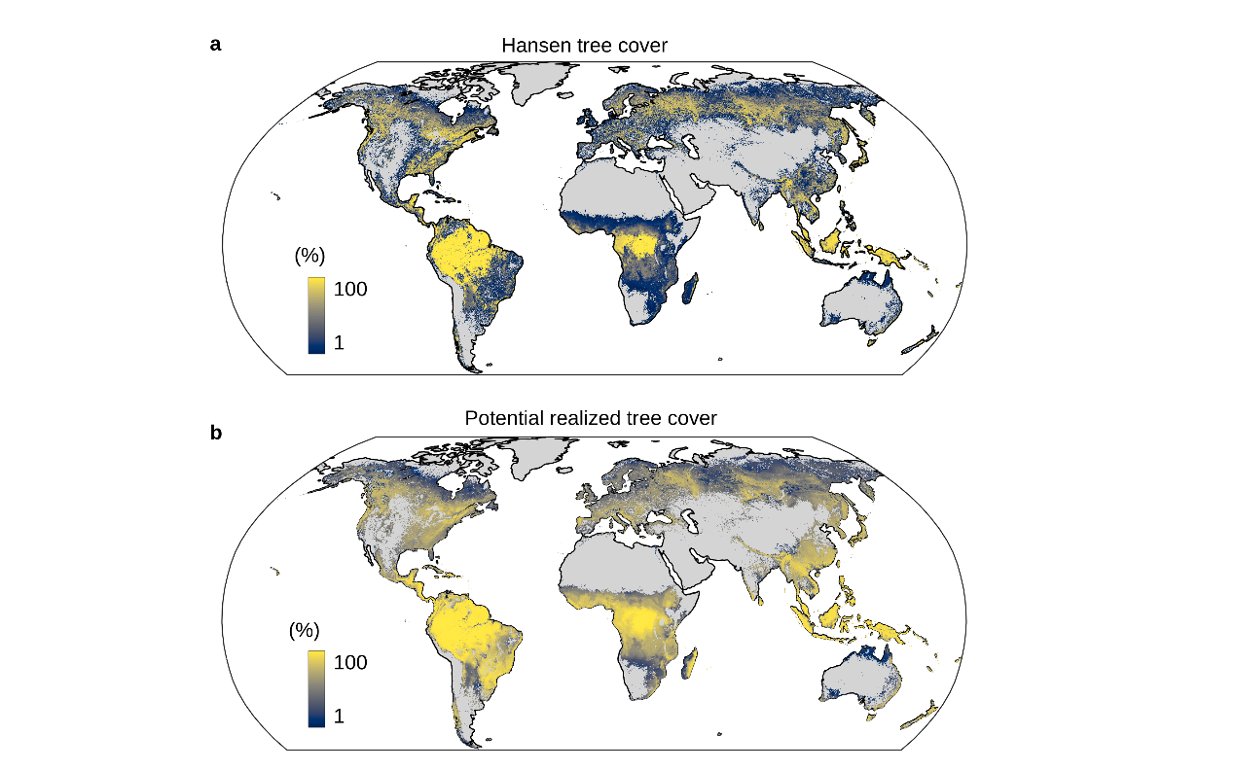
Extended Data Fig. 3 | Spatial patterns of (a) global tree cover based on Hansen et al (2013) at a spatial resolution of 30 arc-second (approximately 1 km at the equator), and (b) potential realized tree cover predicted by a model trained on intact forests.

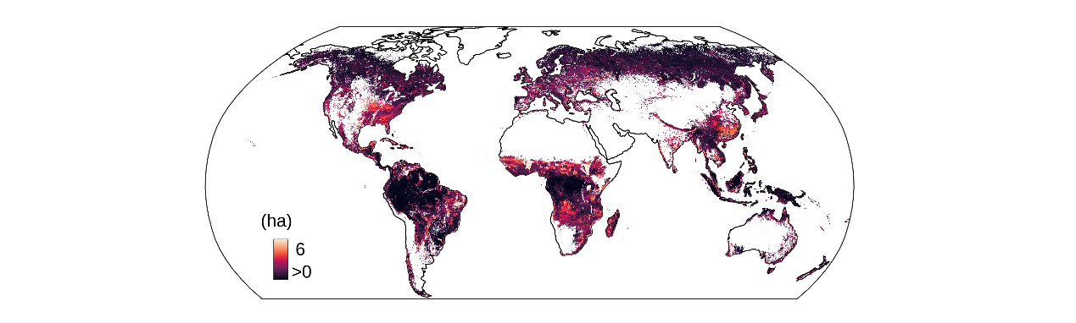
Extended Data Fig. 4 | Uncertainty map of predicted potential realized tree cover. The uncertainty is calculated at the pixel level as the standard deviation of a five-fold cross-validation.

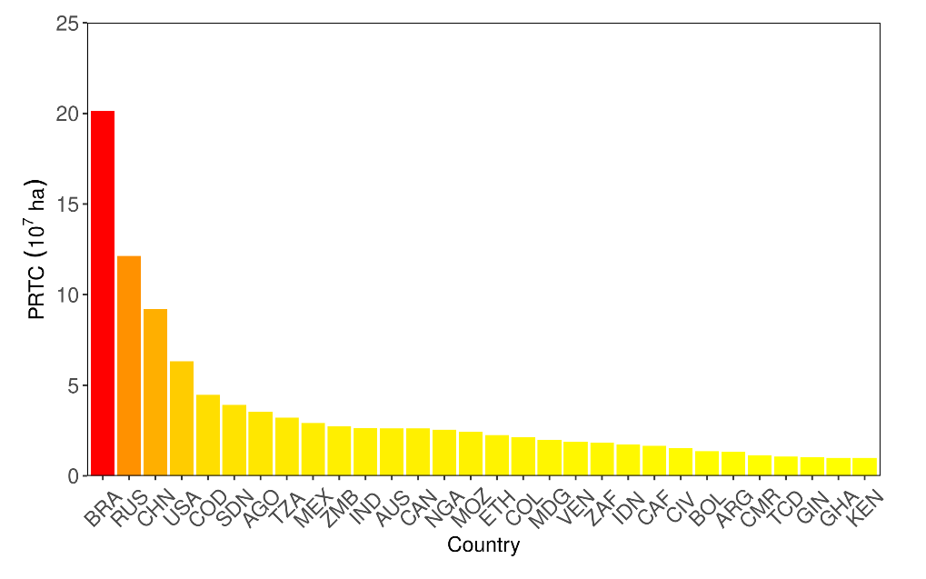
Extended Data Fig. 5 | The areas of PRTC in the top 30 countries. The country codes refer to https://www.iso.org/iso-3166-country-codes.html.

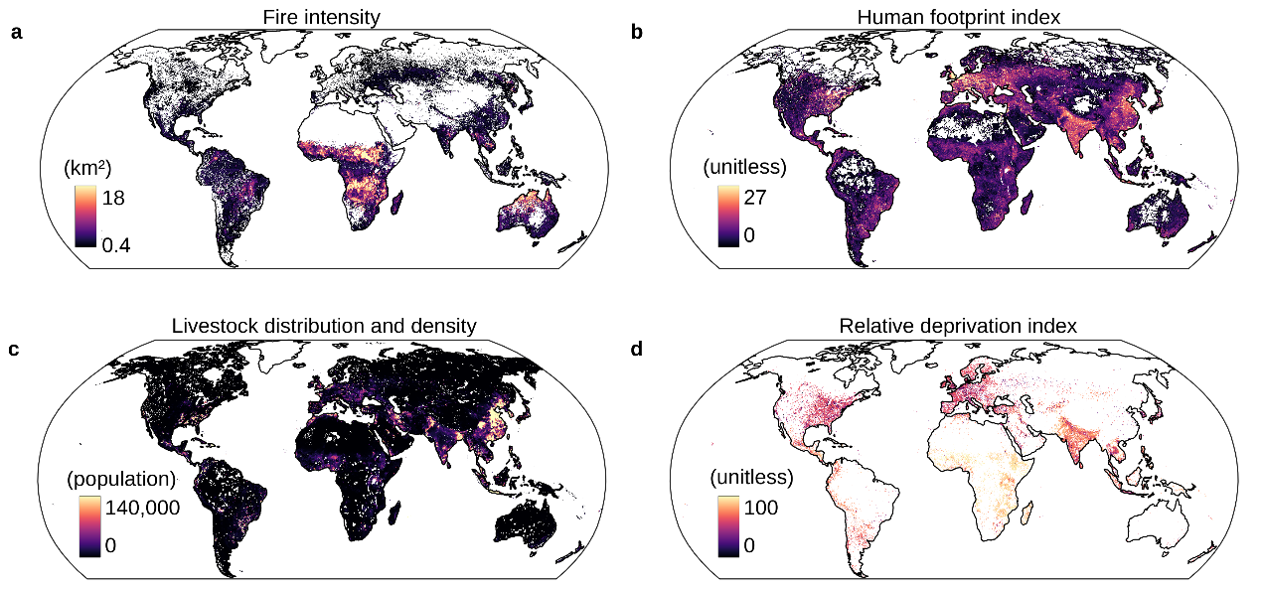
Extended Data Fig. 6 | Spatial patterns of (a) Fire activity expressed by burned areas averaged over 1982–2000, (b) Human footprint index, (c) Livestock density, and (d) Relative deprivation index.
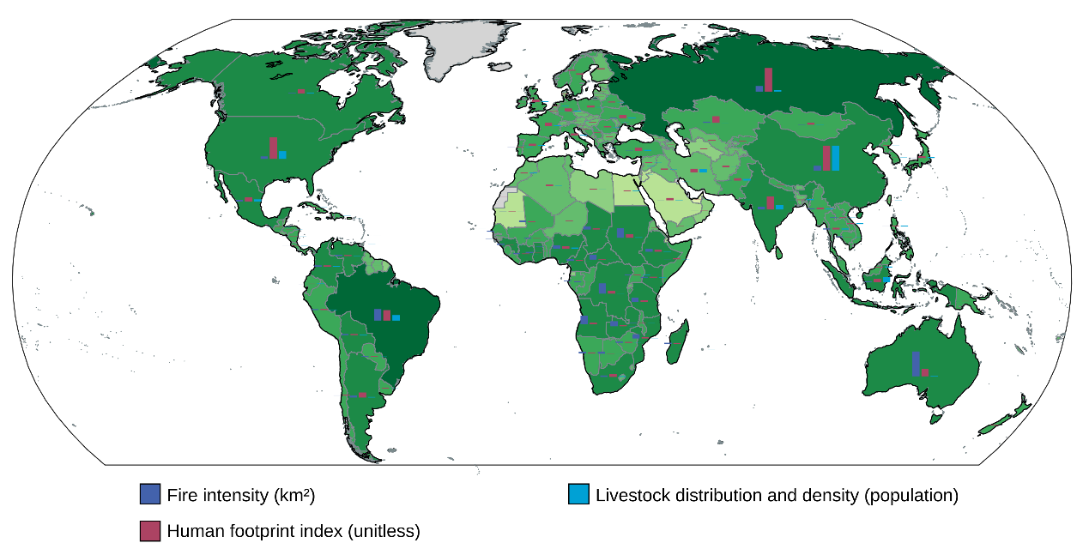
Extended Data Fig. 7 | Relative proportions of fire activity (km²), human footprint index and livestock density across global country-level. Color in background indicates PRTC across global countries, corresponding to Fig. 1b.

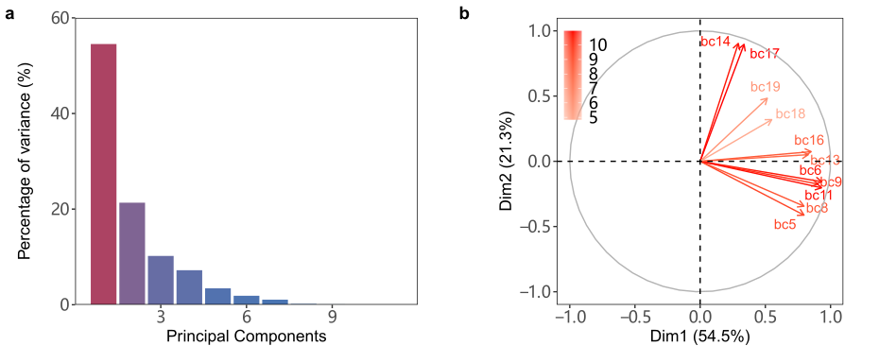
Extended Data Fig. 8 | PCA analysis for the extreme climate variables. (a) The relative importance of the principal components explaining the variance of 11 extreme climatic variables ordered from largest to the smallest. (b) The individual variable contributing to the first and second principal components (Dim1 and Dim2). bc5 = max temperature of warmest month, bc6 = min temperature of coldest month, bc8 = mean temperature of wettest quarter, bc9 = mean temperature of driest quarter, bc11 = mean temperature of coldest quarter, bc13 = precipitation of wettest month, bc14 = precipitation of driest month, bc16 = precipitation of wettest quarter, bc17 = precipitation of driest quarter, bc18 = precipitation of warmest quarter, bc19 = precipitation of coldest quarter.

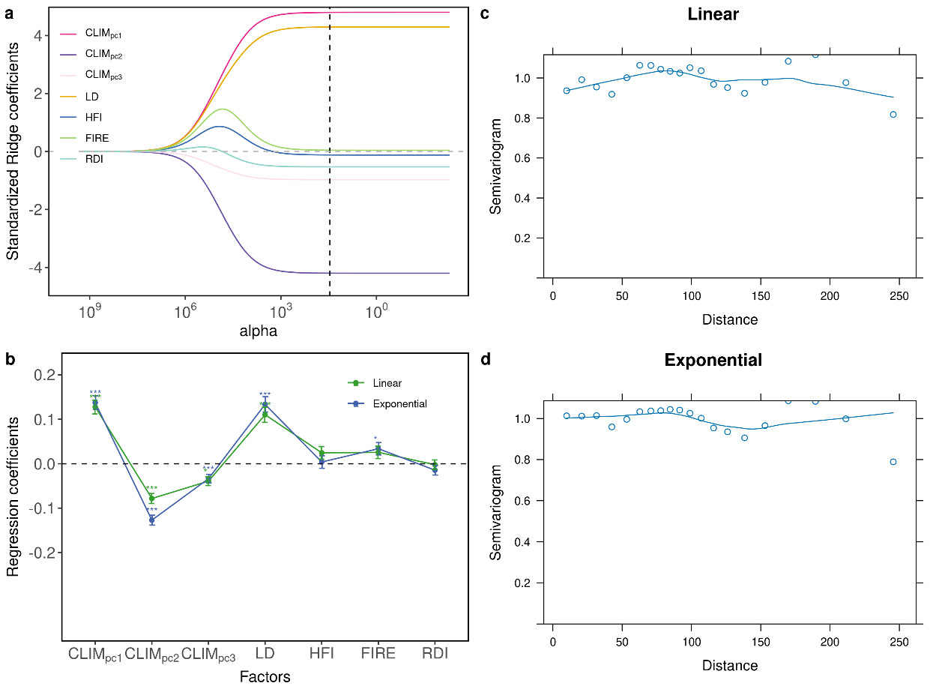
Extended Data Fig. 9 | Relationships between PRTC and climatic and socioeconomic factors accounting for spatial autocorrelation. (a) Relationships based on a ridge regression; variables were standardized prior to modelling and the dashed line shows the optimal tuning parameter (alpha =16) preventing overfitting, based on a Cross-Validation. (b) Spatial modelling relationships based on linear and exponential correlation structures included in gls, variables were standardized prior to modelling. ***, **, *: p < 0.001, 0.01, 0.05, respectively. (c-d) Semivariogram showing the spatial autocorrelation of the sample points based on linear and exponential correlation structures included in gls. A smooth almost-horizontal line around 1, indicating there is no spatial autocorrelation in our model residuals.
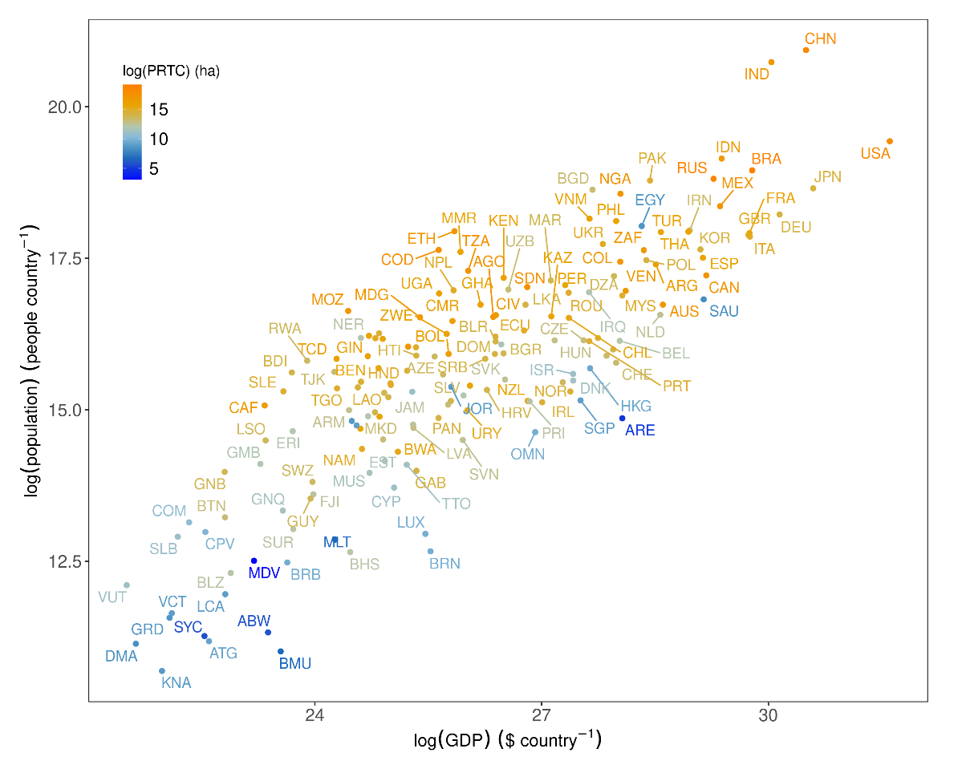
Extended Data Fig. 10 | Relationships between log-transformed human population, GDP and PRTC across global country level. The country codes refer to https://www.iso.org/iso-3166-country-codes.html.

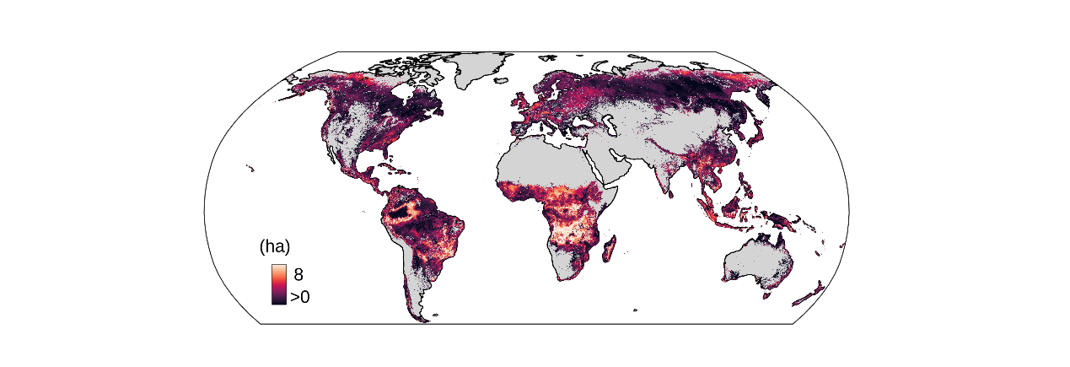
Extended Data Fig. 11 | Uncertainty map of predicted PRTC under future climate scenario (SSP585) by 2100. The uncertainty is calculated at the pixel level as the standard deviation of 11 ESMs predicted PRTC.

Extended Table 1. Data used for modeling global tree canopy cover.
Data set | Source | Reference
Bioclimatic (WorldClim V2.1) 1) Annual variables  2) Seasonality variables  3) Climate extreme variables | Mean annual temperature, annual precipitation | ⁵⁶
 | e.g., Annual range in temperature and precipitation | ⁵⁶
 | e.g., Max temperature of warmest month  Precipitation of driest Month | ⁵⁶
Solar radiation | WorldClim V2.1 | ⁵⁶
Soil properties | Sandy fraction/soil organic carbon/CEC V1.2 | ⁵⁷
Digital elevation model | Shuttle Radar Topography Mission | https://earthexplorer.usgs.gov/

Extended Table 2. Controlling factors for PRTC
Environmental variable | Data coverage | Reference
Climate extreme variables | Gridded | ⁵⁶
Fire activity | Gridded | ⁵⁹
Human-footprint index | Gridded | ⁵⁰
Relative Deprivation Index | Gridded | ⁵¹
Livestock density | Gridded | ⁵²
GDP-PPP (parity of purchasing power, international dollar, $) | Country level | https://data.worldbank.org/
GDP per capita, PPP (international dollar, $) | Country level | https://data.worldbank.org/
Human population total (people) | Country level | https://data.worldbank.org/

Extended Table 3. CMIP6 models used in this study. In total, 11 ESMs providing all climate extreme variables, are available as listed in the table.
 | Models | Nation | Spatial resolution
1 | ACCESS-CM2 | Australia | 1.25° × 1.8750°
2 | GISS-E2-1-G | USA | 2° × 2.5°
3 | HadGEM3-GC31-LL | UK | 1.25° × 1.875
4 | MIROC6 | Japan | 1.40625° × 1.40625°
5 | MPI-ESM1-2-HR | Germany | 1.875° × 1.875°
6 | MRI-ESM2-0 | Japan | 1.125° × 1.125°
7 | UKESM1-0-LL | UK | 1.88° × 1.25°
8 | IPSL-CM6A-LR | France | 1.89° × 3.75°
9 | EC-Earth3-Veg | EC-Earth Consortium, Europe | 1° × 1°
10 | FIO-ESM-2-0 | China | 1.25° × 0.9°
11 | INM-CM5-0 | Russia | 1.5° × 2°

