Measuring Plant Cysteine Oxidase Interactions with Substrates Using Intrinsic Tryptophan Fluorescence

Supplementary Information

Dona M Gunawardanaª, Daisy A. Southernª, Emily Flashman^{b*}

ª – Department of Chemistry, University of Oxford, Oxford OX1 3TA, U.K.; dona.gunawardana@chem.ox.ac.uk, daisysouthern2000@gmail.com
^{b} – Department of Biology, University of Oxford, Oxford OX1 3RB, UK; emily.flashman@biology.ox.ac.uk

*Corresponding author

Table of Contents:
Figure S1 - Alignment of AtPCO sequences showing conserved Trp residues.
Figure S2 - AtPCO4.Ni(II) is inactive.
Figure S3 - Trp fluorescence quenching is due to binding of substrate.
Figure S4 - Binding of shorter version of RAP2.12₂₋₇ shows weaker binding to AtPCO4.
Figure S5 - K_{D} determination of AtPCO4 with RAP2.12, ZPR2 and VRN2.
Table S1- N-terminal sequences of known PCO substrates
Supplementary Figures
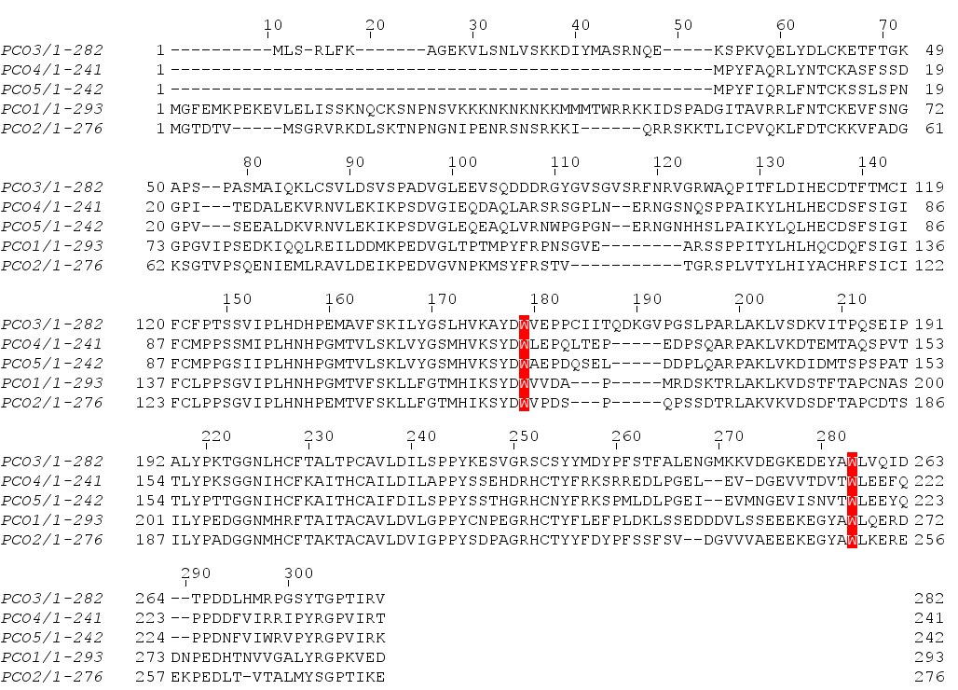
Supplementary Figure S1. Alignment of AtPCO sequences showing conserved Trp residues. Two conserved Trp residues 121 and 217 (AtPCO4 numbering) highlighted in red.
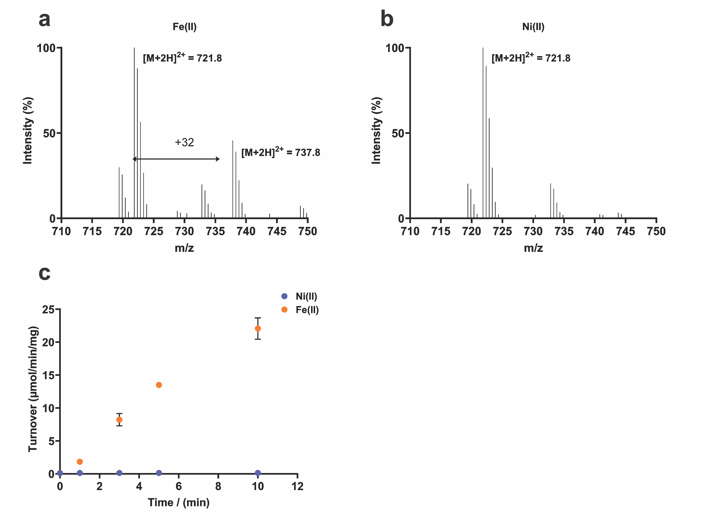
Supplementary Figure S2. AtPCO4.Ni(II) is inactive. Recombinant AtPCO4.Fe(II) catalyses oxidation of RAP2₂₋₁₅, as demonstrated by the presence of a peak in the mass spectrum corresponding to a 32 Da mass increase on the RAP2₂₋₁₅ ion (a). In contrast, AtPCO4.Ni(II) is inactive, as demonstrated by the absence of 32 Da mass increase on the RAP2₂₋₁₅ ion (b) after 10 minutes (c).

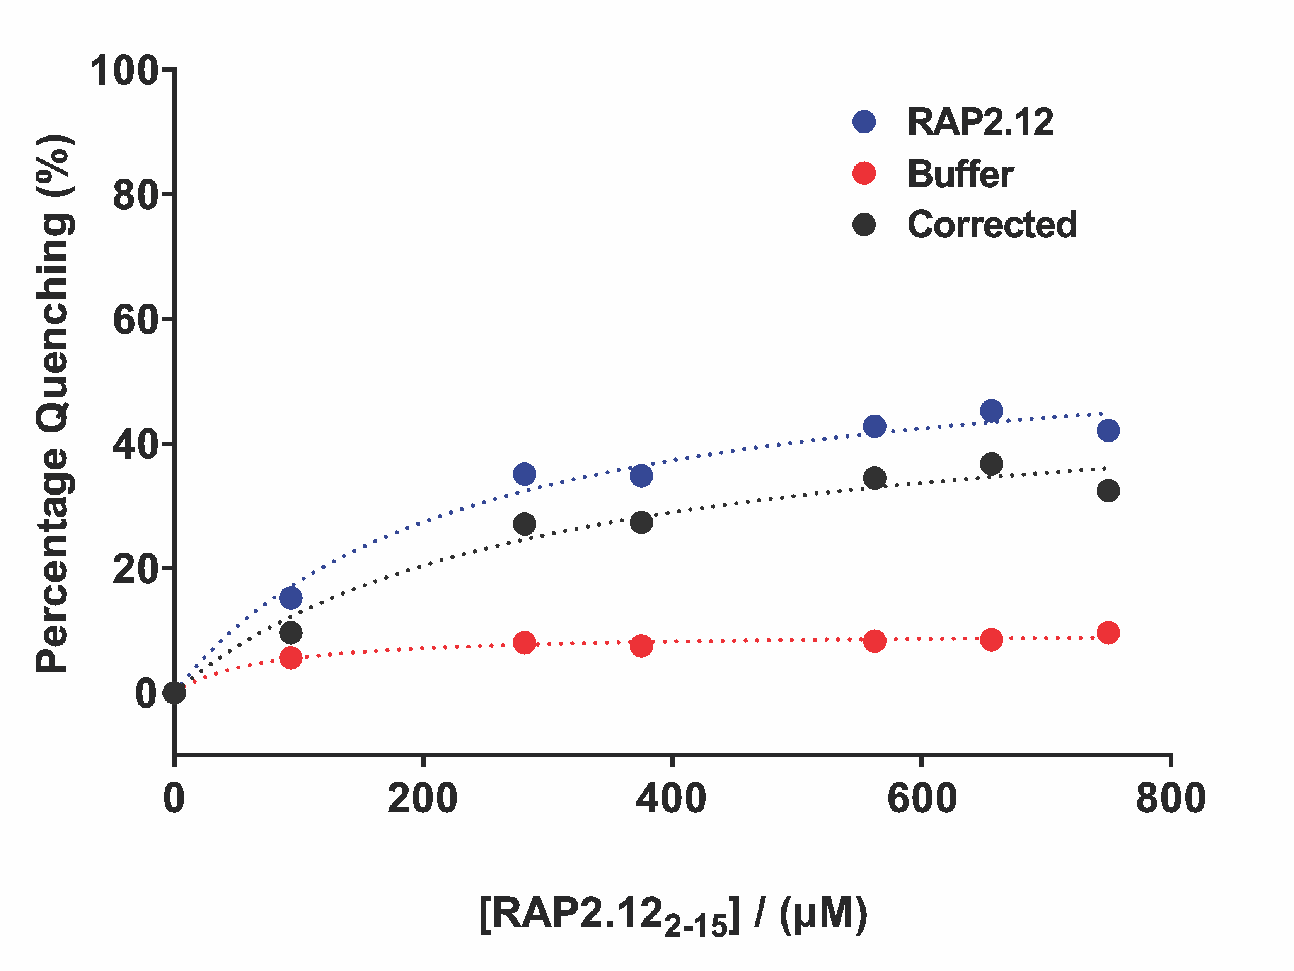
Supplementary Figure S3. Trp fluorescence quenching is due to binding of substrate. Trp fluorescence quenching as a % maximum fluorescence observed with 8 µM AtPCO4.Ni(II) upon addition of 3 µL increments of 46.8 µM RAP2₂₋₁₅ solution or equivalent volumes of buffer control. A concentration-dependent effect confirms that the degree of Trp fluorescence quenching correlates with substrate binding.

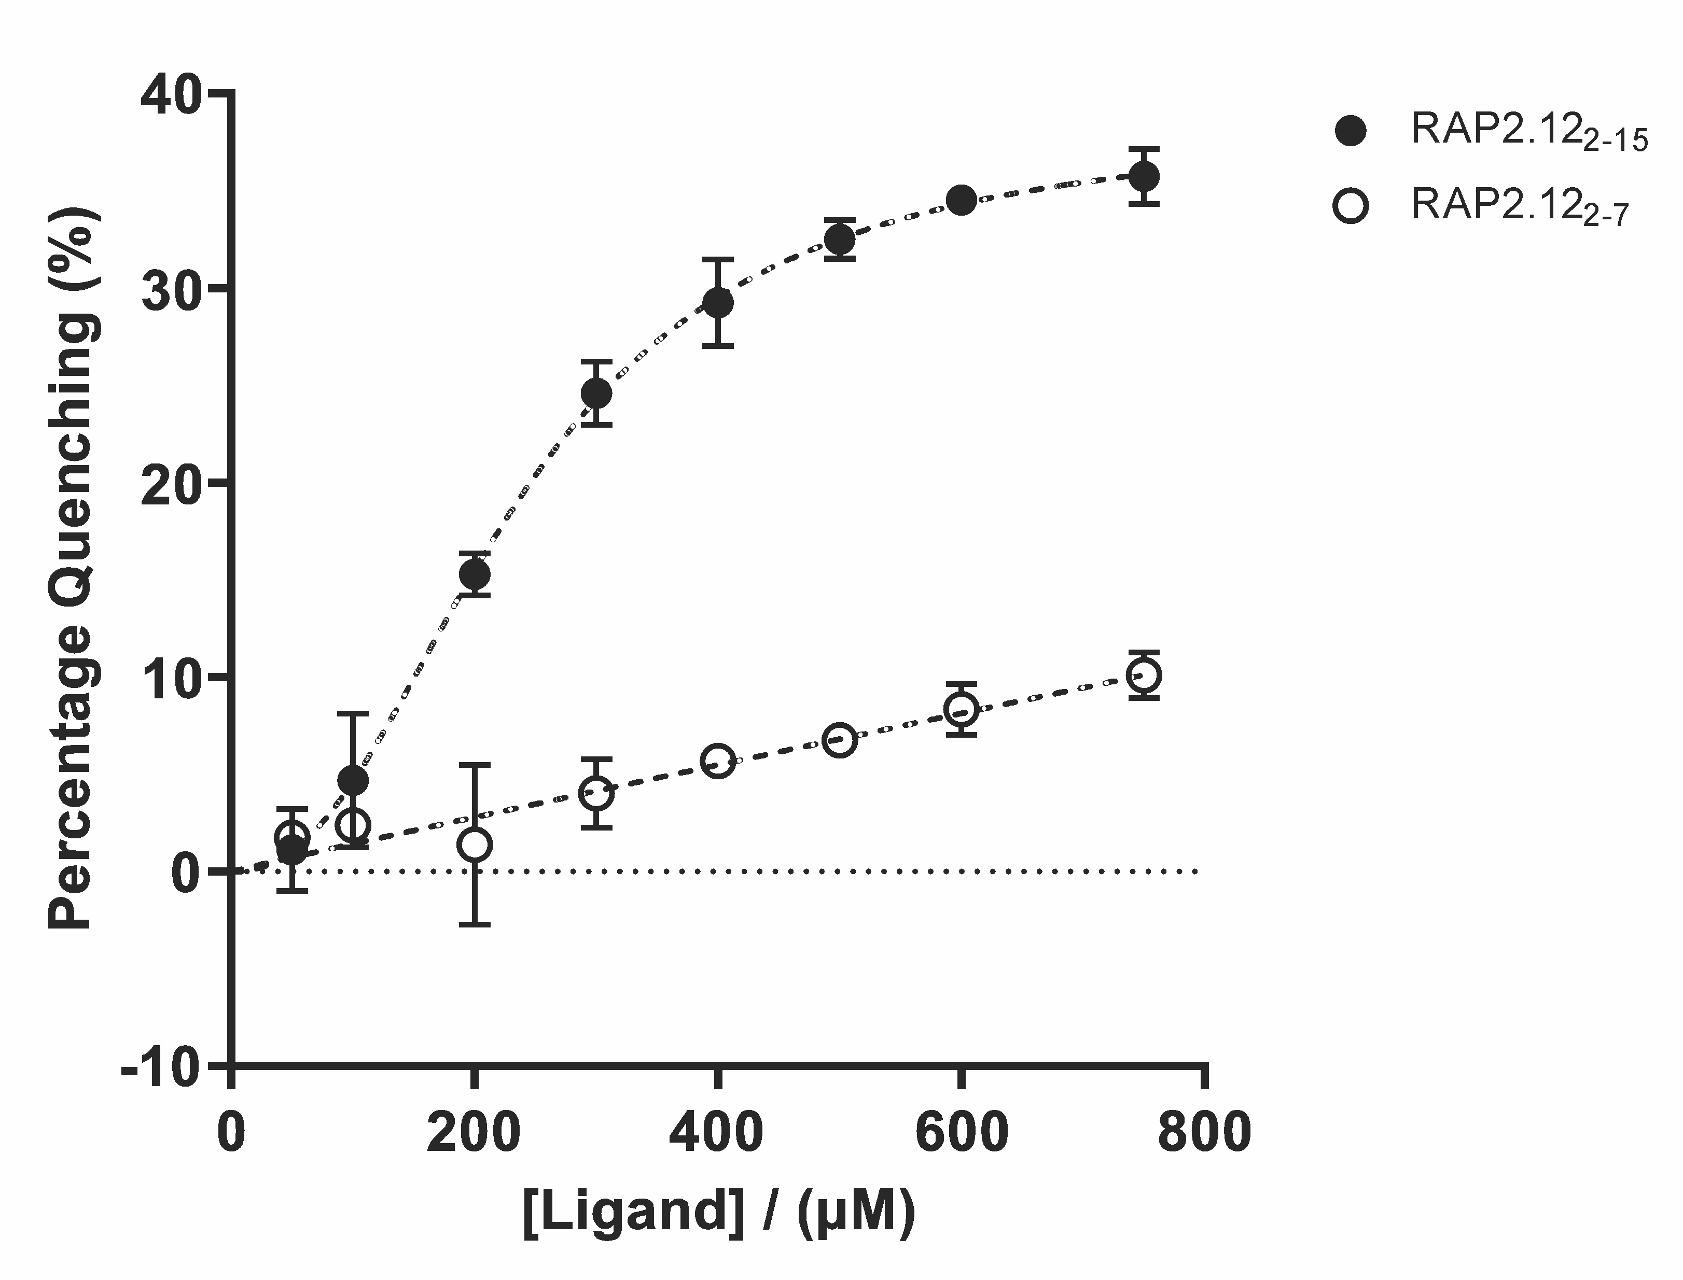
Supplementary Figure S4. Binding of RAP2.12₂₋₇ shows weaker binding to AtPCO4 than RAP2.12₂₋₁₅. Trp fluorescence quenching as a % maximum fluorescence observed with 8 µM AtPCO4.Ni(II) upon addition of 0-750 µM RAP2₂₋₇ or 0-750 µM RAP2₂₋₁₅. A concentration-dependent effect confirms that the degree of Trp fluorescence quenching with RAP2₂₋₇ correlates with substrate binding, but the effect is much weaker than that observed for RAP2₂₋₁₅. Error bars display S.E (n=3).

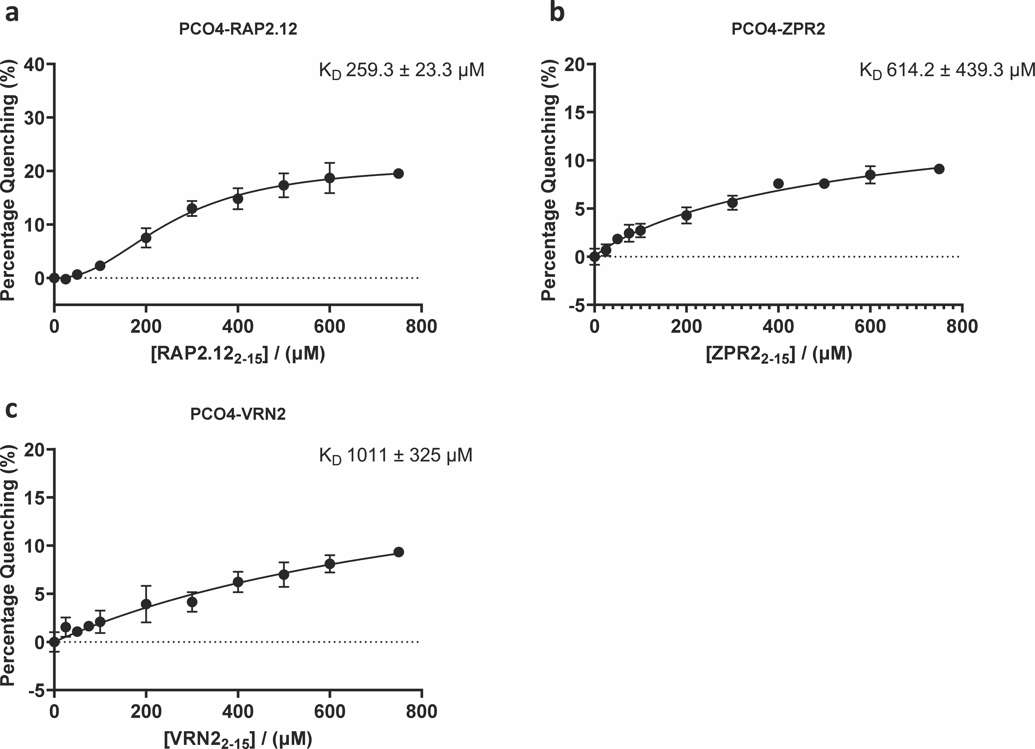
Supplementary Figure S5. K_{D} determination of AtPCO4 with RAP2.12, ZPR2 and VRN2. Trp fluorescence quenching of AtCO4.Ni(II) at 2 µM (with 4 µM Ni(II)) yield similar binding parameters to AtPCO4.Ni(II) at 8 µM (with 16 µM Ni(II)). For ZPR2 one site-specific binding with Hill slope (Y=Bmax*X^h/(Kd^h + X^h) model was fitted to be consistent with curve fitting at 8 µM AtPCO4.Ni(II). Error bars display S.E (n=3).

Supplementary Tables
Name | Gene locus | N-terminal sequence (initiating Met is removed)
RAP2.12 | At1g53910 | CGGAIISDFIPPPR
RAP2.2 | At3g14230 | CGGAIISDFIPPPR
RAP2.3 | At3g16770 | CGGAIISDYIAPLV
HRE1 | At1g72360 | CGGAILSDIIAPSA
HRE2 | At2g47520 | CGGAIISDFIWSKS
VRN2 | At4g16845 | CRQNCRAKSSPEEV
ZPR2 | At3g60890 | CLTTSEPPFPDTDT

Supplementary Table 1. N-terminal sequences of known PCO substrates. Residues 2-15 (Met_{init} removed) of Arabidopsis thaliana ERF-VIIs (RAP2.12, RAP2.2, RAP2.3, HRE1, HRE2), VRN2 and ZPR2 are shown. These sequences were used in peptidic form for binding assays.

