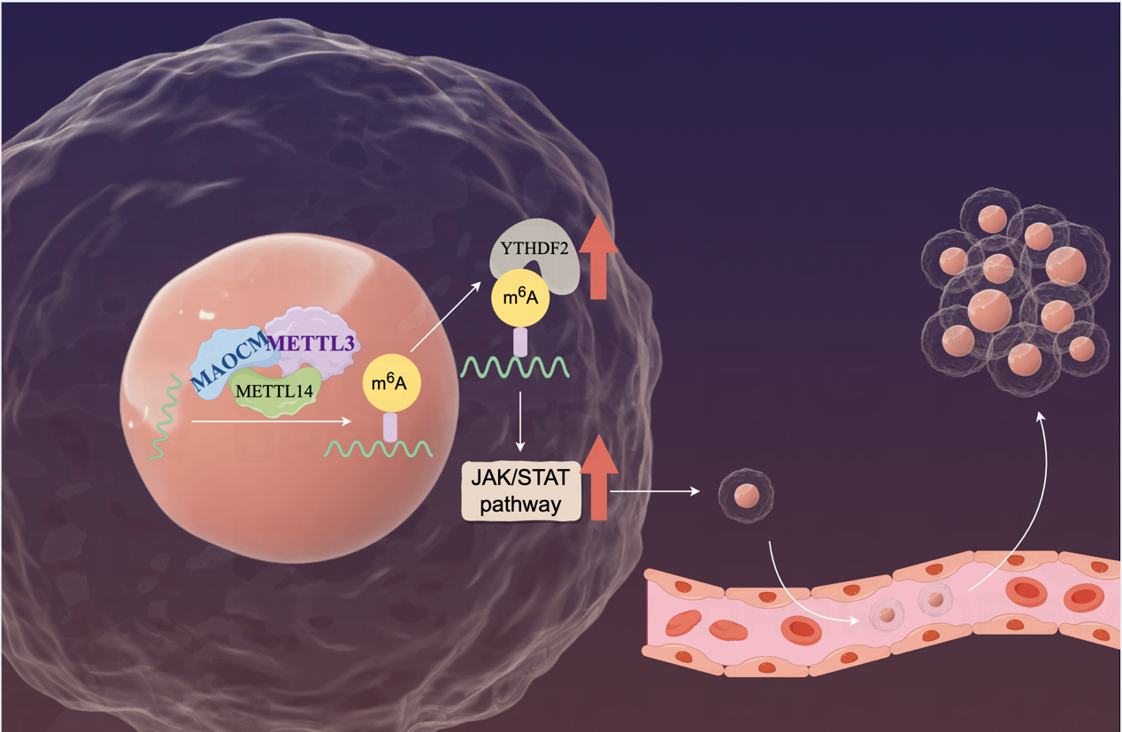
Graphical abstract: YTHDF2 Promotes the Metastasis of Oral Squamous Cell Carcinoma through JAK-STAT Pathway. By Figdraw.

