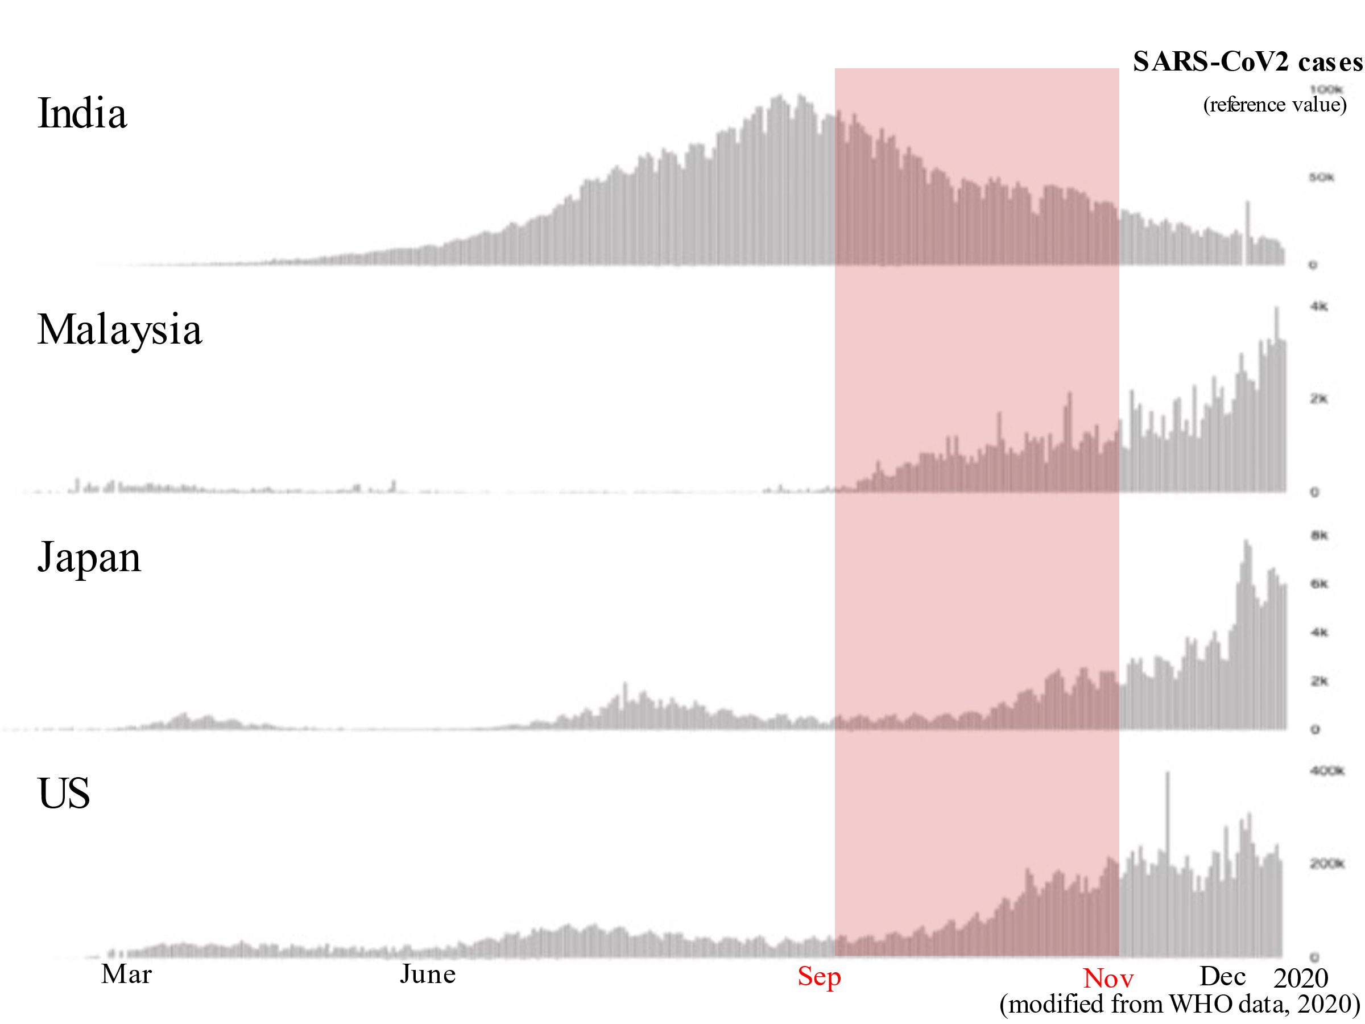

Supplementary Figure 1. The number of SARS-CoV2 cases per day in India, Malaysia, Japan and US from September to November 2020 (From WHO statistical data).
The red band indicates the period we surveyed. India was just past the peak of the second wave of SARS-CoV2 infection, Malaysia was at the beginning of the spread of infection, Japan was between the second and third waves, and the US was at the beginning of the third wave of the spread of infection.

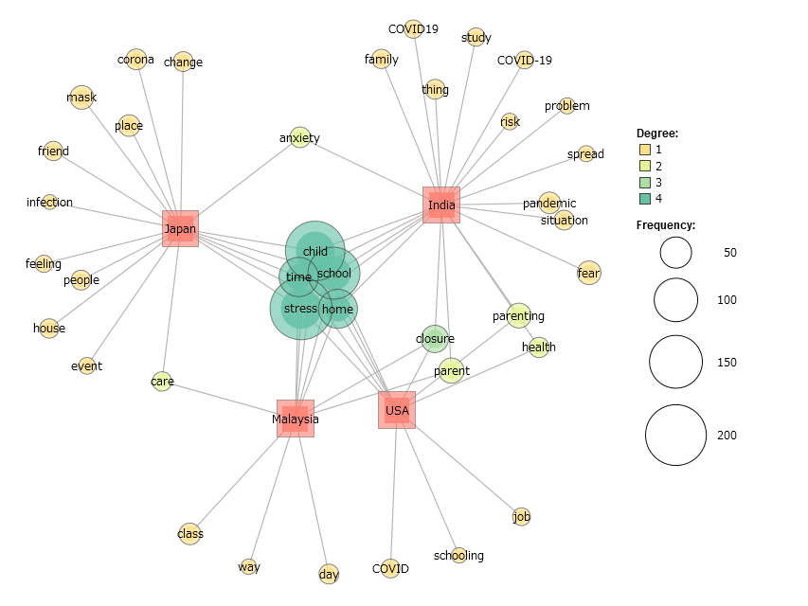

Supplementary Figure 2. The cross-cultural co-occurrence network analysis of parenting stress. The 60 most frequently reported words were listed with the characteristic words for each country. If a word was common to more than one country, two lines were drawn for each country.

r

Supplementary Figure 3. Pearson correlation analyses between the PSI-SF (including sub-scales), CAS, and ACE across all countries. The size and color of the circles reflect correlation coefficients for each combination of the correlation analysis.

