Title: Typical chest CT features can determine the severity of Coronavirus Disease 2019 (COVID-19): a systematic review and meta-analysis of observational studies
Type of manuscript: Systematic review
Running Head: Typical chest CT features can determine the severity of Coronavirus
Authors:
Nahid Hashemimadani ¹, Zahra Emami¹, Leila Janani², Mohammad E. Khamseh^{1*}

1 Endocrine Research Center, Institute of Endocrinology and Metabolism, Iran University of Medical Sciences (IUMS), Tehran, Iran.
2 Department of Biostatistics, School of Public Health, Iran University of Medical Sciences (IUMS), Tehran, Iran

Corresponding Author:
Dr Mohammad E. Khamseh
Professor of Endocrinology and Metabolism, Endocrine Research Center, Institute of Endocrinology and Metabolism, No. 10, Firoozeh St., Vali-asr Ave., Vali-asr Sq., Tehran Iran.
Email: Khamseh.m@iums.ac.ir
https://orcid.org/0000-0003-4313-8440
Tel: +98-21-88945172
Fax: 98-21-88945173

Abstract
Background It remains unclear whether a specific chest CT characteristic is associated with the clinical severity of COVID-19. This meta-analysis was performed to assess the relationship between different chest CT features and severity of clinical presentation in COVID-19.
Methods PubMed, Embase, Scopus, web of science databases (WOS), Cochrane library, and Google scholar were searched up to May 19, 2020 for observational studies that assessed the relationship of different chest CT manifestations and the severity of clinical presentation in COVID-19 infection. Risk of bias assessment was evaluated applying the Newcastle-Ottawa Scale. A random-effects model or fixed-effects model, as appropriately, were used to pool results. Heterogeneity was assessed using Forest plot, Cochran's Q test, and I2. Publication bias was assessed applying Egger’s test.
Results A total of 18 studies involving 3323 patients were included. Bronchial wall thickening (OR 11.64, 95% CI 1.81- 74.66) was more likely to be associated with severe cases of COVID-19 infection, followed by linear opacity (OR 3.27, 95% CI 1.10- 9.70), and GGO (OR 1.37, 95% CI 1.08- 1.73). However, there was no significant association between the presence of consolidation and severity of clinical presentation (OR 2.33, 95% CI 0.85- 6.36). Considering the lesion distribution bilateral lung involvement was more frequently associated with severe clinical presentation (OR 3.44, 95% CI 1.74- 6.79).
Conclusions Our meta-analysis of observational studies suggests some specific chest CT features. The presence of these CT features can help the physicians to early and appropriately approach to the severe and fatal cases of COVID-19.
Keywords: Covid-19, Chest CT features, Clinical severity

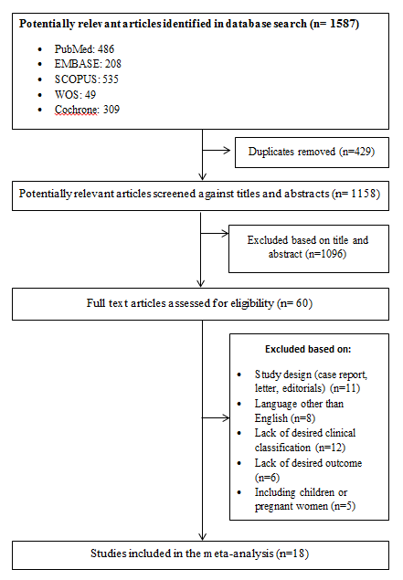
Figure 1. Flow diagram of literature search and study selection.

Table 1. Characteristics of included studies.
Study | Population size (n) | Male (n) | CT manifestations
Study | Population size (n) | Male (n) | Common type |  |  |  |  | Severe type
Study | Population size (n) | Male (n) | GGO | consolidation | linear opacity | bronchial wall thickening | bilateral lung involvement | GOO | consolidation | linear opacity | bronchial wall thickening | bilateral lung involvement
Li  (6) | 83 | 44 | 56 | 31 | 31 | 3 | 54 | 25 | 22 | 23 | 16 | 25
Li  (19) | 78 | 38 |  |  |  |  | 37 |  |  |  |  | 8
Zhao  (5) | 101 | 56 | 73 | 36 |  | 22 | 69 | 14 | 8 |  | 6 | 14
Yang  (1) | 149 | 81 | 287 | 170 | 31 |  |  | 0 | 0 | 0
Wang  (2) | 138 | 75 | 102 |  |  |  | 102 | 36 |  |  |  | 36
Huang  (20) | 41 | 30 |  |  |  |  | 27 |  |  |  |  | 13
Feng  (3) | 476 | 271 | 311 | 68 | 88 |  | 266 | 114 | 19 | 41 |  | 107
Chu  (11) | 54 | 36 | 7 | 2 |  |  | 11 | 32 | 4 |  |  | 35
Colombi  (8) | 236 | 177 | 47 |  |  |  | 123 | 35 |  |  |  | 100
Chen  (12) | 145 | 79 | 60 |  |  |  | 75 | 29 |  |  |  | 40
Guan  (13) | 1099 | 637 | 449 |  |  |  | 368 | 101 |  |  |  | 137
Liu  (14) | 73 | 41 | 43 | 0 |  | 47 | 31 | 22 | 8 |  | 7 | 24
Liu  (15) | 72 | 39 | 14 | 6 |  |  |  | 2 | 0
Zhang  (16) | 120 | 43 | 78 | 37 | 50 |  | 40 | 29 | 25 | 25 |  | 28
Zheng  (4) | 161 | 80 | 62 |  |  |  | 63 | 20 |  |  |  | 26
Han  (10) | 108 | 38 | 65 | 6 |  |  |  | 0 | 0
Huang  (17) | 54 | 28 | 24 | 3 |  |  | 34 | 3 | 0 |  |  | 1
Wan  (18) | 135 | 72 | 95 |  |  |  | 95 | 40 |  |  |  | 40
GOO; ground glass opacity.

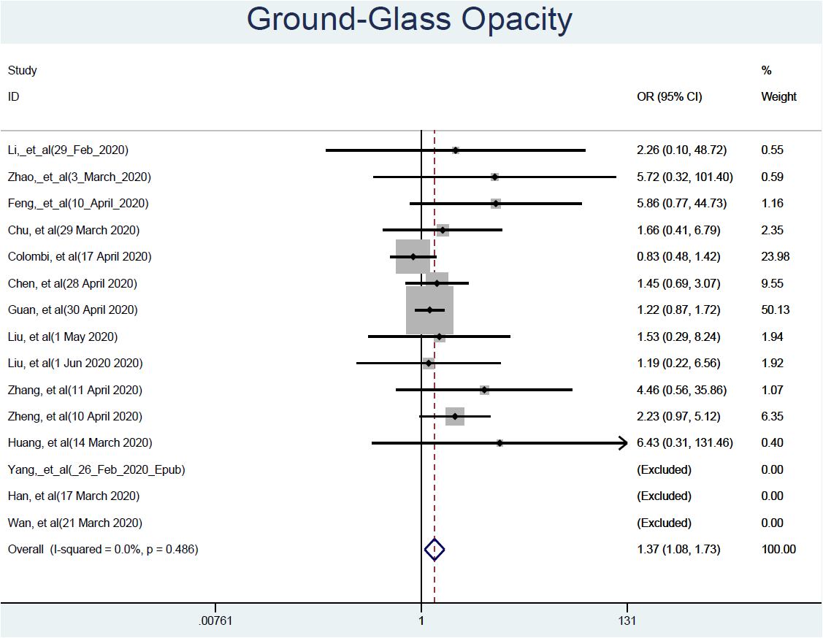 Figure 2. Forest plot showing the association between ground glass opacity in chest CT images and severity of clinical presentation.

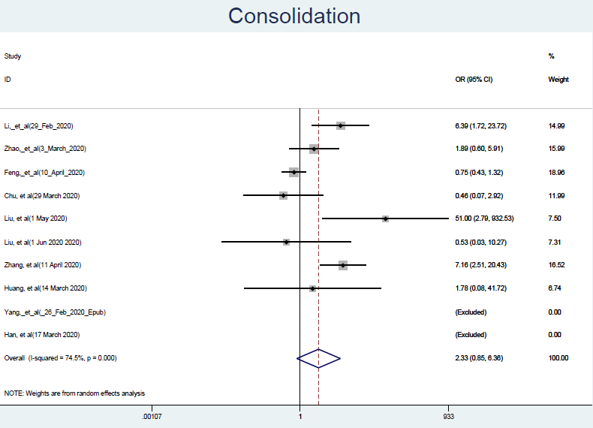Figure 3. Forest plot showing the association between consolidation in chest CT images and severity of clinical presentation.

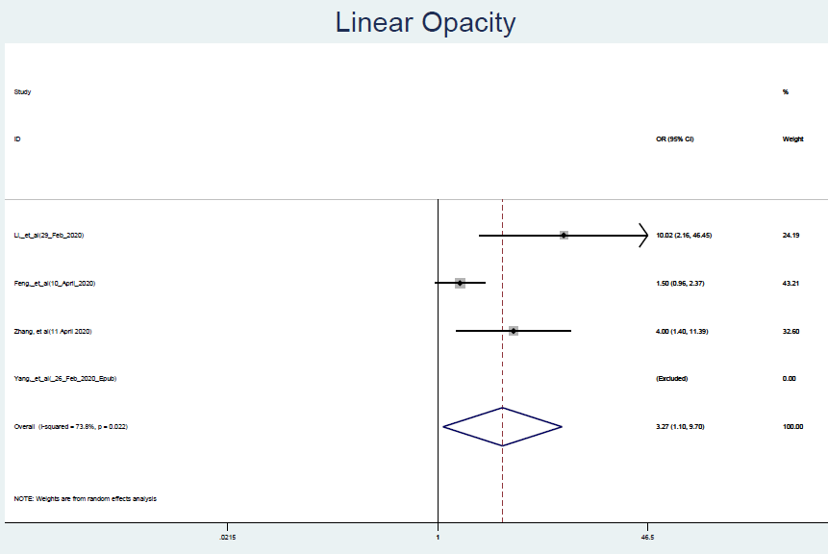Figure 4. Forest plot showing the association between linear opacity in chest CT images and severity of clinical presentation.

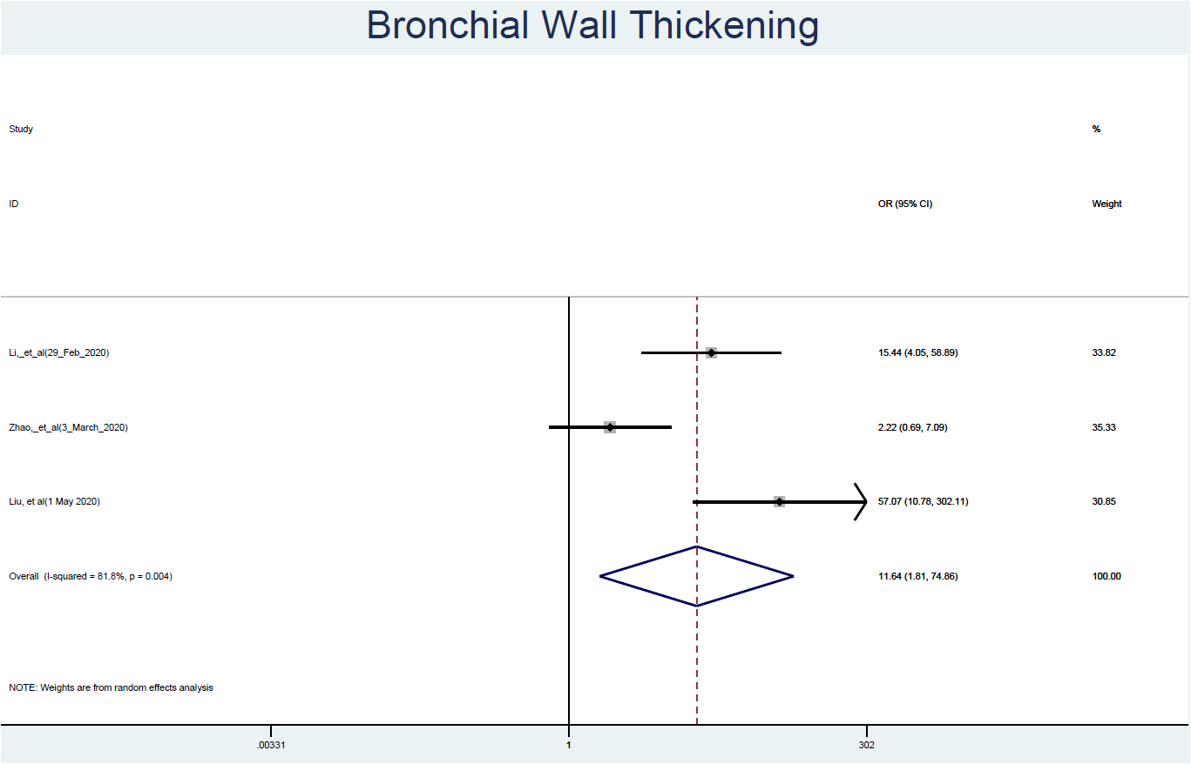
Figure 5. Forest plot showing the association between bronchial wall thickening in chest CT images and severity of clinical presentation.

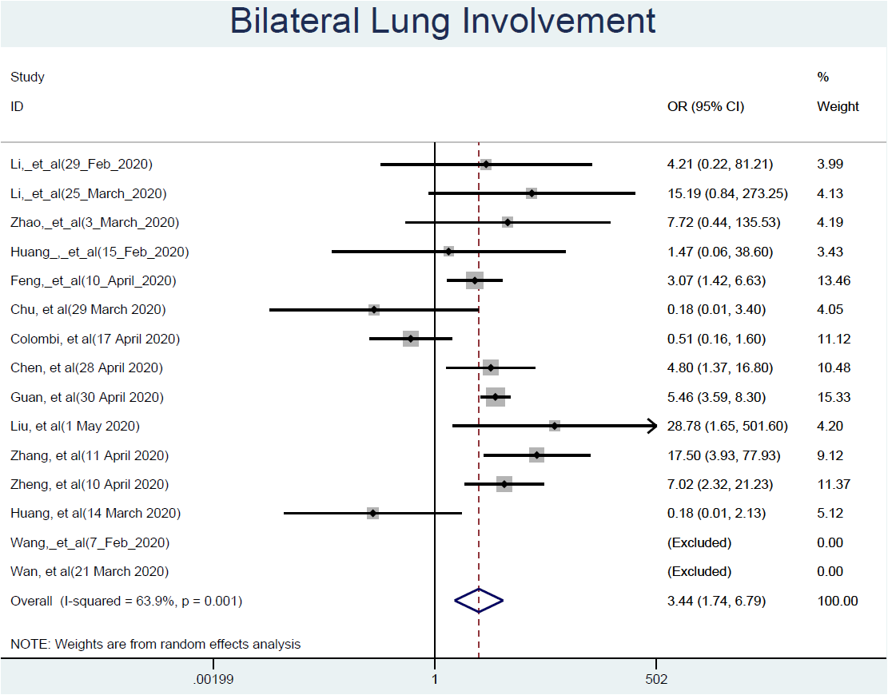Figure 6. Forest plot showing the association between bilateral lung involvement in chest CT images and severity of clinical presentation.

