Supplementary file

eTable 1. Literature search strategy.
Pubmed
Searches |  | Results
#1 | (((((((((((((((((sodium glucose cotransporter[Text Word]) OR (sodium-glucose-cotransporter-2 inhibitors[Text Word])) OR (sglt-2[Text Word])) OR (sglt2[Text Word])) OR (canagliflozin[Text Word])) OR (invokana[Text Word])) OR (dapagliflozin[Text Word])) OR (farxiga[Text Word])) OR (empagliflozin[Text Word])) OR (jardiance[Text Word])) OR (ertugliflozin[Text Word])) OR (luseogliflozin[Text Word])) OR (tofogliflozin[Text Word])) OR (ipragliflozin[Text Word])) OR (sergliflozin[Text Word])) OR (sotagliflozin[Text Word])) OR (remo gliflozins[Text Word])) OR (bexagliflozin[Text Word]) | 14,369
#2 | (((((((cohort study[Text Word]) OR (prospective cohort[Text Word])) OR (retrospective cohort[Text Word])) OR (longitudinal cohort[Text Word])) OR (follow-up study[Text Word])) OR (observational cohort[Text Word])) OR (observational study[Text Word])) OR (cohort[Text Word]) | 1,209,922
#3 | (((((((((AKI[Title/Abstract]) OR (renal injury[Title/Abstract])) OR (kidney injury[Title/Abstract])) OR (renal damage[Title/Abstract])) OR (kidney damage[Title/Abstract])) OR (nephrotic injury[Title/Abstract])) OR (nephrotic damage[Title/Abstract])) OR (renal impairment[Title/Abstract])) OR (kidney impairment[Title/Abstract])) OR (contrast-induced AKI[Title/Abstract]) | 90,800
#4 | #1 AND #2 AND #3 | 67

Embase
Searches |  | Results
#1 | 'sodium glucose cotransporter'/exp OR 'sodium-glucose-cotransporter-2 inhibitors' OR 'sglt-2' OR 'sglt2' OR 'canagliflozin'/exp OR 'invokana'/exp OR 'dapagliflozin'/exp OR 'farxiga'/exp OR 'empagliflozin'/exp OR 'jardiance'/exp OR 'ertugliflozin'/exp OR 'luseogliflozin'/exp OR 'tofogliflozin'/exp OR 'ipragliflozin'/exp OR 'sergliflozin'/exp OR 'sotagliflozin'/exp OR 'remo gliflozins' OR 'bexagliflozin' | 16,790
#2 | 'cohort study'/exp OR 'prospective cohort' OR 'retrospective cohort'/exp OR 'longitudinal cohort'/exp OR 'follow-up study'/exp OR ''/exp OR 'nephrotic damage' OR 'observational study' OR 'cohort'/exp | 630,986
#3 | 'AKI'/exp OR 'renal injury' OR 'kidney injury'/exp OR 'renal damage'/exp OR 'kidney damage'/exp OR 'nephrotic injury'/exp OR 'nephrotic damage' OR 'renal impairment' OR 'kidney impairment'/exp OR 'contrast-induced AKI'/exp | 51,983
#4 | #1 AND #2 AND #3 | 17

the Cochrane Library
Searches |  | Results
#1 | (sodium glucose cotransporter) OR (sodium-glucose-cotransporter-2 inhibitors) OR (sglt-2) OR (sglt2) OR (canagliflozin) | 3,577
#2 | (invokana) OR (dapagliflozin) OR (farxiga) OR (empagliflozin) OR (jardiance) | 4,283
#3 | (ertugliflozin) OR (luseogliflozin) OR (tofogliflozin) OR (ipragliflozin) OR (sergliflozin) | 604
#4 | (sotagliflozin) OR (remo gliflozins) OR (bexagliflozin) | 201
#5 | #1 OR #2 OR #3 OR #4 | 6,491
#6 | (cohort study or prospective cohort or retrospective cohort or longitudinal cohort or follow-up study or observational cohort or observational study).mp. or cohort.af. [mp=ti, ot, ab, tx, kw, ct, sh, fx, hw] | 106,076
#7 | (AKI or renal injury or kidney injury or renal damage or kidney damage or nephrotic injury or nephrotic damage or renal impairment or kidney impairment).mp. or contrast-induced AKI.af. [mp=ti, ot, ab, tx, kw, ct, sh, fx, hw] | 11,177
#8 | #5 AND #6 AND #7 | 33

ClinicalTrial.gov
Basic search
37 Studies found for: SGLT2 inhibitor and renal impairment | Completed Studies | Studies With Results | Cohort Studies. Also searched for Sodium-Glucose Transporter 2 Inhibitors and SODIUM-GLUCOSE TRANSPORTER 2.

eTable 2. Characteristics of Included Literature.
Authors | Year | T2DM | Conditions | Exposition (I/C) | Participants (I/C) | Age | Gender (G/F) | Definition of CI-AKI
Present Study | 2024 | 100% | CCS | DAPA/PL | 2071/2071 | I: 66 (59-72)  C: 66 (58-72) | I: 1470/601  C: 1522/549 | ESUR and KDIGO criteria.
Gizem Çabuk | 2024 | 100% | stable angina or ACS | SGLT2i/PL | 133/212 | I: 61.68 ± 9.91  C: 63.58 ± 9.85 | I: 83/50  C: 131/81 | ESUR criteria.
Pasquale Paolisso | 2023 | 100% | AMI | SGLT2i/PL | 111/535 | I: 66 (59-73)  C: 72 (62-80) | I: 90/21  C: 405/130 | ESUR criteria.
Uğur Özkan | 2023 | 100% | NSTEMI | SGLT2i/PL | 104/208 | I: 60 (52-70)  C: 58.2 (52-71) | I: 66/38  C: 123/85 | The diagnosis of CI-AKI was determined as a 0.5 mg/dL (absolute) or 25% (relative) increase in creatinine value within 48 h, an increase in creatinine level of more than 1.5 times the baseline within 7 days, or a urinary output of less than 0.5 mL/kg/h for at least 6 h after using the contrast agent compared to its level before the procedure.
Mateus Paiva Marques Feitosa | 2023 | 100% | stable CAD | SGLT2i/PL | 22/20 | I: 65 ± 10  C: 64 ± 6 | I: 14/8  C: 15/5 | KDIGO criteria.
Rui Hua | 2022 | 100% | CAD | SGLT2i/PL | 242/242 | I: 62.6 (55-63)  C: 63.6 (57-71) | I: 205/37  C: 206/36 | ESUR and KDIGO criteria.
Santos-Gallego C | 2020 | 100% | Patients underwent PCI | SGLT2i/PL | 52/52 | I: 64.7 ± 8.8  C: 64.7 ± 8.8 | I: 34/18  C: 34/18 | CI-AKI was defined as increase in Creat higher than 30% or higher than 0.3mg/dL one day post-PCI.
I, Intervention; CCS, Chronic Coronary Syndrome; DAPA, Dapagliflozin; PL, Placebo; ACS, Acute Coronary Syndrome; SGLT2i, Sodium-glucose cotransporter-2 inhibitor; AMI, Acute Myocardial Infarction; NSTEMI, Non-ST-Segment Elevation Myocardial Infarction; CAD, Coronary Atherosclerotic Heart Disease; PCI, Percutaneous Coronary Intervention; T2DM, Type 2 Diabetes Mellitus; ESUR, the European Society of Urogenital Radiology serum creatinine criteria; KDIGO, the Kidney Disease: Improving Global Outcomes serum creatinine criteria.

eTable 3. Risk of bias of the included studies.
Author, Study, Year | Study Design | Tool | Conclusion
Present Study, 2024 | ACS | NOS | Low Risk
Gizem Çabuk, 2024 | PCS | NOS | Low Risk
Pasquale Paolisso, 2023 | RCS | NOS | Low Risk
Uğur Özkan, 2023 | RCS | NOS | Low Risk
Mateus Paiva Marques Feitosa, 2023 | PCS | NOS | Low Risk
Rui Hua, 2022 | RCS | NOS | Low Risk
Santos-Gallego C, 2020 | RCS | NOS | Low Risk
ACS, ambispective cohort study; PCS, prospective cohort study; RCS, retrospective cohort study; NOS, Newcastle-Ottawa scale (NOS)

eFigure 1. Subgroup analysis of meta-analysis of SGLT2i on CI-AKI.
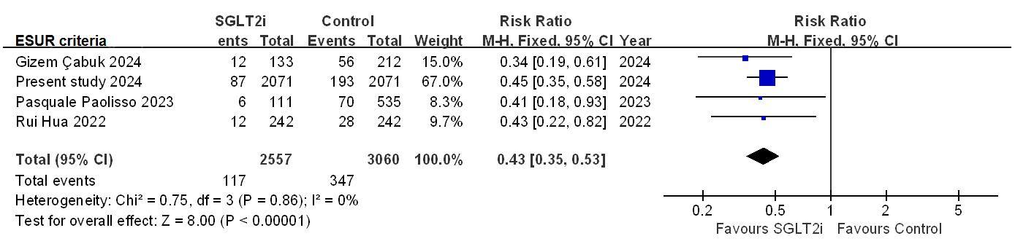
eFigure 1 (A). Subgroup analysis of SGLT2i on CI-AKI_{ESUR}.

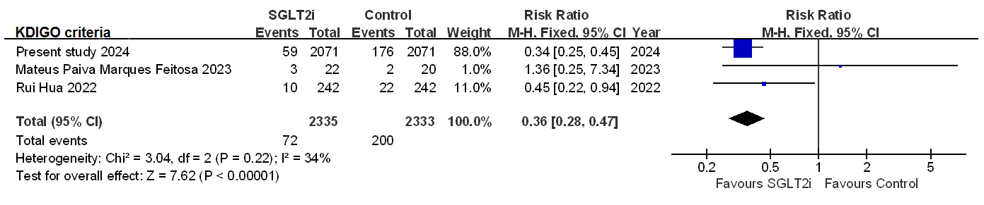
eFigure 1 (B). Subgroup analysis of SGLT2i on CI-AKI_{KDIGO}.

eFigure 2. Funnel plot of the included studies in the meta-analysis on the effect of developing CI-AKIafter PCI/CAG/CCTA.
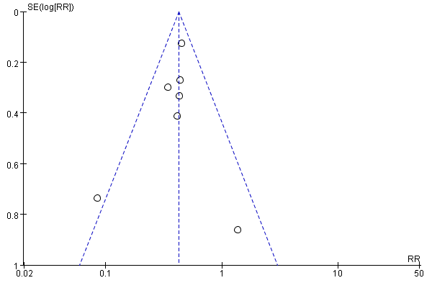
eFigure 2 (A). The selection of outcome criteria: Present Study, ESUR; Gizem Çabuk, ESUR; Pasquale Paolisso, ESUR; Uğur Özkan, other standard; Mateus Paiva Marques Feitosa, KDIGO; Rui Hua, ESUR; Santos-Gallego C, other standard.

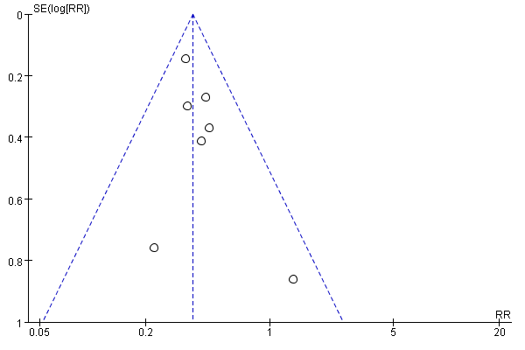
eFigure 2 (B). The selection of outcome criteria: Present Study, KDIGO; Gizem Çabuk, ESUR; Pasquale Paolisso, ESUR; Uğur Özkan, other standard; Mateus Paiva Marques Feitosa, KDIGO; Rui Hua, KDIGO; Santos-Gallego C, other standard.

