Supplementary Materials

Supplementary Figures
Supplementary Figure 1. Schematic diagram of diffusion tensor imaging (DTI) and neurite orientation dispersion and density imaging (NODDI) models.
Supplementary Figure 2. Pipeline of tract-based spatial statistics (TBSS) and gray matter-based spatial statistics (GBSS).
Supplementary Figure 3. (A) Regression lines for each diffusion index (mean FWF of GM, mean ODI, and mean FA of WM) with age on the X-axis and the diffusion indices on the Y-axis for both healthy control and depression groups. (B) Interaction plots depicting the interaction between diagnosis (healthy control vs. depression) and sex.
Supplementary Tables
Supplementary Table 1. MNI coordinates and volumes of clusters (pFWE<0.05; ≥100 mm3) from gray matter-based spatial statistics demonstrating significantly higher gray matter free water fraction (FWF) in individuals with major depressive disorder relative to healthy participants.
Supplementary Table 2. MNI coordinates and volumes of clusters (pFWE<0.05; ≥100 mm3) from tract-based spatial statistics demonstrating significantly lower white matter fractional anisotropy (FA) in individuals with major depressive disorder relative to healthy participants.
Supplementary Figure 1. Schematic diagram of diffusion tensor imaging (DTI) and neurite orientation dispersion and density imaging (NODDI) models. DTI is a single-compartment model that approximates each voxel as an ellipsoid, assuming a Gaussian distribution of water diffusion. In contrast, NODDI models each voxel as comprising three compartments: intra-neurite (axons and dendrites), extra-neurite (surrounding glial cells and membranes), and free water (cerebrospinal fluid and edema). The neurite density index (NDI) represents the proportion of intra-neurite components within the total tissue. The orientation dispersion index (ODI) measures the angular variation of neurites, indicating how aligned or dispersed the neurite orientations are. The free water fraction (FWF) calculates the proportion of free water components within the total signal, which may indicate regions of edema or cerebrospinal fluid.
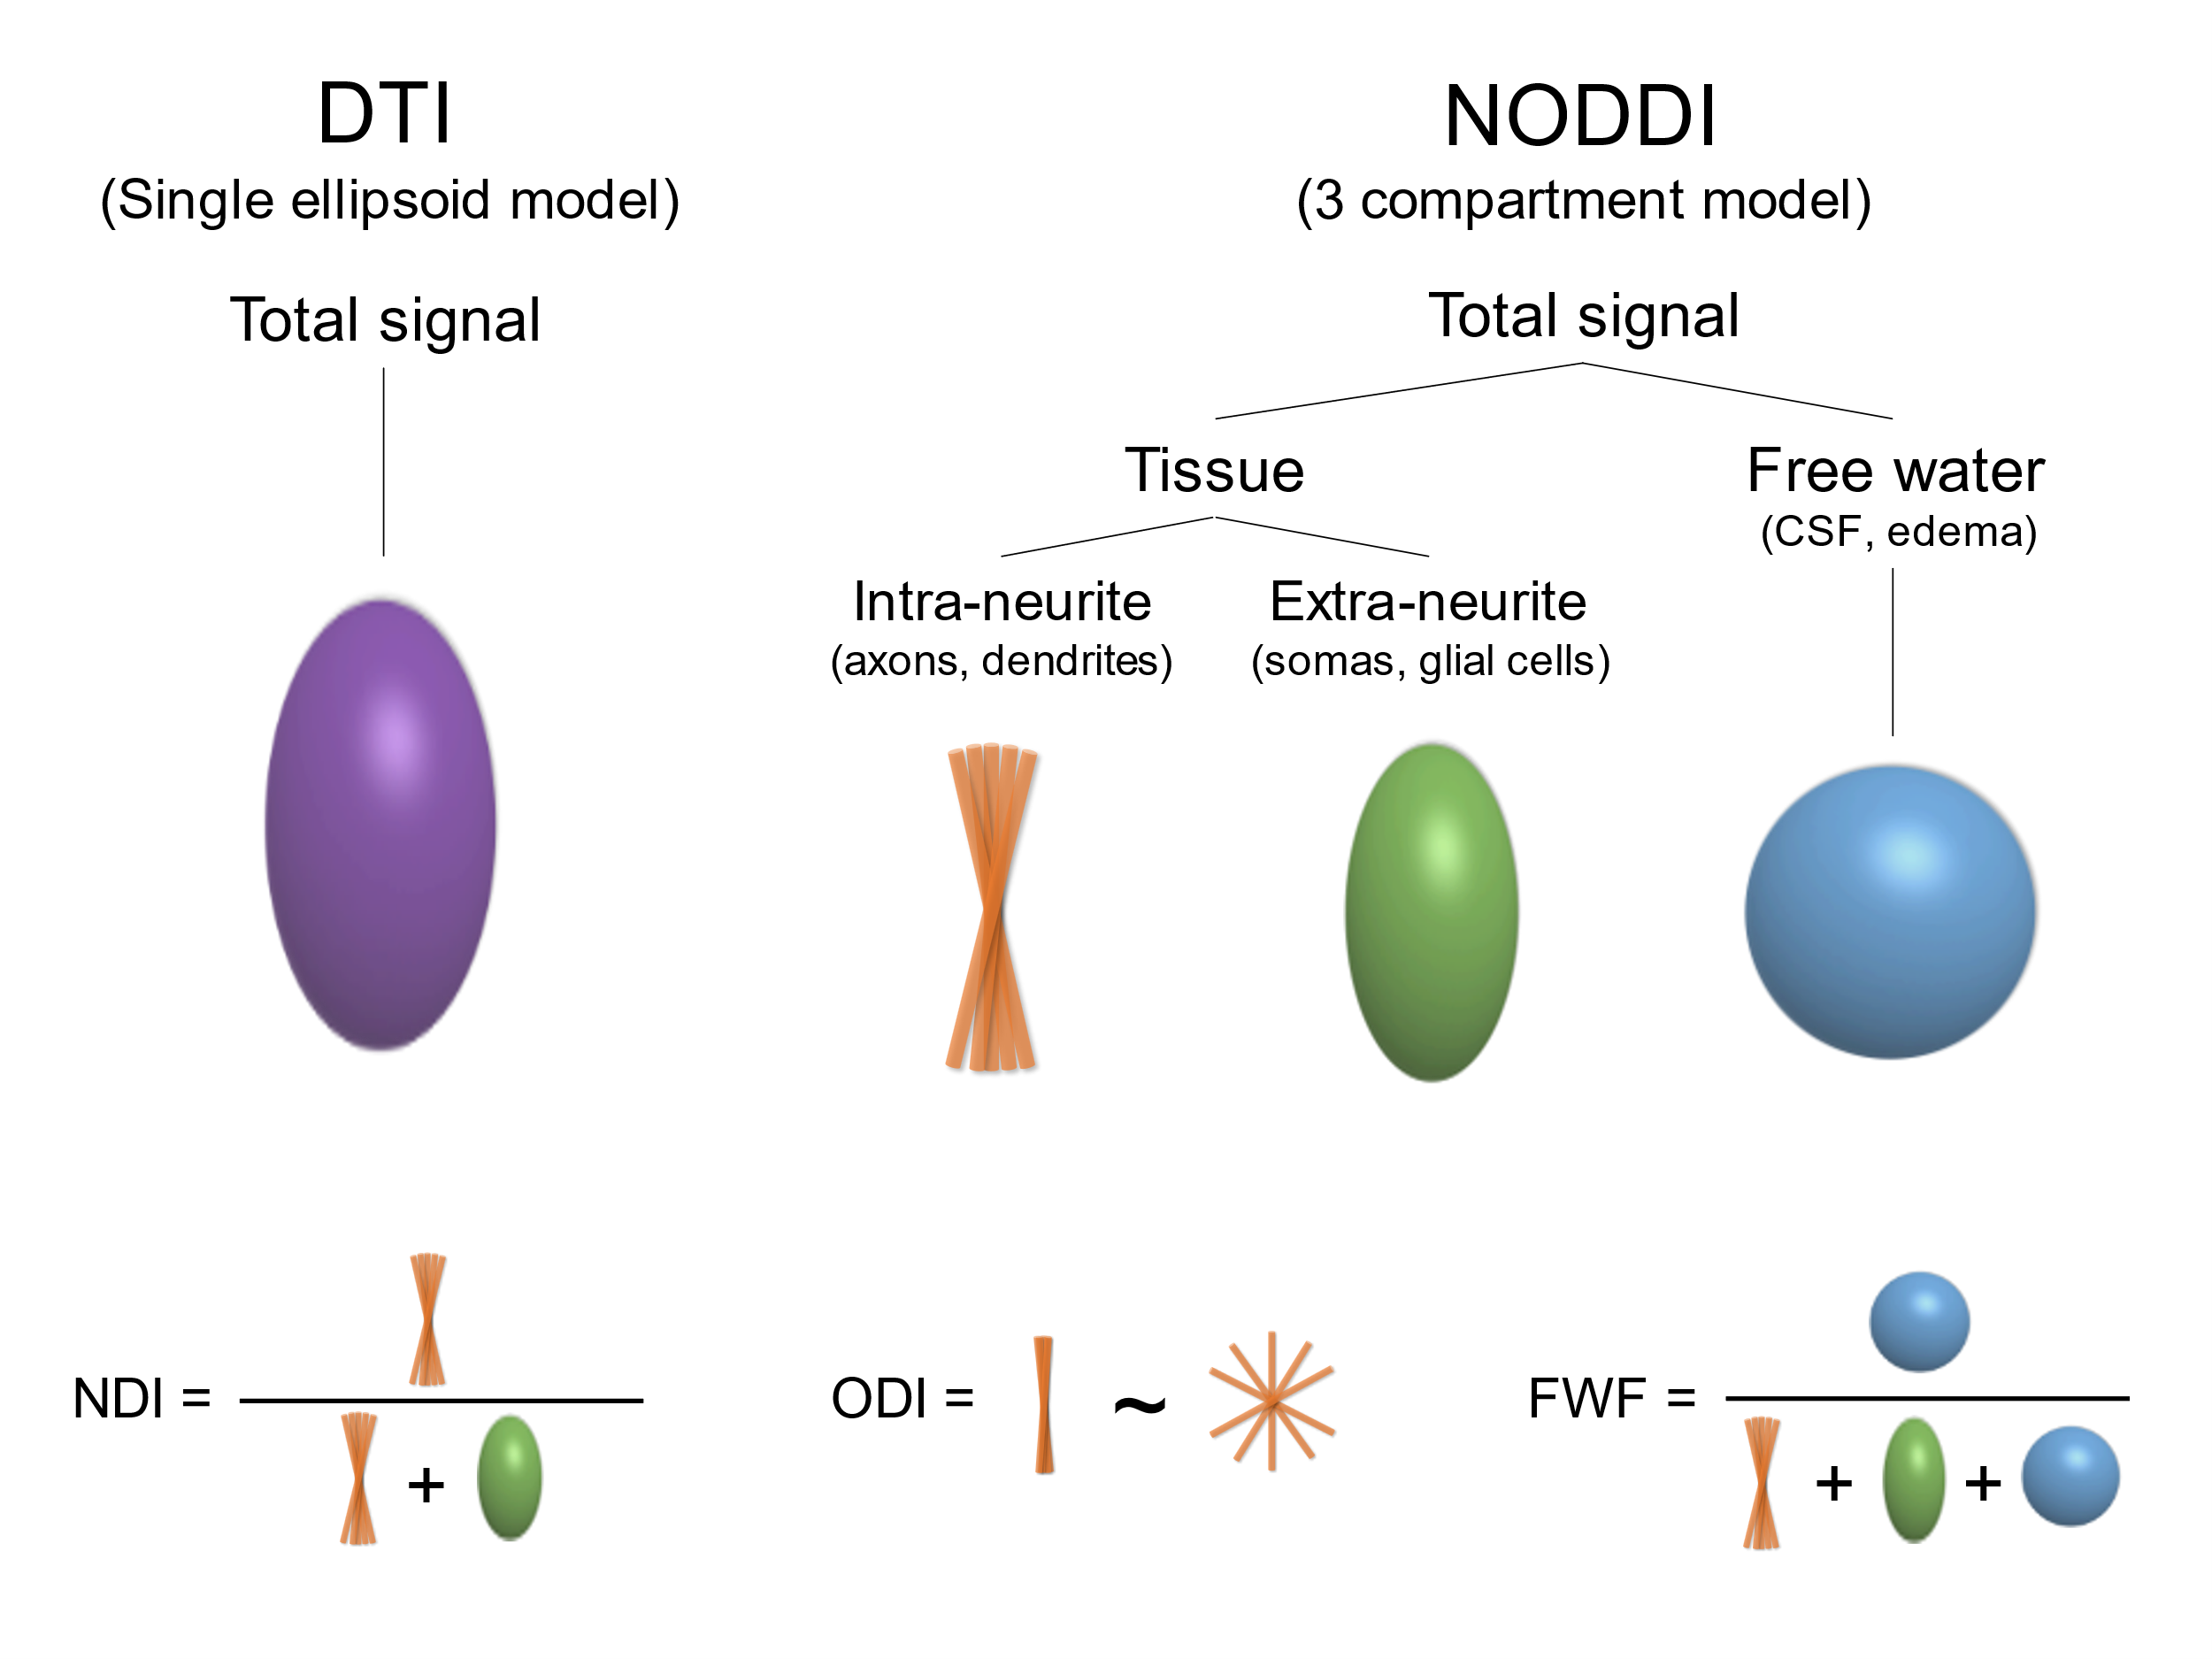

Supplementary Figure 2. Pipeline of tract-based spatial statistics (TBSS) and gray matter-based spatial statistics (GBSS). (A) In TBSS, fractional anisotropy (FA) images of all subjects are registered to the Montreal Neurological Institute (MNI) space to create a mean FA image. This mean FA image is used to generate an FA skeleton mask image, onto which FA values of each subject are projected. Neurite density index (NDI), orientation dispersion index (ODI), and free water fraction (FWF) images are also projected onto the FA skeleton using the same projection vectors. (B) In GBSS, T1-weighted images of all subjects are segmented into gray matter and registered to MNI space to create a mean gray matter image. This mean gray matter image is used to generate a gray matter skeleton mask image, onto which NDI, ODI, and FWF images are projected for gray matter analysis.
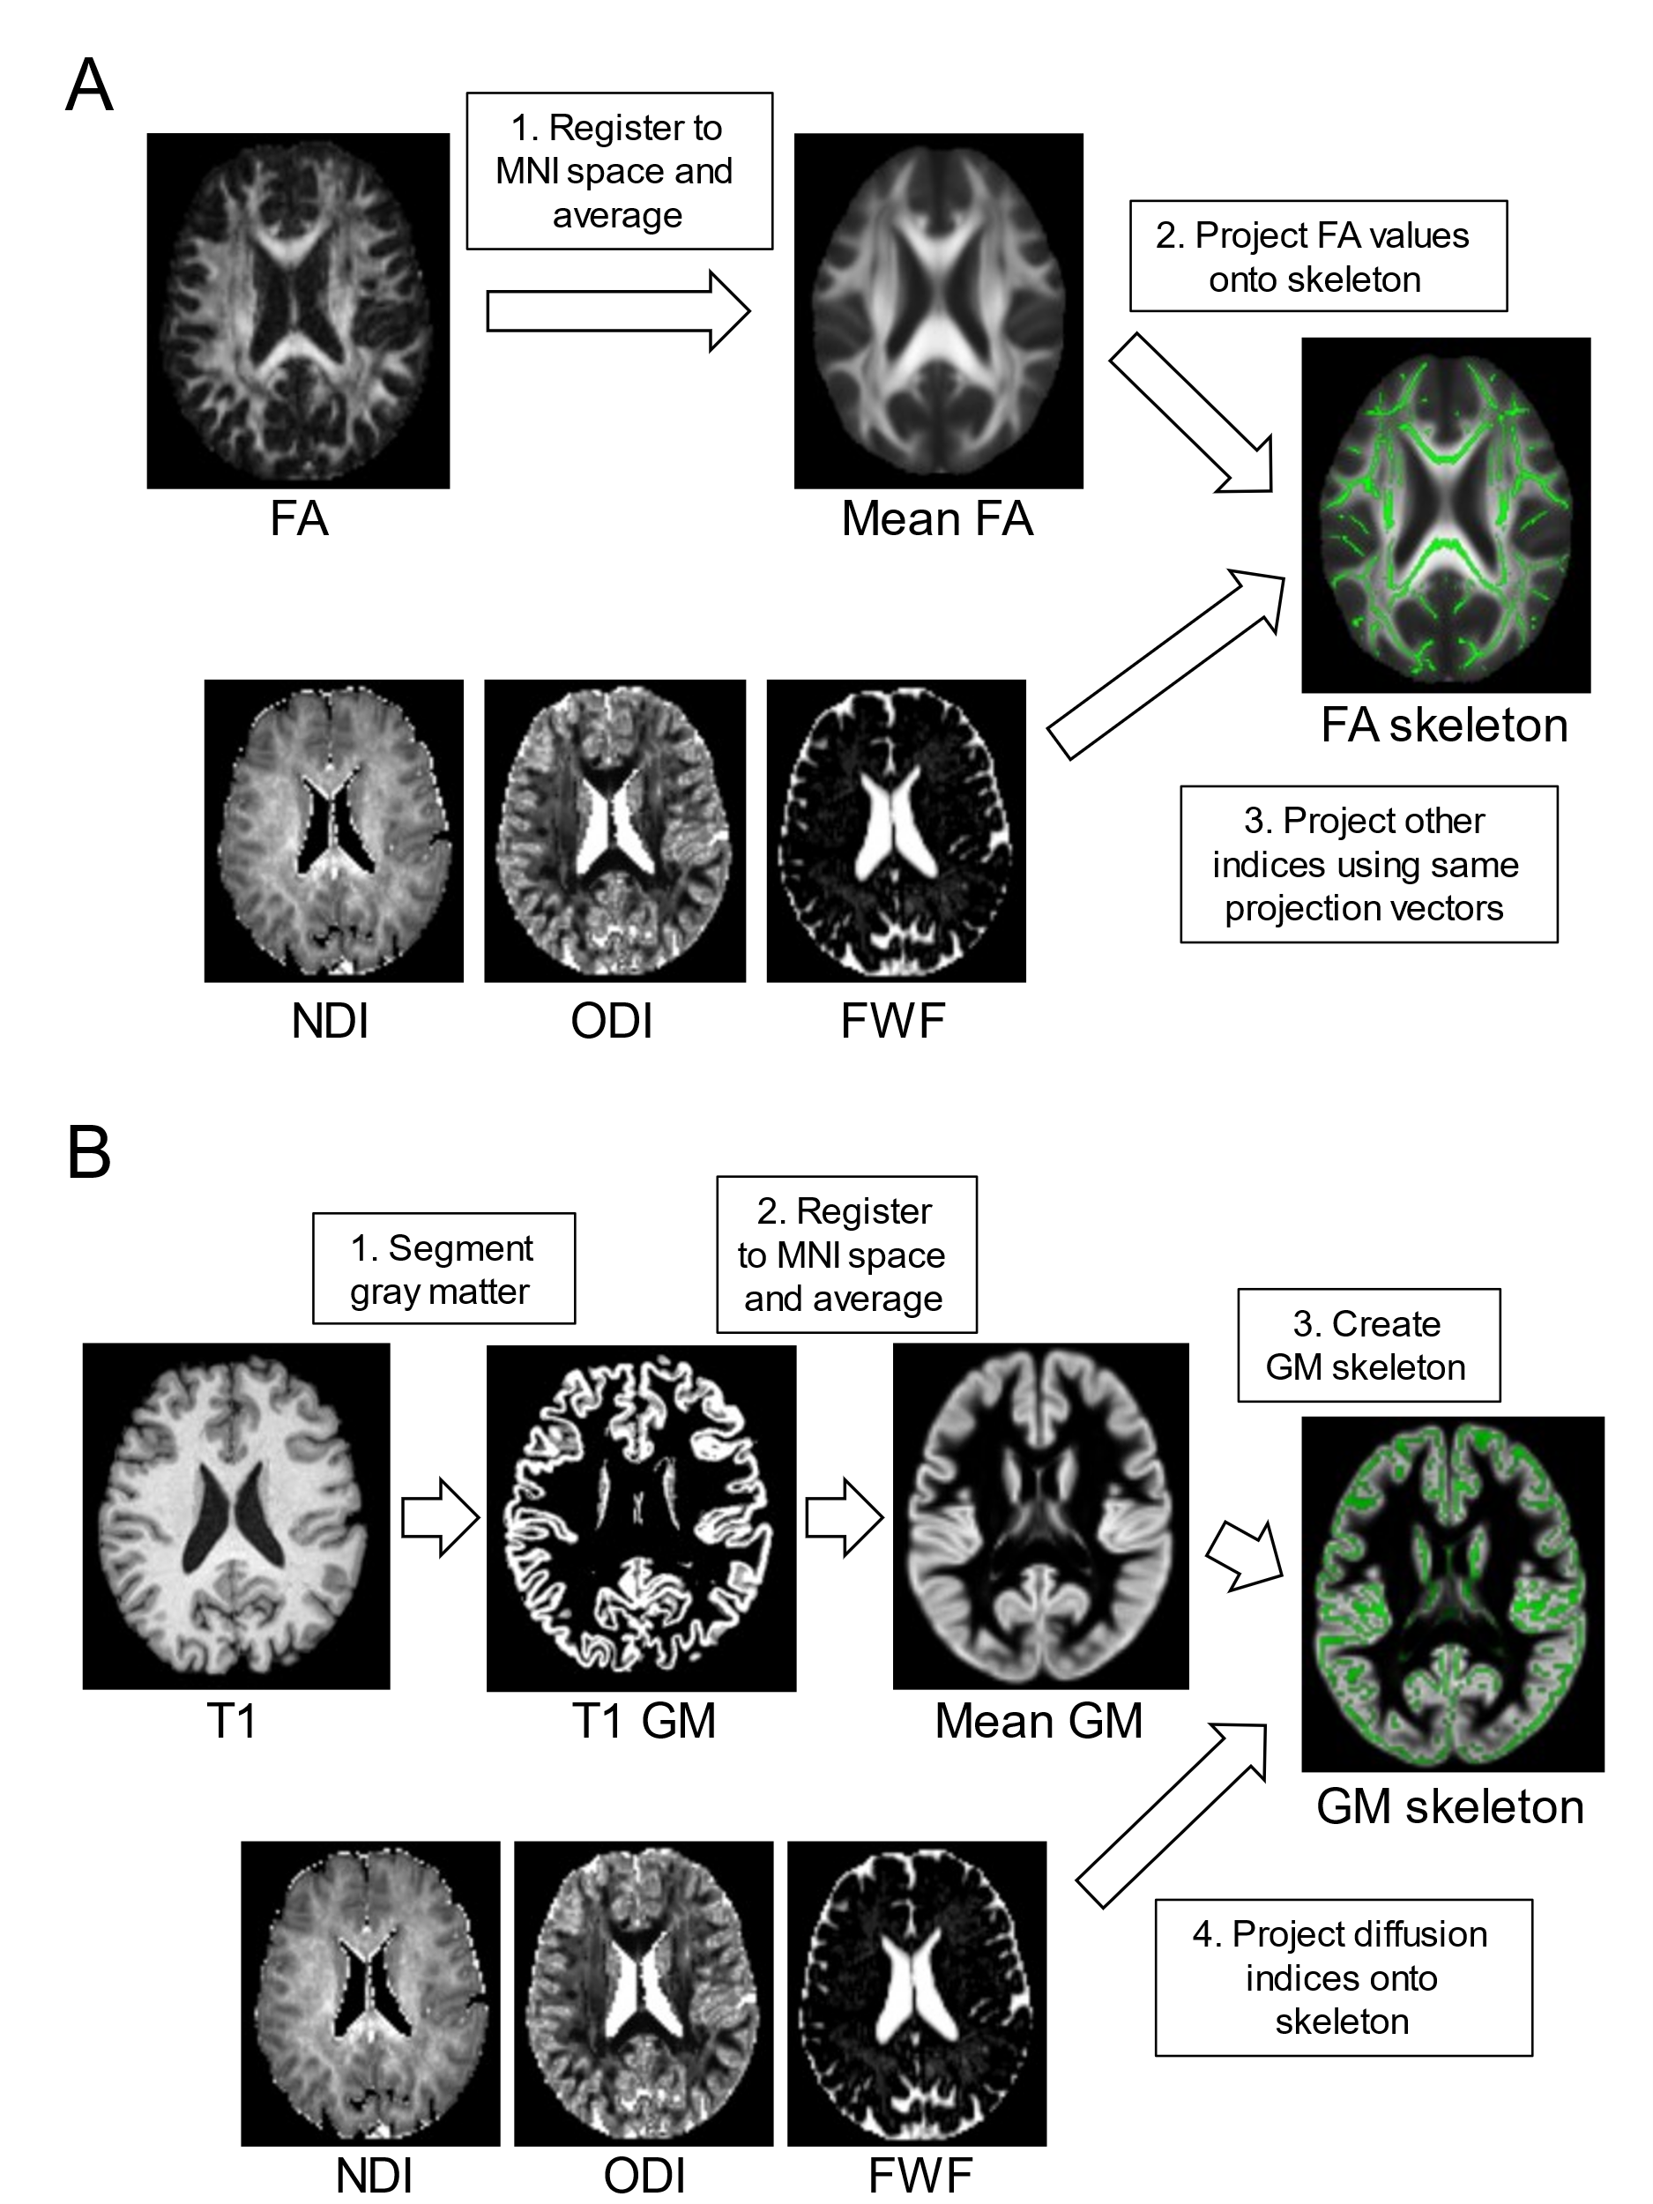
Supplementary Figure 3. (A) Regression lines for each diffusion index (mean FWF of GM, mean ODI and mean FA of WM) plotted against age. The X-axis represents age, and the Y-axis represents the diffusion indices for both healthy control and depression groups. (B) Interaction plots showing the interaction between diagnosis (healthy control vs. depression) and sex on diffusion indices.
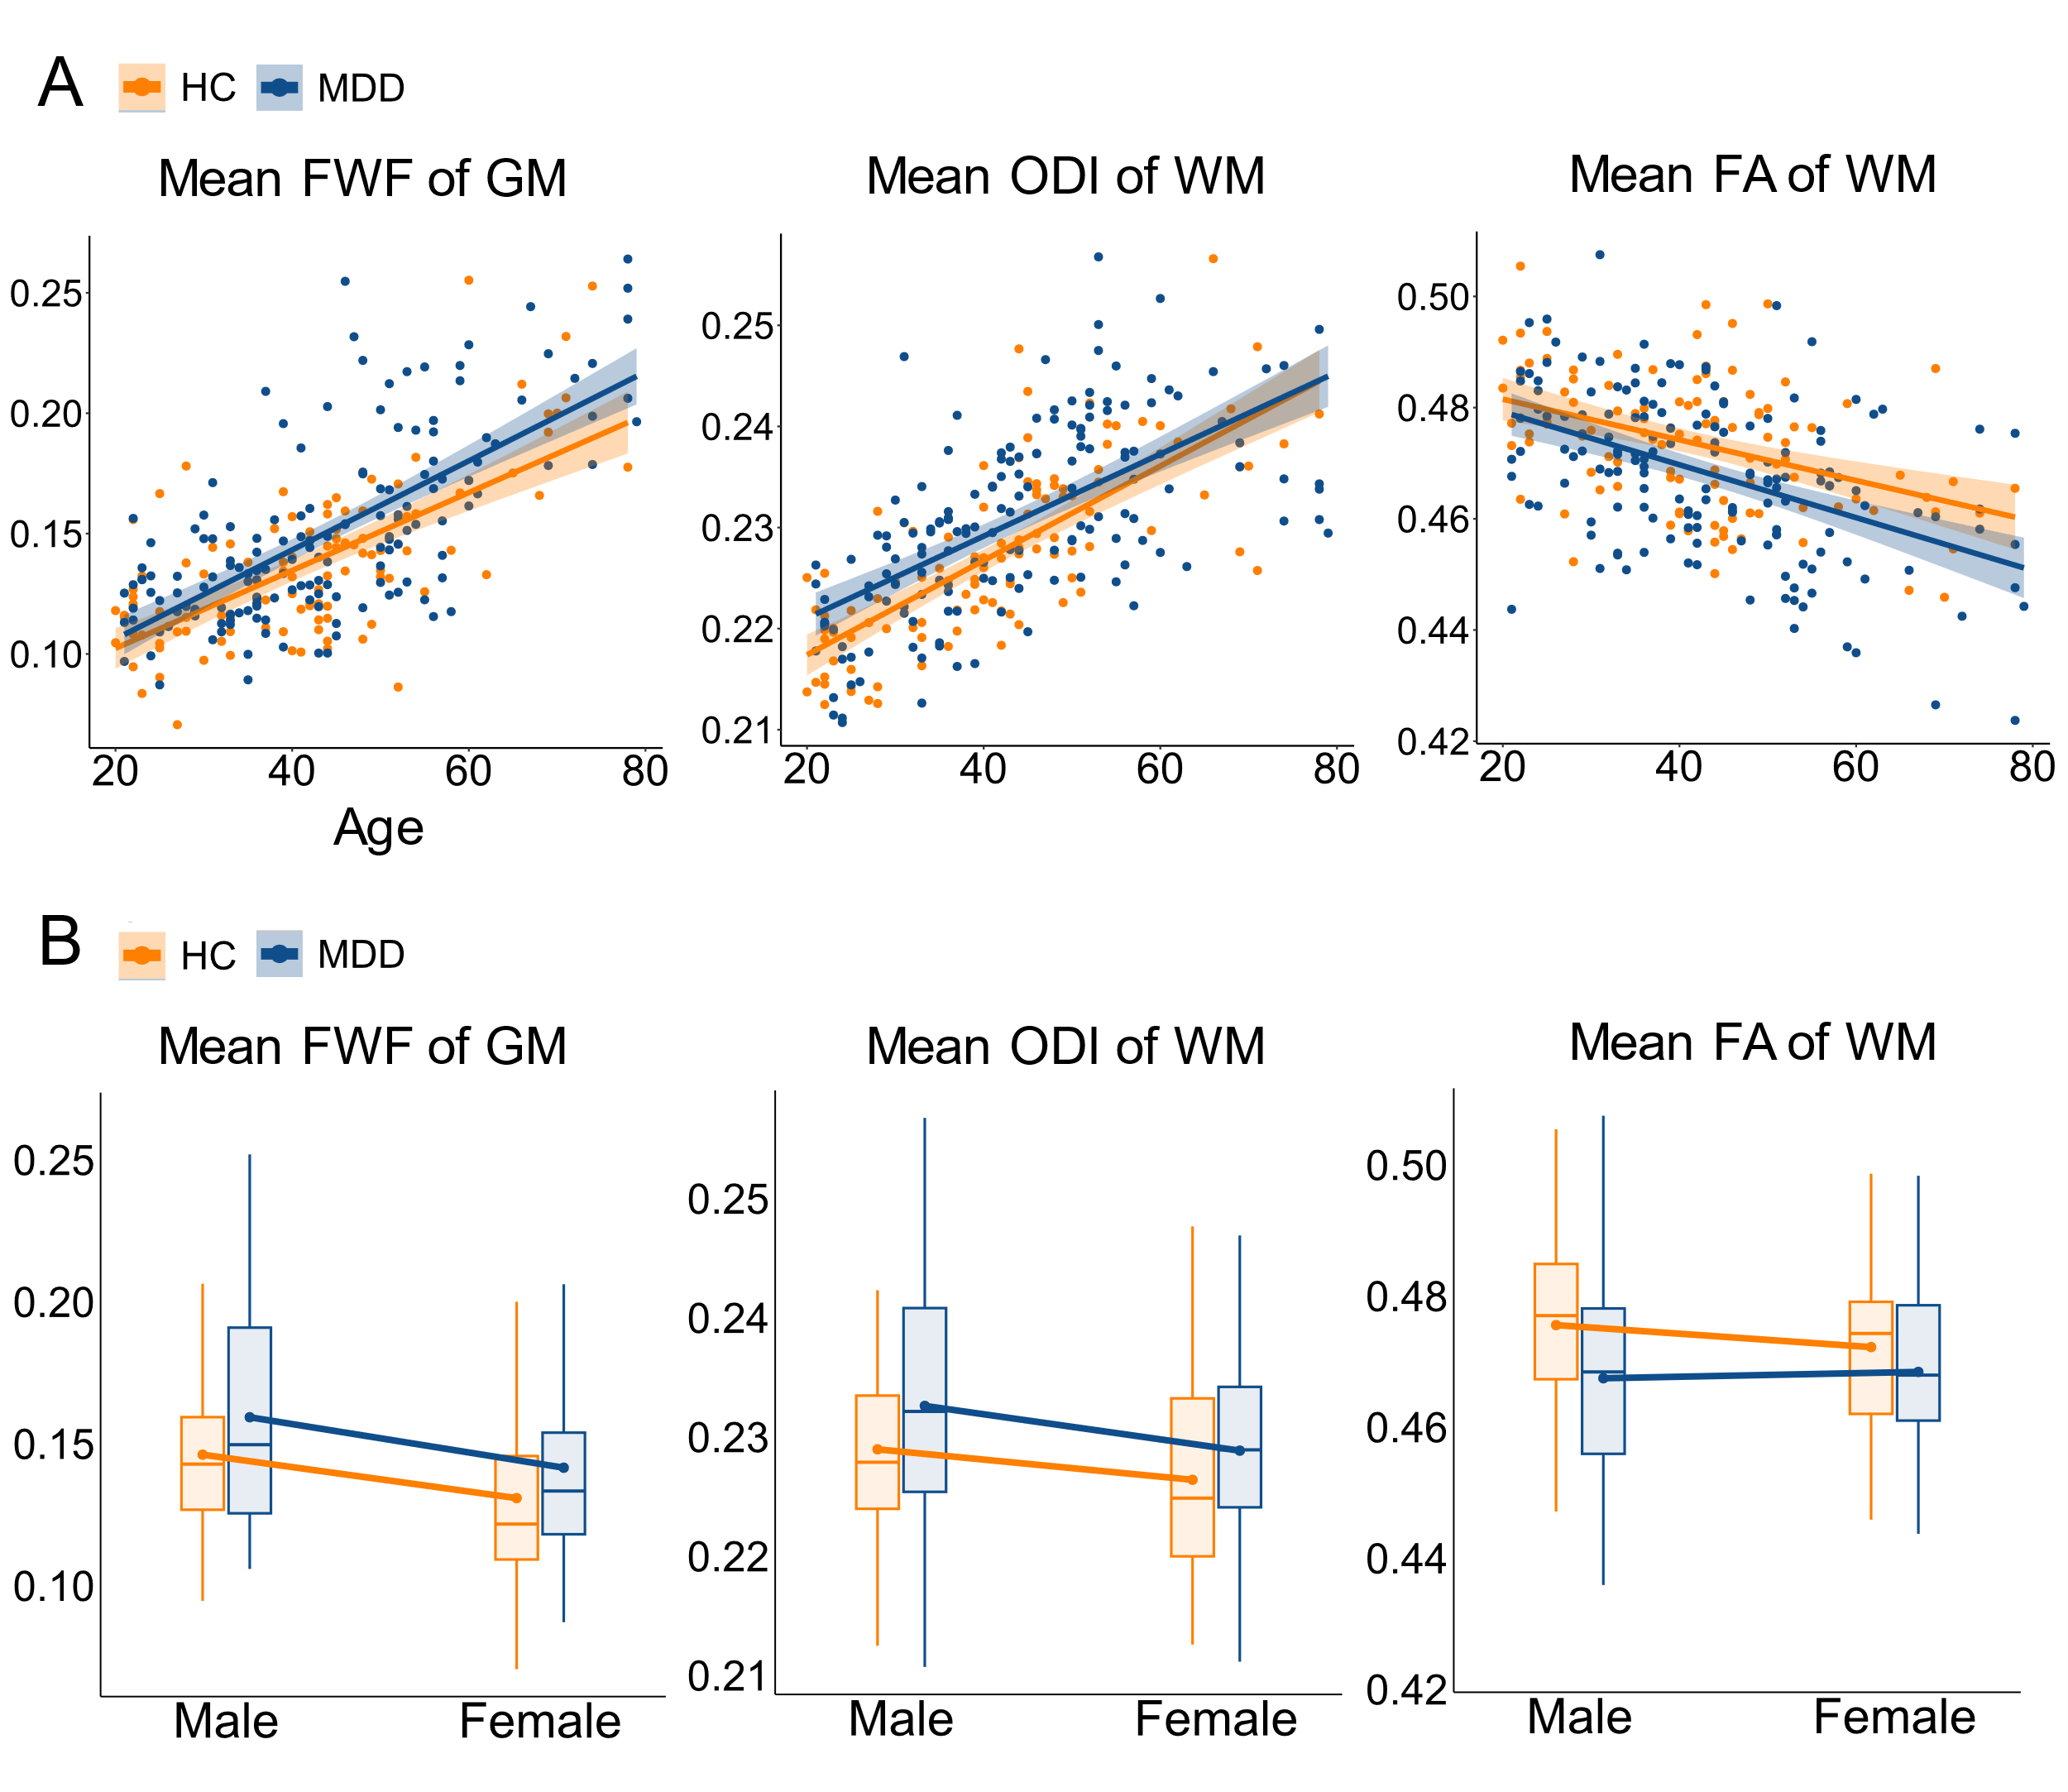
Supplementary Table 1. MNI coordinates and volumes of clusters (pFWE<0.05; ≥100 mm3) from gray matter-based spatial statistics showing significantly higher gray matter free water fraction (FWF) in individuals with major depressive disorder relative to healthy participants.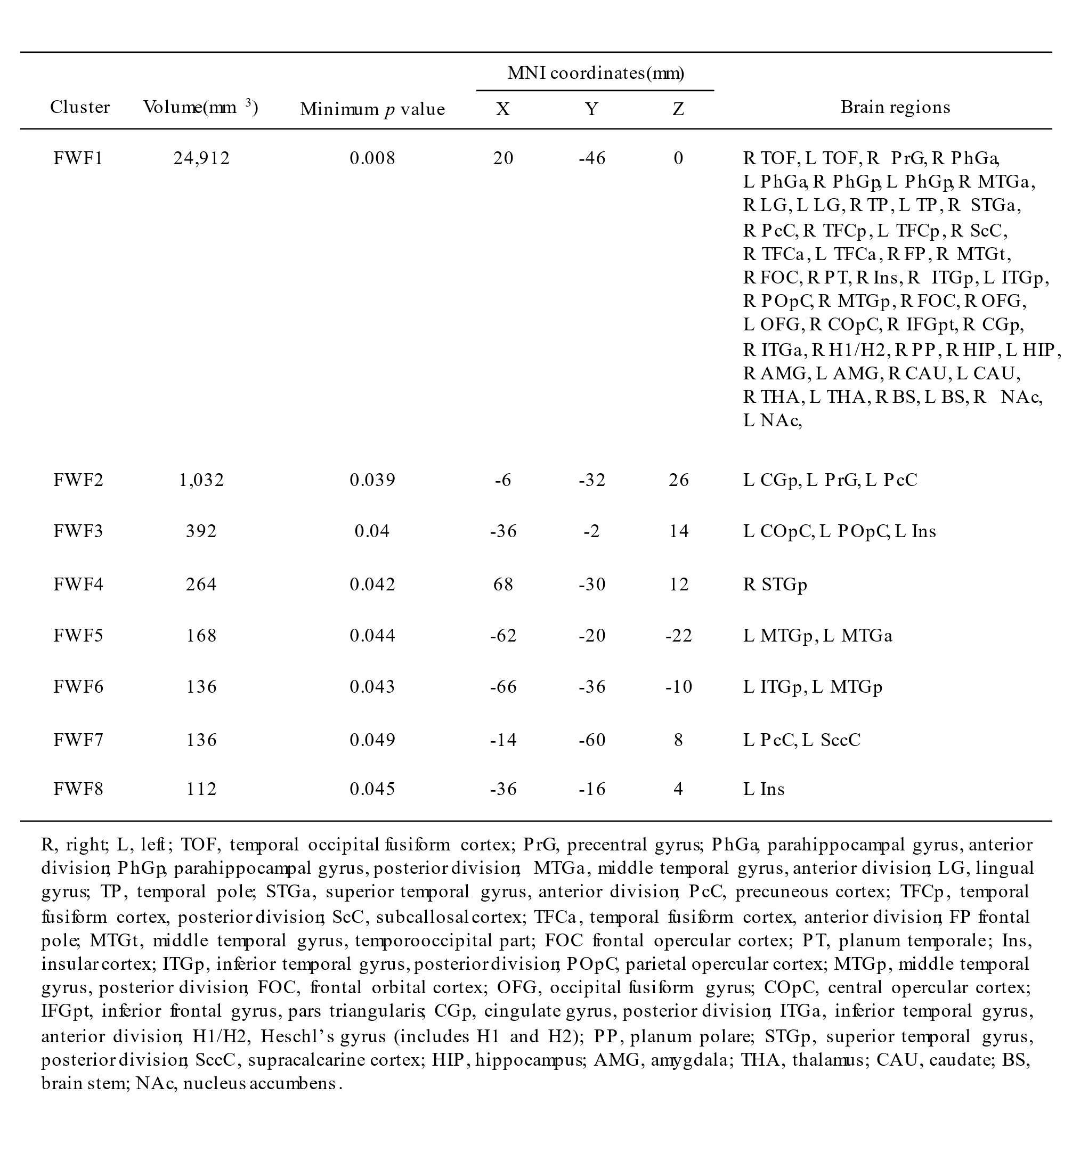
Supplementary Table 2. MNI coordinates and volumes of clusters (pFWE<0.05; ≥100 mm3) from tract-based spatial statistics showing significantly lower white matter fractional anisotropy (FA) in individuals with major depressive disorder relative to healthy participants.
