Environmental Degradation and Fragmentation of Microplastics: Dependence on Polymer Type, Humidity, UV Dose and Temperature

Patrizia Pfohl^{1‡}, Katherine Santizo^{1‡}, Joana Sipe², Mark Wiesner², Sam Harrison³, Claus Svendsen⁴, Wendel Wohlleben^{1*}
1 BASF SE, Carl-Bosch-Str. 38, 67056 Ludwigshafen, Germany
2 Department of Civil and Environmental Engineering, Duke University, Durham, NC 27708, USA
3 UK Centre for Ecology and Hydrology, Lancaster Environment Centre, Lancaster, UK
4 UK Centre for Ecology and Hydrology, Wallingford, Oxfordshire, UK

Corresponding author:
Wendel Wohlleben, wendel.wohlleben@basf.com

Number of pages 16
Number of figures 7
Number of tables 5
Supporting Information

Scanning electron microscopy (SEM)
Polymer particles were prepared for Scanning Electron Microscope (SEM) (Apreo S, ThermoFisher Scientific) imaging by placing particles on a 12 mm SEM stub using ultra-smooth carbon adhesive tabs (Electron Microscopy Services). These polymer samples were prepared in a cleanroom and then gold sputter-coated at 12 mA for 600 s using a Denton Desk V sputter coater and gold target. These tabs were then placed in the SEM and imaged at various magnifications with settings of 5.0 kV beam and 25 pA current.

Differential scanning calorimetry (DSC)
Differential scanning calorimetry (DSC) (TA Instruments DSC 2500) was used to characterize thermal properties of the polymer samples. Samples were prepared by placing them in Tzero hermetic crimped pans. The polymer samples and pans were weighed and heated for 10°C/min for two heating and cooling cycles to specific ranges that were unique to each polymer in duplicate samples. TPU was not reported since it was an elastomer, PA-6 was heated from -50°C to 240°C, PP from -50°C to 200°C, HIPS from -50°C to 150°C, and LDPE from -50°C to 150°C. The resulting data files were then analyzed via TRIOS software for comparison to their pristine curves.

Attenuated total reflectance Fourier-transform infrared spectroscopy (ATR FT-IR)
The chemical composition of the microplastic surfaces before and after UV aging were analyzed by FT-IR spectroscopy to investigate changes in the carbonyl index, as described earlier.¹ The chemical compositions were determined using a Tensor 27, Bruker FT-IR spectrometer with a diamond ATR accessory (platinum). The FT-IR spectra were recorded in the region of 4000-400 cm⁻¹ with 30 scans at a resolution of 4 cm⁻¹. For determination of the carbonyl index, the ratio between two peaks was calculated:
HIPS 1720 cm⁻¹ : 2920 cm⁻¹
LDPE 1715 cm⁻¹ : 2900 cm⁻¹
PA-6 1715 cm⁻¹ : 2860 cm⁻¹
PP 1725 cm⁻¹ : 2918 cm⁻¹
TPU 1760 cm⁻¹ : 2860 cm⁻¹
Gel permeation chromatography (GPC)
The molar mass distributions of the studied polymer powders before and after UV aging were determined by Gel Permeation Chromatography (GPC) as described earlier.¹
For PA-6 and TPU, a modular GPC system with a combination of columns (HFIP-LG Guard column, 2 x PL HFIPgel columns, 300 x 7.5 mm, 3-100 µm, Agilent) was combined with a refractive index detector (8 µl, Agilent). The temperature was set to 35°C and the flow rate to 1.0 mL/min. Calibration was conducted using a polymethylmethacrylate calibration kit (with a known molar mass distribution) and 12 calibration points. Approximately 6 mg of each sample was dissolved in approximately 4 mL eluent (1,1,1,3,3,3 – Hexafluoro-2-propanol, Alfa Aesar) over 5 hours on a shaking table at room temperature. The resulting solutions were filtered through Millipore-Millex-FG 0.2 µm filters prior to injection.
For HIPS a modular GPC system with a combination of columns (PLgel Mixed-B guard column and 3 x PLgel Mixed-B columns, 300 x 7.5 mm, 10 µm, Agilent) was combined with a refractive index detector (8 µl, Agilent). The temperature was set to 35°C and the flow rate to 1.0 mL/min. The calibration was obtained with narrow molar mass standards (Polystyrene (PS) molar mass range 580-6870000 g/mol, Agilent). Extrapolation was used to estimate the molecular weight distribution outside the range of these calibration standards with respect to the exclusion and permeation limits. 2 mg of each sample was dissolved in approximately 4 mL eluent (Tetrahydrofuran, Fischer Chemical) overnight on a shaking table at room temperature. The resulting solutions were filtered through Chromafil Xtra PTFE FG 0.2 µm filters prior to injection.
For LDPE high temperature (HT-)GPC was used. The chromatographic system consisted of a PolymerChar GPC-IR (Valencia, Spain) high temperature GPC chromatograph equipped with an internal IR5 infra-red detector (IR5). The autosampler oven compartment was set at 160º Celsius and the column compartment was set at 150º Celsius. The columns used were 4 Agilent “Mixed A” 30cm 20-micron linear mixed-bed columns. The chromatographic solvent used was 1,2,4 trichlorobenzene and contained 200 ppm of butylated hydroxytoluene (BHT). The solvent source was nitrogen sparged. The injection volume used was 200 microliters and the flow rate was 1.0 milliliters/minute.
Calibration of the GPC column set was performed with 21 narrow molecular weight distribution polystyrene standards with molecular weights ranging from 580 to 8,400,000 and were arranged in 6 “cocktail” mixtures with at least a decade of separation between individual molecular weights. The standards were purchased from Agilent Technologies. The polystyrene standards were prepared at 0.025 grams in 50 milliliters of solvent for molecular weights equal to or greater than 1,000,000, and 0.05 grams in 50 milliliters of solvent for molecular weights less than 1,000,000. The polystyrene standards were pre-dissolved at 80 ºC with gentle agitation for 30 minutes then cooled and the room temperature solution is transferred cooled into the autosampler dissolution oven at 160ºC for 30 minutes. The polystyrene standard peak molecular weights were converted to polyethylene molecular weights using Equation 1 (as described in Williams and Ward, J. Polym. Sci., Polym. Let., 6, 621 (1968)).:
$M_{polyethylene}=A× {\left(M_{polystyrene}\right)}^{B}$ (EQ1)
where M is the molecular weight, A has a value of 0.4315 and B is equal to 1.0. A fifth order polynomial was used to fit the respective polyethylene-equivalent calibration points.

The total plate count of the GPC column set was performed with decane which was introduced into blank sample via a micropump controlled with the PolymerChar GPC-IR system. The plate count for the chromatographic system should be greater than 18,000 for the 4 Agilent “Mixed A” 30cm 20-micron linear mixed-bed columns.
Samples were prepared in a semi-automatic manner with the PolymerChar “Instrument Control” Software, wherein the samples were weight-targeted at 2 mg/ml, and the solvent (contained 200ppm BHT) was added to a pre nitrogen-sparged septa-capped vial, via the PolymerChar high temperature autosampler. The samples were dissolved for 2 hours at 160º Celsius under “low speed” shaking.
The calculations of Mn, Mw, and Mz were based on GPC results using the internal IR5 detector (measurement channel) of the PolymerChar GPC-IR chromatograph according to Equations 2-4, using PolymerChar GPCOne™ software, the baseline-subtracted IR chromatogram at each equally-spaced data collection point (i), and the polyethylene equivalent molecular weight obtained from the narrow standard calibration curve for the point (i) from Equation 1.

$Mn=\frac{\sum^{i}{IR_{i}}}{\sum^{i}{\left({IR_{i}}/{{M_{polyethylene}}_{i}}\right)}}$ (EQ 2)
$Mw=\frac{\sum^{i}{\left(IR_{i}*{M_{polyethylene}}_{i}\right)}}{\sum^{i}{IR_{i}}}$ (EQ 3)
$Mz=\frac{\sum^{i}{\left(IR_{i}*{{M_{polyethylene}}_{i}}^{2}\right)}}{\sum^{i}{\left(IR_{i}*{M_{polyethylene}}_{i}\right)}}$ (EQ 4)

For PP Molecular Weight and Molecular Weight Distribution (MWD) was measured by way of GPC in 1,2,4-trichlorobenzene (TCB). Molecular weight parameters (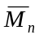, 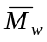, 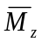) and molecular weight distributions for all the samples were measured by using a GPC-IR apparatus by PolymerChar, which was equipped with a column set of four PLgel Olexis mixed-bed (Polymer Laboratories) and an IR5 infrared detector (PolymerChar). The dimensions of the columns were 300 × 7.5 mm and their particle size 13 µm. The mobile phase flow rate was kept at 1.0 mL/min. All the measurements were carried out at 150°C. Solution concentrations were 1.5 mg/mL (at 150°C) and 0.3 g/L of 2,6-diterbuthyl-p-chresole were added to prevent degradation. For GPC calculation, a universal calibration curve was obtained using 16 polystyrene (PS) standard samples supplied by PolymerChar (peak molecular weights ranging from 266 to 1220000). A third order polynomial fit was used for interpolating the experimental data and obtain the relevant calibration curve. Data acquisition and processing was done by using Empower 3 (Waters).
The Mark-Houwink relationship was used to determine the molecular weight distribution and the relevant average molecular weights: the K values were K_{PS} = 1.21 × 10⁻⁴ dL/g and K_{PP} = 1.90 × 10⁻⁴ dL/g for PS and polypropylene (PP) respectively, while the Mark-Houwink exponents α = 0.706 for PS and α = 0.725 for PP were used.

Fraunhofer light scattering
The size distribution as well as D10, D50 and D90 measurements were taken for all pristine cryomilled polymer particles as well as for three UV aged 2000 h particles (HIPS, TPU, PA-6) using a Mastersizer 3000 (Malvern, UK). These particles were sonicated, suspended in ethanol, and placed in the mixing receptacle at 2000 rpm until the obscuration was in the 2-10% range. The samples were measured 20-30 times and the last 10 measurements were used for analysis.

Single particle counter
Analogously to our previous study,¹ the secondary microplastic particles >1 µm were counted with an Abakus® Mobil Fluid laser particle counter (Klotz GmbH) equipped with a laser sensor LDS 2148(0) (1-139 µm). For this purpose, 0.7 mL of the NanoRelease dispersion was filled up to 500 mL with ultrapure water. For sensor protection the sample was filtered with a 190 µm pre-filter (nylon, Rotert). The measurement was performed with 200 mL of the sample. Data evaluation was performed with C.A.R. Lab. Duplicate samples were measured and values for blank measurements were subtracted.

Analytical ultracentrifugation with refractive index detector (AUC-RI)
Analogously to our previous study,¹ Analytical Ultracentrifugation served to determine the concentration and particle size distribution of secondary nanoplastics. The AUC-Beckman XL centrifuge is equipped with an interference optical system synchronized to the centrifugal rotation, so that the colloidal sedimentation profile during centrifugation is monitored over time. By adjusting the centrifugation speed, the mass concentration and particle size distribution were determined in three overlapping size intervals of 10-150 nm (12 000 rpm ≙ 10 500 rcf), 40-800 nm (3 000 rpm ≙ 650 rcf) and 300-5000 nm (1 000 rpm ≙ 70 rcf); with 3 hours centrifugation time each. For data evaluation of the absorption profiles (resolved in time and radius) SedFit v14.0 was used with the corresponding polymer density (SI Table 1).² Duplicate samples were measured and values for blank measurements were subtracted. In the case of pristine LDPE (ρ < 1), D₂O instead of water was used to measure flotation instead of sedimentation. The density of LDPE increased due to UV aging,³ enabling measurements by sedimentation.

Dissolved organic carbon (DOC)
To determine the concentration of released water-soluble organics, as described earlier,¹ the filtered NanoRelease sample was diluted with ultrapure water with dilution factors of 1:10 and 1:20 and total carbon (sample combusted catalytically on a Pt/Al₂O₃ catalyst in an oxygen stream at ca. 680 °C) and total inorganic carbon (sample acidified with 25 wt.-% phosphoric acid) were quantified as CO₂ via NDIR detection (Shimadzu TOC-L). DOC was calculated as the difference between total carbon and total inorganic carbon. Due to lack of substance, it was not possible to conduct duplicate measurements.

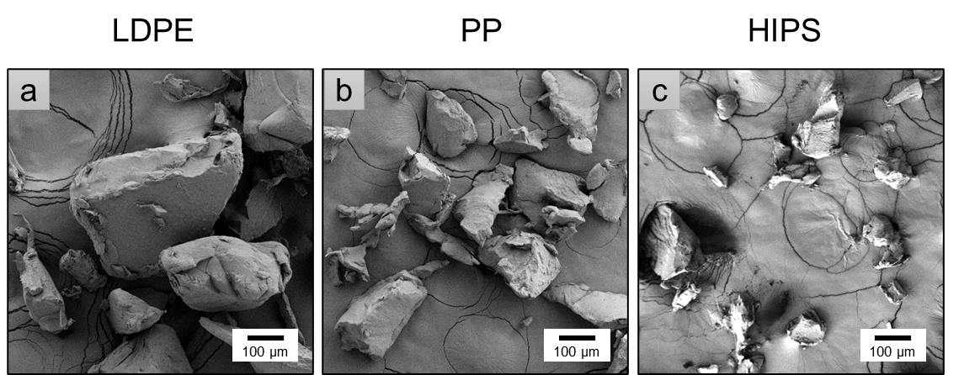
SI Figure 1: Scanning electron microscope (SEM) images showing the shapes and sizes of the polymer powders used for UV aging experiments: (a) LDPE, (b) PP, (c) HIPS. Images of the investigated PA-6 and TPU_ether_arom have been published in the SI of our previous study.¹

SI Table 1: Physical-chemical properties of the investigated polymer powders. Data for the investigated PA-6 and TPU_ether_arom are published in the SI of our previous study.¹
Polymer | Density [g/cm³]^{[a]} | T_{g}  [°C]^{[b]} | T_{m}  [°C]^{[b]} | Mean particle size d50 [µm]^{[c]} | M_{n} [g/mol]^{[d]} | M_{w} [g/mol]^{[d]}
LDPE | 0.917 | - | 104.56 ± 0.05 | 420 | 9 830 | 63 600
PP | 0.905 | - | 164.01 ± 0.15 | 294 | 24 958 | 276 458
HIPS | 1.04 | 95.64 ± 0.03 | - | 178 | 62 000 | 199 000
[a] Values adopted from material safety datasheets of polymer materials.
[b] Values determined by DSC, 2nd heating curve, 10 K/min.
[c] Values determined by Fraunhofer light scattering, ISO13320.
[d] Values determined by GPC (see method description above).

SI Table 2: Polydispersity (PDI), mass (M_{w}) and number (M_{n}) average molecular weight of the sol fraction of pristine and UV aged microplastics determined by GPC. Crosslinking after UV aging was observed for TPU and LDPE.
Polymer | UV protocol | UV irradiation [h] | M_{n}  [g/mol] | M_{w}  [g/mol] | PDI | Insoluble gel fraction [%]
PP | pristine | 0 | 24958 | 276458 | 11.1 | -
PP | Kalahari | 2000 | 23335 | 228984 | 9.8 | -
PP | ISO4892, RH = 50% | 2000 | 21610 | 218589 | 10.1 | -
PP | ISO4892, RH = 75% | 2000 | 21355 | 219836 | 10.3 | -
LDPE | pristine | 0 | 9 830 | 63 600 | - | -
LDPE | Kalahari | 2000 | 1 230 | 1 870 | - | 52
LDPE | ISO4892, RH = 50% | 2000 | 2 480 | 6 800 | - | 43
LDPE | ISO4892, RH = 75% | 2000 | 1 520 | 2 770 | - | 40
HIPS | pristine | 0 | 62 000 | 199 000 | 3.2 | -
HIPS | Kalahari | 2000 | 19 700 | 195 000 | 9.9 | -
HIPS | ISO4892, RH = 50% | 2000 | 15 500 | 189 000 | 12.2 | -
HIPS | ISO4892, RH = 75% | 2000 | 16 800 | 171 000 | 10.2 | -
PA-6 | pristine | 0 | 16400 | 57900 | 3.5 | -
PA-6 | Kalahari | 2000 | 2770 | 12000 | 4.3 | -
PA-6 | ISO4892, RH = 50% | 2000 | 2350 | 8990 | 3.8 | -
PA-6 | ISO4892, RH = 75% | 2000 | 2130 | 8130 | 3.8 | -
TPU | pristine | 0 | 32600 | 137000 | 4.2 | -
TPU | Kalahari | 2000 | 1860 | 11400 | 6.1 | 73
TPU | ISO4892, RH = 50% | 2000 | 1940 | 14600 | 7.5 | 71
TPU | ISO4892, RH = 75% | 2000 | 2140 | 19200 | 9.0 | 69

SI Table 3: GPC molecular weight results of UV aged LDPE and TPU (2000h).
LINEAR LDPE equivalent values | M_{w} estimate (g/mol) | M_{n} estimate (g/mol) | Insoluble gel fraction* (%)
Kalahari | 2 060 000 | 2 360 | 52
ISO4892, RH = 50% | 1 730 000 | 5 370 | 43
ISO4892, RH = 75% | 1 600 000 | 2 860 | 40
LINEAR TPU equivalent values | M_{w} estimate (g/mol) | M_{n} estimate (g/mol) | Insoluble gel fraction* (%)
Kalahari | 1 463 000 | 6 870 | 73
ISO4892, RH = 50% | 1 424 000 | 6 670 | 71
ISO4892, RH = 75% | 1 386 000 | 6 890 | 69
* Insoluble gel fraction comprises network polymer that is crosslinked beyond the gel point and was calculated as (100 - mass recovery)%, in which the mass recovery of the sample was calculated from the GPC-IR5 measurement channel chromatogram. The Mw and Mn values of the insoluble gel fraction were both conservatively estimated to be 3 983 000 g/mol (LDPE) and 2 000 000 g/mol (TPU), based on the column exclusion limit reported by the vendors in linear PE/TPU equivalent values. In reality, the molecular weight of the insoluble gel fraction is infinite. The M_{w} and M_{n} values were calculated according to the following equations:

$$M_{w,estimate}=f\left(M_{w,sol}+M_{w,gel}\right)=w_{sol}*M_{w,sol}+(1-w_{sol})*M_{w,gel,estimate}$$
$$M_{n,estimate}=f\left(M_{n,sol}+M_{n,gel}\right)=\frac{1}{\frac{w_{sol}}{M_{n,sol}}+\frac{1-w_{sol}}{M_{n,gel,estimate}}}$$

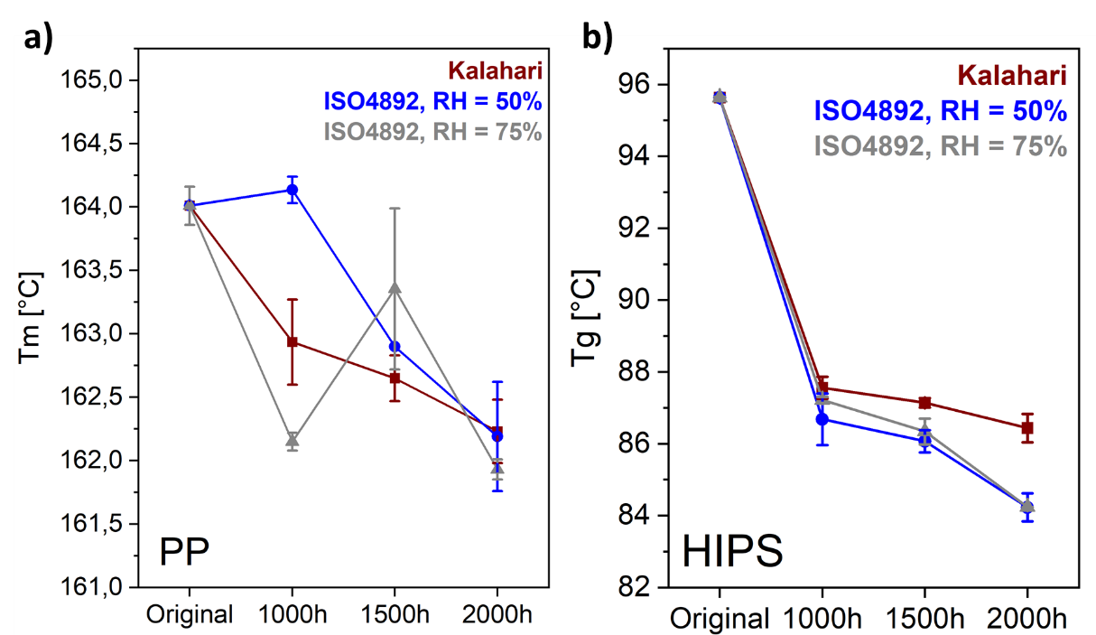
SI Figure 2: Changes in thermal properties of PP and HIPS after UV aging; a) melting point decrease of PP, b) glass transition temperature decrease of HIPS.

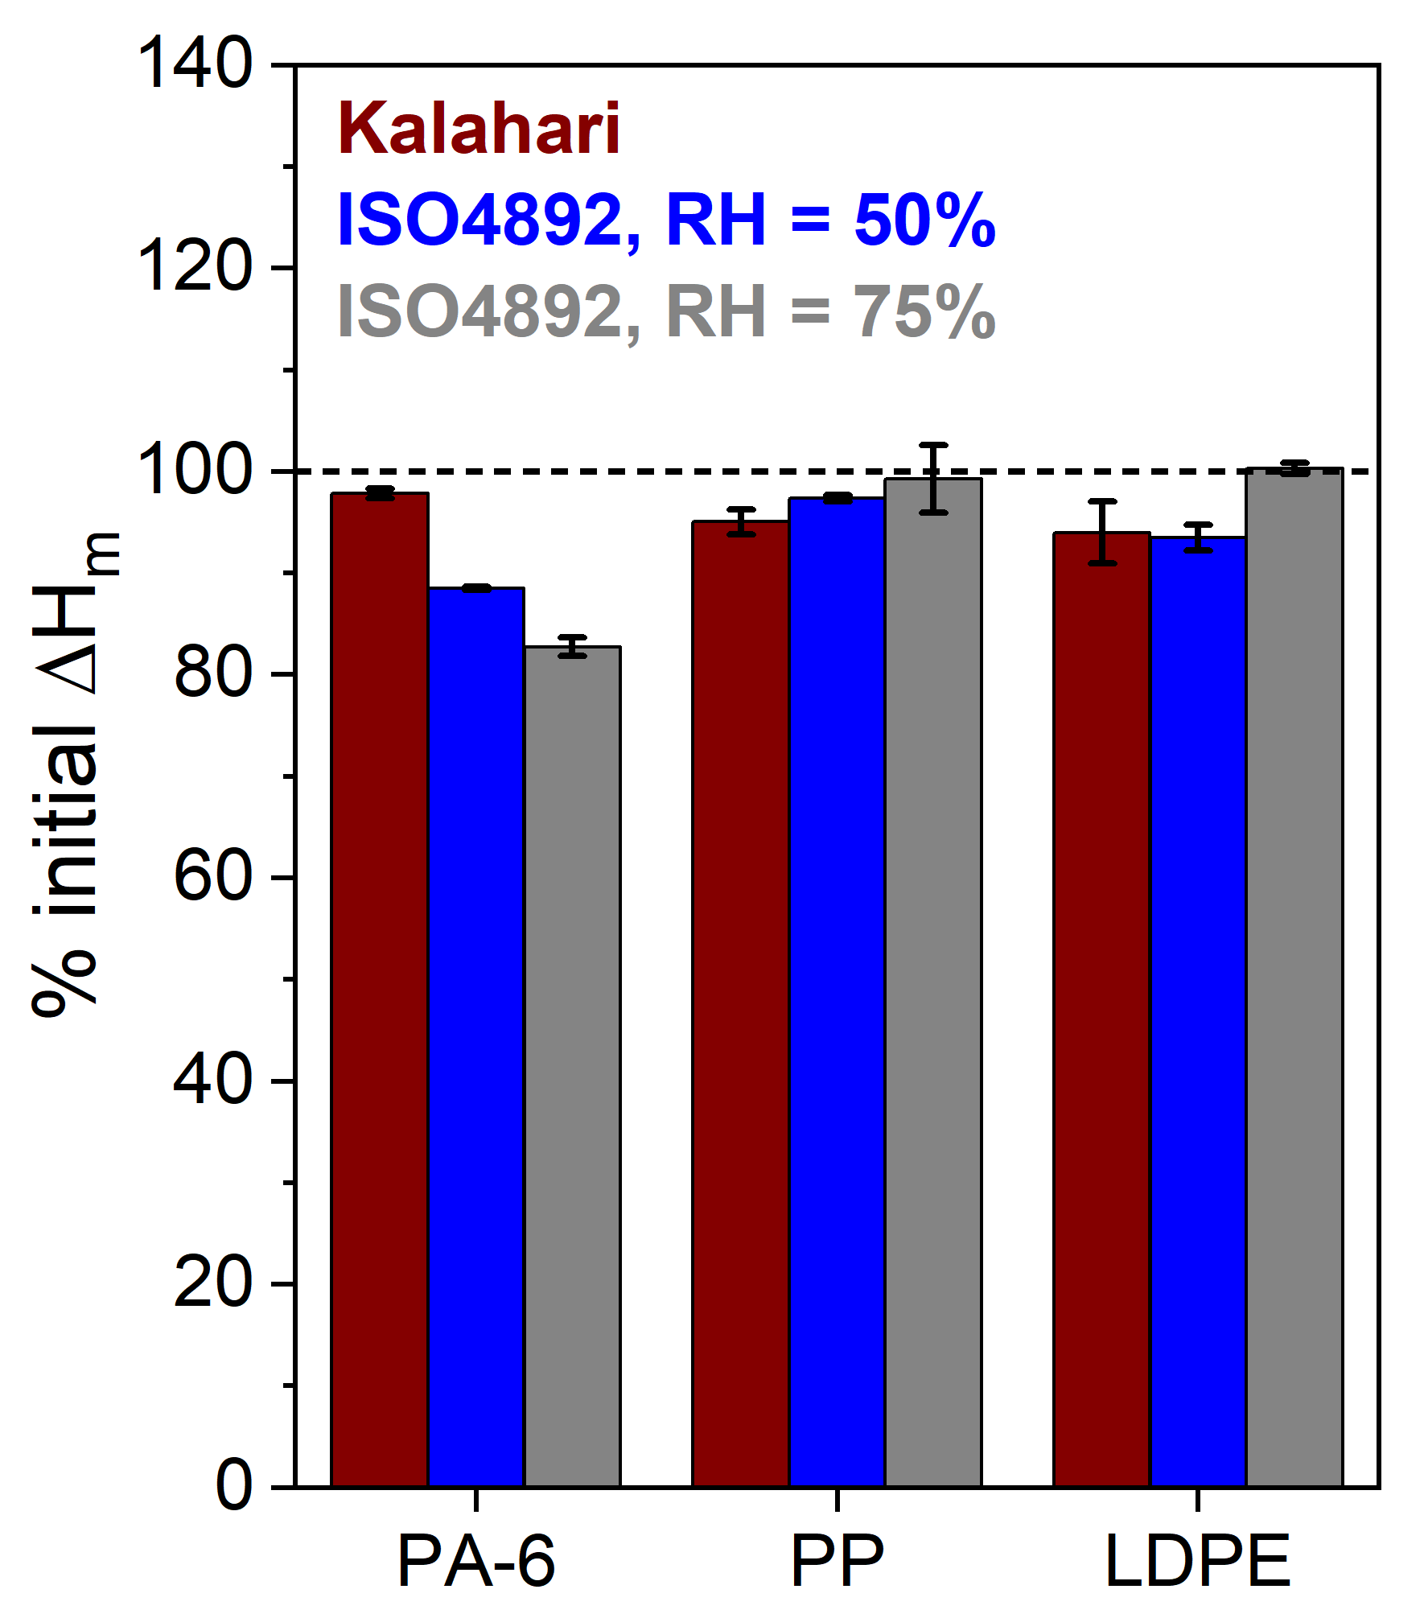
SI Figure 3: Percentage of initial ∆H_{m} (2nd heating curve) after UV aging of PA-6, PP and LDPE by different UV aging protocols.

SI Table 4: Thermal properties of the investigated polymers after UV aging by three different protocols, duplicate measurements. Results were obtained by DSC data evaluation of the 2nd heating curve. Additional results (*) were obtained by DSC data evaluation of the 1st heating curve.
Polymer | UV protocol | UV irradiation [h] | T_{g} [°C] | T_{m} [°C] | ∆H_{m} [J/g] | Heating curve
LDPE | pristine | 0 | - | 104.56 ± 0.05 | 131.24 ± 0.72 | 2nd
LDPE | Kalahari | 1000 | - | 107.00 ± 0.29 | 118.70 ± 3.53 | 2nd
LDPE | Kalahari | 1500 | - | 106.94 ± 0.31 | 121.52 ± 1.71 | 2nd
LDPE | Kalahari | 2000 | - | 107.66 ± 0.38 | 123.38 ± 4.05 | 2nd
LDPE |  | 2000* | - | 111.07 ± 0.63 | 138.08 ± 1.94 | 1st
LDPE | ISO4892, RH = 50% | 1000 | - | 104.50 ± 0.19 | 124.84 ± 0.73 | 2nd
LDPE | ISO4892, RH = 50% | 1500 | - | 105.98 ± 0.15 | 124.72 ± 0.09 | 2nd
LDPE | ISO4892, RH = 50% | 2000 | - | 107.41 ± 0.16 | 122.69 ± 1.69 | 2nd
LDPE |  | 2000* | - | 109.72 ± 0.05 | 135.29 ± 0.79 | 1st
LDPE | ISO4892, RH = 75% | 1000 | - | 104.75 ± 0.09 | 117.78 ± 4.61 | 2nd
LDPE | ISO4892, RH = 75% | 1500 | - | 105.76 ± 0.47 | 124.65 ± 1.24 | 2nd
LDPE | ISO4892, RH = 75% | 2000 | - | 106.45 ± 0.46 | 131.66 ± 0.75 | 2nd
 |  | 2000* | - | 108.03 ± 0.75 | 145.98 ± 1.89 | 1st
PP | pristine | 0 | - | 164.01 ± 0.15 | 83.49 ± 1.42 | 2nd
PP | Kalahari | 1000 | - | 162.94 ± 0.34 | 81.73 ± 2.26 | 2nd
PP | Kalahari | 1500 | - | 162.65 ± 0.18 | 78.89 | 2nd
PP | Kalahari | 2000 | - | 162.23 ± 0.25 | 79.35 ± 1.05 | 2nd
PP | Kalahari | 2000* | - | 165.91 ± 0.1 | 78.32 ± 1.57 | 1st
PP | ISO4892, RH = 50% | 1000 | - | 164.14 ± 0.11 | 76.99 ± 0.55 | 2nd
PP | ISO4892, RH = 50% | 1500 | - | 162.90 | 74.75 | 2nd
PP | ISO4892, RH = 50% | 2000 | - | 162.19 ± 0.43 | 81.32 ± 0.26 | 2nd
PP | ISO4892, RH = 50% | 2000* | - | 165.55 ± 0.24 | 76.039 ± 0.28 | 1st
PP | ISO4892, RH = 75% | 1000 | - | 162.15 ± 0.07 | 79.33 ± 0.35 | 2nd
PP | ISO4892, RH = 75% | 1500 | - | 163.36 ± 0.64 | 82.39 ± 0.41 | 2nd
PP | ISO4892, RH = 75% | 2000 | - | 161.93 ± 0.08 | 82.88 ± 2.76 | 2nd
PP | ISO4892, RH = 75% | 2000* | - | 165.60 | 69.02 | 1st
HIPS | pristine | 0 | 95.64 ± 0.03 | - | - | 2nd
HIPS | Kalahari | 1000 | 87.56 ± 0.31 | - | - | 2nd
HIPS | Kalahari | 1500 | 87.14 ± 0.13 | - | - | 2nd
HIPS | Kalahari | 2000 | 86.44 ± 0.40 | - | - | 2nd
HIPS | ISO4892, RH = 50% | 1000 | 86.68 ± 0.72 | - | - | 2nd
HIPS | ISO4892, RH = 50% | 1500 | 86.07 ± 0.31 | - | - | 2nd
HIPS | ISO4892, RH = 50% | 2000 | 84.23 ± 0.39 | - | - | 2nd
HIPS | ISO4892, RH = 75% | 1000 | 87.22 ± 0.09 | - | - | 2nd
HIPS | ISO4892, RH = 75% | 1500 | 86.34 ± 0.36 | - | - | 2nd
HIPS | ISO4892, RH = 75% | 2000 | 84.24 ± 0.01 | - | - | 2nd
PA-6 | pristine | 0 | - | 217.88 ± 3.09 | 93.14 ± 3.86 | 2nd
PA-6 | Kalahari | 1000 | - | 210.07 ± 0.77 | 91.68 ± 0.35 | 2nd
PA-6 | Kalahari | 1500 | - | 202.62 ± 4.19 | 88.47 ± 0.11 | 2nd
PA-6 | Kalahari | 2000 | - | 200.98 ± 0.01 | 91.15 ± 0.41 | 2nd
PA-6 | ISO4892, RH = 50% | 1000 | - | 198.64 ± 2.90 | 95.64 ± 2.70 | 2nd
PA-6 | ISO4892, RH = 50% | 1500 | - | 200.44 ± 1.31 | 90.87 ± 3.61 | 2nd
PA-6 | ISO4892, RH = 50% | 2000 | - | 198.51 ± 1.82 | 82.42 ± 0.14 | 2nd
PA-6 | ISO4892, RH = 75% | 1000 | - | 206.77 ± 0.21 | 97.57 ± 0.25 | 2nd
PA-6 | ISO4892, RH = 75% | 1500 | - | 201.08 ± 0.49 | 84.65 ± 0.24 | 2nd
PA-6 | ISO4892, RH = 75% | 2000 | - | 194.35 ± 0.83 | 77.08 ± 0.75 | 2nd

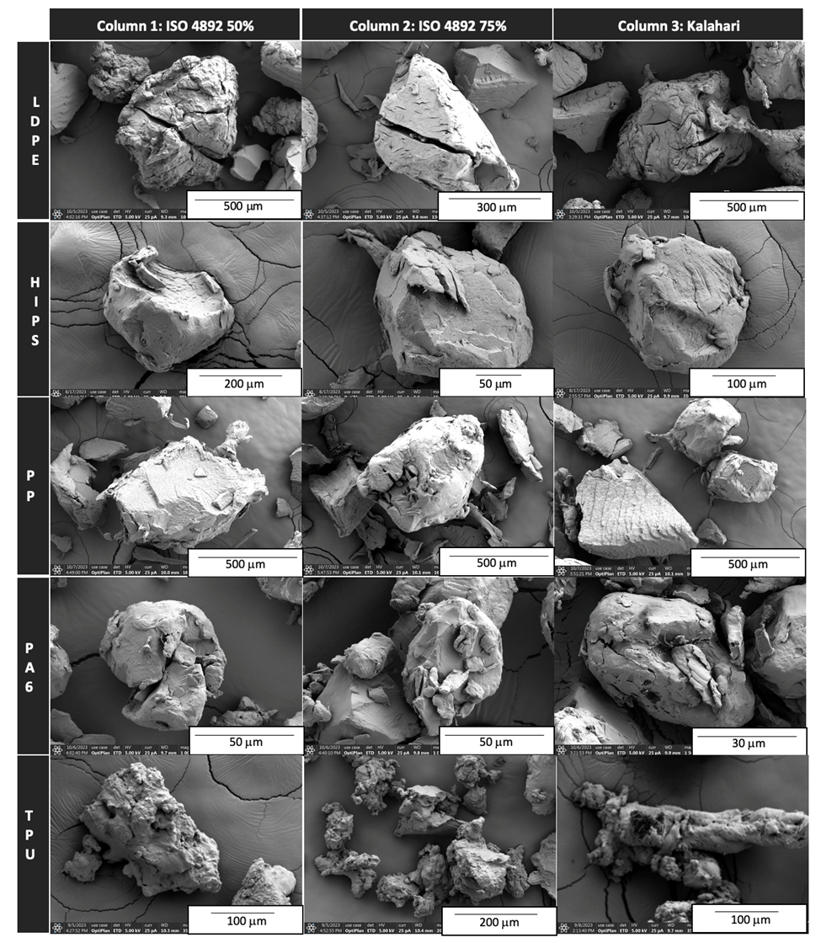
SI Figure 4: SEM images of UV aged polymers for each UV aging protocol, all at 2000 h duration.

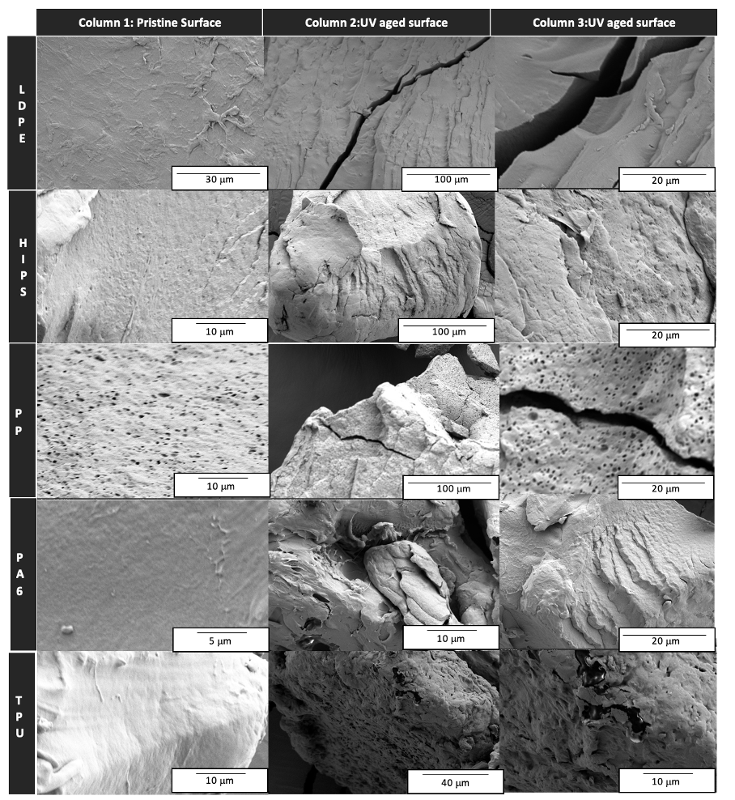
SI Figure 5: SEM images of UV aged polymer surfaces all at Kalahari 2000 h duration.
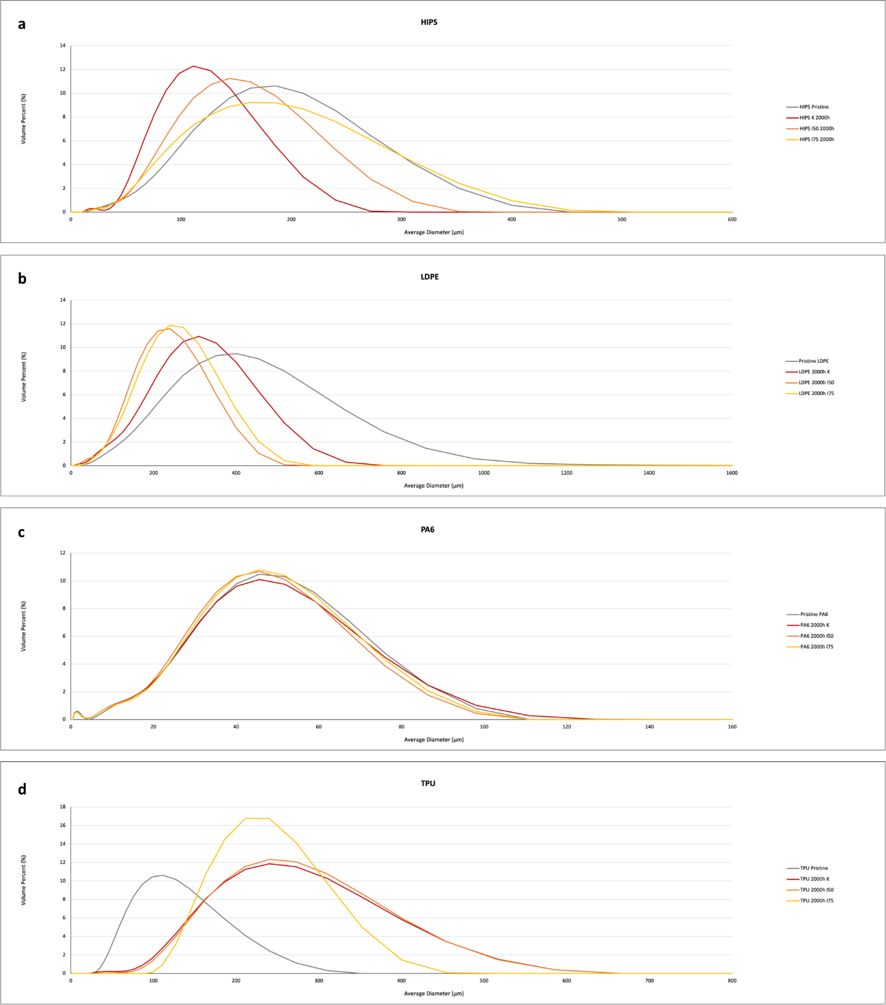
SI Figure 6: Particle size distribution of investigated polymer powders before and after 2000 h UV aging by 3 different protocols. A) HIPS, b) LDPE, c) PA-6, d) TPU. Size distributions were determined by Fraunhofer diffraction.

SI Table 5: Secondary micro- (1-139 µm), nanoplastic (0.01-0.99 µm) and DOC (< 0.02 µm) masses per gram polymer obtained for pristine and 2000h aged microplastics after NanoRelease tests.
Polymer | Aging | Microplastics [mg/g_{polymer}] | Nanoplastics [mg/g_{polymer}] | Dissolved [mg/g_{polymer}]
PA-6 | pristine | 193.33 ± 3.27 | 0.08 | 2.57
PA-6 | Kalahari | 193.03 | 0.37 ± 0.21 | 28.78
PA-6 | ISO4892, RH = 50% | 81.88 ± 24.47 | 2.36 ± 1.30 | 47.44
PA-6 | ISO4892, RH = 75% | 151.63 | 0.61 ± 0.09 | 47.44
HIPS | pristine | 0.16 ± 0.04 | 0.02 | < 0.08
HIPS | Kalahari | 47.02 ± 8.46 | 2.46 ± 1.34 | 4.36
HIPS | ISO4892, RH = 50% | 30.69 ± 6.71 | 1.36 ± 0.42 | 10.89
HIPS | ISO4892, RH = 75% | 55.44 ± 10.32 | 3.40 ± 0.96 | 3.73
PP | pristine | 0.13 ± 0.00 | 0.05 ± 0.01 | 0.11
PP | Kalahari | 0.86 ± 0.40 | 0.12 ± 0.04 | 0.17
PP | ISO4892, RH = 50% | 0.62 ± 0.29 | 0.12 ± 0.02 | 0.15
PP | ISO4892, RH = 75% | 0.89 ± 0.06 | 0.22 ± 0.03 | 0.19
LDPE | pristine | 0.02 ± 0.00 | 0 ± 0 | < 0.08
LDPE | Kalahari | 19.45 ± 0.14 | 2.26 ± 0.12 | 5.29
LDPE | ISO4892, RH = 50% | 13.56 ± 0.60 | 0.52 ± 0.01 | 12.44
LDPE | ISO4892, RH = 75% | 26.08 ± 0.64 | 1.15 ± 0.37 | 2.96
TPU | pristine | 0.05 ± 0.01 | 0.27 | 0.08
TPU | Kalahari | 0.48 ± 0.13 | 0.80 ± 0.08 | 7.23
TPU | ISO4892, RH = 50% | 3.07 ± 0.54 | 0.84 ± 0.00 | 12.44
TPU | ISO4892, RH = 75% | 2.61 ± 0.07 | 1.45 ± 0.26 | 7.39

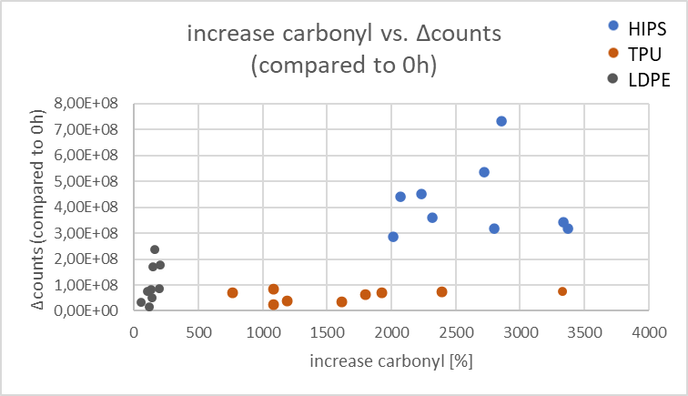
SI Figure 7: Correlation-plot of ∆counts of microplastics vs. carbonyl index increase [%] for HIPS, TPU and LDPE.

References SI:
(1) Pfohl, P.; Wagner, M.; Meyer, L.; Domercq, P.; Praetorius, A.; Hüffer, T.; Hofmann, T.; Wohlleben, W. Environmental Degradation of Microplastics: How to Measure Fragmentation Rates to Secondary Micro- and Nanoplastic Fragments and Dissociation into Dissolved Organics. Environ Sci Technol 2022, 56 (16), 11323-11334. DOI: 10.1021/acs.est.2c01228.
(2) Schuck, P.; Balbo, A. Analytical Ultracentrifugation in the Study of Protein Selfassociation and Heterogeneous Protein-Protein Interactions. In Protein-Protein Interactions: A Molecular Cloning Manual, 2005.
(3) Komitov, P.; Kostov, G.; Stanchev, S. Ageing of LDPE: Structural changes. Polymer Degradation and Stability 1989, 24 (4), 303-312. DOI: https://doi.org/10.1016/0141-3910(89)90040-2.

