Additional file 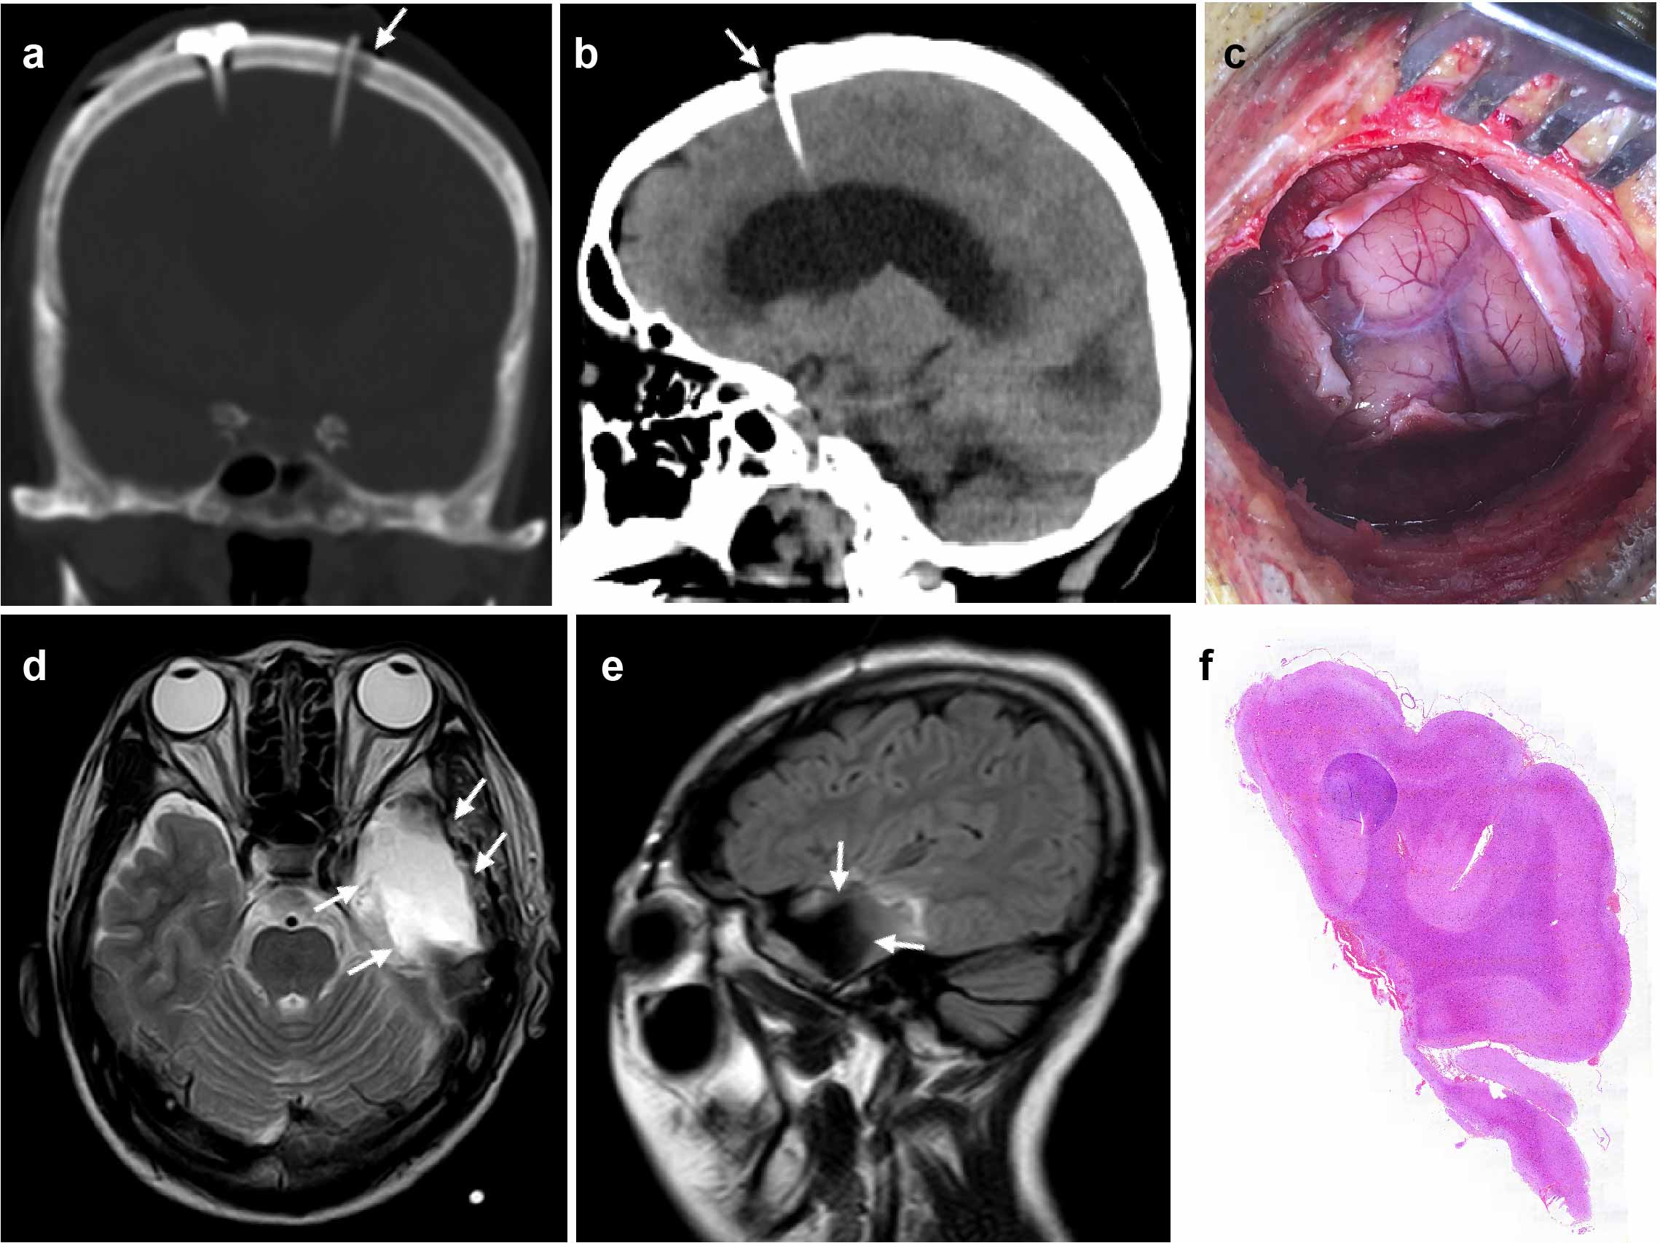
Supplementary Fig. 1 Anatomical location of leptomeningeal tissue.
(a-b) In a patient with lung cancer and LM, the Kocher's puncture point is positioned 12 cm caudally from the glabella, with a lateral deviation of approximately 1-2 cm from the midline. (c) The image shows the dura mater opened after drilling, exposing the turbid leptomeninges affected by metastasis. (d-e) These MRI images show a patient with non-neoplastic drug-refractory epilepsy following surgical resection of the seizure focus in the anterior temporal lobe. The surgical resection extends 4.5 centimeters posterior from the temporal pole on the left side and 5.5 centimeters on the right side. (f) This image depicts H&E-stained sections of the anterior temporal lobe from the same patient. a-b corresponds to coronal and sagittal CT views, while d-e shows axial T2 and sagittal T2 FLAIR MRI views.
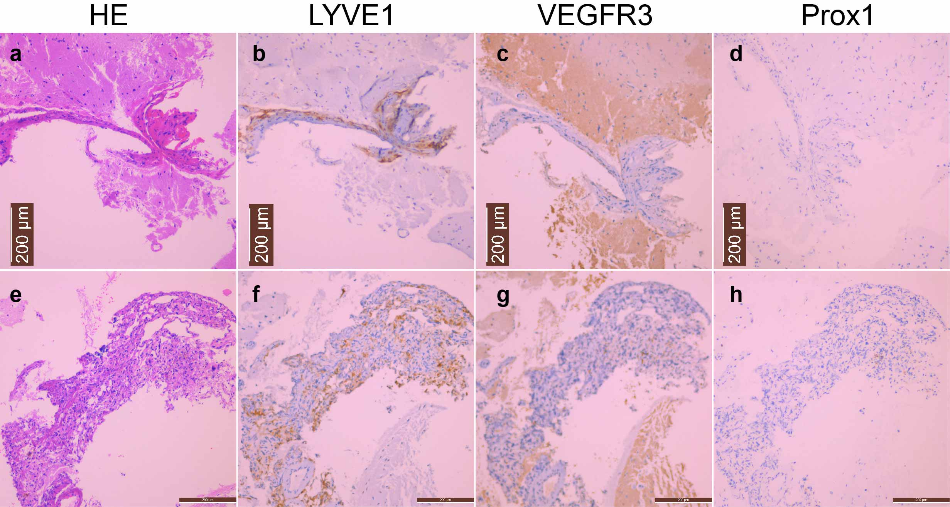
Supplementary Fig. 2 Expression of various lymphatic-specific antibodies differs in the leptomeninges.
(a-d) and (e-h) were obtained from two patients with lung cancer LM, (a) and (e) are stained with H&E, while (b-c) and (f-h) are stained with immunohistochemistry. (b) and (f) Samples show well-defined lymphatic-like structures when using LYVE1-specific antibodies. (c) and (g) There is widespread expression of VEGFR3 in brain parenchyma. (d) and (h) The expression of Prox1 in the leptomeninges is sparse and difficult to detect. (Scale: a-h, 200μm)

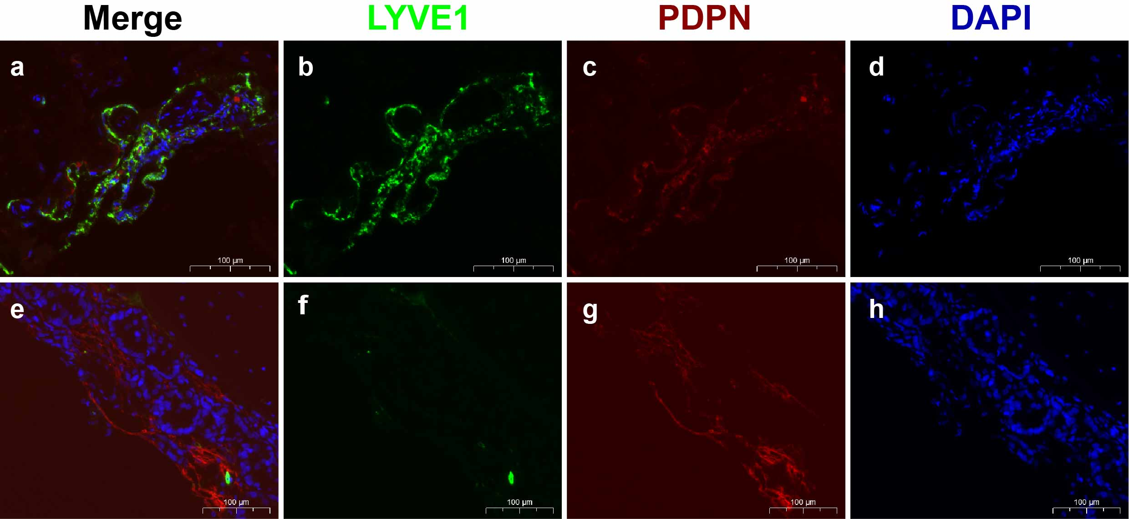
Supplementary Fig. 3 Two types of lymphatic vessels are present in the leptomeninges.
(a-d) One type of lymphatic vessel shows co-labeling with LYVE1⁺ and PDPN⁺. (e-h) Another type of lymphatic vessel shows labeling with PDPN⁺ and LYVE1⁻. (Scale bar: a-h, 100μm)
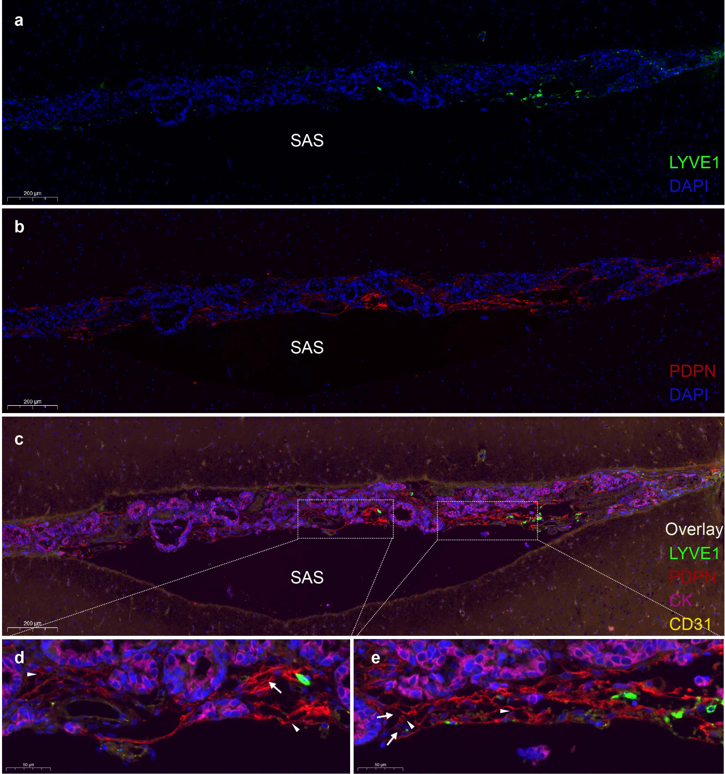 Supplementary Fig. 4 Characteristics of leptomeningeal lymphangiogenesis.
(a-c) Peritumoral lymphatic vessels around the LM show positive staining for PDPN and negative staining for LYVE1. (d) and (e) Local magnifications of c reveal an expanded area of PDPN-positive vessels, forming irregular vascular networks. Within these networks, endothelial cell expansion is accompanied by bridge-like structures (arrows), valve-like structures (arrowheads), and the formation of small tubes. (Scale bar: a-c, 200μm; d-e 50μm)

