Table 1
Hammett σ values and pK_{a} data of  1,3-cyclohexadiene-1-carboxylic acid  (dihydrobenzoic acid)  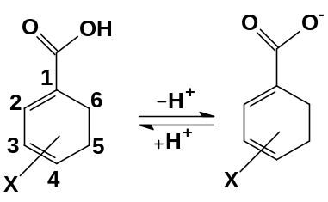 |  |  |  | pK_{a}s  of Benzoic acids  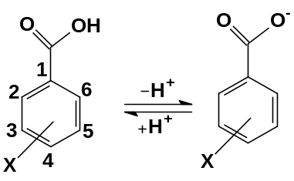
Sl. No. | X | Hammett σ | pK_{a}  present work by DFT | Exptl.* | DFT#
1 | H | 0.00 | 4.78 | 4.20 | 4.24**
2 | 4-NO₂ | 0.78 | 3.20 | 3.43 | 3.38
3 | 4-CH₃O | -0.27 | 6.06 | 4.47
4 | 4-CN | 0.66 | 3.55 | 3.55
5 | 4-NH₂ | -0.66 | 7.44 | 4.88
6 | 4-Br | 0.23 | 4.53 | 3.97
7 | 4-Cl | 0.23 | 4.84 | 3.98 | 3.85
8 | 4-CH₃ | -0.17 | 5.51 | 4.37 | 4.41
9 | 3-NO₂ | 0.71 | 3.74 | 3.49
10 | 3-CH₃O | 0.12 | 4.38 | 4.09
11 | 3-CN | 0.56 | 3.95 | 3.60
12 | 3-NH₂ | -0.16 | 4.52 | 4.78
13 | 3-Br | 0.39 | 3.82 | 3.81
14 | 3-Cl | 0.37 | 3.99 | 3.83 | 4.20
15 | 3-CH₃ | -0.07 | 5.00 | 4.27
*From reference 6, # From reference 8, **determined in this article by SMD_{sSAS} method
Table 2: ΔGº data at 298.15 K of isomerization of
2-X-1,3-Cyclohexadiene and Hammett σ values
Sl. No. |  | X | Taft σ* | Hammett σ |  | ΔGº  kJ mole⁻¹
 |  | X | ortho | meta | para | ΔGº  kJ mole⁻¹
1 |  | H | 0.49 | 0.00 | 0.00 | 1.48*
2 |  | CH₃O | 1.81 | 0.12 | -0.27 | -5.00*
3 |  | i-PrO | 1.62 | 0.07 | -0.45 | -4.37*
4 |  | (CH₃CH₂)₂CHO | - | 0.10 | -0.32 | -4.49*
5 |  | NH₂ | 0.62 | -0.16 | -0.66 | -7.10#
6 |  | NO₂ | 4.00 | 0.71 | 0.78 | 0.96#
7 |  | COCH₃ | 1.65 | 0.38 | 0.50 | -1.23#
8 |  | OH | 1.34 | 0.12 | -0.37 | -5.97#
*From reference 9, #present work, DFT calculated

Table 3 (including optimized structures) contains the Second Order Perturbation Analysis data and also BLA (Bond Length alternation) values
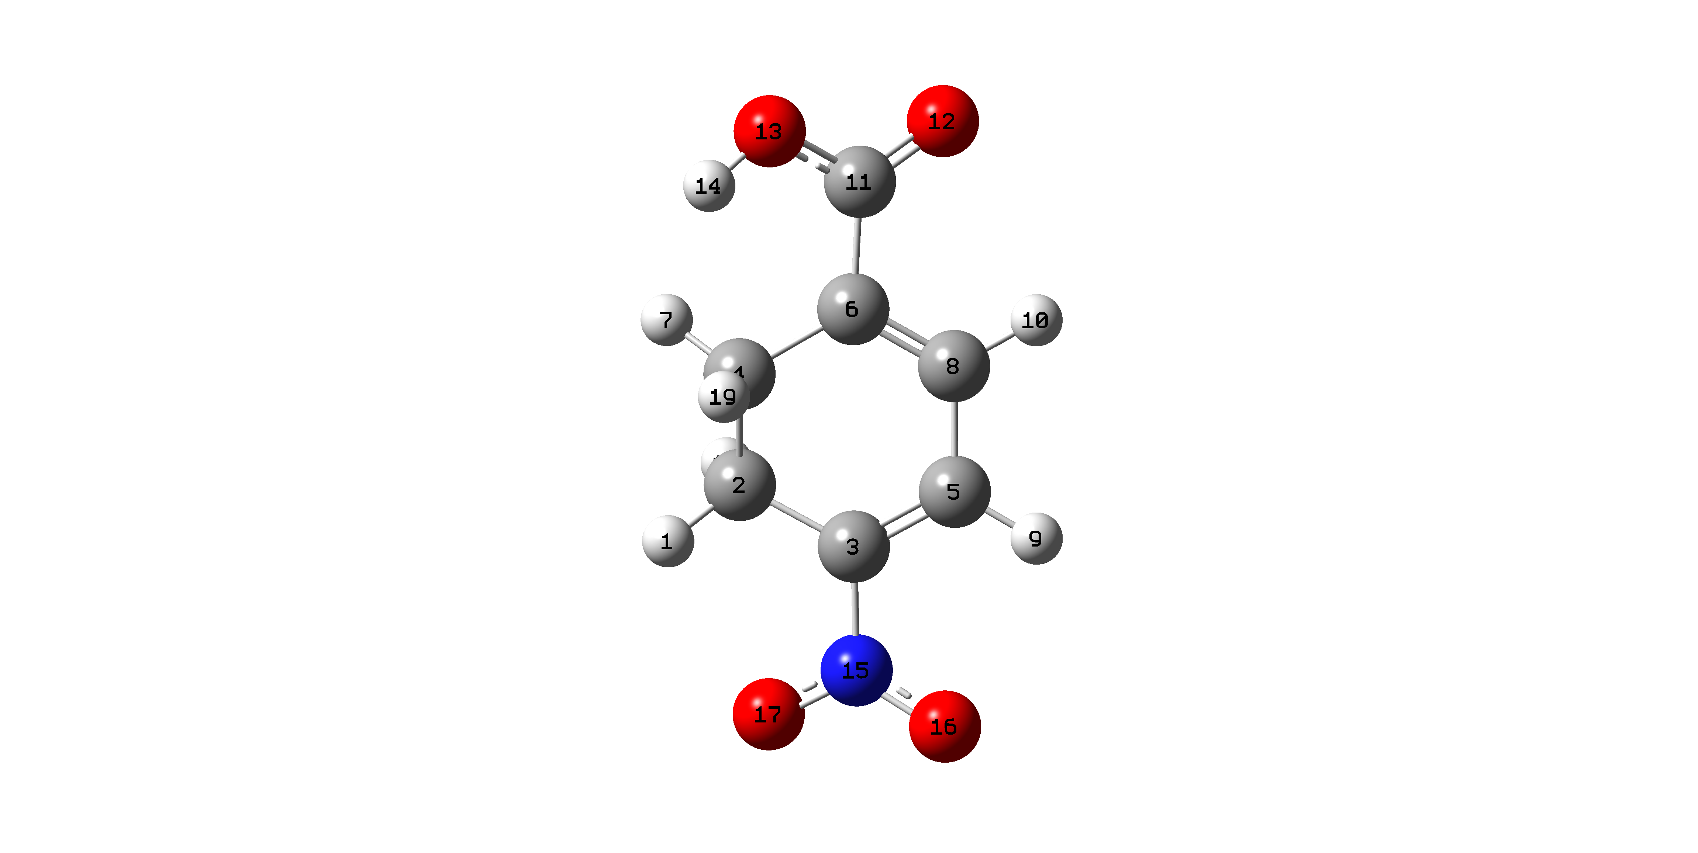  4-Nitro-1,3-Cyclohexadiene-1-carboxylic acid  BLA: 0.006 |  |  |  |  | 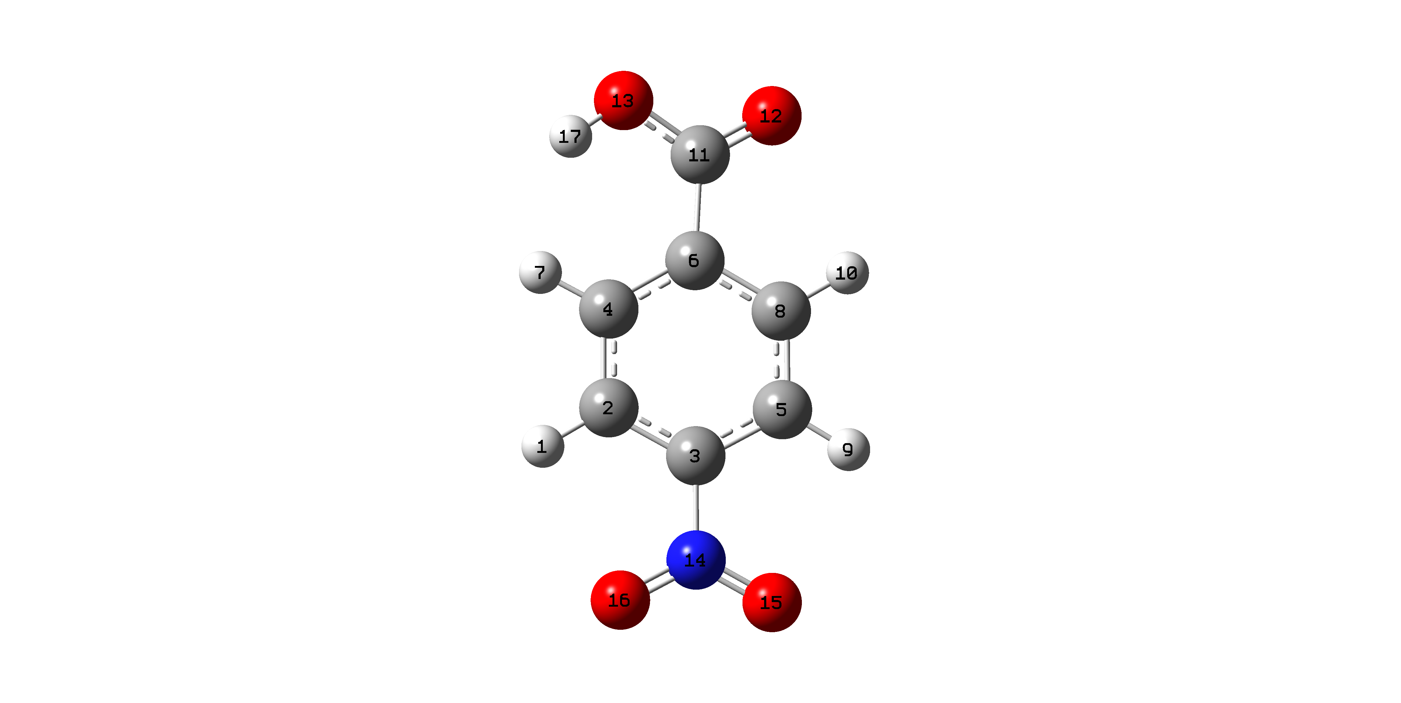  4-Nitro-Benzoic acid  BLA: 0.006
Donor(D) |  | Acceptor(A) |  | D-A  stabilization  energy | Donor(D) |  | Acceptor(A) |  | D-A  stabilization  energy
BD* N15-O17 |  | BD* C3-C5 |  | 10.46 | BD*C11-C12 |  | BD*C4-C6 |  | 56.10
BD* C11-O12 |  | BD*C6-C8 |  | 29.43 | BD*C2-C3 |  | BD*C5-C8 |  | 210.78
LP O17 |  | BD* C3-N15 |  | 11.79 | BD*C2-C3 |  | BD*C4-C6 |  | 327.36
LP O16 |  | BD* C3-N15 |  | 12.77 | LPO12 |  | BD*C6-C11 |  | 16.18
LP O12 |  | BD* C6-C11 |  | 19.83 | BDC5-C8 |  | BD*C4-C6 |  | 28.02
BD C6-C8 |  | C11-O12 |  | 22.65 | BD C4-C6 |  | BD*C11-O12 |  | 20.26
BD C6-C8 |  | BD* C3-C5 |  | 16.28 | BD C4-C6 |  | BD*C5-C8 |  | 27.04
BD C3-C5 |  | BD* N15-O17 |  | 32.58 | BD C4-C6 |  | BD*C2-C3 |  | 29.16
BD C3-C5 |  | BD* C6-C8 |  | 12.95 | BD C2-C3 |  | BD*C4-C6 |  | 26.70
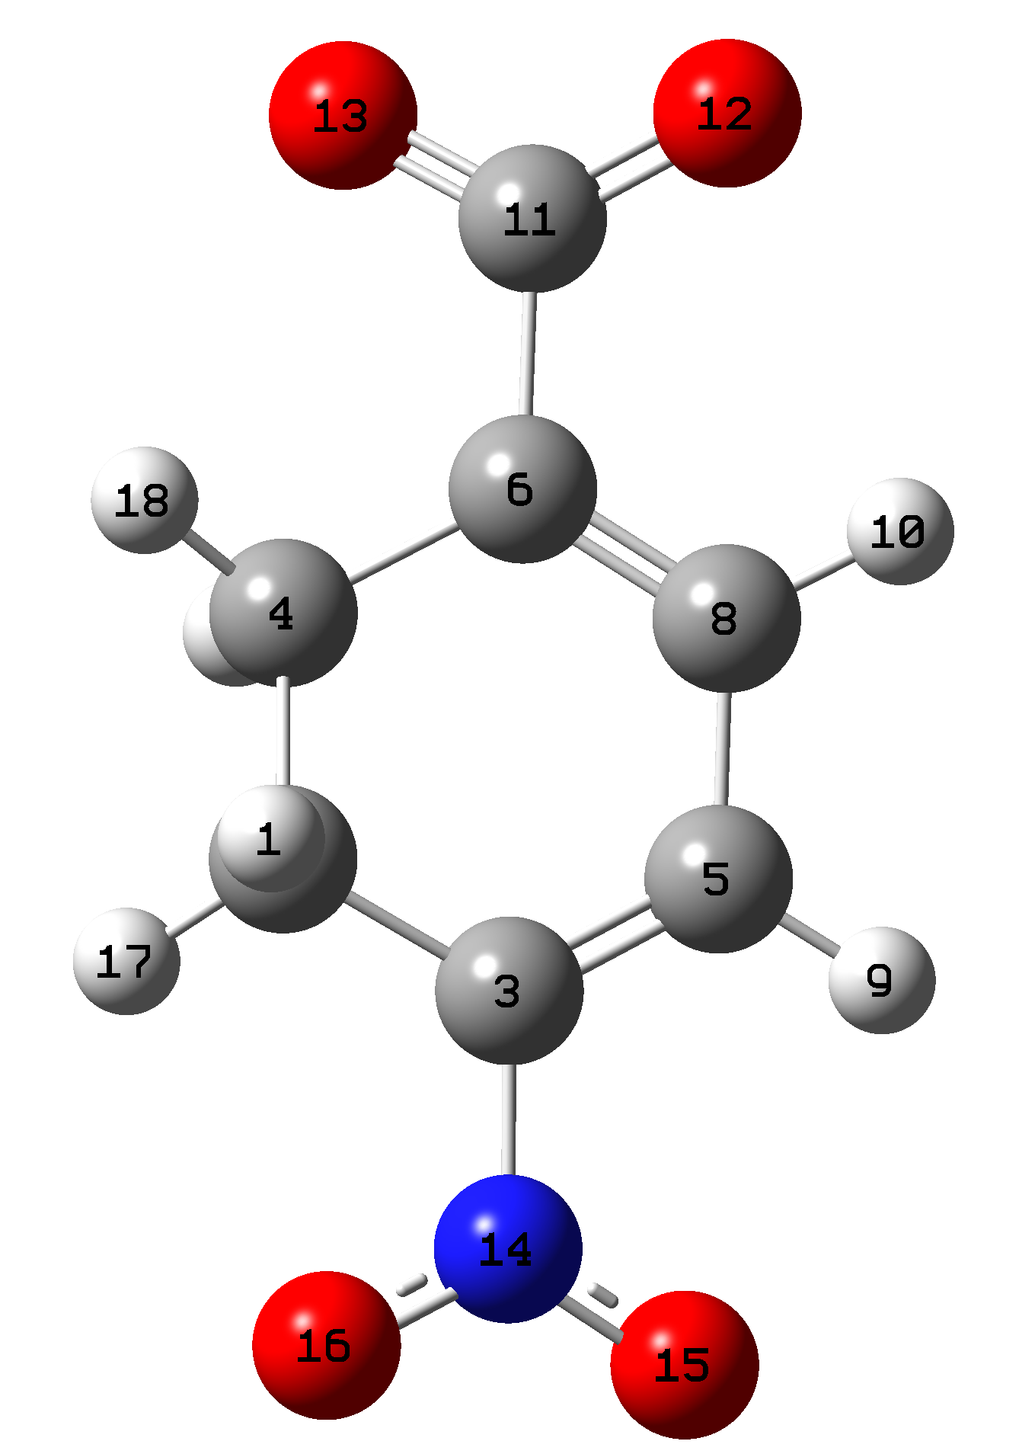  Conjgate base of 4-Nitro-1,3-Cyclohexadiene-1-carboxylic acid  BLA: 0.015 |  |  |  |  | 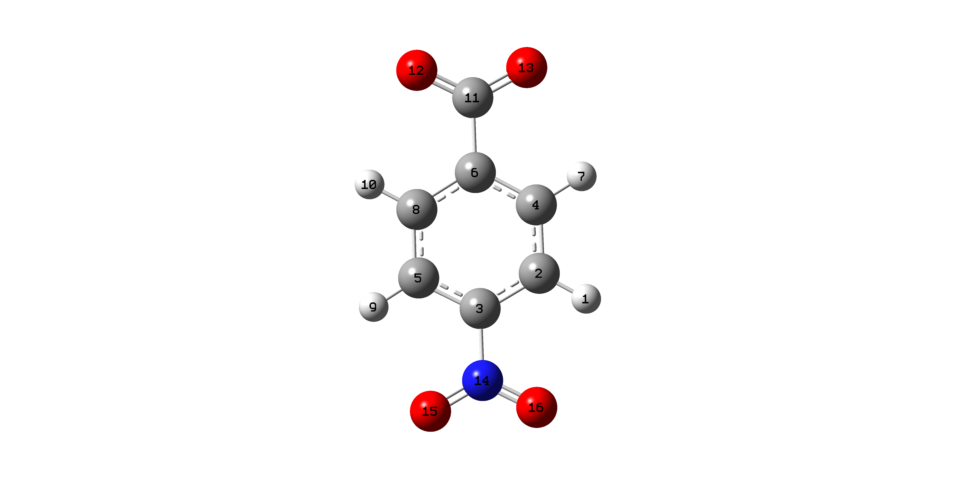  Conjugate base 4-Nitro-Benzoic acid  BLA: 0.016
BD* N14-16 |  | BD* C3-C5 |  | 11.37 | BD* N14-O15 |  | BD* C3-C5 |  | 20.35
BD* C11-O13 |  | BD* C6-C8 |  | 35.37 | BD* C3-C5 |  | BD* C6-C8 |  | 231.23
BD* C3-C5 |  | BD* C6-C8 |  | 38.65 | BD* C3-C5 |  | BD* C2-C4 |  | 222.56
LP O16 |  | BD* C3-N14 |  | 11.21 | LPO 16 |  | BD* C3-N14 |  | 12.89
LP O15 |  | BD* C3-N14 |  | 12.19 | LPO 15 |  | BD* C3-N14 |  | 12.89
LP O13 |  | BD* C6-C11 |  | 17.65 | LPO 13 |  | BD* C6-C11 |  | 18.46
LP O12 |  | C6-C11 |  | 18.20 | LPO 12 |  | BD* C6-C11 |  | 18.45
BD C3-C5 |  | BD* N14-O16 |  | 37.20 | LP* C11 |  | BD* C6-C8 |  | 33.17
BD C6-C8 |  | BD* C11-O13 |  | 16.83 | BD C6-C8 |  | BD* C3-C5 |  | 34.12
BD C6-C8 |  | BD* C3-C5 |  | 19.78 | BD C6-C8 |  | BD* C2-C4 |  | 25.69
BD C3-C5 |  | BD* N14-O16 |  | 37.20 | BD C6-C8 |  | LP* C11 |  | 32.13
BD C3-C5 |  | BD* C6-C8 |  | 11.34 | BD C3-C5 |  | BD*N14-O15 |  | 34.38
 |  |  |  |  | BD C3-C5 |  | BD* C6-C8 |  | 23.97
 |  |  |  |  | BD C3-C5 |  | BD* C2-C4 |  | 26.63
 |  |  |  |  | BD C2-C4 |  | BD* C6-C8 |  | 29.49
 |  |  |  |  | BD C2-C4 |  | BD* C3-C5 |  | 29.63
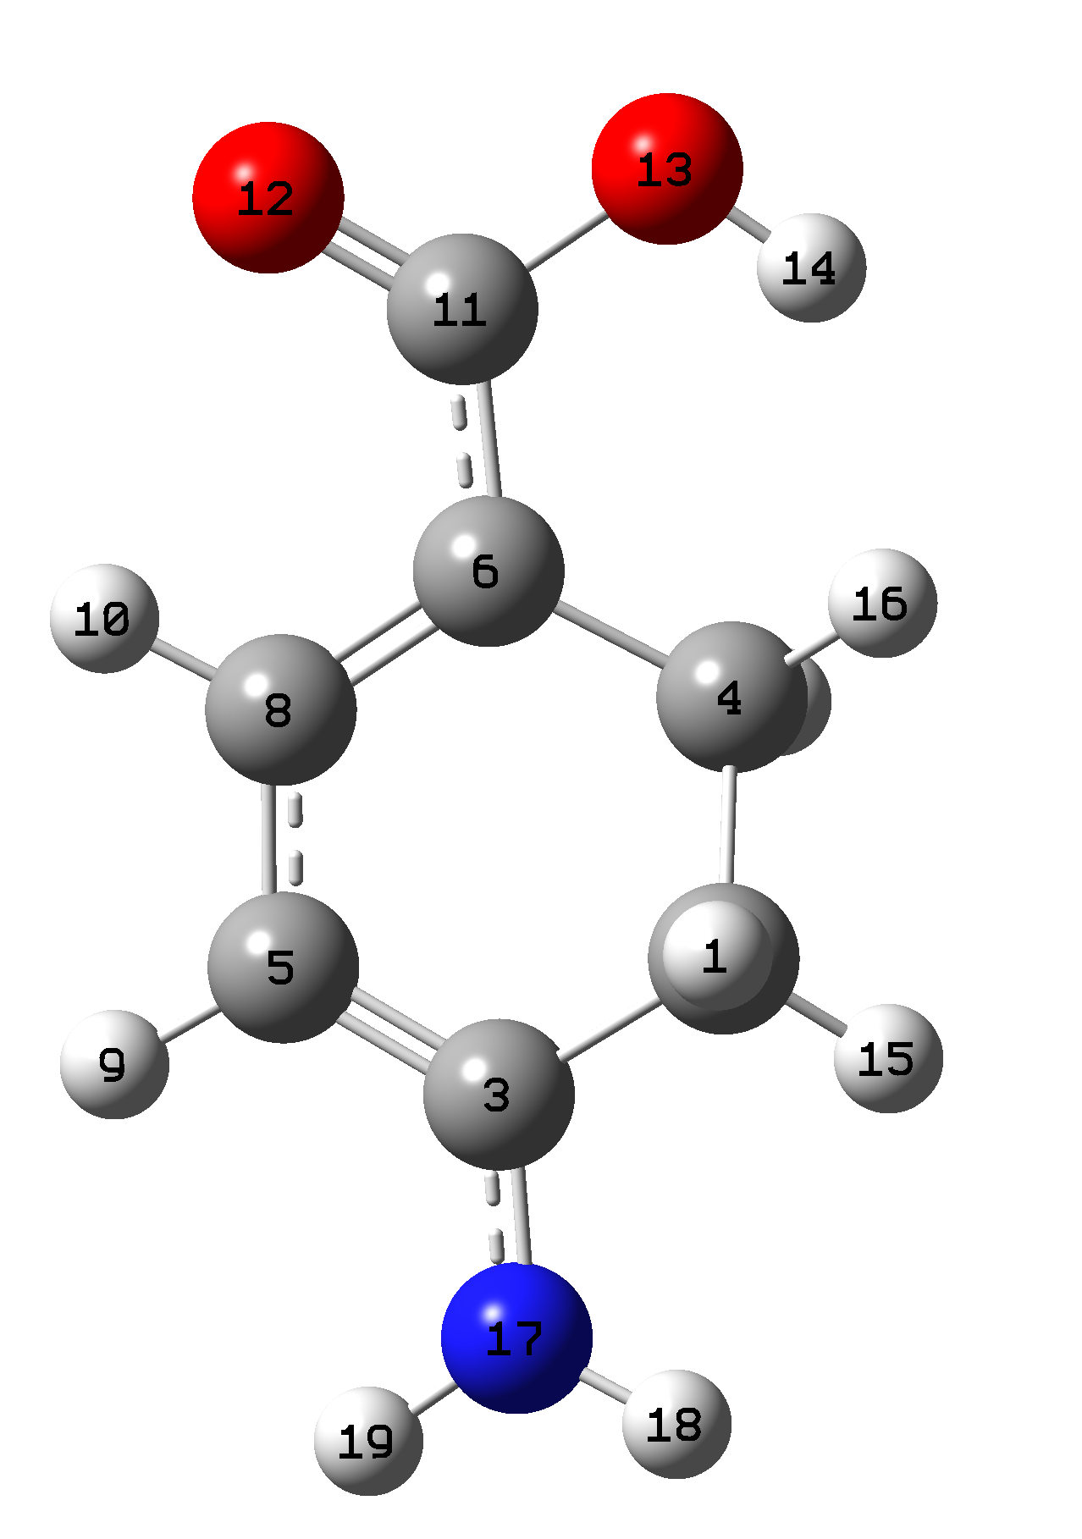  4-Amino-1,3-Cyclohexadiene-1-carboxylic acid  BLA 0.118 |  |  |  |  | 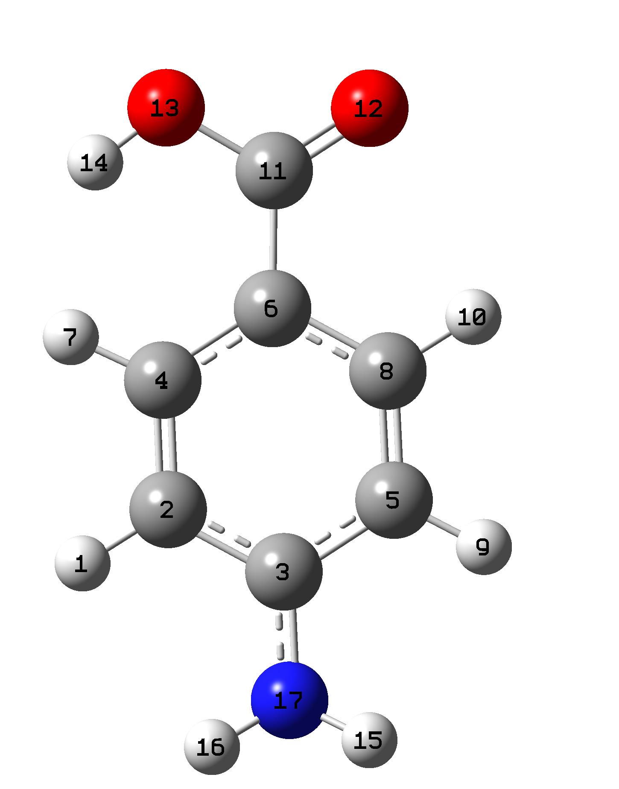  4-Amino-benzoic acid  BLA 0.109
BD* C11- C12 |  | BD* C6-C8 |  | 67.35 | LP N17 |  | LP* C3 |  | 68.49
BD* C3-C5 |  | BD* C6-C8 |  | 166.98 | LP O12 |  | BD* C6-C11 |  | 18.59
LP N17 |  | BD* C3-C5 |  | 79.36 | LP C6 |  | BD* C11-O12 |  | 80.56
LP O12 |  | BD* C6-C11 |  | 16.84 | LP C6 |  | BD* C5-C8 |  | 83.17
BD C6-C8 |  | BD* C11-O12 |  | 41.88 | LP C6 |  | BD* C2-C4 |  | 86.11
BD C3-C5 |  | BD* C6-C8 |  | 38.79 | LP* C3 |  | BD* C5-C8 |  | 59.80
 |  |  |  |  | LP* C3 |  | BD* C2-C4 |  | 62.62
 |  |  |  |  | BD C5-C8 |  | LP C6 |  | 46.54
 |  |  |  |  | BD C5-C8 |  | LP* C3 |  | 66.95
 |  |  |  |  | BD C2-C4 |  | LP C6 |  | 46.41
 |  |  |  |  | BD C2-C4 |  | LP* C3 |  | 65.45
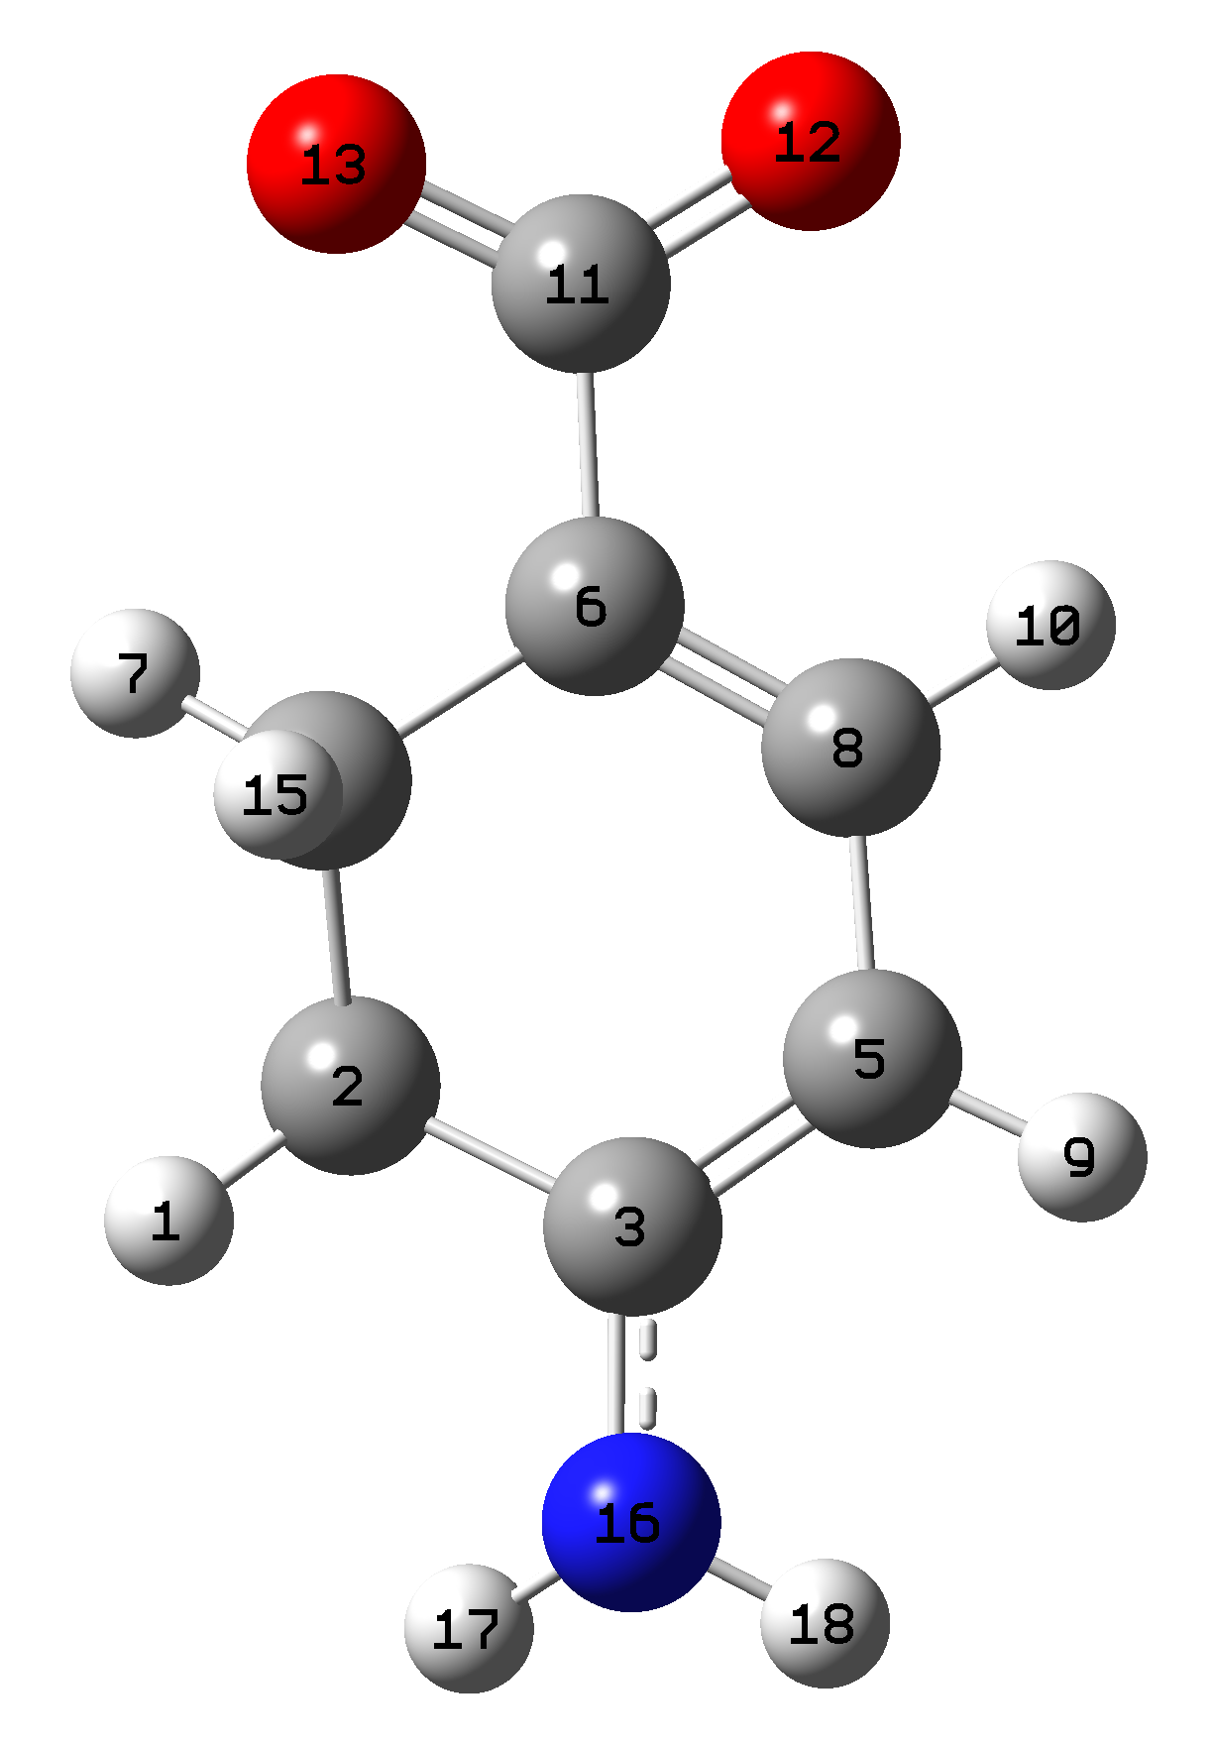  Conjugate base of 4-Amino-1,3-Cyclohexadiene-1-carboxylic acid  BLA 0.134 |  |  |  |  | 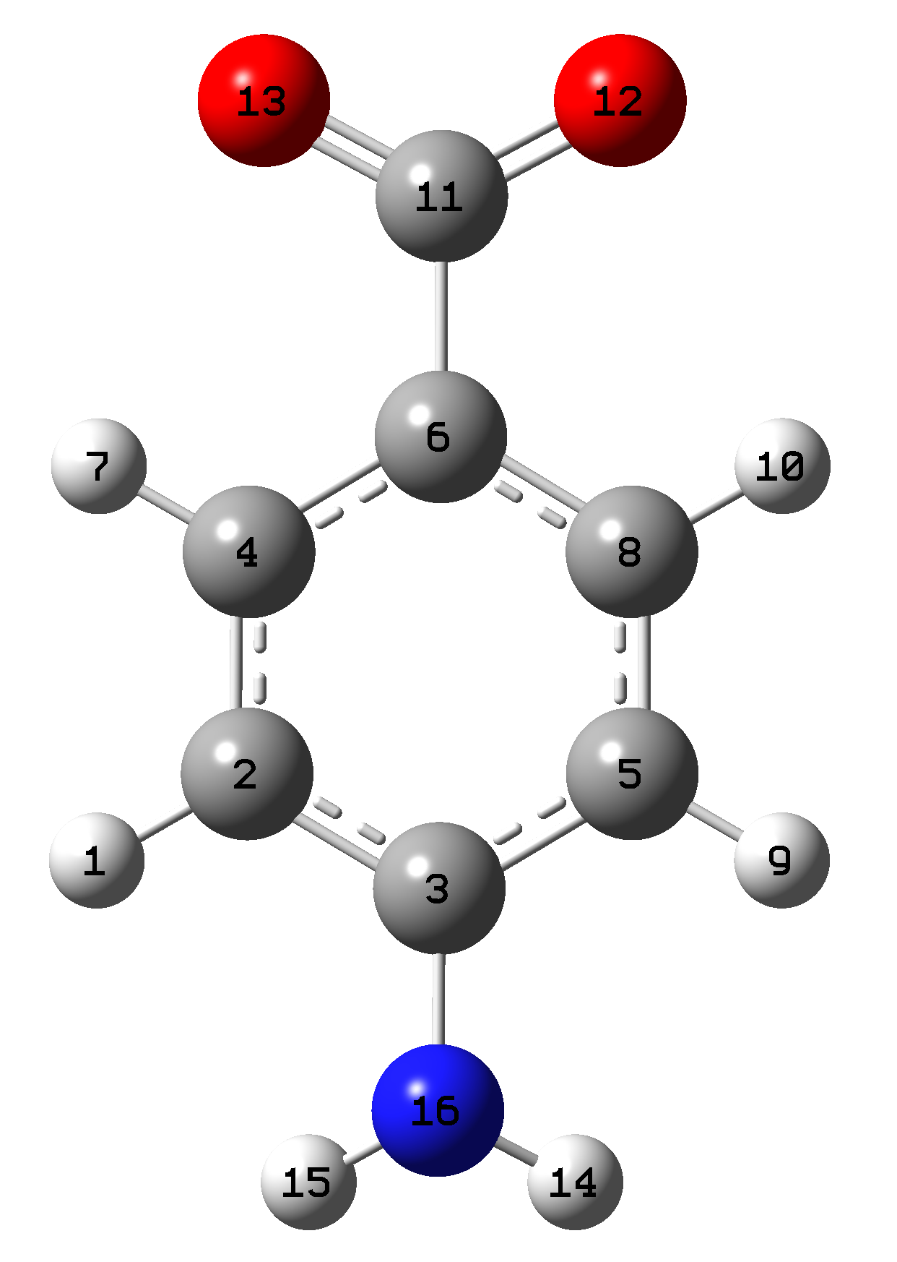  Conjuagate base of 4-Amino-benzoic acid  BLA 0.129
BD* C11-O13 | BD* C6-C8 |  | 42.31 |  | LP N16 | BD* C3-C5 |  | 32.33
BD* C3-C5 | BD* C6-C8 |  | 83.20 |  | LP O13 | BD* C6-C11 |  | 16.92
LP N16 | BD* C3-C5 |  | 48.38 |  | LP O12 | BD* C6 -C11 |  | 16.92
LP O13 | BD* C6-C11 |  | 15.53 |  | LP* C11 | BD* C6-C8 |  | 36.59
LP O12 | BD* C6-C11 |  | 16.16 |  | BD C6-C8 | BD* C3-C5 |  | 22.92
BD C6-C8 | BD* C11-O13 |  | 24.24 |  | BD C6-C8 | BD* C2-C4 |  | 33.03
BD C6-C8 | BD* C3-C5 |  | 10.83 |  | BD C6-C8 | LP* C11 |  | 40.46
BD C3-C5 | BD* C6-C8 |  | 25.01 |  | BD C3-C5 | BD* C6-C8 |  | 37.95
 |  |  |  |  | BD C3-C5 | BD* C2-C4 |  | 21.73
 |  |  |  |  | BD C2-C4 | BD* C6-C8 |  | 21.61
 |  |  |  |  | BD C2-C4 | BD* C3-C5 |  | 30.55
Note: LP=Lone pair; BD = Bonding orbital; BD* = Anti-bonding orbital; LP*=Unfilled valence shell non-bonding orbital; The donor-acceptor stabilization energy is in kcal/mole.

