Table S1. Cox proportional hazards regression analysis for RFS and OS in the total group
 | B | Wald | HR_with_95CI | P
RFS | 0.765 | 20.41 | 2.15(1.542-2.996) | <0.0001
OS | 1.469 | 46.64 | 4.348 (2.852-6.630) | <0.0001

Table S2. Coefficients for selected features in the LASSO regression models on MVI=M2 status
M2 λ1se=0.05807354, In(λ)= -2.7066179687
Index | coefficient
C3 | -0.0152649361
Tumor.Size | 0.2578120535
Cirrhosis | 0.0004005816
Tumor.Capsule | 0.0820389245
Edmondson.stage | 0.5540150412

Table S3. Multivariate logistic regression analysis of M2 presence based on data in the training group
 | B | Wald | OR_with_95CI | P
(Intercept) | -5.142 | 23.796 | 0.006(0.001-0.044) | <0.001
C3 | -1.642 | 6.119 | 0.194(0.05-0.682) | 0.013
Tumor.Size | 1.189 | 13.683 | 3.283(1.771-6.271) | <0.001
Tumor.Capsule | 0.952 | 5.767 | 2.591(1.175-5.611) | 0.016
Edmondson.stage | 1.448 | 19.011 | 4.254(2.263-8.373) | <0.001

Figure S1A
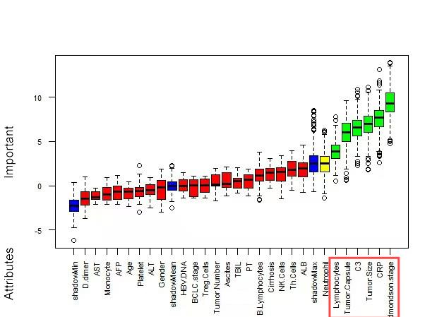
Using the Boruta method for the selection of demographic and clinical features, the six attributes located below the green box are identified as having the highest contribution and are also marked with a red box line as the most important features for identification.

Figure S1B
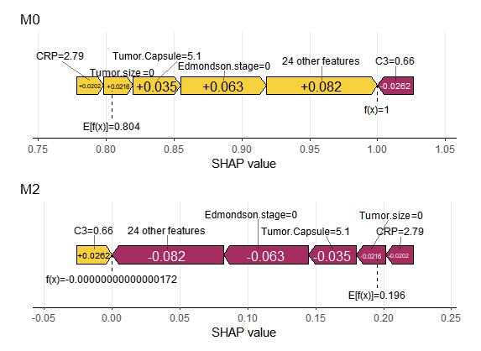
The SHAP summary plot of the XGBoost model reveals that C3, Tumor-size, Tumor-capsule, CRP, and Edmondson-stage are the five features with the highest SHAP values. For each of these features, a higher SHAP value indicates a higher risk of M2 development.
Figure S1C 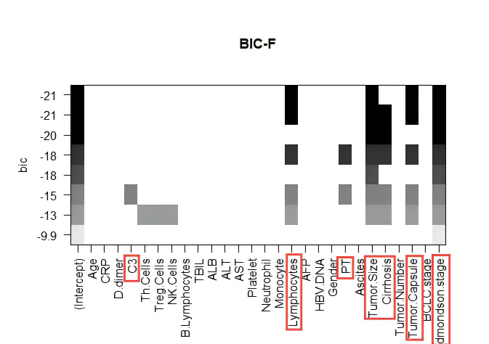
Darker colors represent lower BIC values, indicating the greater importance of the corresponding features. The features specifically marked with red box lines are identified as the most important variables within the Best subset.

Figure S1D
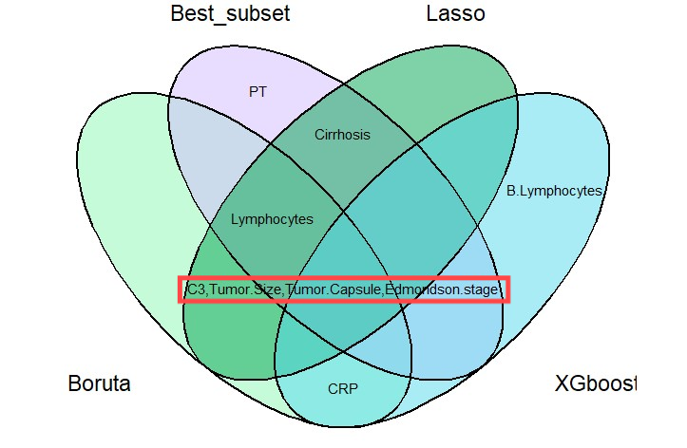
The intersection of the selected variables is visualized using a Venn diagram. The variables specifically marked with red box lines within the diagram represent the important variables that result from intersecting the outcomes of four distinct machine learning algorithms

