Additional file 1

eMethods
Diagnosis of ARDS for COVID-19 disease by WHO(1)
Onset: within 1 week of a known clinical insult (i.e. pneumonia) or new or worsening respiratory symptoms.
Chest imaging: (radiograph, CT scan, or lung ultrasound): bilateral opacities, not fully explained by volume overload, lobar or lung collapse, or nodules.
Origin of pulmonary infiltrates: respiratory failure not fully explained by cardiac failure or fluid overload. Need objective assessment (e.g. echocardiography) to exclude hydrostatic cause of infiltrates/oedema if no risk factor present.
Oxygenation impairment in adults: Mild ARDS: 200 mmHg < PaO₂/FiO₂ ≤ 300 mmHg (with PEEP or CPAP ≥ 5 cmH2O); Moderate ARDS: 100 mmHg < PaO₂/FiO₂ ≤ 200 mmHg (with PEEP ≥ 5 cmH2O); Severe ARDS: PaO₂/FiO₂ ≤ 100 mmHg (with PEEP ≥ 5 cmH2O).
Definitions
Severity of illness was assessed on the basis of Sequential Organ Failure Assessment (SOFA) score at hospital admission and on the day of ARDS diagnosis. Immunosuppression was defined as having human immunodeficiency virus infection, hematological malignant tumor, cirrhosis, chronic renal disease, organ transplantation, or under immunosuppressor treatment within 30 days before admission. Chronic pulmonary diseases included chronic obstructive pulmonary disease, asthma, chronic bronchitis, bronchiectasis, and pulmonary tuberculosis. Lymphopenia was defined as any value below 1.0 × 10⁹/L. Hyperglycemia was defined as a glucose level >200 mg/dL at any time of the day.(2) Viral shedding were defined as continuously twice negative results of SARS-CoV-2 detection from throat-swab specimens. Durations of viral shedding were calculated as days from symptom onset to first negative test.

eTables
eTable 1 Characteristics of 382 patients with ARDS associated with COVID-19, stratified by outcome
Characteristics | All | Non-survivors | Survivors | P-value
N(%) | 382 (100.0) | 203 (53.1) | 179 (46.9)
Age, year | 60.7 ± 14.1 | 59.1 ± 14.0 | 63.0 ± 14.0 | 0.0077
Male sex | 234 (61.3) | 128 (63.1) | 106 (59.2) | 0.4425
Smoking history | 35 (9.2) | 18 (8.9) | 17 (9.5) | 0.8313
Days from onset at admission | 11.0 (8.0 - 15.0) | 10.0 (7.0 - 14.0) | 12.0 (9.0 - 16.5) | 0.0029
Medical history
Chronic pulmonary diseases | 20 (5.2) | 15 (7.4) | 5 (2.8) | 0.0442
Hypertension | 136 (35.6) | 89 (43.8) | 47 (26.3) | 0.0003
Diabetes | 67 (17.5) | 46 (22.7) | 21 (11.7) | 0.0051
Chronic liver diseases | 15 (3.9) | 9 (4.4) | 6 (3.4) | 0.5871
Chronic renal diseases | 6 (1.6) | 4 (2.0) | 2 (1.1) | 0.5034
Cardiovascular diseases | 28 (7.3) | 22 (10.8) | 6 (3.4) | 0.0051
Malignant tumor | 12 (3.1) | 9 (4.4) | 3 (1.7) | 0.1231
Hematological malignant tumor | 2 (0.6) | 2 (1.2) | 0 (0.0) | 0.1548
Immunosuppressive conditions | 14 (3.7) | 11 (5.4) | 3 (1.7) | 0.0521
SOFA score at admission | 2.0 (2.0 - 3.0) | 2.0 (2.0 - 3.0) | 2.0 (2.0 - 3.0) | 0.1393
Corticosteroid therapy before admission | 40 (10.5) | 18 (8.9) | 22 (12.3) | 0.2755
Temperature on admission, ℃ | 36.8 ± 0.7 | 36.9 ± 0.8 | 36.7 ± 0.5 | 0.0069
Heart rate, min⁻¹ | 90.9 ± 15.3 | 92.9 ± 16.3 | 88.0 ± 13.1 | 0.0018
Respiratory rate, min⁻¹ | 24.0 ± 6.3 | 24.5 ± 7.1 | 23.3 ± 5.0 | 0.0609
Laboratory findings at admission
Blood leukocyte count, × 10⁹/L | 8.1 (5.2 - 11.3) | 8.4 (5.1 - 11.7) | 7.5 (5.4 - 10.0) | 0.2593
Lymphocyte count, × 10⁹/L | 0.7 (0.5 - 1.0) | 0.6 (0.5 - 0.8) | 0.8 (0.6 - 1.1) | <.0001
Neutrophil count, × 10⁹/L | 6.9 (4.0 - 10.2) | 7.4 (4.2 - 10.7) | 5.7 (4.0 - 8.7) | 0.0508
SpO₂/FiO₂ | 229.3 (175.5 - 352.4) | 218.6 (170.0 - 366.7) | 241.5 (184.0 - 332.8) | 0.2133
CRP, mg/L | 89.0 (38.0 - 159.9) | 96.7 (45.9 - 160.0) | 68.7 (28.6 - 138.5) | 0.0026
D-dimer, mg/L | 1.5 (0.7 - 8.0) | 1.5 (0.6 - 9.5) | 1.5 (0.7 - 7.1) | 0.9913
Lactate dehydrogenase, U/L | 409.0 (304.0 - 545.0) | 429.0 (320.0 - 569.0) | 386.5 (277.0 - 509.5) | 0.0124
Bilateral involvement | 358 (93.7) | 190 (93.6) | 168 (93.9) | 0.9172
Corticosteroid therapy | 226 (59.2) | 135 (66.5) | 91 (50.8) | 0.0019
Antivirus drugs
Lopinavir | 91 (24.0) | 46 (22.9) | 45 (25.3) | 0.5859
Ganciclovir | 32 (8.4) | 10 (5.0) | 22 (12.4) | 0.0099
Interferon | 103 (27.2) | 57 (28.4) | 46 (25.8) | 0.5827
Oseltamivir | 64 (16.9) | 24 (11.9) | 40 (22.5) | 0.0063
Respiratory support
High-frequency oscillation ventilation | 146 (38.8) | 104 (52.5) | 42 (23.6) | <.0001
NIMV | 147 (38.5) | 134 (66.0) | 13 (7.3) | <.0001
IMV | 94 (24.6) | 90 (44.3) | 4 (2.2) | <.0001
ECMO | 11 (2.9) | 11 (5.4) | 0 (0.0) | 0.0016
Hyperglycemia | 32 (8.4) | 25 (12.3) | 7 (3.9) | 0.0031
In-hospital days | 12.0 (7.0 - 18.0) | 14.0 (9.0 - 21.0) | 10.0 (6.0 - 13.0) | <.0001
Duration of viral shedding from symptom onset, day | 18.0 (14.0 - 23.0) | 18.0 (14.0 - 23.25) | 18.0 (14.0 - 23.0) | 0.9704
Notes: Data are n (%) or mean (SD). For continuous variables, t-test or Mann-Whitney U test was used to calculate the P value unless otherwise noted. For categorical variables, chi-square test was used to calculate the P value unless otherwise noted.ARDS was defined according to World Health Organization interim guidance.
Abbreviations: ARDS, acute respiratory distress syndrome; SOFA, sequential Organ Failure Assessment; CRP, c-reactive protein; MV, mechanical ventilation; NIMV, non-invasive mechanical ventilation; IMV, invasive mechanical ventilation; ECMO, extracorporeal membrane oxygenation; SpO2, pulse oxygen saturation; FIO2, fraction of inspired oxygen.

eTable 2 Results of logistic regression model for propensity score of corticosteroid treatment

Covariate | Estimates | Standard deviation | P-value
Age | -0.0263 | 0.0091 | 0.0038
Sex | 0.204 | 0.1213 | 0.0926
Smoking | 0.1913 | 0.2143 | 0.3719
Heart rate | 0.0203 | 0.00877 | 0.0209
Temperature | 0.2804 | 0.1831 | 0.1256
Respiratory rate | 0.0278 | 0.0207 | 0.1783
SpO₂/FiO₂ | 0.00116 | 0.00128 | 0.3671
Lymphocyte count | -0.9425 | 0.2541 | 0.0002
Neutrophil count | 0.00384 | 0.00215 | 0.0743
C-reactive protein | 0.00479 | 0.0272 | 0.8603
SOFA score | 0.0855 | 0.0857 | 0.3187

Note: Propensity score was calculated by a non-parsimonious logistic regression model that included: age; sex; SOFA score at admission; temperature, respiratory rate, SpO₂/FiO₂ ratio, blood lymphocyte count, blood neutrophil count, and level of c-reactive protein at admission.
Abbreviations: SOFA, sequential Organ Failure Assessment; SpO2, pulse oxygen saturation; FIO2, fraction of inspired oxygen.

eTable 3 Sensitivity analysis for estimated effects of corticosteroid treatment on sixty-day mortality
 | No. | Hazard Ratio | 95% CI | P Value
ARDS patients defined by Berlin definition | 185 | 0.44 | 0.23, 0.86 | 0.0161
Excluding lopinavir treated patients | 291 | 0.46 | 0.19, 1.16 | 0.0997
ARDS onset as baseline | 382 | 0.56 | 0.28, 1.12 | 0.1000
Notes: All of the models assessed the effects of corticosteroids as a time-varying covariate. Adjusted for age, sex, SOFA score at admission, propensity score of corticosteroid treatment, and comorbidities: diabetes, hypertension, chronic pulmonary disease, chronic renal or liver disease, solid malignant tumor, hematologic malignancy, and immunosuppressive status. Propensity score was calculated by a non-parsimonious logistic regression model that included: age; sex; SOFA score at admission; temperature, respiratory rate, SpO2/FiO2 ratio, blood lymphocyte count, blood neutrophil count, and level of c-reactive protein at admission.
Abbreviations: ARDS, acute respiratory distress syndrome; SOFA, sequential Organ Failure Assessment; SpO2, pulse oxygen saturation; FIO2, fraction of inspired oxygen.

eFigures
eFigure 1 Workflow of the Selection process for patients with ARDS associated with COVID-19
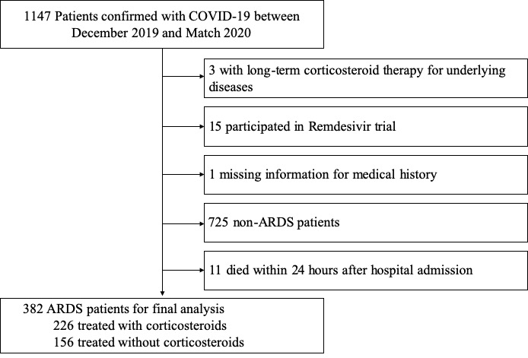
Abbreviations: COVID-19= coronavirus disease 2019, ARDS=acute respiratory distress syndrome.
eFigure S2 Changes in interleukin-6 after ARDS onset for patients with ARDS associated with COVID-19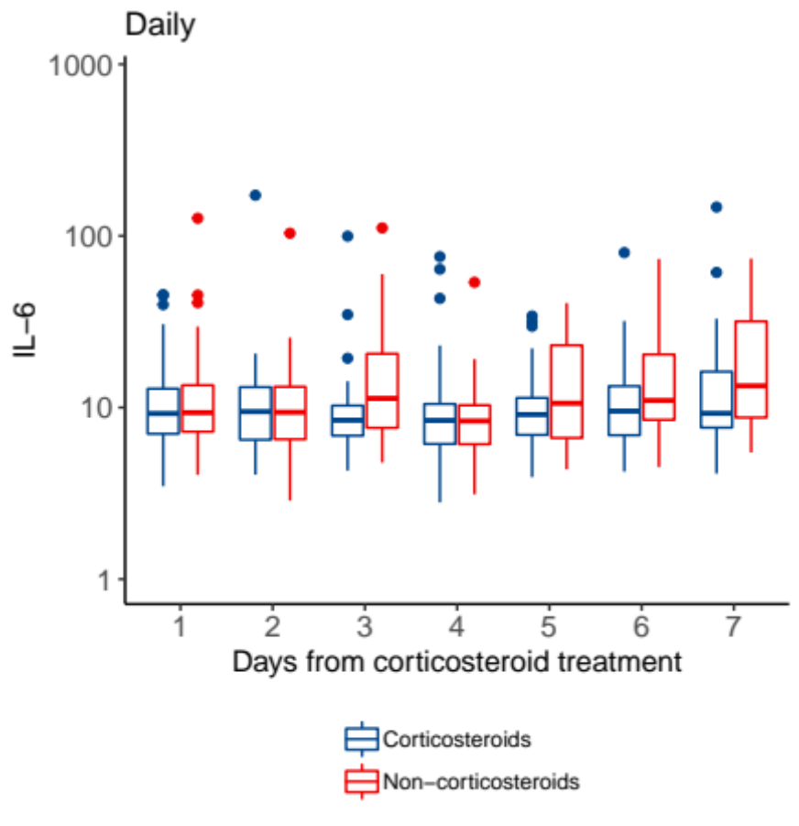
Abbreviations: COVID-19= coronavirus disease 2019, ARDS=acute respiratory distress syndrome.
Reference
1. Organization WH. Clinical management of COVID-19, interim guidance, 27 May 2020. . [cited 2020 March 13, 2020]Available from: https://www.who.int/publications-detail/clinical-management-of-severe-acute-respiratory-infection-when-novel-coronavirus-(ncov)-infection-is-suspected
2. Perez A, Jansen-Chaparro S, Saigi I, et al. Glucocorticoid-induced hyperglycemia. J Diabetes 2014;6(1):9-20.

