Supporting Information
Hyperammonemia-derived Neurovascular Inflammation Mediated by MAO-A and δ-Secretase in Neurodegenerative Brain Models

Minh Tran¹⁻³, Khanh V. Do^{1,3}, You Jung Kang^{1,2}, Yen N. Diep¹⁻³, Ariunzaya Jamsranjav¹⁻³, Luke P. Lee^{1,2,5-7*}, Hansang Cho^{1-3*}

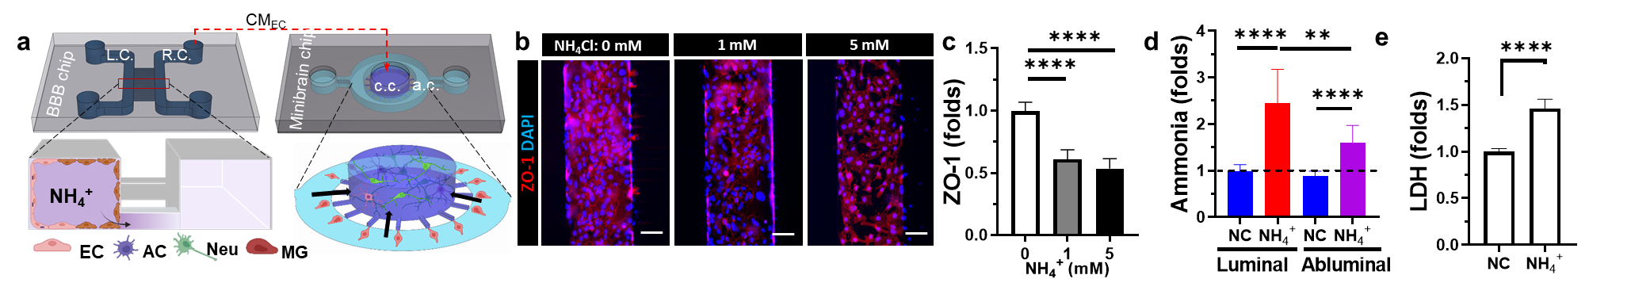
Figure S1. Schematic of 3D brain edema models on microfluidics platform. (a) Schematics description of mini-brain models for ammonia (NH₄⁺) infiltration from a 3D blood-brain barrier chamber (left) and a 3D brain tissue chamber (right). (b) Fluorescent images showing endothelial tightness (ZO-1) on 3D BBB model response to ammonia in different concentrations. (c) Quantification of endothelial tightness. Quantification of (d) ammonia level from luminal and abluminal side, (e) LDH cytotoxic release from ammonia-treated endothelial cell at 1 mM. Scale bars, 500 μm (b). Sample size, n=3 (c-e). Data are represented as Mean ± SD. Individual dots represent the mean value at a single treatment. ns, non-significant difference; ****, p < 0.0001, calculated by one‐way ANOVA with Tukey post‐hoc correction for multiple comparisons (c,d), independent sample t-test (e). Ammonia NH₄⁺, NH₄Cl 1 mM, 5mM. AC represents Astrocytes; Neu, neuron; MG, microglia; DAPI, nucleus.

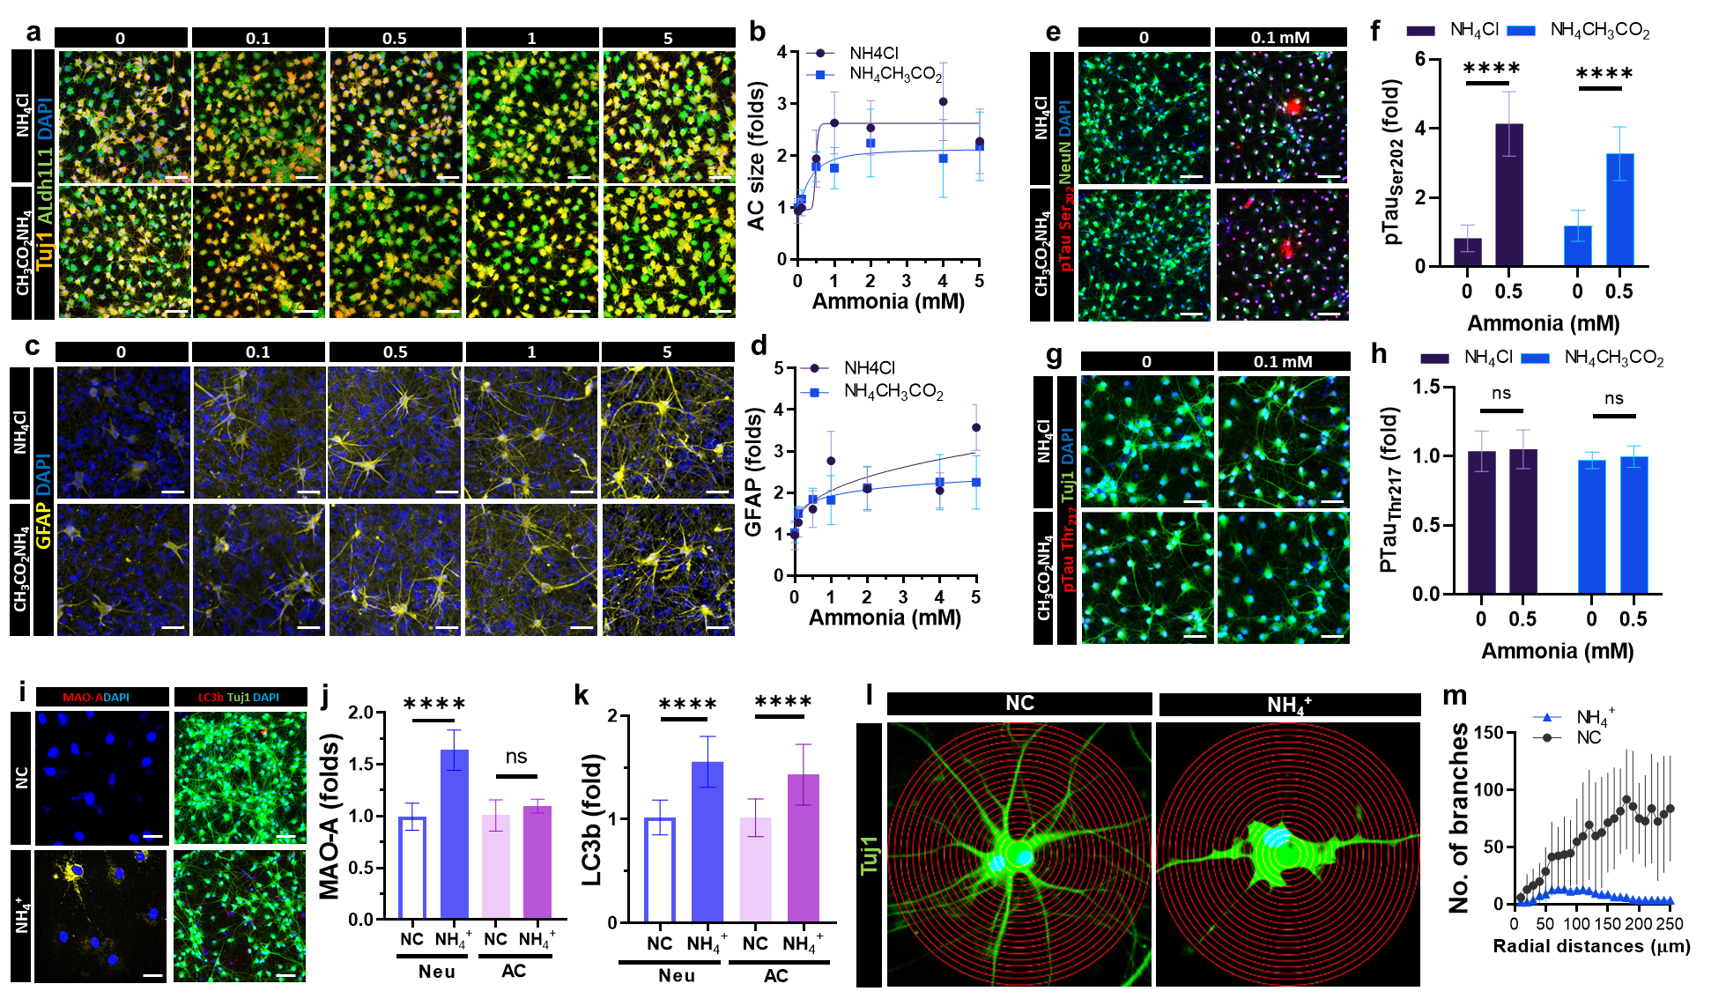
Figure S2. Schematic of brain tissues exposore to ammonia. (a,c) Fluorescent images of brain tissues model showing the representative markers for hypertrophic astrogliosis. Quantification of (b) astrocytes size and (d) GFAP expression. (e,g) Fluorescent images of brain tissues model showing the representative markers for neurondegeneration ptau at Ser202 and Thr217 residue. Quantification of (f) pTau Ser202 expression and (d) pTau Thr217 expression. (i) Fluorescent images of brain tissues model showing the MAO-A and LC3b. Quantification of (j) MAO-A expression and (k) LC3b expression. (l) The expansion of neuronal cells indicated by an interval of concentric circles, (m) the count of astrocytic branches emanating from the central nucleus. Scale bars, 100 μm (a,c,e,g,i). Sample size, n=50 (b,m), 10 (d,f,h,g,k). Data are represented as Mean ± SD. Individual dots represent the mean value at a single treatment. ns, non-significant difference; ****, p < 0.0001, calculated by independent sample t-test (e). Ammonia NH₄⁺, NH₄Cl 1 mM, 5mM. AC represents Astrocytes; Neu, neuron; MG, microglia; DAPI, nucleus.

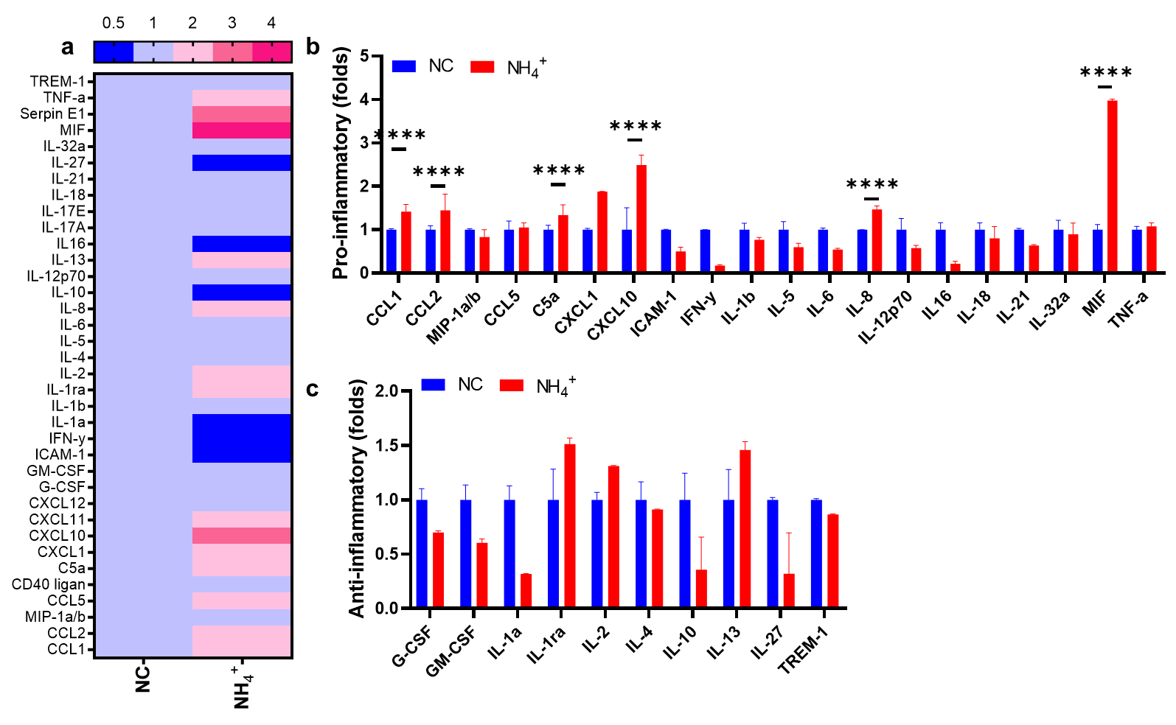

Figure S3. (a) Heat map color visualization of human cytokine array release from endothelial cells. (b,c) Quantification of pro-inflammtory factors and anti-inflammtory factors release from brain endothelium.. Sample size, n= 4. Data are represented as Mean ± SD. ns, non-significant difference; ****, p < 0.0001, calculated by independent sample t-test. Ammonia NH₄⁺, NH₄Cl 0.5 mM. AC, Astrocytes.
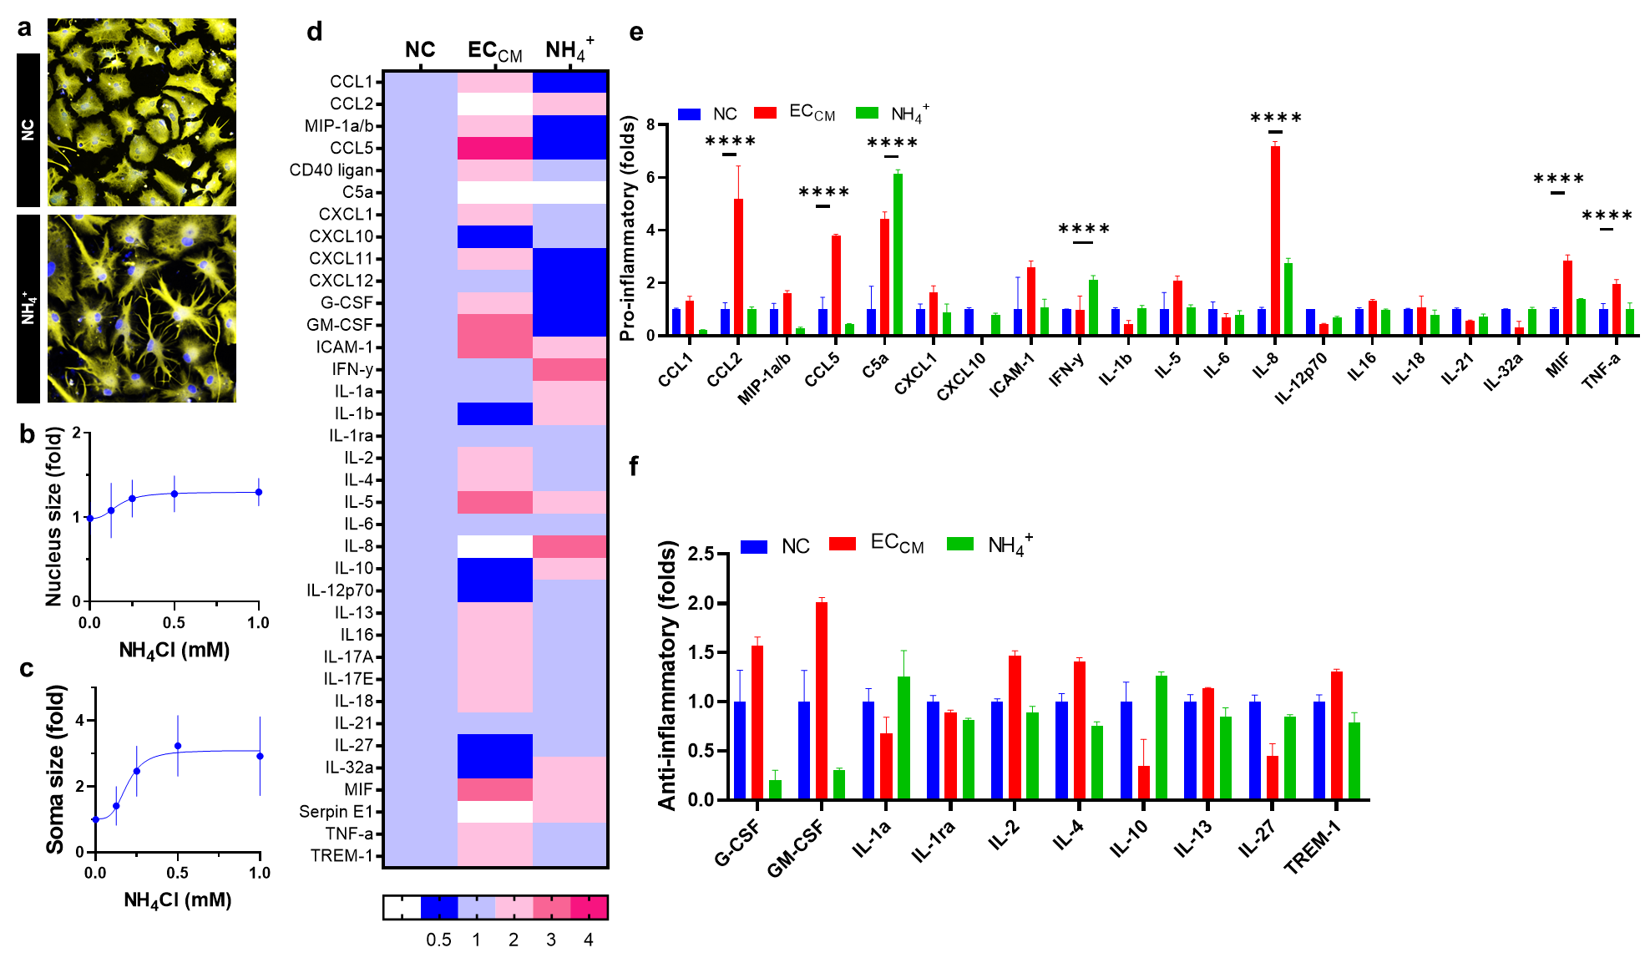
Figure S4. (a) Fluorescent images of single astrocytes exposure to ammonia. Quantification of (b) nucleus size, (c) astrocytes size. (d) Heat map color visualization of human cytokine array release from endothelial cells. (e,f) Quantification of pro-inflammtory factors and anti-inflammtory factors release from brain endothelium.. Sample size, n= 4. Data are represented as Mean ± SD. ns, non-significant difference; ****, p < 0.0001, calculated by one‐way ANOVA with Tukey post‐hoc correction for multiple comparisons. Ammonia NH₄⁺, NH4Cl 0.5 mM.

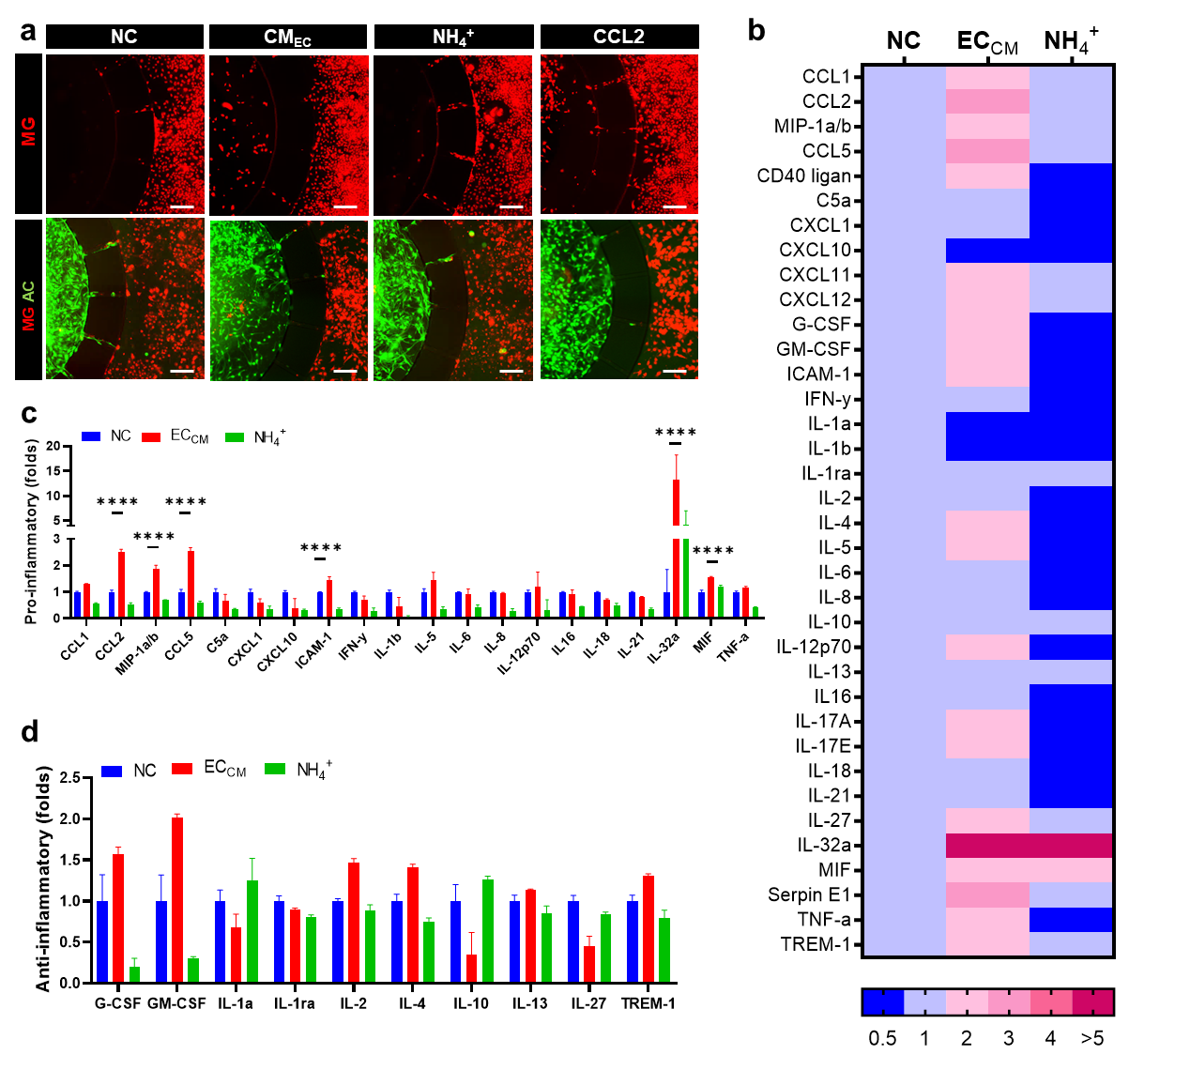

Figure S5. (a) Fluorescent images of astrocytes (green)-microglia (red) interaction in ammonia environment. The mobility of microglia (red) from a.c. in response to conditioned media collected from ammonia-treated endothelium (CM_{EC}) and ammonia (NH₄⁺) into c.c. (b) Heat map color visualization of human cytokine array release from endothelial cells. (cg) Quantification of pro-inflammtory factors and anti-inflammtory factors release from brain endothelium.. Sample size, n= 4. Data are represented as Mean ± SD. ns, non-significant difference; ****, p < 0.0001, calculated by one‐way ANOVA with Tukey post‐hoc correction for multiple comparisons. Ammonia NH₄⁺, NH4Cl 0.5 mM; AC, astrocytes; MG, microglia.

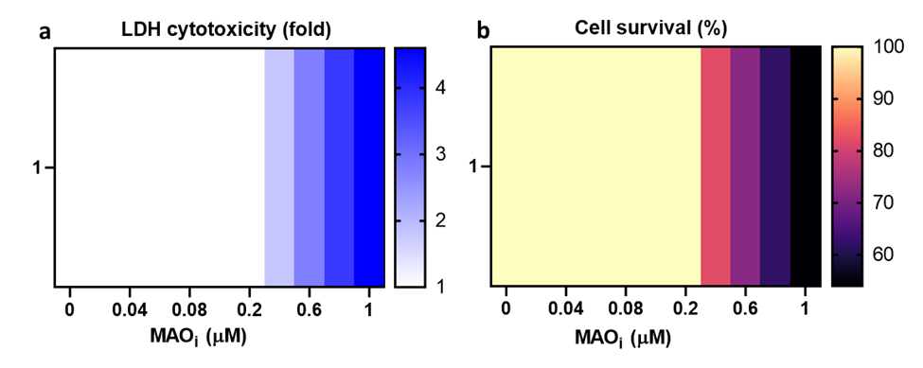

Figure S6. The MAO-A inhibitor toxicity screening in 3D neurons and astrocytes. (a, b) Heat map visualization of LDH cytotoxicity and cell survival in a series of MAO-A inhibitor concentrations (0-1 μM).

Table S1. Key resources tables.
REAGENT or RESOURCE | SOURCE | IDENTIFIER (Cat#)
Chemicals, reagents, media and supplements
9:1 PDMS and Curing reagent | Dowhitech | Sylgard 184 A/B
Glass | MatRek Corporation | P384G-1.5-10872-C
DMEM/F12 | Thermofisher | 11320-033
DMEM/F12 (glutamine free) | Thermofisher | 21331020
B27 Serum free supplement | Thermofisher | 17500-4001
Heparin | Stemcell technologies | 7980
EGF | Sigma Aldrich | E9644-.2MG
FGF-basic, human recombinant | Stemgent | 03-0002
EBM-2 | Lonza | 190860
Prigrow IV media | abmgood | TM004
FBS | Sigma Aldrich | F2442
Penicilin/streptomycin | Sigma Aldrich | P4333
HEPES buffer solution (1M) | Gibco | 15630-106
DPBS | Sigma Aldrich | D8537
PBS 10X | Sigma Aldrich | 11666789001
Accutase | Gibco | A11105-01
Trypsin | Sigma Aldrich | T3924
20% Matrigel | Corning™ | 356235
2 mg/ml p.H 7.5 Collagen I | Corning™ | 354249
1 mg/ml Poly D-lysine | Sigma Aldrich | A-003-M
FITC-dextran  wt 3,000-5000  wt 10,000  wt 40,000  wt 60,000-70,000 | Sigma Aldrich | FD4  SLCD1383  SLCB8958  SLCB8500
OGB-1 | Thermofisher | O6806
Rhod-2 | Abcam | ab142780
H2DCFDA (ROS indicator) | Thermofisher | D399
mitoSOX | Invitrogen | M36008
JC-10 | Sigma Aldrich | MAK159
DAF-FM Diacetate (NO indicator) | Invitrogen | D23844
PI | Thermofisher | R37169
LPS | Invitrogen | 00-4976-93
CCL2 | Invitrogen | RP8648
Clorgyline | Merck | M3778
DAPI | Merck | D9542
Hoechst (DAPI) | Invitrogen | H21486
4% paraformaldehyde solution | 바이오세상 | PC2031-100-00
BSA | Bovogen | BSAS 0.1
Critical commercial assays
PKH26 Red Fluorescent Cell Linker Kit + DILUENT B | Merck | PKH26PCL-1KT
Glutamine/Glutamate kit | Sigma Aldrich | GLN1-1KT
Glutamine/Ammonia kit | Megazyme | K-GLNAM
LDH kit | Merck | 11644793001
H₂O₂ kit | Invitrogen | A22188
Proteome profiler human cytokine array | R&D System | ARY005B
Antibodies
1:100 ZO-1 | Invitrogen | 40-2200
VE-cad | Invitrogen | 36-1900
PECAM | Invitrogen | 48-0319-42
GFAP | Sigma Aldrich | AB5541
APQ-4 | Thermofisher | MA524587
ALDH1L1 | Abcam | AB190298
Tuj1 | Novus Biologicals | NBP1-42568
NeuN | Abcam | Ab177487
MAO-A | Abcam | ab126751
AEP | Novous | #AF2199
pTau Ser202, Thr205 | Invitrogen | MN1020
pTau Thr217 | Invitrogen | PA5-37639
iNOS | Thermofisher | PA1-036
CD86 | Abcam | Ab239075
CD206 | Novus biologicals | NB6001415
LC3b | Cell signaling | 3868
Bassoon | Santa Cruz | sc-58509
Synapsin-1 | Abcam | AB254349
1:500 Anti-mouse  AlexaFluor™ 488  AlexaFluor™ 594  AlexaFluor™ 647 | Abcam | ab150113  ab150116  ab150115
1:500 Anti-rabbit  AlexaFluor™ 488  AlexaFluor™ 594  AlexaFluor™ 647 | Abcam | ab150077  ab150080  ab150079
1:500 Anti-chicken  AlexaFluor™ 647 | Abcam | ab150171
1:500 Anti-goat  AlexaFluor™ 594 | R&D System | NL003
Equipment
96-well absorbance reader | Bio Tek Instrument, Inc | Take3 Micro-Volume Plate
Confocal microscope | Nanoscope Systems Co., Ltd. | K1-Fluo[ABM] RT-SD
Microscope | Nikon Corporation Tokyo, Japan | Eclipse Ti2-E
Oxygen Plasma machine | Plasma Etch benchtop system | PE 50XL with standard accessoties
Experimental models: Cell lines
Immortalized Human Cerebral Microvascular Endothelial Cell Line (hCMEC/D3) | CELLutions Biosystem, Inc. | CLU512
ReN cell VM human neural progenitor cells (NPCs) | MilliporeSigma | SCC008
Immortalized Human Microglia SV40 cells | Applied Biological Materials, Inc. | T0251
Software
Graphpad Prism | GraphPad Software | https://www.graphpad.com/
Fiji (ImageJ) | National Institutes of Health | https://imagej.nih.gov/ij/
Shapr3D | Shapr3D Software | https://www.shapr3d.com/
NIS-elements | NIS-element Nikon Software | https://www.microscope.healthcare.nikon.com/en_EU/products/software/nis-elements
BioRender | BioRender | https://www.biorender.com/

