Appendix 1: Technical details on methodology for model development.

Image Pre-processing
The image sizes and annotated labels were parsed from the XML files generated by the annotation tool. We set aside 15% of the images as validation data for evaluating model performance. To ensure that the images were a uniform size, we first padded the images with black pixels to a square where the width was equal to the height. Then, we resized the image to the shape of a 256 × 256 pixel grid. To improve the robustness of the model, the images were put through a data augmentation pipeline after re-sizing, where we vertically/horizontally flipped the image with probability 0.5, cropped the image (such that it includes all six landmarks) with probability 0.5, and added Gaussian noises with probability 0.5. In the preprocessing pipeline, we scaled the image pixel values to 0-1, and normalized them to assume means of 0.485, 0.456, 0.406, and standard deviations of 0.229, 0.224, 0.225 along the RGB channels. This is in line with the implementation on ResNet.⁴ This standardization scheme provides stability in training and limit distributional shift when pretrained weights are utilized.
Model Architecture and Hyperparameters
We primarily used the ResNet34 implementation from PyTorch.⁹ We started from a pretrained checkpoint on ImageNet² and changed the final linear layer’s output shape to be compatible with our use case (of length 13). We fine-tuned the model over 6000 epochs with a batch size of 64. The optimization process was performed with an Adam optimizer whose learning rate is initialized to be 0.0001. Different hyperparameters were attempted on learning rates and batch size. Other backbones such as DenseNet, and EfficientNet were also attempted.^{5, 14} The training process was carried on a NVIDIA RTX A4000 Graphics Card.
Measurement of HGA-AP and version
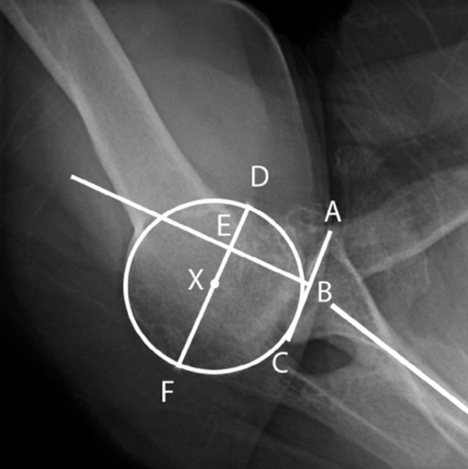
The figure below provides a reference for the lines and points used to calculate HGA-AP and version based on the points the model was trained to identify.

Here we go through the measurement procedure on obtaining the centering parameter ρˆ and the retroversion parameter γˆ, based on the inferred vector of point labels yˆ.
First, we scale the inferred output to match the original size of the input images. Then,
we can effectively infer the interested parameters with the predicted coordinates from the model under Euclidean geometry. As a reminder, the inferred label includes (circle fit to humeral articular surface, spinoglenoid notch, anterior lip of glenoid fossa, posterior lip of glenoid fossa, center of glenoid fossa, base of glenoid vault).
Humero-glenoid alignment in the anteroposterior plane (HGA-AP) can be obtained by using the following process:
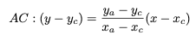
First, we calculated the line equation of AC:

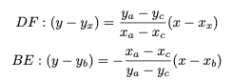
DF is parallel to AC, passing X. BE is perpendicular to AC, passing the midpoint of AC, hence:

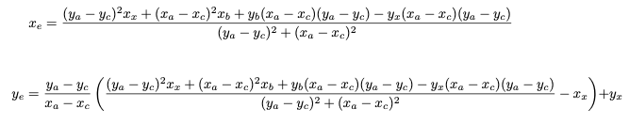
The intersection point of DF and BE is hence given by:

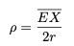
Then, we can calculate

The version (∠PCS) was measured as:
