Supplementary Material

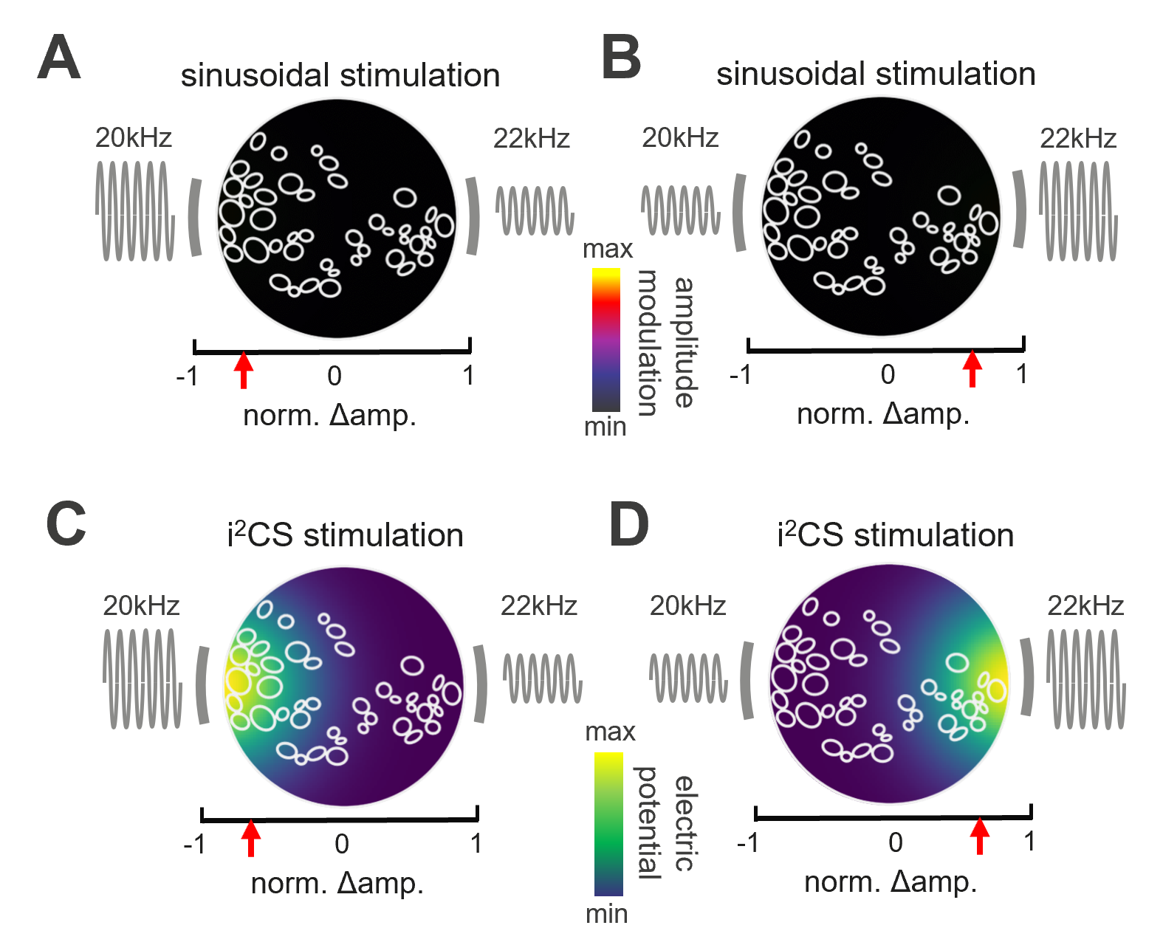

Figure S 1: Interferential profile and electric potential obtained via sinusoidal stimulation and i²CS.

(A) Sketch of the cross-section of the nerve, scaled fascicles from the real experiment are outlined in white. The colormap represents the peak-to-peak amplitude of the beat interference envelope as obtained during sinusoidal stimulation. (B) Same as in A, but for the other steering direction. (C) Same as in A), but the colormap represents the strength of the electric potential created by the 2 sources (grey bars) under a particular current steering ratio (red arrow on x-axis) during i²CS. The carrier frequencies and relative amplitudes are depicted next to the 2 sources. (D) Same as in C but for the other steering direction.

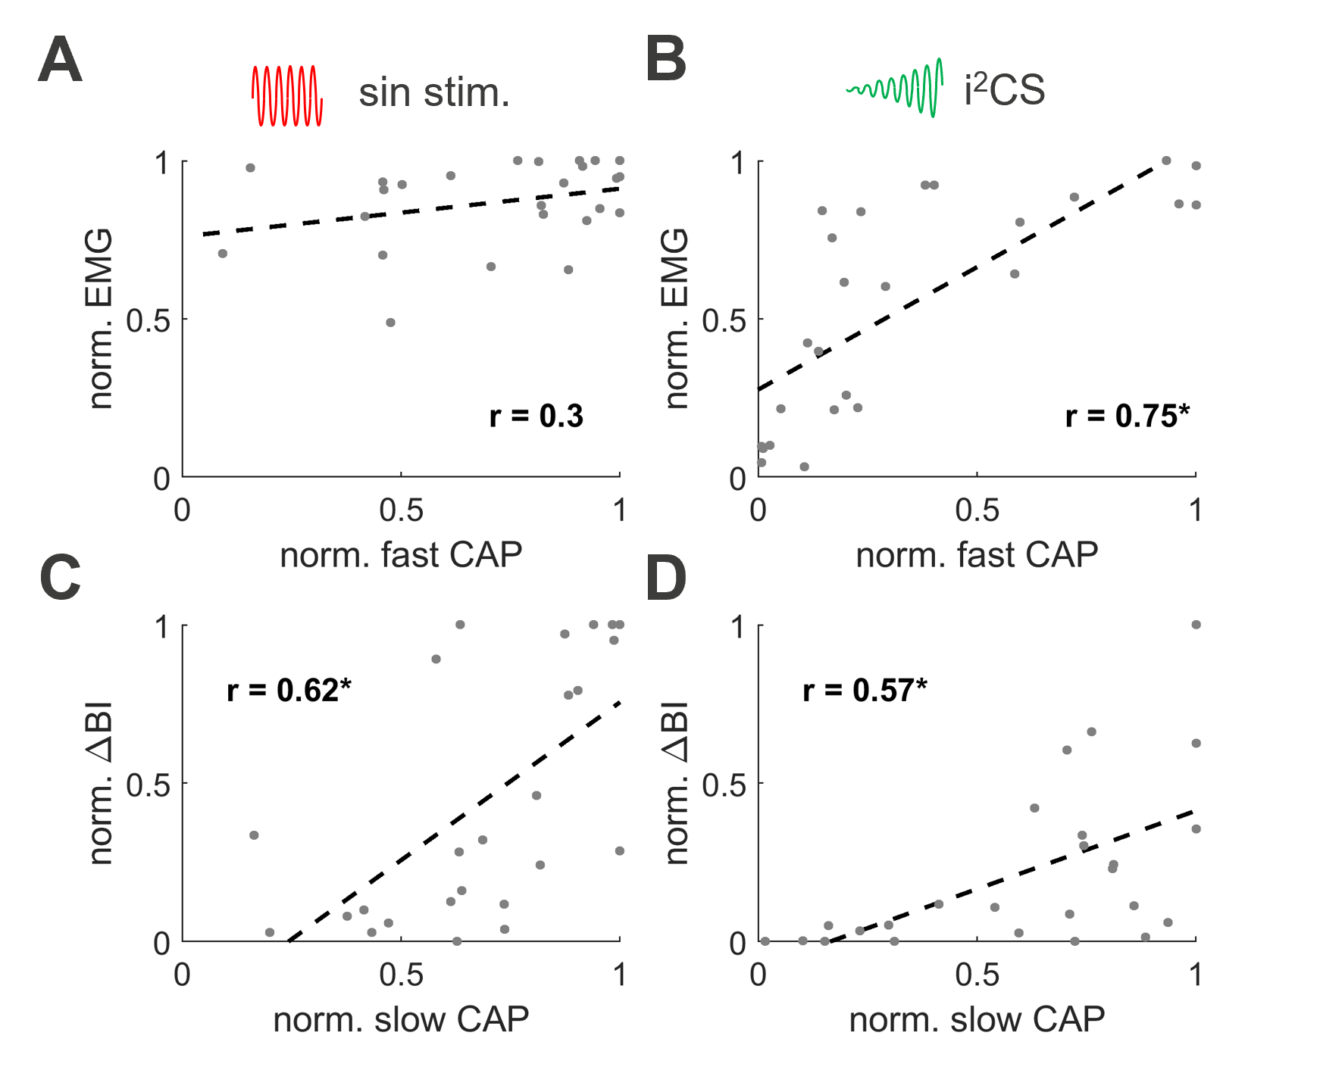

Figure S 2: Correlation of eCAP and physiological responses.

(A) Linear correlation between the fast A-fiber CAP response and the laryngeal EMG response upon sinusoidal stimulation (regression is denoted by dashed line, a star on the r-value denotes a significant correlation at p<0.01). (B) Same as in A, but for i²CS stimulation. (C) Same as in A, but for the linear correlation between the slow A-fiber CAP response and the breathing interval reduction. (D) Same as in C, but for i²CS stimulation. Datapoints in each panel represent responses of 5 different steering ratios from the same 5 animals depicted in Figure 5 L (i.e., n = 25 in total).

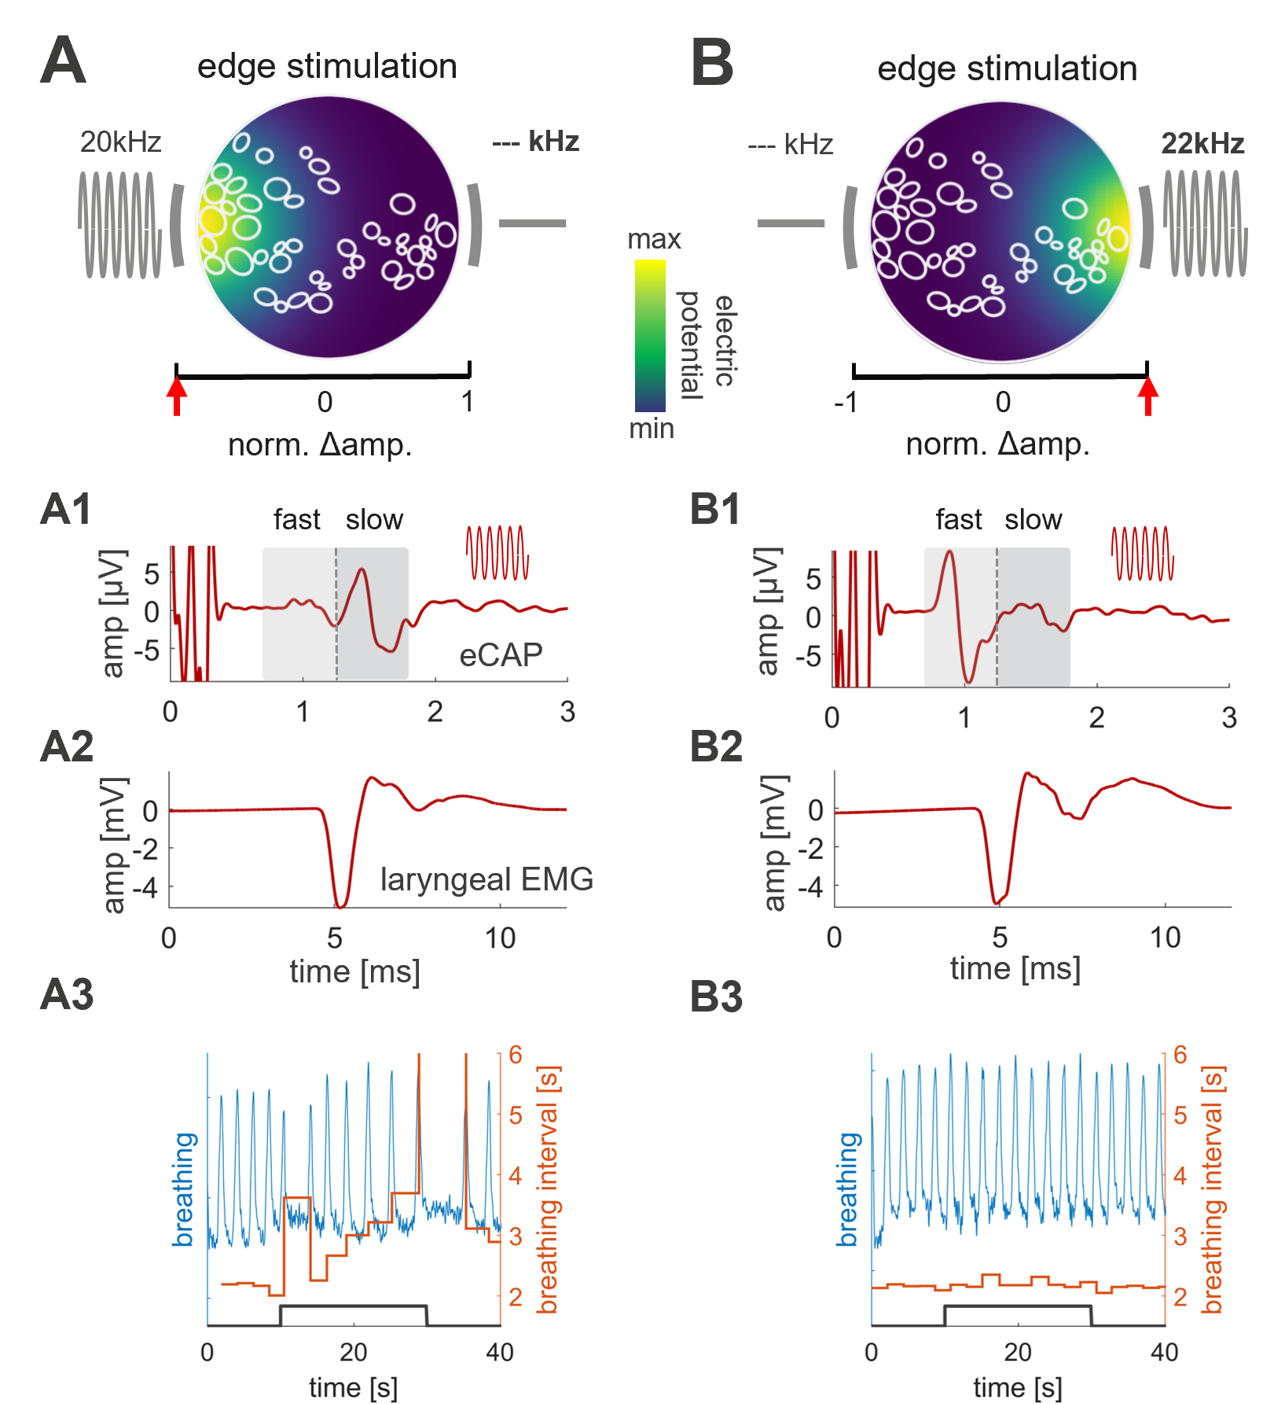

Figure S 3: Pure sinusoidal edge stimulation.

(A) Schematic cross section of a stimulated VN at the level of an implanted MCE; shown are outlines of nerve fascicles and the 2 contacts (grey bars) used for stimulation, with the left source at maximum amplitude (red arrow on left side of x-axis) and the right source inactive; The colormap represents the strength of the electric field. (A1) eCAP response, triggered from the onset of stimulation, with 1.5 mA total current delivered through the left source only; slow and fast eCAP components are identified by the shaded areas corresponding to time windows defined by the average conduction velocities for ‘slow’ and ‘fast’ A-fibers. (A2) Strong laryngeal EMG response to edge stimulation. (A3) Breathing response (blue) and respective change in breathing interval (orange during a 20 sec long train of edge stimulation (black trace). (B) Same as in A, but for the opposite electrode contact (i.e., the right side). The laryngeal EMG response is similar to that for left side stimulation, whereas the breathing response is absent.

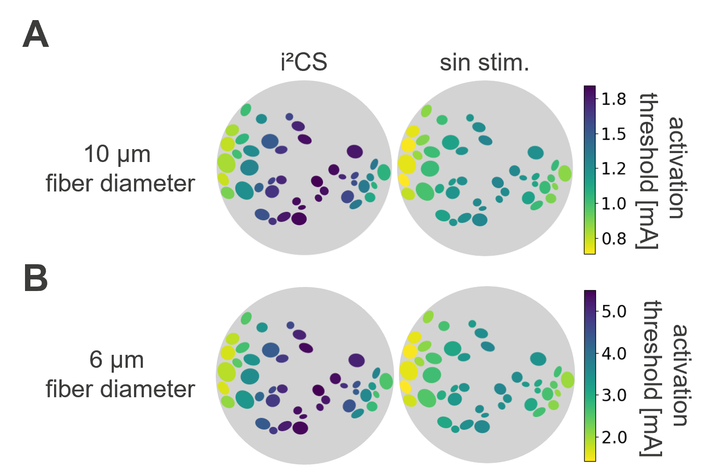

Figure S 4: Activation thresholds for different fiber diameters and stimulation conditions.

(A) Activation threshold for 10 μm fibers for i²CS (left) and sinusoidal stimulation (right) at a steering ratio of 0, showing an increased threshold at the center of maximum AM for i²CS compared to sinusoidal stimulation. (B) Same as in A but for 6 μm fibers. Note the similarity in relative activation thresholds for different fascicles between A and B.

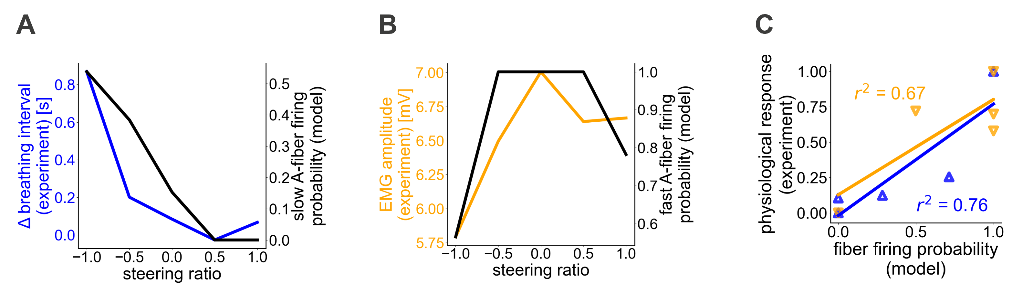

Figure S 5: Anatomically realistic biophysical model of the nerve-electrode interface replicates experimentally measured activation of organ-specific fibers in response to sinusoidal stimulation.

(A) Modeled slow A-fiber responses to sinusoidal stimulation with different steering ratios (having combined total current amplitude of 1.5 mA) and change in breathing rate experimentally measured using sinusoidal stimulation with the same steering ratios. (B) Modeled fast A-fiber responses and laryngeal EMG responses recorded experimentally. (C) Correlation between modeled fiber firing probabilities and normalized physiological responses obtained experimentally in the same animal: fast A-fibers vs. laryngeal EMG (orange), slow A-fiber vs. breathing response (blue).

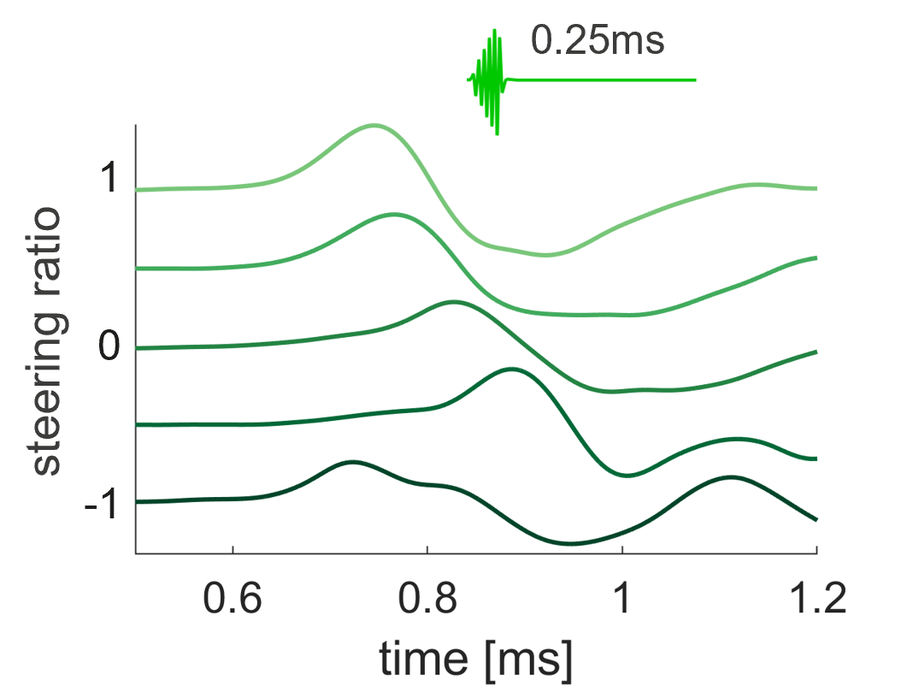

Figure S 6: CAP responses from one example animal to a 0.25 ms long i²CS stimulation at different steering ratios (total amplitude 2 mA).

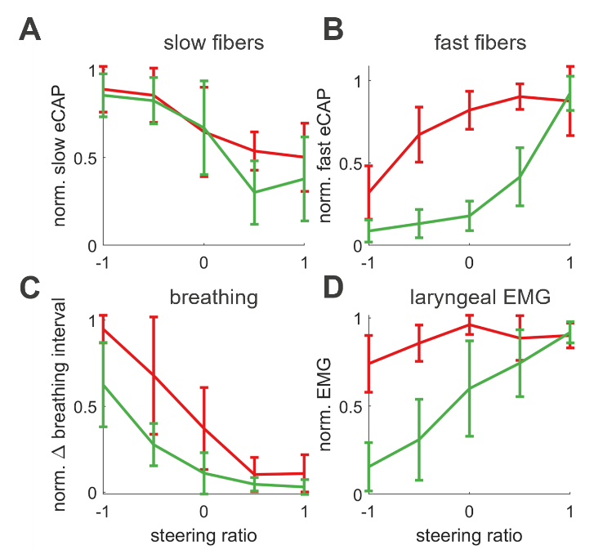

Figure S 7: Normalized eCAP and physiological response across the population indicates a differential effect of steering ratio between i²CS and sinusoidal stimulation.

(A) Normalized slow eCAP responses for sinusoidal and interferential stimulation at different steering ratios. (B) Same as in (A), but for fast eCAPs. (C) Normalized magnitude of the (desired) breathing response (change in breathing interval) at different steering ratios, for interferential and equivalent sinusoidal stimulation. (D) Normalized amplitude of the (undesired) laryngeal EMG at different steering ratios. All data is shown as mean±SD from n = 5 animals.

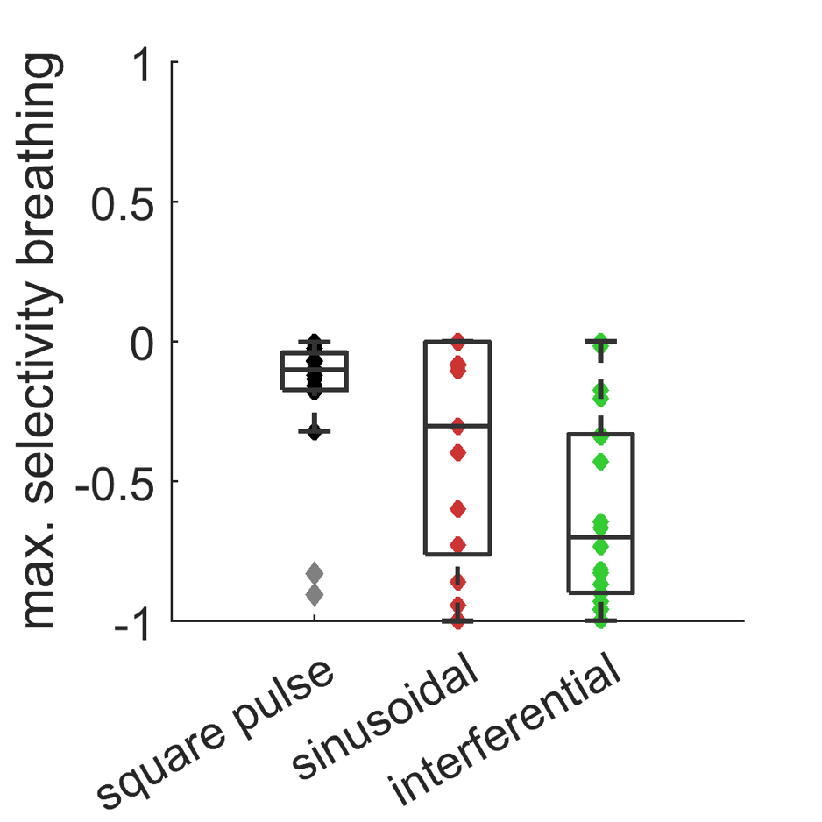

Figure S 8: Comparison of square pulse, sinusoidal and interferential stimulation selectivity.

Selectivity indices (SIs) for pulsed stimulation extracted from functional mapping data reported in (Jayaprakash et al., 2023). The electrode with the largest selectivity value for each stimulation strength was used; only stimulus trains eliciting >20% BI reduction from at least 1 electrode were considered, resulting in 20 observations in 4 animals. Sinusoidal and interferential data were extracted from newly performed experiments (6 animals, 30 datapoints).

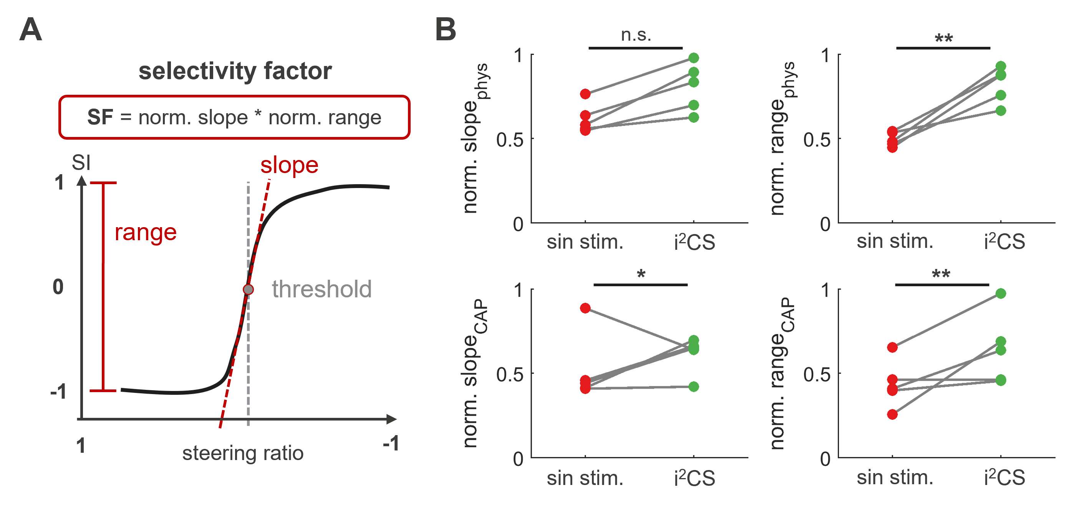

Figure S 9: Calculation of selectivity factor and underlying parameters.

(A) The selectivity factor is calculated from two key parameters of the sigmoidal fit to the data: The slope can be seen as a measure of how sharp the separation between the two readouts is in terms of spatial selectivity and is calculated as the normalized angle between the slope and the x-axis. The range represents a measure of the maximal, relative difference between the two readouts in terms of selectivity and is calculated as the normalized difference between the maximum and the minimum value of the function. Finally, the threshold is the x-axis value where the slope is maximal and provides spatial information about where on the cross-section the shift in selectivity occurs. (B) All values from A plotted separately for all animals used in the comparison. Note that most parameters show significantly higher values for interferential stimulation (*p<0.05 **p<0.01, Wilcoxon rank-sum test).

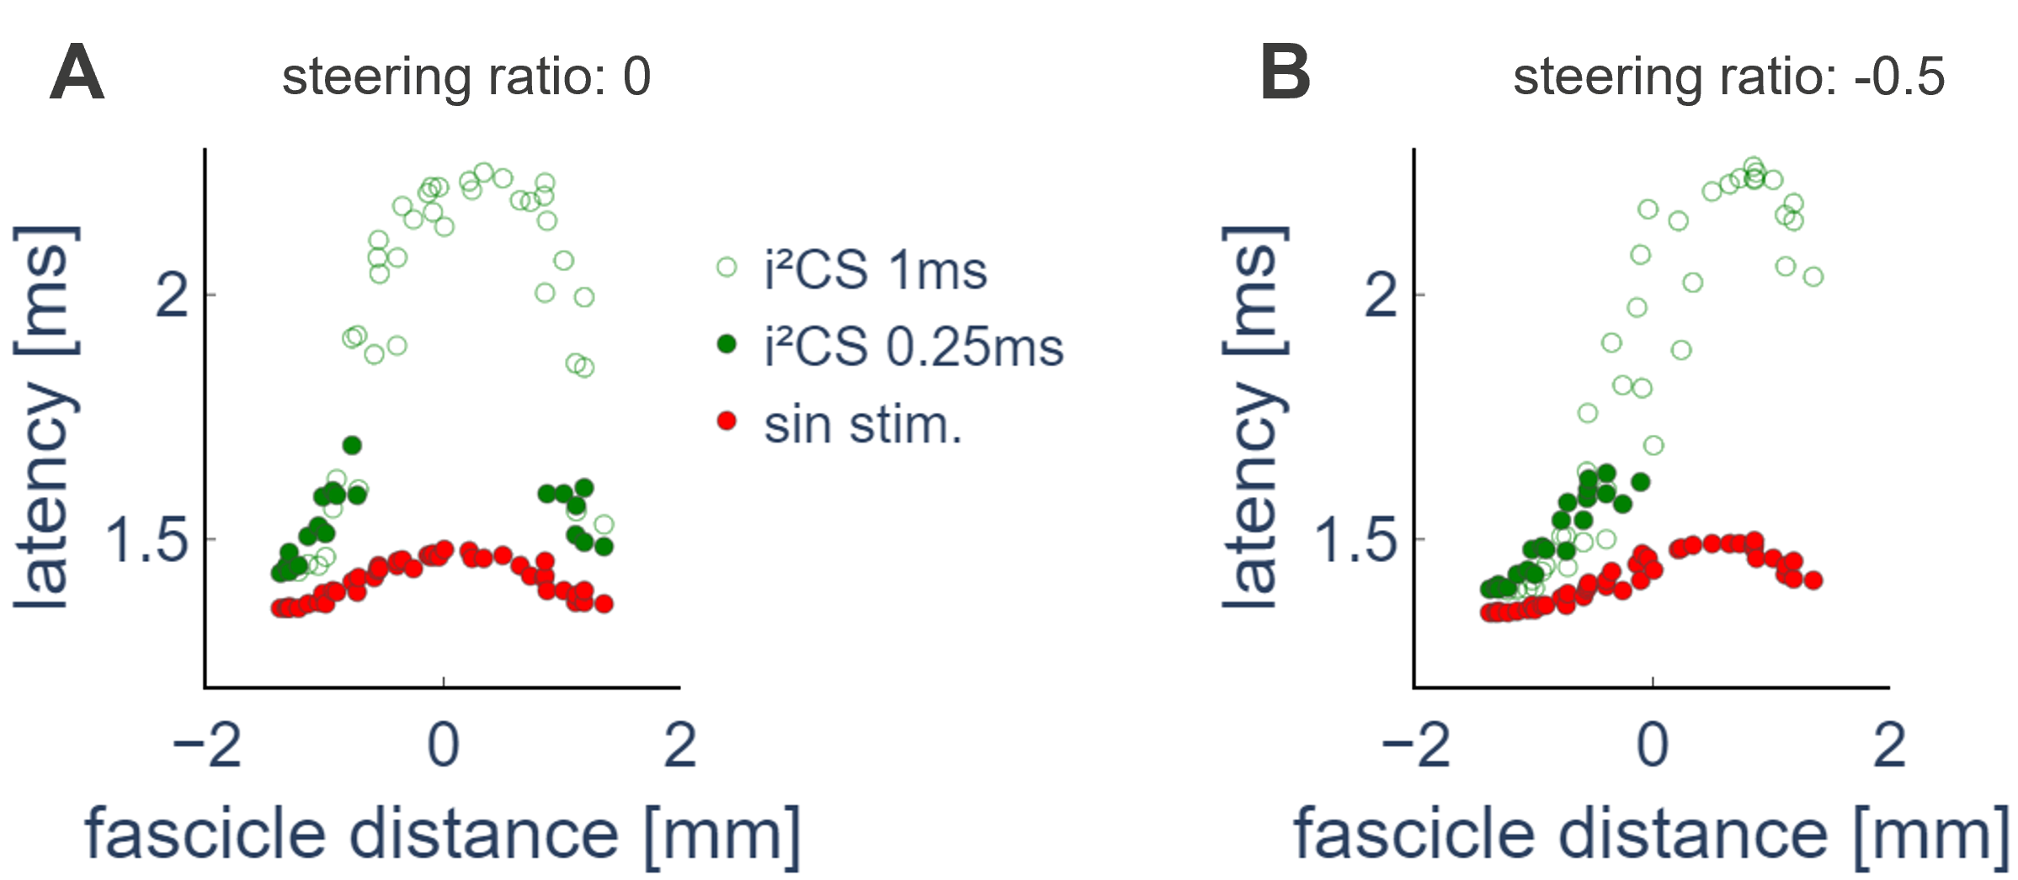

Figure S 10: Spatio-temporal activation pattern within the nerve during sinusoidal stimulation and i²CS with different beat durations.

(A) Time of fiber activation for each A-fiber based on the respective fascicle index resulting from the application of different stimulation waveforms for a current steering in the center of the nerve (steering index = 0) and a total amplitude of 1.5 mA: PS0 (red), i²CS with a beat duration of 0.25 ms (green dots), and i²CS with a beat duration of 1 ms (green empty dots) (B) Same as A), but for a current steering towards the left side of the nerve cross-section (steering index = -0.5).

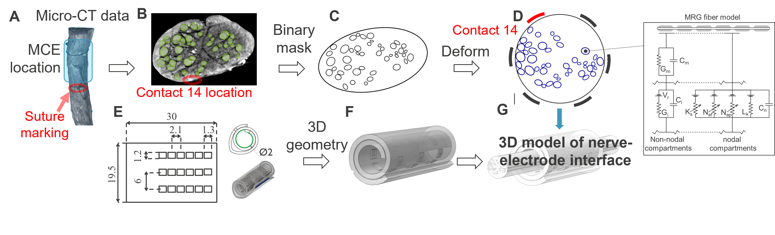

Figure S 11: Pipeline for computational modeling.

(A-D) Histological images obtained from the VN at the cuff location are analyzed to extract the boundaries of the whole nerve and single fascicles. The binary mask containing these boundaries is then deformed to a circular shape to account for the deformation resulting from cuffing the nerve. (E, F) The geometrical parameters of the cuff are used to derive a 3D model of the cuff. (G) The 3D nerve model and cuff geometry are combined to obtain the final 3D model.

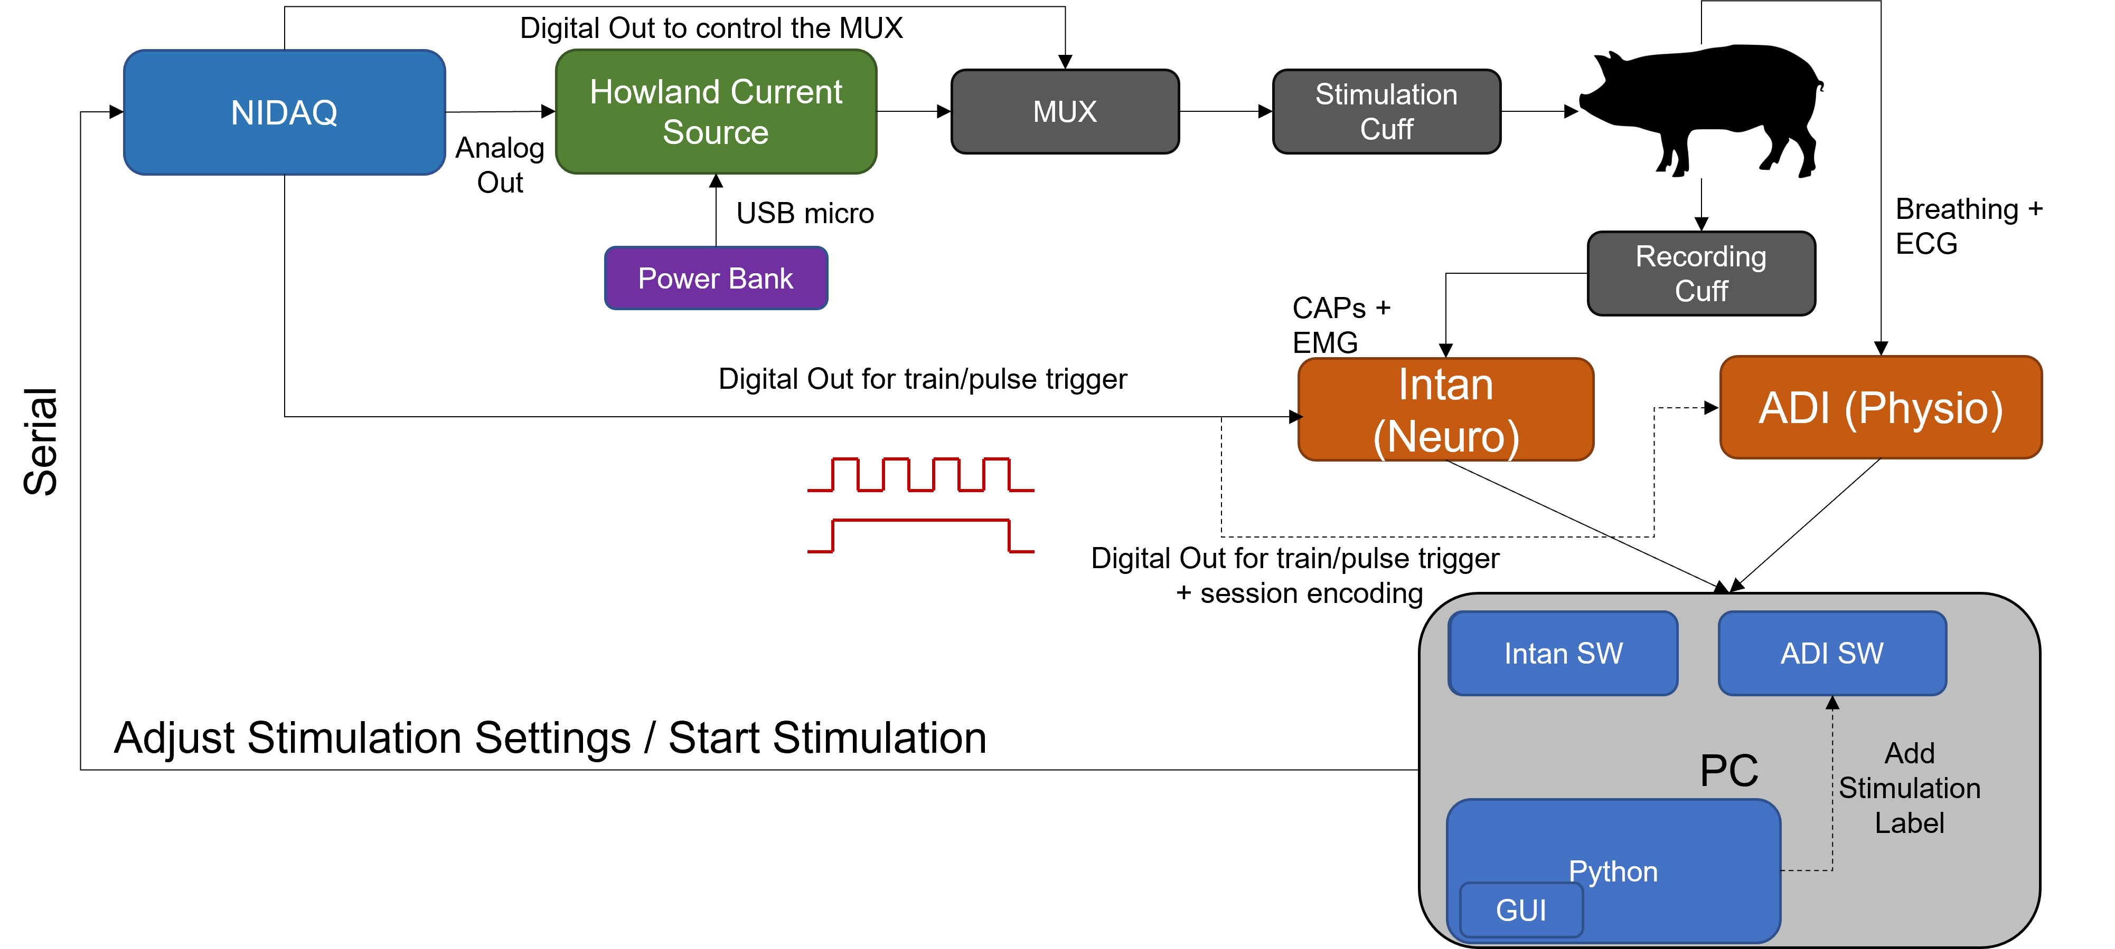

Figure S 12: Diagram of the experimental setup for in-vivo experiments.

The PCIe-6363 DAQ is controlled via a PC to produce the required analog stimulation waveforms and generates additional digital signals used to mark the start and end of each pulse and of the whole stimulation train. The voltage signals are transmitted to the custom Howland current source to convert the signal to current. The current signals are then multiplexed to address specific electrodes on the stimulation cuff. Neural and physiological signals are recorded from the animal and transmitted to the PC.

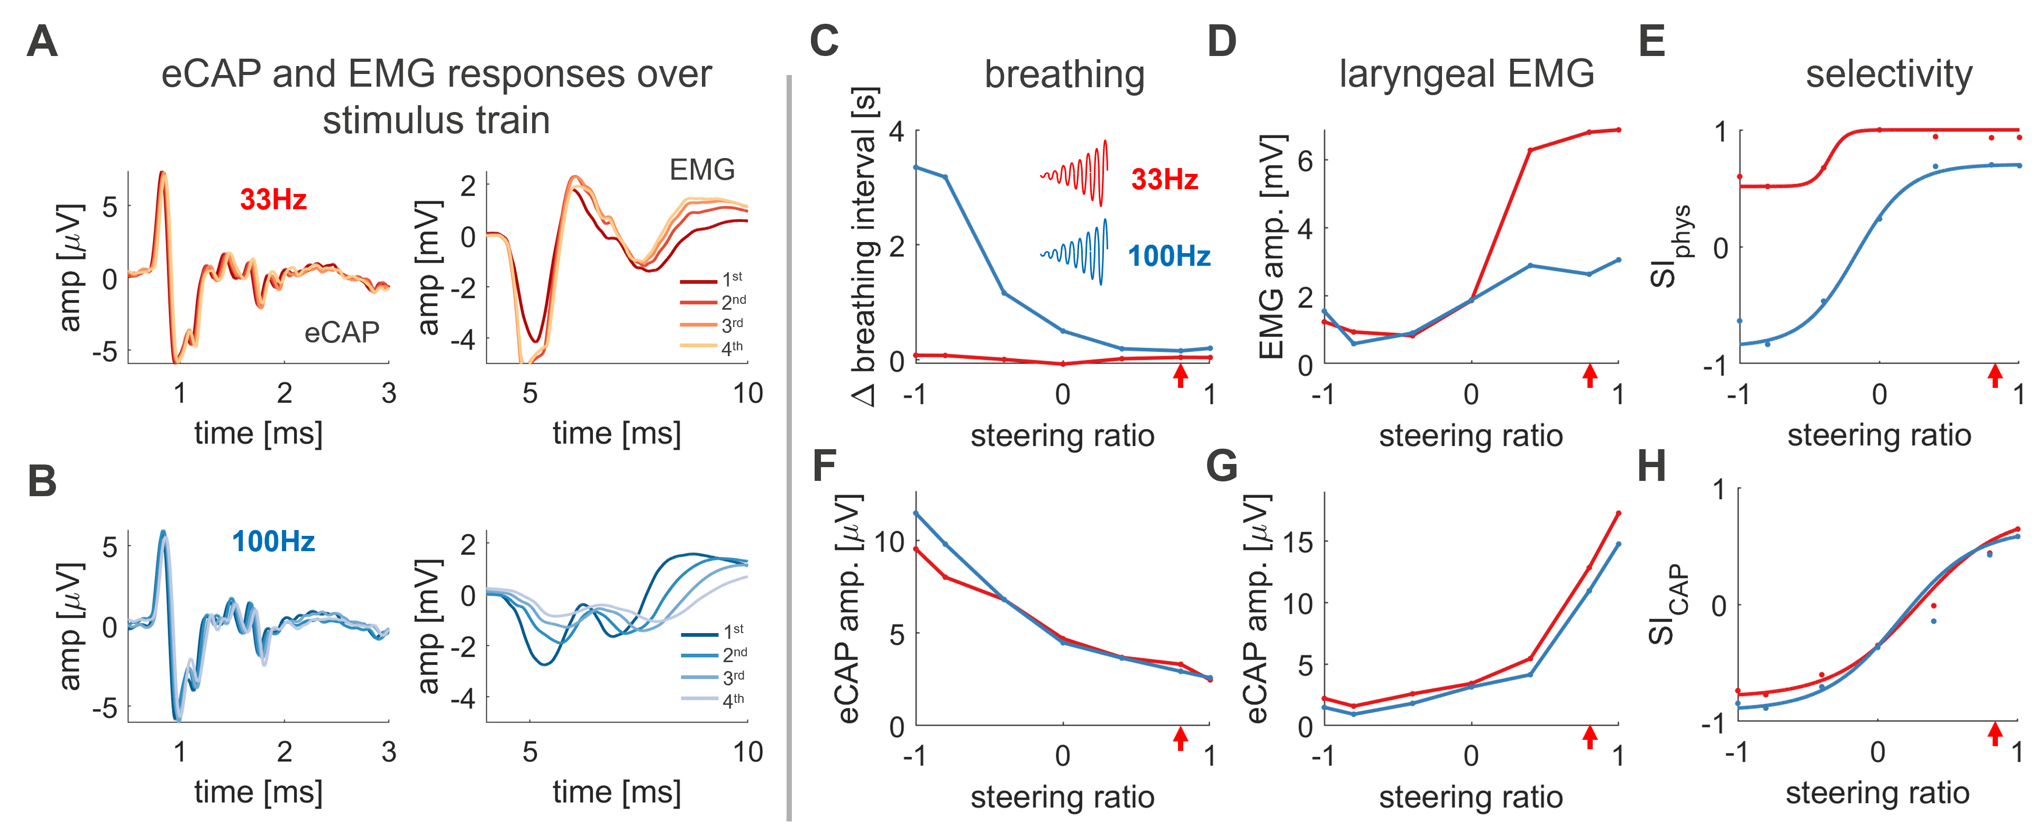

Figure S 13: Effect of repetition frequency on breathing and laryngeal EMG response.
(A) Example average eCAP (left) and EMG (right) responses for the first (darkest trace) to last (lightest trace) quarter of the 20 sec stimulus train to 33 Hz inter-stimulus-interval (ITI) i²CS stimulation at a steering ratio of 0.9. (B) Same as in A, but for 100 Hz ITI. Note the reduced laryngeal EMG response over time while the eCAP response is unaffected. (C) Breathing interval at different steering ratios. Note the much stronger activation of breathing responses at 100 Hz ITI. (D) Average amplitude over the whole stimulus train of the laryngeal EMG response at different steering ratios. (E) Selectivity index as calculated from the physiological responses in C and D, fitted with a sigmoidal function. (F) eCAP amplitude for slow A-fibers at different steering ratios. (G) Same as in F, but for fast A-fibers. (H) Selectivity index as calculated from eCAP amplitudes in F and G, fitted with a sigmoidal function. Red arrows denote the steering ratio of the

