Supplementary file
Anticorrosion properties of ionic liquid functionalized graphene oxide epoxy composite coating on the carbon steel for CCUS environment
Nikhil Rahul Dhongde ª, Sayani Adhikari ª, Prasanna Venkatesh Rajaraman ^{a*}
ª Department of Chemical Engineering, Indian Institute of Technology, Guwahati – 781039, Assam, India
*Corresponding Author; Email: rprasanna@iitg.ac.in

S1: Properties of epoxy and hardener
Bisphenol A diglycidyl ether (epoxy) Properties
Chemical formula | C₂₁H₂₄O₄
Molar mass | 340.419 (g/mol)
density | 1.16 (g/mL at 25 °C (lit.))
Epoxide equivalent weight (EEW) | 172-176
Solid content | 73-77 %

4-4’-diaminodiphenyl sulfone (hardener) Properties
Chemical formula | [4-(NH₂)C₆H₄]₂SO₂
Molar mass | 248.30 (g/mol)
Bulk density | 250‑350 (kg/m³)
Amine value | 230-250 (KOH mg /g)
Solid content | 48-52 %

S2: FESEM image of 1 wt% GO/epoxy coating after treatment with CO₂-NaCl medium
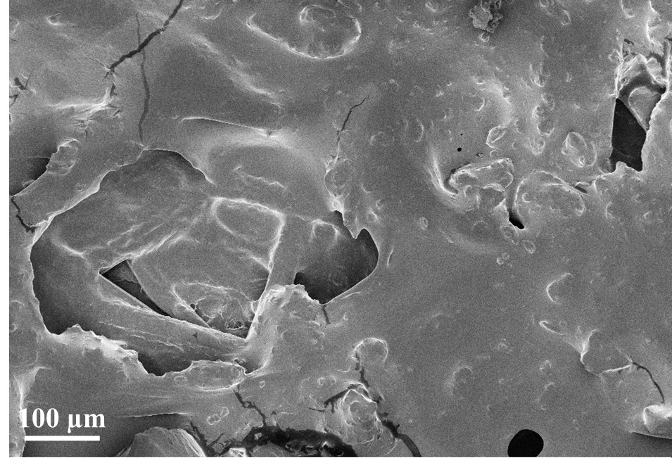
Fig. S1: FESEM image of 1 wt% GO/epoxy coating after treatment with CO₂-NaCl medium

