Table 1: Selected CMIP Six GCMs
SN | GCMs | Horizontal Resolution | Temporal  Resolution | Country | Research Center
1 | ACCESS-CM2 | 1.9° × 1.3° | 1 day | Australia | Australian Community Climate and Earth System Simulator
2 | EC-Earth3-Veg | 0.7° × 0.7° | 1 day | Europe | European Community Earth
3 | MIROC6 | 1.4° × 1.4° | 1 day | Japan | National Institute for Environmental Studies, Japan Agency for Marine-Earth Science and Technology, Atmosphere and Ocean Research Institute, RIKEN Center
4 | MPI-ESM1-2-LR | 1.9° × 1.9° | 1 day | Germany | Max Planck Institute for Meteorology
5 | MRI-ESM2-0 | 1.1° × 1.1° | 1 day | Germany | Meteorological Research Institute
6 | NESM3 |  | 1 day | China | Nuist Earth System Model version 3
7 | NorESM2-LM |  | 1 day | Norway | Norwegian Climate Center
8 | NorESM2-MM | 0.9° × 1.25° | 1 day | Norway | Norwegian Climate Center
9 | EC-Earth3 | 0.7° × 0.7° | 1 day | Europe | European Community Earth
10 | MPI_ESM1-2-HR | 0.9° × 0.9° | 1 day |  | Max Planck Institute for Meteorology

Table 2: Quantile Mapping for the Bias Correction
S No | Quantile Mapping Method for Bias Correction
1 | Distribution-based Quantile Mapping (Only for Precipitation):
1.1 | Bernoulli-Gamma distribution
1.2 | Bernoulli-Weibull distribution
1.3 | Bernoulli-Lognormal distribution
1.4 | Bernoulli-Exponential distribution
2 | Parametric Transformation:
2.1 | Power transfer function
2.2 | Exponential-asymptotic transfer function
2.3 | Linear transfer function
2.4 | Scaling transfer function
3 | Non-Parametric Transformation:
3.1 | Empirical quantiles with linear interpolation
3.2 | Empirical quantiles with tri-cubic interpolation
3.3 | Robust empirical quantiles with linear interpolation
3.4 | Robust empirical quantiles with tri-cubic interpolation
3.5 | Smoothing Spline Quantile Mapping

Table 3: Precipitation Ranking under SSP245
S No | Pre-Monsoon |  |  | Monsoon |  |  | Post-Monsoon |  |  | Winter |  |  | Vulnerability
S No | NF | MF | FF | NF | MF | FF | NF | MF | FF | NF | MF | FF | Vulnerability
1 | < 37 | <43 | <31 | 440-620 | <690 | <740 | <23 | <35 | <39 | <59 | <31 | <28 | Very High
2 | 37-48 | 43-48 | 31-36 | 620-735 | 690-830 | 740-882 | 23-28 | 35-40 | 39-43 | 59-67 | 31-35 | 28-35 | High
3 | 48-57 | 48-53 | 36-42 | 750-835 | 830-953 | 882-998 | 28-34 | 40-44 | 43-47 | 67-73 | 35-39 | 35-38 | Moderate
4 | 57-71 | 53-59 | 42-51 | 835-965 | 953-1097 | 998-1154 | 34-43 | 44-52 | 47-53 | 73-80 | 39-43 | 38-42 | Less
5 | 71> | 59> | 51> | 965> | 1097> | 1154> | 43> | 52> | 53> | 80> | 43> | 42> | Very Less
Table 4: Temperature Ranking under SSP245
S No | Pre-Monsoon |  |  | Monsoon |  |  | Post-Monsoon |  |  | Winter |  |  | Vulnerability
S No | NF | MF | FF | NF | MF | FF | NF | MF | FF | NF | MF | FF | Vulnerability
1 | <26 | <27 | <28 | <28 | <30 | <31 | <24 | <25 | <25 | <19 | <20 | <21 | Very Less
2 | 26-28 | 27-29 | 28-29 | 28-29 | 30-31 | 31-32 | 24-26 | 25-27 | 25-27 | 19-20 | 20-22 | 21-22 | Less
3 | 28-30 | 29-31 | 29-31 | 29-30 | 31-32 | 32-33 | 26-27 | 27-28 | 27-28 | 20-22 | 22-23 | 22-23 | Moderate
4 | 30-32 | 31-33 | 31-34 | 30-32 | 32-34 | 33-35 | 27-29 | 28-30 | 28-30 | 22-23 | 23-25 | 23-25 | High
5 | 32> | 33> | 34> | 32> | 34> | 35> | 29> | 30> | 30> | 23> | 25> | 25> | Very High
Table 5: Precipitation Ranking under SSP585
S No | Pre-Monsoon |  |  | Monsoon |  |  | Post-Monsoon |  |  | Winter |  |  | Vulnerability
S No | NF | MF | FF | NF | MF | FF | NF | MF | FF | NF | MF | FF | Vulnerability
1 | <49 | <67 | <20 | <686 | <753 | <817 | <31 | <16 | <36 | <47 | <38 | <44 | Very High
2 | 49-56 | 67-73 | 20-25 | 686-820 | 753-904 | 817-958 | 31-36 | 16-19 | 36-41 | 47-53 | 38-43 | 44-50 | High
3 | 56-62 | 73-82 | 25-30 | 820-920 | 904-1025 | 958-1066 | 36-41 | 19-22 | 41-46 | 53-58 | 43-47 | 50-55 | Moderate
4 | 62-73 | 82-96 | 30-36 | 920-1064 | 1025-1179 | 1066-1215 | 41-48 | 22-26 | 46-52 | 58-65 | 47-54 | 55-65 | Less
5 | 73> | 96> | 36> | 1064> | 1179> | 1215> | 48> | 26> | 52> | 65> | 54> | 65> | Very Less
Table 6: Temperature Ranking under SSP585
S No | Pre-Monsoon |  |  | Monsoon |  |  | Post-Monsoon |  |  | Winter |  |  | Vulnerability
S No | NF | MF | FF | NF | MF | FF | NF | MF | FF | NF | MF | FF | Vulnerability
1 | <26 | <29 | <28 | <29 | <30 | <32 | <25 | <25 | <27 | <17 | <20 | <22 | Very Less
2 | 26-28 | 29-31 | 28-30 | 29-31 | 30-31 | 32-33 | 25-26 | 25-27 | 27-29 | 17-19 | 20-22 | 22-23 | Less
3 | 28-29 | 31-32 | 30-32 | 31-32 | 31-32 | 33-34 | 26-28 | 27-28 | 29-30 | 19-20 | 22-23 | 23-25 | Moderate
4 | 29-32 | 32-35 | 32-35 | 32-34 | 32-34 | 34-36 | 28-29 | 28-30 | 30-32 | 20-22 | 23-25 | 25-26 | High
5 | 32> | 35> | 35> | 34> | 34> | 36> | 29> | 30> | 32> | 22> | 25> | 26> | Very High

Table 6: Questionnaire Response
Layers | Importance of Layers in % |  |  |  |  |  |  |  | Range % | Priority /  Ranking
Layers | 1 | 2 | 3 | 4 | 5 | 6 | 7 | 8 | Range % | Priority /  Ranking
Precipitation | 100 |  |  |  |  |  |  |  | 100 | 1
Temperature | 20 | 60 | 20 |  |  |  |  |  | 20-60 | 2
Land Use Land Cover |  |  | 40 | 20 | 20 | 20 |  |  | 20-40 | 3
Drainage Density |  |  | 20 | 40 | 20 | 20 |  |  | 20-40 | 4
Soil Type |  |  |  | 60 | 40 |  |  |  | 40-60 | 4
Slope |  |  |  | 20 | 60 | 20 |  |  | 20-60 | 5
Elevation Band | 20 |  | 20 |  | 20 | 40 |  |  | 20-40 | 6
Aspects |  |  | 20 |  | 20 |  | 60 | 20 | 20-60 | 7

Table 7: Comparison Matrix
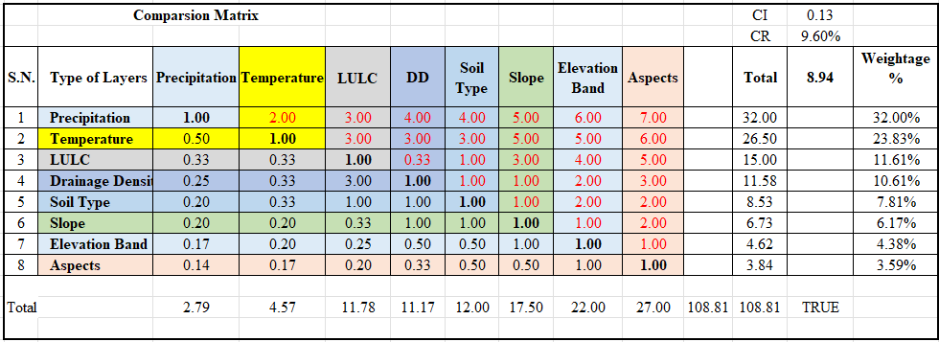
Table 8: Normalized Matrix
