Supplementary Figure Legends:
Figure S1: (A) UMAP plot of cells in tumor and peri-tumor tissues from 2 dCCA samples. (B) UMAP plot showing the expression of KRT19 in all the malignant cells. (C) Bar plot showing the cell type abundance for samples from different groups, as measured by deconvoluted bulk RNA-seq data from TCGA-CHOL cohort. *p < 0.05, **p < 0.01, ***p < 0.001. UMAP, uniform manifold approximation and projection; dCCA, distal cholangiocarcinoma; SC, Schwann cell; SMC, smooth muscle cell.

Figure S2: (A) tSNE plot (top) depicting the distribution of CytoTRACE scores among malignant cells. Dark-green indicates lower scores (low stemness) while dark-red indicates higher scores (high stemness). tSNE plot (bottom) labelling the malignant cells by response phenotype. (B) Correlation analysis of hypoxia with IL2/STAT5, PI3K/AKT/mTOR, KRAS UP (genes upregulated by KRAS activation), and EMT signalings. (C) Heatmap showing functional pathways activated in malignant cells with different CNV levels using GSVA analysis. (D) Kaplan–Meier curves of GSE107943 patients (n = 30) showing the survival rates grouped by the cell abundance in all the epithelial cell clusters. tSNE, t-distributed stochastic neighbor embedding; GSVA, gene set variation analysis; EMT, epithelial-mesenchymal transition; CNV, copy number variation.

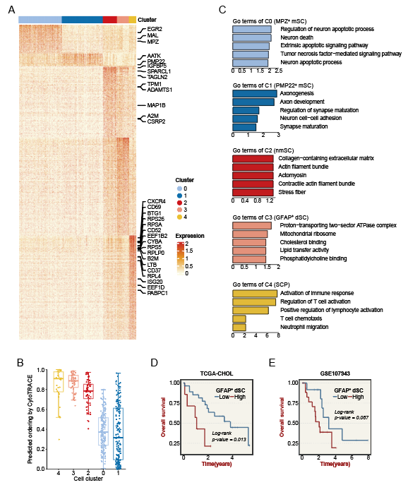
Figure S3: (A) Heatmap showing the scaled expression levels of SC subtype-specific marker genes. (B) CytoTRACE score of each SC subpopulation. (C) GO analysis of DEGs in distinct SC subclusters. (D) Kaplan–Meier curves of TCGA-CHOL patients (n = 36) showing the survival rates grouped by the cell abundance in GFAP+ dSCs. (E) Kaplan–Meier curves of GSE107943 patients (n = 30) showing the survival rates grouped by the cell abundance in GFAP+ dSCs. SC, Schwan cell; GO, gene ontology; DEGs, differentially expressed genes; dSCs, dedifferentiated Schwann cells.

Figure S4: HE staining of patients from the Zhengzhou-dCCA cohort (n = 22). Experiment was repeated once with similar results. Scale bars, 100μm. HE, Hematoxylin eosin; dCCA, distal cholangiocarcinoma.

Figure S5: (A) Cell-cell interaction network of NEAT1⁺ malignant cells, other malignant cells, GFAP⁺ dSCs, and other SCs. The node sizes are proportional to the numbers of each cell type. The width of the edge and numbers represent the relative strength of significant ligand-receptor interactions in two cell types. Subpopulation-specific regulons of each malignant cell subpopulation (B) and SC subpopulation (C) using SCENIC analysis. dSCs, dedifferentiated Schwann cells; SC, Schwann cell.

Figure S6: (A) UMAP plot showing the expression of HMGB1 in all the SC cells. (B) Protein-protein interactions between HMGB1 and 14 dSC marker genes. (C) Representative immunohistochemical staining of HMGB1 protein in the Zhengzhou-dCCA cohort. Experiment was repeated once with similar results. Scale bars, 100μm. (D) Representative IF images of HMGB1 protein levels in ipNF95.6 and RSC96 cells. Experiment was repeated once with similar results. Scale bars, 100μm. (E) Representative IF images of HMGB1 protein levels in CCLP1 and HUCCT1 cells. Experiment was repeated once with similar results. Scale bars, 100μm. *p < 0.05, **p < 0.01, ***p < 0.001. UMAP, uniform manifold approximation and projection; SC, Schwann cell; dSC, dedifferentiated Schwann cell; dCCA, distal cholangiocarcinoma; IF, immunofluorescence.

