Supplementary Material

Short documentation of models

COFFEE
COFFEE is an Integrated Assessment Model (IAM) that uses intertemporal linear programming optimization and is based on a process-based approach. The model aims to depict worldwide energy, industrial, agricultural, and land-use systems. Essentially, COFFEE seeks to determine the most cost-effective arrangement of the depicted systems that meets the requirements and limitations provided as input. The model contains various input data for every geographical area, such as demographic patterns, service needs (like food, transportation, and heating), advancements in technology (like energy technologies costs and efficiency), and the availability of resources (such as biomass, coal, and oil). COFFEE is subject to various simultaneous limitations related to environmental factors (such as carbon budget), institutional factors (like current public policies), and historical factors (used for calibration). Utilizing this information and a set discount rate, COFFEE provides the optimal setup for the worldwide energy, industrial, agricultural, and land-use systems from 2010 to 2100 under the specified circumstances.
COFFEE uses a linear programming optimization technique. It considers various options for energy production, land use, and technology advancement. It then identifies the combination that minimizes overall cost while meeting specified demands and environmental limitations.
The model relies on population and economic growth data, service demands and consumer profile (e.g., diet, mobility), technological development (costs, efficiency, and other market constraints), and resource availability. It also considers environmental constraints and exogenous policy assumptions.
The model operates globally with 18 regional divisions, including major economies like BRICS.
Further information: Model Documentation - COFFEE-TEA - IAMC-Documentation (iamcdocumentation.eu)

GCAM
The Global Change Analysis Model (GCAM) is an integrated assessment model (IAM) that represents the interactions among energy, water, agriculture, land use, the economy, and climate systems globally. In each modelling period, GCAM simulates the competition among various technologies and resources to meet energy and agricultural demands while accounting for environmental constraints and policies. The model aims to evaluate long-term, multi-sectoral, and multi-regional dynamics of global change, projecting from the present up to the year 2100. GCAM has been used to assess the implications of different technological, economic, and policy scenarios on future energy pathways, land-use changes, greenhouse gas emissions, and climate impacts (Calvin et al., 2019).
GCAM utilizes a market-equilibrium approach within a dynamic-recursive simulation. In each five-year time step, the model equilibrates supply and demand across energy, agriculture, and land-use sectors by adjusting prices. Agents (different energy, land, and water sectors) within the model make decisions based on costs, preferences, and policy influences. GCAM accounts for technological change, resource depletion, and environmental feedback, allowing for the evaluation of how different policies or technological advancements could influence global and regional multi-sector systems over time.
GCAM’s primary drivers include exogenous assumptions about population growth, economic development (GDP projections), technological advancements (costs and efficiencies of technologies), resource availability (fossil fuels, renewables, land, water), and policy assumptions (carbon pricing, subsidies, mandates). GCAM also incorporates alternative socio-economic pathways, such as the Shared Socioeconomic Pathways (SSPs), to explore a range of future scenarios based on varying socio-economic conditions (O’Neill et al., 2014).
GCAM operates on a global scale with detailed regional disaggregation. It divides the world into 32 geopolitical regions for energy and economic analysis, 233 water basins, and 384 land-use regions to capture spatial variations in different systems.
More detailed information about GCAM can be found on the official documentation website: https://jgcri.github.io/gcam-doc/
IAMC Wiki: Model Documentation - GCAM - IAMC-Documentation (iamcdocumentation.eu)
Calvin, K., Clarke, L., Edmonds, J., Eom, J., Hejazi, M., et al. (2019). GCAM v5.1: representing the linkages between energy, water, land, climate, and economic systems. Geoscientific Model Development, 12, 677–698. https://doi.org/10.5194/gmd-12-677-2019
O’Neill, B. C., Kriegler, E., Riahi, K., Ebi, K. L., Hallegatte, S., et al. (2014). A new scenario framework for climate change research: the concept of shared socioeconomic pathways. Climatic Change, 122(3), 387–400. https://doi.org/10.1007/s10584-013-0905-2

GEM-E3
GEM-E3 is a large scale multi-sectoral hybrid CGE model designed to evaluate the effects of external shocks on the economy. The model provides a robust framework to capture the complex energy-economy-climate interactions and simulate the impact of climate damages or climate and energy policies on the performance of sectors, sectoral output, prices and bilateral trade, the competitiveness of regions and the welfare of communities. Results have a yearly frequency up to 2030 and 5-year time steps until 2050/2100. The model has a global coverage, with 46 regions, where the G-20 countries, EU27 Member States, and major equipment manufacturing or energy exporting countries are represented individually. All countries are linked through endogenous bilateral trade transactions. The model explicitly represents 68 distinct economic activities, which are interlinked across the production and consumption value chain.
Focus is placed on the representation of the energy system where specialized bottom-up modules of the power generation, buildings and transport sectors have been developed. To this end, the model includes a detailed representation of the power generation system (10 power technologies) and a detailed transport module (private and public transport modes), while different technological options for energy use in buildings and industry are provided. The energy system representation includes an explicit representation of new technologies such as hydrogen, clean fuels, and bioenergy options. The GEM-E3 environment module covers all GHG emissions and a wide range of abatement options, as well as a thoroughly designed carbon market structure (e.g., grandfathering, auctioning, alternative recycling mechanisms). The model has been used extensively by the European Commission, governments and public institutions to assess the macroeconomic, distributional and employment implications of the transition to climate neutrality.
The model is based on advanced applied modelling techniques and has been further extended to allow the representation of semi-endogenous technical progress, endogenous formation of labour skills and human capital and a detailed bottom-up representation of the energy system (in particular transport and power generation), along with non-CO2 emission abatement options and negative emissions technologies. It moves beyond the standard CGE framework as it is dynamic and features involuntary unemployment in the labour market and alternative macroeconomic closures supported by a detailed representation of the financial sector. The model is established on rigorous microeconomic theory, it is empirically estimated (substitution and trade elasticities) and is able to undertake long term analysis as opposed to econometric models that suffer from the Lucas critique. The model can be used both in a comparative and what if analysis frameworks as represents a closed and consistent accounting of resources.
The model is calibrated to a wide range of datasets comprising of IO tables, financial accounting matrices, institutional transactions, energy balances, GHG inventories, bilateral trade matrices, investment matrices and household budget surveys. All countries in the model are linked through endogenous bilateral trade transactions identifying origin and destination. The substitution elasticities of the model are not derived from the general literature but are estimated according to its dimensions and functional forms using the latest available datasets. The model is recursive dynamic through the accumulation of capital via the decision for investments and through the accumulation of knowledge stocks via R&D and human capital development. Model regions are linked through endogenous bilateral trade following the Armington assumption of imperfect substitution across domestic and imported goods . The nested production functions are differentiated by sector and follow a CES structure. For the demand side, the model simulates consumer behaviour and maximizes a Klein-Rubin utility function that results in a Linear Expenditure demand system subject to its disposable income not used for obliged consumption (subsistence minima consumption) and after allowing for the decision on savings. The representative household decides on the allocation of its available for consumption income over different consumption categories (COICOP), distinguishing between durable and non-durable goods. The model has been calibrated to the latest statistics (GTAP 11, IEA, UN, ILO) while Eurostat statistics have been used for the EU.
The key innovations of the model relate to the explicit representation of the financial sector, semi-endogenous dynamics based on R&D induced technical progress and knowledge spillovers, the representation of multiple households , unemployment in the labour market with a representation of five labour skill levels and endogenous formation of labour skills.
The most important results, provided by GEM-E3 are: Full Input-Output tables for each country/region identified in the model, GDP and GDP components, employment by economic activity and by skill and unemployment rates, capital, interest rates and investment by country and sector, private and public consumption, bilateral trade flows, consumption matrices by product and investment matrix by ownership branch, GHG emissions by country, sector and fuel and detailed energy system projections (energy demand by sector and fuel, power generation mix, deployment of transport technologies, energy efficiency improvements).
More details here: https://e3modelling.com/modelling-tools/gem-e3/
IAMC Wiki: Model Documentation - GEM-E3 - IAMC-Documentation (iamcdocumentation.eu)

IMAGE
IMAGE (Integrated Model to Assess the Global Environment) is an integrated assessment modelling framework that simulates the environmental consequences of human activities worldwide. It represents interactions between society, the biosphere and the climate system to assess sustainability issues such as climate change, biodiversity and human well-being. The model can be used to explore the long-term pathways for future environmental and sustainable development problems as well as possible response strategies. It has representations of the energy, agriculture, land use, and climate systems. Typical outputs include projections of energy supply and demand, agricultural production, land use and land cover change, emissions of greenhouse gasses and other pollutants, and demand for water and material resources. The model is calibrated to datasets of energy supply and demand (International Energy Agency) and Agricultural production and land cover (Food and Agricultural Organisation). IMAGE participates in multiple model intercomparison projects covering energy, agriculture, emission scenarios, and sustainable development.
IMAGE is a hybrid systems dynamics model. It employs stylized optimization techniques when meeting climate targets. The model simulates the human and natural environment from 1971 to 2100, with the 1971-2022 period acting as a calibration and spin-up period. The model works on an annual timestep.
Population, economic activity are key exogenous drivers. Assumptions (across the food and energy systems) on technology availability and development, behavioural and lifestyle choices are also inputs. The model can incorporate land protection, energy, and other quantifiable policies.
IMAGE is a global model. Biophysical and land use are represented at a 0.5x0.5 degree grid, while socioeconomic processes are modelled on 26 regions.
For more information, see: https://www.pbl.nl/en/image/home
IAMC Wiki: Model Documentation - IMAGE - IAMC-Documentation (iamcdocumentation.eu)

MESSAGEix-GLOBIOM
IIASA’s Integrated Assessment Model (IAM), MESSAGEix-GLOBIOM, consists of multiple modules. The energy sector model MESSAGE (Model for Energy Supply Strategy Alternatives and their General Environmental Impact) which sits at the core of the IAM, incorporates land-use dynamics through an emulation process, applying inputs from the land-use model GLOBIOM (Global Biosphere Management Model). Through an iterative process, MESSAGE is coupled with a single-sector macro-economic module, MACRO, providing estimates of the macro-economic demand response based on the energy system and service costs derived from MESSAGE. MESSAGEix-GLOBIOM relies on emission data from the air-pollution and GHG model GAINS and uses the simple climate model MAGICC for assessing climate related impacts. MESSAGE has a long history of contributing to major international assessments and scenario studies, such as the IPCC, RCPs, WEC, SSP, GEA and a multitude of European funded research projects.
The model covers all major GHG emission species and major air-pollutants across both the energy and the land-use sectors. Eleven regions provide a global representation, calibrated to historically up until the base-year 2015 using a wide range of private and open-source data. Population and economic drivers and techno-economic assumptions based around the Shared-Socioeconomic Pathway storylines define the scenario space up to 2110 in five-year increments until 2060 and ten-year increments thereafter.
Solution mechanism: Hybrid model (linear program optimization for the energy systems and land-use modules, non-linear program optimization for the macro-economic module) optimizing the energy system so that it can satisfy specified energy demand at the lowest cost over a timeframe from 2020-2100. MESSAGE can be run is run with perfect foresight, while GLOBIOM runs myopically.

Main drivers/exogenous inputs: Population, economic activity are key exogenous drivers of demand, along with assumptions on techno-economic developments.
Regional aggregation: MESSAGE is a global model, differentiating globally between eleven regions. GLOBIOM differentiates globally between 37 regions.
Model documentation: https://docs.messageix.org/projects/global/en/latest/index.html IAMC wiki: Model Documentation - MESSAGE-GLOBIOM - IAMC-Documentation (iamcdocumentation.eu)
V. Krey, et al. MESSAGEix-GLOBIOM Documentation – 2020 release. Technical Report, International Institute for Applied Systems Analysis (IIASA), Laxenburg, Austria, 2020. URL: https://pure.iiasa.ac.at/id/eprint/17115, doi:10.22022/iacc/03-2021.17115.
O. Fricko, et al. The marker quantification of the Shared Socioeconomic Pathway 2: A middle-of-the-road scenario for the 21st century. Global Environmental Change, 42:251–267, 2017. doi:10.1016/j.gloenvcha.2016.06.004.
Petr Havlík, et al. Climate change mitigation through livestock system transitions. Proc. Natl. Acad. Sci. Unit. States Am., 111 (10) (2014), pp. 3709-3714.
Georg Kindermann, et al. Global cost estimates of reducing carbon emissions through avoided deforestation. Proc. Natl. Acad. Sci. Unit. States Am., 105 (30) (2008), pp. 10302-10307.
Sabine Messner, Leo Schrattenholzer. MESSAGE–MACRO: linking an energy supply model with a macroeconomic module and solving it iteratively. Energy, 25 (3) (2000), pp. 267-282.
Markus Amann, et al. Cost-effective control of air quality and greenhouse gases in Europe: Modeling and policy applications. Environmental Modelling & Software, 26(12):1489–1501, 12 2011. doi:10.1016/j.envsoft.2011.07.012.

POLES
The POLES (Prospective Outlook on Long-term Energy Systems) model hosted by the European Commission's Joint Research Centre is a global multi-regional energy-economy partial equilibrium simulation model of the energy sector, with complete modelling from upstream production through to final user demand. It follows a year-by-year recursive modelling, with endogenous international energy prices and lagged adjustments of supply and demand by world region, which allows for describing full development pathways to 2100. The model provides full energy and emission balances for 66 countries or regions worldwide (including an explicit representation of OECD and G20 countries), 14 fuel supply branches (including multiple production pathways for secondary carriers such as power, hydrogen and biofuels) and 15 final demand sectors (with sector-specific end-use modelling for industry, buildings, transport). Following equipment depreciation, choice across fuels or technologies is made with a logit distribution function using total costs and preference factors. CO2 emissions from fossil fuel combustion are derived directly from the projected energy balance. Other emissions from energy and industry are simulated using activity drivers identified in the model and abatement cost curves. Emissions from agriculture and LULUCF are derived from GLOBIOM-G4M lookup tables.
Model documentation: https://dx.doi.org/10.2760/814959
IAMC wiki: Model Documentation - POLES - IAMC-Documentation (iamcdocumentation.eu)
Further information: https://joint-research-centre.ec.europa.eu/poles_en

REMIND
The Regional Model of Investment and Development hosted by PIK is an energy-economy general equilibrium model which links a macro-economic growth model with a bottom-up engineering-based energy system model. It covers twelve world regions, differentiates between various energy carriers and technologies, and represents the dynamics of economic growth and international trade. It is an inter-temporal optimization model, solving for the perfect-foresight equilibrium of the global economy between the years 2005-2150, with flexible time steps. The default time step is 5 years from 2005 (base year) to 2060, then 10-year time-steps out to 2100, followed by 20-year time-steps. The model treats energy as a factor input, with different final energy types contributing to GDP calculations in a nested CES production function, as shown in Figure SI 3.2-3. The model also accounts for crucial drivers of energy system inertia and path dependencies by representing full capacity vintage structure, technological learning of emergent new technologies, as well as adjustment costs for rapidly expanding technologies. The emissions of greenhouse gases (GHGs) and air pollutants are largely represented by source and linked to activities in the energy-economic system. Several energy sector policies are represented explicitly, including energy-sector fuel taxes and consumer subsidies. The model also represents trade in energy resources.
More information about the REMIND-MAgPIE model is available:
Model documentation: https://rse.pik-potsdam.de/doc/remind/2.1.0/ and https://www.pik-potsdam.de/en/institute/departments/transformation-pathways/models/remind
IAMC wiki: Model Documentation - REMIND-MAgPIE - IAMC-Documentation (iamcdocumentation.eu)
GitHub: https://github.com/remindmodel/remind

WITCH
WITCH (World Induced Technical Change Hybrid) is an optimal growth model of the world economy that integrates the sources and consequences of climate change into a unified framework. A climate module links GHG emissions, produced by economic activities, to their accumulation in the atmosphere and the oceans. The effect of these GHG concentrations on global mean temperature is derived. A damage function explicitly accounts for the consequences of temperature increases on the economic system.
Regions interact with each other due to the presence of economic (technology, exhaustible natural resources) and global environmental externalities. In each region, a forward-looking agent maximizes its inter-temporal social welfare function, strategically and simultaneously with other regions. The inter-temporal equilibrium is calculated as an open-loop Nash equilibrium. Alternatively, a cooperative solution can be derived by aggregating the welfare of each region. More precisely, the Nash equilibrium results from a non-cooperative, simultaneous, open membership game with full information. Through the optimization process, regions choose the optimal dynamic path of a set of control variables, namely investments in the main economic variables.
WITCH is a hard-link hybrid model because the energy sector is fully integrated with the rest of the economy, and therefore, investments and the quantity of resources for energy generation are chosen optimally, along with other macroeconomic variables. The model is termed hybrid because the energy sector features a bottom-up characterization. A broad range of different fuels and technologies can be used in energy generation. The energy sector endogenously accounts for technological change, considering the positive externalities stemming from Learning-By-Doing and Learning-By-Researching. Overall, the economy of each region consists of eight sectors: one final good, which can be used for consumption or investments, and seven energy sectors (or technologies): coal, oil, gas, wind & solar, nuclear, electricity, and biofuels.
Model documentation is available at http://doc.witchmodel.org
IAMC Wiki: Model Documentation - WITCH - IAMC-Documentation (iamcdocumentation.eu)

Scenario framework
Table SM1 presents the overview of the scenario framework, with a description of the scenarios, highlighting the incremental changes between them.
Table SM1: Description of scenarios (including action after 2030)
 | Scenario description | Incremental changes between scenarios
Current Policies (CP) | Current policies are defined as currently implemented policies adopted by governments (through legislation) or non-binding targets backed by effective policy instruments. Ambitions and pledges (e.g. NDCs and net-zero pledges) are not considered current policies and are therefore not included in this scenario. After 2030, the ambition levels remain at least constant until 2100. Cut-off for policy inclusion in October 2022, based on the Climate Policy Database (NewClimate Institute, 2022) and the Climate Policy Modelling Protocol (CPMP, 2022).
NDCs | The NDCs scenario builds up on the current policies scenario and assumes the achievement of the NDCs, unconditional and conditional, in 2030. The ambition levels reached in the target year remain at least constant throughout the rest of the century. Further information can be found in the Climate Policy Modelling Protocol (CPMP, 2022) and the Supplementary Material. | In addition to currently implemented policies, countries’ NDC pledges are also taken into account when constructing the emissions pathways.
Long-term strategies (LTS) | The long-term strategies (LTS) scenario builds up on the NDCs scenario, following the NDCs pledges until 2030. After 2030, the scenario assumes the implementation of all announced net-zero targets (countries that do not yet have a net-zero target keep the ambition levels of their NDC). | After 2030, countries that have pledged net-zero emissions reach their goal in their respective net-zero years.
Expanded LTS | The expanded long-term strategies (Expanded LTS) scenario assumes the implementation of all announced net-zero targets and expands the net-zero coverage to all countries. Countries can overachieve their 2030 NDC target (mitigation efforts surpassing the NDC targets already in 2025) if this is cost-effective for reaching the long-term neutrality target. For expanding the net-zero coverage, countries that currently do not have established a net-zero strategy assume a net-zero target year based on the net-zero target year of countries with a similar income level. | Countries can be more ambitious than their NDCs already in 2025, and net-zero emissions targets are assigned to all countries.
Accelerated LTS | The accelerated long-term strategies (Accelerated LTS) scenario builds up on the Expanded LTS scenario, anticipating all targets by 5-10 years. | Countries reach net-zero emissions 5-10 years earlier than in Expanded LTS.

NewClimate Institute (2022). Climate Policy Database. https://doi.org/10.4121/12957986.
Dafnomilis, I. (2024). Climate Policy Modelling Protocol (1.0) [Data set]. Zenodo. https://doi.org/10.5281/zenodo.11657870

Temperature change outcomes from policy pathways
Figure SM1 presents the mean global surface temperature change (50th percentile), relative to pre-industrial levels, for all scenarios, for all models, until 2100. Probabilistic temperature simulations are performed using the MAGICC (Model for the Assessment of Greenhouse Gas Induced Climate Change) model, version 7.5.3, covering all the most important greenhouse gas emissions and short-lived climate forcers (Kikstra et al., 2022).
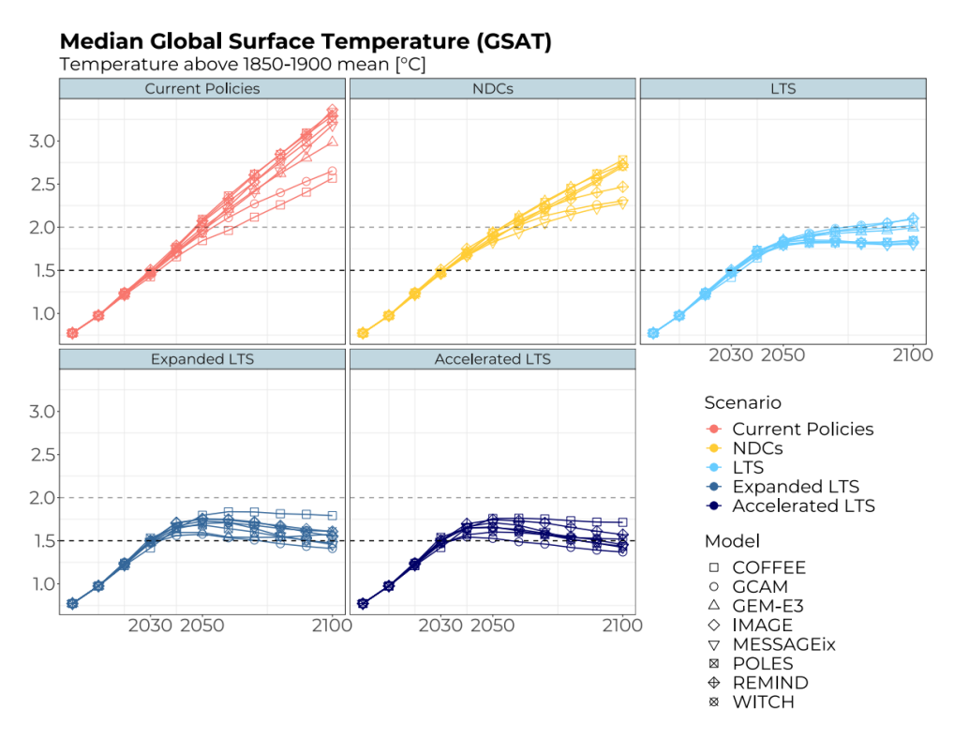
Figure SM1. Temperature change (50th percentile), per scenario, per model

Primary energy
Figure SM2 presents the overview of primary energy at the global level, in 2050 and 2100, for all scenarios, for all models. The figure highlights the changes in the energy system from mid to end of century and provides an insight into model differences.

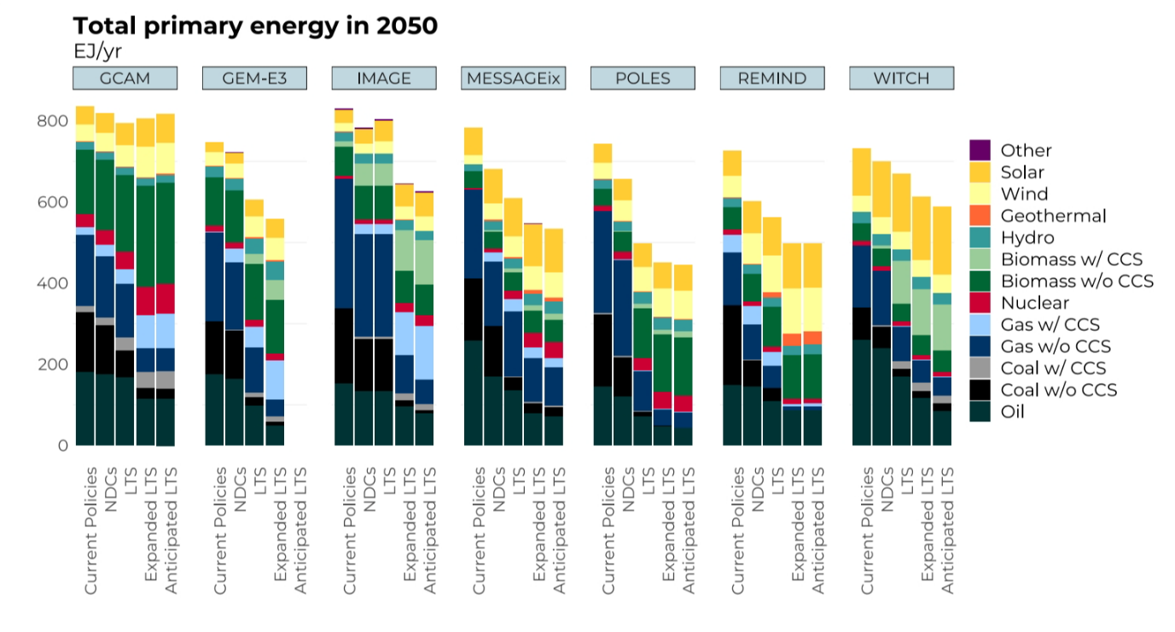
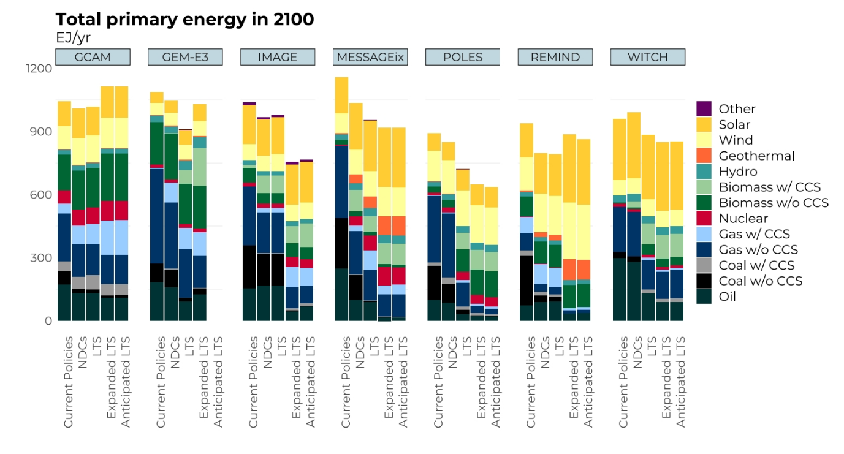
Figure SM2. Global primary energy, per scenario, per model: a) in 2050; b) in 2100
The role of nuclear energy (in terms of primary energy) is depicted in Figure SM3. Both scenario and model preferences determine the role of nuclear in the energy mix. CP and NDCs show lower deployment of nuclear energy, while the more stringent climate policy becomes (Expanded and Accelerated LTS scenarios), the larger deployment of nuclear, especially in 2100. The outcomes are highly model-driven, with GEM-E3, REMIND and WITCH on the lower band for nuclear deployment, regardless of the scenario and timeframe, while GCAM and MESSAGEix figure on the upper band, especially for the LTS scenarios, and mid to end of century.

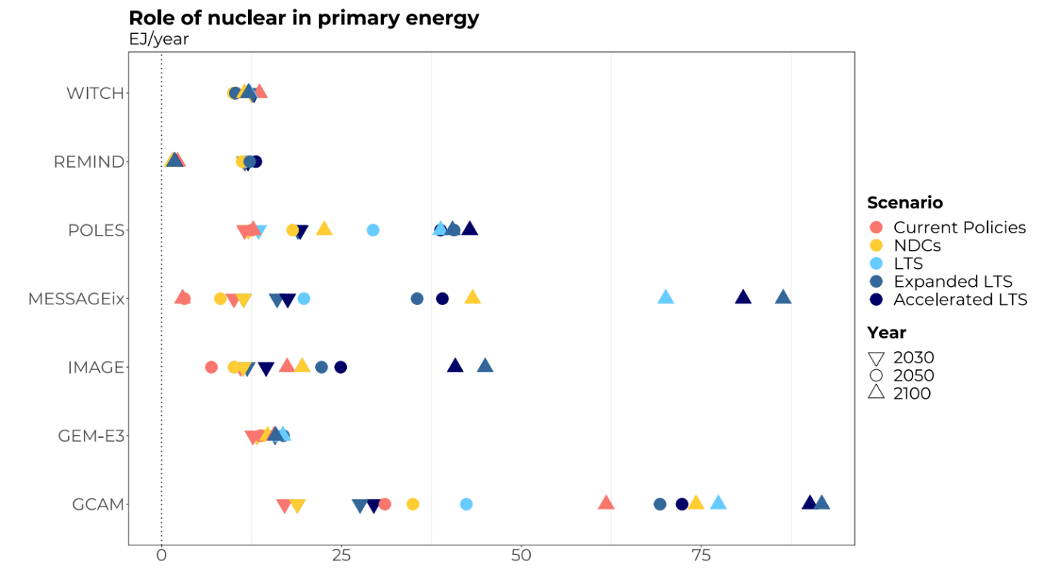
Figure SM3. Role of nuclear in primary energy (in EJ/year), per scenario, per model, overtime (2020, 2030, 2050 and 2100)

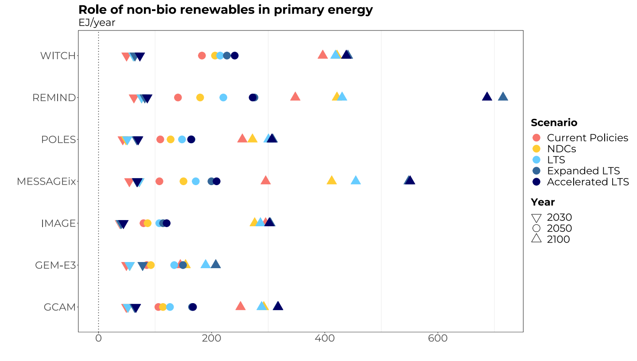
Figure SM4. Role of non-bio renewables in primary energy (in EJ/year), per scenario, per model, overtime (2020, 2030, 2050 and 2100)

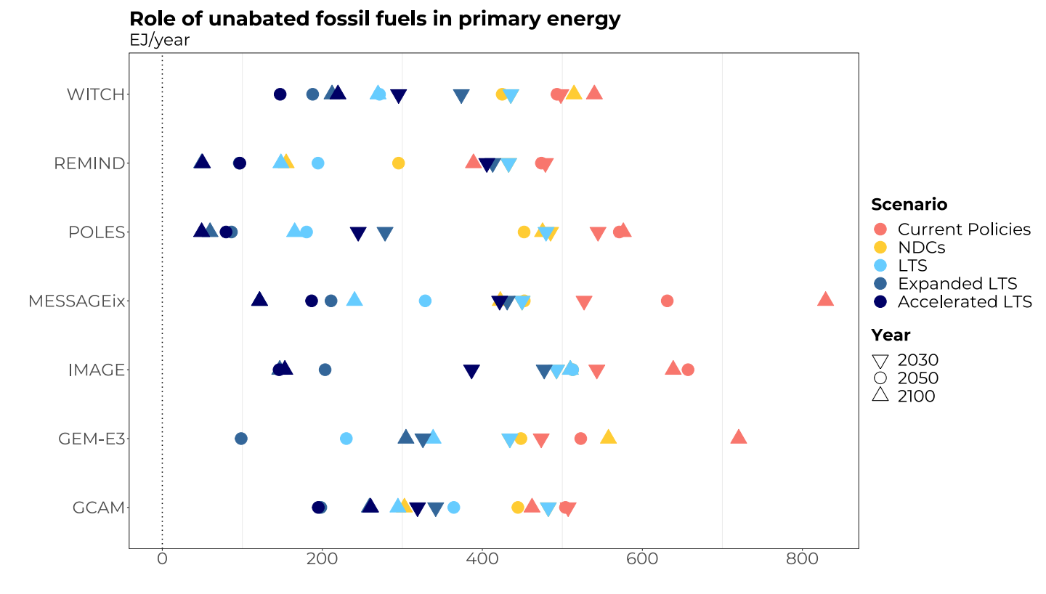
Figure SM5. Role of unabated fossil fuels in primary energy (in EJ/year), per scenario, per model, overtime (2020, 2030, 2050 and 2100)

Regional pathways

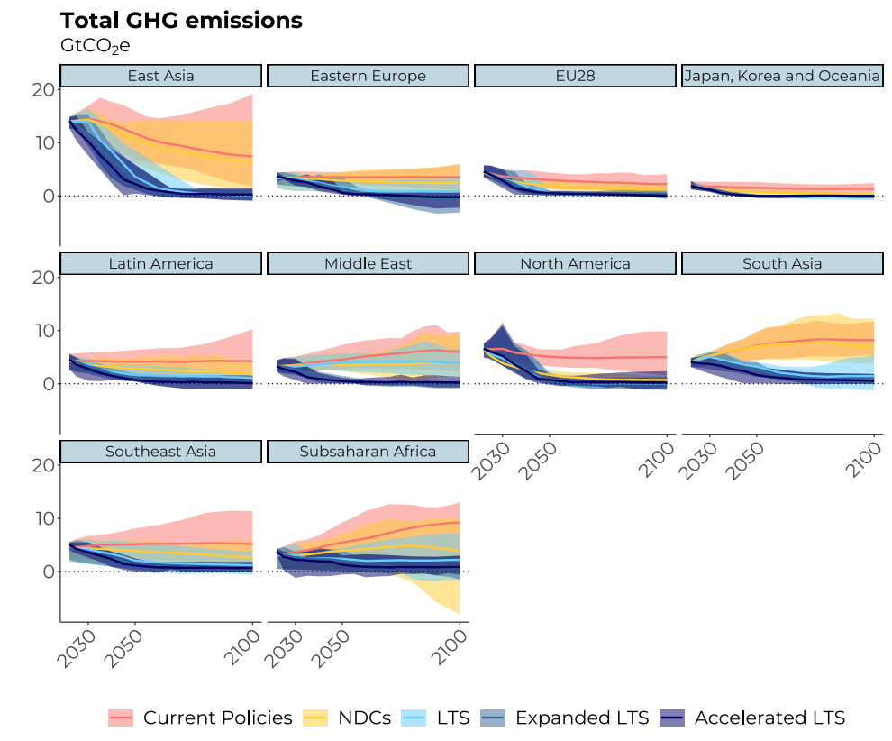

Figure SM6. Regional emission pathways, per scenario, showing model range (shaded area) and model mean (lines)

Modelling protocol
Note: for the scientific paper, the scenarios were renamed as follows i) Glasgow = LTS; ii) Glasgow+ = Expanded LTS; and Glasgow++ = Accelerated LTS.
ENGAGE draft modelling protocol for Task 4.5 – Consistency of mid-century strategies and policies with the overall objectives of the Paris Agreement and identification of potential for strengthening current policies

26th October 2022

Glasgow++

1. Introduction
This protocol provides the scenario framework for the national and global-level model runs under Task 4.5. This task aims at exploring the consistency of mid-century strategies and policies with the overall objectives of the Paris Agreement. The methodological approach includes model runs from both national and global teams. The protocol integrates national and global pathways into a coherent set of low-carbon mid-century strategies, assessing national mid-century strategies and their consistency with global pathways to 1.5/2°C warming levels and identifying the most effective policies in different countries and sectors.
The exercise looks specifically into the new net-zero targets proposed by many countries. The questions are focused on 1) how to achieve these targets, 2) how effective are current targets, and 3) how can net-zero targets be strengthened to achieve the Paris goals.
For this exercise, the Current Policies and NDC scenarios will be updated. Additionally, three main scenarios are proposed: (i) the Glasgow scenario, which assumes the full implementation of the NDCs and the announced net-zero pledges from COP26; (ii) the Glasgow+ scenario, which expands the net-zero pledges from COP26 to all countries; and (iii) the 1.5/2°C warming global pathways that are obtained from previous tasks developed in the ENGAGE project. A fourth scenario is also proposed, it is based on the outcomes from the previous scenarios. It is the Glasgow++ scenario, aiming at filling the gap between the mid-century strategies (as depicted by the Glasgow+ scenario) and the 1.5°C and 2°C global warming scenarios for each region of interest.
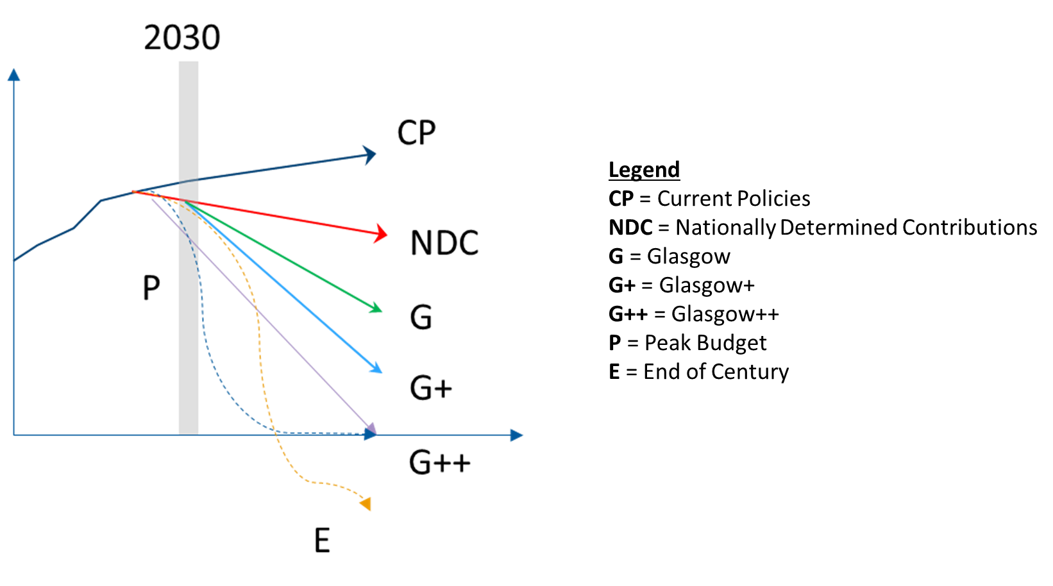
Figure SM6 - Illustrative concept of the scenario framework

The key expected outputs will inform long-term strategies based on up-to-date insights on the strengthening of NDCs and the outcomes of COP26. The final set of scenarios developed in this task will feed into Milestone 9 - “Final set of national decarbonization pathways based on NDCs and mid-century strategies”, due by December 2022 (M40). This scenario exercise will feed into Deliverable 4.5 - “Report on consistency between national and global decarbonization pathways considering sectoral and technology aspects”, due by June 2023 (M46).

2. Scenario framework

General specifications
- 1.5/2ºC: Climate action starts in 2025 and expands to 2050/2100 to inform mid-century strategies
- Population and GDP projections follow the SSP2-type scenarios

1.5°/2°C scenarios
For global models, the full-century 1.5ºC/2ºC global scenarios should follow the budgets below:
- 2ºC: CO₂ emissions budget of 1,000 GtCO₂ from 2020 onwards
- 1.5ºC: CO₂ emissions budget of 700 GtCO₂ from 2020 onwards
Models that cannot achieve these budgets should aim for the lowest budgets feasible.
For national models, the scenario will be the full-century 1.5ºC, following the carbon budgets as presented in Table 1. Additionally, there is the option to run a full-century 2ºC scenario. The carbon budgets are calculated based on recent results from the IMAGE model. A model that cannot achieve these budgets should aim for the lowest budgets feasible.

Table SM2: National CO₂ budgets for 2020-2050 period
National Teams | CO₂ Budget 2020-2050 in GtCO₂
National Teams | full century 1.5°C | full century 1.5°C (excl. LULUCF) | full century 2°C | full century 2°C (excl. LULUCF)
Brazil | 9.6 | 2.3 | 14.2 | 8.7
China | 155.5 | 160.7 | 232.7 | 237.6
India | 34.0 | 32.3 | 58.7 | 56.4
Indonesia | 9.4 | -0.6 | 20.6 | 10.9
Japan | 11.0 | 11.9 | 17.6 | 18.5
Mexico | 5.5 | 5.4 | 9.4 | 8.7
South Korea | 4.1 | 4.5 | 11.2 | 11.6
Thailand | 6.9 | 4.9 | 10.2 | 8.8
Vietnam | 4.8 | 3.4 | 7.2 | 5.7

Current Policies
Current Policies are defined as currently implemented policies adopted by governments (through legislation) or non-binding targets backed by effective policy instruments and planned policies in the pipeline to be adopted. Ambitions and pledges are not included.
The Current Policies scenarios describe energy, climate and economic projections for the period until 2030. Modeling teams will update the Current Policies scenario based on the latest policies update, as listed in the enclosed spreadsheet which updates the climate policies until October 2022. After 2030, the ambition levels should remain at least constant throughout the rest of the time frame (2050/2100). This is implemented by extrapolating the “equivalent” carbon price in 2030, using the GDP growth rate of regions from 2030 to 2050/2100. This extrapolation approach follows the method undertaken in Task 3.1 (global models) and Task 4.1 (national models).

NDC-2030+
NDCs scenario aims to represent the goals of each country or region defined in their NDCs. All modeling teams must update the NDC scenario when applicable. Table 2 provides updates for unconditional NDCs for some selected countries. If conditional NDCs have changed they must be updated as well. In case some country of interest is missing, the unconditional NDC update can be found at https://themasites.pbl.nl/o/climate-ndc-policies-tool/#ndc. If a country has no update, the original NDC target must be followed.
The ambition levels reached in the target year should remain at least constant throughout the rest of the century following the recommendations described in the Current Policies section.

Table SM3: Unconditional NDC updates and conditional NDC highlighted in bold cases for selected countries/regions.
European Union (EU-27) | Greenhouse gas emission target for 2030 of at least 55% below 1990 levels.
United Kingdom | Reduce GHG emissions by at least 68% from 1990 levels.
Ukraine | Greenhouse gas emissions 65% below 1990 levels in 2030.
Australia | The unconditional NDC is based on a reduction in emissions of 27% by 2030 (average of the range 26% to 28%).
Brazil | Reduce greenhouse gas emissions by 37%, below 2005 levels, by 2025 (50% below 2005 by 2030).
Canada | Greenhouse gas emission reduction target of at least 40% to 45% below 2005 levels by 2030.
Japan | Reduce greenhouse gas emissions to 46% below 2013 levels, by 2030.
New Zealand | 50% of GHG emissions below 2005 level.
South Korea | Reduce emissions to 40% below 2018 levels, by 2030.
Kazakhstan | 25% of GHG emissions below 1990 (conditional).
Argentina | Net emissions cap at 359 MtCO₂eq in 2030 (unconditional).
China | To achieve the peaking of CO₂ emissions before 2030.  Reduction in CO₂ emissions intensity (emissions per unit of GDP) over 65% by 2030, compared to 2005 levels. Increase in the share of non-fossil fuel in primary energy to around 25% by 2030. New renewable wind and solar installed capacity target of 1,200 GW by 2030. Increase in forest stock volume by 6 billion m3 by 2030, relative to 2005 levels.
India | 33-35% of CO₂ emission intensity of GDP below 2005 level
Indonesia | 29% of GHG emissions below BAU (equals a 40% increase above 2016 level by 2030)
Russia | Limit 2030 emissions to 70% of 1990 level
South Africa | By 2025 and 2030, emissions will be in a range between 398 and 510 Mt CO₂e, and between 350 and 420 Mt CO₂e, respectively.
USA | Reduce greenhouse gas emissions to between 50% and 52% below 2005 levels, by 2030

Glasgow scenario
The Glasgow scenario will consider the NDC pledges and the mid-century strategy pledges (net-zero) announced at COP26 in Glasgow. Many countries have defined a net-zero pledge that determines the target year in which emissions must be net-zero. They have also indicated if the net-zero pledge refers to carbon dioxide (CO₂) or greenhouse gas (GHGs) emissions.
In order to avoid comparisons that deal with different goals, all runs in the Glasgow scenarios will consider a net-zero CO₂ pledge. Therefore, all countries with net-zero GHG pledges will have a theoretical CO₂ target advanced by 10 years. This value is based on the work developed by van Soest et al. (2021) and preliminary results from the Brazilian Land Use and Energy Systems (BLUES) model, which indicated this typical time-lag between GHG and CO₂ net-zero targets.
National modeling teams should consider the net-zero target year regarding their modeling time frame (e.g., if the model’s time frame goes up to 2050 and the net-zero target year is 2070, consider expanding to 2070 or, alternatively, linearly interpolating to 2050). Annex I provides the target years for national modeling teams. The full set of net-zero pledges for all countries can be found in Annex II.
Global modeling teams should consider all net-zero pledges, aggregating them to their specific model regions. For convenience, we used the different GCAM regions (currently the model with the largest number of regions) as a starting point, as presented in Annex III. The aggregation of mid-century strategies from country to regional level is based on the share of emissions from each country within their region. The methodology to define the regional net-zero target year assumed that if the countries with net-zero pledges have a share of 50% or more of total emissions in the region, the region is set to have a net-zero target year equal to the average target year weighted by each countries’ emissions. The emission should be kept at least at the same level between the net-zero year and 2100.
Infeasible outcomes can be reported mentioning the region and year in which the target is infeasible. Modelling teams can relax the time period of the net zero target year in order to reach feasible results.

Glasgow+ scenario
The Glasgow+ scenario drops the NDC pledges and expands mid-century strategy pledges (net-zero) to all countries/regions. For countries/regions that currently do not have established a net-zero strategy, the assumed net-zero target year will be calculated based on a regression that is a function of their income level. For convenience, we used the different GCAM regions as a starting point, as presented in Annex III. National modeling teams that do not have a net-zero target for the Glasgow scenario (see Annex I) and global modeling teams, based on their specific regions, should implement the net-zero target year (CO₂) as presented in Annex III. The emission should be kept at least at the same level between the net-zero year and 2100.
Infeasible outcomes can be reported mentioning the region and year in which the target is infeasible. Modelling teams can relax the time period of the net zero target year in order to reach feasible results.

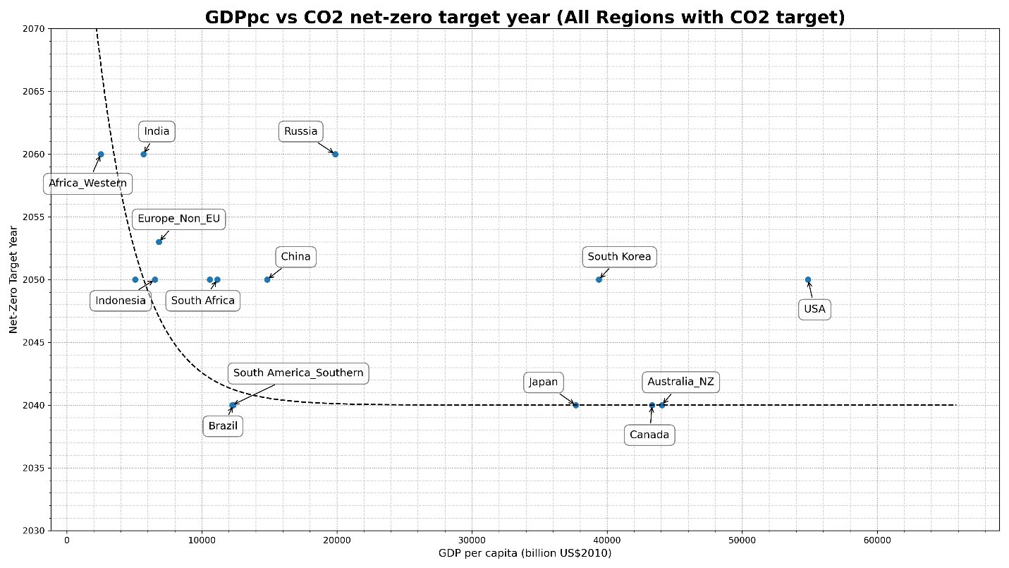
Figure 2: GDP/capita vs net-zero target year. Income along the x-axis; net-zero year along the y-axis. Note that net-zero target years were translated from GHG to CO₂ (with a 10-year gap).

Glasgow++ scenario
The Glasgow++ scenario aims at filling the gap between national mid-century strategies and the 1.5/2oC global scenarios. This scenario builds upon the Glasgow+ scenario and anticipates the action (net-zero target year defined for each region) in 5 or 10 years (depending on the model’s time steps). The NDC trajectory does not need to be followed.

Overview of scenarios
Table SM4: Overview of scenarios
 | Scenario name | National teams | Global teams
 | 1.5/2ºC | EN_15C_E_T45  EN _2C_E_T45 (Optional) | EN_NPi2020_700f_T45 ²  EN_NPi2020_1000f_T45 (Optional)
1 | Current Policies | NP_CurPol_T45 | GP_CurPol_T45
2 | NDC-2030+ | NP_NDC2030_T45 | GP_NDC2030_T45
3 | Glasgow | NP_Glasgow | GP_Glasgow
4 | Glasgow+ | NP_GlasgowP ¹ | GP_GlasgowP
5 | Glasgow++ | NP_GlasgowPP | GP_GlasgowPP
¹ NP_GlasgowP: for Mexico, only.
² For global models: if an update in the 1.5/2ºC is needed, use these tags. These scenarios follow the undergoing NAVIGATE protocol runs (e.g., Task 2.6 and Task 3.5). Alternatively, the ENGAGE 3.1 scenarios can be used.

3. Submission
Results to be submitted in 5-year time steps in the ENGAGE scenario database: https://data.ene.iiasa.ac.at/engage-internal.
With reporting template https://data.ene.iiasa.ac.at/engage-internal/static/files/ENGAGE_CD-LINKS_template_2019-08-22.xlsx
Tutorial for working with the ENGAGE scenario explorer platform: https://software.ene.iiasa.ac.at/ixmp-server/tutorials.html

References
van Soest, H.L., den Elzen, M.G.J. & van Vuuren, D.P. Net-zero emission targets for major emitting countries consistent with the Paris Agreement. Nat Commun 12, 2140 (2021). https://doi.org/10.1038/s41467-021-22294-x

Annex I
Table A: Net-zero CO₂ target year based on official submissions, for Glasgow and Glasgow+
All countries with net-zero GHG pledges have a theoretical CO₂ target advanced by 10 years.
Example: Brazil has a net-zero GHG pledge for 2050. This is translated as net-zero CO₂ in 2040.

Country | Net-zero target year (CO₂) for Glasgow | Net-zero target year (CO₂) for Glasgow+
China | 2050
Brazil | 2040
EU28 | 2040
India | 2060
Japan | 2040
Mexico | - | 2040
Russia | 2060
South Korea | 2050
Thailand | 2050
Vietnam | 2050

Based on: UNEP Emissions Gap Report 2021; https://www.zerotracker.net/.

Annex II
Table B: Net-zero GHG or CO₂ target year based on official submissions
Country | Official net-zero target year | Emission type | Net-zero status
Canada | 2050 | GHG | In law
USA | 2050 | GHG | In policy document
Costa Rica | 2050 | GHG | In policy document
Panama | 2050 | GHG | In policy document
Brazil | 2050 | GHG | In policy document
Chile | 2050 | GHG | In policy document
Ecuador | 2050 | GHG | In policy document
Uruguay | 2050 | CO₂ | In policy document
Nigeria | 2060 | CO₂ | Declaration/pledge
South Africa | 2050 | CO₂ | Declaration/pledge
EU | 2050 | GHG | In law
UK | 2050 | GHG | In law
Turkey | 2053 | CO₂ | In policy document
Ukraine | 2060 | GHG | In policy document
Kazakhstan | 2060 | CO₂ | Declaration/pledge
Russia | 2060 | CO₂ | Declaration/pledge
Saudi Arabia | 2060 | CO₂ | Declaration/pledge
Israel | 2050 | CO₂ | Declaration/pledge
UAE | 2050 | GHG | Declaration/pledge
India | 2070 | GHG | Declaration/pledge
South Korea | 2050 | CO₂ | In law
China | 2060 | GHG | In policy document
Thailand | 2050 | CO₂ | In policy document
Viet Nam | 2050 | CO₂ | In policy document
Malaysia | 2050 | CO₂ | In policy document
Indonesia | 2060 | GHG | Proposed/in discussion
Japan | 2050 | GHG | In law
Australia | 2050 | GHG | Declaration/pledge
New Zeeland | 2050 | GHG | In law
Sri Lanka | 2060 | GHG | In policy document

Source: UNEP Emissions Gap Report 2021; https://www.zerotracker.net/ ; https://www.climatewatchdata.org/net-zero-tracker

Annex III
Table C: Net-zero CO₂ target year based on official submissions, aggregated to the GCAM regions, for Glasgow and Glasgow+
GCAM Region | Countries | Net-zero target year (CO₂) for Glasgow | Net-zero target year (CO₂) for Glasgow+
Eastern Africa | Burundi, Comoros, Djibouti, Eritrea, Ethiopia, Kenya, Madagascar, Mauritius, Reunion, Rwanda, Sudan, Somalia, Uganda | - | 2070
Northern Africa | Algeria, Egypt, Western Sahara, Libya, Morocco, Tunisia | - | 2045
Southern Africa | Angola, Botswana, Lesotho, Mozambique, Malawi, Namibia, Swaziland, Tanzania, Zambia, Zimbabwe | - | 2070
Western Africa | Benin, Burkina Faso, Central African Republic, Cote d’Ivoire, Cameroon, Democratic Republic of the Congo, Congo, Cape Verde, Gabon, Ghana, Guinea, Gambia, Guinea-Bissau, Equatorial Guinea, Liberia, Mali, Mauritania, Niger, Nigeria, Senegal, Sierra Leone, Sao Tome and Principe, Chad, Togo | 2060 | 2060
Argentina | Argentina | - | 2040
Australia/NZ | Australia, New Zeeland | 2040 | 2040
Brazil | Brazil | 2040 | 2040
Canada | Canada | 2040 | 2040
Central America and the Caribbean | Aruba, Anguilla, Netherlands Antilles, Antigua & Barbuda, Bahamas, Belize, Bermuda, Barbados, Costa Rica, Cuba, Cayman Islands, Dominica, Dominican Republic, Guadeloupe, Grenada, Guatemala, Honduras, Haiti, Jamaica, Saint Kitts and Nevis, Saint Lucia, Montserrat, Martinique, Nicaragua, Panama, El Salvador, Trinidad and Tobago, Saint Vincent and the Grenadines | - | 2045
Central Asia | Armenia, Azerbaijan, Georgia, Kazakhstan, Kyrgyzstan, Mongolia, Tajikistan, Turkmenistan, Uzbekistan | - | 2045
China | China | 2050 | 2050
Colombia | Colombia | - | 2040
EU-12 | Bulgaria, Cyprus, Czech Republic, Estonia, Hungary, Lithuania, Latvia, Malta, Poland, Romania, Slovakia, Slovenia | 2050 | 2040
EU-15 | Andorra, Austria, Belgium, Denmark, Finland, France, Germany, Greece, Greenland, Ireland, Italy, Luxembourg, Monaco, Netherlands, Portugal, Sweden, Spain, United Kingdom | 2050 | 2040
Eastern Europe | Belarus, Moldova, Ukraine | 2050 | 2050
European Free Trade Association | Iceland, Norway, Switzerland | - | 2040
Europe Non-EU | Albania, Bosnia and Herzegovina, Croatia, Macedonia, Montenegro, Serbia, Turkey | 2053 | 2053
India | India | 2060 | 2060
Indonesia | Indonesia | 2050 | 2050
Japan | Japan | 2040 | 2040
Mexico | Mexico | - | 2040
Middle East | United Arab Emirates, Bahrain, Iran, Iraq, Israel, Jordan, Kuwait, Lebanon, Oman, Palestine, Qatar, Saudi Arabia, Syria, Yemen | - | 2040
Pakistan | Pakistan | - | 2070
Russia | Russia | 2060 | 2060
South Africa | South Africa | 2050 | 2050
Northern South America | French Guiana, Guyana, Suriname, Venezuela | - | 2050
Southern South America | Bolivia, Chile, Ecuador, Peru, Paraguay, Uruguay | 2040 | 2040
South Asia | Afghanistan, Bangladesh, Bhutan, Sri Lanka, Maldives, Nepal | - | 2065
Southeast Asia | American Samoa, Brunei Darussalam, Cocos (Keeling) Islands, Cook Islands, Christmas Island, Fiji, Federated States of Micronesia, Guam, Cambodia, Kiribati, Lao Peoples Democratic Republic, Marshall Islands, Myanmar, Northern Mariana Islands, Malaysia, Mayotte, New Caledonia, Norfolk Island, Niue, Nauru, Pacific Islands Trust Territory, Pitcairn Islands, Philippines, Palau, Papua New Guinea, Democratic Peoples Republic of Korea, French Polynesia, Singapore, Solomon Islands, Seychelles, Thailand, Tokelau, Timor Leste, Tonga, Tuvalu, Viet Nam, Vanuatu, Samoa | 2050 | 2050
South Korea | South Korea | 2050 | 2050
Taiwan | Taiwan | - | 2040
USA | United States of America | 2050 | 2050

Based on: UNEP Emissions Gap Report 2021; https://www.zerotracker.net/.

Except COFFEE.

