Supplementary Information for
High-resolution based sustainable livestock management in China

Table S1 Damage cost of N losses to air and water ($/kg N).
 | Effect | Type | Subject | Low | Median | High
NO_{x} | Increased incidence of respiratory disease | human health | air/climate | 12.88 | 23.1 | 38.63
NO_{x} | Declining visibility—loss of aesthetics | human health | air/climate | 0.31 | 0.31 | 0.31
NO_{x} | Increased effects of airborne particulates/increased carbon sequestration in forests (includses benefits) | climate | air/climate | -11.59 | -4.51 | 2.58
NO_{x} | Increased damages to buildings from acid | ecosystem | land | 0.09 | 0.09 | 0.09
NO_{x} | Increased ozone exposure to crops | ecosystem | land | 1.29 | 1.51 | 2.58
NO_{x} | Increased ozone exposure to forests | ecosystem | land | 0.89 | 0.89 | 0.89
NO_{x} | Increased loss of plant biodiversity from N enrichment | ecosystem | land | 2.58 | 7.73 | 12.88
NH₃ | Increased incidence of respiratory disease | human health | air/climate | 2.58 | 4.93 | 25.75
NH₃ | Declining visibility—loss of aesthetics | human health | air/climate | 0.31 | 0.31 | 0.31
NH₃ | Increased effects of airborne particulates/increased carbon sequestration in forests (includes benefits) | human health | air/climate | -3.86 | -1.93 | -1.93
NH₃ | Increased damages to buildings from particulates | ecosystem | land | 0.09 | 0.09 | 0.09
NH₃ | Increased loss of plant biodiversity | ecosystem | land | 2.58 | 7.73 | 12.88
N₂O | Increased ultra-violet light exposure from ozone—humans | human health | air/climate | 1.29 | 1.33 | 3.86
N₂O | Increased emission of a greenhouse gas | climate | air/climate | 5.2 | 13.5 | 21.9
N₂O | Increased ultra-violet light exposure from ozone-crops | ecosytem | air/climate | 1.33 | 1.33 | 1.33
N runoff | Declining waterfront property value | ecosystem | freshwater | 0.21 | 0.21 | 0.21
N runoff | Loss of recreational use | ecosystem | freshwater | 0.17 | 0.17 | 0.17
N runoff | Loss of endangered species | ecosystem | freshwater | 0.01 | 0.01 | 0.01
N runoff | Increased eutrophication | ecosystem | freshwater | 6.44 | 16.1 | 25.75
N runoff | Undesirable odor and taste | human health | drinking water | 0.14 | 0.14 | 0.14
N runoff | Nitrate contamination | human health | drinking water | 0.54 | 0.54 | 0.54
N runoff | Increased colon cancer risk | human health | drinking water | 1.76 | 1.76 | 5.15
N leaching | Undesirable odor and taste | human health | drinking water | 0.14 | 0.14 | 0.14
N leaching | Nitrate contamination | human health | drinking water | 0.54 | 0.54 | 0.54
N leaching | Increased colon cancer risk | human health | drinking water | 1.76 | 1.76 | 5.15
coastal N loading | Loss of recreational use | ecosystem | coastal zone | 6.38 | 6.38 | 6.38
coastal N loading | Declines in fisheries and estuarine/marine habitat | ecosystem | coastal zone | 6 | 15.84 | 26
Note: data given here are the original values applicable to the EU and US derived from Sobota et al. (2015), negative values indicate an economic benefit. We have adjusted the data for China’s calculation based on regional weighted PGDP and population density.

Ref: Sobota, D.J., et al. Cost of reactive nitrogen release from human activities to the environment in the United States. Environ Res Lett 10, 25006 (2015).

Table S2 Social benefits of mitigating Nr losses to air and water in China ($/kg N).
Social benefits ($/kg N) | NH₃ | N₂O | NO_{x} | N runoff | N leaching
human health | 4.2 (2.3 ~ 7.8) | 1.1 (1.0 ~ 3.1) | 18.7 (10.6 ~ 26.2) | 2.0 (2.0 ~ 4.7) | 2.0 (2.0 ~ 4.7)
ecosystem | 6.3 (2.1 ~ 10.4) | 1.1 (1.1 ~ 1.1) | 8.1 (3.8 ~ 13.1) | 13.2 (5.5 ~ 20.9) | -
climate | -1.5 (-3.1~ -1.0) | 11.9 (4.1 ~ 17.5) | -3.6 (-9.3 ~ 2.1) | 0.0 (0.0 ~ 0.0) | -

Table S3 Description of future scenario for livestock production
Scenario | Description | Main indicator | Intensive level | Related options | Main consequence or effect
BAU | Only consider current policies and national plans (i.e., ‘Ten-Point Water Plan’, ‘Livestock Manure Recycling Action Plan’) without any further intervention. Consumption of meat and other animal products is growing rapidly | F_{a}=60%  R_{a}=30%  NUE_{a}=15% | L_{dairy cattle}=70%; L_{beef cattle}=30%  L_{pig}=75%; L_{poultry}=75%  L_{sheep}=20%; L_{other animal}=20% | improved level of large-scale cultivation | Substantially increased crop production for animal feed and meat production to feed growing and wealthier population
DIET | Optimize human dietary structure by cutting consumption of animal products following the Chinese Dietary Guidelines. | F_{a}=40%  Ra=30%  NUE_{a}=15% | L_{dairy cattle}=70%; L_{beef cattle}=30%  L_{pig}=75%; L_{poultry}=75%  L_{sheep}=20%; L_{other animal}=20% | Human dietary change | Increased land area released from the reduction of growing animal feed; reduced net land requirement for crop and livestock production under DIET scenario
NUE | Boost N use efficiency through improved feeding and manure management | F_{a}=60%  R_{a}=30%  NUE_{a}=30% | L_{dairy cattle}=70%; L_{beef cattle}=30%  L_{pig}=75%; L_{poultry}=75%  L_{sheep}=20%; L_{other animal}=20% | improved animal feed and manure management | Reduced fertilizer consumption; reduced manure N loss to water and air
REC | Cut livestock waste by improving recycling of livestock manure to cropland to partially substitute synthetic fertilizer nitrogen (N) input and increase crop yield | F_{a}=60%  R_{a}=75%  NUE_{a}=30% | L_{dairy cattle}=75%; L_{beef cattle}=50%  L_{pig}=80%; L_{poultry}=80%  L_{sheep}=40%; L_{other animal}=40% | increase manure recycle to cropland | More manure N being recycled to the field; reduced use of chemical fertilizer N; restore nutrient balances within agricultural systems in China
ALL | Combination of Diet, NUE and REC, namely, LCP diet, improvement in fertilization and manure management, recycling manure N to cropland | F_{a}=40%  R_{a}=75%  NUE_{a}=30% | L_{dairy cattle}=75%; L_{beef cattle}=50%  L_{pig}=80%; L_{poultry}=80%  L_{sheep}=40%; L_{other animal}=40% | combination of all above mentioned options | Reduced livestock production; reduced manure N loss to air and water; more manure N being recycled to the field; reduced use of chemical fertilizer;
Note: F_{a} represents the N share of animal source food to human diet; R_{a} represents the ratio of manure N recycling to field; NUE_{a} represents the N use efficiency of livestock production; L_{animal} refers to the level of intensive animal production.

Fig. S1 | Health, ecosystem and climate effects of livestock pollution in 2017. (a) Health damage from NH₃ emissions; (b) Ecosystem damage from NH₃ emissions; (c) Climate damage from NH₃ emissions; (d) Health damage from GHG emissions; (e) Ecosystem damage from GHG emissions; (f) Climate damage from GHG emissions; (g) Health damage from N leaching and runoff to water bodies; (h) Ecosystem damage from N leaching and runoff to water bodies; (i) Total damage on health, ecosystem and climate. The base map is applied without endorsement from GADM data (https://gadm.org/).

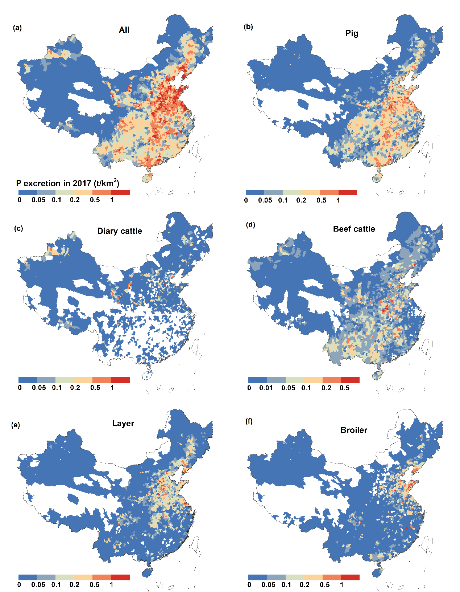
Fig. S2 | Distribution of P in livestock excretion in China on county scale in 2017. Base map is applied without endorsement from GADM data (https://gadm.org/).

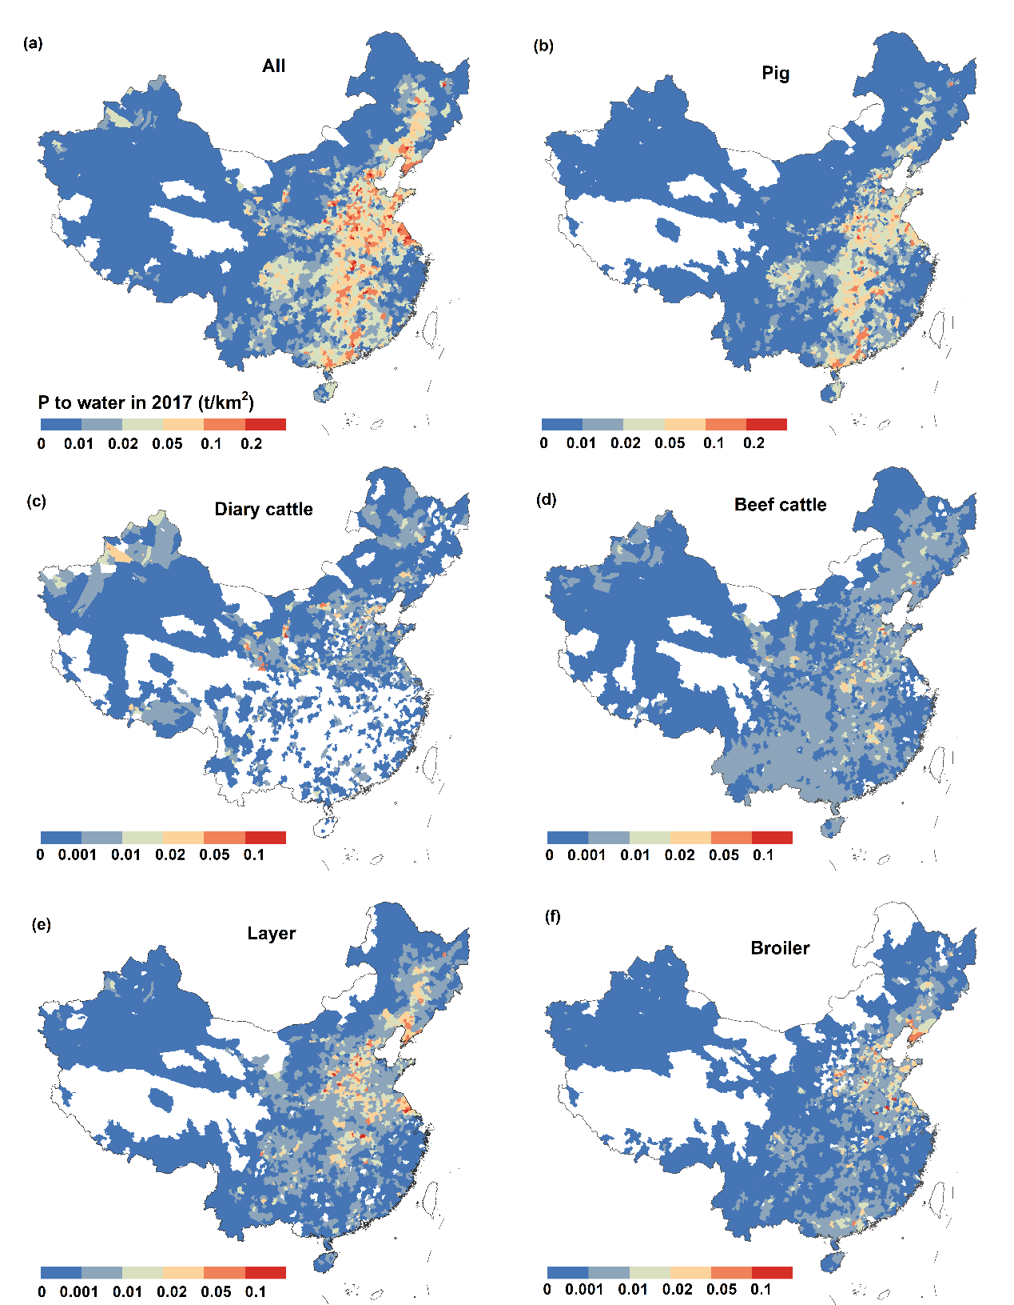
Fig. S3 | Distribution of P loss to water in China on county scale in 2017. Base map is applied without endorsement from GADM data (https://gadm.org/).

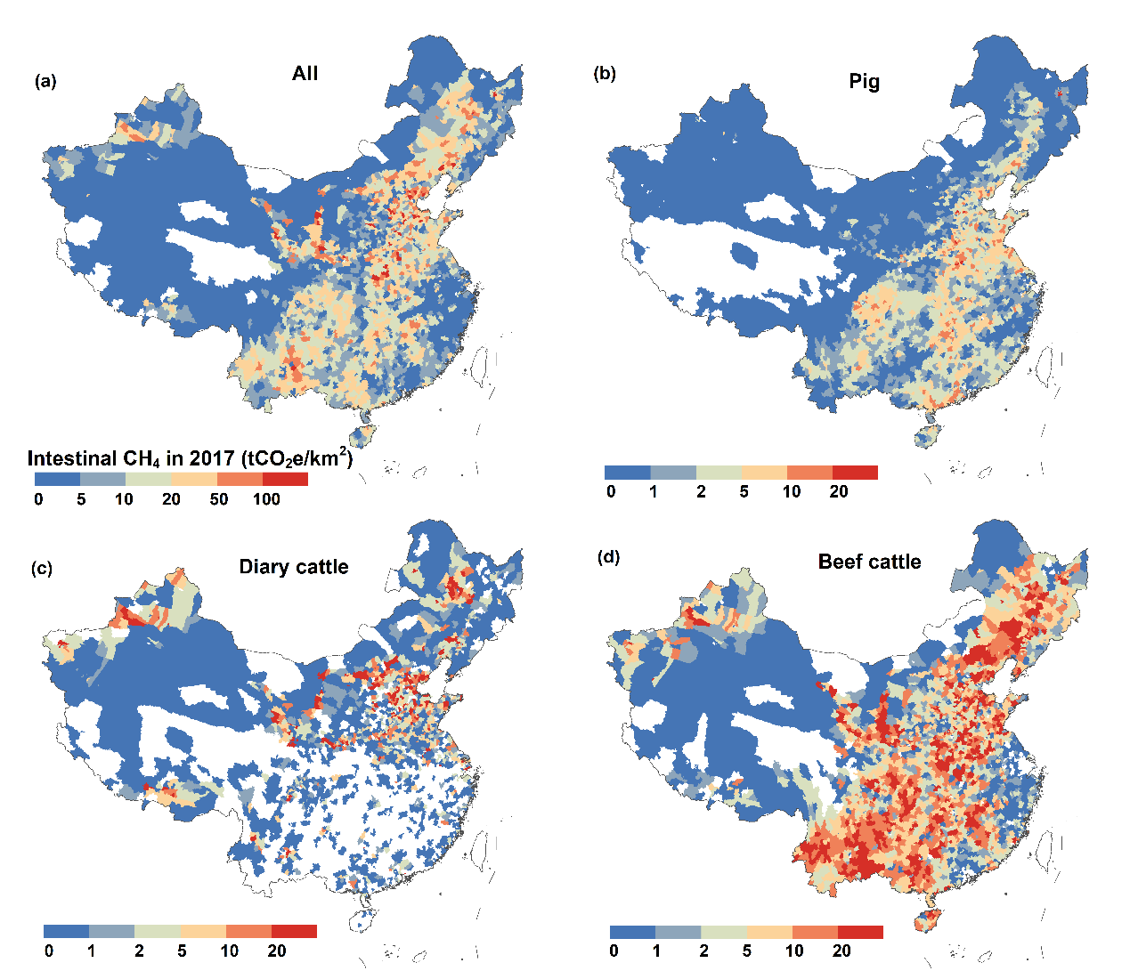
Fig. S4 | Distribution of intestinal CH₄ emission from livestock production in China on county scale in 2017. Base map is applied without endorsement from GADM data (https://gadm.org/).

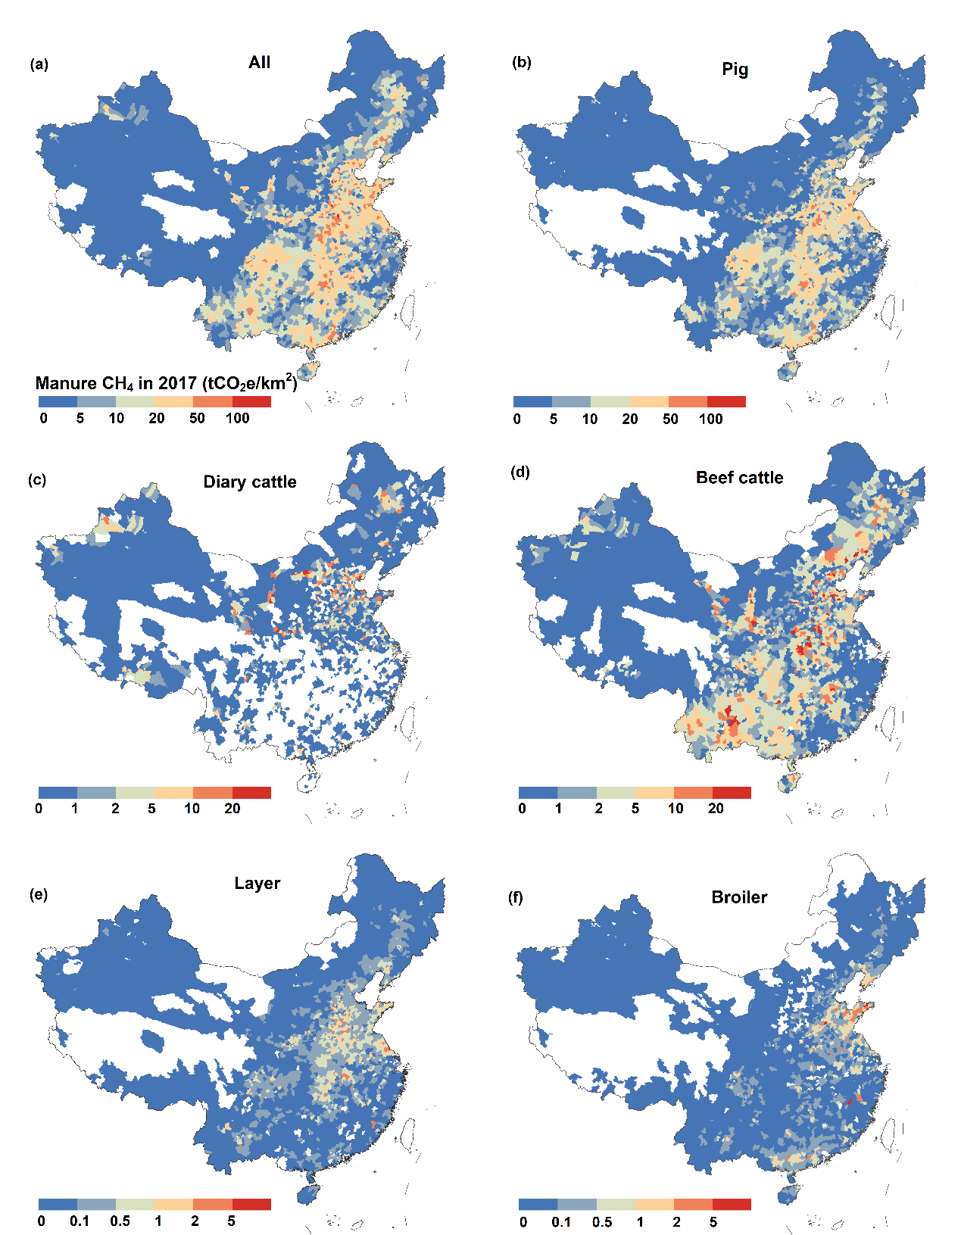
Fig. S5 | Distribution of manure CH₄ emission in China on county scale in 2017. Base map is applied without endorsement from GADM data (https://gadm.org/).

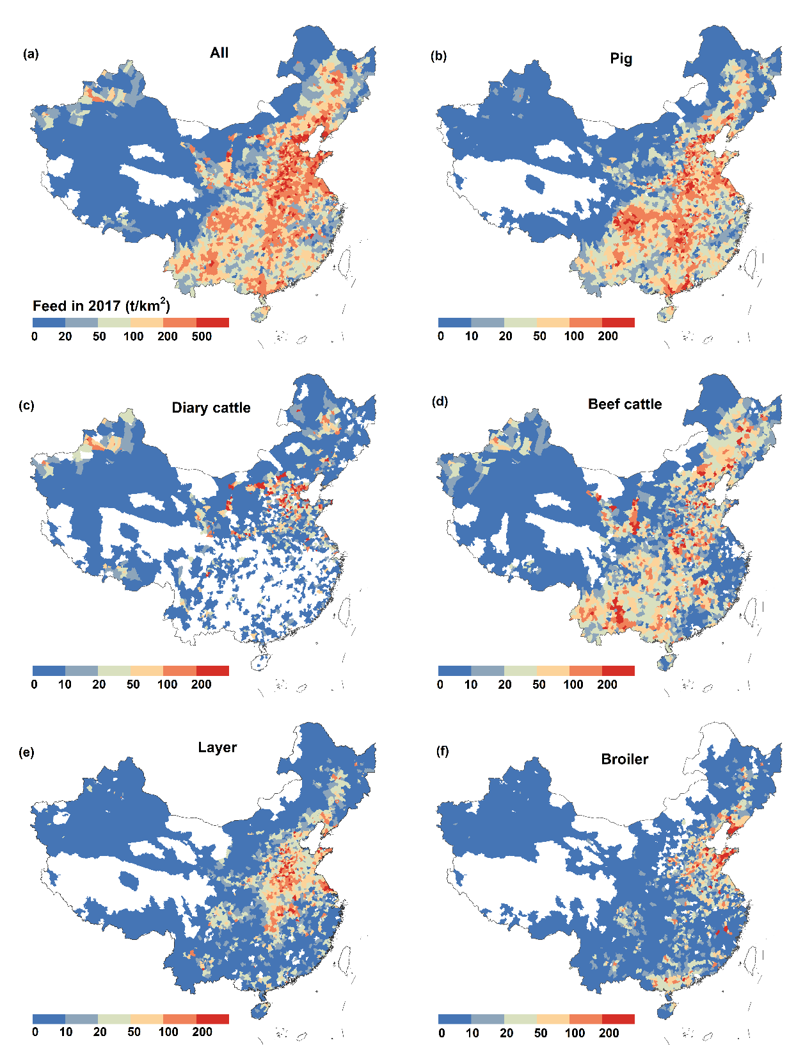
Fig. S6 | Distribution of feed use in livestock production in China on county scale in 2017. Base map is applied without endorsement from GADM data (https://gadm.org/).

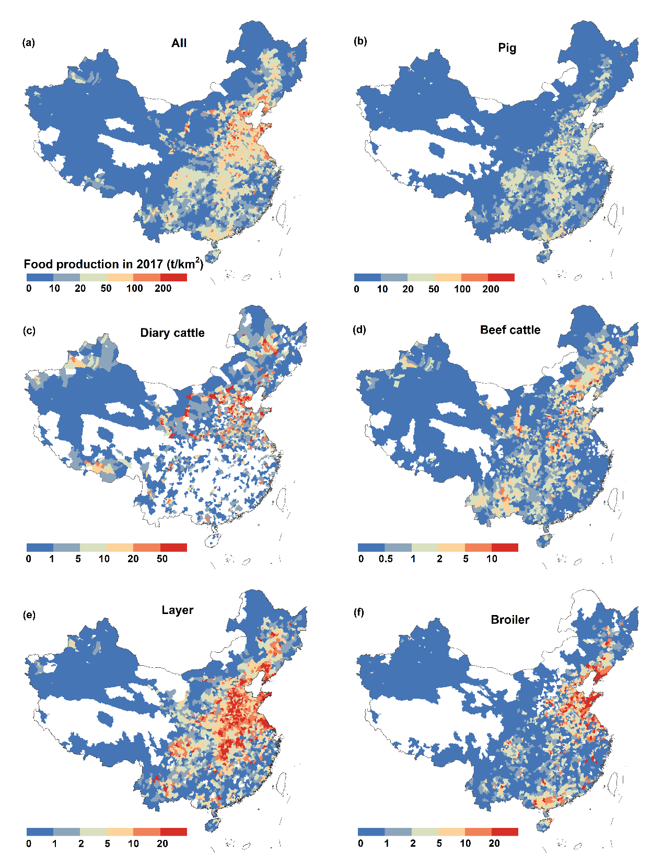
Fig. S7 | Distribution of livestock production in China on county scale in 2017. Base map is applied without endorsement from GADM data (https://gadm.org/).

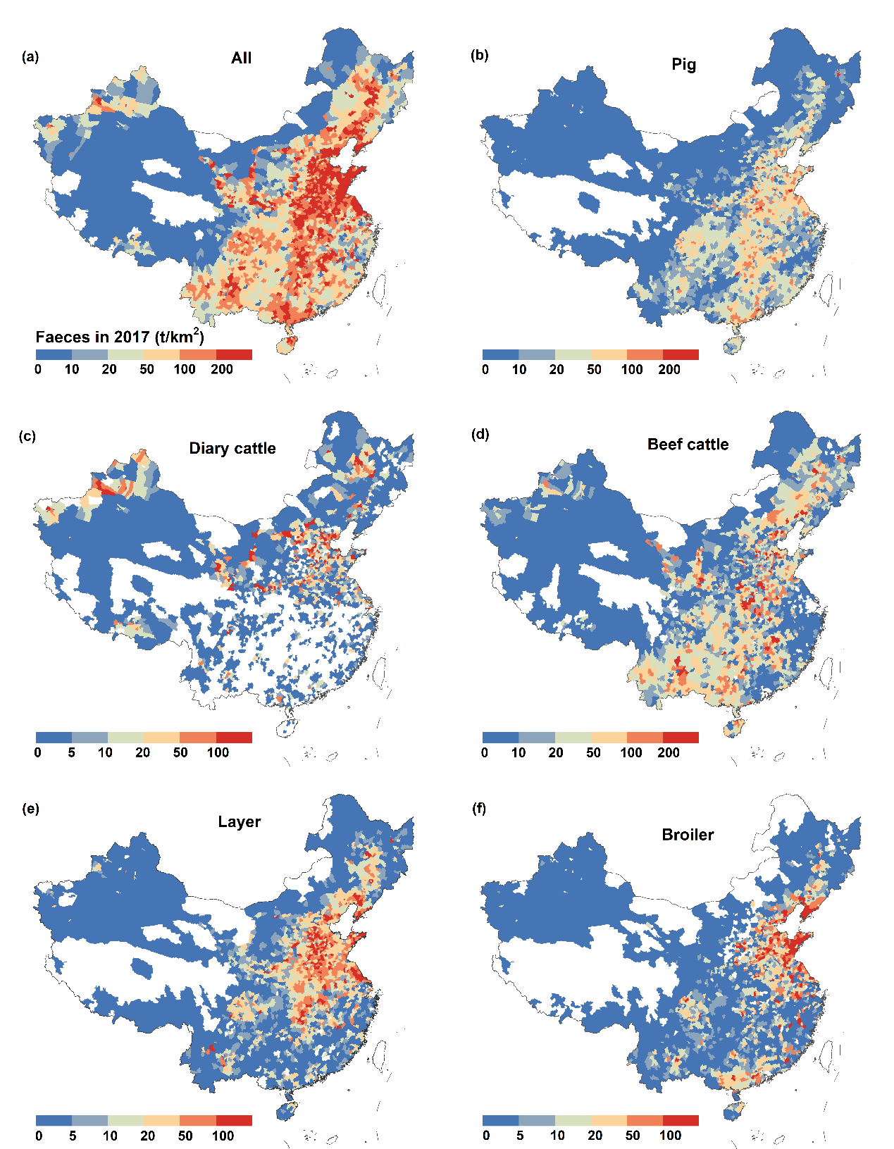
Fig. S8 | Distribution of livestock faeces in China on county scale in 2017. Base map is applied without endorsement from GADM data (https://gadm.org/).

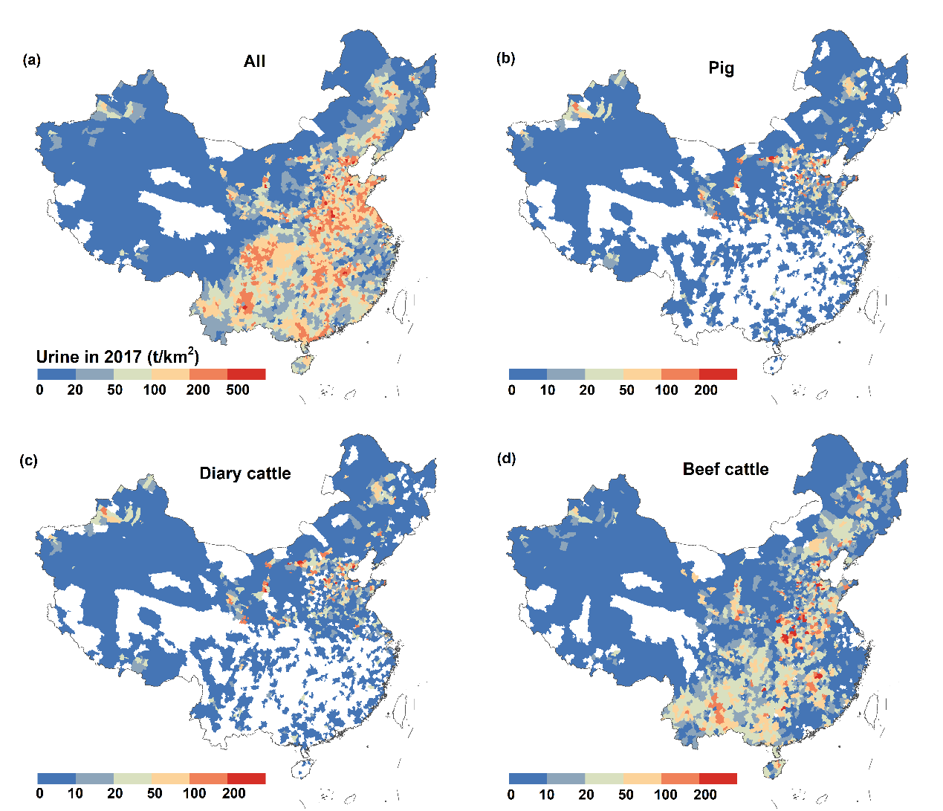
Fig. S9 | Distribution of livestock urine in China on county scale in 2017. Base map is applied without endorsement from GADM data (https://gadm.org/).

