Table S1 Abdominal cross‐sectional skeletal muscle area of rapid muscle loss and non rapid muscle loss patients

 | All patients  (N=482) | Rapid muscle loss  group (N=141) | Non rapid muscle loss group (N=341) | p
Admission CT scan
L3SMA (cm2) mean (SD) | 122.11 (18.76) | 122.26 (17.31) | 122.05 (19.35) | 0.91
L3SMI (cm2/m2) mean (SD) | 43.07 (5.78) | 42.16 (5.39) | 43.44 (5.91) | 0.03*
Follow up CT scan
L3SMA (cm2) mean (SD) | 105.78 (21.15) | 101.61 (18.27) | 107.51 (22.02) | <0.01*
L3SMI (cm2/m2) mean (SD) | 37.27 (6.67) | 34.98 (4.76) | 38.21 (3.71) | <0.01*
ΔL3SMI (%) mean (SD) | 9.14 (0.74) | 9.17 (0.49) | 9.12 (0.41) | <0.01*
ΔL3SMA (cm2) mean (SD) | 16.33 (0.39) | 20.65 (0.55) | 14.54 (0.47) | <0.01*
ΔL3SMA/day | 1.67(0.76) | 2.53 (0.46) | 1.33 (0.28) | <0.01*

L3SMA, skeletal muscle area at L3 slices; L3SMI, skeletal muscle index at L3 slices; ΔL3SMA (admission CT L3SMA-Follow up CT L3SMA)/ admission CT L3SMA, ΔL3SMI (admission CT L3SMI-Follow up CT L3SMI)/ admission CT L3SMI. *: p<0.01.

Table S2 Abdominal cross‐sectional skeletal muscle area of CT re-examination within one week and out of one week patients

 | All patients  (N=482) | CT re-examination within one week group (N=176) | CT re-examination out of one week group (N=306) | p
Admission CT scan
L3SMA (cm2) mean (SD) | 122.11 (18.76) | 122.81 (18.61) | 122.05 (19.35) | 0.78
L3SMI (cm2/m2) mean (SD) | 43.07 (5.78) | 42.81 (5.68) | 43.22 (5.84) | 0.45
Follow up CT scan
L3SMA (cm2) mean (SD) | 105.78 (21.15) | 110.45 (19.89) | 103.09 (21.4) | <0.01*
L3SMI (cm2/m2) mean (SD) | 37.27 (6.67) | 38.81 (6.29) | 36.38 (6.73) | <0.01*
ΔL3SMI (%) mean (SD) | 9.14 (0.74) | 9.09 (0.48) | 9.16 (0.76) | 0.27
ΔL3SMA (cm2) mean (SD) | 16.33 (0.39) | 11.36 (0.4) | 19.18 (0.39) | <0.01*
ΔL3SMA/day | 1.67(0.76) | 1.89(0.87) | 1.56(0.66) | <0.01*

L3SMA, skeletal muscle area at L3 slices; L3SMI, skeletal muscle index at L3 slices; ΔL3SMA (admission CT L3SMA-Follow up CT L3SMA)/ admission CT L3SMA, ΔL3SMI (admission CT L3SMI-Follow up CT L3SMI)/ admission CT L3SMI. *: p<0.01.

Table S3 Biochemical and treatment measures of rapid muscle loss and non rapid muscle loss patients

 | Day 1 |  |  |  |  | Day 3
 | All patient  (N=482) | rapid muscle loss group  (N=271) | non rapid  muscle loss group  (N=211) | p | AUROC for rapid muscle loss (95% CI) | All patients  (N=482) | rapid muscle loss group  (N=271) | non rapid muscle loss group  (N=211) | p | AUROC for rapid muscle loss (95% CI)
Creatinine (umol/L) (median [IQR]) | 78.0 (59, 107) | 78.0 (61, 107) | 76.0 (55, 103) | 0.79 | 0.54 (0.48, 0.59) | 75.0 (58, 103) | 77.0 (59, 106) | 72.0 (56, 102) | 0.57 | 0.52 (0.47,0.57)
Urea (umol/L) (median [IQR]) | 6900(4700, 10400) | 7000 (5100, 10400) | 6700(4400, 10400) | 0.96 | 0.53 (0.48, 0.59) | 7750 (5300, 11590) | 8900 (6400, 12000) | 6600 (4200, 9700) | 0.01* | 0.64 (0.59, 0.69)
UCR (umol/L) (median [IQR]) | 89 (61, 123) | 89(64, 120) | 88 (56, 134) | 0.37 | 0.50(0.45, 0.56) | 101 (71, 141) | 109 (81, 152) | 93 (62, 128) | <0.01* | 0.63 (0.58, 0.68)
ΔUCR (median [IQR]) |  |  |  |  |  | 10.8(-325, 26.3) | 21.6 (7.7, 38.5) | 1.7 (-8.3, 11.7) | <0.01* | 0.78 (0.74, 0.83)
Creatine kinase (u/L) (median [IQR]) | 171.5 (52.0, 486.5) | 175.0 (52.0, 589.0) | 163.0 (50.5, 426.5) | 0.43 | 0.52 (0.47, 0.57) | 172.5 (63.8, 563.5) N=456 | 187.0 (63.5, 608.0) N=255 | 153.0 (67.0, 489.0) N=201 | 0.49 | 0.51 (0.45, 0.57)
Myoglobin (mg/L) (median [IQR]) | 307.5 (110.0, 692.8) | 310.0 (109.0, 835.5) | 299.0 (112.5, 609.0) | 0.51 | 0.52 (0.46, 0.57) | 245.0 (102.0, 672.0) N=401 | 261.5 (102.0, 673.5) N=226 | 234.0 (103.0, 643.5) N=175 | 0.70 | 0.50 (0.45, 0.56)
Hemoglobin (g/L) (median [IQR]) | 106.0 (91.0, 123.0) | 104.0 (90.0, 123.0) | 106.0 (92.0, 124.0) | 0.41 | 0.48 (0.43, 0.53) | 96.0 (85.0, 111.0) | 96.0 (85.0, 110.0) | 98.0 (85.0, 113.0) | 0.39 | 0.46 (0.41, 0.52)
Lactate (mmol/L) (median [IQR]) | 1.6 (1.1, 2.5) | 1.6 (1.1, 2.6) | 1.5 (1.1, 2.3) | 0.12 | 0.54 (0.49, 0.59) | 1.6 (1.1, 2.2) | 1.6 (1.1, 2.2) | 1.6 (1.1, 2.2) | 0.50 | 0.52 (0.46, 0.57)
PCT (ng/ml) (median [IQR]) | 0.9 (0.1, 4.8) | 1.2 (0.2, 5.5) | 0.6 (0.1, 3.9) | 0.02* | 0.56 (0.51, 0.62) | 0.8 (0.1, 3.5) | 0.9 (0.4, 4.1) | 0.6 (0.1, 3.0) | 0.04* | 0.57 (0.51, 0.62)
Lymphocyte count (×109cells/L) (median [IQR]) | 0.7 (0.5, 1.1) | 0.7 (0.4, 1.1) | 0.8 (0.5, 1.1) | 0.07 | 0.45 (0.39, 0.50) | 0.8 (0.5, 1.1) | 0.7 (0.5, 1.1) | 0.8 (0.6, 1.2) | 0.03* | 0.42 (0.36, 0.47)
Albumin (g/L) (median [IQR]) | 30.2 (27.0, 34.0) | 29.8 (26.5, 33.7) | 30.7 (27.2, 34.4) | 0.10 | 0.46 (0.41, 0.51) | 32.3 (29.8, 35.7) | 32.1 (29.6, 35.8) | 32.4 (30.1, 35.2) | 0.80 | 0.48 (0.42, 0.54)
PNI (median [IQR]) | 34.4 (30.2, 38.8) | 33.9 (29.6, 38.2) | 34.9 (30.5, 40.2) | 0.04* | 0.44 (0.39, 0.49) | 36.78(33.7, 40.3) | 36.2 (33.0, 40.1) | 37.0 (34.0, 40.9) | 0.13 | 0.44 (0.38, 0.49)
Types of Nutrition (n)% |  |  |  | 0.77 |  |  |  |  | 0.32
Non | 370 (76.8) | 211 (77.9) | 159 (75.4) |  |  | 76 (15.8) | 46 (17.0) | 30 (14.2)
EN | 112 (23.2) | 60 (22.1) | 52 (24.6) |  |  | 376 (78.0) | 204 (75.3) | 172 (81.5)
PN | 0 (0) | 0 (0) | 0 (0) |  |  | 24 (5.0) | 17 (6.3) | 7 (3.3)
EN+PN | 0 (0) | 0 (0) | 0 (0) |  |  | 6 (1.2) | 4 (1.5) | 2 (0.9)
Calorie intake (kcal/kg/24h) (median [IQR]) | 0 (0, 0) | 0 (0, 0) | 0 (0, 0) | 0.76 | 0.49 (0.45, 0.53) | 12.5 (6.25, 16.67) | 12.5 (5.56, 16.67) | 12.5 (6.67, 16.67) | 0.537 | 0.48 (0.43, 0.53)
Glucose (mmol/L) (median [IQR]) | 8.7 (6.9, 12.4) | 8.9 (6.8, 11.8) | 8.6 (7.0, 12.6) | 0.77 | 0.49 (0.44, 0.55) | 8.8 (6.8, 11.8) | 8.8 (6.9, 11.8) | 8.9 (6.8, 11.7) | 0.90 | 0.48 (0.43, 0.54)
Insulin (IU/24h) (median [IQR]) | 0.0 (0.0, 0.0) | 0.0 (0.0, 0.0) | 0.0 (0.0, 0.0) | 0.62 | 0.51 (0.48, 0.55) | 0.0 (0.00, 8.0) | 0.0 (0.0, 10.0) | 0.0 (0.0, 4.0) | 0.55 | 0.52 (0.47, 0.56)
MAP (mmHg) (median [IQR]) | 75 (71, 78) | 75 (71, 78) | 76 (70, 79) | 0.51 | 0.48 (0.43, 0.54) | 76 (73, 80) | 76 (73, 80) | 77 (72, 80) | 0.82 | 0.48 (0.42, 0.54)
Sum VDI (NEE mg) (median [IQR]) | 3.6 (0.0, 12.6) | 4.2 (0.0, 14.4) | 2.7 (0.0, 12.0) | 0.62 | 0.51 (0.46, 0.56) | 3.6 (0.0, 16.8) | 3.8 (0.0, 16.0) | 3.6 (0.0, 17.2) | 0.98 | 0.49 (0.43, 0.54)
Neuromuscular blocker use. n (%) | 32 (6.64) | 18 (6.64) | 14 (6.63) | 0.50 | 0.50 (0.49, 0.52)
RASS score (median [IQR]) | -1 (-2, 0) | -1 (-2, 0) | -1 (-2, 0) | 0.09 | 0.46 (0.41, 0.51) | -1 (-2, 0) | -1 (-2, 0) | -1 (-2, 0) | 0.64 | 0.49 (0.44, 0.55)
CI, confidence interval; IQR, interquartile range; AUROC, area under the receiver operating characteristic; UCR, urea-to-creatinine ratio; ΔUCR, difference in UCR between day 3 and day 1; PCT, procalcitonin; PNI, prognostic nutritional index; EN, enteral nutrition; PN, parenteral nutrition; MAP, mean arterial pressure; Sum VDI=24-hour vasopressor dose equivalence; NEE, norepinephrine equivalent dose; be calculated as [norepinephrine (μg/min)] + [dopamine (μg/kg/min) ÷ 2] + [epinephrine (μg/min)] + [phenylephrine (μg/min) ÷10], RASS score, richmond agitation-sedation scale score. * p<0 .05.

Fig.S1 Abdominal cross‐sectional skeletal muscle index of rapid muscle loss and non rapid muscle loss patients
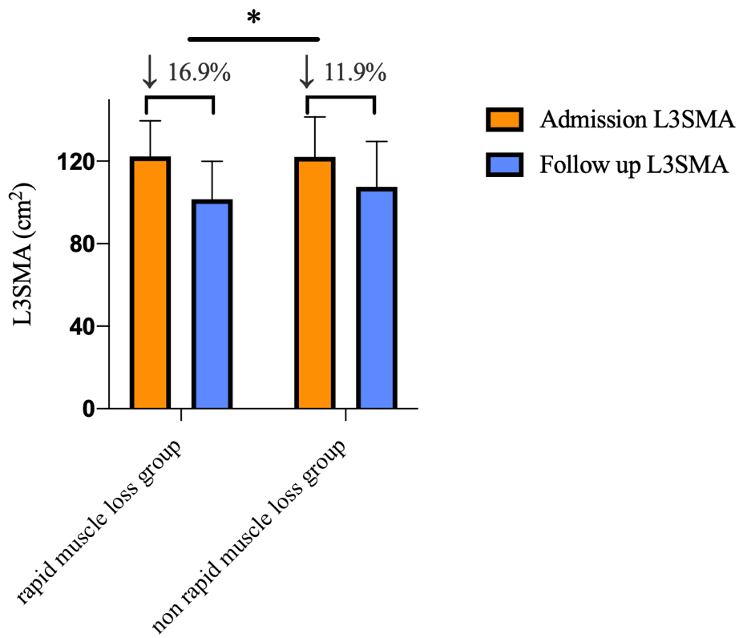

L3SMA, skeletal muscle area at L3 slices. * p<0 .01.

Table S4: Baseline characteristics and clinical outcomes of patients who underwent CT re-examination within one week.
Characteristics | CT re-examination within one week patients  (N=176) | Rapid muscle loss  group  (N=67) | Non rapid muscle loss group  (N=109) | p
Age (year) (mean [SD]) | 61.5 (1.3) | 59.2 (2.1) | 62.8 (1.7) | 0.17
Male (n) (%) | 131 (74.4) | 52 (77.6) | 79 (72.5) | 0.45
Infection site
Respiratory (n) (%) | 116 (65.9) | 43 (64.3) | 77 (67.0) | 0.96
Abdominal (n) (%) | 40 (22.7) | 15 (22.5) | 25 (22.9) | 0.93
Genitourinary (n) (%) | 7 (3.9) | 3 (4.6) | 4 (3.7) | 0.79
Skin/soft tissue (n) (%) | 2 (1.2) | 1 (1.4) | 1 (0.9) | 0.73
Bloodstream (n) (%) | 4 (2.3) | 2 (2.9) | 2 (1.8) | 0.62
Central nervous system (n) (%) | 5 (2.8) | 2 (2.9) | 3 (2.8) | 0.93
Other (n) (%) | 2 (1.2) | 1 (1.4) | 1 (0.9) | 0.26
BMI (mean [SD]) | 23.3 (0.23) | 23.1 (0.28) | 23.5 (0.34) | 0.27
APACHE II (median [IQR]) | 18.00 (13.00, 24.00) | 18.00 (13.00, 21.00) | 19.00 (13.00, 25.00) | 0.17
SOFA (median [IQR]) | 8.00 (6.00, 11.00) | 8.00(6.00, 11.00) | 8.00 (6.00, 11.00) | 0.77
Shock (n) (%) | 117 (66.5) | 40 (59.7) | 77 (70.6) | 0.14
Comorbid conditions
Hypertension (n) (%) | 73 (41.4) | 25 (37.3) | 48 (44.1) | 0.38
Coronary artery disease (n) (%) | 26 (14.8) | 7 (10.4) | 19 (17.4) | 0.49
Heart failure (n) (%) | 25 (14.2) | 8 (11.9) | 17 (15.6) | 0.44
Chronic obstructive pulmonary disease (n) (%) | 11 (6.3) | 4 (6.0) | 7 (6.4) | 0.91
Diabetes mellitus (n) (%) | 46 (26.1) | 17 (25.4) | 29 (26.6) | 0.86
Solid malignant tumors (n) (%) | 30 (17.1) | 11 (16.4) | 18 (16.5) | 0.48
Hematologic cancer (n) (%) | 4 (2.3) | 1 (1.4) | 3 (2.8) | 0.59
Cirrhosis (n) (%) | 2 (1.1) | 1 (1.4) | 1 (0.9) | 0.73
Other (n) (%) | 4 (2.3) | 2 (2.9) | 2 (1.8) | 0.73
Admission vital signs
Temperature (°C) (median [IQR]) | 37.2 (36.5, 38.5) | 37.5 (36.5, 38.3) | 37.1 (36.5, 38.5) | 0.07
Respiratory rate (breaths/min) (median [IQR]) | 21(12, 28) | 20(12, 28) | 21(13, 28) | 0.69
Heart rate (beats/min) (median [IQR]) | 111(76, 130) | 114(88, 131) | 110(72, 130) | 0.51
MAP (mmHg) (median [IQR]) | 74.00 (70.00, 78.00) | 76.00 (70.00, 78.00) | 74.00 (70.00, 77.0) | 0.54
Admission blood tests (median [IQR])
Creatinine (umol/L) (median [IQR]) | 80.00 (61, 111) | 76.00 (60, 111) | 84.00 (63, 111) | 0.98
Urea (umol/L) (median [IQR]) | 6900(4600, 9900) | 6400 (4500, 9200) | 7100(4600, 10500) | 0.19
Urea: creatinine (median [IQR]) | 84.55 (56.52, 114.84) | 79.23 (56.06, 107.55) | 87.3 (56.7, 115.6) | 0.18
Lactate (mmol/L) (median [IQR]) | 1.60 (1.20, 2.30) | 1.6 (1.3, 2.2) | 1.5 (1.1, 2.4) | 0.35
PCT (ng/ml) (median [IQR]) | 0.85 (0.18, 3.99) | 0.77 (0.2, 2.63) | 0.88 (0.18, 5.21) | 0.16
Albumin (g/L) (median [IQR]) | 30.00 (27.00, 34.20) | 29.80 (27.00, 33.70) | 30.2 (26.9, 34.3) | 0.91
Lymphocyte count (×10⁹cells/L) (median [IQR]) | 0.69 (0.46, 1.09) | 0.74 (0.46, 1.11) | 0.62 (0.45, 1.07) | 0.95
Hemoglobin (g/L) (median [IQR]) | 107.0 (90.5, 124.0) | 110.0 (90.0, 128.0) | 103.0 (91.0, 122. 0) | 0.58
Admission L3SMA (cm2) (mean [SD]) | 121.8 (18.6) | 122.4 (18) | 121.5 (19.1) | 0.75
Hospital length of stay (day) (mean [SD]) | 24.4 (1.11) | 28.5 (2.1) | 21.9 (1.16) | <0.01*
ICU length of stay (day) (mean [SD]) | 16.5 (0.85) | 18.6 (1.61) | 15.2 (0.94) | 0.05
Hospital mortality (n) (%) | 41 (23.3) | 13 (19.4) | 28 (25.6) | 0.23
ICU mortality (n) (%) | 40 (22.7) | 12 (17.9) | 28 (23.8) | 0.15
28-day mortality (n) (%) | 39 (22.2) | 13 (19.4) | 26 (23.8) | 0.49
Alive and VFDs-28-day (day) (mean [SD]) | 17.2 (0.79) | 16.9 (1.08) | 17.6 (1.16) | 0.73
BMI, body mass index; APACHE II, acute physiology and chronic health evaluation II; SOFA, sequential organ failure assessment; UCR, urea-to-creatinine ratio; PCT, procalcitonin; RR, Respiratory rate; MAP, mean arterial pressure; L3SMA, skeletal muscle area at L3 slices; VFDs-28-day, mechanical ventilation free days to day28. * p<0 .05.

Table S5: Multivariate logistic regression exploring the impact of UCR on the risk of CT re-examination within one week patients

 | Adjusted for UCR_D1 |  | Adjusted for UCR_D3 |  | Adjusted for ΔUCR
 | OR (95% CI) | P value | OR (95% CI) | P value | OR (95% CI) | P value
Age | 0.98 (0.96,1.00) | 0.09 | 0.98 (0.96,1.00) | 0.05 | 0.98 (0.96,1.01) | 0.12
Male | 1.41 (0.57,3.52) | 0.46 | 1.57 (0.62,3.94) | 0.34 | 1.34 (0.51,3.53) | 0.55
BMI | 0.94 (0.84,1.06) | 0.34 | 0.94 (0.83,1.06) | 0.27 | 0.95 (0.84,1.08) | 0.41
SOFA | 0.99 (0.89,1.09) | 0.86 | 0.97 (0.88,1.07) | 0.59 | 0.98 (0.88,1.09) | 0.70
L3SMA on Day 1 | 1.00 (0.99,1.01) | 0.92 | 1.00 (0.98,1.01) | 0.88 | 1.00 (0.98,1.03) | 0.84
Lactate | 1.09 (0.95,1.25) | 0.22 | 1.10 (0.96,1.26) | 0.17 | 1.01 (0.95,1.28) | 0.19
PCT | 0.96 (0.91,1.01) | 0.12 | 0.96 (0.91,1.01) | 0.14 | 0.95 (0.90,1.01) | 0.12
PNI | 0.99 (0.95,1.04) | 0.70 | 0.99 (0.95,1.04) | 0.73 | 1.00 (0.95,1.05) | 0.68
UCR_D1 | 1.00 (0.99,1.01) | 0.37 | — | — | — | —
UCR_D3 | — | — | 1.01 (0.99,1.01) | 0.08 | — | —
ΔUCR | — | — | — | — | 1.03 (1.02,1.05) | <0.01*

The reference group was CT re-examination out of one week group. OR, odds ratio; CI, Confidence interval; SOFA, sequential organ failure assessment; BMI, body mass index; PCT, procalcitonin; PNI, prognostic nutritional index; L3SMA1, skeletal muscle area at L3 slices on admission day; UCR, urea-to-creatinine ratio; UCR_D1, urea-to-creatinine ratio on day1; UCR_D3, urea-to-creatinine ratio on day3; ΔUCR, difference in UCR between day 3 and day 1. *: p <0 .01.

Demographics |  | OR  (95% CI), p | AUROC for rapid muscle loss  (95% CI), p
Age | ≥60 | 1.07 (1.04-1.11), <0.01* | 0.82 (0.74-0.91), 0.04*
Age | <60 | 1.01 (0.99-1.03) | 0.67 (0.55-0.79)
Sex | Female | 1.03 (1.00-1.05), 0.51 | 0.73 (0.57-0.89), 0.76
Sex | Male | 1.04 (1.02-1.06) | 0.76 (0.68-0.84)
BMI | ≥24 | 1.07 (1.03-1.11), 0.07 | 0.75 (0.63-0.88), 0.93
BMI | <24 | 1.03 (1.01-1.04) | 0.76 (0.66-0.85)
Diabetes mellitus | Yes | 1.03 (1.01-1.04), 0.12 | 0.81 (0.68-0.93), 0.37
Diabetes mellitus | No | 1.01 (1.00-1.02) | 0.73 (0.64-0.82)
SOFA | ≥8 | 1.03 (1.01-1.06), 0.91 | 0.77 (0.67-0.87), 0.66
SOFA | <8 | 1.04 (1.01-1.07) | 0.74 (0.62-0.85)
PNI on day 1 | ≥34 | 1.03 (1.00-1.05), 0.24 | 0.69 (0.58-0.80), 0.06
PNI on day 1 | <34 | 1.05 (1.02-1.07) | 0.82 (0.72-0.92)
L3SMI on day 1 | ≥40 | 1.04 (1.02-1.06), 0.81 | 0.74 (0.65-0.83), 0.57
L3SMI on day 1 | <40 | 1.03 (1.01-1.06) | 0.78 (0.66-0.91)
Mechanical ventilation | Yes | 1.03 (1.01-1.05), 0.10 | 0.74 (0.65-0.82), 0.26
Mechanical ventilation | No | 1.07 (1.03-1.13) | 0.83 (0.68-0.99)
Insulin use | Yes | 1.02 (1.00-1.04), 0.08 | 0.75 (0.63-0.88), 0.98
Insulin use | No | 1.05 (1.02-1.07) | 0.75 (0.65-0.85)
Neuromuscular blockers use | Yes | 1.00 (0.98-1.03), <0.01* | 0.70 (0.36-1.00), 0.74
Neuromuscular blockers use | No | 1.04 (1.02-1.06) | 0.76 (0.68-0.84)
vasopressors use | Yes | 1.03 (1.01-1.05), 0.29 | 0.76 (0.66-0.85), 0.83
vasopressors use | No | 1.05 (1.02-1.09) | 0.74 (0.61-0.87)
Nutrition support | Yes | 1.00 (0.98-1.03), <0.01* | 0.58 (0.39-0.78), 0.04*
 | No | 1.05 (1.03-1.07) | 0.79 (0.72-0.87)
Table S6 Subgroup analyses for predicting rapid muscle loss with ΔUCR

OR, odds ratio; CI, Confidence interval; AUROC, area under the receiver operating characteristic; BMI, body mass index; SOFA, sequential organ failure assessment; PNI, prognostic nutritional index; L3SMI, skeletal muscle index at L3 slices; UCR, urea-to-creatinine ratio; ΔUCR, difference in UCR between day 3 and day 1. *: p<0 .05.

Fig. S2 Forest plot of subgroup analyses of ΔUCR.
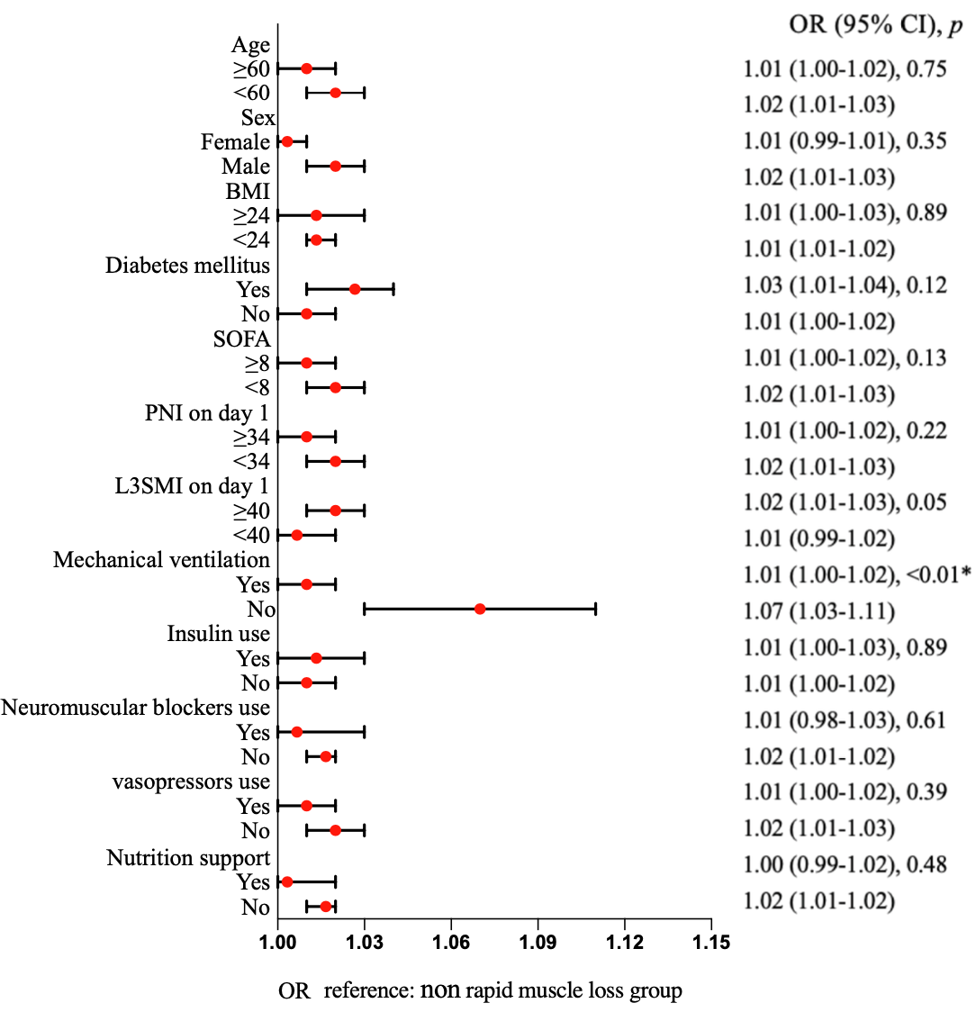
OR, odds ratio; CI, Confidence interval; AUROC, area under the receiver operating characteristic; BMI, body mass index; SOFA, sequential organ failure assessment; PNI, prognostic nutritional index; L3SMI, skeletal muscle index at L3 slices; UCR, urea-to-creatinine ratio; ΔUCR, difference in UCR between day 3 and day 1. *: p<0 .05.

