SUPPLEMENTARY INFORMATION
Cascade upconversion：a strategy enabling four-photon lithography in week light
DBPR

Supplementary numerical simulation method
The energy transmission processes involving UCNPs, TTA, photoinitiators, and monomers can be calculated and represented through the population of relevant energy levels for each particle. By conducting dynamic simulations on energy level equations, one can obtain the variation of energy level proportion for each particle over time and with initial conditions, ultimately leading to the characterization of photopolymerization under different conditions. Supplementary Figure 1 illustrates the CUC energy transmission process along with energy level labeling. Initially, the interaction between Ho³⁺Yb³⁺ doped UCNPs and the excitation light, as well as the excited-state absorption upconversion process, is shown, with the energy level equation presented as Formula (1). Here, I₁ represents the intensity of the 980 nm excitation light, $σ$denotes the absorption cross-section of UCNPs for the excitation light, Y₁ and Y₂ correspond to the ground state ²F_{7/2} and excited state ²F_{5/2} of Yb³⁺, respectively, with Yb³⁺ transferring resonant energy to Ho³⁺. H₁, H₂, and H₃ signify the ground state ⁵I₈, excited state ⁵I₇, and excited state ⁵F₅ of Ho³⁺.
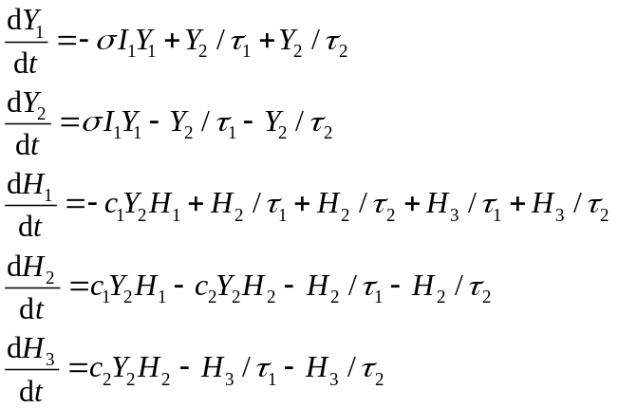 (1)
Upon excitation, Ho³⁺ relaxes to its ground state and emits red light at 645 nm, as shown in Formula (2), with the intensity of the red light emission positively correlated to the population of the Ho³⁺'s excited state ⁵F₅. I₂ represents the intensity of the 645 nm light emitted by UCNPs.
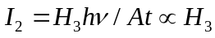 (2)
Formula (3) presents the energy level equation for the TTA system. P₁ is the ground state of the photosensitizer, whereas P₂ and P₃ represent the singlet and the triplet excited states of the photosensitizer. P₄ is the ground state of the annihilator, whereas P₅ and P₆ represent, respectively, the middle and the final excited states of the annihilator. Annihilator molecules transition from P₄ to P₅ via the triplet−triplet energy transfer (TTET), and P₅ transitions to P₆ through self-colliding.
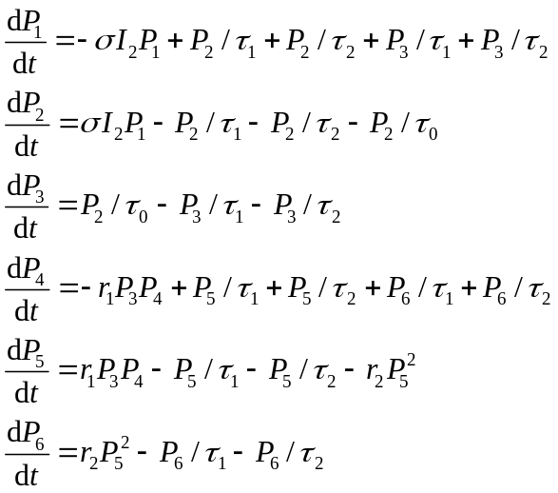 (3)
Formula (4) shows the energy level equation of photoinitiator 184. N₁ is the ground state of the photoinitiator. N₂ is excited from N₁ using the energy of P₆, and N₂ transforms into triplet state N₃ through ISC. N₃ will relax to N₁ and will be decomposed into N₄(the radical) where the radical sequentially initials the polymerization of the monomer. Formula (5) shows the process of monomer polymerization triggered by free radicals.
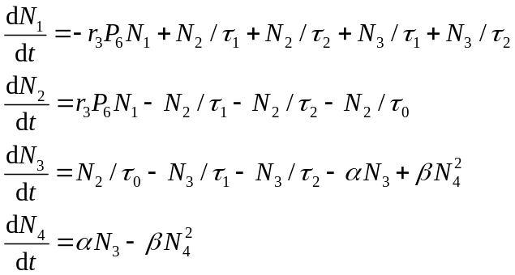 (4)
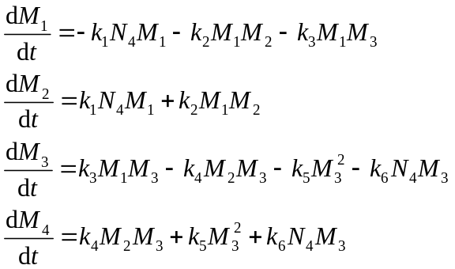 (5)
To simplify these formulas, τ₀ refers to the all ISC rate, τ₁ refers to the all nonradiative-relaxation rate, and τ₂ designates all spontaneous radiation rates. In addition, c₁ is the coupling coefficient of Y₂ and H₁, c₂ is the coupling coefficient of Y₂ and H₂. r₁ is the coupling coefficient of P₃ and P₄, whereas r₂ is the self-colliding coefficient of P₅ and r₃ is the coupling coefficient of P₆ and N₁. The α variable represents the decomposing rate of N₃, β is the recombining rate, and γ is the polymerizing rate. The k₁ variable designates the reacting coefficient of N₄ and M₁ whereas k₂ is the reacting coefficient of M₁ and M₂, k₃ is the reacting coefficient of M₁ and M₃, k₄ is the reacting coefficient of M₂ and M₃, k₅ is the self-reacting coefficient among M₃, and finally, k₆ is the reacting coefficient of N₄ and M₃. These coefficients are cited from previous experiment and simulation works. Supplementary Figure 2 illustrates the numerical simulation evolution of all energy levels over time.
A region measuring 60 μm × 60 μm with a resolution of 400 × 400 was established, allowing for individual calculation and evolution of energy level equations at each point within the area. The initial 980 nm excitation beam was Gaussian with a waist radius of 2 μm, as depicted in Supplementary Figure 3(a). Supplementary Figure 3(b-e) illustrates the simulations of three critical intermediate stages and the final polymerization outcome of Ho³⁺/Yb³⁺-doped UCNPs-TTA CUCPP. The shape of the 645 nm light spot was obtained by calculating the point spread function based on the population pattern of the Ho³⁺ H3 energy level. Supplementary Figure 5(f-h) demonstrates the simulations of two significant intermediate processes and the final polymerization result of Tm³⁺/Yb³⁺-doped UCNPs multiphoton polymerization. The shape of the UV light spot was derived by calculating the point spread function based on the population pattern of the Tm³⁺ excited state energy level. By setting the same threshold on the final photopolymerization pattern, where points above a certain value are fully polymerized, the final photopolymerization pattern can be obtained, and the relationship between the polymerization radius, irradiation time, and excitation intensity can be analyzed.

Supplementary Methods

Synthesis method for the β-NaYF4:20%Yb,10%Ho
Here, α-NaYF₄ UCNPs were selected owing to their straightforward synthesis process and controllability. To synthesize 10 nm-sized α-NaYF₄: 20%Yb, 10%Ho particles, a typical protocol involved mixing an aqueous solution comprising 1 mmol NaCF₃COO, 0.7 mmol Y(CF₃COO)₃, 0.2 mmol Yb(CF₃COO)₃, and 0.1 mmol Ho(CF₃COO)₃ with 5 mL OA, 5 mL OM, and 10 mL ODE in a 50 mL flask. The mixture was then heated to 130 °C for 30 minutes to create an optically clear solution. This was followed by heating the solution to 290 °C, maintaining it for 30 minutes under an argon atmosphere with intense stirring, and subsequently cooling it to room temperature. The resultant nanoparticles were precipitated using ethanol, separated via centrifugation at 10,000 rpm for 10 minutes, washed twice with a cyclohexane/ethanol blend, and finally re-dispersed in 10 mL cyclohexane for future applications. The synthesis approach for other core nanoparticles mirrored that for α-NaYF₄: 20%Yb, 10%Ho, with the exception of employing distinct precursors.
β-NaYF₄:20%Yb,10%Ho nanoparticles were synthesized from α-NaYF₄: 20%Yb, 10%Ho nanoparticles (obtained through the same procedure as mentioned earlier, with the exception of controlling the Na/Re ratio at 2.5) using the subsequent procedures. Firstly, a NaCF₃COO aqueous solution (2.0 mmol) and 1.0 mmol of α-NaYF₄: 20%Yb,10%Ho nanoparticles dispersed in cyclohexane were introduced into a mixture of 10 mL oleic acid (OA) and 10 mL 1-octadecene (ODE) within a 50 mL flask. The mixture was then heated to 100°C for 20 minutes to evaporate cyclohexane. Following this, the mixture underwent further heating at 130°C for 30 minutes, after which it was heated to 320°C and held at this temperature for 45 minutes under an argon atmosphere while being vigorously stirred. The resultant nanoparticles were processed as previously detailed: they were precipitated, washed, and re-dispersed in cyclohexane. Next, an aqueous solution containing 0.9 mmol YCl₃·6H₂O and 0.1 mmol ErCl₃·6H₂O was initially combined with 10 mL OA and 10 mL ODE in a 50 mL flask, and subsequently heated to 150°C for 30 minutes to yield an optically clear solution. The solution was then cooled to room temperature, whereupon 6 mmol NH₄F and 3 mmol sodium oleate were rapidly added to the reaction mixture. The solution was subsequently heated to 120°C and maintained for 30 minutes, followed by heating to 300°C and holding for 60 minutes under argon flow with vigorous stirring, prior to being cooled to room temperature. The resulting nanoparticles were precipitated with the addition of ethanol, collected via centrifugation, washed twice with a cyclohexane/ethanol blend, and ultimately re-dispersed in 10 mL cyclohexane for subsequent use.

Supplementary figures
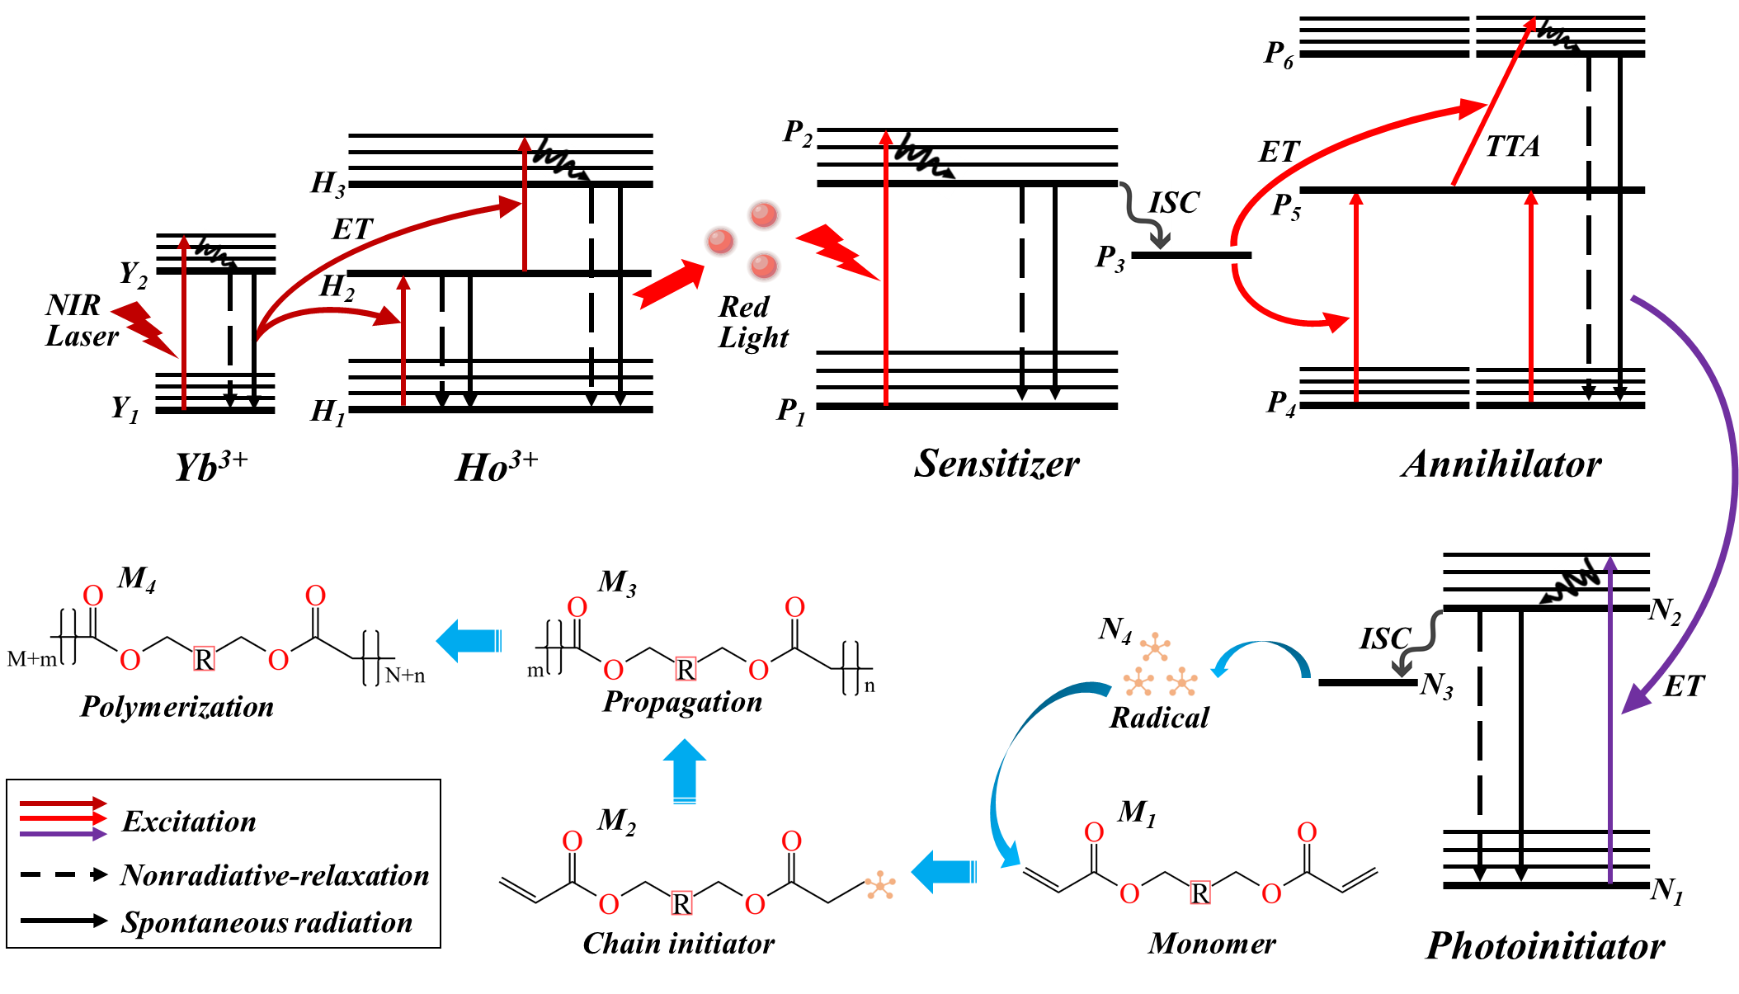
Supplementary Figure 1. Energy level structure, energy transmission process, photoinitiators generate free radical and monomer polymerization of Ho³⁺/Yb³⁺-doped UCNPs-TTA CUCPP.

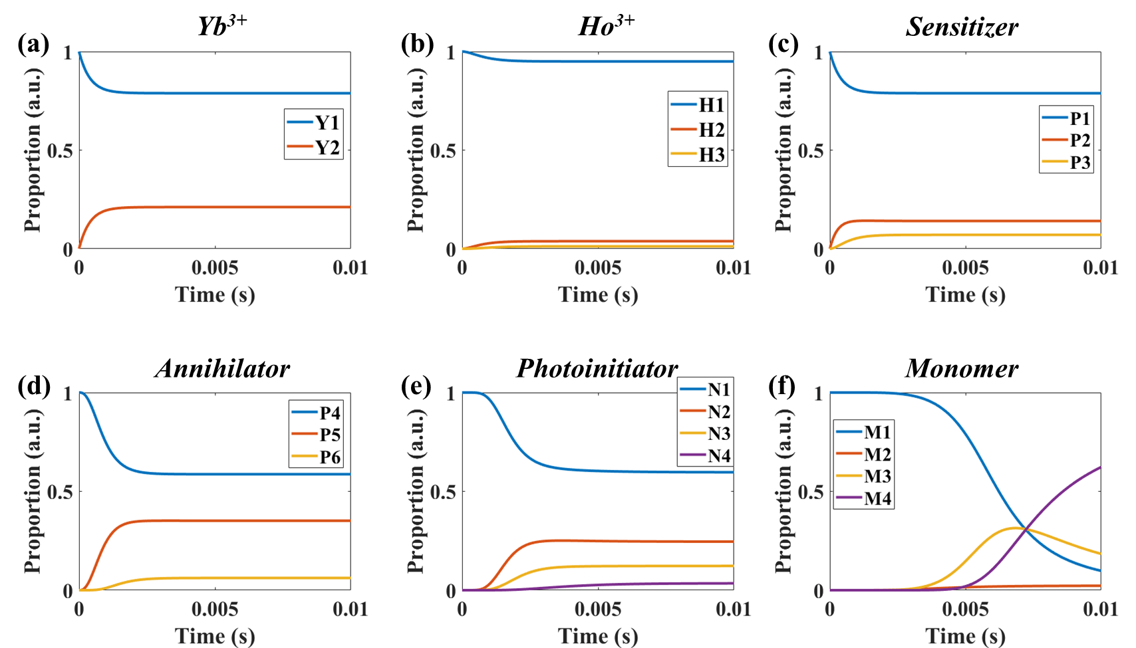
Supplementary Figure 2. Dynamic simulation of state proportion changes with increasing time: (a) Yb³⁺, (b) Ho³⁺, (c) Sensitizer, (d) annihilator, (e) photoinitiator, (f) monomer.

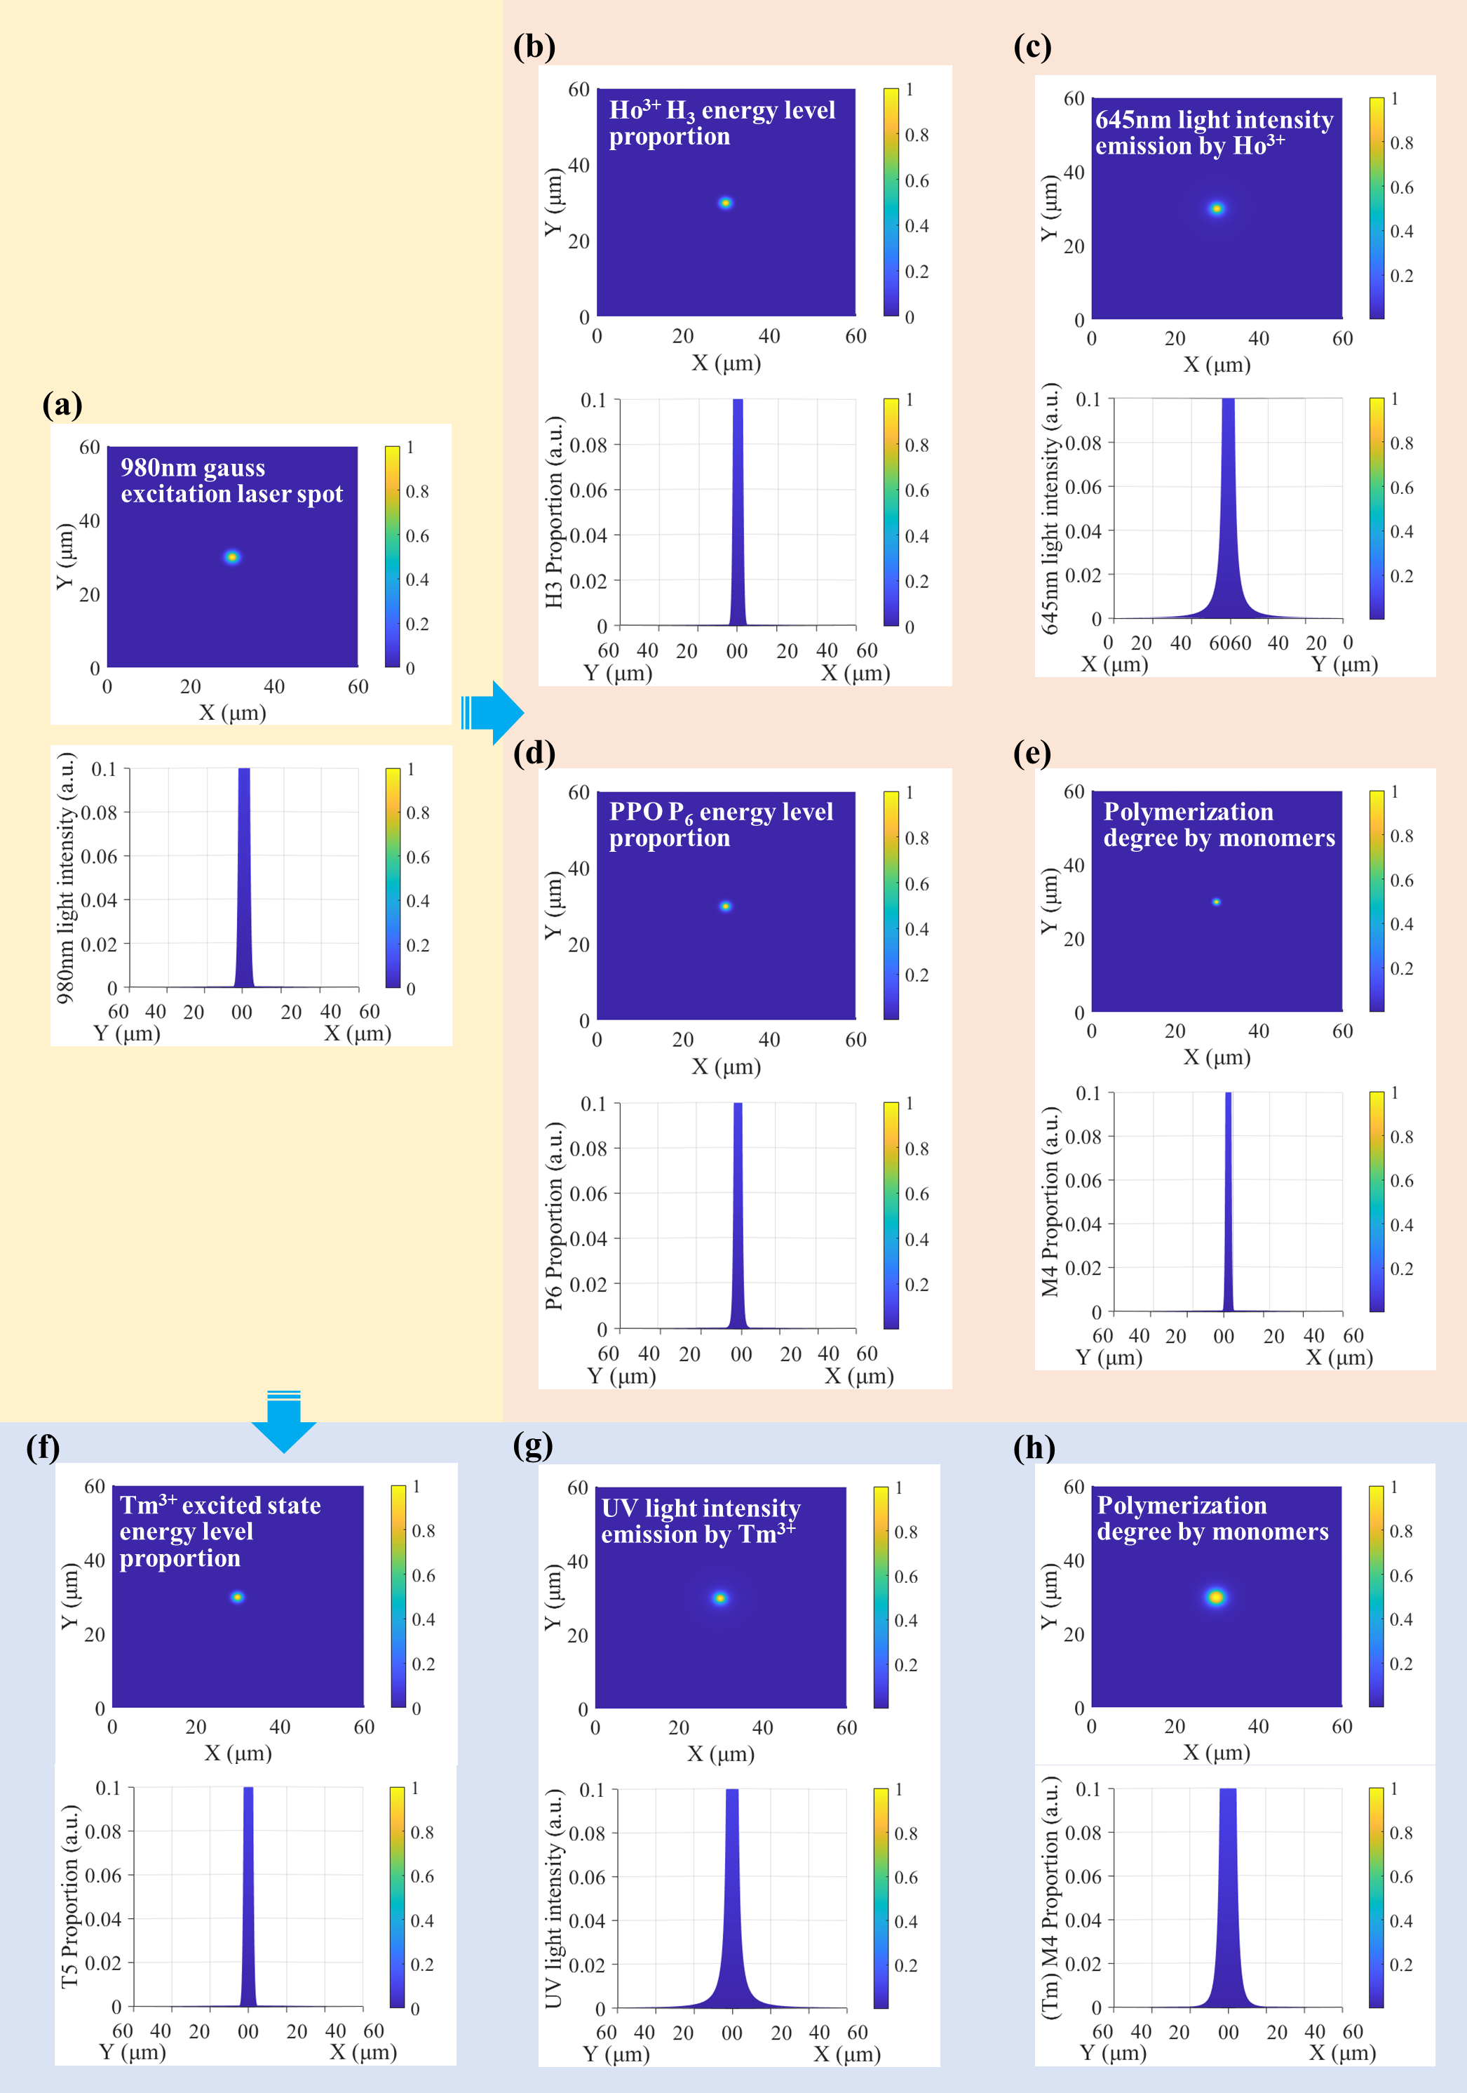
Supplementary Figure 3. (a) Numerical simulation of the 980nm excitation light spot and the lateral view of light energy distribution. (b) Numerical simulation of the Ho³⁺ H₃ energy level proportion distribution, and its lateral view. (c) Numerical simulation of the 645nm light intensity distribution emitted by Ho³⁺/Yb³⁺-doped UCNPs and its lateral view. (d) Numerical simulation of the PPO P₆ energy level proportion distribution, and its lateral view. (e) Numerical simulation of the Ho³⁺/Yb³⁺-doped UCNPs-TTA CUCPP degree, and its lateral view. (f) Numerical simulation of the Tm³⁺ excited state energy level proportion distribution, and its lateral view. (g) Numerical simulation of the UV light intensity distribution emitted by Tm³⁺/Yb³⁺-doped UCNPs and its lateral view. (h) Numerical simulation of the Tm³⁺/Yb³⁺-doped UCPP degree, and its lateral view.

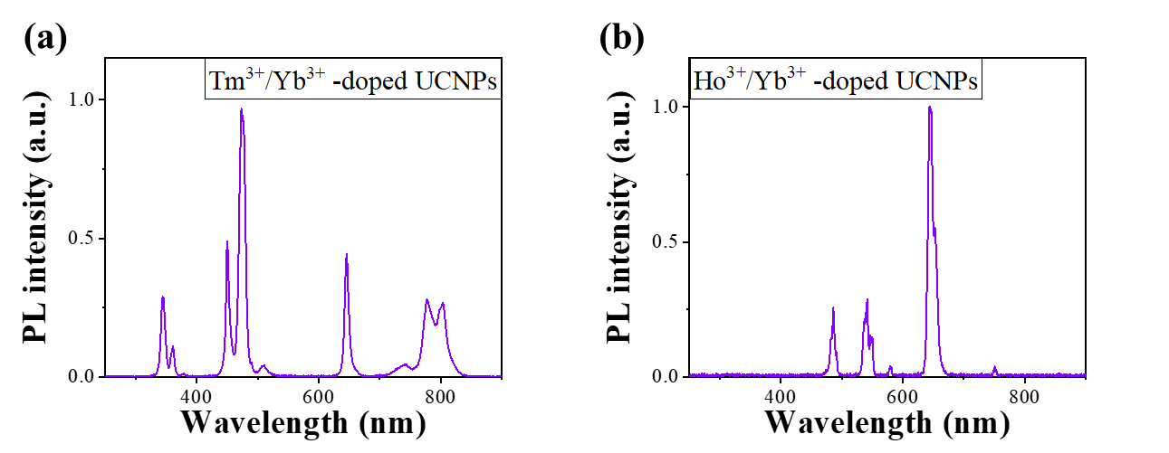
Supplementary Figure 4. (a) Spectrum of Tm³⁺-doped UCNPs excited by 980 nm laser. (a)Spectrum of Ho³⁺-doped UCNPs excited by 980 nm laser.

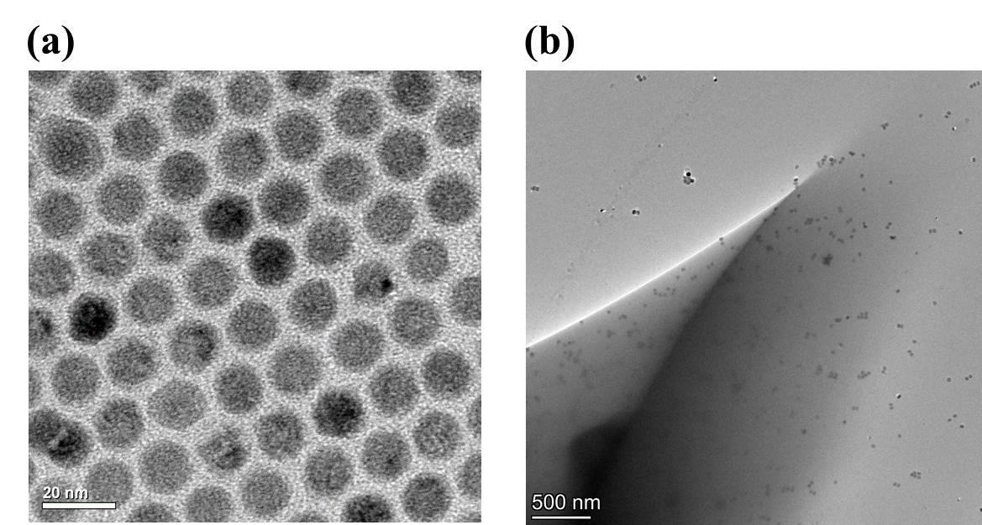
Supplementary Figure 5. (a) Transmission electron microscope images of hexagonal core-shell-shell β-NaYF₄: Ho³⁺/Yb³⁺@NaYbF₄@NaYF₄ UCNPs. (b) Transmission electron microscope images of UCNPs in Polymerized Photoresist.

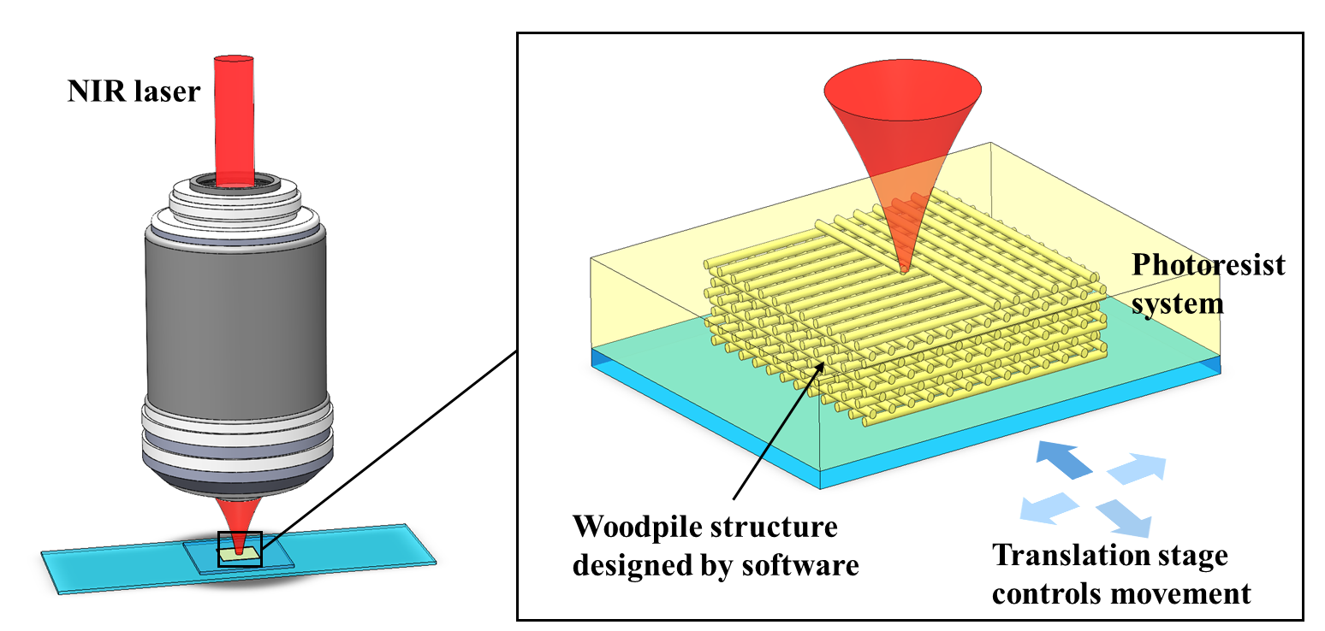
Supplementary Figure 6. NIR laser direct writing method and control

