Supplementary Material

Guangping Li^{1,#}, Yuxuan Wang^{1,#},Yan Shen^{1,2,3,#}, Haiqiong Guo^{4,}, Qingxiu He^{1,#}, Yong Hu^{1,2}, Haibin Liu^{5,*}, Zhihua Lin^{1,2,3,*} and Yuanqiang Wang^{1,2,3,*}

✉ Haibin Liu
liuhaibin@dongeejiao.com
Zhihua Lin
zhlin@cqut.edu.cn
Yuanqiang Wang
wangyqnn@cqut.edu.cn

¹School of Pharmacy and Bioengineering, Chongqing University of Technology, Chongqing, China, 400054.
²Chongqing Key Laboratory of Medicinal Chemistry & Molecular Pharmacology, Chongqing University of Technology, Chongqing, China, 400054.
³Key Laboratory of Target Based Drug Screening and Activity Evaluation, Chongqing University of Technology, Chongqing, China, 400054.
⁴State Key Laboratory of Silkworm Genome Biology, Southwest University, Chongqing, China, 400716.
⁵National Engineering Research Center for Gelatin-based Traditional Chinese Medicine, Dong-E-E-Jiao Co, 252201.

# These authors have equal contribution to the study
*Corresponding author

Supplementary Figure
Certificate of Analysis (COA) of Peptide
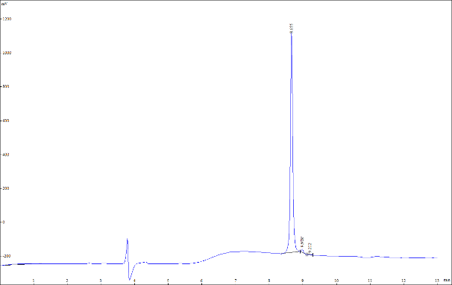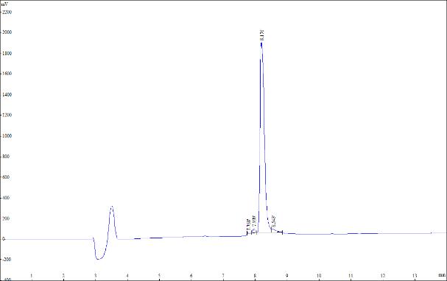
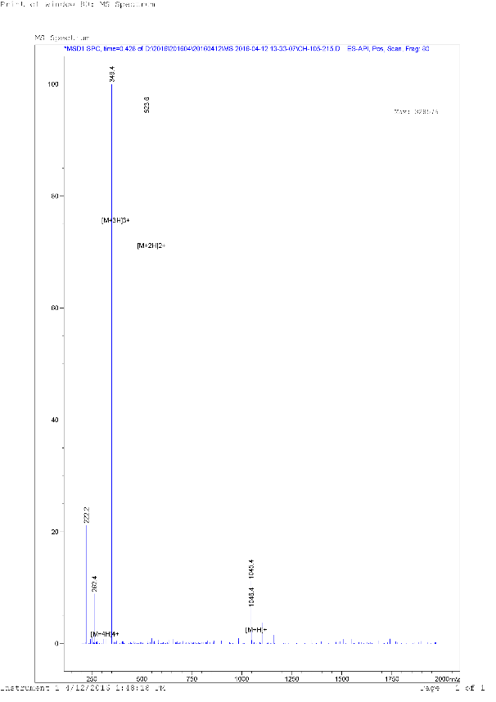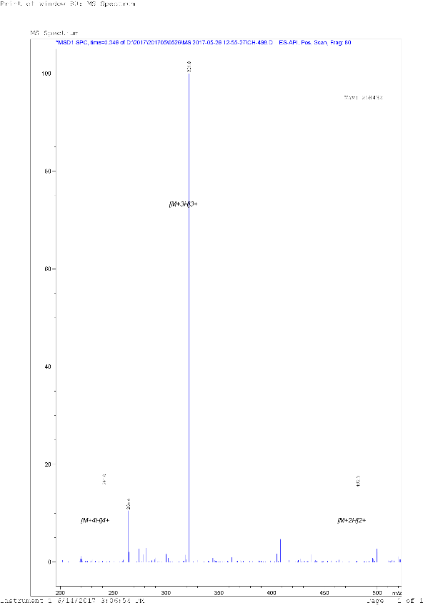
Figure S1 HPLC and MS profiles of peptide RRWWRW Figure S2 HPLC and MS profiles of peptide RRWWR-PEA
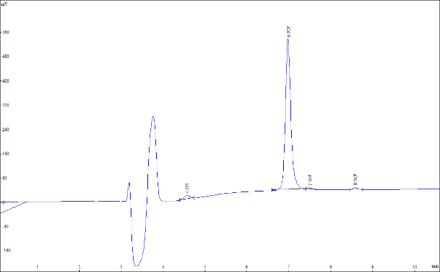
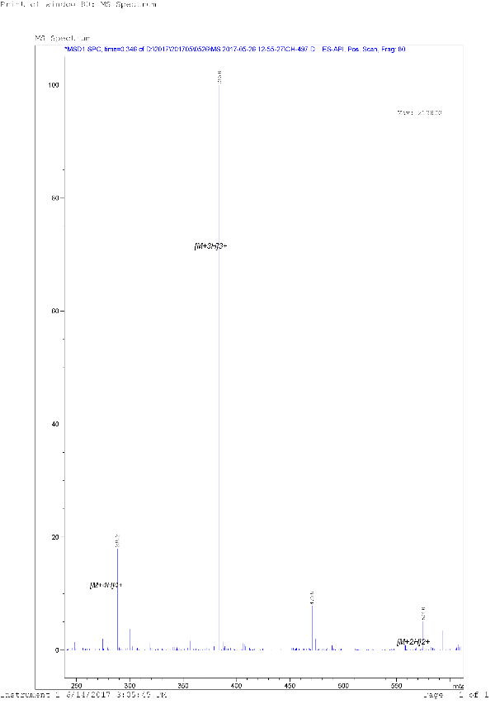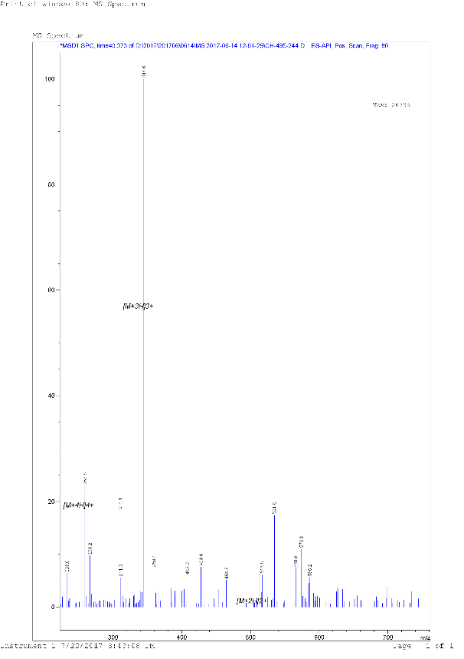
Figure S3 HPLC and MS profiles of peptide RRWWRW-PEA Figure S4 HPLC and MS profiles of peptide RRFFRF-PEA
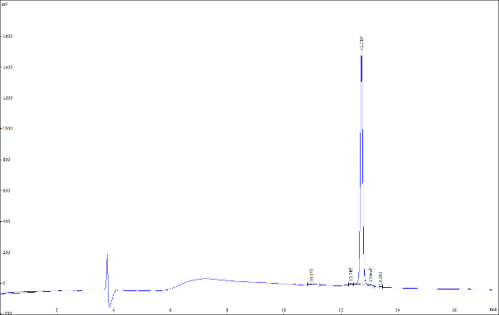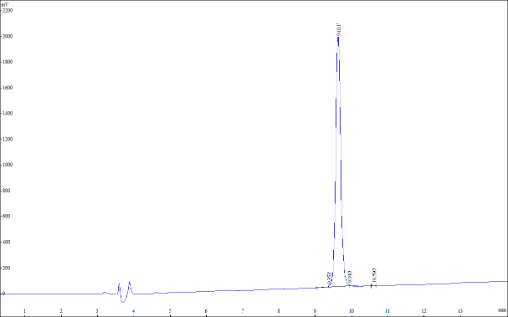
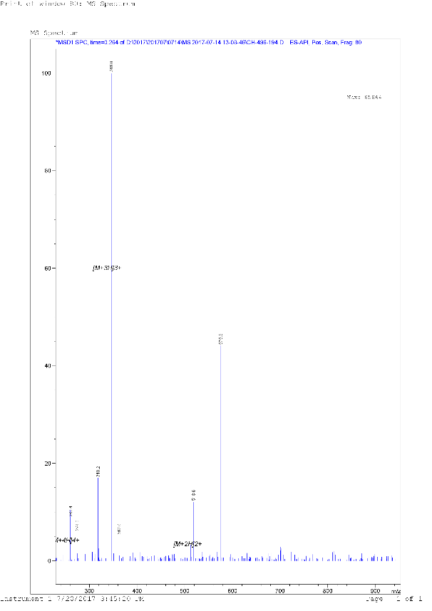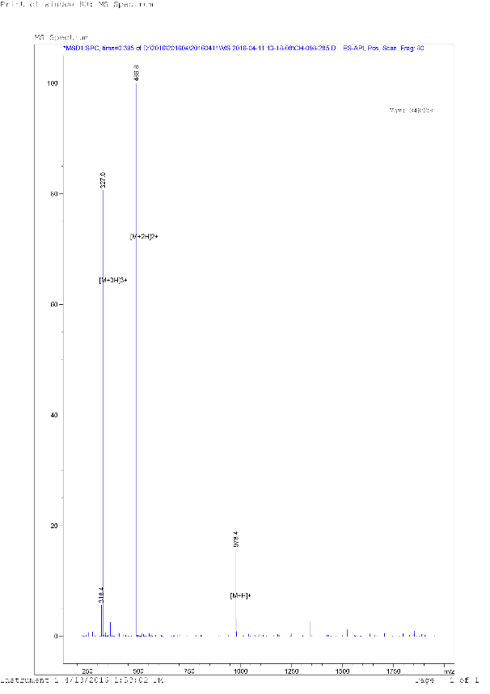
Figure S5 HPLC and MS profiles of polypeptide RR (BIP) (BIP) R-PEA Figure S6 HPLC and MS profiles of polypeptide FRWWQR
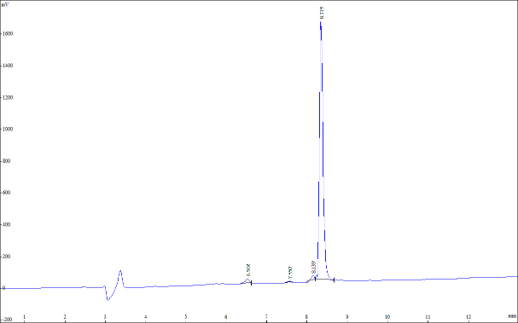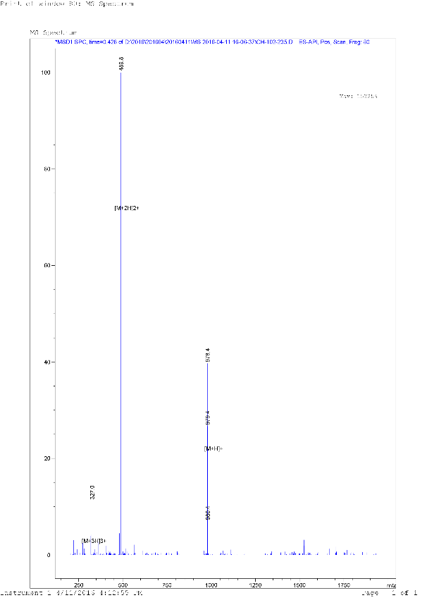
Figure S7 HPLC and MS profiles of polypeptide RRQWFW

Supplementary Table
Related data on different fields in the CoMFA and CoMSIA models
Table S1 Related data on different fields in the CoMFA model of the antimicrobial peptides against S. aureus
CoMFA | LOO |  | PLS |  |  | Normalized Coefficients
CoMFA | n | Q² | SEE | R² | F | S | E
S | 7 | 0.418 | 0.082 | 0.967 | 67.283 | 1.000
E | 5 | 0.476 | 0.204 | 0.774 | 12.310 |  | 1.000
S+E | 5 | 0.512 | 0.943 | 0.102 | 59.916 | 0.731 | 0.269

Table S2 Related data on different fields in the CoMSIA model of the antimicrobial peptides against S. aureus
CoMSIA | LOO |  | PLS |  |  |  | Normalized Coefficients
CoMSIA | n | Q² | SEE | R² | F | S | E | H | D | A
S | 7 | 0.411 | 0.116 | 0.935 | 32.791 | 1.000
E | 6 | 0.490 | 0.144 | 0.893 | 23.585 |  | 1.000
H | 7 | 0.642 | 0.038 | 0.993 | 329.290 |  |  | 1.000
D | 7 | 0.490 | 0.123 | 0.926 | 28.739 |  |  |  | 1.000
A | 6 | 0.492 | 0.068 | 0.976 | 116.912 |  |  |  |  | 1.000
S+E | 10 | 0.584 | 0.045 | 0.992 | 161.382 | 0.392 | 0.608
S+H | 7 | 0.604 | 0.040 | 0.992 | 296.519 | 0.252 |  | 0.748
S+D | 5 | 0.466 | 0.111 | 0.933 | 49.994 | 0.294 |  |  | 0.706
S+A | 10 | 0.415 | 0.017 | 0.999 | 1187.071 | 0.487 |  |  |  | 0.513
E+H | 7 | 0.666 | 0.036 | 0.994 | 358.075 |  | 0.389 | 0.611
E+D | 5 | 0.481 | 0.143 | 0.889 | 28.713 |  | 0.417 |  | 0.583
E+A | 3 | 0.209 | 0.164 | 0.836 | 34.034 |  | 0.607 |  |  | 0.393
H+D | 9 | 0.642 | 0.031 | 0.996 | 382.345 |  |  | 0.577 | 0.423
H+A | 7 | 0.564 | 0.025 | 0.997 | 766.949 |  |  | 0.696 |  | 0.304
D+A | 9 | 0.432 | 0.054 | 0.988 | 123.530 |  |  |  | 0.569 | 0.431
S+E+H | 7 | 0.645 | 0.037 | 0.993 | 339.242 | 0.164 | 0.323 | 0.513
S+E+D | 8 | 0.519 | 0.062 | 0.982 | 104.964 | 0.232 | 0.326 |  | 0.442
S+E+A | 10 | 0.492 | 0.025 | 0.998 | 543.791 | 0.268 | 0.382 |  |  | 0.350
S+H+D | 9 | 0.610 | 0.034 | 0.995 | 317.939 | 0.151 |  | 0.481 | 0.368
S+H+A | 10 | 0.542 | 0.013 | 0.999 | 1876.158 | 0.191 |  | 0.553 |  | 0.256
S+D+A | 9 | 0.492 | 0.033 | 0.995 | 335.620 | 0.232 |  |  | 0.322 | 0.446
E+H+D | 9 | 0.649 | 0.029 | 0.996 | 436.036 |  | 0.245 | 0.452 | 0.303
E+H+A | 10 | 0.571 | 0.013 | 0.999 | 1809.858 |  | 0.300 | 0.480 |  | 0.219
E+D+A | 5 | 0.436 | 0.105 | 0.940 | 56.618 |  | 0.306 |  | 0.400 | 0.294
H+D+A | 9 | 0.587 | 0.018 | 0.999 | 1133.680 |  |  | 0.447 | 0.340 | 0.212
S+E+H+D | 9 | 0.634 | 0.031 | 0.996 | 381.201 | 0.120 | 0.218 | 0.390 | 0.272
S+E+H+A | 10 | 0.572 | 0.014 | 0.999 | 1607.906 | 0.138 | 0.257 | 0.412 |  | 0.194
S+E+D+A | 10 | 0.502 | 0.027 | 0.997 | 435.475 | 0.185 | 0.237 |  | 0.316 | 0.261
S+H+D+A | 9 | 0.572 | 0.020 | 0.998 | 907.613 | 0.127 |  | 0.385 | 0.299 | 0.188
E+H+D+A | 10 | 0.584 | 0.015 | 0.999 | 1373.984 |  | 0.202 | 0.372 | 0.252 | 0.174
S+E+H+D+A | 9 | 0.580 | 0.023 | 0.998 | 662.719 | 0.106 | 0.182 | 0.325 | 0.232 | 0.155

Table S3 Related data on different fields in the CoMFA model of the antimicrobial peptides against E. coli
CoMFA | LOO |  | PLS |  |  | Normalized Coefficients
CoMFA | n | Q² | SEE | R² | F | S | E
S | 1 | 0.139 | 0.246 | 0.406 | 14.376 | 1.000
E | 3 | 0.849 | 0.130 | 0.849 | 35.735 |  | 1.000
S+E | 3 | 0.507 | 0.913 | 0.099 | 66.862 | 0.577 | 0.423

Table S4 Related data on different fields in the CoMSIA model of the antimicrobial peptides against E. coli
CoMSIA | LOO |  | PLS |  |  |  | Normalized Coefficients
CoMSIA | n | Q² | SEE | R² | F | S | E | H | D | A
S | 1 | 0.153 | 0.247 | 0.403 | 14.151 | 1.000
E | 3 | 0.293 | 0.128 | 0.855 | 37.445 |  | 1.000
H | 1 | 0.131 | 0.244 | 0.413 | 14.803 |  |  | 1.000
D | 4 | 0.196 | 0.193 | 0.687 | 9.865 |  |  |  | 1.000
A | 2 | 0.591 | 0.141 | 0.813 | 43.414 |  |  |  |  | 1.000
S+E | 3 | 0.299 | 0.119 | 0.875 | 44.355 | 0.29 | 0.71
S+H | 1 | 0.146 | 0.244 | 0.415 | 14.903 | 0.335 |  | 0.665
S+D | 3 | 0.227 | 0.185 | 0.696 | 14.478 | 0.300 |  |  | 0.700
S+A | 2 | 0.453 | 0.127 | 0.850 | 56.563 | 0.331 |  |  |  | 0.669
E+H | 6 | 0.336 | 0.067 | 0.966 | 76.278 |  | 0.465 | 0.535
E+D | 6 | 0.512 | 0.077 | 0.956 | 57.843 |  | 0.469 |  | 0.531
E+A | 2 | 0.455 | 0.118 | 0.869 | 66.133 |  | 0.555 |  |  | 0.445
H+D | 4 | 0.193 | 0.154 | 0.800 | 17.979 |  |  | 0.523 | 0.477
H+A | 6 | 0.332 | 0.039 | 0.988 | 225.720 |  |  | 0.394 |  | 0.606
D+A | 6 | 0.597 | 0.042 | 0.987 | 198.449 |  |  |  | 0.577 | 0.423
S+E+H | 6 | 0.359 | 0.065 | 0.968 | 80.507 | 0.168 | 0.400 | 0.433
S+E+D | 6 | 0.456 | 0.076 | 0.957 | 58.758 | 0.162 | 0.407 |  | 0.431
S+E+A | 3 | 0.435 | 0.088 | 0.932 | 86.497 | 0.199 | 0.448 |  |  | 0.354
S+H+D | 4 | 0.184 | 0.150 | 0.811 | 19.250 | 0.164 |  | 0.436 | 0.400
S+H+A | 6 | 0.394 | 0.035 | 0.991 | 286.687 | 0.201 |  | 0.452 |  | 0.347
S+D+A | 6 | 0.572 | 0.041 | 0.987 | 208.250 | 0.153 |  |  | 0.457 | 0.390
E+H+D | 6 | 0.436 | 0.070 | 0.963 | 69.517 |  | 0.356 | 0.326 | 0.318
E+H+A | 6 | 0.384 | 0.047 | 0.983 | 155.340 |  | 0.320 | 0.416 |  | 0.264
E+D+A | 5 | 0.573 | 0.065 | 0.966 | 96.841 |  | 0.316 |  | 0.401 | 0.284
H+D+A | 6 | 0.506 | 0.048 | 0.983 | 152.593 |  |  | 0.305 | 0.356 | 0.339
S+E+H+D | 6 | 0.432 | 0.068 | 0.965 | 73.620 | 0.105 | 0.326 | 0.289 | 0.279
S+E+H+A | 5 | 0.392 | 0.061 | 0.970 | 110.960 | 0.134 | 0.306 | 0.323 |  | 0.237
S+E+D+A | 6 | 0.554 | 0.054 | 0.978 | 120.158 | 0.124 | 0.249 |  | 0.365 | 0.262
S+H+D+A | 6 | 0.490 | 0.047 | 0.983 | 158.643 | 0.109 |  | 0.269 | 0.311 | 0.311
E+H+D+A | 6 | 0.516 | 0.052 | 0.980 | 128.966 |  | 0.228 | 0.252 | 0.296 | 0.224
S+E+H+D+A | 6 | 0.509 | 0.053 | 0.979 | 126.400 | 0.088 | 0.215 | 0.225 | 0.263 | 0.209

