Levels, influencing factors, sources and exposure assessment of organophosphate esters in fine particulate matter and total suspended particle from Nanjing, China
Huaizhou Xu ^{b}, Xinyong, Fei ^{b}, Kaili, Wang ª, Beicun Wu ª, Han, Gao ^{c}, Bingyu Wang ^{d*}, Yiqun Chen ^{a*}
ª School of Public Health, Anhui Medical University, Hefei, 230032, China
^{b} Shenzhen Ecological Environment Intelligent Control Center, Shenzhen, 518034, China
^{c} State Environmental Protection Key Laboratory of Soil Environmental Management and Pollution Control, Nanjing Institute of Environmental Sciences, Ministry of Ecology and Environment of China, Nanjing, Jiangsu 210042, China
^{d} Jiangsu Key Laboratory of Chemical Pollution Control and Resources Reuse, School of Environment and Biological Engineering, Nanjing University of Science & Technology, Jiangsu 210094, China

*Corresponding author: bingyuwang@njust.edu.cn; yiqunchen90@163.com
Table S1. Details information of thirteen organophosphate esters (OPEs).
Types | Compounds | Abbreviation | Molecular Formula | Molecular Weight | CAS | Vapor pressure  (pa. at 25°C) ^{a,b} | Log K_{OA}
Alkyl phosphate | Trimethyl phosphate | TMP | C₃H₉O₄P | 141.07 | 512-56-1 | 5.60×10⁻³ | 5.88^{c}
Alkyl phosphate | Triethyl phosphate | TEP | C₆H₁₅O₄P | 182.15 | 78-40-4 | 2.90×10⁻¹ | 6.63^{c}
Alkyl phosphate | Tripropyl phosphate | TPP | C₉H₂₁O₄P | 224.24 | 513-08-6 | 2.90×10⁻² | 6.43^{c}
Alkyl phosphate | Tributyl phosphate | TnBP | C₁₂H₂₇O₄P | 266.31 | 126-73-8 | 1.10×10⁻³ | 8.03^{d}
Alkyl phosphate | Tris(2-butoxyethyl) phosphate | TBEP | C₁₈H₃₉O₇P | 398.47 | 78-51-3 | 6.13×10⁻² | 11.4^{d}
Alkyl phosphate | Tri(2-ethylhexyl) phosphate | TEHP | C₂₄H₅₁O₄P | 434.63 | 78-42-2 | 7.50×10⁻¹ | 11.6^{d}
Halogenated phosphate | Tris(2-chloroethyl) phosphate | TCEP | C₆H₁₂Cl₃O₄P | 285.49 | 115-96-8 | 1.20×10⁻⁶ | 8.38^{d}
Halogenated phosphate | Tris(2-chloroisopropyl) phosphate | TCPP | C₉H₁₈Cl₃O₄P | 327.57 | 13674-84-5 | 3.30×10⁻⁵ | 9.77^{d}
Halogenated phosphate | Tris(1,3-dichloroisopropyl) phosphate | TDCPP | C₉H₁₅Cl₆O₄P | 430.91 | 13674-87-8 | 1.80×10⁻⁷ | 10.6^{d}
Halogenated phosphate | Tris(2,3-dibromopropyl) phosphate | TDBPP | C₉HBr₆O₄P | 697.61 | 126-72-7 | 2.10×10⁻⁷ | 13.0^{d}
Aryl phosphate | Tritolyl phosphate | TCP | C₂₁H₂₁PO₄ | 368.36 | 1330-78-5 | 7.40×10⁻⁸ | 11.9^{d}
Aryl phosphate | Triphenyl phosphate | TPhP | C₁₈H₁₅O₄P | 326.28 | 115-86-6 | 8.25×10⁻⁸ | 10.8^{d}
Aryl phosphate | 2-Ethylhexyl diphenyl phosphate | EHDPP | C₂₀H₂₇O₄P | 362.40 | 1241-94-7 | 2.25×10⁻⁴ | 11.0^{d}

K_{OA}: octanol–air partition coefficient
ª G.L. Wei, D.Q. Li, M.N. Zhou, Y.S. Liao, Z.Y. Xie, T.L. Guo, J.J. Li, S.Y. Zhang, Z.Q. Liang, 2015. Organophosphorus flame retardants and plasticizers: Sources, occurrence, toxicity and human exposure. Environ. Pollut. 196, 29–46. https://doi.org/10.1016/j.envpol.2014.09.012
^{b} Elżbieta Bruchajzer, Barbara Frydrych, Jadwiga Anna Szymańska, 2015. Organophosphorus flame retardants: Toxicity and influence on human health, Med. Pr. 66, 235–264. https://doi.org/10.13075/mp.5893.00120
^{c} A. Zhao, C. Wei, Y. Xin, X. JZ. Wang, Q. Q. Zhu, J. X. Xie, H. Y. Ma, J. Z. Xu, M. Wang, 2023. Pollution profiles, influencing factors, and source apportionment of target and suspect organophosphate esters in ambient air: A case study in a typical city of Northern China, J. Hazard. Mater. 444, 130373. https://doi.org/10.1016/j.jhazmat.2022.130373
^{d} Q.Z. Wang, H.X Zhao, Y. Wang, Q. Xie, J.W. Chen and X. Quan, 2017. Determination and prediction of octanol-air partition coefficients for organophosphate flame retardants. Ecotoxicol. Environ. Saf. 145, 283–288. https://doi.org/10.1016/j.ecoenv.2017.07.040
Table S2. The parameters in LC-MS, method limits of detection, recoveries and RSDs for thirteen organophosphate esters (OPEs).
OPEs | Parent ion (m/z) | Daughter ion (m/z) |  | MDLs (pg/m³) | DF (%) | (n=3)
 |  |  |  |  |  | Recoveries (%) | RSDs (%)
TMP | 140.9 | 108.8* | 79.1 | 4.25 | 6.50 | 73.6 | 11.1
TEP | 182.6 | 127.0 | 98.7* | 0.05 | 100 | 89.2 | 6.53
TPP | 225.1 | 98.9* | 141.1 | 0.03 | 10.9 | 80.4 | 7.95
TnBP | 267.1 | 155.0 | 98.9* | 0.58 | 82.6 | 87.8 | 8.79
TBEP | 399.2 | 298.9 | 198.9* | 0.45 | 71.7 | 94.3 | 3.21
TEHP | 435.5 | 98.7* | 112.9 | 0.15 | 100 | 91.6 | 4.67
TCEP | 284.8 | 223.1* | 99.3 | 1.45 | 100 | 105 | 8.35
TCPP | 327.0 | 174.7 | 99.0* | 8.17 | 87.0 | 111 | 9.15
TDCPP | 430.9 | 208.7 | 99.0* | 1.32 | 100 | 76.3 | 6.19
TDBPP | 698.5 | 500.8 | 299.1* | 0.93 | 78.3 | 86.1 | 10.3
TCP | 369.3 | 243.3 | 164.8* | 0.10 | 100 | 93.2 | 5.49
TPhP | 327.1 | 214.9* | 152.1 | 0.05 | 100 | 74.7 | 4.97
EHDPP | 362.7 | 250.9* | 151.9 | 1.48 | 89.1 | 83.9 | 7.52
*ions for quantitative determination
Table S3. Details of meteorological parameters in sampling site.

Number | Time | Weather | Average temperature (°C) | Average relative humidity (%) | Average pressure (hPa) | Average wind speed (Km/h)
1 | 2017/06/20 | shower to cloudy | 26.4 | 73 | 1003.1 | 5
2 | 2017/06/21 | overcast | 26.3 | 85 | 1004.9 | 13
3 | 2017/06/22 | overcast | 23.4 | 95 | 1006.0 | 11
4 | 2017/06/23 | shower to heavy rain | 24.9 | 92 | 1003.9 | 8
5 | 2017/06/24 | thundershower to overcast | 26.4 | 80 | 1001.5 | 5
6 | 2017/06/25 | thundershower to overcast | 27.8 | 70 | 1004.1 | 7
7 | 2017/06/28 | thundershower to overcast | 25.6 | 85 | 1009.3 | 6
8 | 2017/06/29 | cloudy to thundershower | 25.9 | 78 | 1008.1 | 7
9 | 2017/06/30 | thundery to moderate/heavy rain | 26.0 | 90 | 1006.3 | 6
10 | 2017/07/03 | thundershower | 26.9 | 87 | 1005.4 | 7
11 | 2017/07/04 | thundershower to overcast | 28.9 | 78 | 1006.7 | 8
12 | 2017/07/05 | thundershower to cloudy | 29.2 | 84 | 1007.7 | 5
13 | 2017/07/07 | thundershower to cloudy | 29.1 | 80 | 1005.6 | 6
14 | 2017/07/08 | thundershower | 28.6 | 84 | 1005.4 | 6
15 | 2017/07/09 | thundershower to cloudy | 28.4 | 84 | 1002.2 | 9
16 | 2017/07/11 | thundershower to cloudy | 28.9 | 79 | 1008.0 | 6
17 | 2017/07/12 | cloudy | 31.4 | 74 | 1007.6 | 6
18 | 2017/07/13 | cloudy | 31.4 | 75 | 1005.7 | 8
19 | 2017/08/22 | cloudy to sunny | 29.9 | 76 | 1007.0 | 12
20 | 2017/08/23 | sunny | 31.1 | 81 | 1007.0 | 13
21 | 2017/08/24 | cloudy thundershower to | 31.8 | 81 | 1008.0 | 9
22 | 2017/08/27 | sunny to cloudy | 27.9 | 78 | 1010.7 | 10
23 | 2017/08/28 | cloudy to overcast | 31.1 | 77 | 1010.8 | 10
24 | 2017/08/29 | thundershower to overcast | 25.9 | 85 | 1014.6 | 13
25 | 2017/09/01 | cloudy to overcast | 23.8 | 78 | 1011.3 | 11
26 | 2017/09/02 | overcast to shower | 22.9 | 81 | 1011.0 | 11
27 | 2017/09/03 | moderate rain to thundershower | 21.9 | 96 | 1010.8 | 13
28 | 2017/09/06 | moderate rain to shower | 24.4 | 95 | 1009.3 | 7
29 | 2017/09/07 | cloudy | 24.8 | 87 | 1011.1 | 5
30 | 2017/09/08 | cloudy | 24.8 | 82 | 1010.9 | 10
31 | 2017/09/12 | sunny | 23.9 | 84 | 1017.1 | 6
32 | 2017/09/13 | cloudy | 24.9 | 72 | 1018.3 | 12
33 | 2017/09/14 | sunny to cloudy | 23.6 | 70 | 1016.1 | 12
34 | 2017/09/18 | sunny to cloudy | 25.0 | 69 | 1010.3 | 6
35 | 2017/09/19 | shower | 25.6 | 81 | 1011.7 | 7
36 | 2017/09/20 | shower to overcast | 21.6 | 95 | 1013.8 | 7
37 | 2017/09/23 | shower to light/moderate rain | 22.1 | 992 | 1014.9 | 9
38 | 2017/09/24 | heavy rain to shower | 21.2 | 99 | 1010.9 | 11
39 | 2017/09/25 | heavy rain to shower | 22.8 | 100 | 1008.2 | 6
40 | 2017/09/26 | overcast | 26.6 | 94 | 1009.1 | 9
41 | 2017/09/27 | shower | 22.5 | 95 | 1012.8 | 11
42 | 2017/09/28 | cloudy to overcast | 21.2 | 77 | 1016.6 | 5
43 | 2017/10/09 | sunny | 24.1 | 87 | 1016.8 | 11
44 | 2017/10/10 | thundershower | 24.4 | 92 | 1018.9 | 13
45 | 2017/10/11 | shower to light/moderate rain | 15.7 | 99 | 1023.0 | 11
46 | 2017/10/17 | light rain | 17.0 | 85 | 1024.4 | 10
47 | 2017/10/18 | overcast | 16.3 | 84 | 1022.3 | 13
48 | 2017/10/19 | cloudy | 16.1 | 84 | 1020.5 | 8
49 | 2017/10/29 | cloudy | 15.7 | 66 | 1030.4 | 11
50 | 2017/10/30 | sunny | 11.8 | 58 | 1030.2 | 6
51 | 2017/10/31 | sunny | 12.9 | 64 | 1024.0 | 8
52 | 2017/11/01 | sunny to cloudy | 15.7 | 66 | 1019.7 | 4
53 | 2017/11/02 | cloudy | 17.2 | 65 | 1018.8 | 5
54 | 2017/11/03 | cloudy | 16.1 | 72 | 1029.0 | 12
55 | 2017/11/10 | cloudy | 16.3 | 69 | 1022.6 | 10
56 | 2017/11/11 | cloudy to overcast | 12.6 | 51 | 1023.4 | 10
57 | 2017/11/12 | cloudy to overcast | 14.7 | 64 | 1019.4 | 8
58 | 2017/11/15 | cloudy to overcast | 15.1 | 71 | 1021.7 | 7
59 | 2017/11/16 | light rain | 13.6 | 86 | 1018.0 | 14
60 | 2017/11/17 | light rain | 14.7 | 93 | 1019.5 | 14
61 | 2017/11/24 | sunny to cloudy | 8.6 | 49 | 1027.9 | 5
62 | 2017/11/25 | cloudy | 11.5 | 51 | 1024.8 | 5
63 | 2017/11/26 | cloudy | 11.1 | 58 | 1027.1 | 9
64 | 2017/11/27 | cloudy | 11.3 | 71 | 1021.1 | 14
65 | 2017/11/28 | light rain | 12.9 | 81 | 1023.3 | 5
66 | 2017/11/29 | light to moderate rain | 11.7 | 68 | 1028.0 | 14
67 | 2017/12/02 | cloudy | 7.5 | 72 | 1025.8 | 6
68 | 2017/12/03 | cloudy | 9.1 | 75 | 1024.9 | 5
69 | 2017/12/04 | sunny | 8.3 | 71 | 1029.4 | 7

Table S4. The mass concentration of PM_{2.5} and TSP collected at sampling time.
Sampling time | PM_{2.5} (µg/m³) | TSP (µg/m³) | The proportion of PM_{2.5} to TSP
2017/06/20 | 106 | 146 | 72.4%
2017/06/23 | 107 | 159 | 67.3%
2017/06/28 | 118 | 144 | 82.1%
2017/07/03 | 18.9 | 40.2 | 47.1%
2017/07/07 | 33.6 | 69.4 | 48.4%
2017/07/11 | 41.2 | 80.2 | 51.4%
2017/08/22 | 49.5 | 100 | 49.4%
2017/08/27 | 33.6 | 79.5 | 42.3%
2017/09/01 | 92.7 | 158 | 58.7%
2017/09/06 | 62.0 | 111 | 55.7%
2017/09/12 | 74.8 | 177 | 42.2%
2017/09/18 | 122 | 155 | 78.8%
2017/09/23 | 103 | 140 | 73.4%
2017/09/26 | 39.2 | 82.0 | 47.8%
2017/10/09 | 70.4 | 106 | 66.6%
2017/10/17 | 59.5 | 107 | 55.6%
2017/10/29 | 95.7 | 165 | 57.9%
2017/11/01 | 90.0 | 202 | 44.6%
2017/11/10 | 110 | 209 | 52.6%
2017/11/15 | 65.7 | 136 | 48.3%
2017/11/24 | 145 | 263 | 55.0%
2017/11/27 | 98.7 | 217 | 45.4%
2017/12/02 | 116 | 197 | 59.0%

Table S5. The concentration of OPEs in PM_{2.5} and TSP (p value < 0.05 are highlighted).
OPEs | PM_{2.5} (pg/m³) |  |  |  | TSP (pg/m³) |  |  |  | Z | p
OPEs | Range | Median | Mean | Std. | Range | Median | Mean | Std. | Z | p
TEP | 0.86−3.14 | 1.87 | 1.94 | 0.68 | 1.26−5.10 | 2.77 | 2.90 | 1.24 | -2.67 | 0.008
TnBP | ND−22.5 | 2.00 | 3.98 | 5.16 | ND−22.0 | 1.76 | 4.43 | 5.52 | -0.44 | 0.965
TBEP | ND−0.86 | 0.65 | 0.64 | 0.10 | ND−1.05 | 0.70 | 0.73 | 0.20 | -1.03 | 0.303
TEHP | 5.36−29.4 | 18.0 | 18.1 | 6.20 | 10.2−54.0 | 28.9 | 31.6 | 11.1 | -4.09 | <0.001
TCEP | 9.80−26.9 | 14.4 | 15.7 | 4.38 | 11.8−26.3 | 18.5 | 18.8 | 4.13 | -2.56 | 0.010
TCPP | ND−353 | 15.4 | 76.5 | 117 | ND−272 | 14.6 | 57.8 | 87.7 | -0.45 | 0.655
TDCPP | 1.59−3.41 | 2.25 | 2.33 | 0.48 | 1.59−3.30 | 2.27 | 2.43 | 0.41 | -0.70 | 0.482
TDBPP | ND−2.13 | 1.41 | 1.36 | 0.34 | ND−2.44 | 1.62 | 1.51 | 0.43 | -1.30 | 0.195
TCP | 0.66−3.50 | 1.61 | 1.77 | 0.75 | 0.77−4.44 | 2.28 | 2.34 | 0.93 | -2.16 | 0.030
TPhP | 6.17−82.4 | 16.2 | 23.0 | 20.6 | 4.65−91.6 | 20.3 | 28.9 | 24.5 | -0.76 | 0.448
EHDPP | ND−5.48 | 2.43 | 2.54 | 0.92 | ND−6.39 | 2.96 | 2.99 | 1.28 | -1.10 | 0.273
ΣAlkyl-OPEs | 12.8−34.3 | 22.3 | 23.8 | 5.99 | 13.3−60.5 | 35.5 | 38.6 | 13.1 | -4.01 | <0.001
ΣHalogenated-OPEs | 13.3−374 | 33.9 | 82.4 | 113 | 18.9−301 | 35.1 | 75.1 | 86.3 | -1.04 | 0.297
ΣAryl-OPEs | 8.05−87.8 | 21.2 | 27.0 | 21.2 | 5.48−8.16 | 23.8 | 34.0 | 25.5 | -1.13 | 0.258
ΣOPEs | 57.0−404 | 93.0 | 133 | 106 | 37.7−354 | 126 | 148 | 83.7 | -1.62 | 0.106
ND: no detected.
Table S6. The mass normalized concentration of OPEs in PM_{2.5} and TSP (p value< 0.05 are highlighted).
OPEs | PM_{2.5} (ng/g) |  |  |  | TSP (ng/g) |  |  |  | Z | p
OPEs | Range | Median | Mean | Std. | Range | Median | Mean | Std. | Z | p
TEP | 12.7−45.2 | 27.0 | 26.6 | 8.55 | 11.8−37.3 | 20.0 | 21.2 | 6.12 | -2.30 | 0.022
TnBP | ND−1186 | 16.6 | 89.1 | 243 | ND−153 | 9.98 | 32.6 | 46.9 | -1.32 | 0.188
TBEP | ND−25.5 | 4.31 | 5.43 | 6.95 | ND−14.7 | 5.56 | 5.51 | 3.45 | -2.10 | 0.036
TEHP | 103-712 | 215 | 265 | 148 | 105−492 | 216 | 243 | 96.3 | -0.10 | 0.921
TCEP | 70.7-762 | 191 | 248 | 162 | 51.9−362 | 138 | 155 | 69.1 | -2.43 | 0.015
TCPP | ND−6074 | 180 | 974 | 1577 | ND−2991 | 99.8 | 473 | 765 | -2.26 | 0.024
TDCPP | 13.6−117 | 27.7 | 36.7 | 23.6 | 9.92−47.8 | 19.0 | 19.8 | 8.32 | -3.75 | <0.001
TDBPP | ND−29.5 | 14.0 | 13.6 | 9.08 | ND−16.3 | 8.91 | 7.94 | 5.12 | -3.64 | <0.001
TCP | 6.18−102 | 22.6 | 29.1 | 23.9 | 4.87−56.8 | 14.8 | 19.5 | 12.5 | -1.55 | 0.121
TPhP | 54.2−712 | 195 | 297 | 209 | 49.1−465 | 167 | 191 | 131 | -1.59 | 0.111
EHDPP | ND−123 | 24.9 | 36.1 | 30.9 | ND−56.0 | 16.6 | 22.0 | 15.8 | -2.74 | 0.006
ΣAlkyl-OPEs | 138−1515 | 281 | 386 | 303 | 129−548 | 255 | 302 | 125 | -0.60 | 0.546
ΣHalogenated-OPEs | 94.0−6554 | 462 | 1273 | 1678 | 103−3224 | 250 | 655 | 798 | -1.77 | 0.077
ΣAryl-OPEs | 78.0−851 | 281 | 362 | 232 | 68.9−528 | 225 | 233 | 136 | -1.81 | 0.070
ΣOPEs | 424−7628 | 1230 | 2021 | 1857 | 474−3889 | 850 | 1189 | 830 | -2.01 | 0.044
ND: no detected.
Table S7. Component matrix and total variance of OPEs in PM_{2.5} and TSP (values>0.4 are highlighted).
OPEs | PM_{2.5} |  |  |  | TSP
OPEs | PC1(28.2%) | PC2(19.7%) | PC3(15.9%) | PC4(11.4%) | PC1(38.6%) | PC2(15.6%) | PC3(11.9%) | PC4(9.82%)
TEP | 0.453 | -0.089 | -0.279 | 0.102 | 0.404 | -0.221 | 0.321 | -0.113
TnBP | -0.289 | -0.086 | 0.251 | 0.614 | 0.021 | 0.381 | 0.389 | 0.060
TBEP | 0.067 | 0.322 | 0.476 | -0.351 | 0.227 | 0.303 | -0.564 | 0.145
TEHP | 0.408 | 0.303 | 0.147 | -0.289 | 0.403 | 0.107 | -0.182 | -0.027
TCEP | -0.164 | 0.514 | -0.074 | 0.224 | 0.259 | 0.367 | 0.117 | -0.391
TCPP | -0.222 | 0.435 | -0.110 | 0.100 | -0.095 | 0.574 | 0.047 | -0.139
TDCPP | 0.0234 | 0.307 | -0.417 | 0.107 | 0.261 | 0.230 | 0.473 | 0.421
TDBPP | 0.341 | 0.319 | -0.339 | 0.189 | 0.425 | 0.062 | -0.003 | -0.154
TCP | 0.323 | 0.153 | 0.455 | 0.194 | 0.373 | -0.042 | -0.322 | -0.164
TPhP | 0.431 | -0.324 | -0.056 | 0.211 | 0.329 | -0.424 | 0.190 | -0.115
EHDPP | 0.238 | 0.108 | 0.309 | 0.465 | 0.223 | -0.011 | -0.120 | 0.741

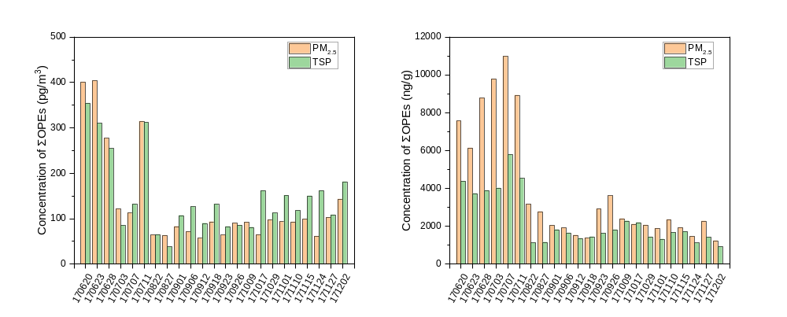
Fig. S1. (a) The concentration of ΣOPEs (pg/m³) in PM_{2.5} and TSP, (b) the mass normalized concentration of ΣOPEs (ng/g) in PM_{2.5} and TSP. (X-axis refer to sampling time, displayed in terms of year, month, and date)
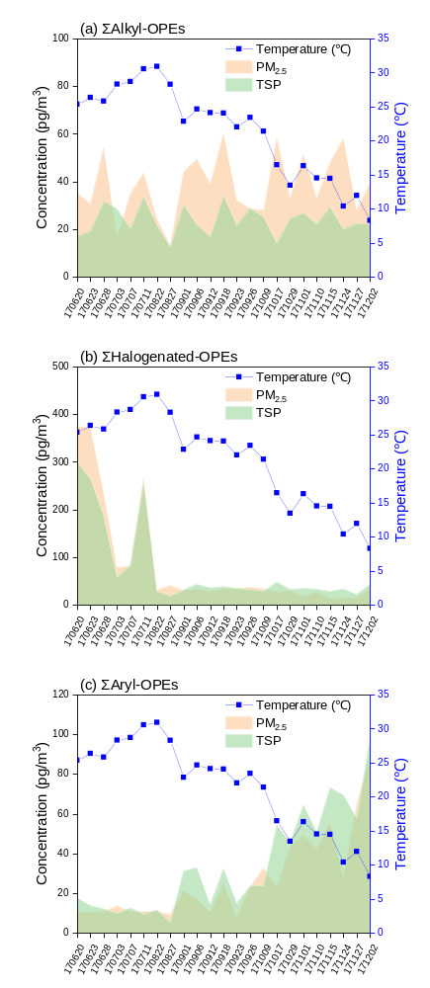
Fig. S2. The temperature and concentration of OPEs (PM_{2.5} colored in orange and TSP colored in green) at different sampling days, (a) alkyl-OPEs, (b) halogenated-OPEs and (c) aryl-OPEs. (X-axis refer to sampling time, displayed in terms of year, month, and date)
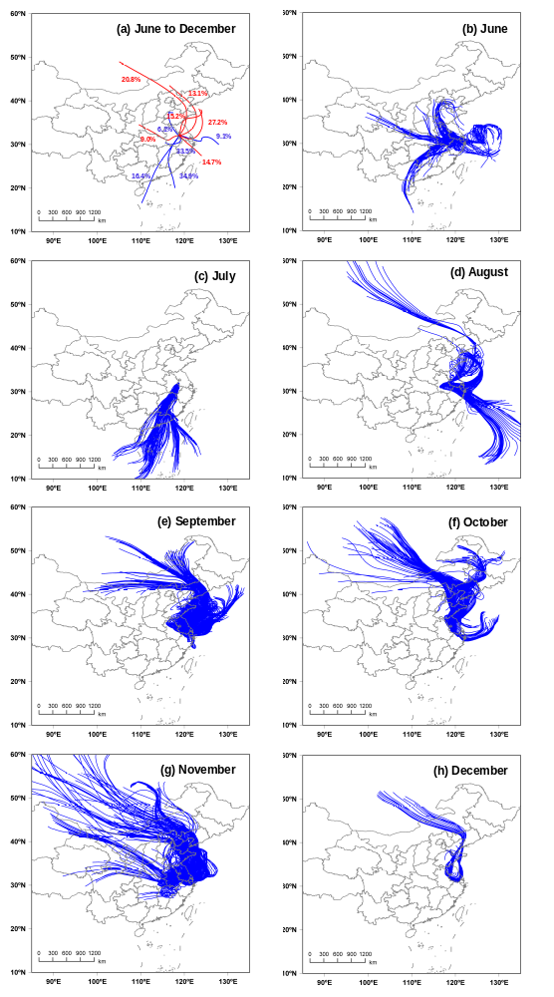
Fig. S3. Cluster of air mass trajectories at different sampling periods. (a) June to July colored in blue, and August to December colored in red, (b) June, (c) July, (d) August, (e) September, (f) October, (g) November, (h) December.

