Additional TREM2 genotype identification methods
TREM2 genotype identification was conducted in F0 and F1 generation mice using polymerase chain reaction (PCR). Initially, a male and a female homozygous TREM2 knockout (KO) mouse were purchased as the F0 generation. These mice produced four offspring, constituting the F1 generation. PCR was employed to confirm the TREM2 genotype in both F0 and F1 generations. Specifically, toe samples were collected from these mice and one wildtype (WT) mouse, which served as a control for TREM2 genotype identification. Total DNA extraction from the samples was performed using an Animal Genomic DNA Quick Extraction Kit for PCR Analysis (Cat# D0065S, Beyotime Biotechnology, Shanghai, China), following the manufacturer’s protocol. PCR reactions were set up in 20 µl volumes on a PCR System (Bio-Rad, USA). Each 20 µl PCR reaction included 8 µl ddH₂O, 10 µl 2 × Taq Master Mix (Cat# P112-AA, Vazyme), 0.5 µl forward primer (10 pmol/µl), 0.5 µl reverse primer (10 pmol/µl), and 1 µl genomic DNA. The PCR protocol began with an initial denaturation step at 95 °C for 5 minutes, followed by 10 cycles of 30 seconds at 95 °C, 30 seconds at 60 °C, and an extension step at 68 °C with a rate of 1 kilobase per minute. This was succeeded by 26 cycles of 30 seconds at 95 °C, 30 seconds at 55 °C, and an extension step at 72 °C with the same extension rate. Finally, a 5-minute extension at 72 °C was performed, followed by a 2-minute holding step at 10 °C. Agarose gel electrophoresis was performed using 2% agarose gel (Cat# 1110GR100, BioFroxx), and DNA bands were visualized using GelstainRedTM nucleic acid dye (Cat# S2009L, UE). DNA fragment sizes were determined using a DNA marker (Cat# BM411-02, Trans DNA Marker II). The primer sequences used for identifying TREM2 mutant genotype were as follows: forward primer, 5’-TTACACAAGACTGGAGCCCTGAGGA-3’; reverse primer, 5’-TCTGACCACAGGTGTTC CCG-3’. The primer sequences for the WT genotype were as follows: forward primer, 5’-CCCTAGGAATTCCTGGATTCTCCC-3’; reverse primer, 5’-TCTGACCACAGGTGTTCCC G-3’.

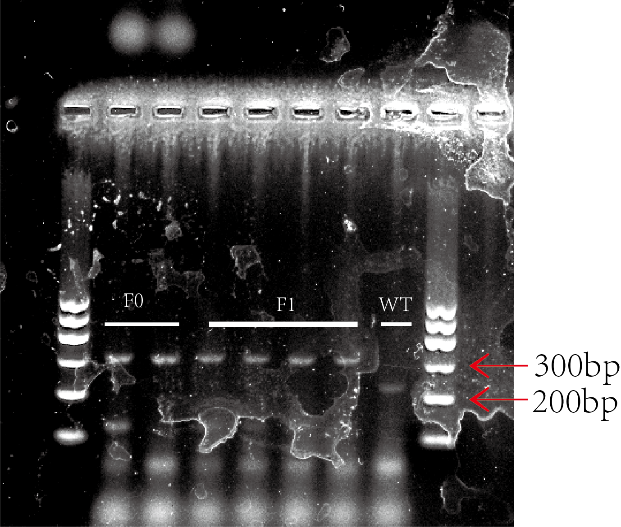
Figure S1 Image of TREM2 genotype identification.
TREM2 genotype identification displays a mutant band at approximately 300 bp and a wild-type (WT) band at around 200 bp. Accordingly, all F0 and F1 mice were genotyped as homozygous for TREM2 KO. The adult male TREM2 KO mice used in this study were progeny of the F1 generation.
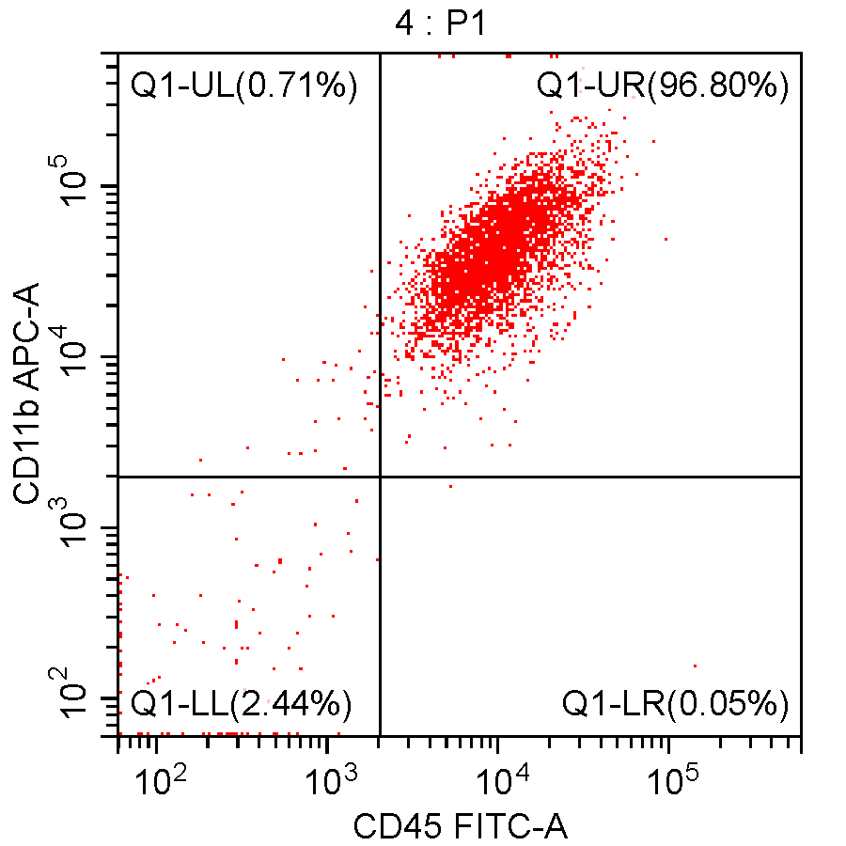
Figure S2 Detection the purity of magnetically sorted microglial cells by Flow cytometry.
Surface markers of microglia were identified as CD45⁺CD11b⁺. Cells were isolated from the suspended brain cell mixture of mice using CD11b beads. Analysis of CD45⁺ CD11b⁺ expression indicated a microglial cell purity exceeding 95%.
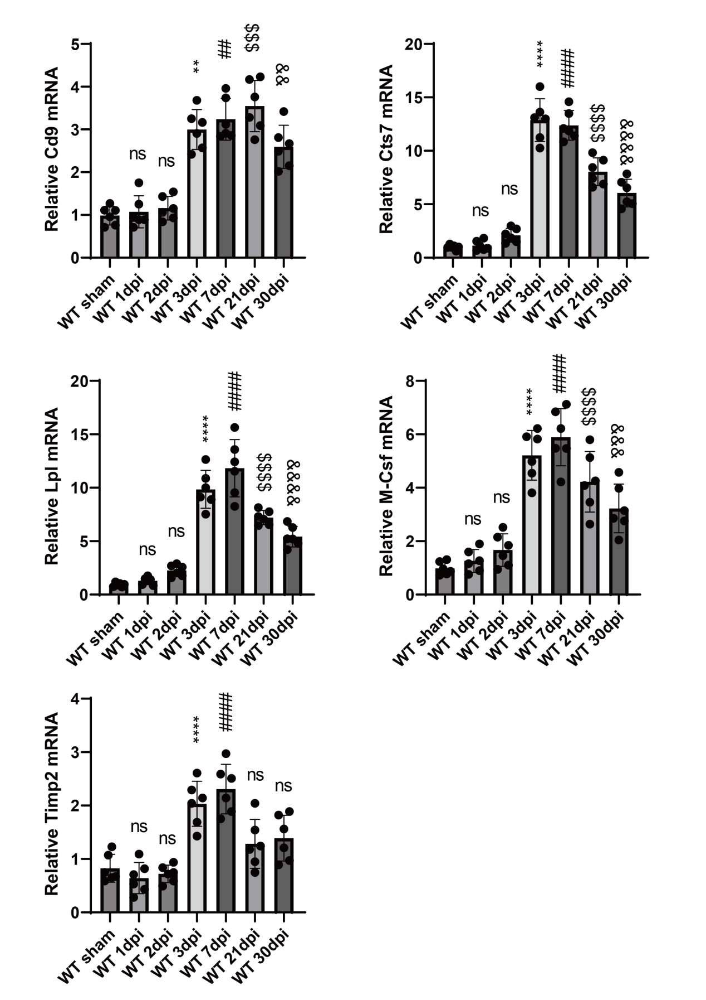
Figure S3 DAM marker genes expressed in microglia from TBI mouse at different time point.
Relative gene expression in microglia in TBI mice lesion at different time point and sham mice (n = 6 per group). Selected DAM marker genes: Cd9、Cst7、Lpl、M-Csf、Timp2.Data are expressed as the means ± S.D. WT Sham vs. WT TBI at different time point;**P < 0.01,****P < 0.0001;##P < 0.01,####P < 0.0001;$$$P < 0.001,$$$$P < 0.0001;&&P < 0.01,&&&P < 0.001,&&&&P < 0.0001.

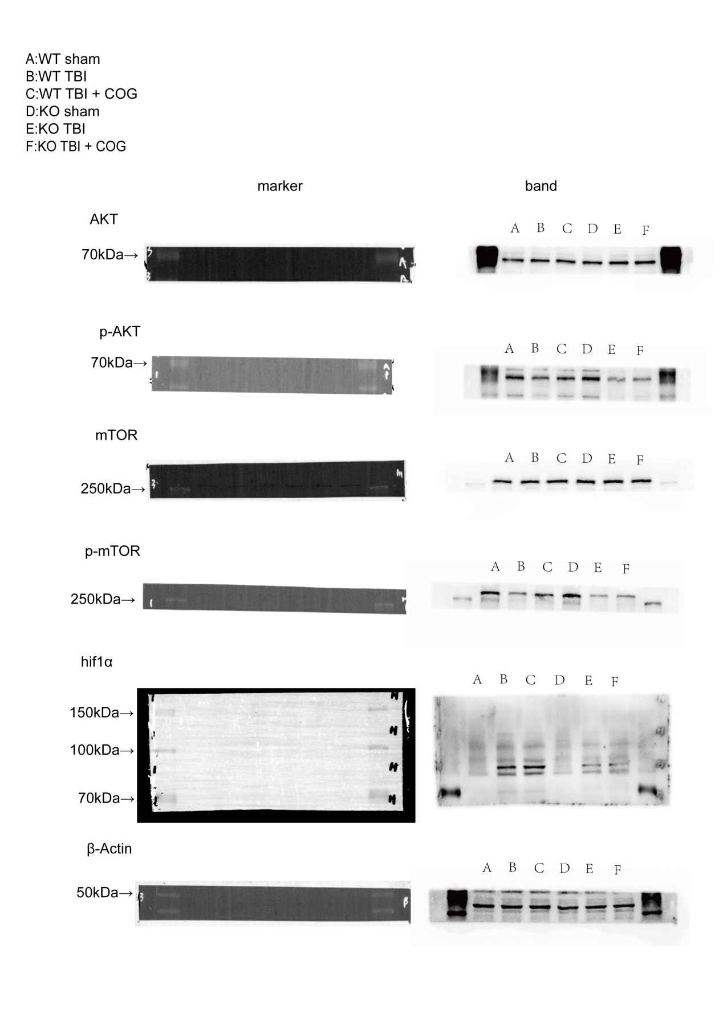
Figure S4 Raw western blot bands in Fig. 6H

