Supporting information for:
WNT-induced association of Frizzled and LRP6 is not sufficient for the initiation of WNT/β-catenin signaling

Jan Hendrik Voss¹, Zsombor Koszegi², Yining Yan¹, Emily Shorter³, Lukas Grätz¹, Johanna T. Lanner³, Davide Calebiro², Gunnar Schulte^{1*}

Affiliations:
¹Karolinska Institutet, Department of Physiology & Pharmacology, Sec. Receptor Biology & Signaling, Biomedicum, S-17165 Stockholm, Sweden
²Department of Metabolism and Systems Science, College of Medicine and Health, University of Birmingham, Birmingham B15 2TT, UK; Centre of Membrane Proteins and Receptors (COMPARE), Universities of Nottingham and Birmingham, Birmingham B15 2TT, UK
³Karolinska Institutet, Department of Physiology & Pharmacology, Sec. Molecular Muscle Physiology & Pathophysiology, Biomedicum, S-17165 Stockholm, Sweden
* Corresponding author; gunnar.schulte@ki.se

Table S1: Plasmids used which were not originally created in this study.
HA-FZD_{4/5/7}-Nluc | Grätz et al. ³⁸  Grätz & Kowalski-Jahn et al. ¹⁴
FLAG-DVL2 | Gift from Vítězslav Bryja (Brno, CZ)
DVL1-HA | Gift from Vítězslav Bryja (Brno, CZ)
DVL3-HA | Gift from Vítězslav Bryja (Brno, CZ)
HA-FZD₅ R^{6.32}A-Nluc | Grätz & Kowalski-Jahn et al. ¹⁴
HiBiT-FZD_{4/5/7} | Kozielewicz et al. ³⁰
8x SuperTOPFlash | Addgene #12456 ³²
pRL-TK (Renilla control plasmid) | Promega AF025846
β₂-Nluc | Bowin et al. ¹⁷
ΔCRD-FZD₅-Nluc | Grätz et al. ³⁸
MESD | Gift from Stephane Angers (Toronto, CA)
SNAP-β₂ | Grimes et al. ⁵¹

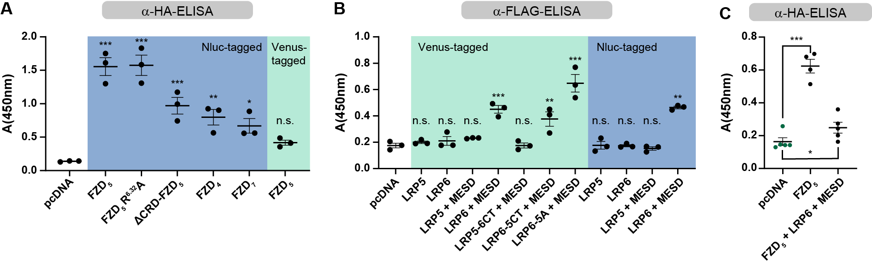
Supplementary Figure 1. Surface expression of constructs employed in the study. Surface expression in HEK293 cells was determined by surface ELISA employing the N-terminal HA-tags (for FZDs) or FLAG-tags (for LRPs). A. Surface expression of HA-FZD-Nluc/Venus constructs. B. Surface expression of FLAG-LRP-Nluc/Venus constructs. C. Co-expression of LRP6-Venus reduces FZD₅-Nluc surface expression, which stays in a detectable range. Data are presented as a mean ± SEM of three (A, B) or four to five (C) experiments. Statistical significance was assessed by a one-way ANOVA with Dunnett’s post-hoc test and the following significance levels: *, p < 0.05; **, p < 0.01; ***, p < 0.001.

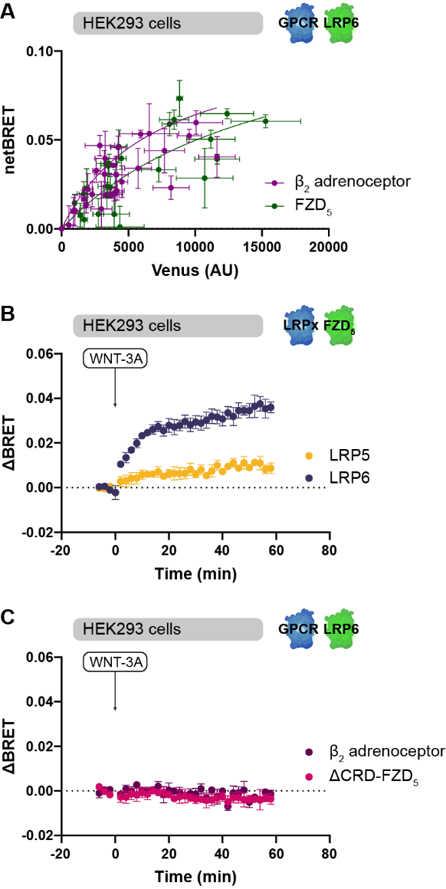
Supplementary Figure 2. FZD₅ and LRP6 form a dynamic, but not a constitutive complex. A. Acceptor titration experiments with LRP6-Venus using β₂-adrenoceptor-Nluc and FZD₅-Nluc as donors. B. Kinetic BRET experiments as performed in Fig. 1B with inverse probe setup (LRP6-Nluc and FZD₅-Venus). C. Absence of dynamic interaction between β₂-adrenoceptor-Nluc and ΔCRD-FZD₅-Nluc with LRP6-Venus upon WNT-3A stimulation (1000 ng/ml). Data points are taken from three independent experiments (A; error bars represent the SD of three technical replicates), or shown as a mean ± SEM of three independent experiments (B, C).

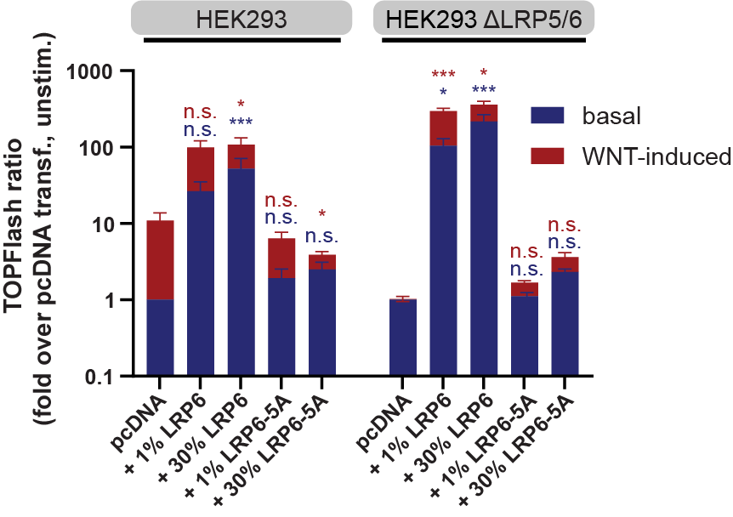
Supplementary Figure 3. The LRP6-5A phosphorylation-deficient mutant is functionally inactive. TOPFlash reporter gene experiments showing basal (blue) and WNT-3A-induced (red) TOPFlash reporter gene expression in HEK293 or HEK293 ΔLRP5/6 cells transfected as indicated. Data were normalized to the respective untransfected, unstimulated condition of each cell line for each biological replicate. Bar graphs display mean ± SEM of four independent experiments performed in triplicate. Statistical comparisons were made by a one-way ANOVA followed by Dunnett’s post-hoc test. In the untreated samples (blue), the pcDNA-transfected sample of each group served as a reference for the multiple comparisons. For the WNT-induced samples (red), the fold-increase of the WNT stimulated condition over the basal condition was subjected to statistical analysis * p < 0.05, ** p < 0.01, *** p < 0.001.

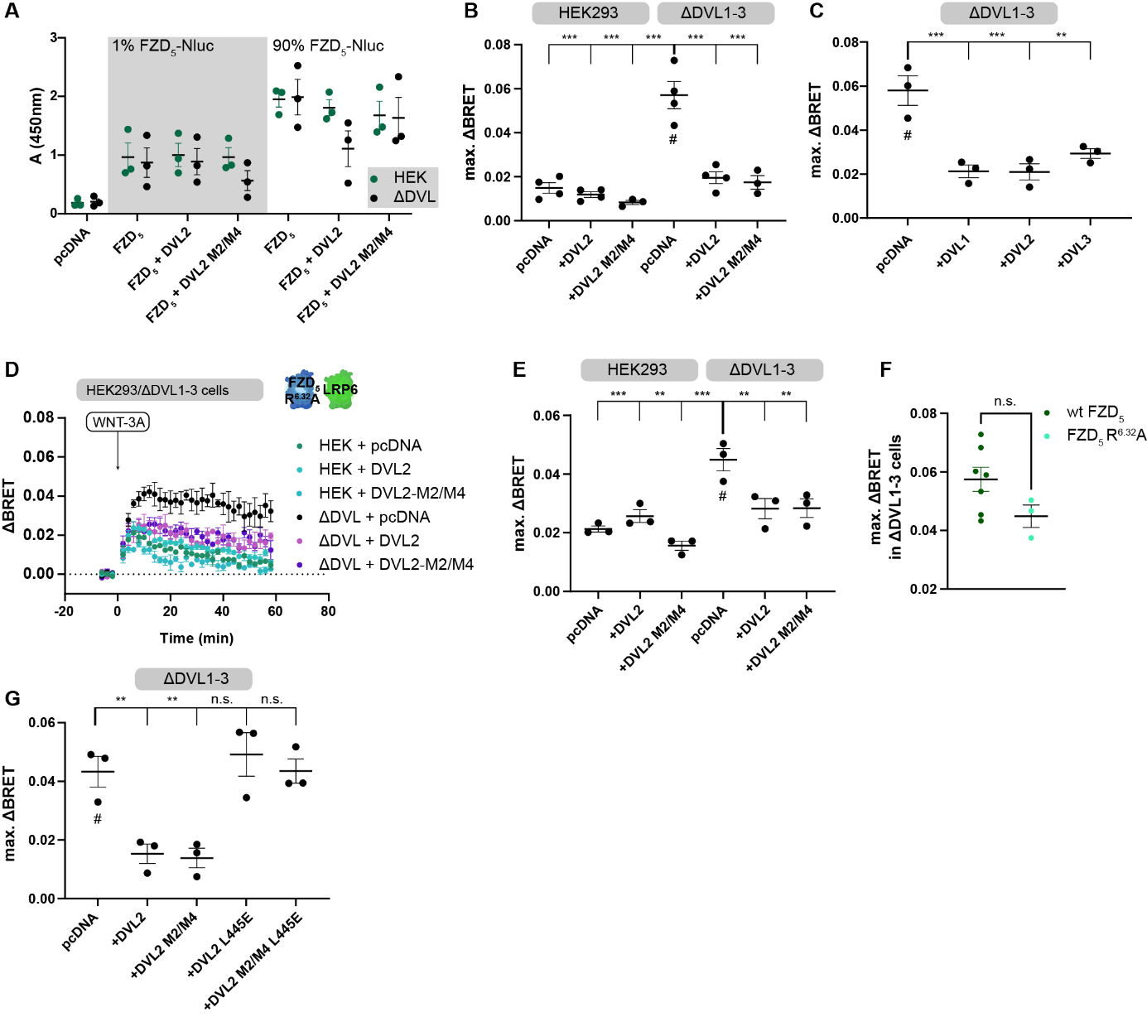
Supplementary Figure 4. DVL-FZD interactions reduce the dynamic ΔBRET range between FZD₅ and LRP6 upon WNT-3A stimulation. A. Surface expression of FZD₅-Nluc is not decreased upon co-expression of DVL2 or DVL2 M2/M4 in HEK293 and ΔDVL1-3 cells as determined by anti-HA surface ELISA. B. ΔBRET_{max} in HEK293 cells and ΔDVL1-3 cells transfected either with the BRET sensor pair alone or additionally with DVL2 or DVL2 M2/M4. Paired with Fig. 2C. C. ΔBRET_{max} values of ΔDVL1-3 cells transfected either with the FZD₅-LRP6 BRET sensor pair and pcDNA, DVL1, DVL2, and DVL3 stimulated with 1000 ng/ml WNT-3A. Paired with Fig. 2D. D. ΔBRET traces of HEK293 or ΔDVL1-3 cells transfected with FZD₅ R^{6.32}A-Nluc, LRP6-Venus, and either pcDNA, DVL2, or DVL2-M2/M4 as indicated, stimulated with 1000 ng/ml WNT-3A. E. ΔBRET_{max} values of HEK293 or ΔDVL1-3 cells transfected with the BRET sensor pair and pcDNA, DVL2, or DVL2 M2/M4. Paired with Supp. Fig. 3D. F. The observed WNT-3A-induced ΔBRETmax is not significantly different in ΔDVL1-3 cells if a FZD₅ R^{6.32}A-Nluc donor is used compared to WT FZD₅-Nluc. ΔBRETmax values taken from Supp. Fig. 3D and Fig. 2C. G. ΔBRET_{max} values of ΔDVL1-3 cells transfected either with the BRET sensor pair and pcDNA, DVL2, DVL2 M2/M4, or the L445E mutants of these DVL2 constructs. Paired with Fig. 2E. Statistical analysis was performed by one-way ANOVA and Dunnett’s post-hoc test. # indicates the dataset used as reference for multiple comparisons. *, p < 0.05; ** p < 0.01, *** p < 0.001.
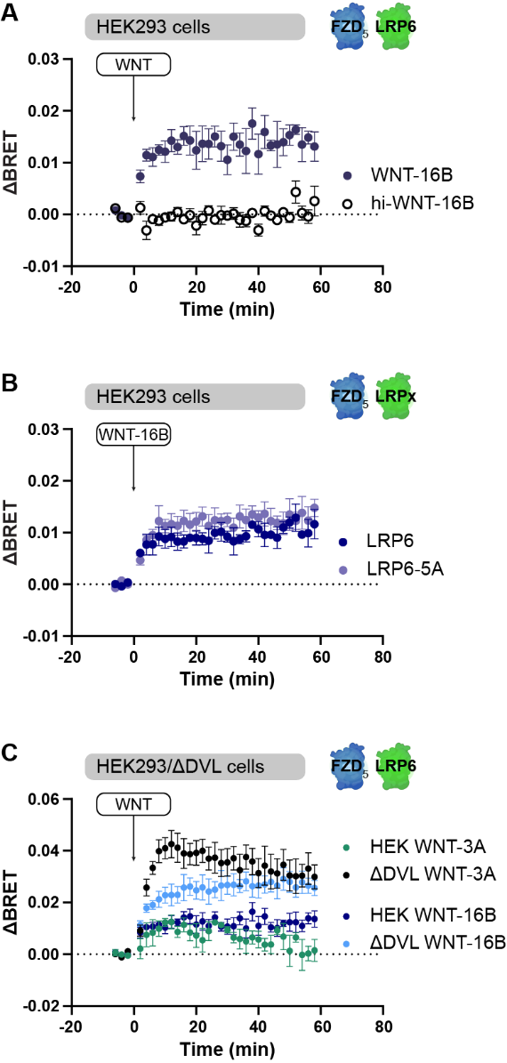
Supplementary Figure 5. WNT-16B behaves similar to WNT-3A in FZD₅-LRP6-BRET assays. A. Kinetic ΔBRET traces of 1000 ng/ml WNT-16B or heat-inactivated WNT-16B (hi-WNT-16B) in HEK cells transfected with FZD₅-Nluc and LRP6-Venus. B. Kinetic ΔBRET traces of 1000 ng/ml WNT-16B in HEK cells transfected with FZD₅-Nluc and LRP6- or LRP6-5A-Venus. C. Direct comparison of kinetic ΔBRET traces of HEK and ΔDVL cells stimulated with 1000 ng/ml WNT-3A or WNT-16B. All data points are shown as mean ± SEM of three or more individual experiments performed in triplicate.

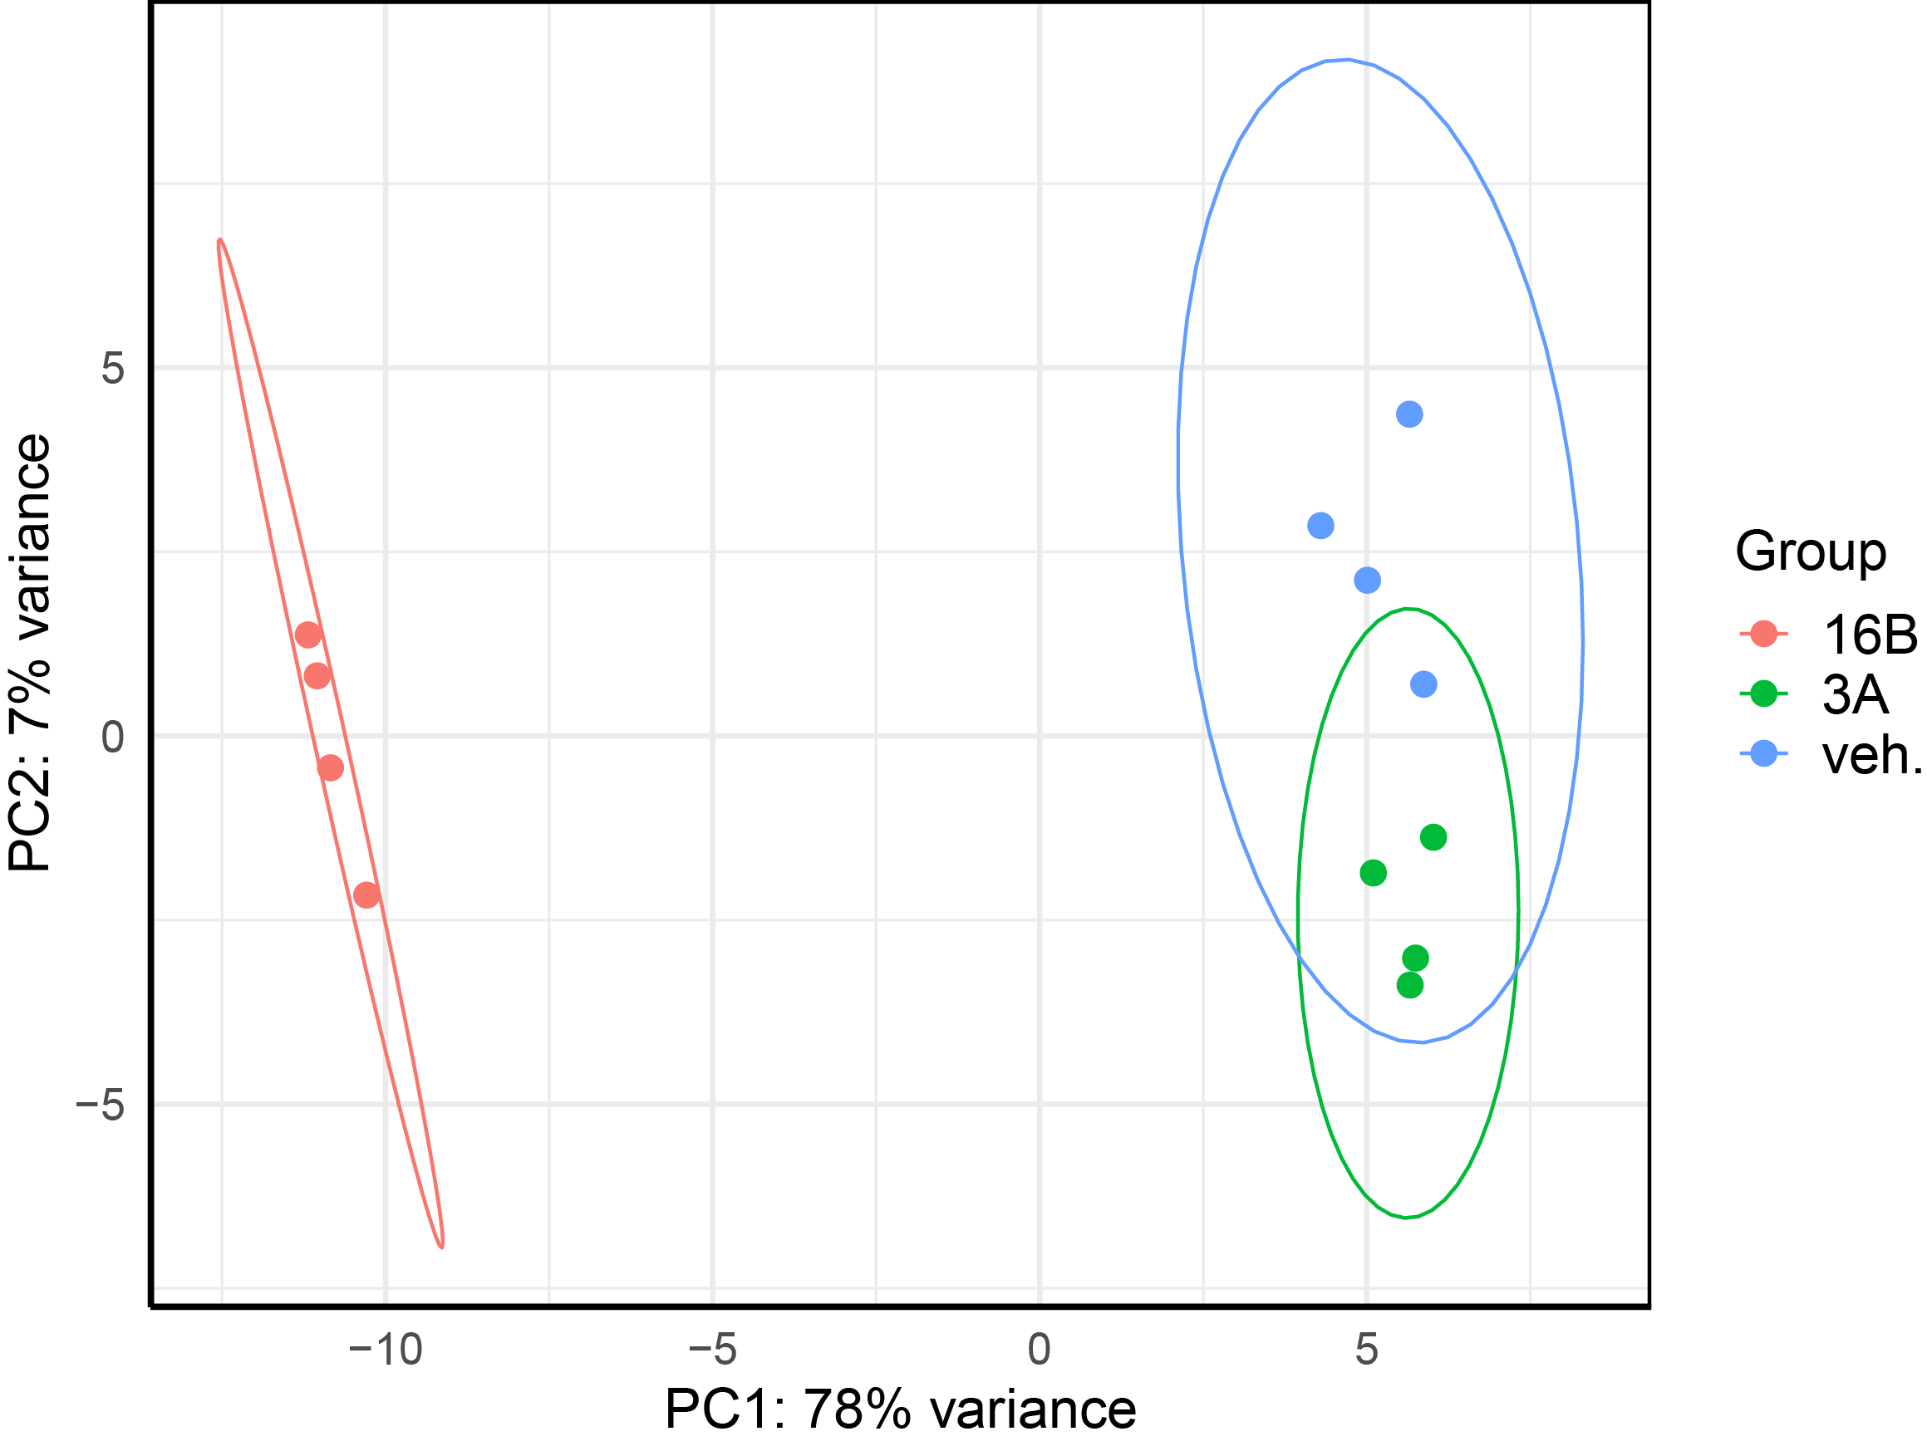
Supplementary Figure 6. PCA plot confirms clustering of samples according to treatment groups. Data underwent variance stabilizing transformation and was used to perform principal component analysis (PCA) using DESeq2 ⁵⁵. The resulting plot shows the samples in a 2D plane spanned by their first two principal components.

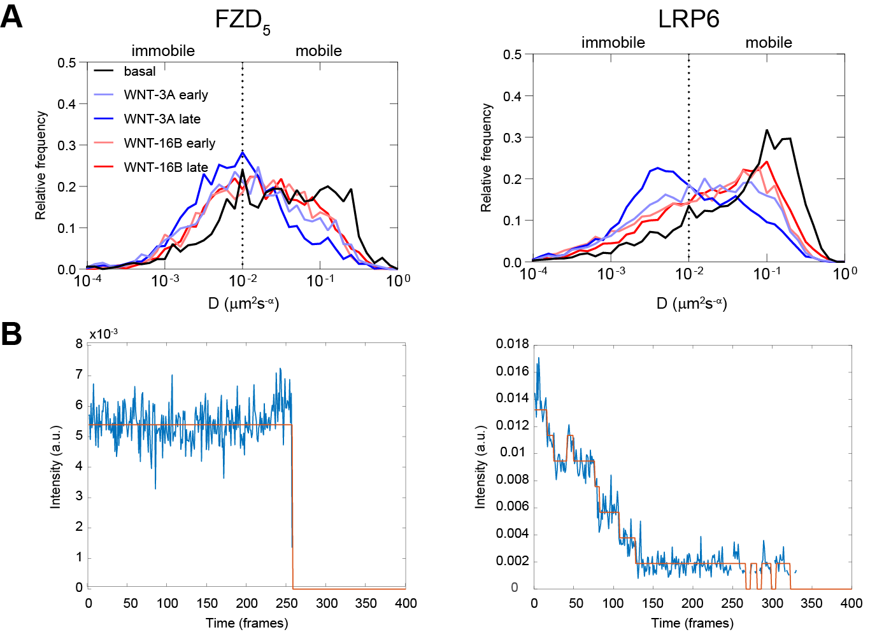
Supplementary Figure 7. Distribution of FZD₅ and LRP6 diffusion coefficients. A. Distributions of diffusion coefficient revealed by time-averaged mean squared displacement analysis at basal and following 100 nM WNT-3A and 100 nM WNT-16B stimulations. Early stimulation: 2-10 min, late stimulation: 11-25 min. n = 18, 25, 22, 17, 27 cells for FZD₅-LRP6 basal, WNT-3A early, WNT-3A late, WNT-16B early, and WNT-16B late, respectively, from six independent experiments. B. Representative examples of single-step (left) and multi-step photobleaching (right), indicating the presence of single and multiple molecules, respectively.

