Supplementary information for the article

“Specific interactions between the alkaline protease of P. aeruginosa and its natural peptide inhibitor: Ab initio molecular simulations”

Ryosuke Saito, Kyohei Imai, Shohei Yamamoto, Takuya Ezawa, Satoshi Sugiyama,
Linn Samira Mari Evenseth, Ingebrigt Sylte and Noriyuki Kurita

Contents

Table S1. pKa values evaluated by the PROPKA 3.0 program [11, 12] and the protonation states and positions of His residues in the APR + APRin complex.

Figure S1. Structures of (a) APR and (b) APRin [7]. The gray and purple spheres indicate
the Zn and Ca ions involved in APR, respectively.

Figure S2. Protonation states of histidine.

Figure S3. Protonation states of glutamic acid.

Figure S4. Structures of the N- and C-terminals of APR and APRin peptides employed
in this study: (a) NH₂ and COOH, (b) NH₃⁺ and COO⁻, and (c) Ace and NMe.

Table S1. pKa values evaluated by the PROPKA 3.0 program [11, 12] and the protonation states and positions of His residues in the APR + APRin complex.
His residue | pKa | Protonation | Position
His14 | 6.8 | Hip⁺ | APR surface
His27 | 6.0 | Hip⁺ | APR surface
His110 | 6.1 | Hip⁺ | APR surface
His176 | −3.1 | Hid | Coordinated with Zn
His180 | −5.1 | Hid | Coordinated with Zn
His186 | −1.6 | Hid | Coordinated with Zn
His452 | 6.4 | Hip⁺ | APR surface
His27 of APRin | 6.3 | Hip⁺ | APRin surface

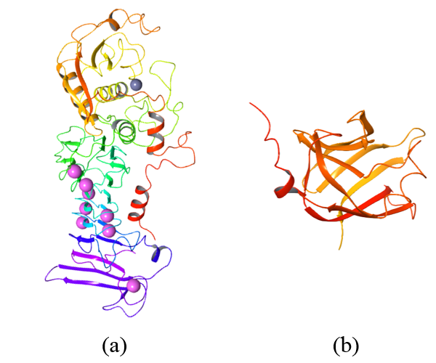

Figure S1. Structures of (a) APR and (b) APRin [7]. The gray and purple spheres indicate
the Zn and Ca ions involved in APR, respectively.

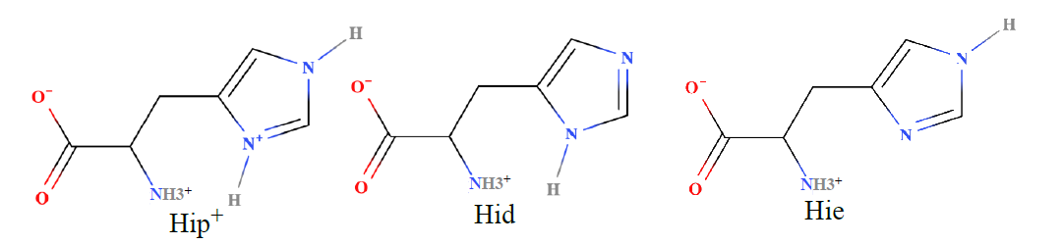

Figure S2. Protonation states of histidine.

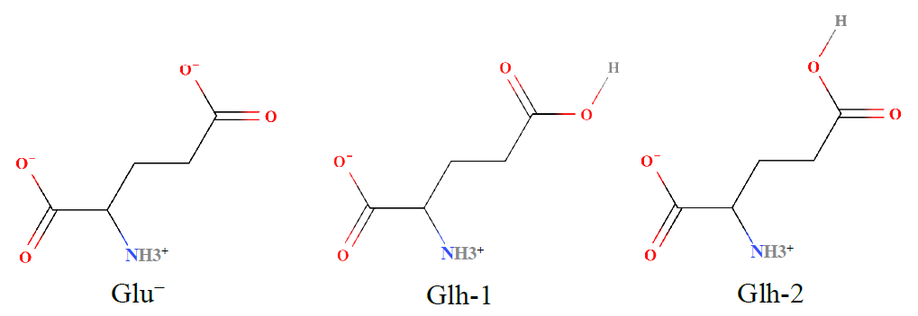

Figure S3. Protonation states of glutamic acid.

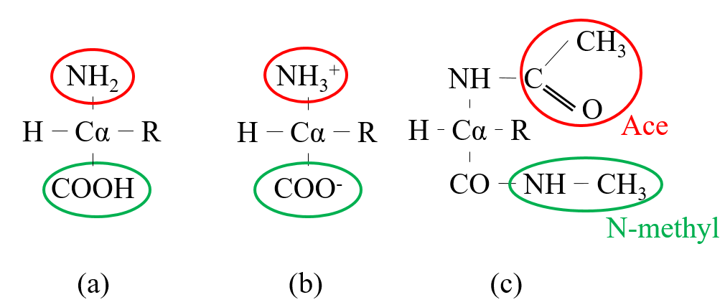

Figure S4. Structures of the N- and C-terminals of APR and APRin peptides employed
in this study: (a) NH₂ and COOH, (b) NH₃⁺ and COO⁻, and (c) Ace and N-methyl.

