Table.1. For methylene blue bosorption onto banana leaves, the experimental range and amounts of the independent factors were (Crini, G 2006):
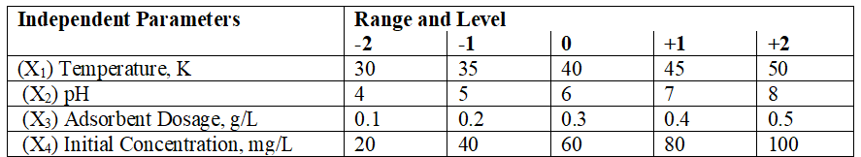

Table.2. For the biosorption of MB with Banana Leaves, showing observed and predicted data (Salleh, M. A. M. 2008)
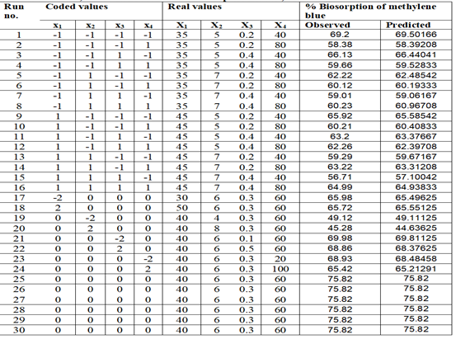
Table 3. ANOVA for the whole quadratic model of methylene blue onto adsorbent leaves (Enayatollahi I 2014).

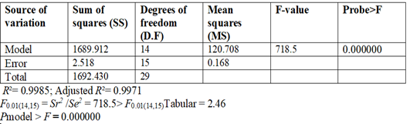
Table.4. The model for biosorption of MB onto Adsorbent has coefficients, t- statistics, and probability (Zaharia, C, and Suteu, D 2012).:
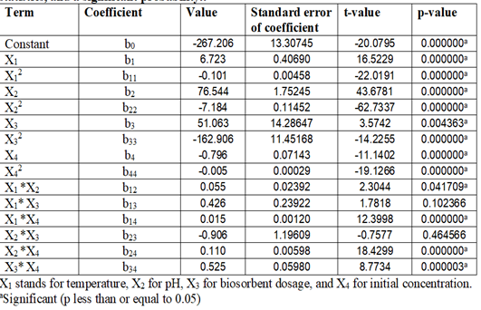
Table.5. Optimum variable values derived from regression models for the removal of MB (Zaharia, C, and Suteu, D 2012):
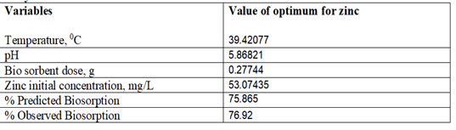
Table-. _7. The ANN Model's Statistical Performance (Zaharia, C, and Suteu, D 2012).
