Supplementary

High-entropy-doping effect in a rapid-charging lithium-ion anode Nb₂O₅
Junling Xu^{1*†}, Fuqiang Xie^{1†}, Lipeng Huang¹, Nana Li², Shang Peng², Wensheng Ma³, Kai Zhang², Yanxue Wu⁴, Lianyi Shao¹, Xiaoyan Shi¹, Jizhang Chen⁵, Li Tao⁶, Kai Zhang⁷, Zhonghua Zhang³, Yonggang Wang^{8*}, Zhipeng Sun^{1*}

¹School of Materials and Energy, Guangdong University of Technology, Guangzhou 510006, China.
²Center for High Pressure Science and Technology Advanced Research (HPSTAR), Shanghai 201203, China.
³School of Materials Science and Engineering, Shandong University, Jinan 250061, China.
⁴Analysis and Test Center, Guangdong University of Technology, Guangzhou 510006, China.
⁵Co-Innovation Center of Efficient Processing and Utilization of Forest Resources, College of Materials Science and Engineering, Nanjing Forestry University, Nanjing 210037, China.
⁶Key Lab of Advanced Optoelectronic Quantum Architecture and Measurement (Ministry of Education), School of Physics, Beijing Institute of Technology, Beijing 100081, China.
⁷Frontiers Science Center for New Organic Matter, Renewable Energy Conversion and Storage Center (RECAST), Key Laboratory of Advanced Energy Materials Chemistry (Ministry of Education), College of Chemistry, Nankai University, Tianjin 300071, China.
⁸Department of Chemistry and Shanghai Key Laboratory of Molecular Catalysis and Innovative Materials, Institute of New Energy, iChEM (Collaborative Innovation Center of Chemistry for Energy Materials), Fudan University, Shanghai 200433, China.

†These authors contributed equally to this work.
Email: jlxu@gdut.edu.cn (Junling Xu); ygwang@fudan.edu.cn (Yonggang Wang); zpsunxj@gdut.edu.cn (Zhipeng Sun)

Supplementary Table S1 | The samples and corresponding doping elements for Nb₂O₅ (red items refer to HED-Nb₂O₅).
Samples | The doping elements
N1C1 | Mg
N1C3 | Mg
N3C1 | Mo、In、Y
N3C8 | Mn、Mg、Cr
N5C1 | Zn、Mg、Ca、Cr、Al
N5C3 | Zn、Mg、Ca、Cr、Al
N5C5 | Mn、Fe、Co、Ni、Cu
N5C5’ | Zn、Mg、Ca、Cr、Al
N5C5’’ | Sn、Ca、Sr、Ba、Ce
N5C10 | Mn、Fe、Co、Ni、Cu
N5C15 | Mn、Fe、Co、Ni、Cu
N6C6 | Zn、Mg、Ca、Cr、Al、Mo
N6C15 | Mn、Fe、Co、Ni、Cu、Cr
N6C18 | Mn、Fe、Co、Ni、Cu、Cr
N6C30 | Mn、Fe、Co、Ni、Cu、Cr
N7C1 | Zn、Mg、Ca、Cr、Al、Y、In
N7C3 | Zn、Mg、Ca、Cr、Al、Mn、In
N7C8 | Zn、Mg、Ca、Cr、Al、Mo、La
N8C2 | Zn、Mg、Ca、Cr、Al、In、Y、La
N10C1 | Zn、Mg、Ca、Cr、Al、Sn、Ca、Sr、Ba、Ce
N10C3 | Zn、Mg、Ca、Cr、Al、Sn,、Ca、Sr、Ba、Ce
N10C5 | Zn、Mg、Ca、Cr、Al、Sn、Ca、Sr、Ba、Ce
N10C9 | Zn、Mg、Ca、Cr、Al、Sn、Ca、Sr、Ba、Ce
N10C12 | Zn、Mg、Ca、Cr、Al、Sn、Ca、Sr、Ba、Ce
N10C15 | Mn、Fe、Co、Ni、Cu、Zn、Mg、Ca、Sr、Al
N11C2 | Zn、Mg、Ca、Cr、Al、Sn、Ca、Sr、Ba、Ce、La
N12C1 | Zn、Mg、Ca、Cr、Al、Sn、Ca、Sr、Ba、Ce、Mo、In
N12C3 | Zn、Mg、Ca、Cr、Al、Sn、Ca、Sr、Ba、Ce、Mo、In
N12C4 | Zn、Mg、Ca、Cr、Al、Sn、Ca、Sr、Ba、Ce、Mo、In
N12C5 | Zn、Mg、Ca、Cr、Al、Sn、Ca、Sr、Ba、Ce、Mo、In
N12C8 | Zn、Mg、Ca、Cr、Al、Sn、Ca、Sr、Ba、Ce、Mo、La
N13C2 | Zn、Mg、Ca、Cr、Al、Sn、Ca、Sr、Ba、Ce、Mo、Y、La
N13C3 | Zn、Mg、Ca、Cr、Al、Sn、Ca、Sr、Ba、Ce、Mo、Y、La
N14C1 | Zn、Mg、Ca、Cr、Al、Sn、Ca、Sr、Ba、Ce、Mo、In、Y、La
N14C4 | Zn、Mg、Ca、Cr、Al、Sn、Ca、Sr、Ba、Ce、Mo、In、Y、La
N15C1 | Mn、Fe、Co、Ni、Cu、Zn、Mg、Ca、Sr、Al、Zn、Ga、Sr、Ba、Ce
N15C3 | Mn、Fe、Co、Ni、Cu、Zn、Mg、Ca、Sr、Al、Zn、Ga、Sr、Ba、Ce
N15C3’ | Zn、Mg、Ca、Cr、Al、Sn、Ca、Sr、Ba、Ce、Mo、Sb、In、Y、La
N15C5 | Mn、Fe、Co、Ni、Cu、Zn、Mg、Ca、Sr、Al、Zn、Ga、Sr、Ba、Ce
N15C9 | Mn、Fe、Co、Ni、Cu、Zn、Mg、Ca、Sr、Al、Zn、Ga、Sr、Ba、Ce
N15C10 | Mn、Fe、Co、Ni、Cu、Zn、Mg、Ca、Sr、Al、Zn、Ga、Sr、Ba、Ce
N16C2 | Mn、Fe、Co、Ni、Cu、Zn、Mg、Ca、Sr、Al、Zn、Ga、Sr、Ba、Ce、La
N16C3 | Mn、Fe、Co、Ni、Cu、Zn、Mg、Ca、Sr、Al、Zn、Ga、Sr、Ba、Ce、La
N17C1 | Mn、Fe、Co、Ni、Cu、Zn、Mg、Ca、Sr、Al、Zn、Ga、Sr、Ba、Ce、In、Y
N17C3 | Mn、Fe、Co、Ni、Cu、Zn、Mg、Ca、Sr、Al、Zn、Ga、Sr、Ba、Ce、Mo、In
N17C7 | Mn、Fe、Co、Ni、Cu、Zn、Mg、Ca、Sr、Al、Zn、Ga、Sr、Ba、Ce、Y、In
N19C5 | Mn、Fe、Co、Ni、Cu、Zn、Mg、Ca、Sr、Al、Zn、Ga、Sr、Ba、Ce、Mo、In、Y、La
N20C1 | Mn、Fe、Co、Ni、Cu、Zn、Mg、Ca、Sr、Al、Zn、Ga、Sr、Ba、Ce、Mo、Sb、In、Y、La
N20C3 | Mn、Fe、Co、Ni、Cu、Zn、Mg、Ca、Sr、Al、Zn、Ga、Sr、Ba、Ce、Mo、Sb、In、Y、La
N20C10 | Mn、Fe、Co、Ni、Cu、Zn、Mg、Ca、Sr、Al、Zn、Ga、Sr、Ba、Ce、Mo、Sb、In、Y、La

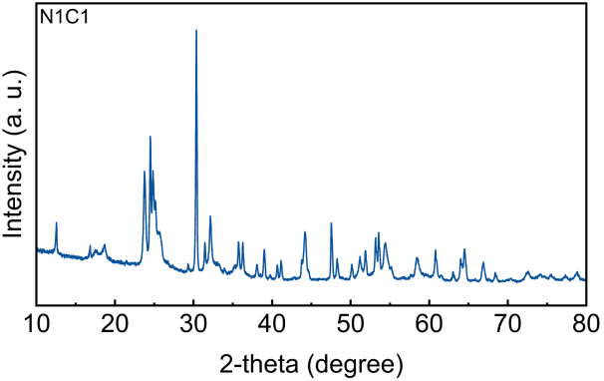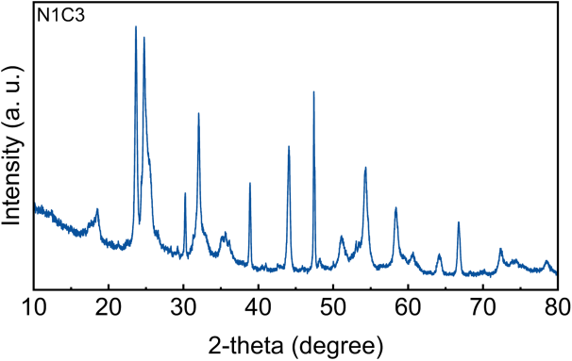
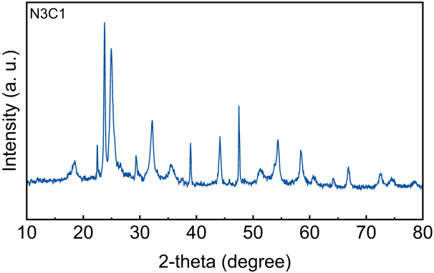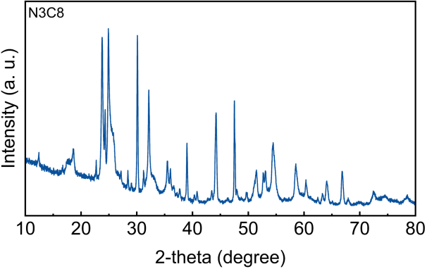
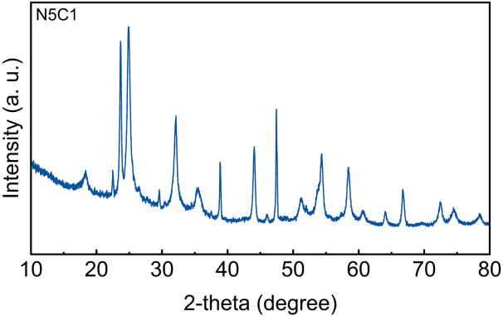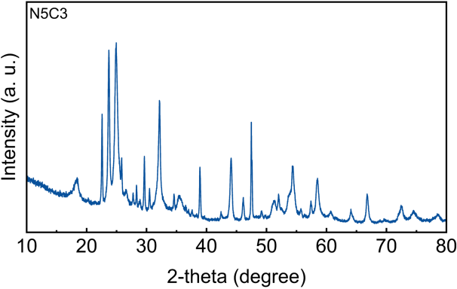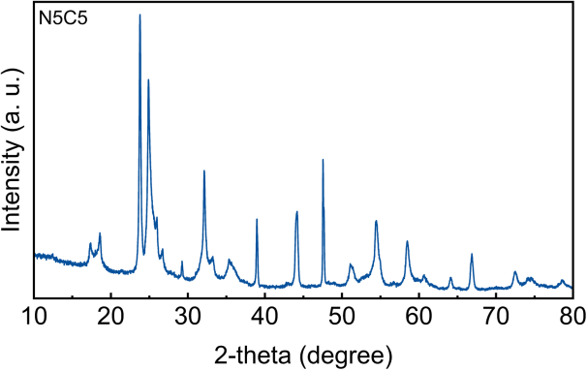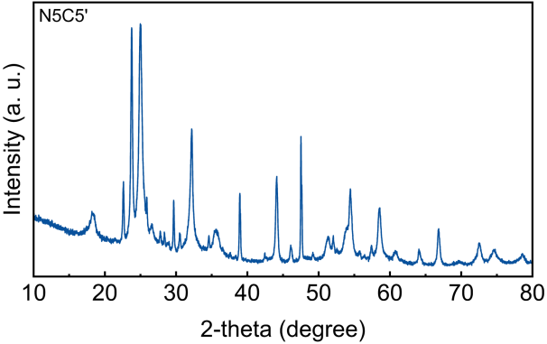
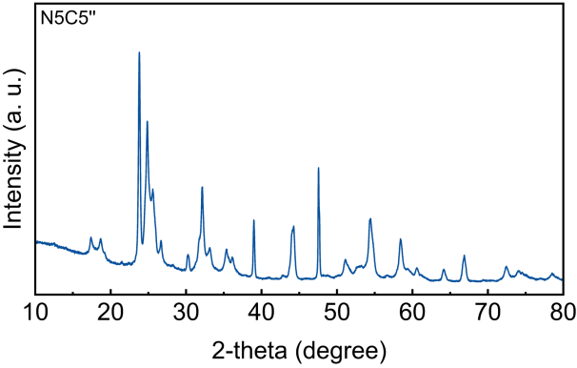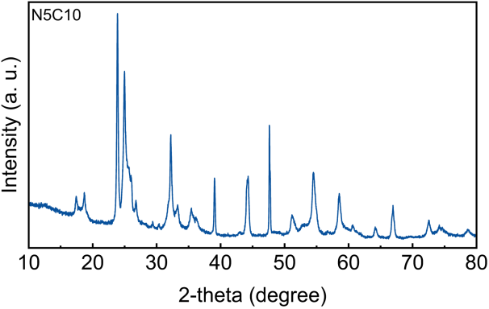
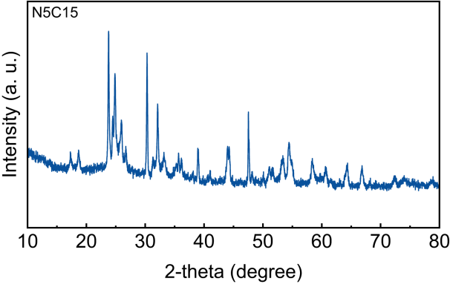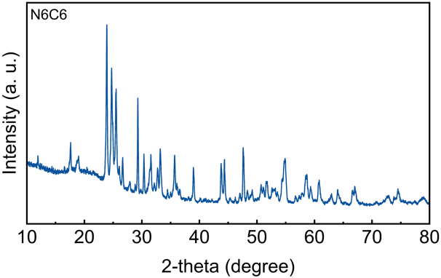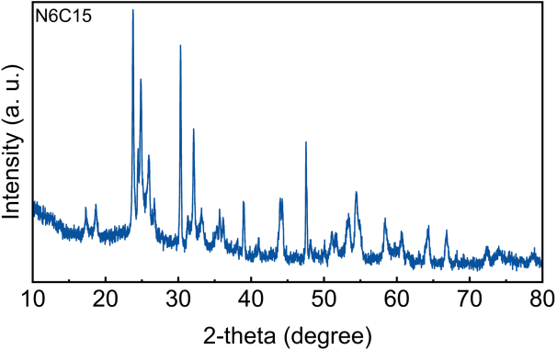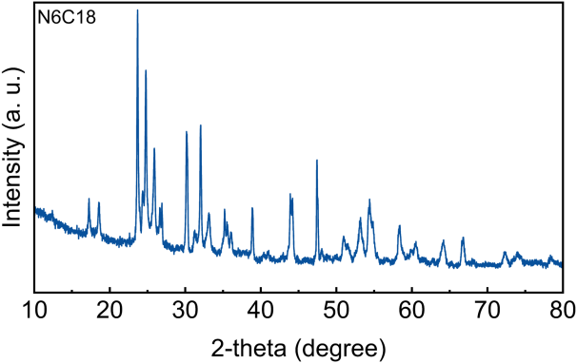
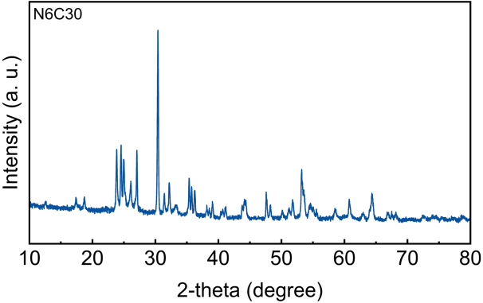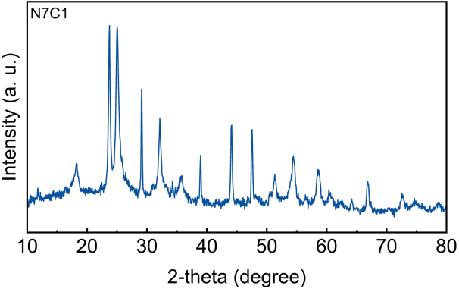
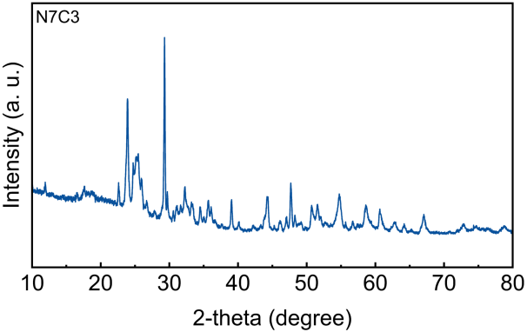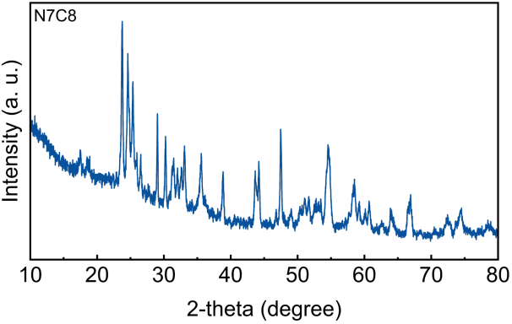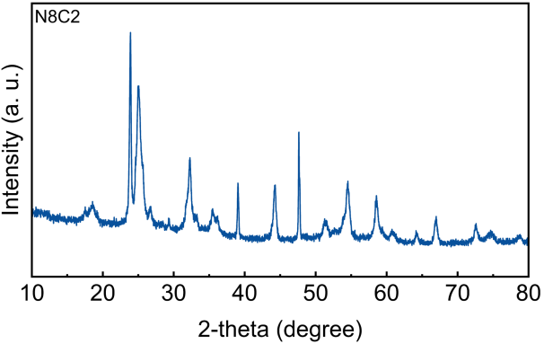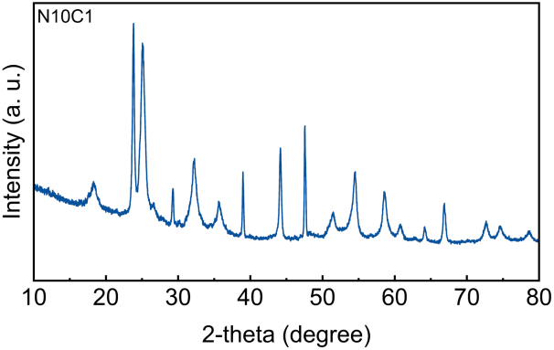
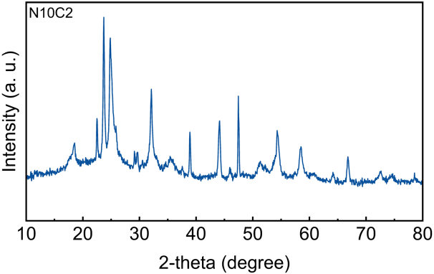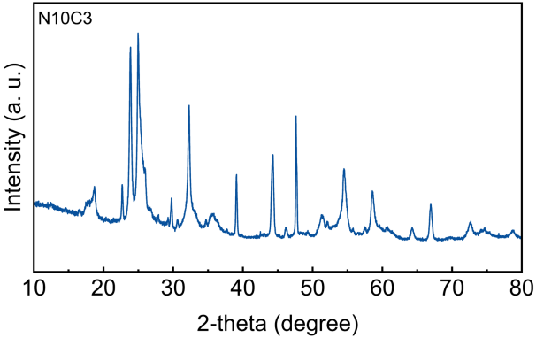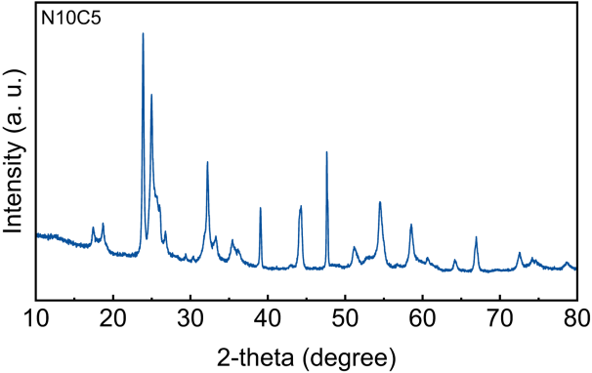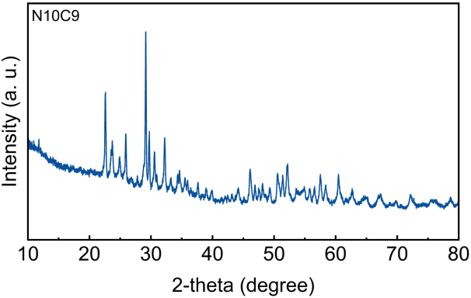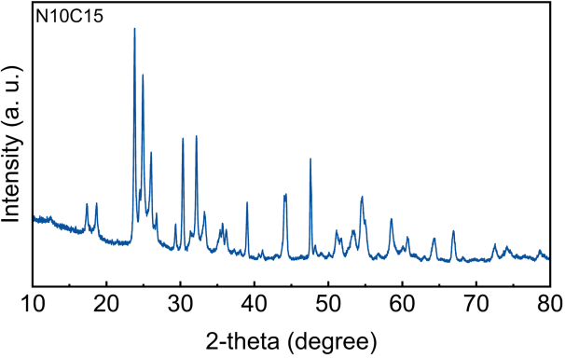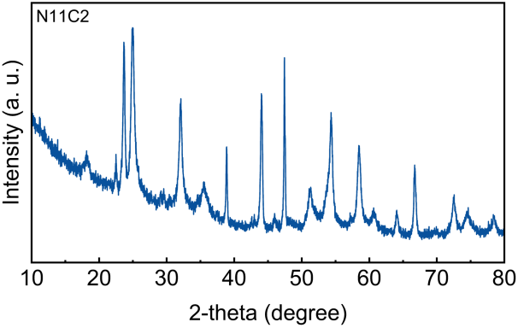
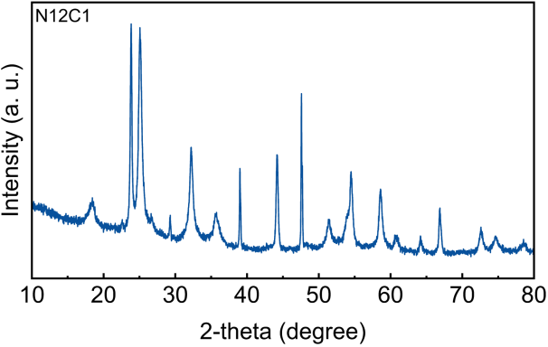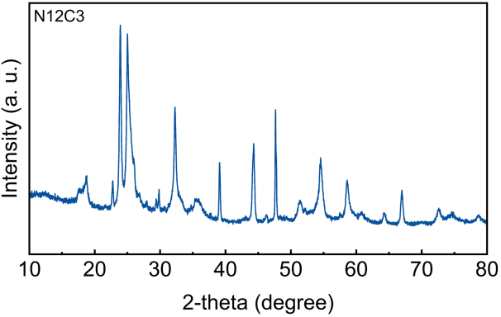
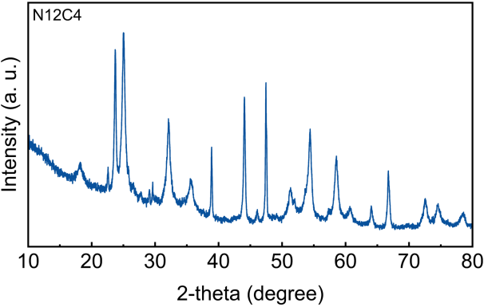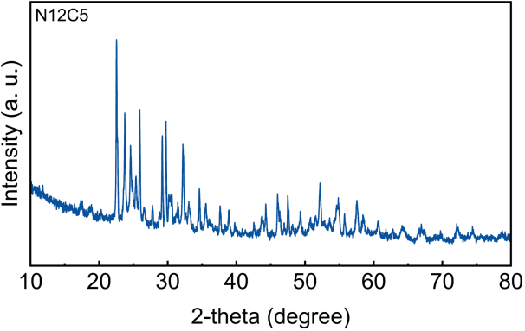
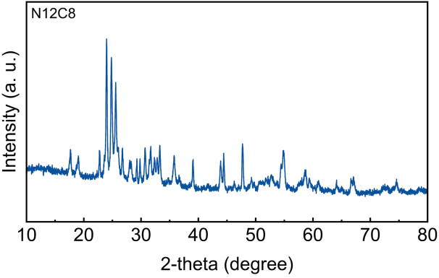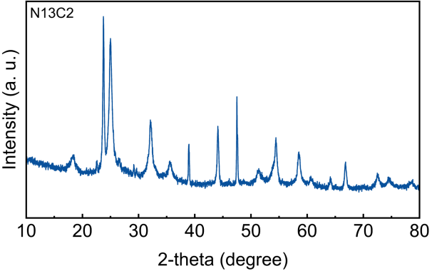
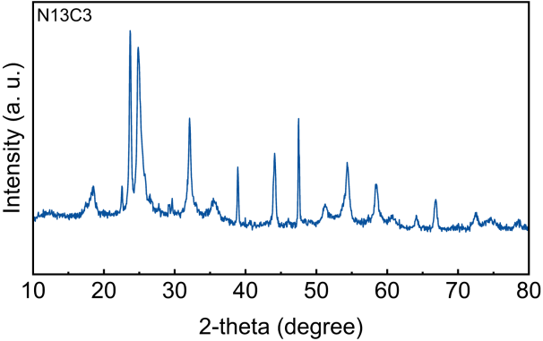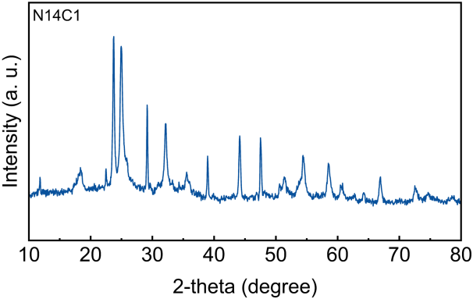
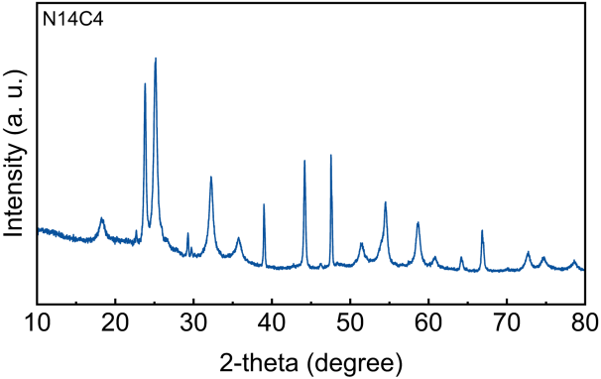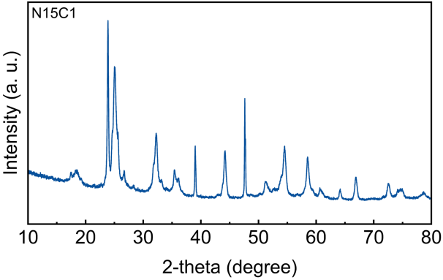
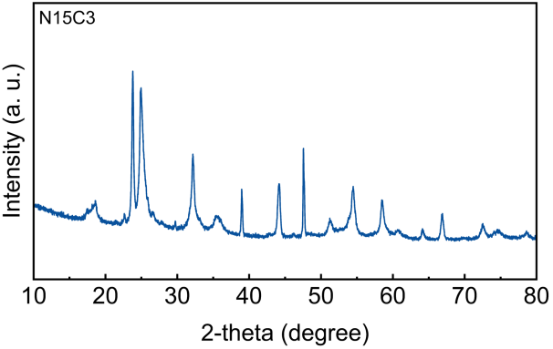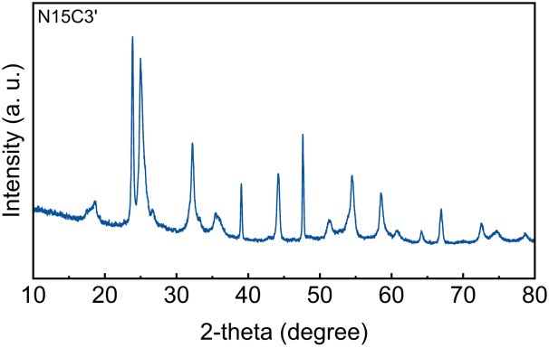
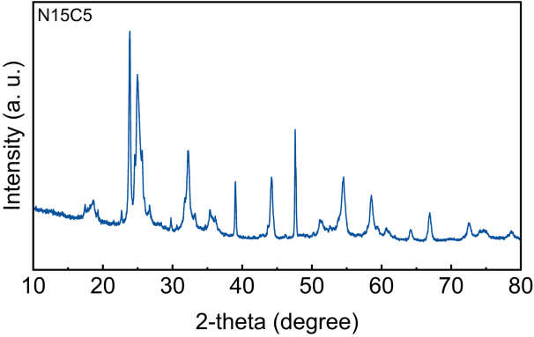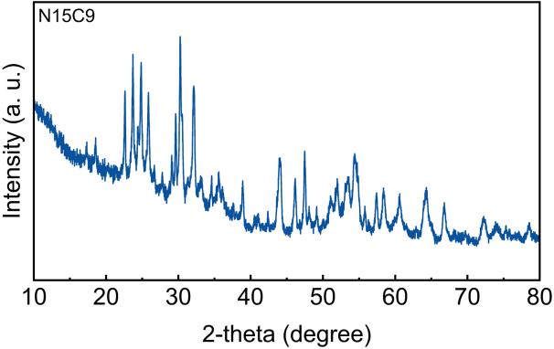
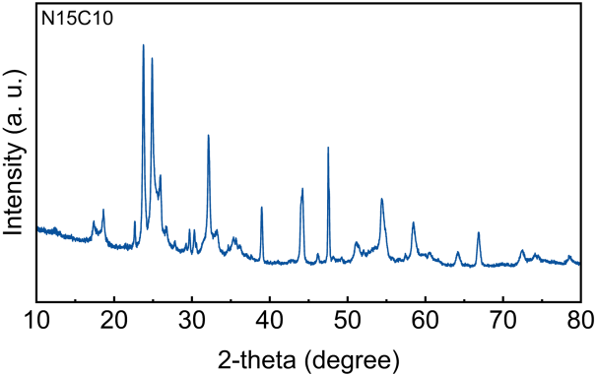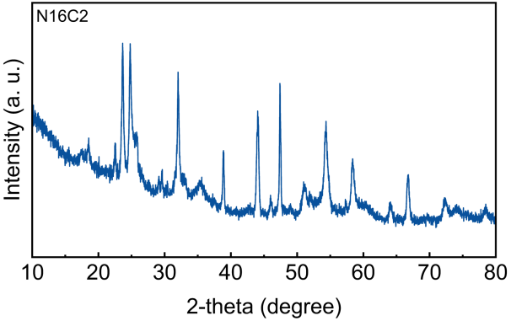
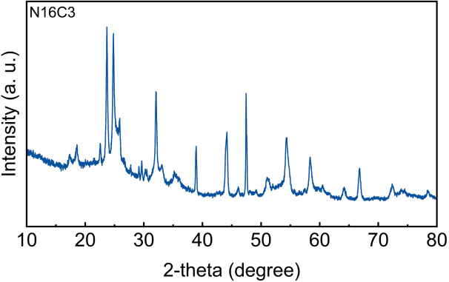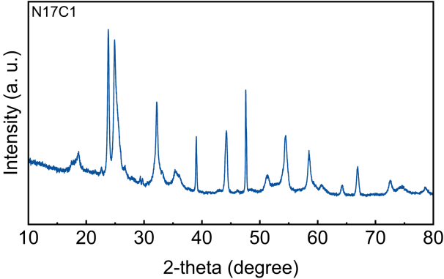
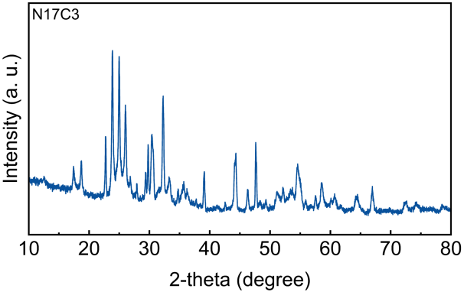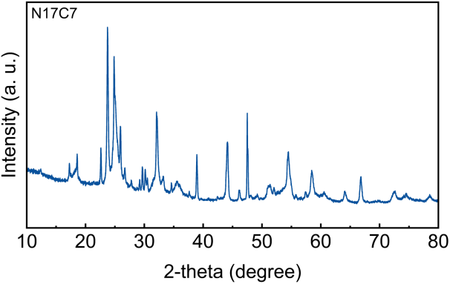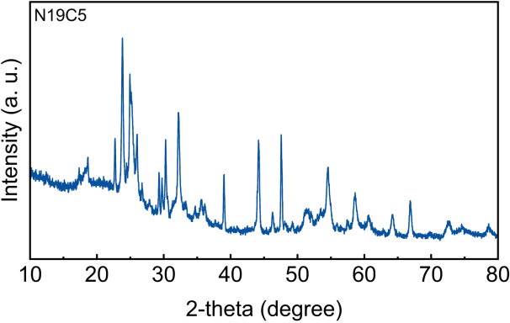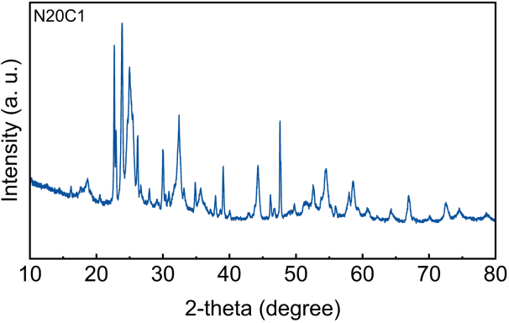
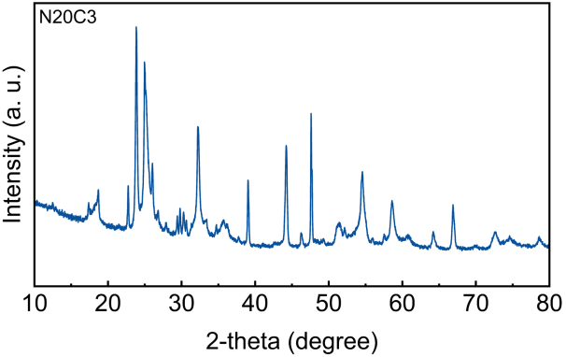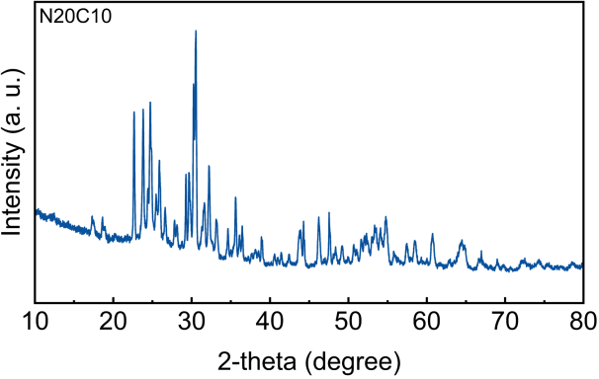
Fig. S1. The XRD patterns of doped Nb₂O₅ with different numbers (N) and concentrations (C) of doping elements.

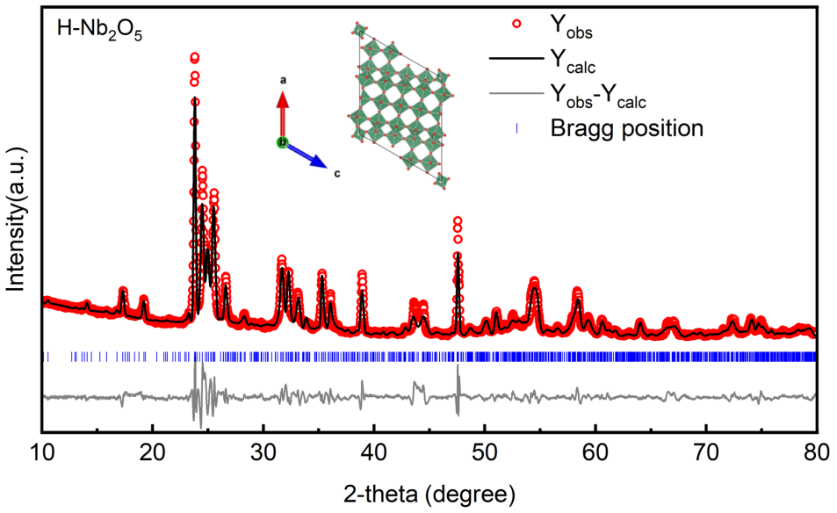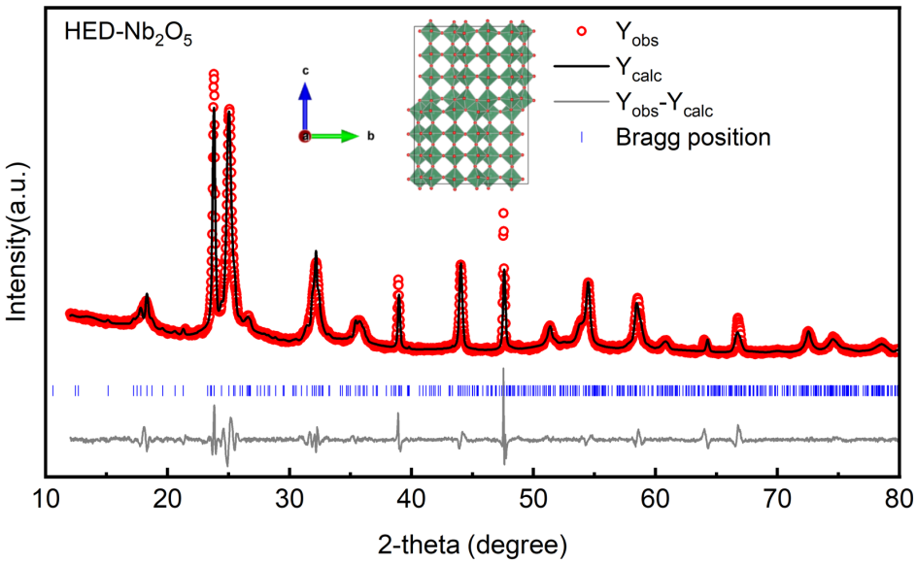
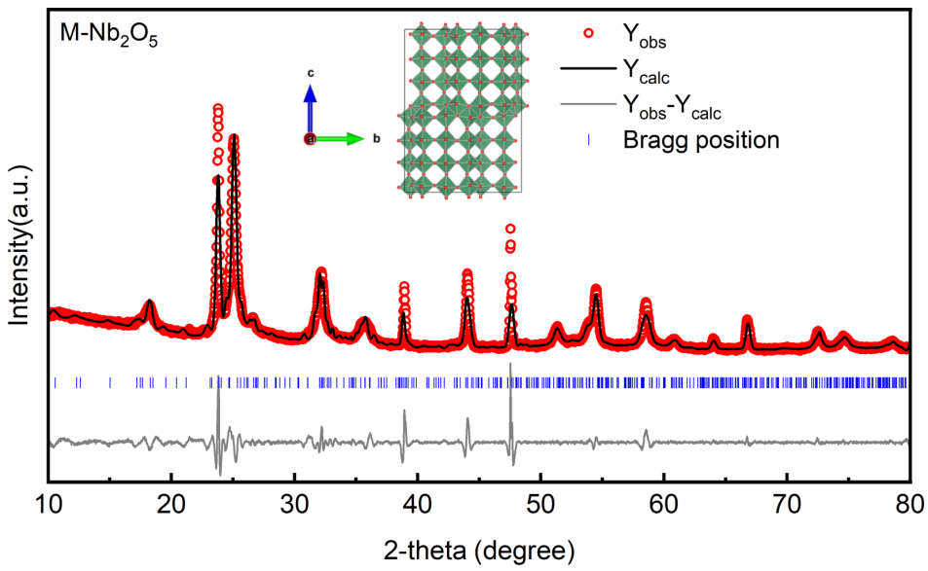
Fig. S2. Rietveld refinement of XRD patterns of H-Nb₂O₅, HED(N15C3)-Nb₂O₅ and M-Nb₂O₅.
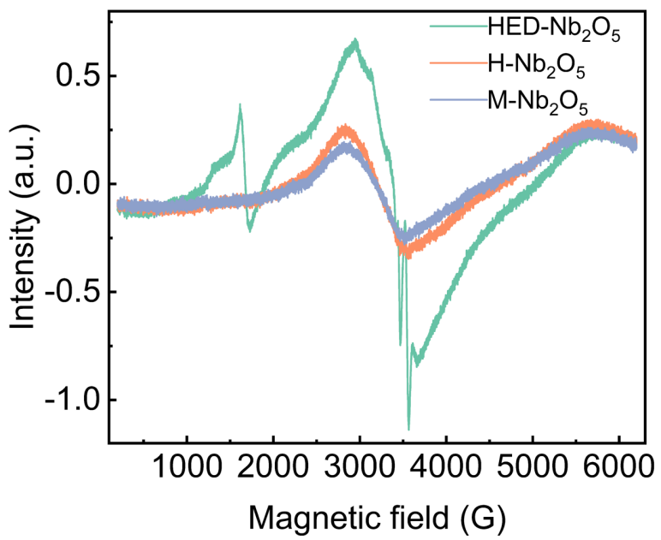
Fig. S3. EPR spectra of HED(N15C3)-Nb₂O₅, H-Nb₂O₅ and M-Nb₂O₅.

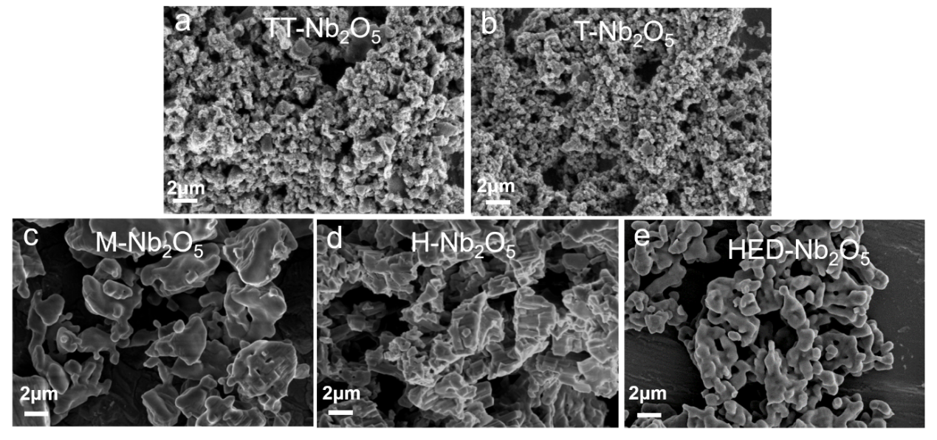
Fig. S4. The SEM images of (a) TT-, (b) T-, (c) M-, (d) H-, and (e) HED(N15C3)-Nb₂O₅ .

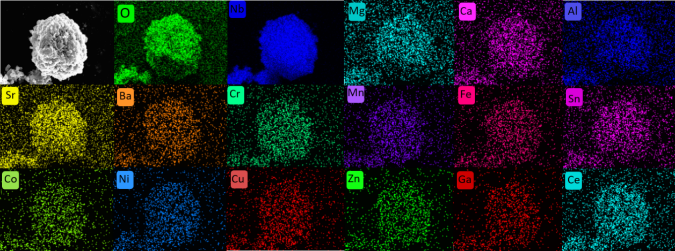

Fig. S5. The SEM-EDS mapping of HED(N15C3)-Nb₂O₅ .

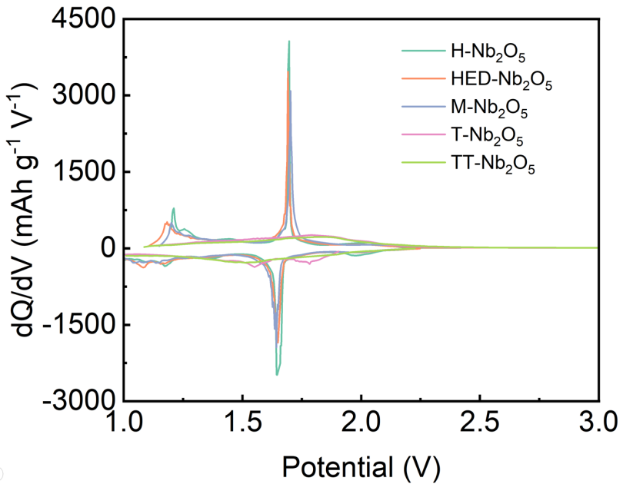

Fig. S6：The comparison of dQ/dV curves of niobium oxides at 0.5C.

Fig. S7. The charge/discharge curves and dQ/dV curves of niobium oxides at different scan rates.
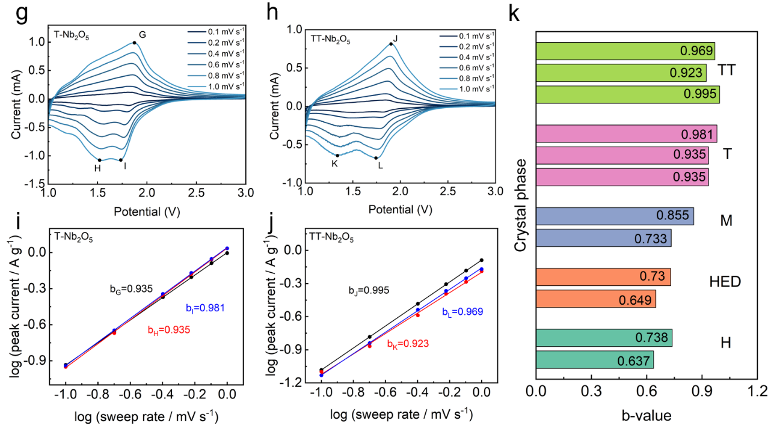
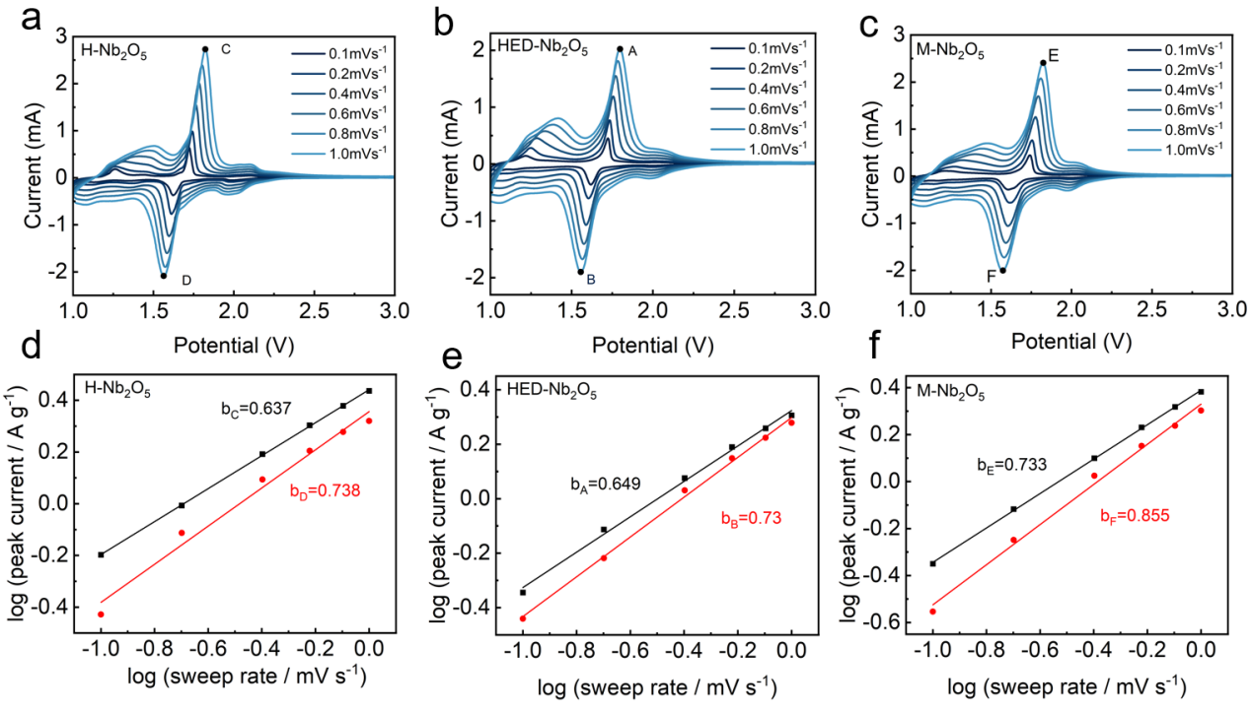

Fig. S8. CV curves and their corresponding power law fits of niobium oxides for each redox peaks.

