Supplementary data

Sub-ambient radiative cooling realized using CaCO₃ microparticle-based single layer without metal reflector for entire
Hangyu Lim, Dongwoo Chae, Soomin Son, Sucheol Ju, Jisung Ha and Heon Lee *
Department of Material Science and Engineering, Korea University, Seoul, South Korea

The Supporting Information contains:
Number of Pages: 6
Number of Figures: 3
Number of Tables: 1
References

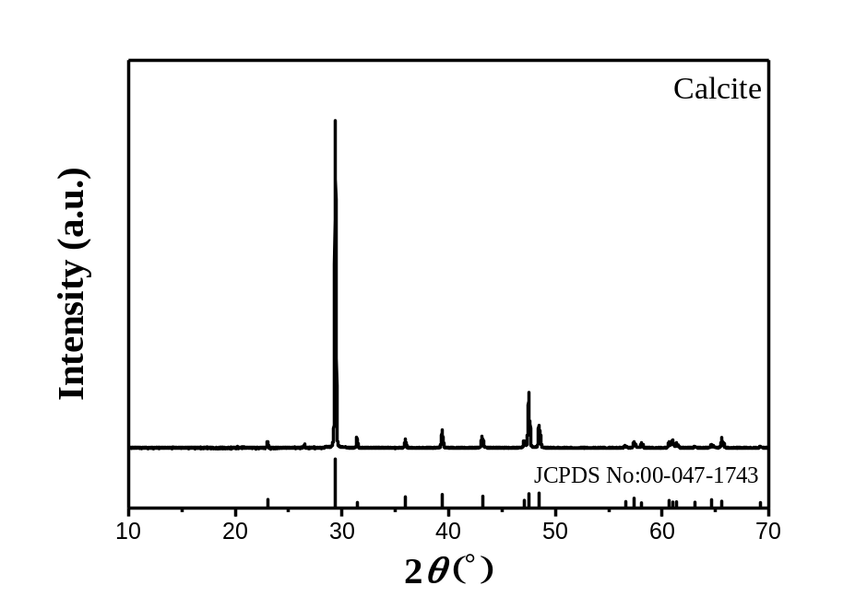

Figure. S1 XRD 2Ɵ scan data of CaCO₃ powders

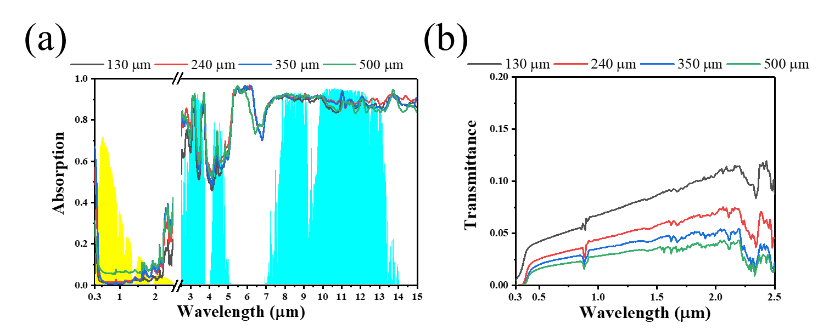
Figure. S2. Optical properties of CaCO₃ on glass in accordance with thickness. (a) Absorption and (b) transmittance.

Table S1. Average absorption (0.3-2.5 µm), emissivity (8-13 µm) and net cooling power at 300 K in accordance with thickness of CaCO₃ composite.
Sample | Solar power absorption ratio  (0.3-2.5 µm) | Average emissivity  (8-13 µm) | Net cooling power at 300 K  (W/m²)
130 µm | 0.027 | 0.883 | 105.5
240 µm | 0.042 | 0.902 | 95.0
350 µm | 0.041 | 0.896 | 93.1
500 µm | 0.079 | 0.886 | 59.7

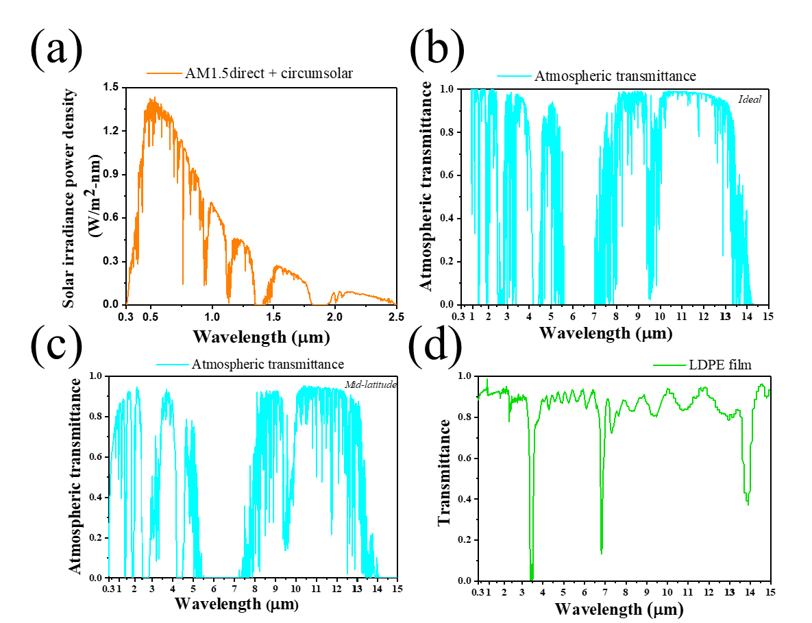

Figure. S3. (a) Solar power density of AM1.5 direct + circumsolar and (b) ideal and (c) mid-latitude atmospheric transmittance window in range of 0.3–15 μm.^{1,2} (d) Transmittance of
LDPE film using wind shield when measuring outside.

References
1. Berk, A. et al. MODTRAN® 6: A major upgrade of the MODTRAN® radiative transfer code. in Workshop on Hyperspectral Image and Signal Processing, Evolution in Remote Sensing vols 2014-June (IEEE Computer Society, 2014).
2. S. D. Lord, A New Software Tool for Computing Earth's Atmospheric Transmission of Near- and Far-Infrared Radiation, Vol. 103957, Ames Research Center, Moffett Field, CA, USA 1992

