Supplementary eFigures1-4
eFigureS1 Leave-one-out analysis of Effect of genetically proxied PDE5 inhibitors on risk of CHD
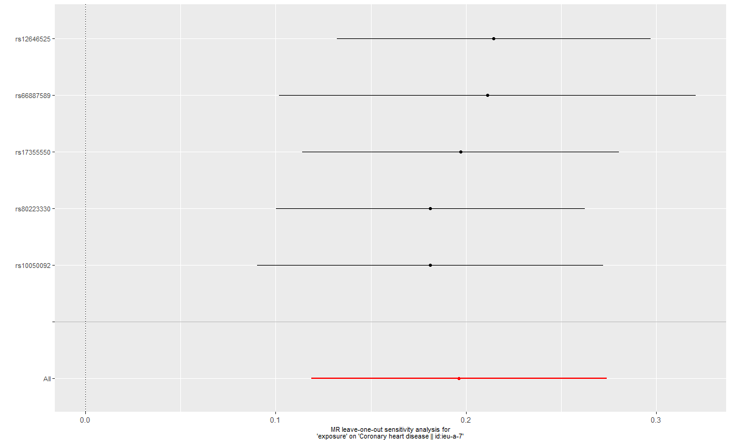
After removing each SNP, all error lines are on the right side of 0, indicating that the results are reliable.

eFigureS2 Leave-one-out analysis of Effect of genetically proxied PDE5 inhibitors on risk of Diabetes
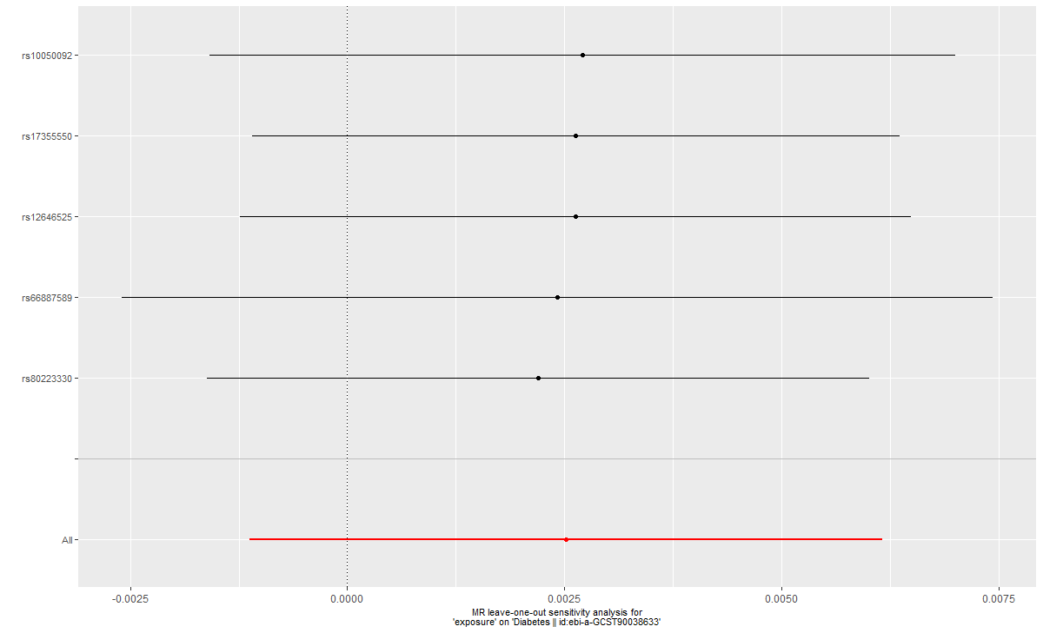
After removing each SNP, error lines are across the line of 0, indicating that the results are not reliable.

eFigureS3 Leave-one-out analysis of Effect of genetically proxied PDE5 inhibitors on risk of Breast cancer
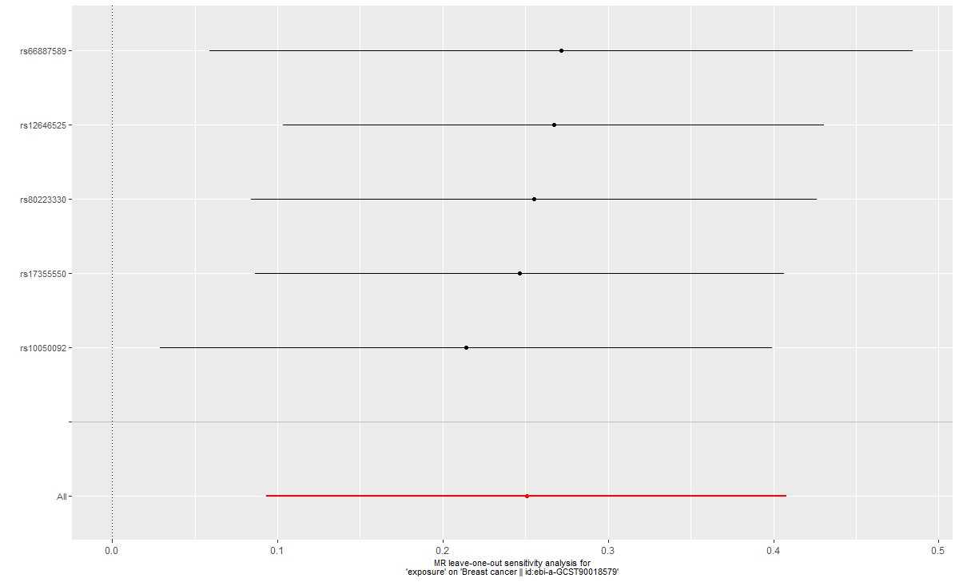
After removing each SNP, all error lines are on the right side of 0, indicating that the results are reliable.

eFigureS4 Leave-one-out analysis of Effect of genetically proxied PDE5 inhibitors on risk of Prostatic Cancer.
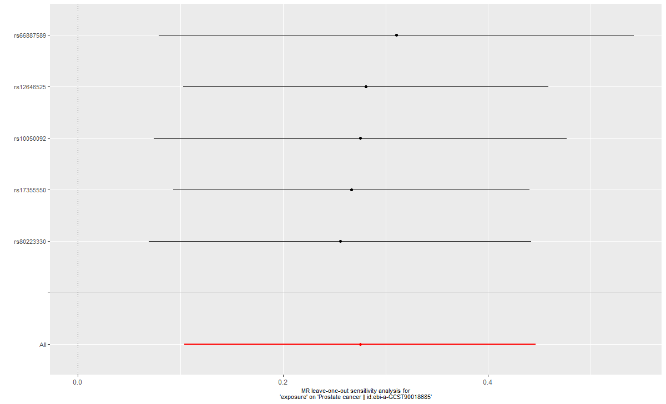
After removing each SNP, all error lines are on the right side of 0, indicating that the results are reliable.

