Graphical Abstarct:

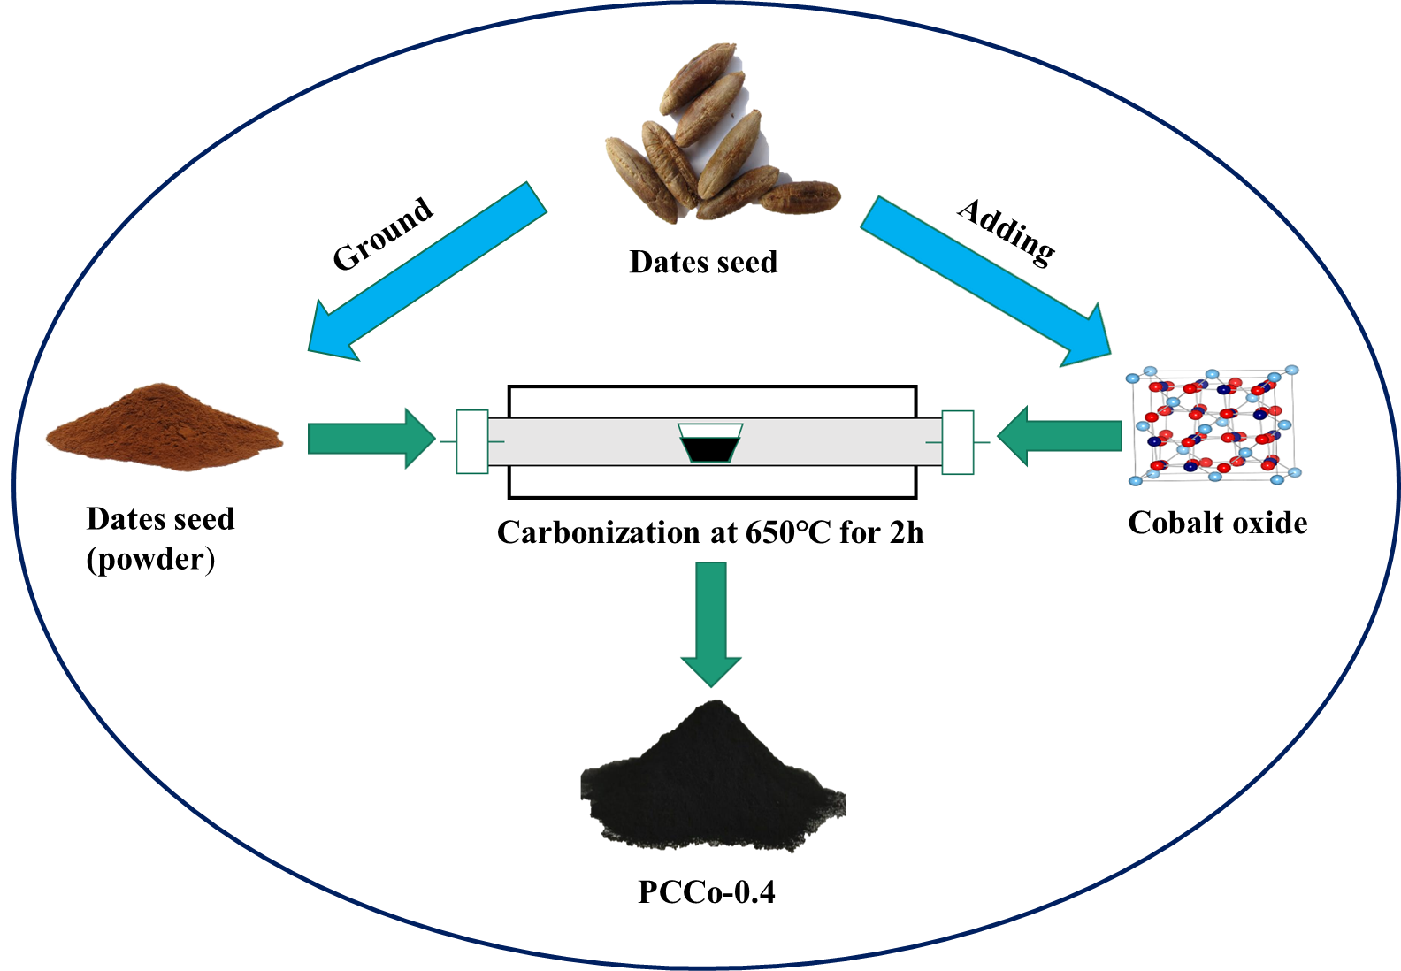

Scheme: Schematic depicted of the synthesis of PCCo-0.4 composites by one-step carbonization and activation process from date seed and cobalt oxide (Co₃O₄).

