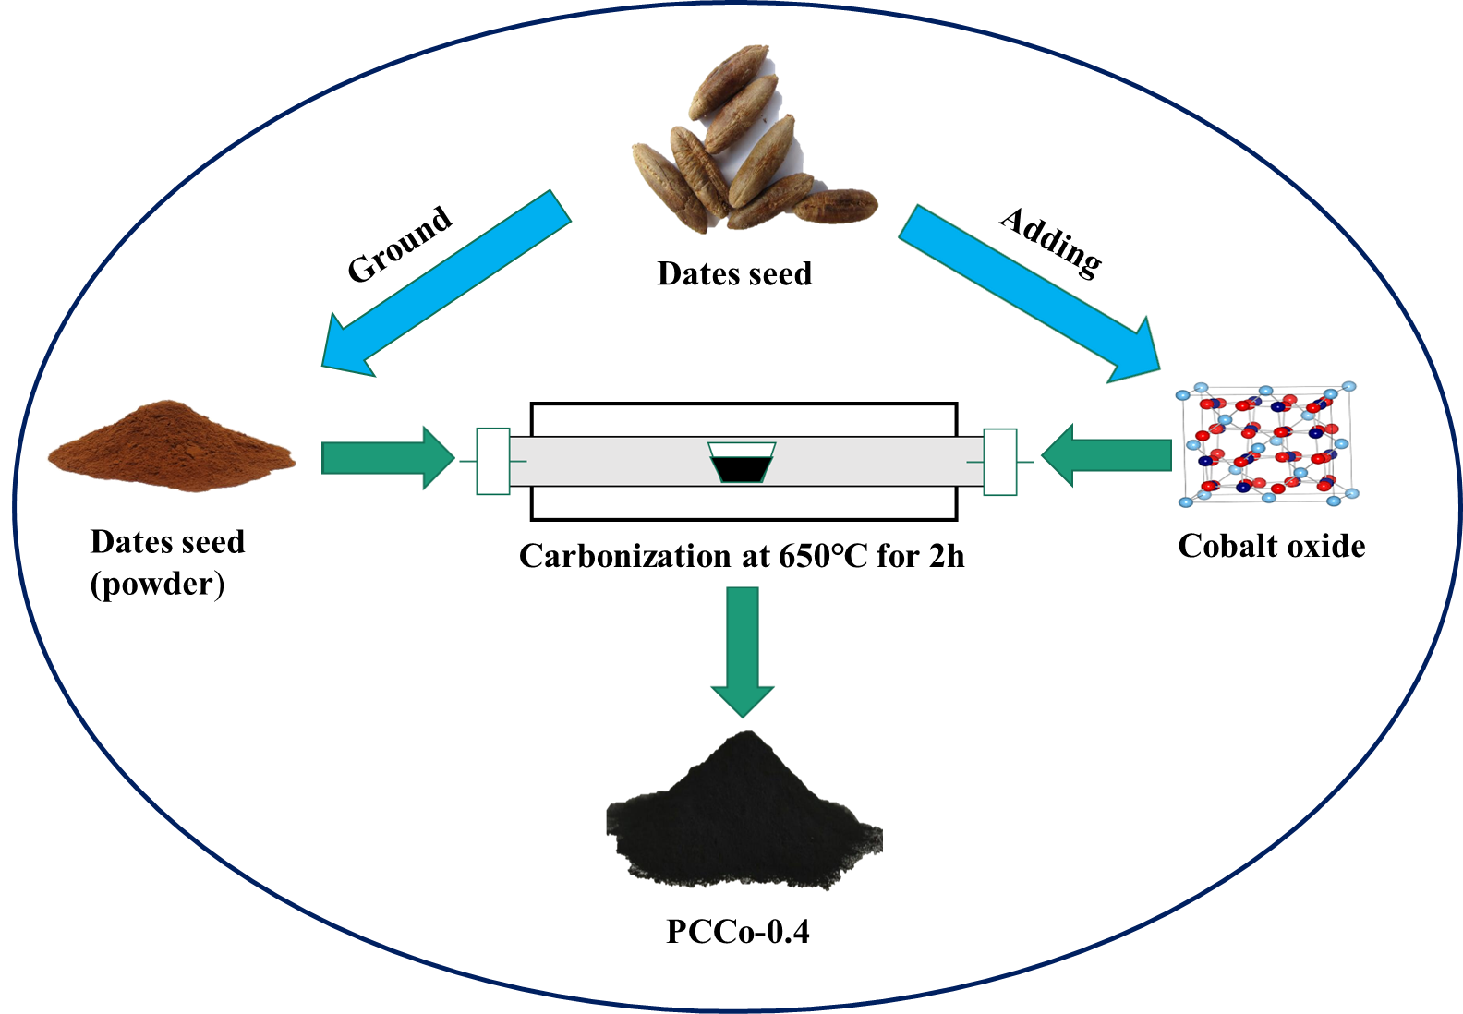
Scheme (1) A schematic depicts the synthesis of PCCo composites by a one-step carbonization and activation process from date seed and cobalt oxide (Co₃O₄).

