Variable effects of a fire-retardant gradient on seasonal wetland communities
Appendix S1. Supplemental data

Section S1: Water Quality
Conductivity exhibited a negative quadratic relationship, which increased approximately at the manufacturer’s recommended fire-retardant concentration (18%; Figure S1). Phosphate exhibited a nonlinear relationship with fire retardant concentration and increased as fire retardant concentration increased (Figure S2). Phosphate values beyond fire retardant concentrations of about 12% reached the maximum values perceivable by the Hach DR3900. It is possible that phosphate values continued to rise above the maximum level detected. Nitrates and chlorophyll-a both increased linearly with added fire-retardant concentration (Figures S3 and S4 respectively). Turbidity, pH, and temperature did not have significant relationships with fire retardant concentration.

Section S2: Vegetation Cover
The relationship between vegetation cover and fire-retardant concentration exhibited a unimodal curve peaking at low concentrations of fire retardant and decreased at concentrations exceeding 2% (Figure S5).

Section S3: Fairy shrimp
Fairy shrimp (Order Anostraca) abundance exhibited a unimodal relationship with fire retardant peaking at low concentrations of fire retardant and decreasing at concentrations exceeding 4%. These results are for the early period of the experiment (Figure S6). Fairy shrimp abundance did not exhibit a significant relationship with fire retardant concentration during the middle and late phases of the experiment.

Section S4: Endemic invertebrates
Two invertebrate families (Branchinectidae and Cyzicidae) are endemic to vernal pools in the Central Valley of California. Endemic abundance exhibited a unimodal relationship that peaked at medium concentrations and declined at around 10% fire retardant concentration (Figures S7a and S7b). This occurred during the first two phases but changed during the late phase of the experiment: abundance showed a weaker unimodal relationship with fire retardant (Figure S7c).

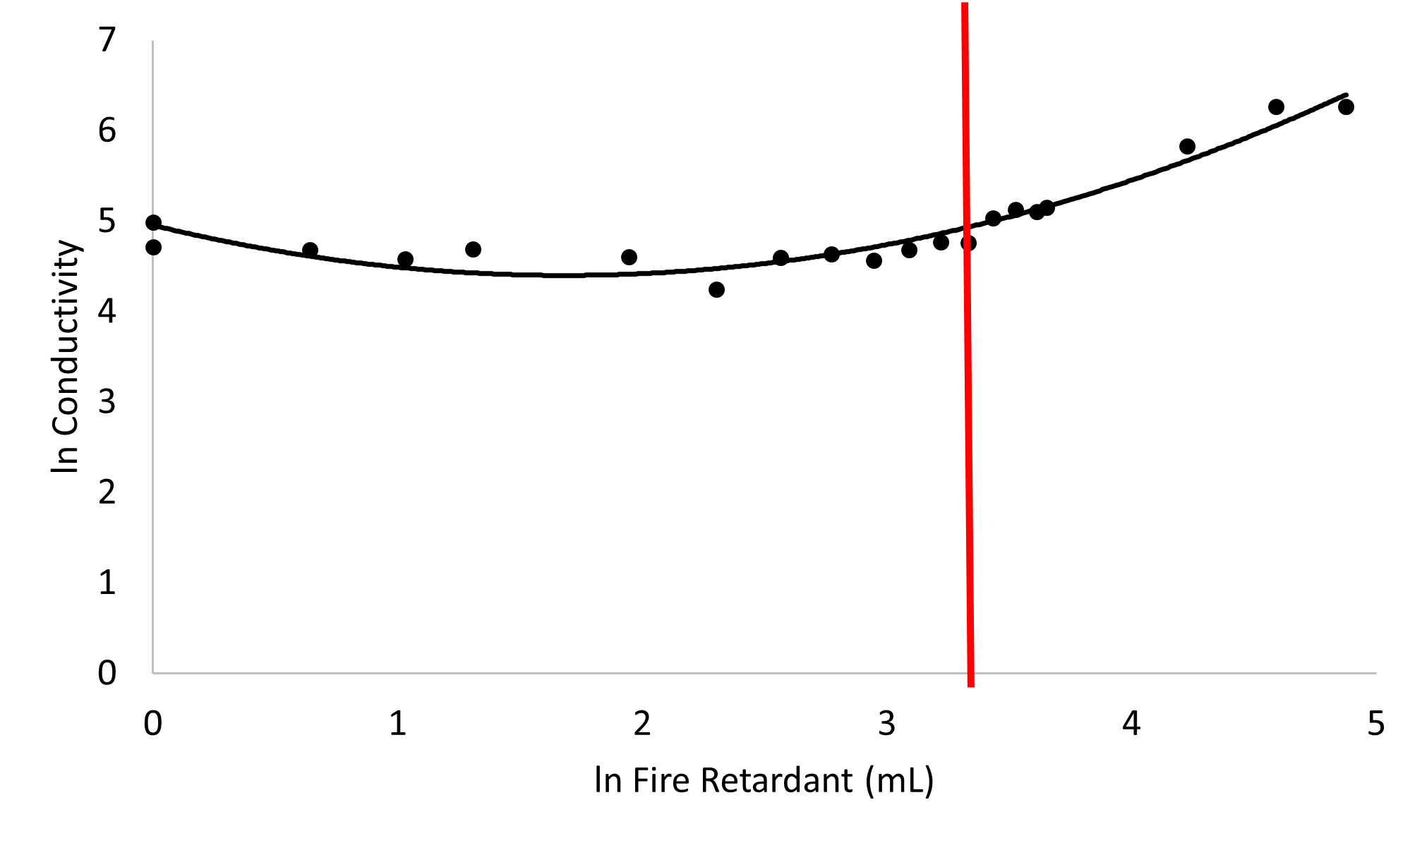
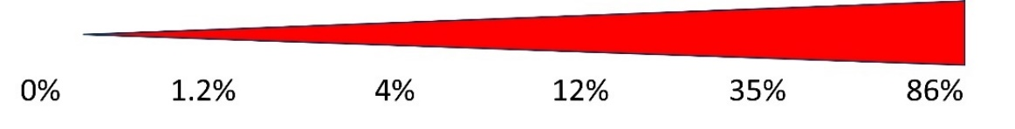

Figure S1. Relationship between conductivity and fire retardant (y=0.1959x²-0.6589x+4.9556, R²=0.93, df= 17, n= 20, P<0.001). The red triangle represents fire retardant concentration increasing from left to right across the x-axis. The manufacturer’s recommended fire-retardant concentration level (18%) is shown by the red line.

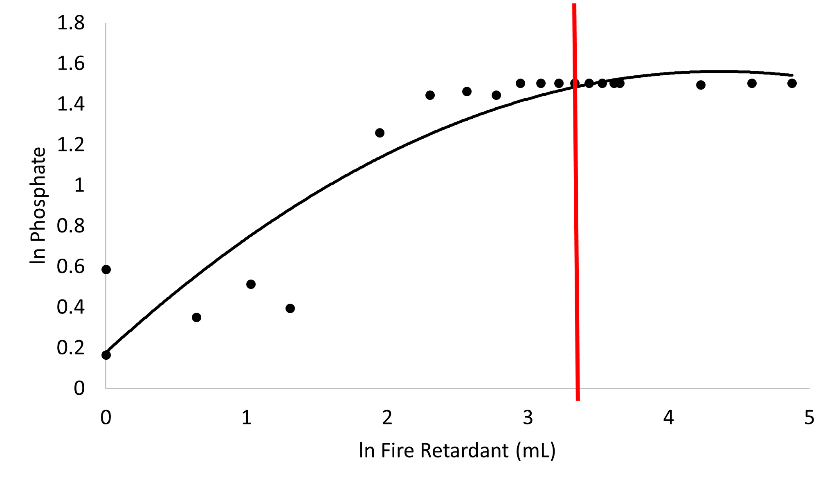

Figure S2. Relationship between phosphate and fire retardant (y=-0.0727x²+0.6345x+0.1775, R²=0.87, df= 17, n= 20, P<0.001). The red triangle represents fire retardant concentration increasing from left to right across the x-axis. The manufacturer’s recommended fire-retardant concentration level (18%) is shown by the red line.

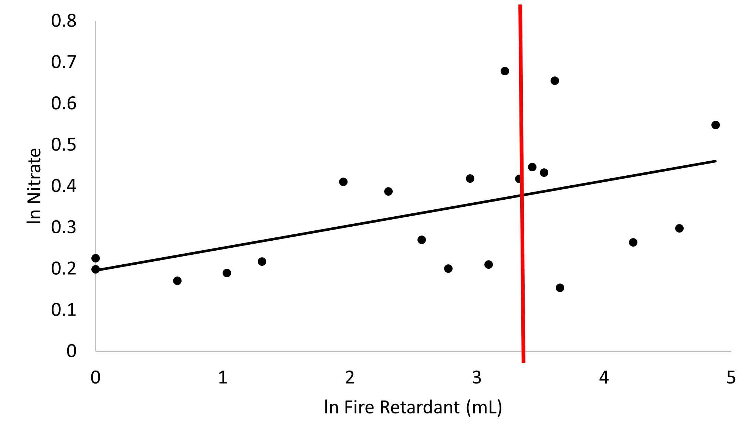

Figure S3. Relationship between nitrate and fire retardant (y=0.0544x+0.196, R²=0.24, df= 18, n= 20, P=0.029). The red triangle represents fire retardant concentration increasing from left to right across the x-axis. The manufacturer’s recommended fire-retardant concentration level (18%) is shown by the red line.

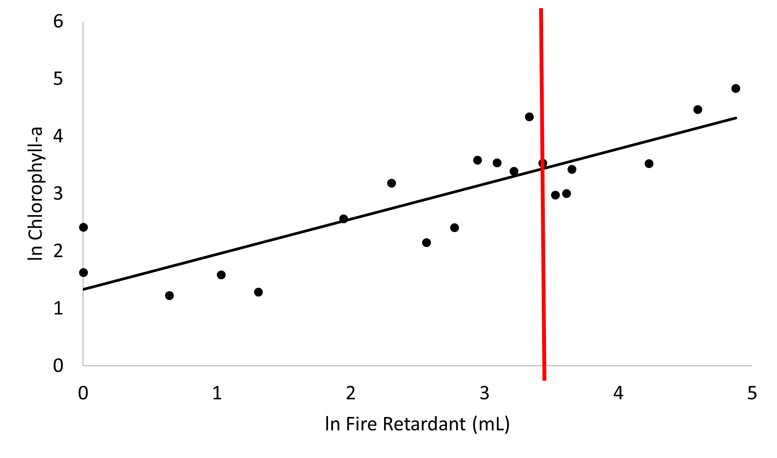

Figure S4. Relationship between chlorophyll-a and fire retardant (y=0.6121x+1.3322, R²=0.71, df= 18, n= 20, P<0.001). The red triangle represents fire retardant concentration increasing from left to right across the x-axis. The manufacturer’s recommended fire-retardant concentration level (18%) is shown by the red line.

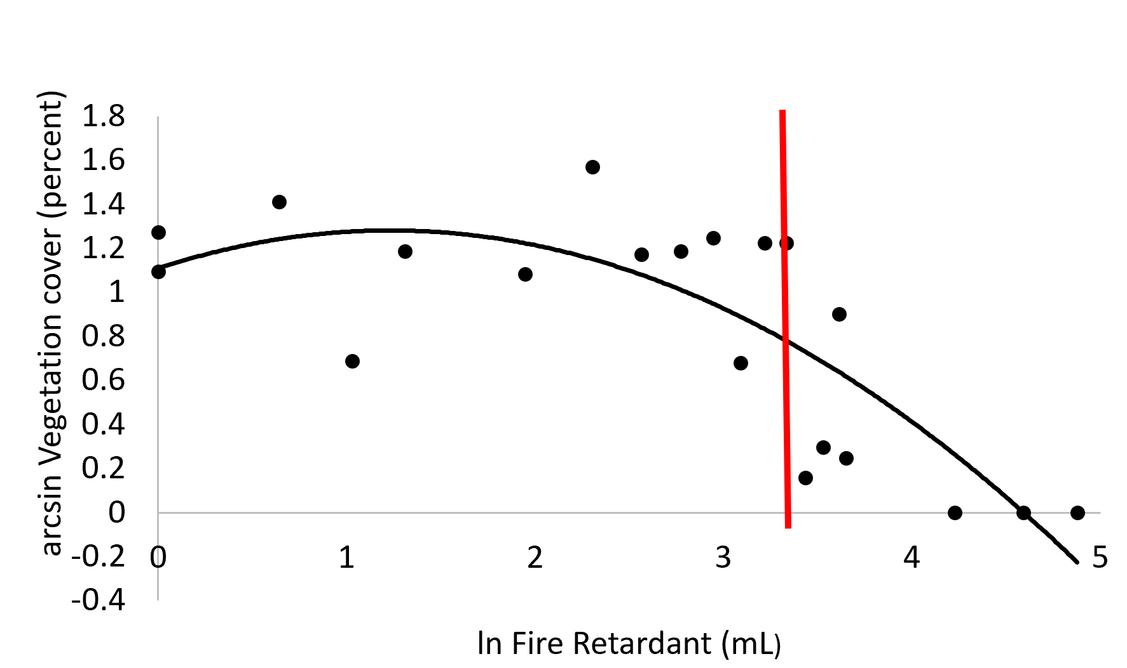

Figure S5. Relationship between percent cover of vegetation and fire retardant (y=-0.1135x²+0.2794x+1.1098, R²=0.63, df= 17, n= 20, P=0.002). The red triangle represents fire retardant concentration increasing from left to right across the x-axis. The manufacturer’s recommended fire-retardant concentration level (18%) is shown by the red line.

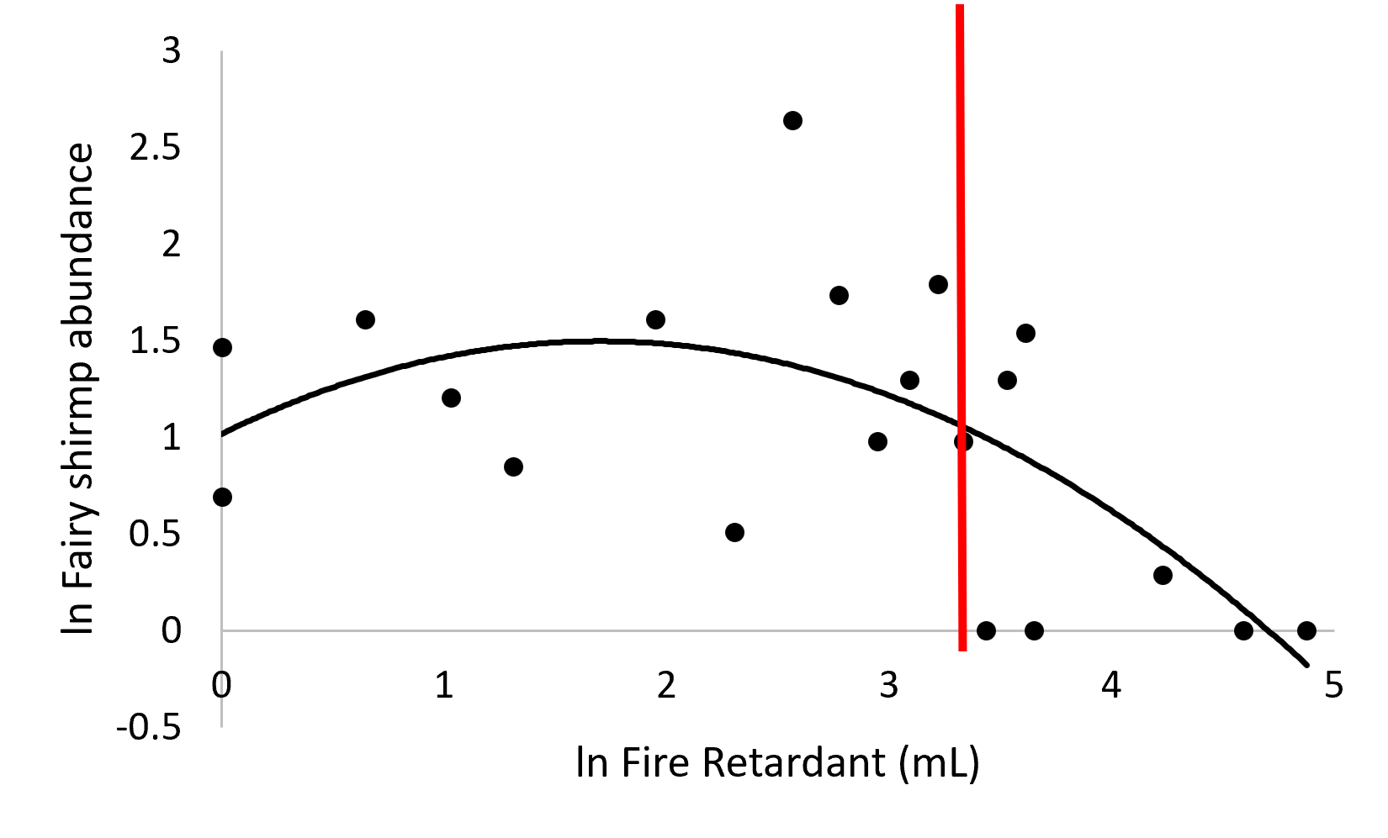
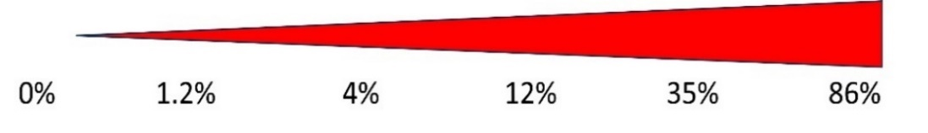

Figure S6. Relationship between fairy shrimp abundance and fire retardant during the early phase of the experiment (y=-0.1659x²+0.5637+1.0185, R²=0.37, df= 17, n= 20, P=0.019). The red triangle represents fire retardant concentration increasing from left to right across the x-axis. The manufacturer’s recommended fire-retardant concentration level (18%) is shown by the red line.

- Early Phase
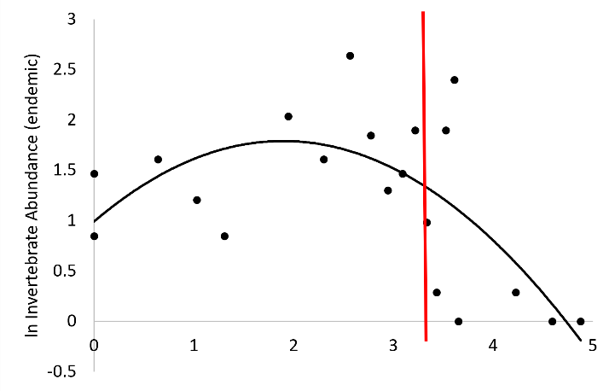
- Middle Phase
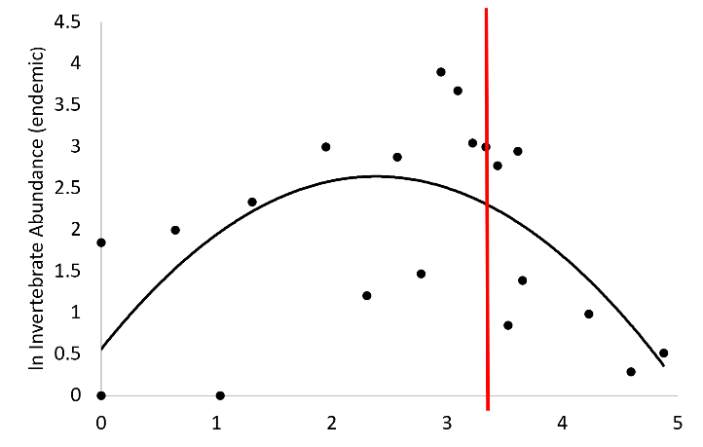
- Late Phase
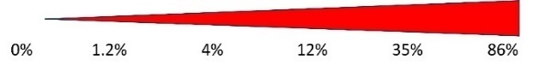
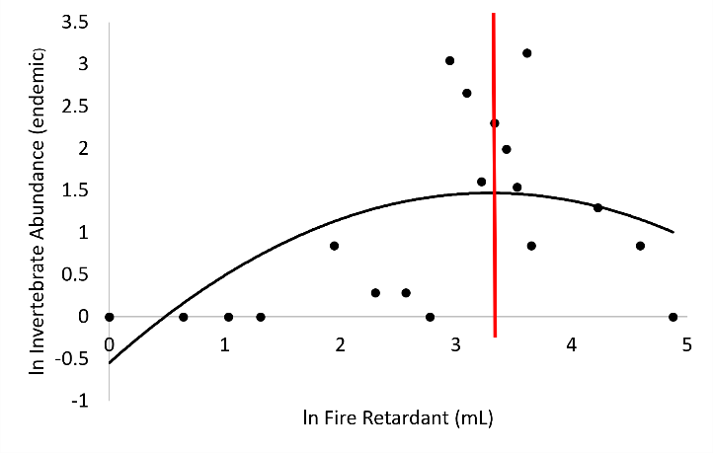
Figure S7. Relationship between endemic invertebrate abundance and fire-retardant concentration during the early (y=-0.2227x²+0.844x+0.9908, R²=0.43, df= 17, n= 20, P=0.009), middle (y=-0.3666x²+1.7471x+0.5575, R²=0.38, df= 17, n= 20, P=0.017), and late (y=-0.1861x²+1.2258x-0.5472, R²=0.35, df= 17, n= 20, P=0.026) phases of the experiment. The phases represent data averaged from weeks 1-6 (December-January), 7-11 (February-March), and 12-17 (March-April), respectively. The red triangle represents fire retardant concentration increasing from left to right across the x-axis. The manufacturer’s recommended fire-retardant concentration level (18%) is shown by the red line.

Tables.
Table S1. Fire retardant was added over the course of two application events. This table shows the volume applied during each of those events as well as the total volume and transformed value used for analysis.
Mesocosm Number | Application 1 (9/17/22) | Application 2 (10/19/22) |  | Total
-- | mL of fire retardant (FR) added | mL of FR added | mL of FR added | ln (mL of FR+1) | Concentration of FR in 150mL spray solution
1 | 0 | 0 | 0 | 0 | 0%
2 | 0 | 0 | 0 | 0 | 0%
3 | 0 | 0.9 | 0.9 | 0.64 | 0.6%
4 | 0 | 1.8 | 1.8 | 1.03 | 1.2%
5 | 2.7 | 0 | 2.7 | 1.31 | 1.8%
6 | 2.7 | 3.3 | 6 | 1.95 | 4%
7 | 2.7 | 6.3 | 9 | 2.30 | 6%
8 | 2.7 | 9.3 | 12 | 2.56 | 8%
9 | 0 | 15 | 15 | 2.77 | 10%
10 | 0 | 18 | 18 | 2.94 | 12%
11 | 0 | 21 | 21 | 3.09 | 14%
12 | 0 | 24 | 24 | 3.22 | 16%
13 | 27 | 0 | 27 | 3.33 | 18%
14 | 27 | 3 | 30 | 3.43 | 20%
15 | 27 | 6 | 33 | 3.53 | 22%
16 | 27 | 9 | 36 | 3.61 | 24%
17 | 37.5 | 0 | 37.5 | 3.65 | 25%
18 | 37.5 | 30 | 67.5 | 4.23 | 45%
19 | 37.5 | 60 | 97.5 | 4.59 | 65%
20 | 37.5 | 92.5 | 130 | 4.88 | 86%

