Humidity-Controlled Sorbents for Efficient Cation Separation
Jinjiang Liang¹, Xin Chen¹, Yining Zhang¹, Jiahao Feng¹, Xinshui Zhang¹, Ning Xue¹, Yihang Yang¹, Tianyi Gao¹, Ran Wei¹, Jiameng Yu¹, Chenxiang Hu^{1,2}, Yue Zhang^{1,2}, Yi Yu^{1,2}, Wei Liu^{1,2}*

¹School of Physical Science and Technology, ShanghaiTech University, Shanghai 201210, China.
²Shanghai Key Laboratory of High-resolution Electron Microscopy, ShanghaiTech University; Shanghai, 201210, China

*Corresponding author. Email: liuwei1@shanghaitech.edu.cn (W.L.)

Supporting Notes

Note S1

There are generally two ways to express the water vapor content in the air: one is by the partial pressure of water vapor, and the other is by relative humidity, which represents the percentage of the current water vapor partial pressure relative to the saturation vapor pressure of water at a given temperature. As the temperature increases, the saturation vapor pressure of water rises continuously (as shown by the blue line), and the saturation vapor pressure of salt solutions also increases (Fig 1c). However, the relative humidity does not significantly change with temperature (as shown in Supplementary Fig. 1). In fact, measuring water vapor partial pressure is quite challenging and varies significantly with temperature, making it difficult to control, measure, and describe the water vapor content in experiments. In contrast, relative humidity is easier to measure, and the equilibrium relative humidity of different salts does not vary significantly with temperature. Therefore, relative humidity is used in experiments to describe the water vapor content in the environment.

Note S2

The separation and purification of different ions are achieved by controlling the relative humidity. Specifically, the selectivity of ions is essentially determined by the ion activity product between different salts. When the humidity is controlled to allow only lithium chloride to deliquesce, the resulting lithium chloride solution is nearly saturated. According to inductively coupled plasma optical emission spectrometry (ICP) results, at 25°C and 40% relative humidity, the deliquescence concentration of lithium chloride is 7.35 mol L⁻¹, while the concentrations of saturated sodium chloride and saturated potassium chloride are 6.14 mol L⁻¹ and 4.58 mol L⁻¹, respectively. This difference inhibits the dissolution of impurity salts, thereby allowing the purification of lithium chloride. Additionally, the lower the relative humidity, the higher the concentration of the deliquesced solution, and the better the purification effect.

Note S3

Due to the composite sorbent being significantly larger than the maximum field of view that can be captured by an electron microscope, it is not feasible to image the entire cross-section of the beads in a single shot. To address this, we maintained all parameters constant while capturing electron microscope images and element distribution maps. We took an 8$×$8 grid of images at 500 μm intervals in the x and y directions. Subsequently, we used Python to stitch the collected images together, resulting in a clear and complete view of the composite sorbent (Fig. 3a).

Note S4

Currently, compared to the industrial evaporation pond method for lithium extraction, excluding labor and equipment costs, the cost is approximately $7,087 ton⁻¹ LCE¹. In 100 cycles, an average of 1 g of sorbent can extract 11.49 g of Li, requiring approximately 72 m³ of air with 40% RH. According to data from the China Meteorological Data Service Centre², the average daytime relative humidity in Tibet, Xinjiang, and Qinghai (the main distribution areas of salt lakes) is below 40%. This means that ambient air can be directly used during lithium extraction, so the main energy consumption comes from air transportation. Using industrial fans to transport air is highly energy-efficient. Large industrial fans can move 30,000 m³ of air per hour with a power consumption of only 0.37 kW, resulting in an energy consumption of just 0.077 kWh kg⁻¹ Li. The industrial electricity price in China is about $0.087 kWh⁻¹, resulting in an energy cost of approximately $6.699 ton⁻¹ of Li extracted. Additionally, the industrial prices of PAN, CS, and DMF are $1,269 ton⁻¹, $1,551 ton⁻¹, and $578 ton⁻¹, respectively. Extracting one ton of lithium requires 58.00 kg of PAN, 29.00 kg of CS, and 548.10 kg of DMF, leading to the cost of raw materials is $435.38 ton_{Li}⁻¹ for lithium extraction (equivalent to $81.89 ton⁻¹ LCE), excluding labor and equipment costs.

Note S5

Accurately predicting the vapor pressure of a single-solute solution is quite challenging. The current approach primarily involves experimentally measuring the vapor pressure at different temperatures and concentrations, fitting the obtained data, and using empirical formulas to predict the solution's vapor pressure. Consequently, theoretically predicting the vapor pressure of a binary solute solution becomes even more difficult. Therefore, we performed theoretical calculations of the vapor pressure of LiCl and NaCl mixed solutions using an ideal model—Raoult's law:

$$P_{sol}=P_{LiCl} X_{LiCl}+P_{NaCl}X_{NaCl}$$

P_{sol} is , P_{LiCl} is the vapor pressure corresponding to a lithium chloride solution with the same concentration as the mixed solution, X_{LiCl} is the mole fraction of lithium chloride, P_{NaCl} is the vapor pressure corresponding to a sodium chloride solution with the same concentration as the mixed solution, X_{NaCl} is the mole fraction of sodium chloride. We know that the relative humidity multiplied by the saturation vapor pressure of water gives the partial pressure of water vapor. Therefore, the relative humidity can be expressed by the following relationship:

$${RH}_{sol}={RH}_{LiCl} X_{LiCl}+{RH}_{NaCl}X_{NaCl}$$

Although the actual humidity of the solution may exhibit positive or negative deviations from the theoretical calculations, this does not affect the overall trend. Therefore, qualitative analysis can still be performed based on the calculated results.

Supporting Figures:
Supplementary Figure 1 | The states of LiCl, NaCl, KCl and MgCl₂ under different relative humidity. At 25 °C, the relative humidity of 11-33% can selectively extract LiCl, 33-75% can selectively extract MgCl₂ and 75-84% can selectively extract NaCl

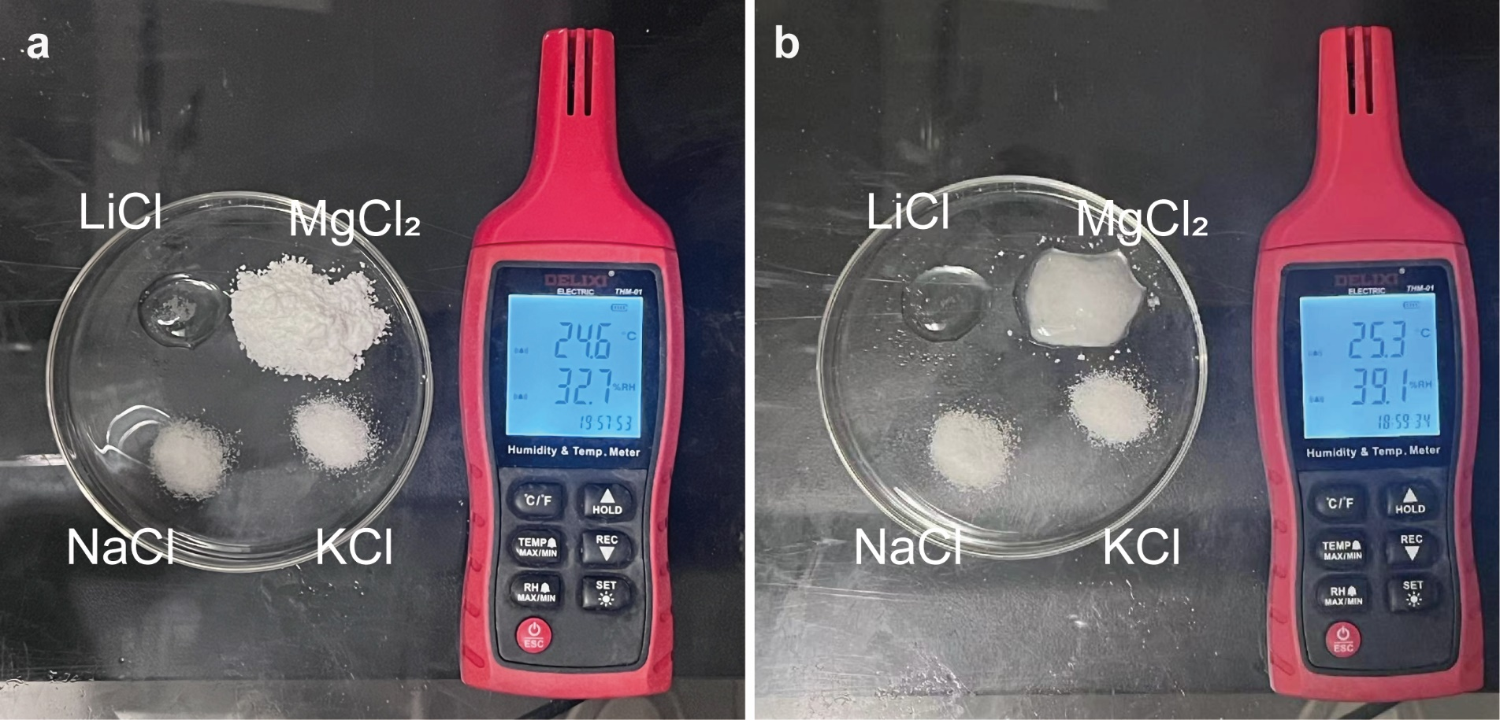
Supplementary Figure 2 | Humidity absorption of LiCl, NaCl, KCl and MgCl₂. a, At low humidity (RH < 33%), LiCl absorbs moisture and becomes a LiCl solution, while NaCl, KCl and MgCl₂ remain solid. b, When the RH is controlled between 33% and 75%, LiCl and MgCl₂ are in a liquefied state, while NaCl and KCl remain solid.

Supplementary Figure 3 | Confusion matrix. The performance of the sklearn's linear model on test set is presented.

Supplementary Figure 4 | Performance of linear regression model in the training and test sets of polymer contact angles. The contact angle between polyacrylonitrile and chitosan was predicted.

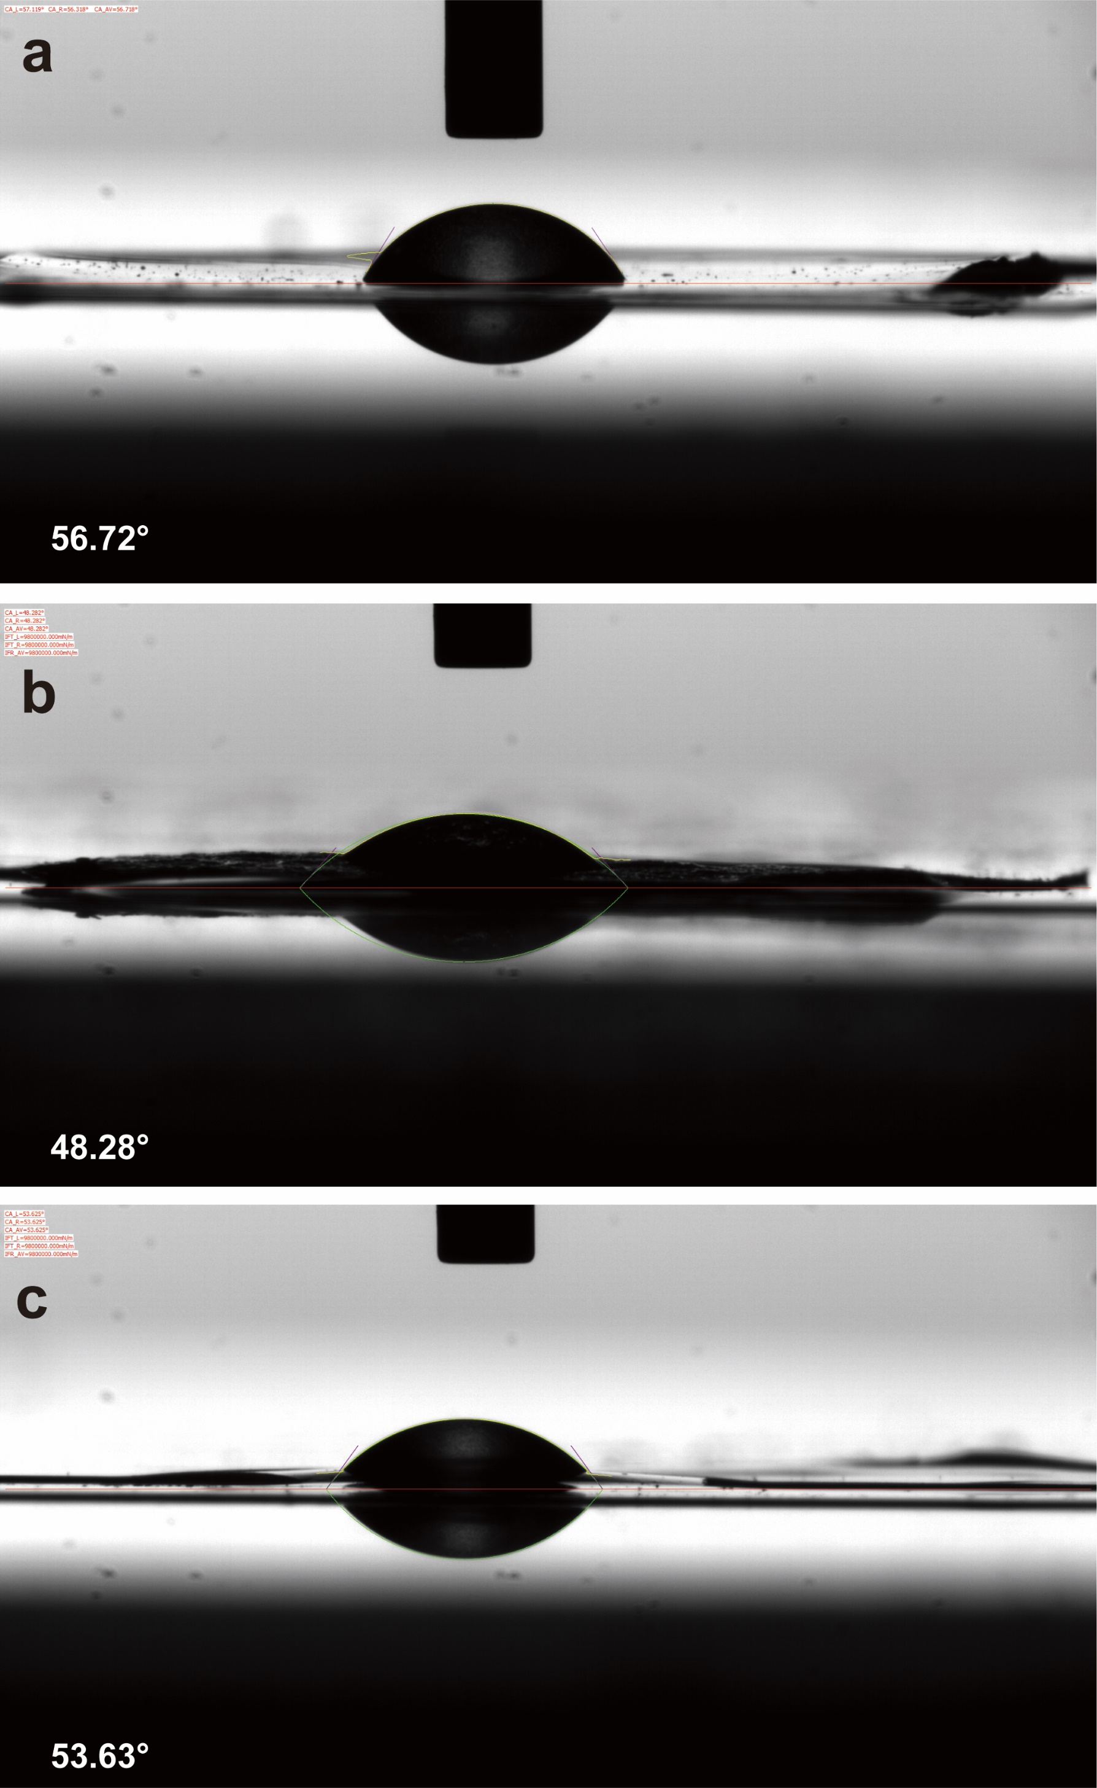
Supplementary Figure 5 | Contact Angle of a, polypropylene, b, chitosan, and c, polypropylene-chitosan composite film

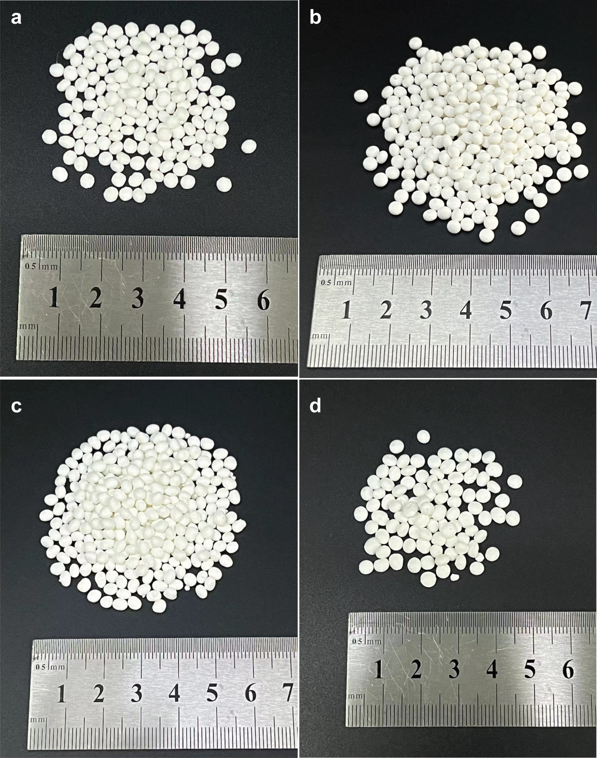
Supplementary Figure 6 | Four kinds of polymer adsorption spheres were synthesized. a, Polyacrylonitrile adsorption ball b, Polyacrylonitrile-chitosan composite adsorption sphere c, Polyacrylonitrile-ethyl cellulose composite adsorption sphere d, Polyacrylonitrile-cellulose acetate composite adsorption ball
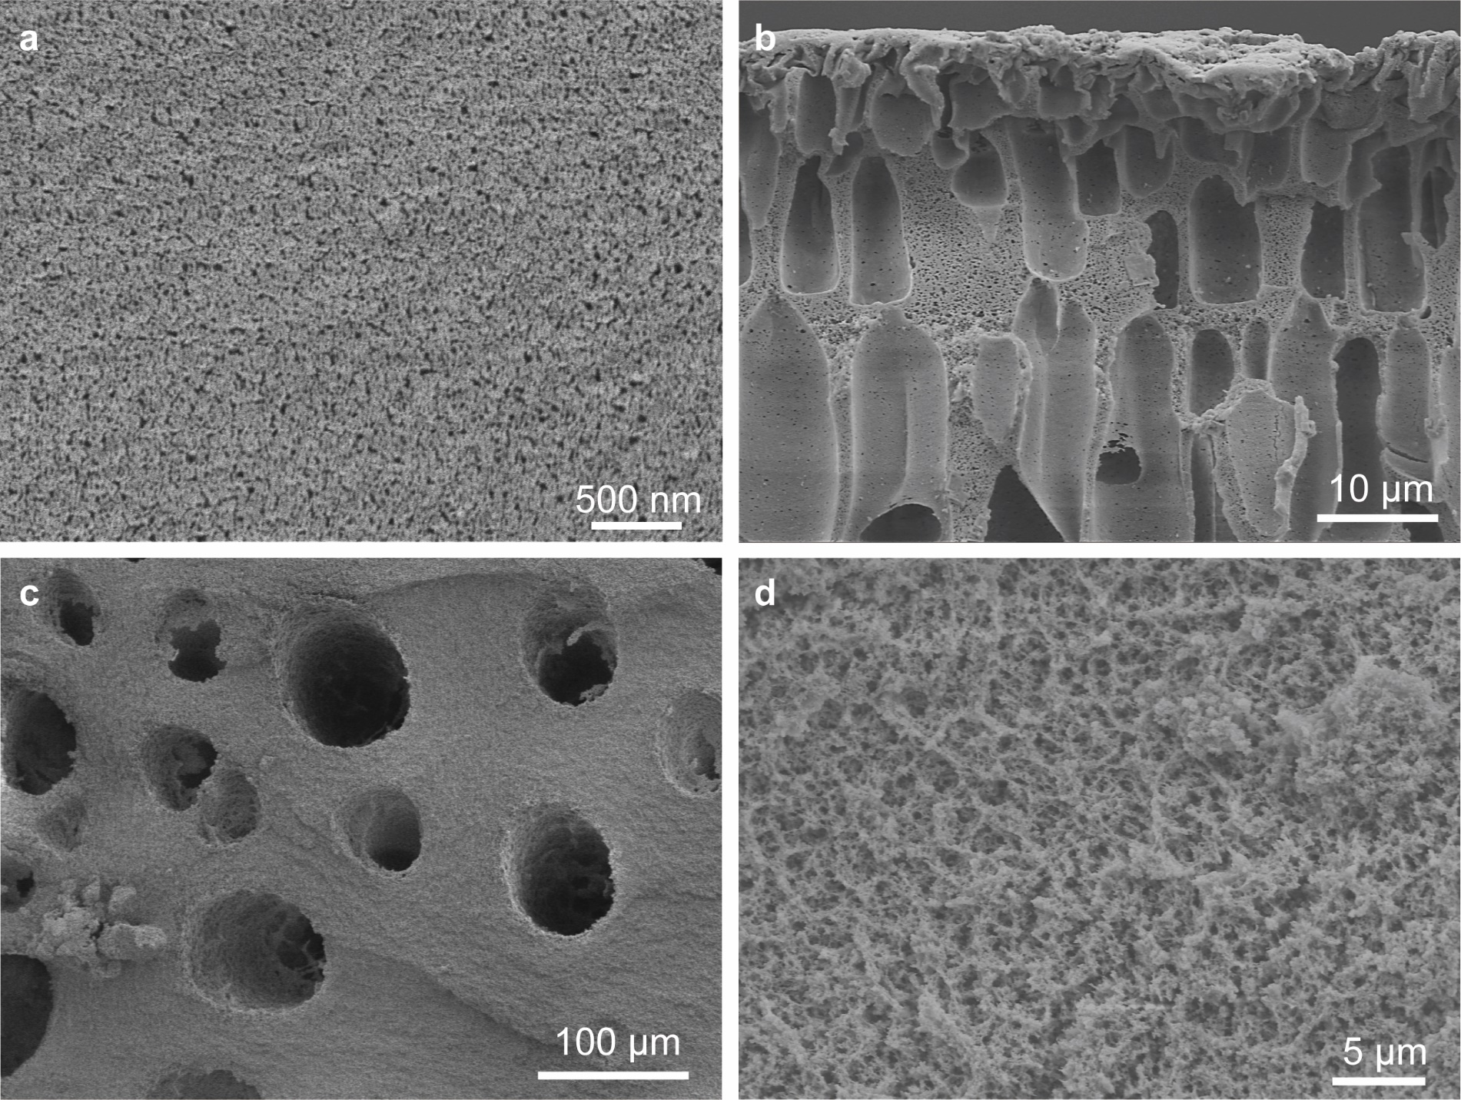
Supplementary Figure 7 | SEM images of the surface and different cross-sections of the sorbent (a) Surface of the sorbent (b) Cross-section near the surface of the sorbent (c) Cross-section near the center of the sorbent (d) Pore walls of the sorbent.

Supplementary Figure 8 | Pore diameter distribution measured by BET nitrogen adsorption.

Supplementary Figure 9 | a, SEM Mosaic image of section of polyacrylonitrile-chitosan composite adsorption sphere before lithium extraction. EDS mapping of b, nitrogen c, oxygen

Supplementary Figure 10 | Absorption rate of water and lithium chloride solution by polyacrylonitrile-chitosan adsorption spheres

Supplementary Figure 11 | The large depth of field (LDF) mode of the JSM-7800F captures the SEM and EDS of the complete adsorption sphere. Due to the large size of the adsorption ball, it is difficult for SEM to photograph the complete morphology of the ball. Although LDF mode can see the complete morphology, its resolution is relatively low.

Supplementary Figure 12 | EDS mapping of surface of adsorption sphere after lithium extraction. Chlorine is uniformly distributed on the surface and covers the signals of C, N and O, and a small amount of Na is scattered on the surface

Supplementary Figure 13 | EDS mapping of the middle of the surface of adsorption sphere after lithium extraction.

Supplementary Figure 14 | Enlarged EDS view of the middle area of the surface of adsorption sphere after lithium extraction. NaCl crystallizes in a cube form and does not form a solid solution with lithium chloride

Supplementary Figure 15 | Positive mode mass spectra of TOF-SIMS

Supplementary Figure 16 | Negative mode mass spectra of TOF-SIMS

Supplementary Figure 17 | TOF-SIMS two-dimensional imaging at the cross section position of the adsorption sphere near the surface.

Supplementary Figure 18 | a, XRD of recovered powder after lithium extraction. b, Recovered LiCl powder

Supplementary Figure 19 | SEM and EDS images of recovered powder after lithium extraction a, SEM image b, EDS distribution of Sodium c, EDS distribution of Chloride d, EDS spectrum.

Supplementary Figure 20 | a, Effect of the ratio of mixed salt to adsorption ball on adsorption capacity and purity b, Recovery rate, sorbent utilization

Supplementary Figure 21 | a, Purity at different humidities b, Purity at different adsorption time.

Supplementary Figure 22 | The change of adsorption capacity of adsorption ball with time in 8.5 M LiCl solution a, adsorption for 7200s b, figure S22 zoomed in at 0-600s.

Supplementary Figure 23 | In a LiCl-NaCl mixed salt with a lithium ion content of 3.33% under 40% RH, the water absorption rate of LiCl and the mass fraction of the resulting LiCl solution.

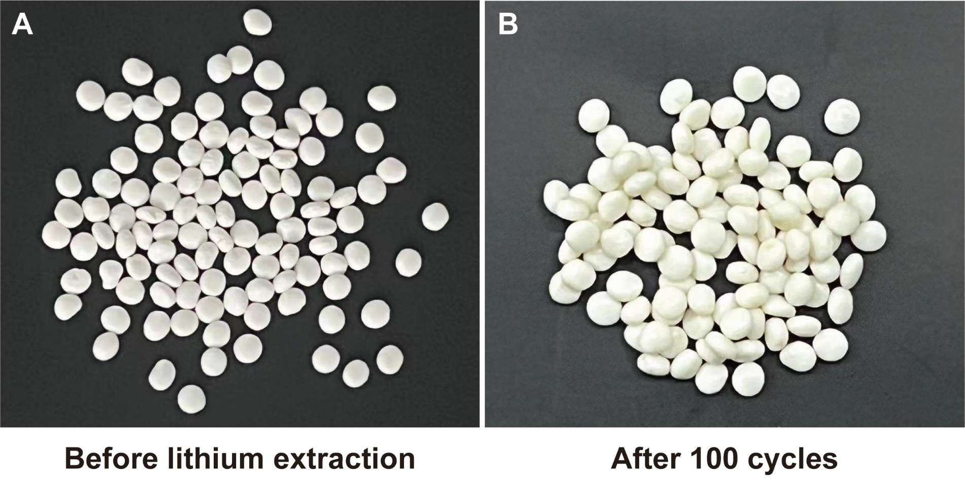
Supplementary Figure 24 | Isothermal adsorption of adsorption spheres in 8.5 M LiCl solution

Supplementary Figure 25 | IR of precursor，adsorbed spheres before and after lithium extraction. There was no significant displacement of the peak before and after preparation of the sorbents, before and after absorption of the composite adsorption ball and after extraction of lithium

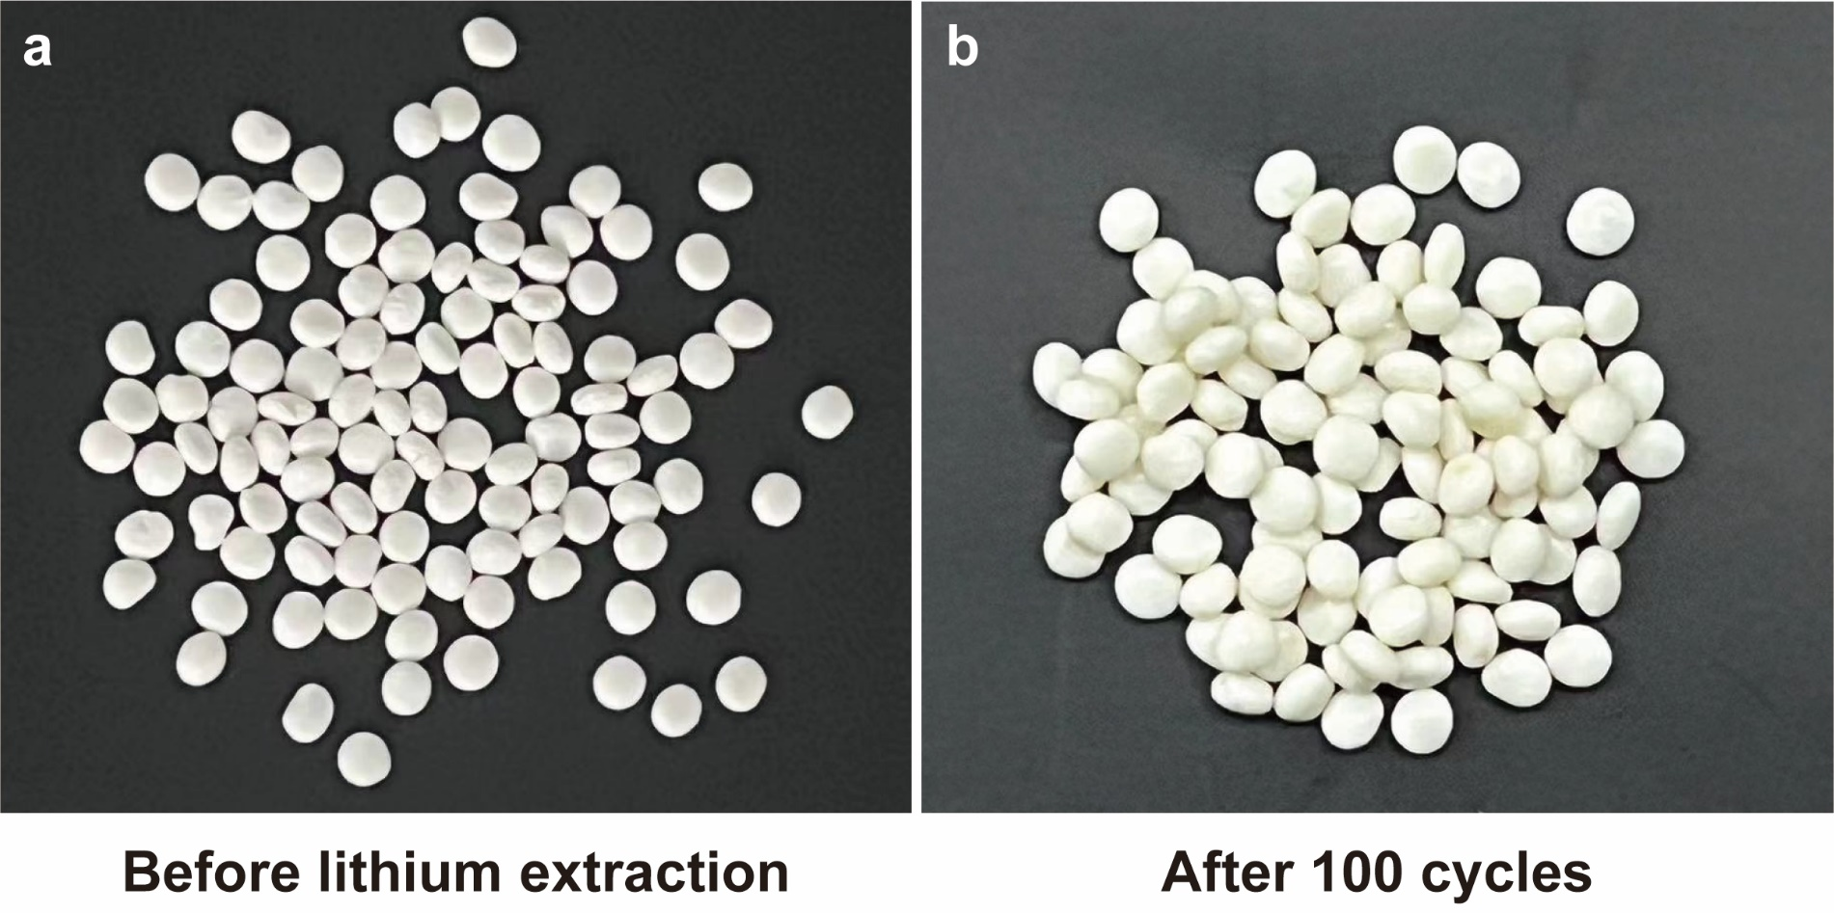
Supplementary Figure 26 | The changes of adsorption spheres before and after 100 cycles a, before lithium extraction b, after 100 cycles lithium extraction

Supplementary Table 1 | Aluminum-based adsorbent
Equilibrium time (h) | Adsorption capacity (mg g⁻¹) | Adsorption rate (mg g⁻¹ h⁻¹) | Recycle | References
2 | 7.3 | 3.64 | 12 | ³
4 | 6.3 | 1.58 | 8 | ⁴
4 | 3.0 | 0.75 | Not mentioned | ⁵
2 | 9.33 | 4.67 | Not mentioned | ⁶
36 | 5.69 | 0.16 | Not mentioned | ⁷
Average | 6.3 | 2.16 | 10

Supplementary Table 2 | Manganese-based adsorbent
Equilibrium time (h) | Adsorption capacity (mg g⁻¹) | Adsorption rate (mg g⁻¹ h⁻¹) | Recycle | References
24 | 23.5 | 0.98 | Not mentioned | ⁸
72 | 40.9 | 0.57 | Not mentioned | ⁹
72 | 28.3 | 0.39 | 6 | ¹⁰
24 | 26.9 | 1.12 | Not mentioned | ¹¹
24 | 27.2 | 1.13 | 10 | ¹²
120 | 59.4 | 0.50 | Not mentioned | ¹³
12 | 39 | 3.25 | Not mentioned | ¹⁴
12 | 37.6 | 3.13 | Not mentioned | ¹⁵
24 | 33.1 | 1.38 | 5 | ¹⁶
12 | 27.7 | 2.31 | 5 | ¹⁷
48 | 31.7 | 0.66 | 20 | ¹⁸
Average | 34.11 | 1.40 | 9.2

Supplementary Table 3 | Titanium-based adsorbent
Equilibrium time (h) | Adsorption capacity (mg g⁻¹) | Adsorption rate (mg g⁻¹ h⁻¹) | Recycle | References
24 | 32.6 | 1.36 | Not mentioned | ¹⁹
24 | 21 | 0.88 | Not mentioned | ²⁰
8 | 27.4 | 3.43 | 4 | ²¹
24 | 34.2 | 1.43 | 8 | ²²
8 | 33.4 | 4.17 | Not mentioned | ²³
24 | 34.4 | 1.43 | 5 | ²⁴
24 | 52 | 2.17 | 5 | ²⁴
24 | 39.5 | 1.65 | 6 | ²⁵
48 | 34.8 | 0.73 | 9 | ²⁶
Average | 34.36 | 1.91 | 6.14

Supplementary Table 4 | Lithium extraction by electrochemical electrode
Electrodes | Adsorption capacity (mg g⁻¹) | Adsorption rate (mg g⁻¹ h⁻¹) | Recycle | References
Ag//LFP | 38.9 | 3.86 | Not mentioned | ²⁷
LiMn₂O₄ film electrode | 26.1 | 13.05 | Not mentioned | ²⁸
λ-MnO₂-PPy-PSS | 35.2 | 17.10 | 100 | ²⁹
LiFePO₄ | 38.9 | 2.13 | Not mentioned | ³⁰
NiHCF//$λ$-MnO₂ | 14.9 | 14.88 | 100 | ³¹
NMMO/AC | 14.4 | 21.10 | 30 | ³²
LiMn₂O₄ flow-type system | 24 | 9.60 | Not mentioned | ³³
LiMn₂O₄@carbon fiber | 12 | 2.40 | 100 | ³⁴
AC//LNCM/rGO | 13.8 | 20.76 | 30 | ³⁵
LiMn₂O₄/Zn | 4.9 | 0.98 | 10 | ³⁶
Average | 22.31 | 10.59 | 61.67

1 Xu, R. et al. Continuous lithium extraction from brine by efficient redox-couple electrodialysis. Matter, doi:10.1016/j.matt.2024.07.014.
2 Historical Data Set of Surface Meteorological Observation in China (Monthly value), <https://data.cma.cn/data/detail/dataCode/A.0019.0001.S001.html> (
3 Zhong, J., Lin, S. & Yu, J. Li+ adsorption performance and mechanism using lithium/aluminum layered double hydroxides in low grade brines. Desalination 505, 114983, doi:https://doi.org/10.1016/j.desal.2021.114983 (2021).
4 Chen, J., Lin, S. & Yu, J. High-selective cyclic adsorption and magnetic recovery performance of magnetic lithium-aluminum layered double hydroxides (MLDHs) in extracting Li+ from ultrahigh Mg/Li ratio brines. Separation and Purification Technology 255, 117710, doi:https://doi.org/10.1016/j.seppur.2020.117710 (2021).
5 Menzheres, L. T., Ryabtsev, A. D. & Mamylova, E. V. Synthesis of Selective Sorbent LiCl ⋅ 2Al(OH)3 ⋅ nH2O. Theoretical Foundations of Chemical Engineering 53, 821-826, doi:10.1134/S0040579518050172 (2019).
6 Zhong, J., Lin, S. & Yu, J. Effects of excessive lithium deintercalation on Li+ adsorption performance and structural stability of lithium/aluminum layered double hydroxides. Journal of Colloid and Interface Science 572, 107-113, doi:https://doi.org/10.1016/j.jcis.2020.03.081 (2020).
7 Jiang, H., Zhang, S., Yang, Y. & Yu, J. Synergic and competitive adsorption of Li–Na–MgCl2 onto lithium–aluminum hydroxides. Adsorption 26, 1039-1049, doi:10.1007/s10450-020-00208-5 (2020).
8 Wang, L., Ma, W., Liu, R., Li, H. Y. & Meng, C. G. Correlation between Li+ adsorption capacity and the preparation conditions of spinel lithium manganese precursor. Solid State Ionics 177, 1421-1428, doi:https://doi.org/10.1016/j.ssi.2006.07.019 (2006).
9 Chitrakar, R., Kanoh, H., Miyai, Y. & Ooi, K. Recovery of Lithium from Seawater Using Manganese Oxide Adsorbent (H1.6Mn1.6O4) Derived from Li1.6Mn1.6O4. Industrial & Engineering Chemistry Research 40, 2054-2058, doi:10.1021/ie000911h (2001).
10 Xiao, J.-L., Sun, S.-Y., Wang, J., Li, P. & Yu, J.-G. Synthesis and Adsorption Properties of Li1.6Mn1.6O4 Spinel. Industrial & Engineering Chemistry Research 52, 11967-11973, doi:10.1021/ie400691d (2013).
11 Sun, S.-Y., Xiao, J.-L., Wang, J., Song, X. & Yu, J.-G. Synthesis and Adsorption Properties of Li1.6Mn1.6O4 by a Combination of Redox Precipitation and Solid-Phase Reaction. Industrial & Engineering Chemistry Research 53, 15517-15521, doi:10.1021/ie5004625 (2014).
12 Shi, X. et al. Synthesis and properties of Li1.6Mn1.6O4 and its adsorption application. Hydrometallurgy 110, 99-106, doi:https://doi.org/10.1016/j.hydromet.2011.09.004 (2011).
13 Zandevakili, S., Ranjbar, M. & Ehteshamzadeh, M. Synthesis of a nanostructure ion sieve with improved lithium adsorption capacity. Micro & Nano Letters 9, 455-459, doi:https://doi.org/10.1049/mnl.2014.0086 (2014).
14 Zhang, Q.-H., Li, S.-P., Sun, S.-Y., Yin, X.-S. & Yu, J.-G. Lithium selective adsorption on 1-D MnO2 nanostructure ion-sieve. Advanced Powder Technology 20, 432-437, doi:https://doi.org/10.1016/j.apt.2009.02.008 (2009).
15 Wang, L., Meng, C. G. & Ma, W. Study on Li+ uptake by lithium ion-sieve via the pH technique. Colloids and Surfaces A: Physicochemical and Engineering Aspects 334, 34-39, doi:https://doi.org/10.1016/j.colsurfa.2008.09.050 (2009).
16 Chung, K. S. et al. Preparation of ion-sieve type (H)[M0. 5Mn1. 5] O4 (M= Mg, Zn) and their lithium adsorption properties in seawater. Solid State Phenomena 124, 739-742 (2007).
17 Chen, M. et al. Improved performance of Al-doped LiMn2O4 ion-sieves for Li+ adsorption. Microporous and Mesoporous Materials 261, 29-34, doi:https://doi.org/10.1016/j.micromeso.2017.10.058 (2018).
18 Gaifang, C. et al. Synthesis, Adsorption Properties and Stability of Cr-Doped Lithium Ion Sieve in Salt Lake Brine. Bulletin of the Chemical Society of Japan (2019).
19 Chitrakar, R., Makita, Y., Ooi, K. & Sonoda, A. Lithium recovery from salt lake brine by H2TiO3. Dalton Transactions 43, 8933-8939, doi:10.1039/C4DT00467A (2014).
20 Chitrakar, R., Makita, Y., Ooi, K. & Sonoda, A. Lithium recovery from salt lake brine by H 2 TiO 3. Dalton Transactions 43, 8933-8939 (2014).
21 Marthi, R. & Smith, Y. R. Application and limitations of a H2TiO3 – Diatomaceous earth composite synthesized from titania slag as a selective lithium adsorbent. Separation and Purification Technology 254, 117580, doi:https://doi.org/10.1016/j.seppur.2020.117580 (2021).
22 Li, X. et al. Taming wettability of lithium ion sieve via different TiO2 precursors for effective Li recovery from aqueous lithium resources. Chemical Engineering Journal 392, 123731, doi:https://doi.org/10.1016/j.cej.2019.123731 (2020).
23 Zhang, L.-Y., Liu, Y.-W., Huang, L. & Li, N. A novel study on preparation of H 2 TiO 3–lithium adsorbent with titanyl sulfate as titanium source by inorganic precipitation–peptization method. RSC advances 8, 1385-1391 (2018).
24 Gu, D., Sun, W., Han, G., Cui, Q. & Wang, H. Lithium ion sieve synthesized via an improved solid state method and adsorption performance for West Taijinar Salt Lake brine. Chemical Engineering Journal 350, 474-483, doi:https://doi.org/10.1016/j.cej.2018.05.191 (2018).
25 Wang, S. et al. High adsorption performance of the Mo-doped titanium oxide sieve for lithium ions. Hydrometallurgy 187, 30-37, doi:https://doi.org/10.1016/j.hydromet.2019.05.004 (2019).
26 Wang, S., Chen, X., Zhang, Y., Zhang, Y. & Zheng, S. Lithium adsorption from brine by iron-doped titanium lithium ion sieves. Particuology 41, 40-47, doi:https://doi.org/10.1016/j.partic.2018.02.001 (2018).
27 Liu, X., Chen, X., Zhao, Z. & Liang, X. Effect of Na+ on Li extraction from brine using LiFePO4/FePO4 electrodes. Hydrometallurgy 146, 24-28, doi:https://doi.org/10.1016/j.hydromet.2014.03.010 (2014).
28 Xu, X. et al. A Self-Supported λ-MnO2 Film Electrode used for Electrochemical Lithium Recovery from Brines. ChemPlusChem 83, 521-528, doi:https://doi.org/10.1002/cplu.201800185 (2018).
29 Du, X. et al. A novel electroactive λ-MnO 2/PPy/PSS core–shell nanorod coated electrode for selective recovery of lithium ions at low concentration. Journal of Materials Chemistry A 4, 13989-13996 (2016).
30 Liu, X., Chen, X., He, L. & Zhao, Z. Study on extraction of lithium from salt lake brine by membrane electrolysis. Desalination 376, 35-40 (2015).
31 Trócoli, R., Erinmwingbovo, C. & La Mantia, F. Optimized Lithium Recovery from Brines by using an Electrochemical Ion-Pumping Process Based on λ-MnO2 and Nickel Hexacyanoferrate. ChemElectroChem 4, 143-149, doi:https://doi.org/10.1002/celc.201600509 (2017).
32 Zhao, X., Li, G., Feng, M. & Wang, Y. Semi-continuous electrochemical extraction of lithium from brine using CF-NMMO/AC asymmetric hybrid capacitors. Electrochimica Acta 331, 135285, doi:https://doi.org/10.1016/j.electacta.2019.135285 (2020).
33 Joo, H. et al. Application of a Flow-Type Electrochemical Lithium Recovery System with λ-MnO2/LiMn2O4: Experiment and Simulation. ACS Sustainable Chemistry & Engineering 8, 9622-9631, doi:10.1021/acssuschemeng.9b07427 (2020).
34 Xu, W., He, L. & Zhao, Z. Lithium extraction from high Mg/Li brine via electrochemical intercalation/de-intercalation system using LiMn2O4 materials. Desalination 503, 114935, doi:https://doi.org/10.1016/j.desal.2021.114935 (2021).
35 Zhao, X. et al. Lithium extraction from brine in an ionic selective desalination battery. Desalination 481, 114360, doi:https://doi.org/10.1016/j.desal.2020.114360 (2020).
36 Kim, S., Kim, M., Woo, S., Kang, H. & Kim, S. Performance of ring oscillators composed of gate-all-around FETs with varying numbers of nanowire channels using TCAD simulation. Current Applied Physics 18, 340-344, doi:https://doi.org/10.1016/j.cap.2017.12.012 (2018).

