Supplementary Text

Supplementary Section A. Methods

Extended methods. To introduce the details of ARCHIE, first we briefly describe standard canonical correlation (CC) analysis. For n individuals, let $G^{n×p}$ be the normalized genotype matrix for p variants and $E^{n×g}$ be the normalized gene-expression matrix for g genes all of which are distant (trans) to the variants. The classical CC analysis seeks to find linear combinations of variants ($u^{p×1}$) and genes ($v^{g×1}$) such that the correlation between $Gu$ and $Ev$ is maximized i.e.,

$\left(u,v\right)= {argmax}_{ }{\tilde{v}}^{T}E^{T}G\tilde{u}$

with $||\tilde{u}{||}_{2} = 1$ and $||\tilde{v}{||}_{2} = 1$

where $||.{||}_{h}$denotes the L_{h} norm. The subsequent pairs of CC components are obtained by similarly maximizing the correlation between $Gu$ and $Ev$ and under the constraint of being uncorrelated or orthogonal to the previous components. In practice, this can be obtained from the summary statistics of standard trans-eQTL mapping. If $\left(u_{k},v_{k}\right)$ denote the $k^{th}$ pair of CC components, then

$u_{k}=k^{th}$ eigen-vector of $W^{T}W$

where $W= Σ_{EE}^{-1/2}Σ_{GE}Σ_{GG}^{-1/2}$ and $v_{k}=Wu$ ; $Σ_{GG}$ and $Σ_{EE}$ are the column-correlations of $G$ and $E$ respectively and $Σ_{GE}$ is the cross-covariance matrix between the variants and the gene-expressions. In practice, we approximate $Σ_{GG}$ and $Σ_{EE}$ by the empirical LD-matrix and a penalized co-expression matrix (See next section) using external reference samples and $Σ_{GE}$ can be obtained from the summary statistics of the regression for trans-eQTL mapping across all pairs of variants and gene-expressions. Thus, although the objective function involves the individual data matrices $G$ and $E$, in practice the solution cab be obtained based on two sets of summary association statistics and external reference samples.

The CC components represent latent linear factors which explain the correlation between the variants and the gene-expressions by aggregating multiple, possibly weaker, associations. However, it is difficult to interpret the CC components directly since all variants and gene-expressions would have non-zero coefficients in the corresponding components for all pairs $\left(u_{k},v_{k}\right)$. For better interpretation, we proposed to derive CC components that will involve only limited number of SNPs and genes based on sparse canonical correlation analysis (sCCA). We introduce penalty terms to regularize the CC components thus effectively reducing the smaller components to 0 for a suitable penalty. In particular we use an L₁ penalty on each of the CC components, similar to LASSO. The optimization problem we solve is given by

$\left(u,v\right)= {argmax}_{ }{\tilde{v}}^{T}W\tilde{u}$

with $||\tilde{u}{||}_{1} ≤ c_{u}$ ;$||\tilde{v}{||}_{1} ≤ c_{v}$and $||\tilde{u}{||}_{2} = 1$, $||\tilde{v}{||}_{2} = 1$

We have used L₁ penalty in this context as this is known to produce sparse solution and thus allows for variable selection. The resulting pair of sCC components $\left(u,v\right)$ denote the coefficient loadings of the corresponding variants and genes respectively. A non-zero element in $u$ (or $v$) implies that the respective variant (or gene) was selected.

We solve the above optimization problem using an alternating maximization approach¹. We note that for a fixed $u= u_{0}$, the objective function is similar to a standard LASSO as:

$v= {argmax}_{ }{\tilde{v}}^{T}Wu_{0}$ with $||\tilde{v}{||}_{1} ≤ c_{v}$ and $||\tilde{v}{||}_{2} = 1$

and similarly, for a fixed $u= u_{0}$

$u= {argmax}_{ }v_{0}^{T}W\tilde{u}$ with $||\tilde{u}{||}_{1} ≤ c_{u}$ and $||\tilde{u}{||}_{2} = 1$

For given sparsity levels determined by sparsity parameters $c_{u}$ and $c_{v}$, the above optimization problems can be solved by alternating between $u$ and $v$ and using the soft-thresholding technique via the following algorithm

Initialize $\left(u,v\right)$ = $\left(u_{0},v_{0}\right)$ with the first principal-components of $W^{T}W$ and $WW^{T}$ respectively.

Iterate until convergence:

$v_{t} ←{argmax}_{ }v^{T}Wu_{t-1}$ with $||v{||}_{1} ≤ c_{v}$ and normalize $v$ such that $||v{||}_{2} = 1$

$u_{t} ←{argmax}_{ }v_{t-1}^{T}Wu$ with $||v{||}_{1} ≤ c_{u}$ and normalize $u$ such that $||u{||}_{2} = 1$

cc-value is defined as $q^{2}= \frac{{(v^{T}Wu)}^{2}}{\sqrt{{(u}^{T}W^{T}Wu)(v^{T}WW^{T}v)}}$

Steps 2a and 2b can be solved using a soft thresholding operator $S\left(a,b\right)=sign(a)(\left|a\right|-b)$ as described in Witten and Tibshirani². Given the first pair of sparse CC components, we use the previous algorithm with a matrix deflated cross-covariance matrix to obtain the subsequent pairs of CC components

$$W_{deflated}= W-|q|vu^{T}$$

Choice of sparsity parameters

Most applications of variable selection use cross-validation techniques to determine the choice the tuning parameters that will maximize the prediction accuracy in an independent test sample. However, in our analysis, prediction is not the aim and interpretation of sCC components is of greater interest. Further, because of individual level data are typically not available, a cross-validation approach is not feasible. Below we propose choosing sparsity parameters based on an intersection-minimization approach to improve the interpretation of the sparse CC components.

Although traditional CC analysis produces orthogonal components, in sCCA orthogonality cannot be guaranteed by the estimation algorithm we used. Here, we aim to minimize the intersection of the variants (genes) selected in successive variant- (gene-) components to ensure that we capture approximately orthogonal patterns of trans-association. In particular, we use the following algorithm to estimate the tuning parameters:

Let, $c_{uk}$and $c_{vk}$ , $k=1,2, 3,..,min\left(p,q\right)-1,$are a set of grid points for the tuning parameters associated with variants and gene expression components, respectively.

For $k=2, 3,.., min⁡(p,q)$

Determine the largest $c_{uk} ∈[0,1]$ through a grid search such that $||u_{k}⨀{u_{k+1}}{||}_{0}$ is minimized.

Determine the largest $c_{vk}∈[0,1]$ through a grid search such that $||v_{k}⨀{v_{k+1}}{||}_{0}$ is minimized.

$c_{u}=max(c_{uk})$ and $c_{v}=\max{(c_{vk})}$

where $⨀$ denotes element wise vector multiplication. In steps 1a and b, $c_{uk}$and $c_{vk}$ are determined using a two-way grid-search. We do not know of any theoretical results that might guarantee that the sets of variants (genes) can always be chosen to be mutually exclusive. However, in our analysis with the eQTLGen data, we obtained non-intersecting sets of selected genes and variants across the ARCHIE components making them orthogonal. Of note, in our sCCA framework, we have the additional flexibility of using different tuning parameters for different sparse CC components given by the $c_{uk}$and $c_{vk}$ respectively.

Construction of the covariance matrices
Estimating $Σ_{EE}$: To apply ARCHIE, we need to estimate $Σ_{EE}$ which denotes the covariance between the gene-expressions for the g genes in our analysis. For this, we used individual level gene-expressions in whole blood for the GTEx (v8) participants. We first regressed the normalized gene-expressions of each of the g genes on standard covariates like age, sex, genetic PCs and top 30 PEER factors and quantile normalized the residuals. However, since typically the number of genes (g) is much larger than the number of individuals, the standard covariance (or correlation) matrix estimate is rank deficient and hence not invertible. Hence, we estimated a $Σ_{EE}$ using a penalized covariance matrix³ of the quantile-normalized residuals. Such shrinkage-based co-expression estimates have been previously used in estimate high-dimensional matrices in functional genomics applications and exploits the Ledoit-Wolf lemma^{4,5} for analytic calculation of the optimal shrinkage intensity.
Estimating $Σ_{GG}$: We estimated $Σ_{GG}$ using sample linkage-disequilibrium (r) matrix constructed using the individual-level genotype data from 5,000 randomly chosen individuals of European descent in UK Biobank data⁶.

Supplementary Section B. Numerical experiments.

We performed a small-scale resampling experiment to evaluate the performance of ARCHIE in capturing downstream trait-specific effects.

A. Identification of downstream genes.

To demonstrate that ARCHIE can identify downstream trans-associations, we simulate individual level gene-expression data for N individuals (N=1,000 or 30,000). First, we randomly sampled 50 SNPs from the UK Biobank data with MAF varying between 20-35%, at least 50 Kb apart, such that the LD between any pair of SNPs is less than 0.1. Then we simulated gene-expression data using the causal model shown in Supplementary Figure 1. In particular, SNPs 1-5 had direct regulatory effect (proxy “cis” SNPs) on the expression levels of Gene 1, SNPs 6-10 on that of Gene 2 etc. In particular, the gene expressions were simulated from the following gaussian error model:

$$E_{j} \sim N(\sum_{i=1}^{k}{β_{i}G_{ij}},1)$$

Where $E_{j}$is the expression level of a gene (Gene 1-4) in the j^{th} individual, $G_{ij}$ is the standardized genotype at the i^{th} SNP of the j^{th} individual and $β_{i}$ is the corresponding direct effect of the i^{th} SNP. We set $β_{i}\sim N(0.7,0.1)$ through for each SNP.

Subsequently, we simulated the expression levels of the downstream genes: Gene 5-9 using the expressions levels of Gene 1-4 in a gaussian error model as follows:

$$Y_{j} \sim N(\sum_{i=1}^{k}{γ_{i}X_{in;ij}},1)$$

Where $Y_{j}$ is the expression of a downstream gene (Gene 5-9) for the j^{th} individual, $X_{in;ij}$is the gene expression in j^{th} individual of the i^{th} gene which has direct causal effect on the downstream gene expression and $γ_{i}$ is the corresponding direct effect. For example, the expression level of Gene 5 is regulated by that Gene 1; the expression level of Gene 7 is regulated by Gene 1 and Gene 2 etc. For direct effects on Gene 5 and Gene 6, $γ_{i} \sim N(0.5,0.1)$ reflecting stronger regulatory effects and for direct effects on Gene 7-9 $γ_{i} \sim N(0.4,0.1)$ to reflect weaker regulatory effects.

The aim of ARCHIE is to comprehensively identify Genes 7-9 which has associations (direct or indirect) with multiple SNPs, but the effect of the SNPs might be substantially attenuated due to the intermediate gene network. In our application with eQTLGen data, ideally the SNPs 1-40 are associated with a particular trait or disease (curated from external GWAS). Thus Gene 7-9 would reflect genes which cumulates independent effects of multiple SNPs associated with the trait. In contrast, Genes 5 and 6 reflect genes that are regulated by a smaller number of SNPs and the corresponding associations arise due to pleiotropy. Using this simulated data, we applied ARCHIE and compared the results to that obtained from standard trans-eQTL mapping (significance cut-off 1 × 10⁻⁰⁶) for two different sample size (1,000 and 30,000).

From the results (Supplementary Table 1) we see that ARCHIE selects Genes 7-9 (or at least two of them) with high probability since these genes have upstream associations to several and Genes 5-6 with lower probability. In comparison, standard trans-eQTL mapping detects Genes 5 and 6 with higher probability and has much reduced power to identify Genes 7-9 due to weaker effect size. This demonstrates that ARCHIE identifies broad trans regulatory effects despite the effects being weaker and not detectable through trans-eQTL mapping. The standard approach on the other hand, can identify associations which might arise due to pleiotropy and might not be consequential to the overall genetic regulatory networks underlying a trait.

B. Assessing trait-specificity.

Next, we demonstrate through resampling experiments that ARCHIE can potentially identify trait specific trans associations. Using data from eQTLGen consortium, we construct a matrix (A^{p×g}) of trans-eQTL summary statistics (Z-values) across for p variants and g genes. Out of the p variants, we set δ proportion of them to be related to a particular trait. Thus, for high values of δ we expect that the matrix A would reflect trans-association patterns pertaining to the trait and hence should be captured by the ARCHIE components. For low values of δ, the matrix A would reflect a competitive null situation, with the trans-association not pertaining to any particular trait. Using this matrix, A, along with the corresponding estimates of LD and co-expression as described above, we estimate the ARCHIE components and evaluate their significance. In particular, the quantity of interest is the empirical probability of at least one ARCHIE component to significant. To estimate that, we perform the above experiment multiple times for fixed values of p, g and δ and calculate the proportion of times at least one ARCHIE component is significant. We would expect ARCHIE to have higher probability of identifying significant components with increasing value of.

In our numerical experiments, we set p = 100, g = 5,000 throughout all the settings. We studied the empirical probability of at least one ARCHIE component to be significant with varying values of δ. Given a particular trait, e.g. Type-1 Diabetes, for each value of δ, we set δ proportion of the 100 (=p) variants to be related to Type-1 Diabetes. We further repeated the experiment with Height, Rheumatoid Arthritis and LDL Cholesterol (Supplementary Figure 6). For δ=0, the estimated probability of at least one ARCHIE component to be significant is lesser than 0.001. This indicates that the testing procedure against the competitive null hypothesis we adopted via the resampling algorithm outlined, can maintain type-I error. Further across the 4 different traits, we note that with increasing δ, the estimated probability of at least one ARCHIE component to be significant increases and is greater than 80% when δ > 0.75 for all the four traits. This indicates that with increasing trait-specificity in the matrix of summary statistics, ARCHIE has an increased probability of identifying a significant component by aggregating the corresponding weaker trans-associations.

Supplementary Section C. Follow-up analysis.
Enrichment analysis. To see if the selected genes in the gene-component of ARCHIE were enriched in pre-defined pathways, we used gene-set (pathway) enrichment analysis. In particular we applied hypergeometric (Fisher’s exact) test to see if the selected genes are overrepresented in the pathways compared to what is expected at random. Further, to adjust for multiple testing, we use a false discovery rate (FDR) adjusted p-value for evaluating significance of the pathways. Gene-sets were obtained from numerous known and reported databases including Molecular signatures database^{7,8} (MSigDB containing several known databases like KEGG, REACTOME, GO and Wiki Pathways), TRRUST⁹, ITFP¹⁰ and RegNetwork¹¹. We used several commonly used online tools like FUMA and Shiny GO (See URL) for the analysis. Further, we obtained pre-computed lists of genes that are differentially expressed in a particular tissue for GTEx (v8) participants. Using a similar enrichment test, we investigated whether the gene-set selected by ARCHIE is enriched among these differentially expressed genes in each of the 54 tissues. Similar to gene-set (pathway) enrichment, we used also tested for interaction enrichment among the protein corresponding to the selected genes via hypergeometric test using the data from STRING (v11.0)¹².

Differentially expressed genes. For each tissue, we curated lists of differentially expressed genes across the genome. To do this we used individual level gene expression data from GTEx v8 whole blood. We first adjusted each gene-expression using standard covariates like age, sex, genetic PCs and top 30 PEER factors and quantile normalized the residuals. Following this we performed a two-sided t-test for the expression of a gene in a particular tissue against the rest. We defined a gene to be differentially expressed in a tissue, if the corresponding tissue-specific gene-expression was significantly different from that in the rest of the tissues, i.e. p-value of the two-sided t-test was < 0.05. The selected target genes were tested for enrichment against these lists of differentially expressed genes for each tissue using a hypergeometric test. All of the genes used in each analysis was used as the corresponding background set.

Supplementary Figures

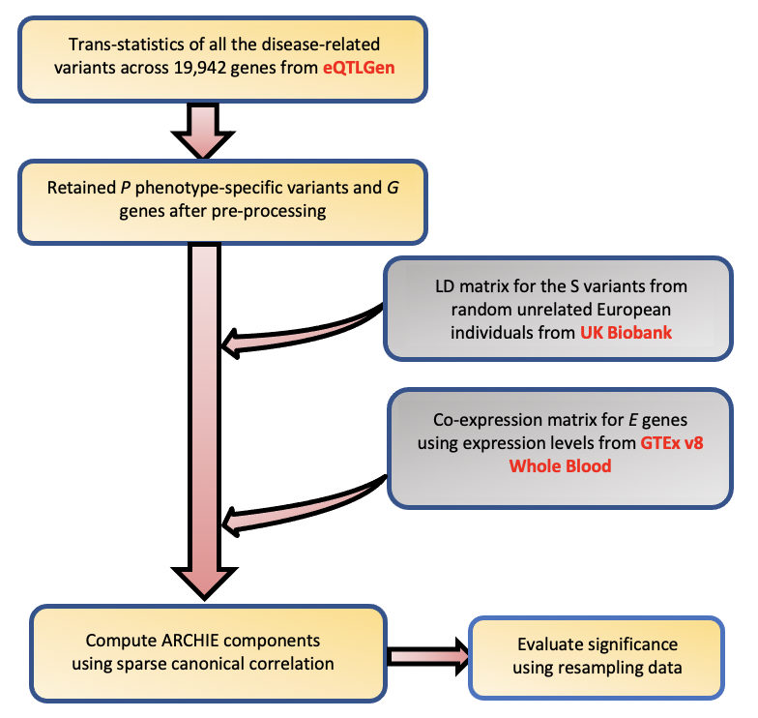
B.
A.

Supplementary Figure 1: (A) Workflow of analysis for the trans summary statistics from standard trans-eQTL mapping reported by eQTLGen consortium. (B) Number of significant components identified by ARCHIE for variants associated 29 traits reported in eQTLGen consortium data.
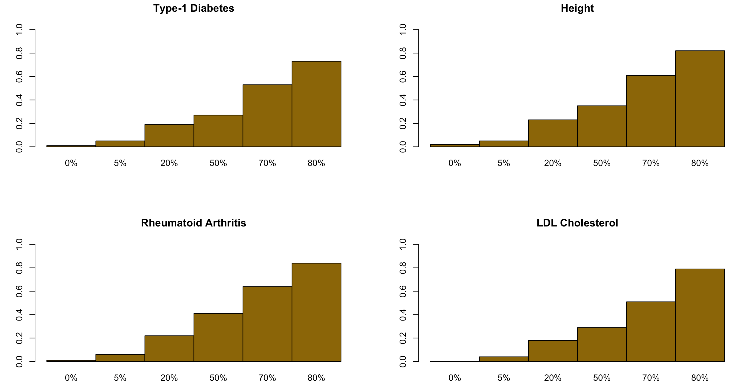

Supplementary Figure 2. Probability of at least one ARCHIE component to be significant for 4 different traits in yellow bars and the corresponding number of significant trans-eQTLs (p-value < 1 × 10⁻⁰⁶) included in the A matrix in black across different values of δ (See Supplementary Methods for details on the resampling experiment). The significance level was set to at 0.001

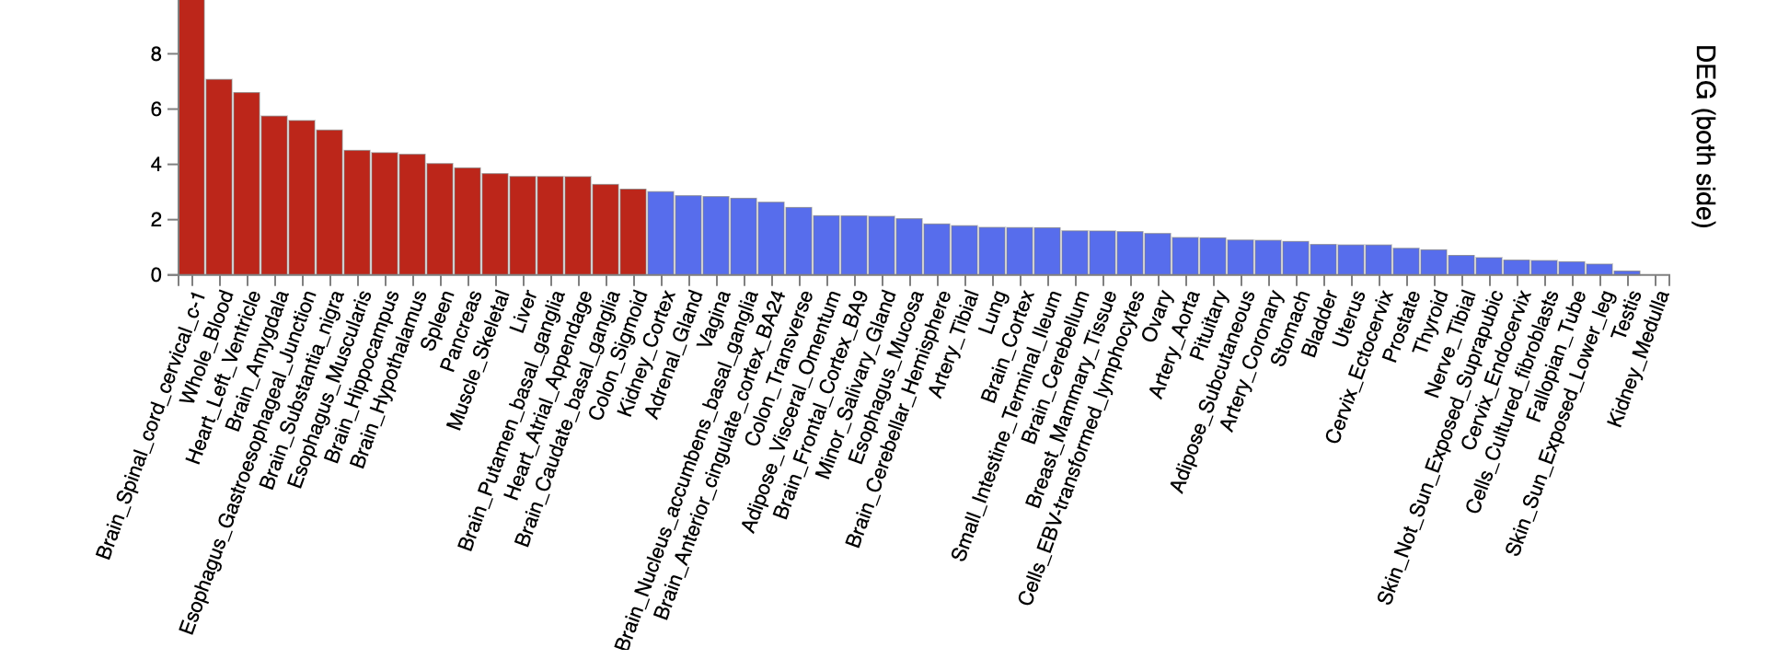
Supplementary Figure 3. Enrichment analysis with the 75 selected target genes for SCZ for enrichment among pre-determined list of differentially expressed genes (DEG; positive and negative) in each tissue of GTEx v8 and their corresponding enrichment p-value. The red bars denote the p-values for the tissues which are significant at FDR-adjusted p-value threshold of 0.001.

Supplementary Figure 4. Log2-transformed mean expression levels for 75 target genes selected by ARCHIE for SCZ across 54 GTEx v8 tissues. Three genes (PADI2, KCNJ10, MLC1) are highly differentially expressed in brain tissues.

A.

Selected variants (variant-component 1)

Selected genes (gene-component 1)
B.
Selected genes (gene-component 2)
Selected variants (variant-component 2)
Supplementary Figure 5. -log₁₀(p-values) for trans-eQTL (as reported in eQTLGen summary statistics) association between variants and genes selected in (A) ARCHIE component 1 and (B) component 2. Any association p-value < 10⁻⁰⁸ is collapsed to 10⁻⁰⁸ for the ease of viewing.

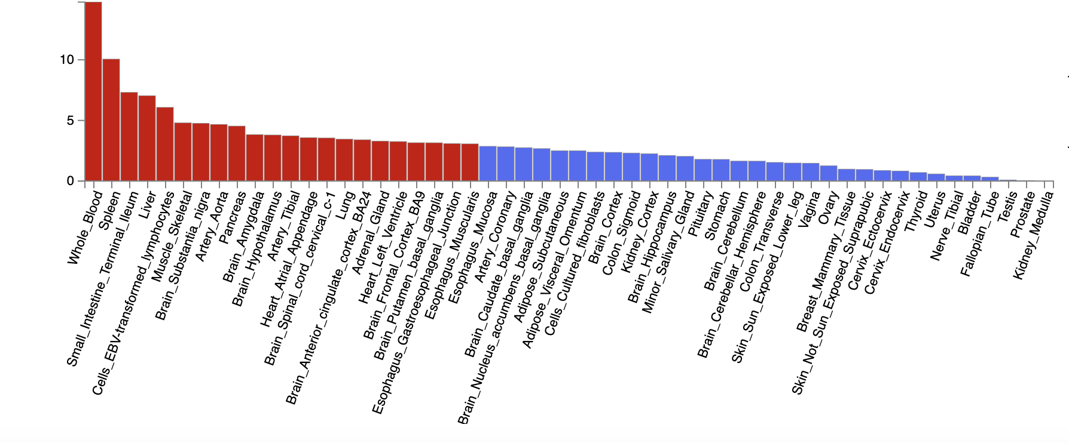
A.
B.
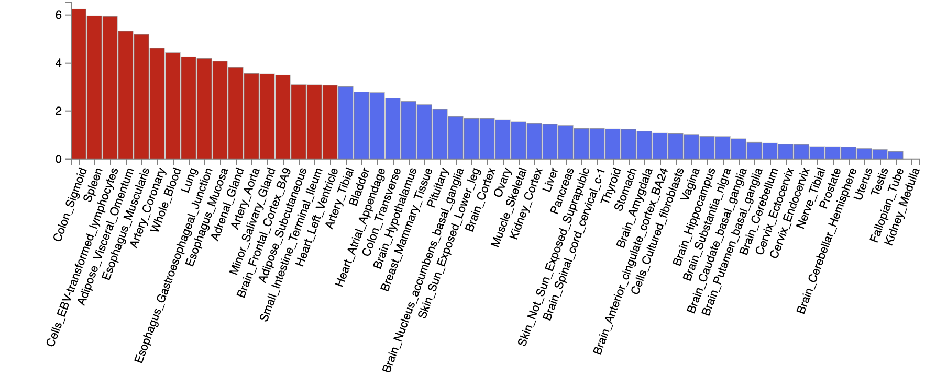
Supplementary Figure 6. Differential expression enrichment analysis for the selected genes in (A) gene-component 1 and (B) gene-component 2 for enrichment among pre-determined list of differentially expressed genes in each tissue of GTEx v8 and their corresponding enrichment p-value. The red bars denote the p-values for the tissues which are significant at FDR-adjusted p-value threshold of 0.001.

References
1. Rosa MJ, Mehta MA, Pich EM, et al. Estimating multivariate similarity between neuroimaging datasets with sparse canonical correlation analysis: An application to perfusion imaging. Front Neurosci. 2015. doi:10.3389/fnins.2015.00366
2. Witten DM, Tibshirani R, Hastie T. A penalized matrix decomposition, with applications to sparse principal components and canonical correlation analysis. Biostatistics. 2009. doi:10.1093/biostatistics/kxp008
3. Schäfer J, Strimmer K. A shrinkage approach to large-scale covariance matrix estimation and implications for functional genomics. Stat Appl Genet Mol Biol. 2005. doi:10.2202/1544-6115.1175
4. Ledoit O, Wolf M. Improved estimation of the covariance matrix of stock returns with an application to portfolio selection. J Empir Financ. 2003. doi:10.1016/S0927-5398(03)00007-0
5. Ledoit O, Wolf M. A well-conditioned estimator for large-dimensional covariance matrices. J Multivar Anal. 2004. doi:10.1016/S0047-259X(03)00096-4
6. Bycroft C, Freeman C, Petkova D, et al. The UK Biobank resource with deep phenotyping and genomic data. Nature. 2018;562:203-209.
7. Liberzon A, Birger C, Thorvaldsdottir H, Ghandi M, Mesirov JP, Tamayo P. The Molecular Signatures Database (MSigDB) hallmark gene set collection. Cell Syst. 2015;1(6):417-425. doi:10.1016/j.cels.2015.12.004
8. Liberzon A, Subramanian A, Pinchback R, Thorvaldsdóttir H, Tamayo P, Mesirov JP. Molecular signatures database (MSigDB) 3.0. Bioinformatics. 2011. doi:10.1093/bioinformatics/btr260
9. Han H, Cho JW, Lee S, et al. TRRUST v2: An expanded reference database of human and mouse transcriptional regulatory interactions. Nucleic Acids Res. 2018. doi:10.1093/nar/gkx1013
10. Zheng G, Tu K, Yang Q, et al. ITFP: An integrated platform of mammalian transcription factors. Bioinformatics. 2008. doi:10.1093/bioinformatics/btn439
11. Liu ZP, Wu C, Miao H, Wu H. RegNetwork: An integrated database of transcriptional and post-transcriptional regulatory networks in human and mouse. Database. 2015. doi:10.1093/database/bav095
12. Szklarczyk D, Gable AL, Lyon D, et al. STRING v11: Protein-protein association networks with increased coverage, supporting functional discovery in genome-wide experimental datasets. Nucleic Acids Res. 2019. doi:10.1093/nar/gky1131

