Supplementary Materials
1. The concentration of uric acid differs statistically significantly (p=0.0243) between groups 1 and 4

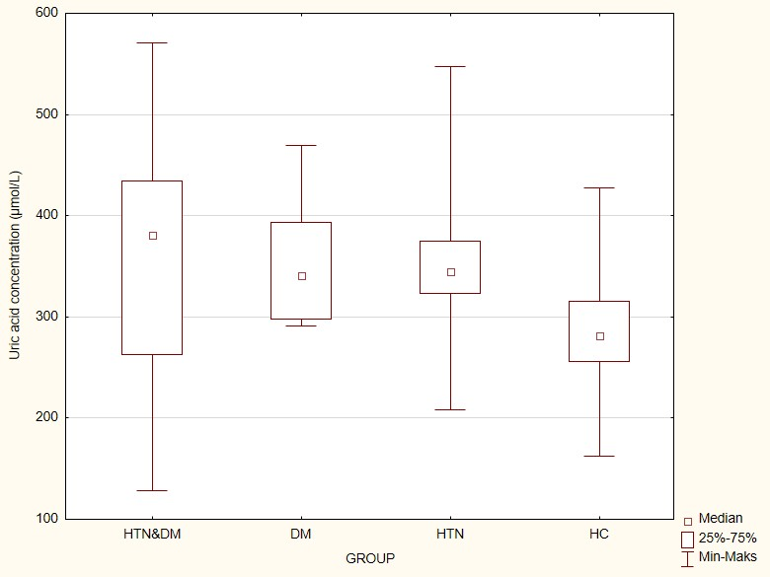

2. LDL cholesterol concentration is statistically significantly different (p=0.0028) between groups 1 and 4 and 2 and 4
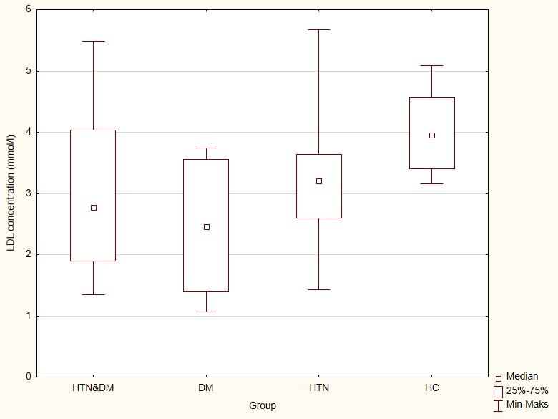
3. The concentration of total cholesterol differs statistically significantly (p=0.0196) between groups 1 and 4

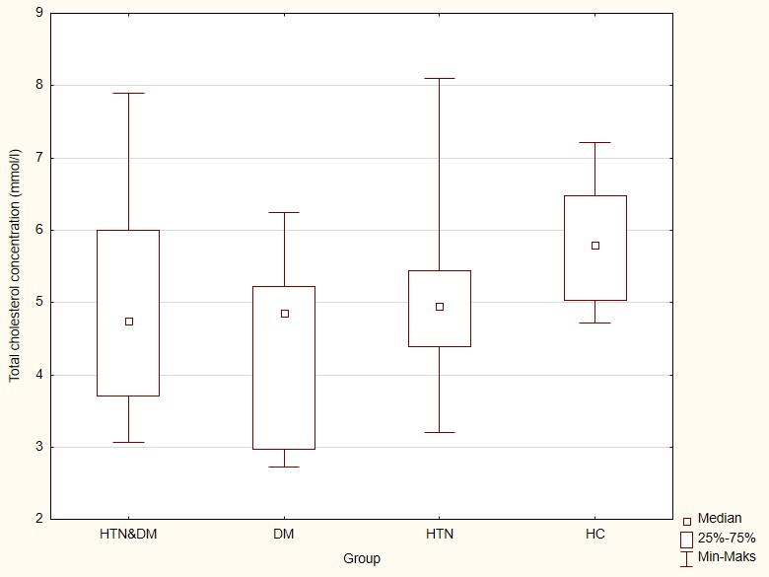

4. The duration of cigarette smoking (in pack-years) was statistically significantly different in patients with the normal thickness of the intima-media complex on the right side and above the norm (p=0.0045)

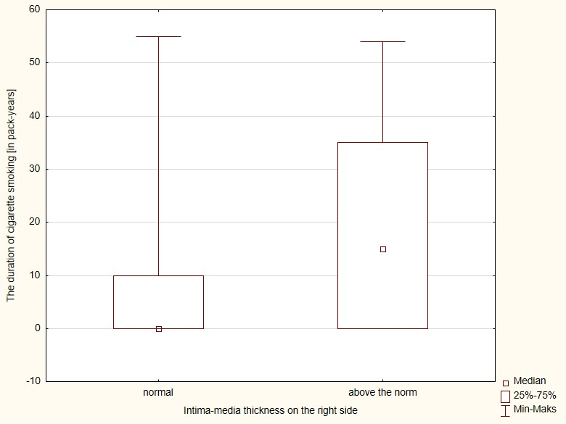
5. In the group of patients treated for diabetes (groups 1 and 2), statistically significant differences were detected regarding the ankle-brachial index on the right side (ABI R) and: the thickness of the intima-media complex on the left (between subgroups 0 and 2) and right (between subgroups 0 and 1 and 0 and 2) and the duration of diabetes treatment (between subgroups 0 and 1)

 | ABI R | n | median | Quadrant deviation | p
Intima Media on the left side  [mm] | Below the norm | 7 | 1,2 | 0,1* | 0,007
Intima Media on the left side  [mm] | Normal | 30 | 1,1 | 0,2 | 0,007
Intima Media on the left side  [mm] | Above the norm | 7 | 1,0 | 0,1* | 0,007
Intima Media on the right side [mm] | Below the norm | 7 | 1,3 | 0,2*,** | 0,0057
Intima Media on the right side [mm] | Normal | 30 | 1,1 | 0,2* | 0,0057
Intima Media on the right side [mm] | Above the norm | 7 | 1,0 | 0,1** | 0,0057
Duration of diabetes treatment [years] | Below the norm | 7 | 17,0 | 5,5* | 0,0078
Duration of diabetes treatment [years] | Normal | 27 | 7,0 | 3,0* | 0,0078
Duration of diabetes treatment [years] | Above the norm | 7 | 9,0 | 3,0 | 0,0078

6. The verbal fluency, as a component od M-ACE scale, presented statistically significant differences between gropus 1 and 3 (p< 0,000) and 1 and 4 (p< 0,000)
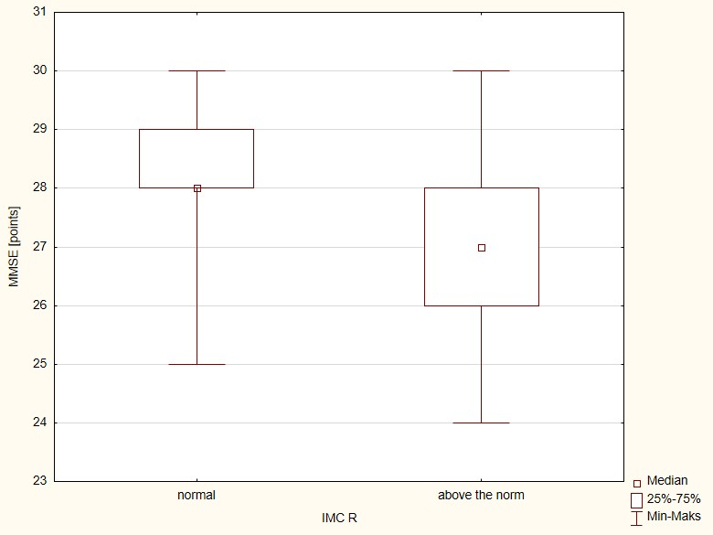
7. Recalling, as a component of MMSE, presented statistically significant differences between gropus and 1 and 4 (p=0,0117)
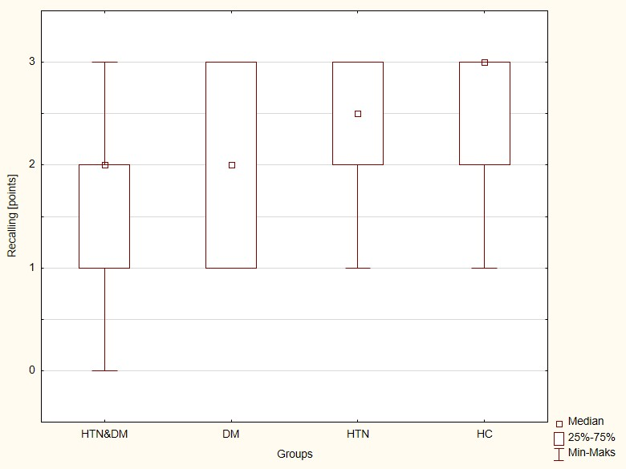

8. Classification of intima-media complex thickness on the right side and MMSE score among patients treated for arterial hypertension (groups 1 and 3) p=0,0076
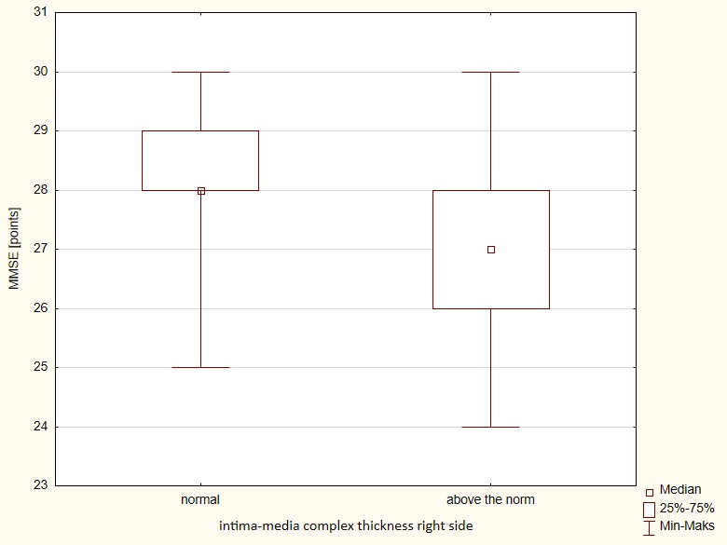

9. Intima-media complex thickness on the left side in study groups

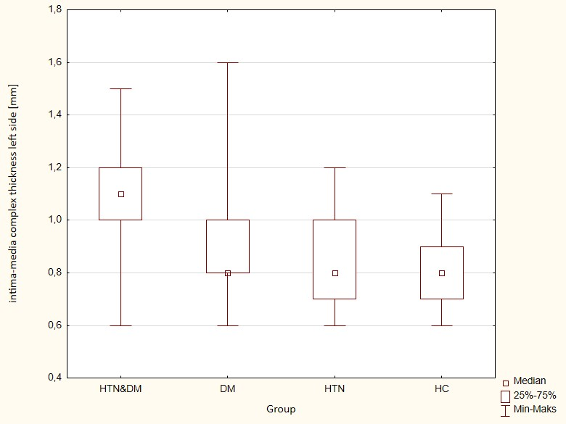

10. Intima-media complex thickness [mm] on the right side in study groups

Group | N | Mean value± SD | p
Group 1 (HTN&DM) | 39 | 1,09 ± 0,2 | --------
Group 2 (DM) | 7 | 0,97 ± 0,3 | NS
Group 3 (HTN) | 18 | 0,87 ± 0,2 | 0,0004
Group 4 (HC) | 20 | 0,8 5± 0,2 | 0,00009

11. Duration of smoking and intima-media complex thickness on the right side in patients treated for arterial hypertension (groups 1 and 3), IMC R - intima-media complex thickness right side
 | The duration of smoking (in pack-years)
IMC R | N | Median value | Quadrant deviation | p
normal | 34 | 0,0 | 1,0 | 0,0017
above normal | 23 | 15,0 | 17,5 | 0,0017

12. Diabetes control and total cholesterol concentration among patients treated for diabetes (groups 1 and 2), TC- total cholesterol
 | Diabetes | N | Mean value ± SD | p
TC [mmol/l] | controlled | 32 | 4,6±1,1 | 0,028
TC [mmol/l] | uncontrolled | 13 | 5,5±1,6 | 0,028

13. Glycated hemoglobin percentage and M-ACE score among patients treated for diabetes (Groups 1 and 2), M-ACE - The Mini-Addenbrooke's Cognitive Examination
 | M-ACE | N | Median value | Quadrant deviation
Glycated Hemoglobin [%] | <22 pkt | 9,0 | 5,7 | 0,9
Glycated Hemoglobin [%] | 22-25pkt, | 13,0 | 6,3 | 0,6
Glycated Hemoglobin [%] | >25 pkt; | 23,0 | 6,5 | 0,7

 | MMSE | N | Median value | Quadrant deviation
Glycated Hemoglobin [%] | 24-26 pkt | 16 | 6,5 | 1,1
Glycated Hemoglobin [%] | 27-30pkt | 29 | 6,3 | 0,6

Tab. 12 Glycated hemoglobin percentage and MMSE score among patients treated for diabetes (groups 1 and 2), MMSE - Mini–Mental State Examination

