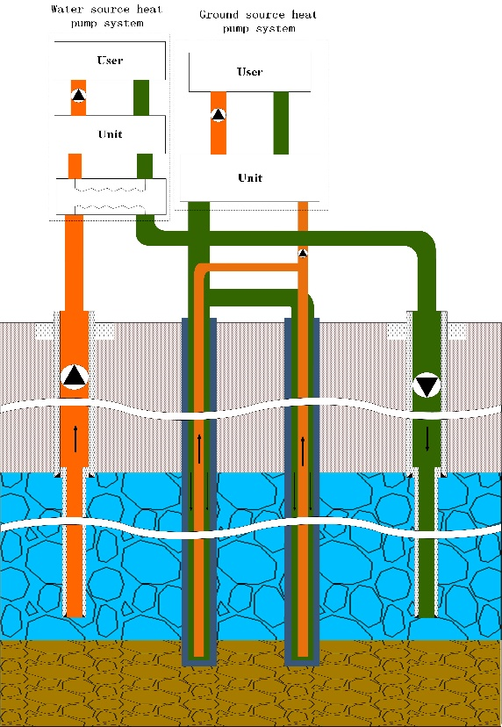
Figure 1. The BHEs is connected to the ground source heat pump (GSHP), and the pumping-injection well is connected to the water source heat pump unit. The two sets of systems provide heating and cooling for the building at the same time.

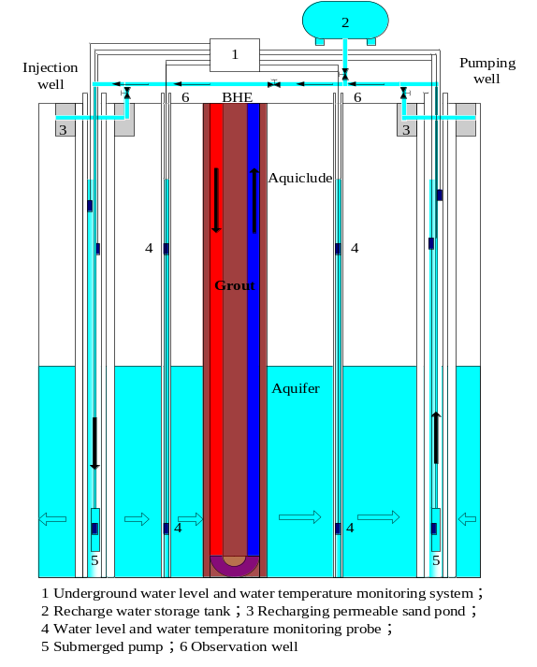
Figure 2. The BHEs is connected with the ground source heat pump （GSHP） unit to provide heating and cooling for the building, and the pumping-injection well is only to increase the intensity of groundwater seepage.

