Supplementary information
Systemic impacts of disruptions at maritime chokepoints

Jasper Verschuur^{1,2,*}, and Jim W. Hall¹

¹Oxford Programme for Sustainable Infrastructure Systems (OPSIS), Environmental Change Institute, University of Oxford, Oxford, United Kingdom
²Department of Engineering Systems and Services, Faculty of Technology, Policy and Management, Delft University of Technology, Delft, the Netherlands

*corresponding author: jasper.verschuur@eci.ox.ac.uk
Oxford Programme for Sustainable Infrastructure Systems (OPSIS), University of Oxford, 3 South Parks Road, Oxford OX1 3QY, United Kingdom

Supplementary Figures

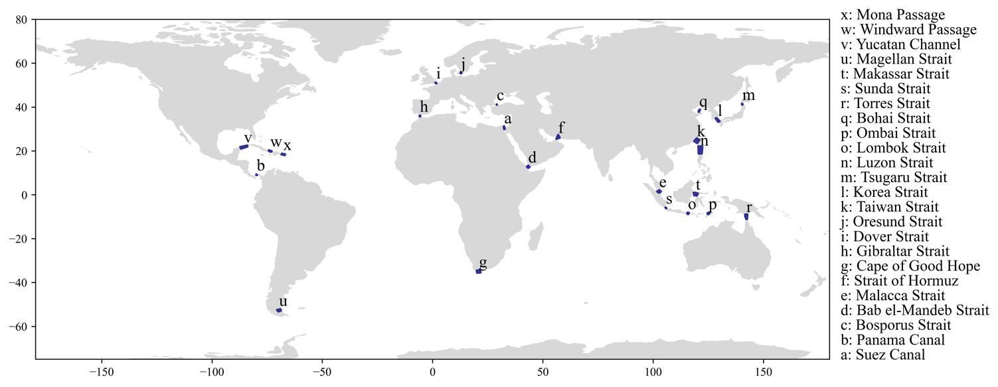
Supplementary Figure 1. Geographical location of the 24 chokepoints considered.

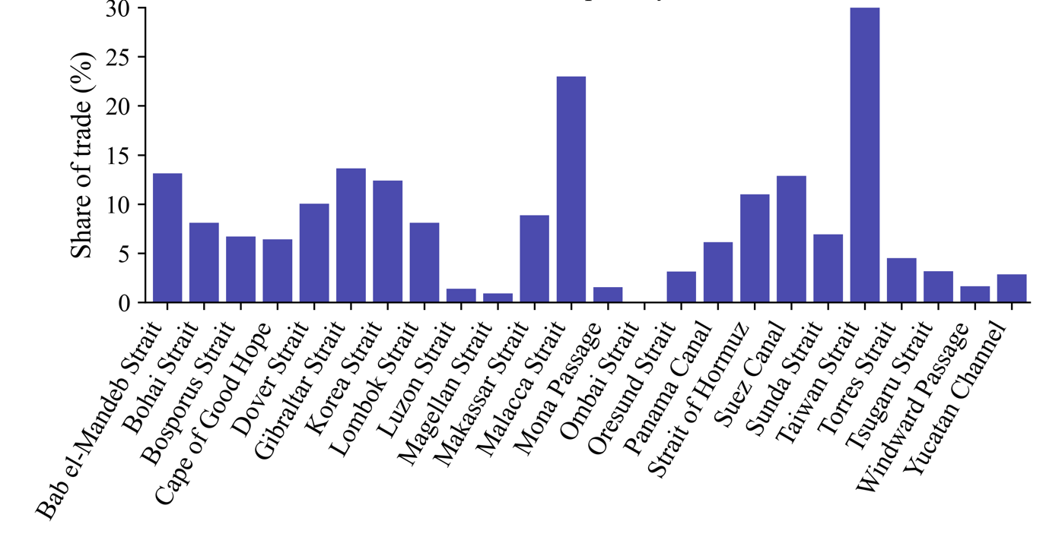
Supplementary Figure 2. Share of global trade volume handled by different chokepoints.

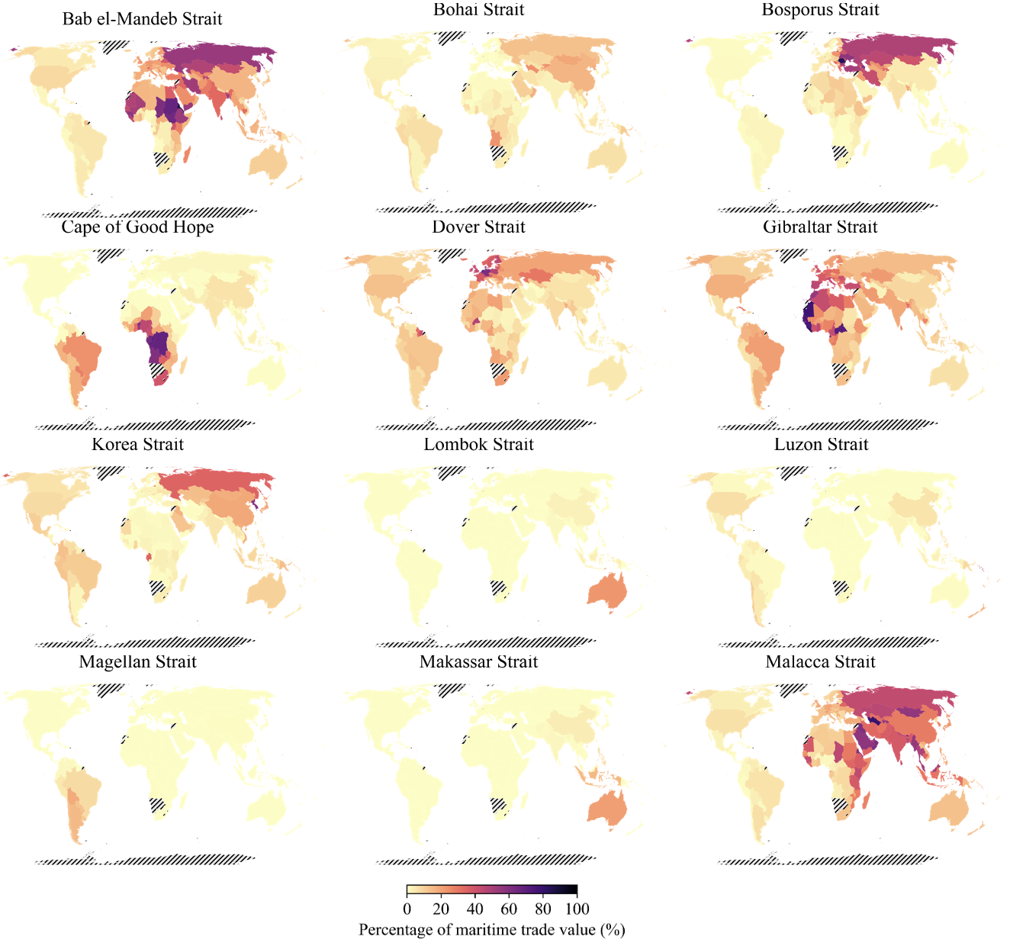

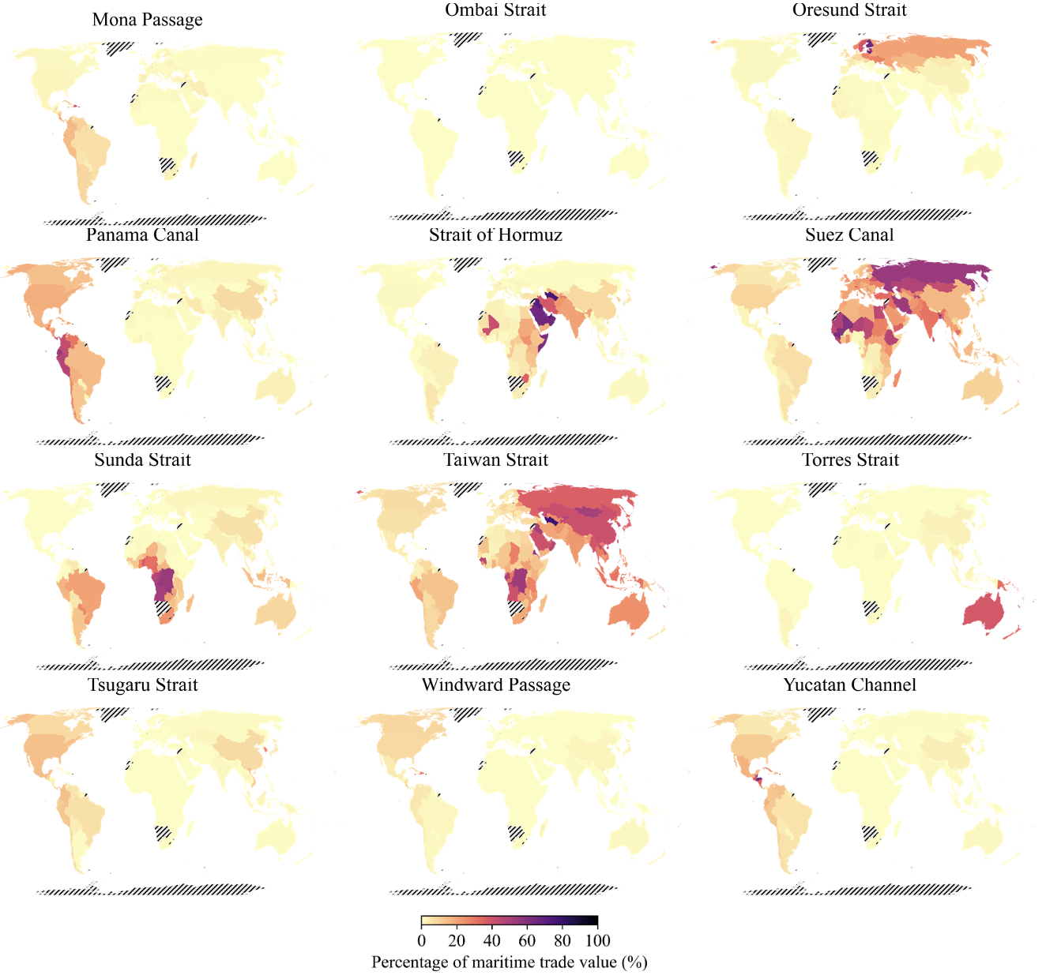
Supplementary Figure 3. Country dependencies on specific chokepoints.

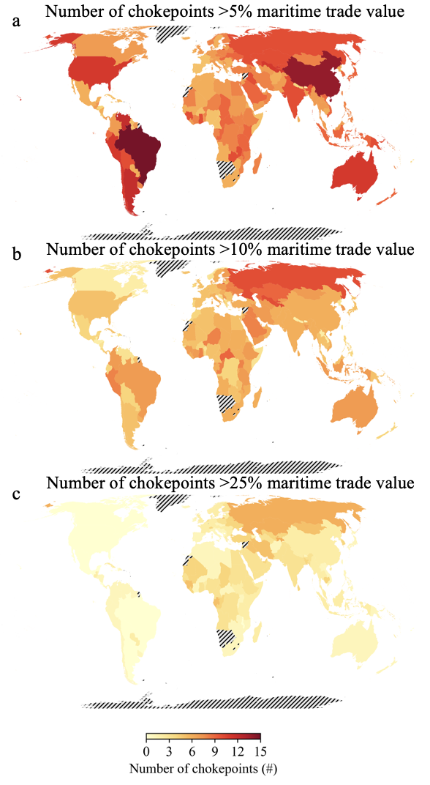
Supplementary Figure 4. Major chokepoint dependencies. Countries’ major chokepoint dependencies, defined as facilitating 5% (a), 10% (b) or 25% (c) of a country’s maritime trade value. Figures (a), (b) and (c) show the number of chokepoints, out of the 24 considered, that meet this criteria.

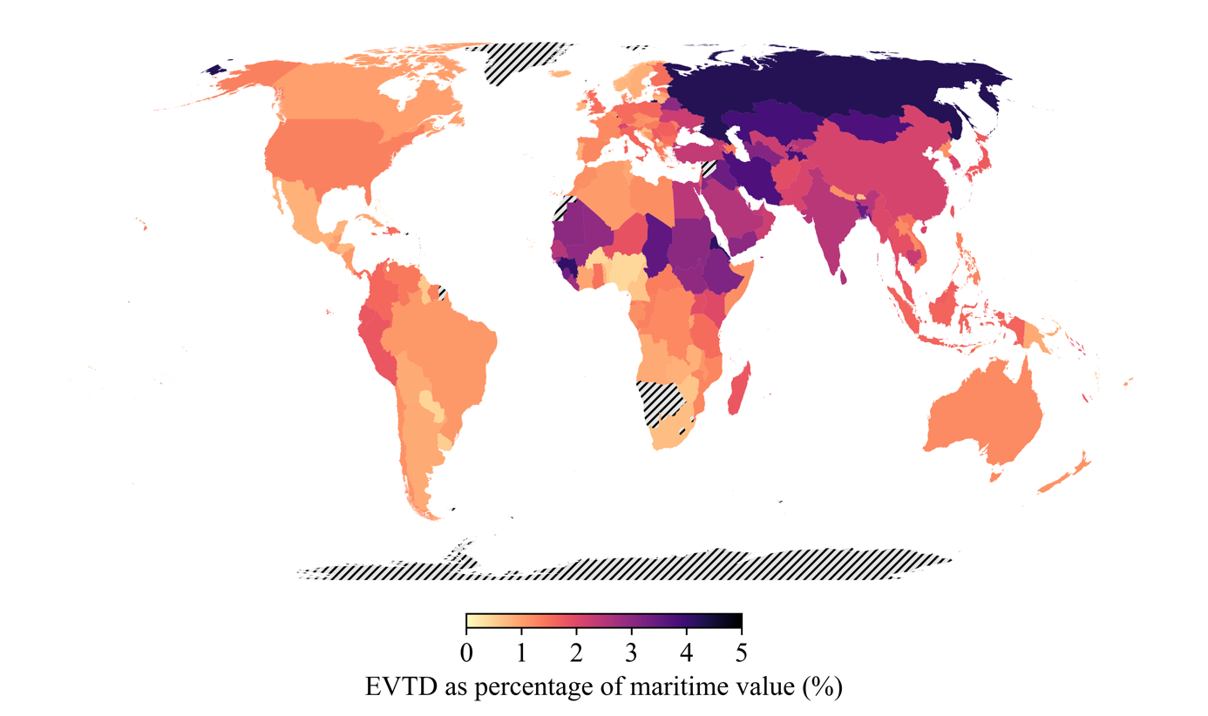
Supplementary Figure 5. EVTD as percentage of maritime trade value.

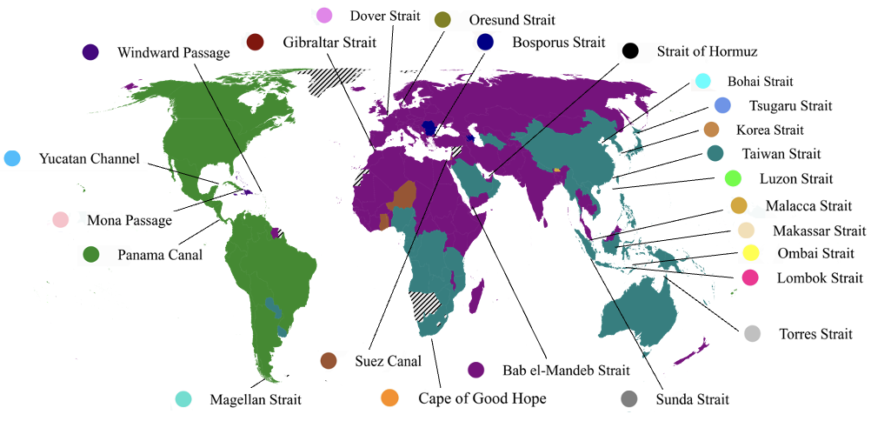
Supplementary Figure 6. Dominant chokepoint of country EVTD

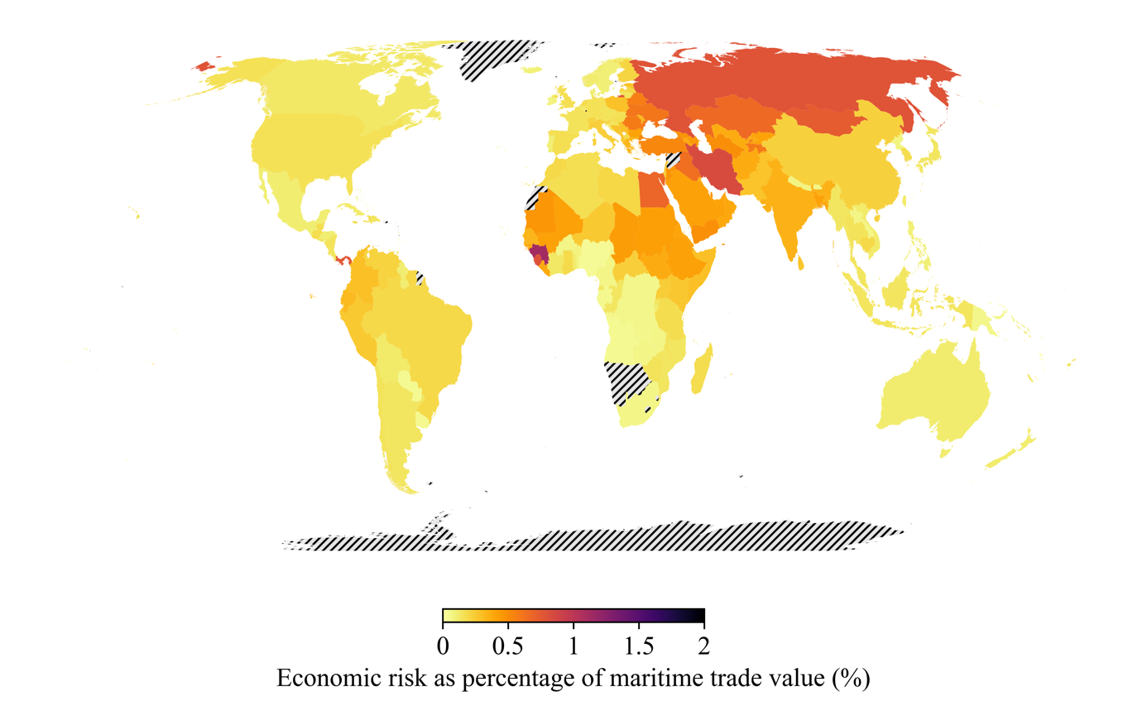
Supplementary Figure 7. Economic risk as percentage of maritime trade value.

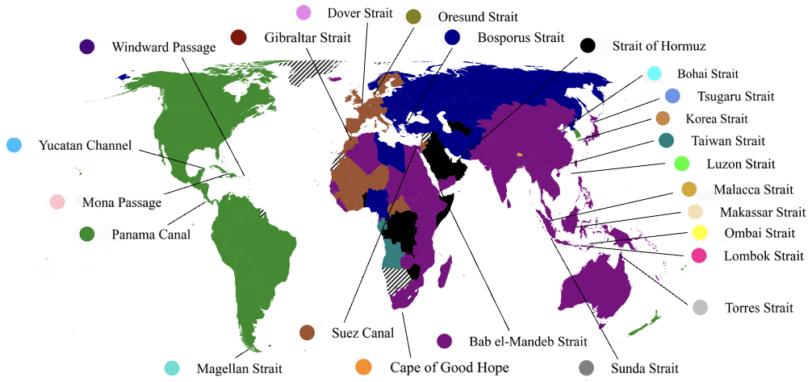

Supplementary Figure 8. Dominant chokepoint of country economic risk

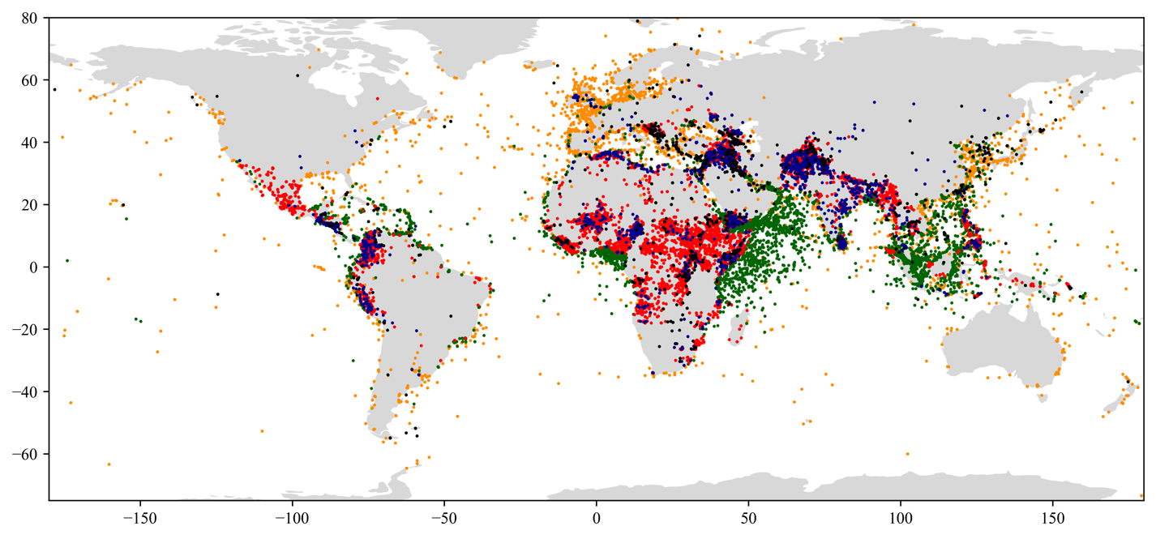
Supplementary Figure 9. The spatial event database of maritime chokepoint hazards. The geographical location of different non-climatic hazard events considered, including (i) piracy (green), (ii) maritime incidents (orange), (iii) terrorist attacks (blue), (iv) armed conflict (red), and (v) interstate conflict (black).

