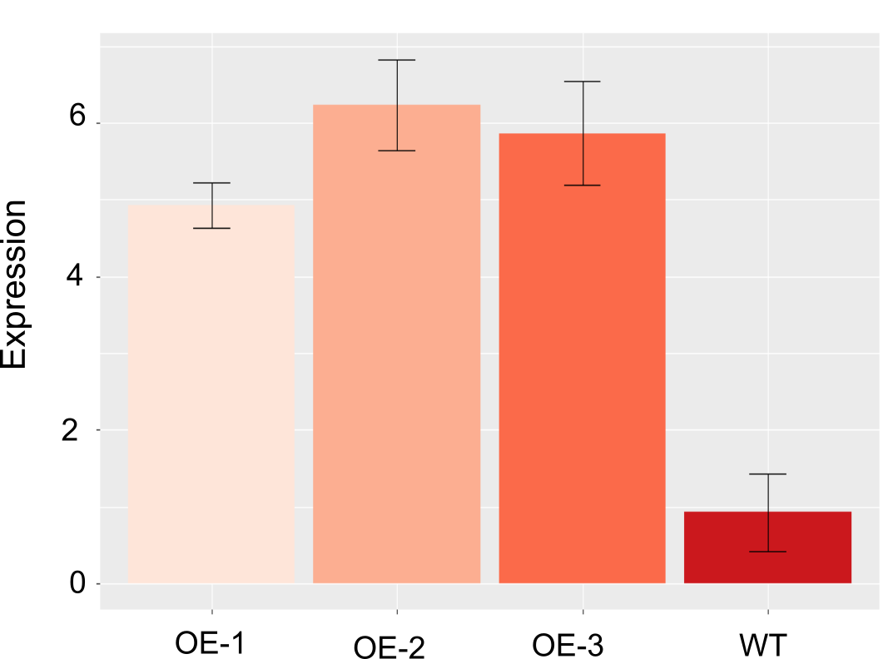
Suppl. Figure 1: Expression in shoots of T₀ plants overexpressing TaBG1-A in wheat. Expression values shown are relative to the expression of TaUbi.

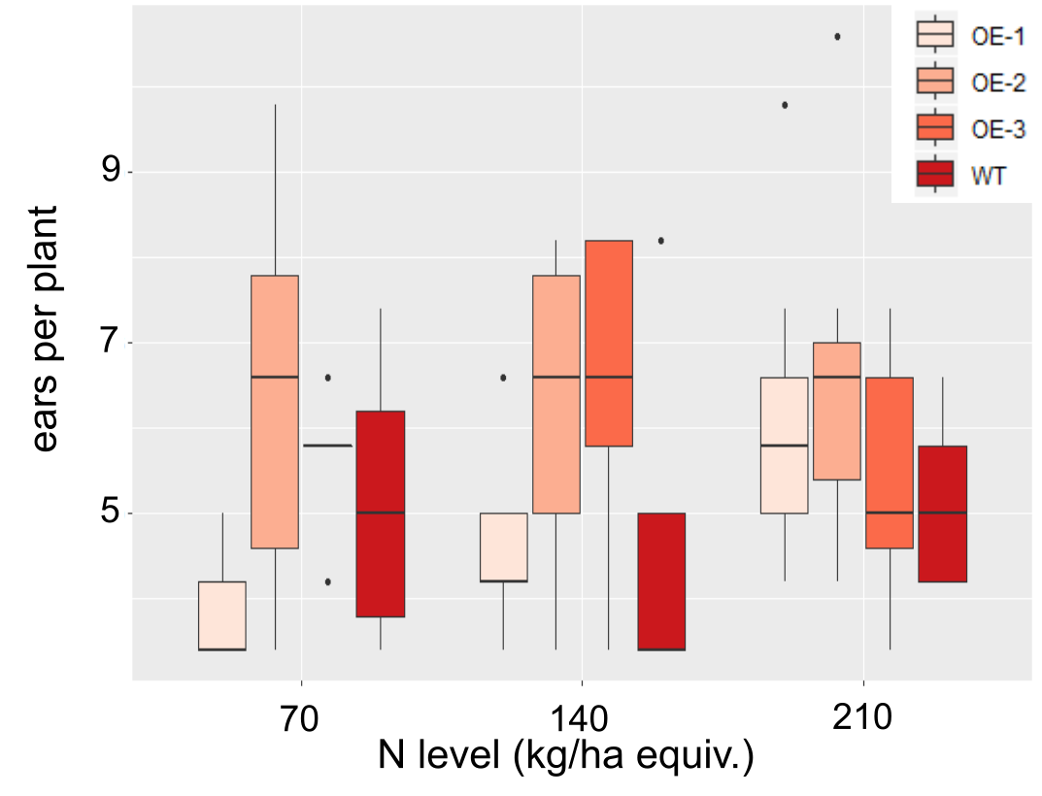

Suppl Figure 2: Number of tillers of plants overexpressing of TaBG1-A. Shown are the measurements from twenty-one plants under three levels of nitrogen, low (70), sufficient (140), and high (210) levels of N. No significant difference to WT were observed.

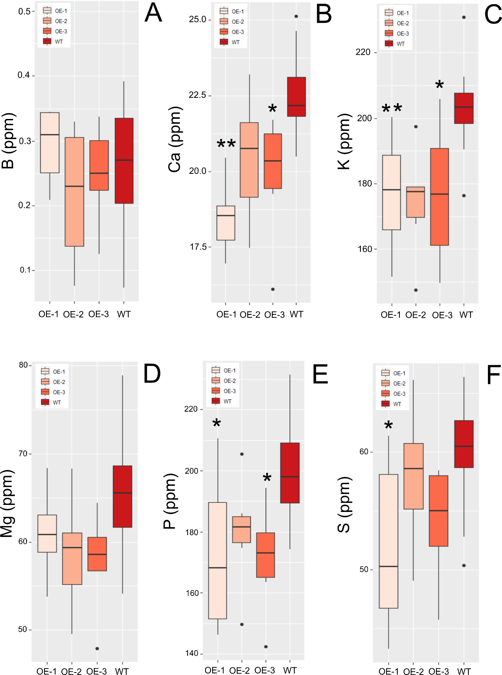
Suppl. Figure 3: Elemental content of TaBG1-A overexpression lines. A) B, B) Ca, C) K, D) Mg, E) P, F) S levels in grains of TaBG1-A overexpression lines relative to WT Fielder. * indicates a significant difference relative to WT p val < 0.05, **p val < 0.01.

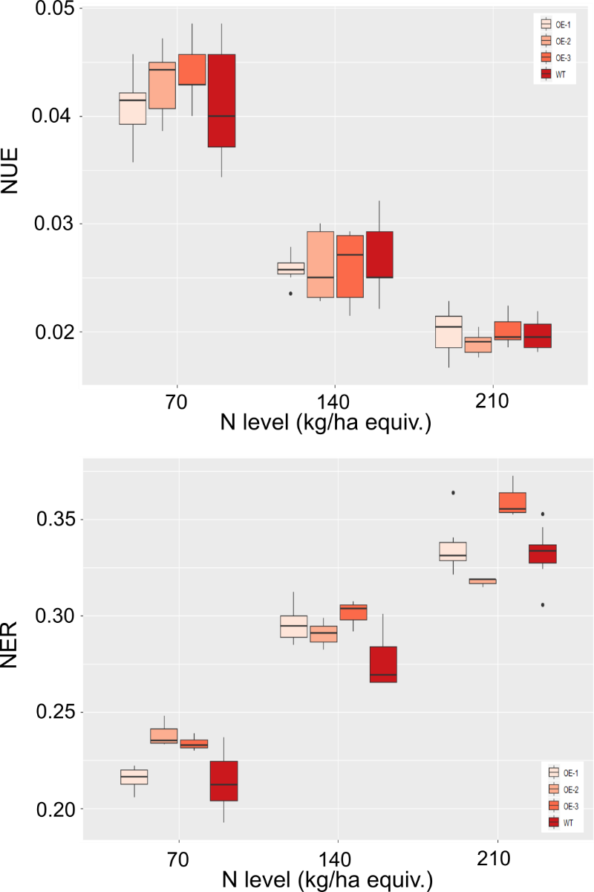

Suppl. Figure 4: Nitrogen Use Efficiency and Nitrogen Efficiency Ratio of TaBG1-A overexpression lines grown under three different N levels. No significant difference to WT was observed.

