Eucommia folium can be prepared into tea with the ability to prevent and treat hyperuricemia
Qing Hao ¹, Ying Liu ¹, Zikun Zhai ¹, Bo Wang ², Lin Jiang ¹, Qiyun Zhang ¹, Jiawei Su ¹, Maiting Zhang ¹, Jiajun Li ¹, Shuo Chen ¹, Ziyun Ye ¹, Qiusheng Zheng ¹, Xiangcheng Fan ³, Jichun Han ¹
¹ College of traditional Chinese medicine, Binzhou Medical University, Yantai, China
² School of Pharmacy, Qilu Medical University, 2018 Jiangmeng Road, Zhoucun District, Zibo City, China
³ Center for Innovative Traditional Chinese Medicine Target and New Drug Research, International Institutes of Medicine, Zhejiang University, Yiwu, China

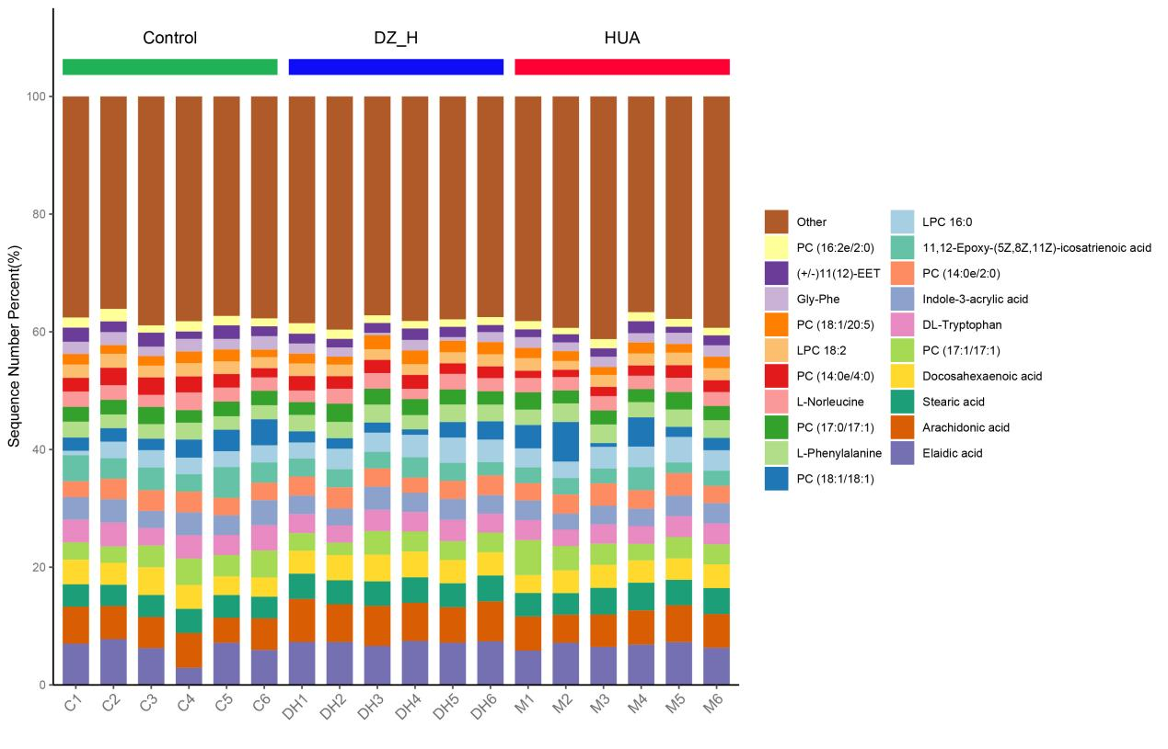
Figure S1. Stacked bar chart of the top 20 metabolite percentages in terms of content.

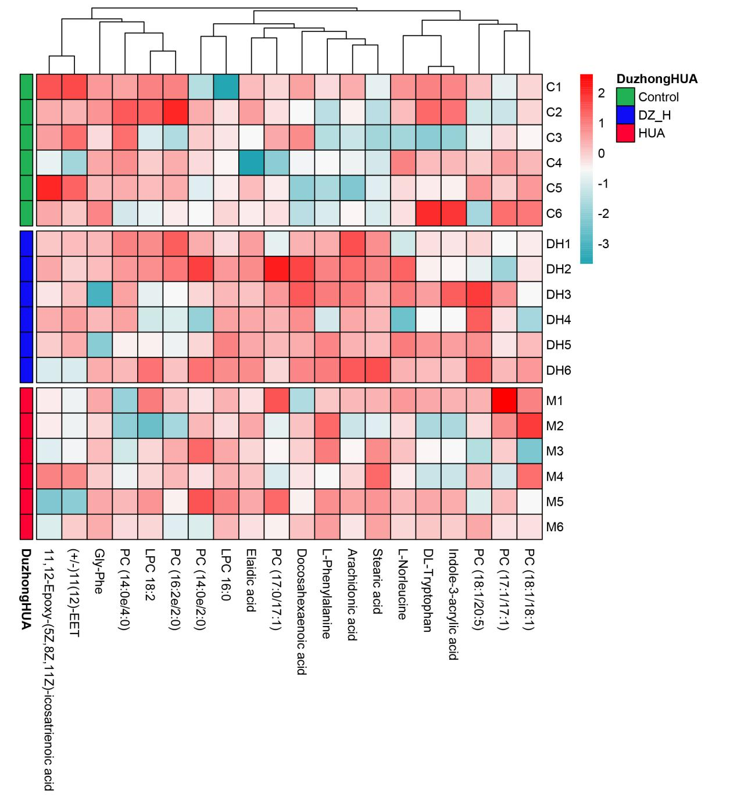
Figure S2. Metabolite heatmap clustering results.

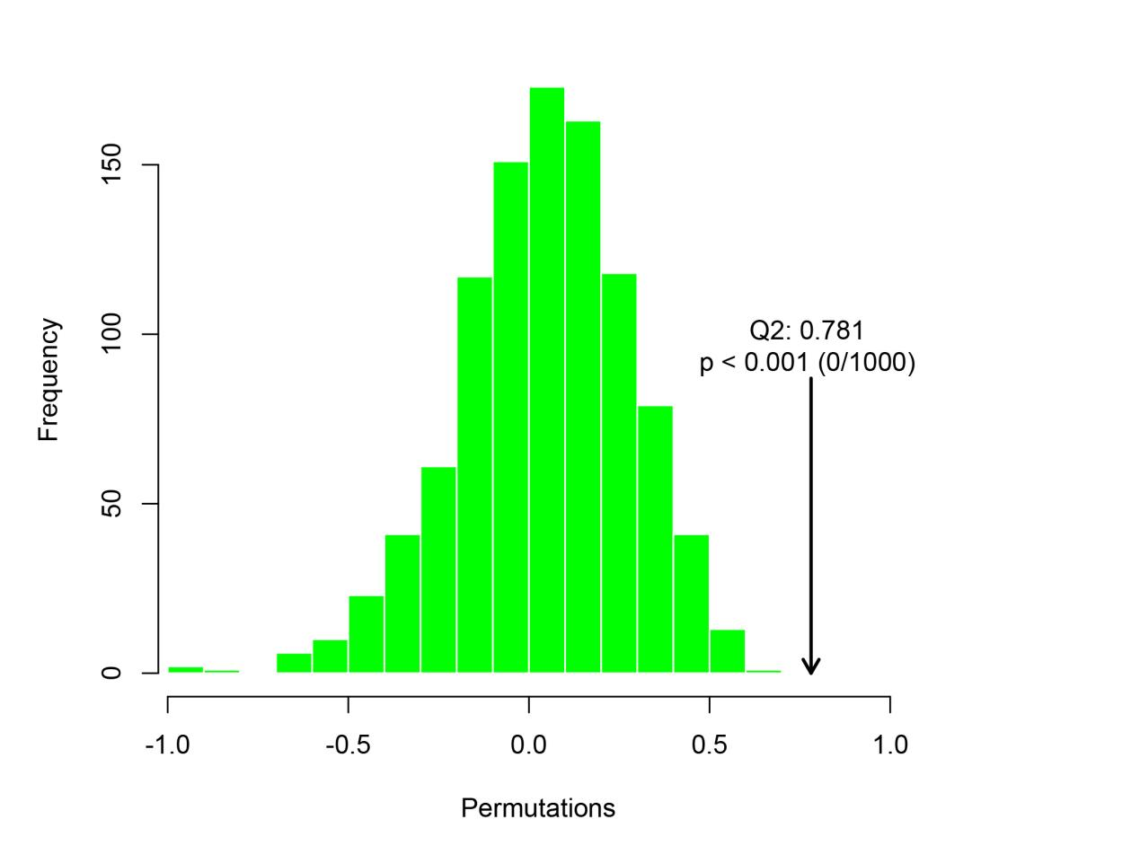
Figure S3. Distribution and p-value of test statistic (Q2) for OPLS-DA permutation test.

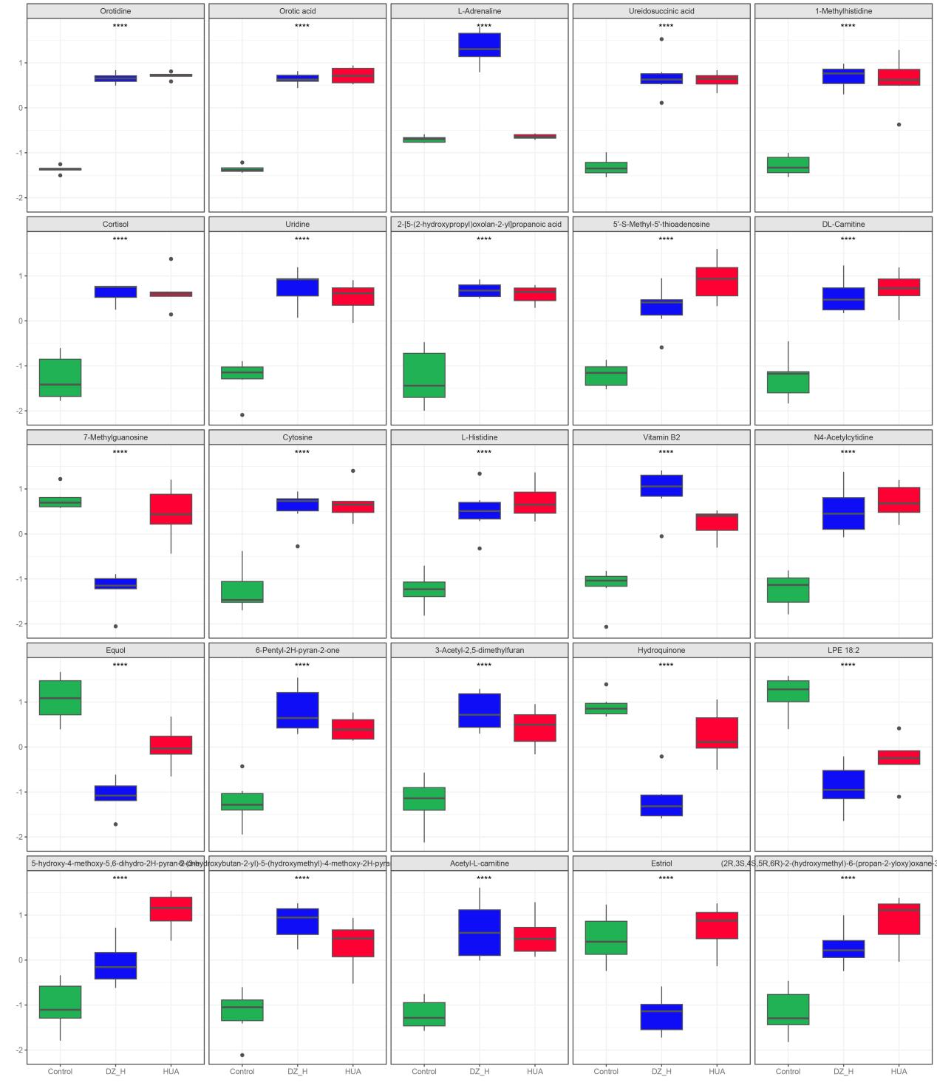
Figure S4. Metabolite differential box plot.

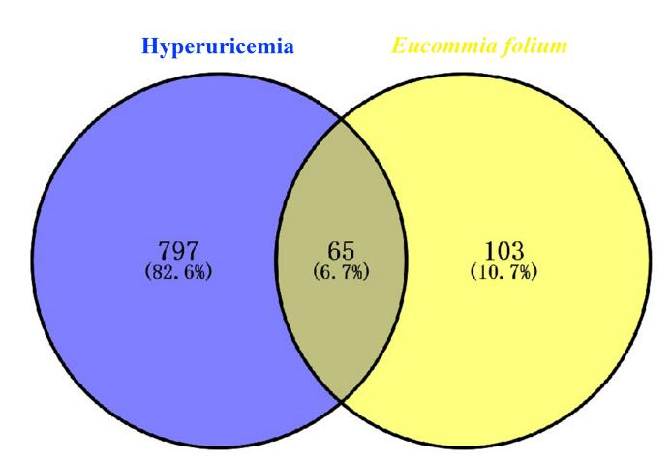
Figure S5. Venn analysis between Eucommia folium related targets and HUA related targets. The intersection represents the effective targets of Eucommia folium after HUA processing.

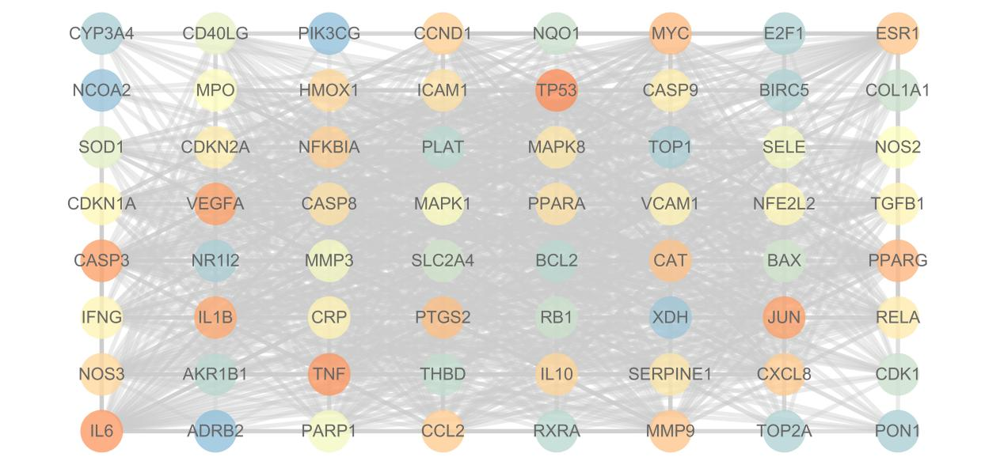
Figure S6. PPI network diagram.

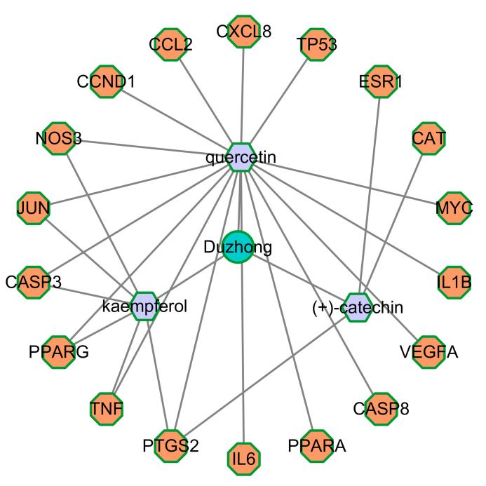
Figure S7. Plant-component-target network diagram

