Supplementary information for
Dynamic Multimodal Information Encryption Combining Programmable Structural Color and Switchable Circularly Polarized Luminescence
Zeyu Feng^{1,4}, Jialei Li^{1,4}, Peng Yang^{1,2}, Xiangxiang Xu¹, Di Wang¹, Jiahe Li¹, Chutian Zhang¹, Jingguo Li³, Hongli Zhang¹*, Gang Zou^{1,2}*, Xin Chen²*
Corresponding author. Email: zhl1992@ustc.edu.cn; mail.xinchen@gmail.com; gangzou@ustc.edu.cn.

The supplementary information includes:
Supplementary Fig. 1-19
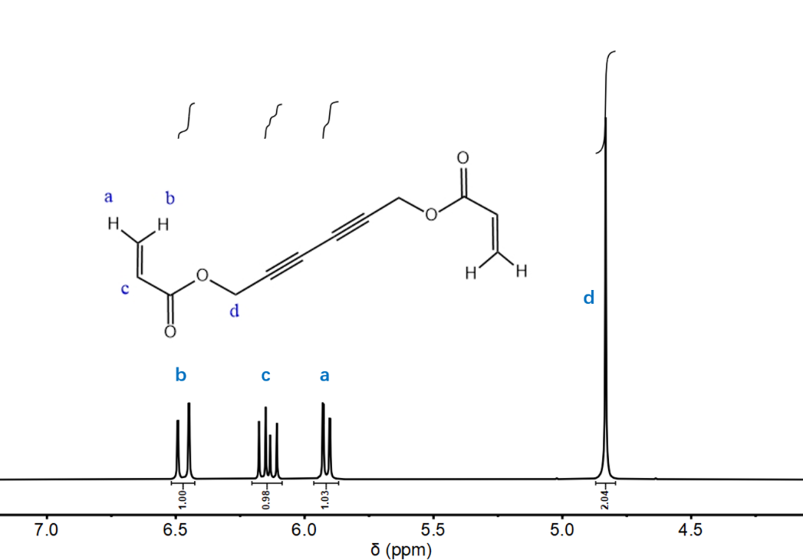
Supplementary Fig. 1. The chemical structure and ¹H NMR characterizations of HD-DA.

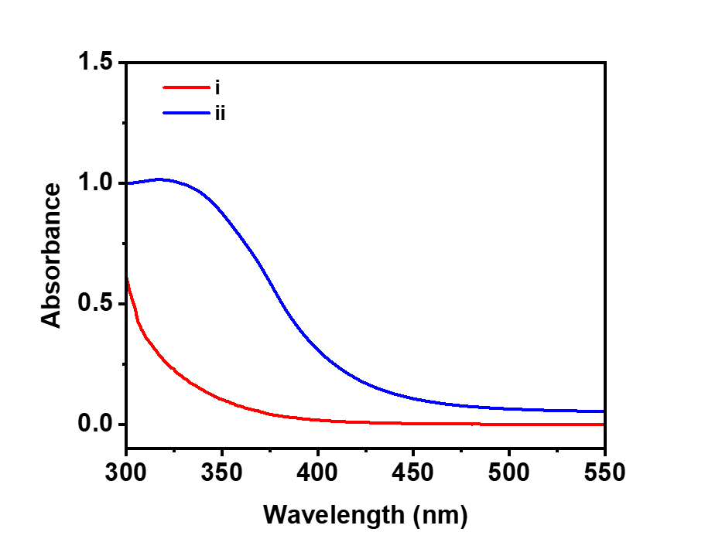
Supplementary Fig. 2. UV-Vis spectra of HD-DA: (i) before and (ii) after 2 min of UV irradiation.
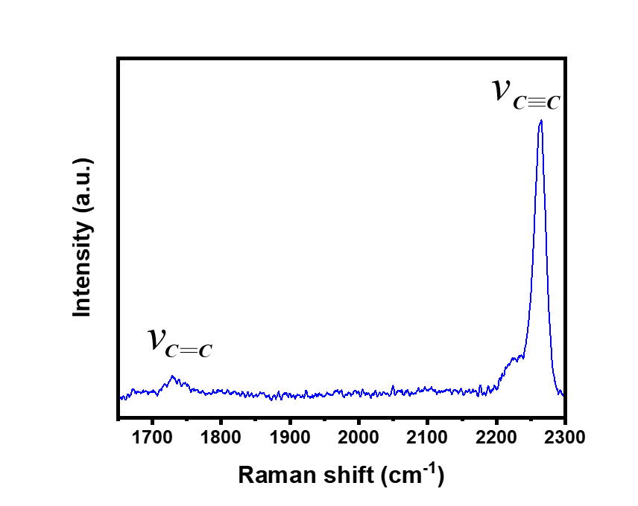
Supplementary Fig. 3. Raman spectroscopy of HD-DA after UV irradiation, using 785 nm laser excitation.

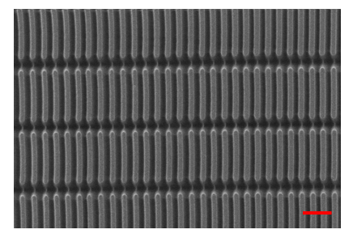
Supplementary Fig. 4. SEM characterizations of PDA cuboid microarrays (structure “i”). Scale bar is 5 μm.

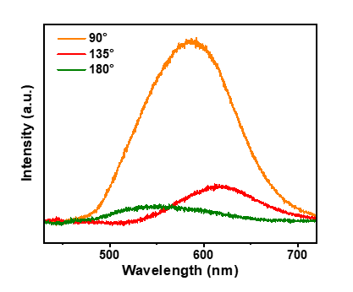
Supplementary Fig. 5. The reflectance spectrum of structural color changes by varying direction of incident light, angle β.

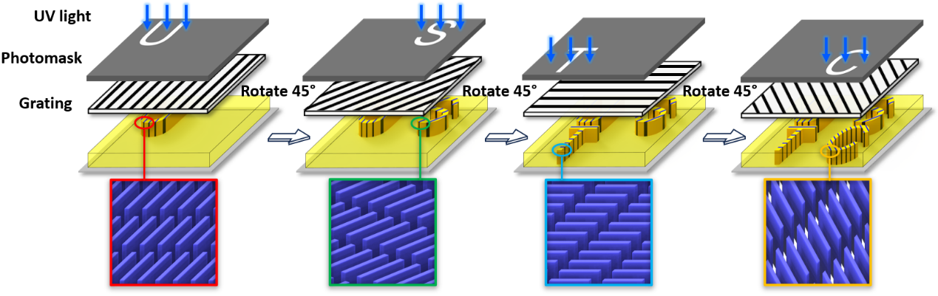
Supplementary Fig. 6. Schematic preparation process of the complexed ‘USTC’ pattern in which each letter has different directions of the aligned cuboid microarrays. The 2,4-hexadiyn-1,6-diacrylate was first mixed with a photo-initiator (2-hydroxy-2-methylpropiophenone) at ratio of 9:1 (v/v), subsequently the mixture used as precursor monomer (2 μL) were spread on the glass. After irradiation with a mercury lamp through the combined photomask ‘U’ with the aligned grating, the displayed ‘U’ character with the inherent double periodic structure within the cuboid microarray (1 μm in horizontal spacing and 10 μm in vertical spacing) could be obtained. Through replacing the photomask to ‘S’, ‘T’ and ‘C’ in turn, along with rotation the grating 45° clockwise, the complexed ‘USTC’ pattern were obtained.

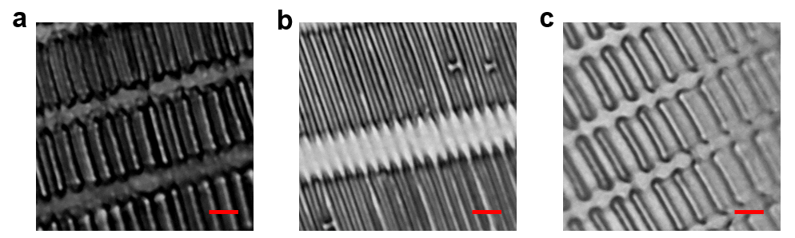
Supplementary Fig. 7. (a) Optical microscope images of PDA cuboid microarrays (structure “i”) before stretching, and their periodic spacing variations for (b) stretching perpendicular to the period direction, (c) parallel to the period direction. Scale bar is 5 μm.

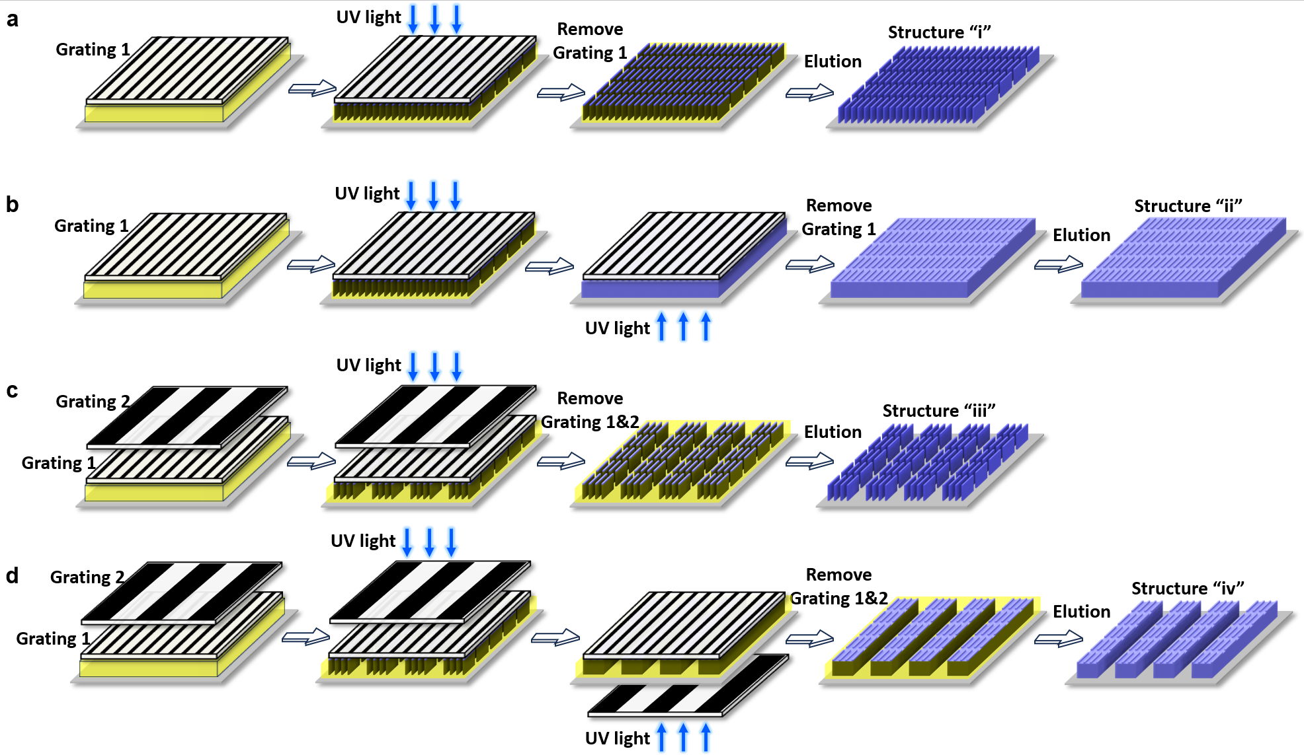
Supplementary Fig. 8. Schematic preparation process of 2D periodic structure of PDA cuboid microarrays: (a) structure “i”, (b) structure “ii”, (c) structure “iii” and (d) structure “iv”.

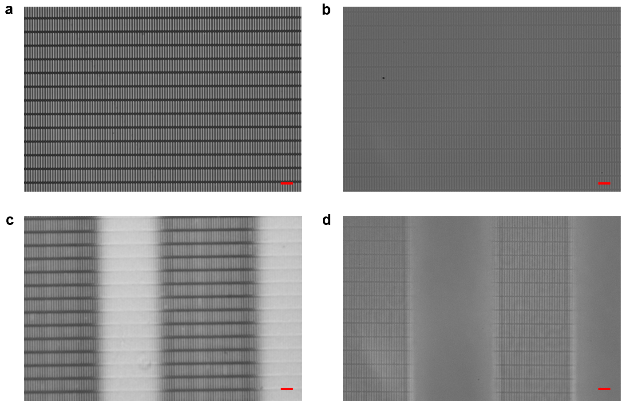
Supplementary Fig. 9. Optical microscope images of 2D periodic structure of PDA cuboid microarrays: (a) structure “i”, (b) structure “ii”, (c) structure “iii” and (d) structure “iv”. Scale bar is 10 μm.

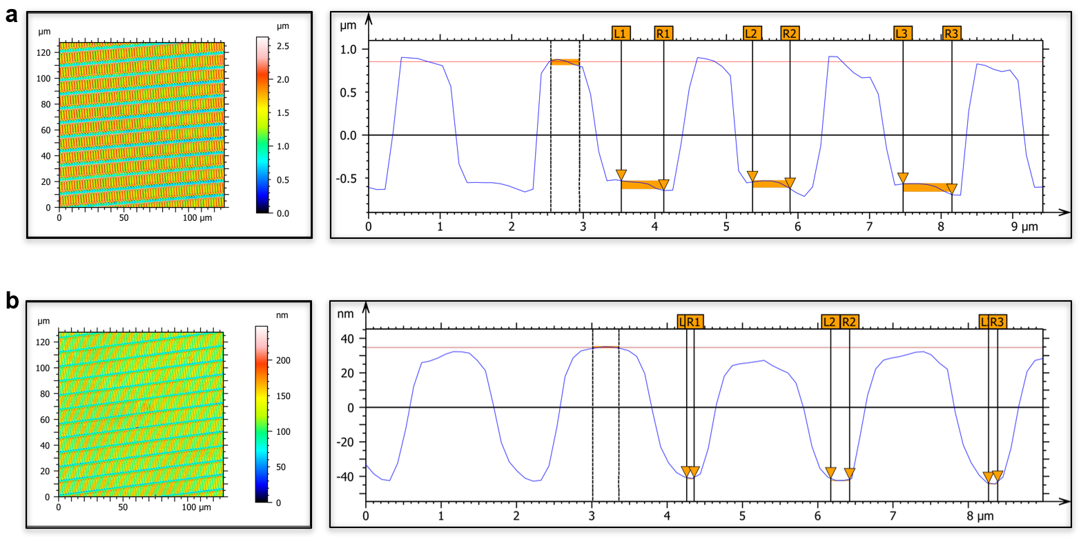
Supplementary Fig. 10. Confocal-microscopy image of 2D periodic structure of PDA cuboid microarrays with different aspect ratios: (a) structure “i”, (b) structure “ii”.

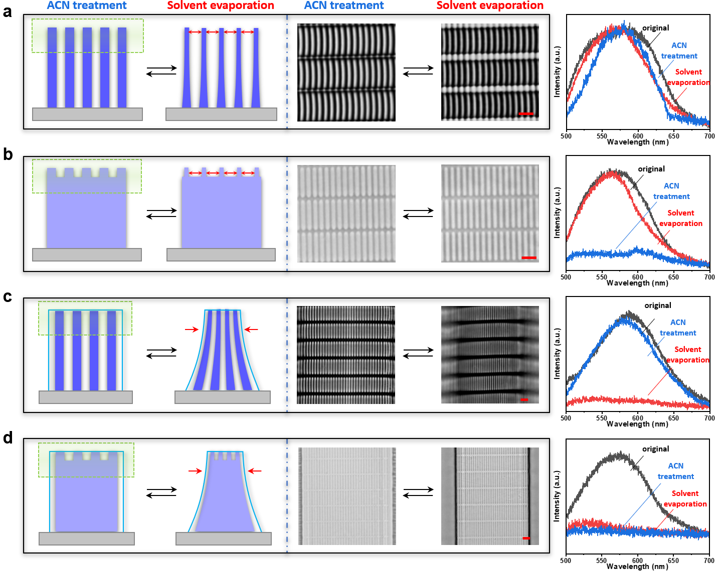
Supplementary Fig. 11. Schematic and optical microscope images of 2D periodic structure of PDA cuboid microarray before and after acetonitrile treatment, as well as their corresponding spectral reflectance: (a) structure “i”, (b) structure “ii”, (c) structure “iii” and (d) structure “iv”. Scale bar is 5 μm.

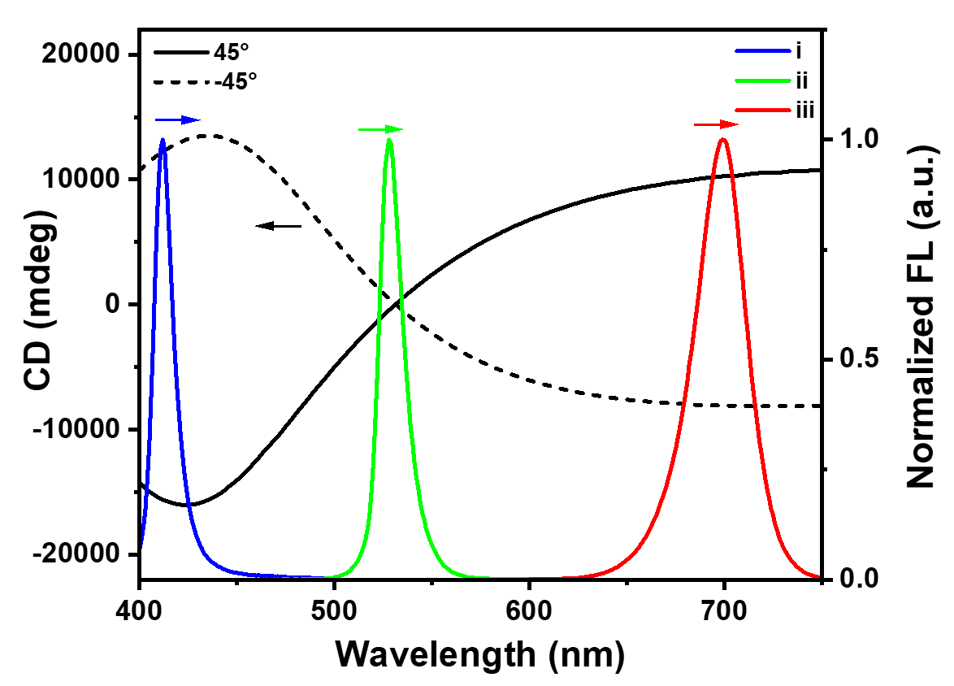
Supplementary Fig. 12. The normalized FL spectrum of three kinds of NCs: (i) CsPbCl₃, (ii) CsPbBr₃, (iii) CsPbI₃. And the CD spectra of TNA with the twist angle 45º and -45º.

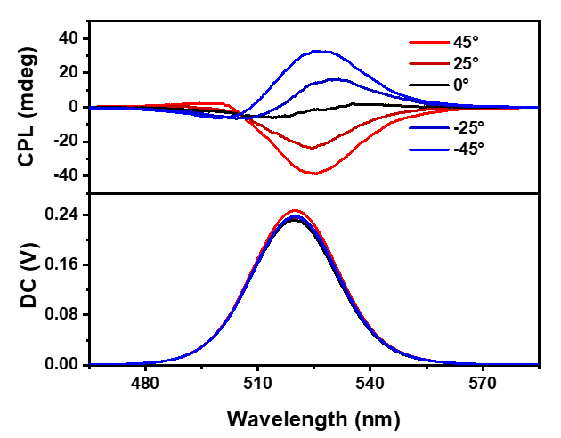
Supplementary Fig. 13. The CPL spectra of CsPbBr₃/TNA hybrid films upon varying the twist angle.

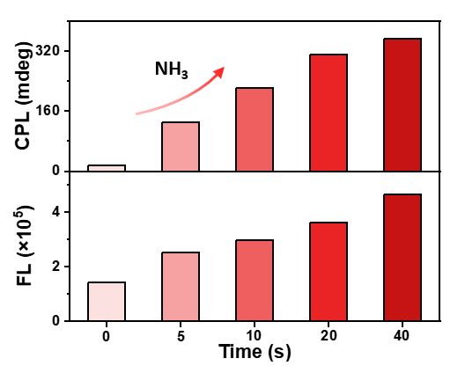
Supplementary Fig. 14. The FL and CPL intensity of CsPbI₃/TNA hybrid films with ammonia gas treatment time.

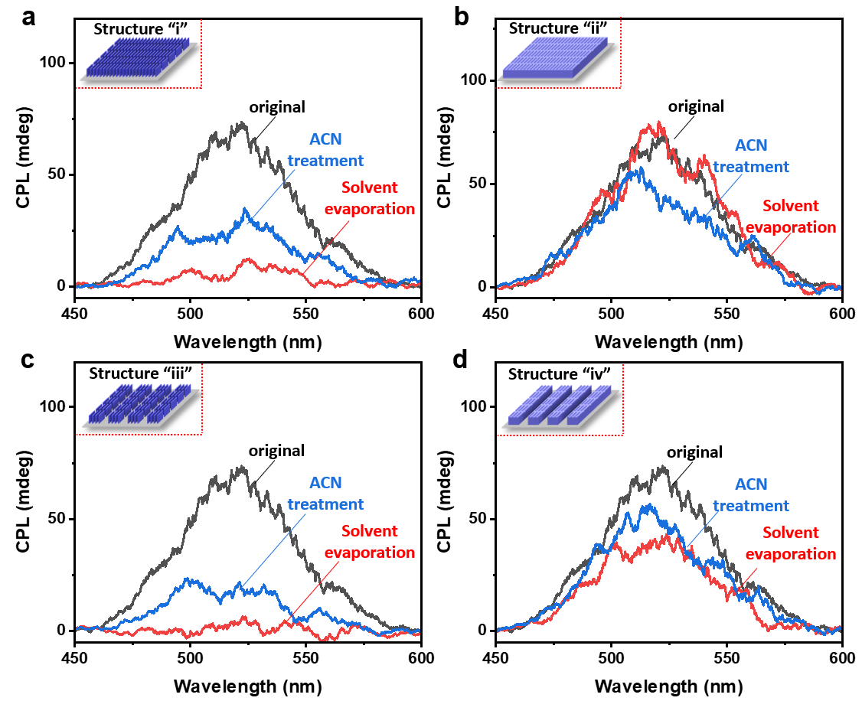
Supplementary Fig. 15. The CPL spectra of the label combined chiral perovskite FL layer (in the case of CsPbBr₃ NCs) and 2D periodic structure of PDA microarray before and after ACN treatment and ACN removel. The 2D periodic structure of PDA microarray is (a) structure “i”, (b) structure “ii”, (c) structure “iii” and (d) structure “iv”.

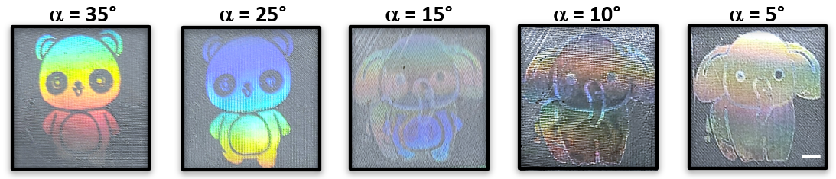
Supplementary Fig. 16. The dynamically changing color signal from “panda” to “elephant” upon varying the view angle. Scale bar is 5 mm.

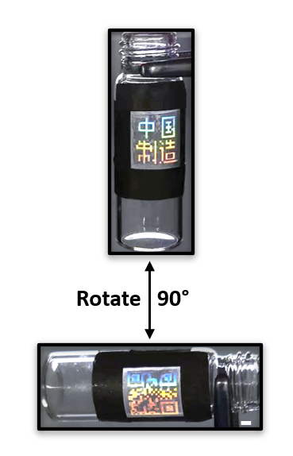
Supplementary Fig. 17. Reversible patterns variation between “中国制造” and QR code pattern by rotating the sample 90º in CW fashion. Scale bar is 2 mm.

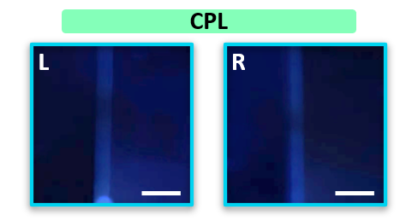
Supplementary Fig. 18. CPL patterns is hidden by the structure “iii” after removing ACN. Scale bar is 2 mm.

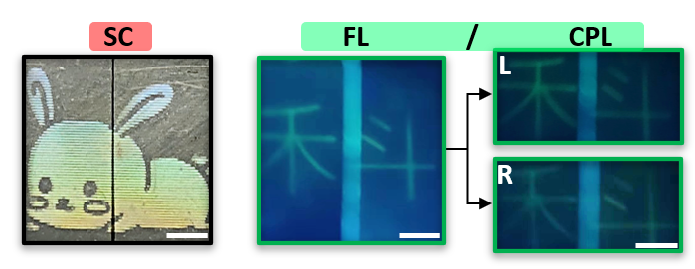
Supplementary Fig. 19. The structural color, fluorescence and CPL information of the label that combined the CsPbBr₃/TNA layer (with “科” image) and 2D periodic structure of PDA microarray (with “rabbit” pattern). Green could be observed in the FL mode. While in CPL mode, similar green “科” image could be observed through left- or right-handed CPF. Scale bar is 2 mm.

