Supplementary Materials for
Time-domain stereoscopic imaging
Zijian Wang et al.
*Corresponding author: Ming Yan, myan@lps.ecnu.edu.cn et al.

This PDF file includes:
Table 1
Figures 1 to 7
Note 1

Supplementary Text
Table 1. Parallels between concepts in pinhole imaging and optical sampling
Pinhole imaging | Optical sampling
Z axis | Absolute time
X axis | Relative time
Pinhole (aperture size) | Time gate (gate pulse width)
Object distance (Z) | Flight time of a detection pulse (T_{D})
Imaging distance (f) | Flight time of a reference pulse (T_{R})
Camera sensor (size) | Reference sampling pulse (pulse width)
Physical length of an object (X_{p}) | Temporal length of an event (delay between a detection pulse and a corresponding reference pulse, t_{p})
Image on camera (x₁) | Time delay between a detection pulse and the m-th reference pulse (Δt₁)
Magnification factor (F= X_{p}/x₁= Z/f) | Scaling factor (M= t_{p}/Δt₁= T_{D}/T_{R})
Operations in space | Operations in time
Adjusting the imaging distance | Changing the optical path of the reference arm
Adjusting the object distance | Changing the optical path of the detection arm

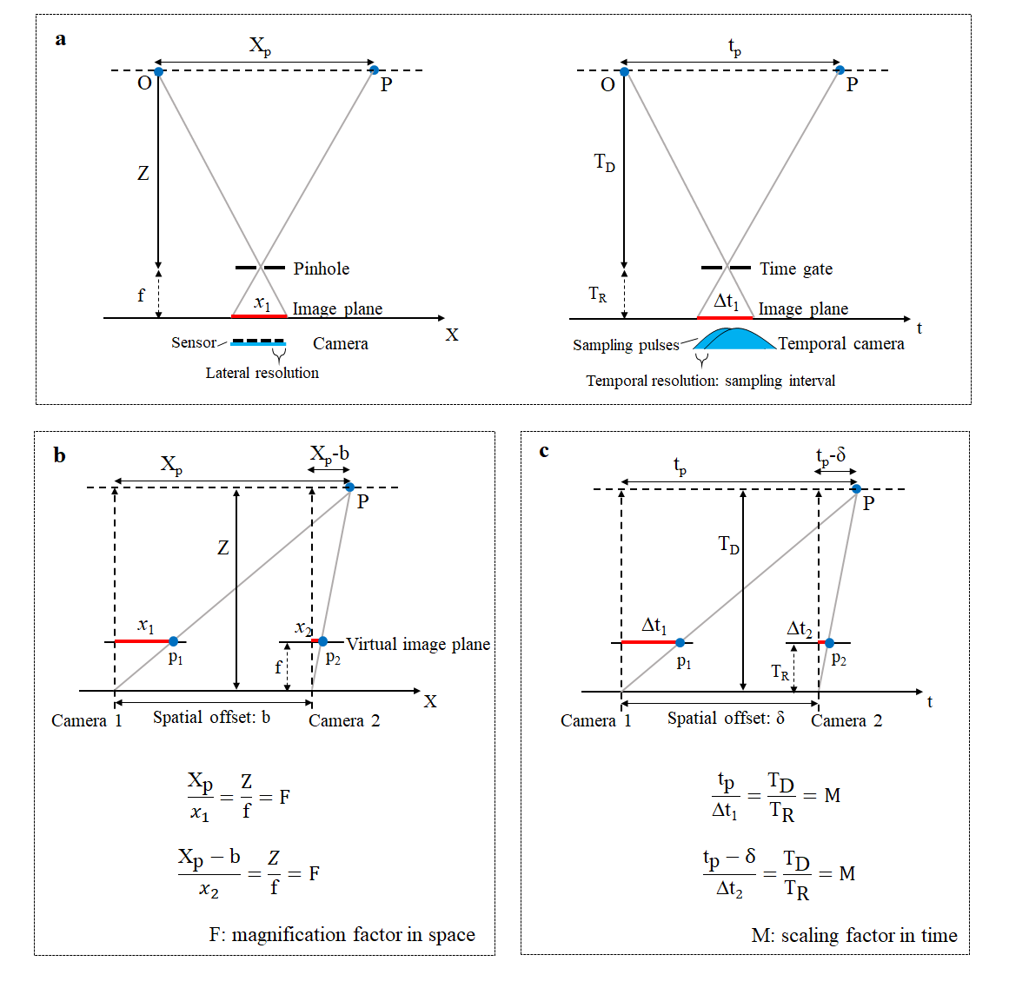
Fig. 1 | Parallels between stereo imaging and TDS. a Pinhole imaging (left) and optical sampling imaging (right). Find the parameters in Supplementary Table 1. An optical sampling gate in time is analogous to a pinhole in space. b Spatial-domain stereo imaging and c time-domain stereo imaging (TDS). In b, an object (P) is projected on the image plane with a magnification factor (F) given by object distance (Z) and image distance (f). The equations follow similar triangles formulas. Using two cameras of a slight spatial offset (b), the depth (Z) can be deduced by Z=b·f/Δx, where the disparity Δx =x₁-x₂. In c, a temporal scaling factor M comes from using the reference pulses to sample the detection pulses. The flight time of a detection pulse is T_{D} and that of a reference pulse is T_{R}. The delay between a detection pulse and a corresponding reference pulse, t_{P}, is scaled down to the relative delay (Δt₁) between the detection pulse and the m-th reference pulse. Similar to spatial-domain measurements, in TDS, T_{D}=δ·T_{R}/Δt, where the temporal disparity Δt=Δt₁-Δt₂ and δ is the temporal separation between two camera gates. Technically, there is no need to measure all the parameters. Considering the center of the first paired comb gates is time zero, the time of the m-th gate pairs can be written as m/f_{r}-δ/2. Then, Δt₁=T_{D}–(m/f_{r} -δ/2). For a special case when the detection pulse arrives at the temporal center of two gates, i.e., Δt₁=δ/2, we have T_{D}=m/f_{r}. Hence, it is easier to calculate T_{D} using the zero-crossing point of a balanced differential curve (as shown in Fig. 1b in the main text). At this point, the images on the two cameras are identical, i.e., Δt=0 and ΔΙ=0, where ΔΙ represents the intensity difference. Note that Δt=0 is a singular point for mathematically calculating T_{D}. In other words, T_{D}=m/f_{r} and m could be any integer. In practice, we use a stroboscopic method to deduce m and then to determine the flight time (T_{D}) and the corresponding distance.

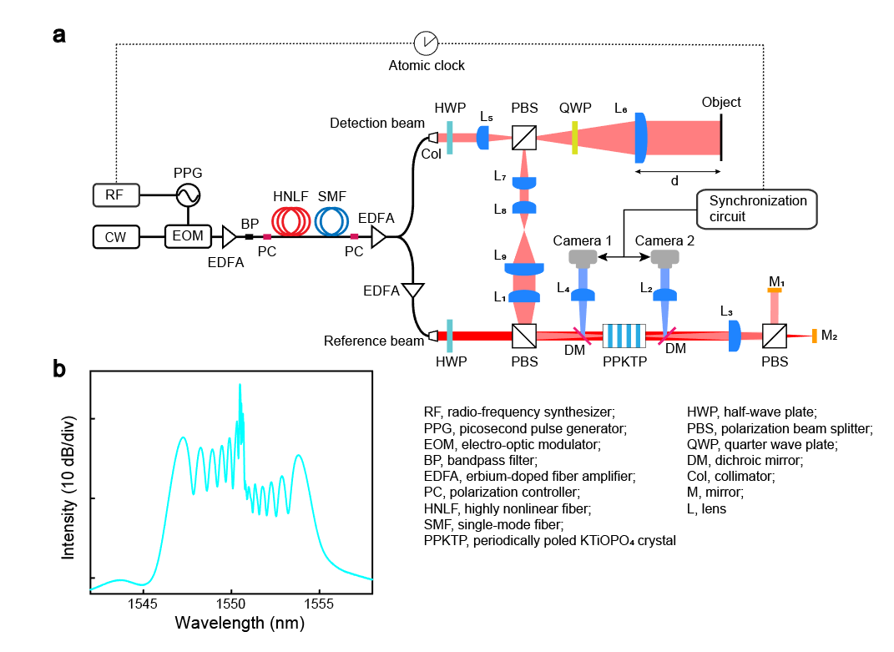
Fig. 2 | Experimental details. a Experimental setup. b The spectrum of the EO comb measured at the output of the detection arm. In the experiment, we used a fiber bandpass filter (BP) with a 1 nm bandwidth (WLTF-BA-P-1550, WL Photonics) to filter out amplified spontaneous emission (ASE) generated in the fiber amplifiers. In the detection arm, the comb passed through a collimator (F810APC-1550, Thorlabs) and a half-wave plate (HWP), then it was expanded by lenses L₅ (f=5 cm) and L₆ (f=20 cm). A quarter-wave plate (QWP) and a polarization beamsplitter (PBS) redirected the reflected detection light. The beam size was reduced by lenses L₆ and L₇ (f=5 cm). Then, after expansion via lens L₈ (f=5cm) and L₉ (f=20cm), the detection beam was launched into twin 4-f imaging systems for balanced imaging. The lenses for beam expansion were adjustable to fit different imaging scenarios.
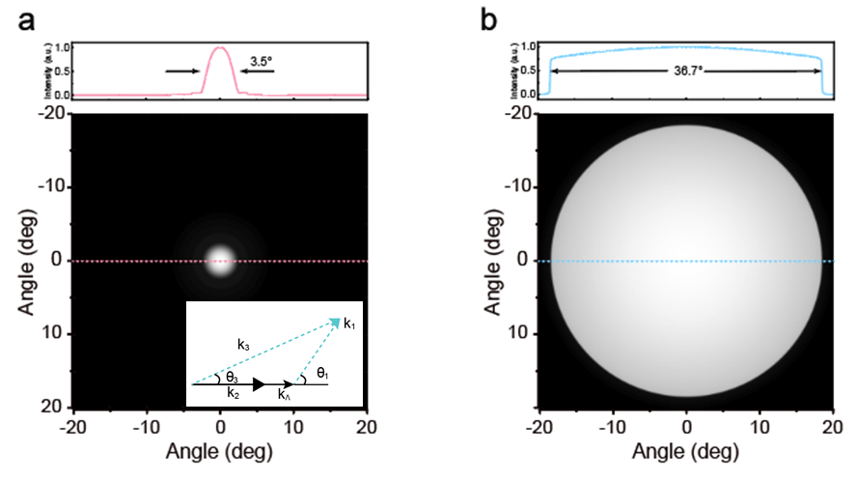
Fig. 3 | Simulation results. a Simulated angular FOV of the 4-mm PPKTP crystal we used. The inset plots the phase matching condition for sum-frequency generation. The symbols $k_{1}$ , $k_{2}$ , $k_{3}$ and $k_{Λ}$ represent the wave vectors of the two fundamental lights, sum-frequency signal and the polarization period. The symbols $θ_{1}$ and$θ_{3}$ represent the incidence angle of the fundamental light and the emission angle of the sum-frequency signal. b The simulation result for using a chirped poling nonlinear crystal.

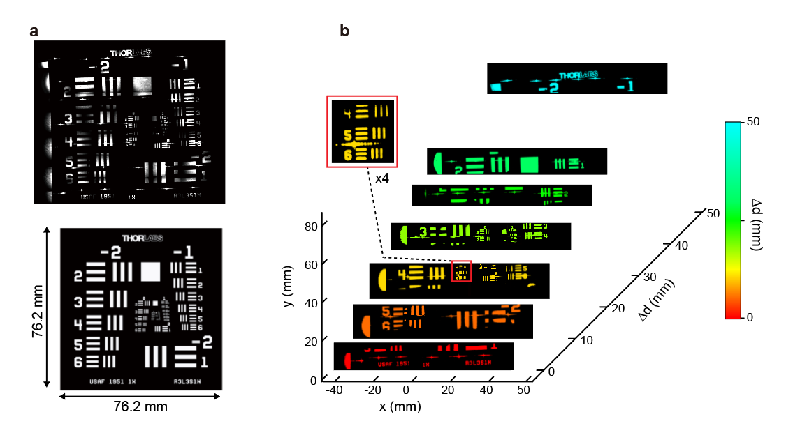
Fig. 4 | 3D imaging with a large FOV. a Stitched images (top) and the 1951-USAF patterns (bottom) for comparison. b Depth imaging combing high lateral resolutions with a large FOV. In the experiment, we used a transmission resolution target in front of a rectangle mirror. The mirror was moved along the axial direction, resulting in different imaging depths (Δd). To expand the imaging FOV, we scanned the detection beam along the x-axis, finished a strip, and then moved the resolution plate along the y-axis to scan the next strip.

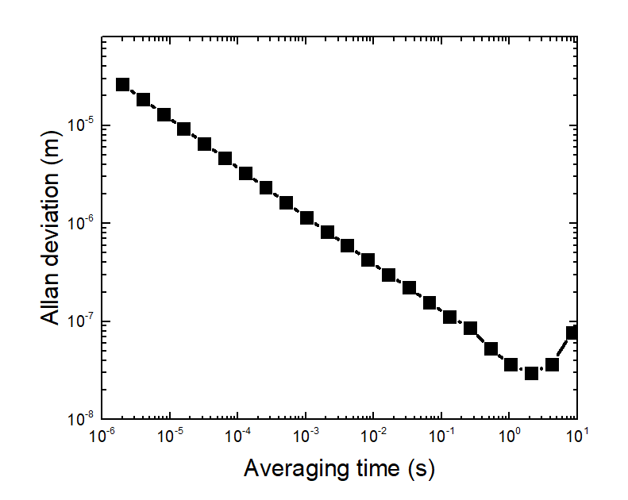
Fig. 5 | Allan deviation measurement. In this study, we simply replaced the cameras with two low-noise single-point photodetectors for balanced detection without changing other optical components. As a result, we achieved a measurement precision of 29.8 nm at 2 s (for a folded optical path of >30 m), suggesting the potential for further enhancing the range imaging precision of our system by employing low-noise cameras.

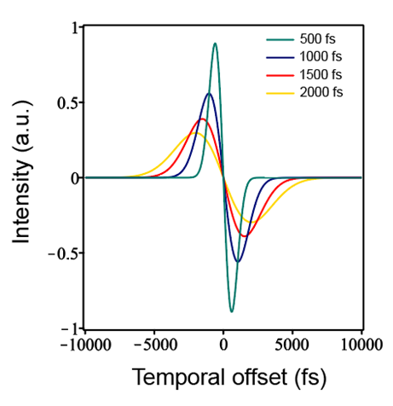
Fig. 6 | Simulation results for TDS signal with different pulse widths. Assuming that the pulse peak power remains unchanged, the equilibrium cross correlation can be mathematically expressed as $I=e^{-\frac{{\left(τ-δ\right)}^{2}}{T_{1}^{2}+T_{2}^{2}}}+e^{-\frac{{\left(τ+δ\right)}^{2}}{T_{1}^{2}+T_{2}^{2}}}$, where I denotes the intensity of the balanced cross-correlation signal, $τ$ represents the time delay or temporal offset between the two pulses, $δ$ indicates the delay fixed by the PPKTP crystal and the two mirrors (M₁ and M₂ in Supplementary Fig. 1a), and $T_{1}$ and $T_{2}$ signify the pulse widths of the two cross-polarized pulses, respectively. For the displayed TDS signals, $δ$ is fixed at 500 fs. The simulation results indicate that although the TDS signal changes with the comb pulse width, the zero-crossing point remains fixed. This is consistent with the experimental results in the main text Fig. 5e. Sweeping the comb’s repetition frequency changes the pulse width, impacting the signal’s amplitude and width. However, the separation of zero-crossing frequencies remains at 16.63 MHz.

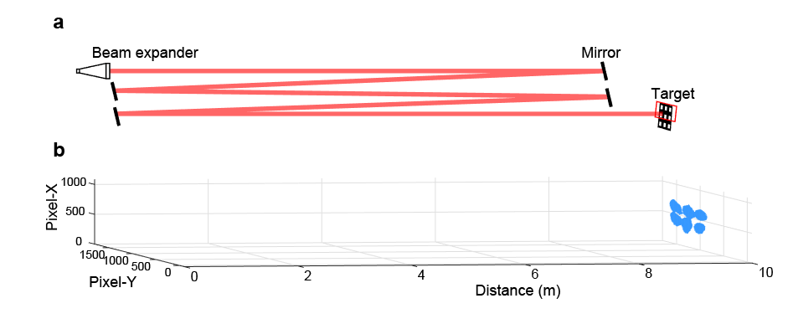
Fig. 7 | Imaging at long distances. a Experimental scheme. b Range imaging results. In a, the imaging area is marked with a red box. The target is a black metal plate inlaid with square-shaped (2 mm×2 mm) glass pieces separated by 2 mm. The standoff distance between the beam expander and the target is 9.6 m. The optical path is folded because of the limited laboratory space. The image is distorted due to several factors including beam divergence, target diffraction, the impact of fold mirrors, and the spatial filtering effect induced by the imaging system.

Note 1. Lateral resolution, depth-of-field (DOF) and field-of-view (FOV)
1) Estimation of the lateral resolution
The lateral resolution of our setup is determined by the imaging lenses as well as the size of the nonlinear crystal. For a 4-f imaging system, the lateral resolution is fundamentally determined by the system’s ability to resolve fine spatial details of the object based on diffraction limits and the numerical aperture (NA) of the lenses in the system. The diffraction limited lateral resolution, R_{x-diffraction}, is given by:
$R_{\text{x-diffraction}}≈\frac{0.61⋅λ}{NA}$ (1)
where λ is the wavelength of the incident light.
However, it is challenging to achieve this diffraction-limited resolution for a sum-frequency imaging system because the lateral resolution is significantly influenced by the size of the nonlinear crystal (due to spatial filtering), provided that it is smaller than the reference beam spot.
Practically, the lateral resolution, $R_{x}$, is determined by the 4-f system as:
$R_{x}=\frac{\sqrt{8ln2∙}λ∙f_{1}}{πL_{x}F}$ (2)
where ${\text{f}}_{\text{1}}$ represents the focal length of the first lens in the 4-f system, L_{x} is the size of crystal’s cross-section, and F is the effective scaling factor for the light passing through two beam expanders before entering the 4f conversion system. Using the experimental parameters: $\text{λ=1.55 µm}$, ${\text{f}}_{\text{1}}\text{=10}\text{0}\text{ mm}$, F=20 and $L_{x}\text{=1 mm}$. The calculated $R_{x}$ is 5.81 μm for Fig. 2e in the main text.
2) Estimation of DOF
Our BCC range imaging system involves two adjustable beam expanders and two identical 4-f nonlinear imaging subsystems. The effective DOF of our system may be approximated using the following equation:
$DOF=\left(\frac{2{R'}_{x}∙f_{2}∙\left(L_{x}/2\right)}{{\left(L_{x}/2\right)}^{2}-{{R'}_{x}}^{2}}\right)∙F^{2}$ (3)
where f₂ (=75 mm) is the focal length of the lens (L₂ or L₄ in Supplementary Fig. 1) in front of the cameras. For Fig. 4f in the main text, the effective scaling factor F was adjusted to 160/9. The parameter ${R'}_{x}$ (=25 μm) is half of the lateral resolution (890 μm) divided by the factor F. Therefore, the estimated DOF is 2.38 m.
3) Limits in FOV and solutions
The FOV of our nonlinear imaging systems are limited by the phase matching conditions for sum-frequency generation in the PPKTP crystal as described in Supplementary Fig. 2a (inset). The mathematical descriptions are given in the following equations:
$\frac{Δk_{‖}}{2π}=\frac{n_{3}}{λ_{3}}cosθ_{3}-\frac{n_{1}}{λ_{1}}cosθ_{1}-\frac{n_{2}}{λ_{2}}-\frac{1}{Λ}$ (4)
$\frac{Δk_{⊥}}{2π}=\frac{n_{3}}{λ_{3}}sinθ_{3}-\frac{n_{1}}{λ_{1}}sinθ_{1}$ (5)
$Δk=\sqrt{Δk_{‖}^{2}+Δk_{⊥}^{2}}$ (6)
The subscripts 1, 2 and 3 represent the fundamental lights and the sum-frequency signal. The symbols n, Δk, and Λ represent the refractive index of the nonlinear crystal, the phase mismatch quantity, and the polarization period of the crystal. The subscripts $‖$ and $⊥$ represent the transverse and longitudinal dimensions. We used the above equations to simulate the angular FOV for a PPKTP crystal at a fixed period of 46.2 μm. The results are shown in Supplementary Fig. 2a. Previously, we have demonstrated that the angular FOV can be expanded using a chirped poling lithium niobate crystal (CPLN). Similarly, it is possible to use an aperiodically poled KTP (KTiOPO₄) crystal to expand the angular FOV of our imaging system. For instance, by using a KTP crystal with a chirped poling period of 17-20 µm, it is possible to achieve an angular FOV of 36.7° (Supplementary Fig. 2b) with a fundamental comb emitting at 1550 nm.

