Supplementary Information
ortho-Ethynyl group assisted regioselective and diastereoselective [2+2] cross-photocycloaddition of alkenes
Xie et al.

Supplementary Figures

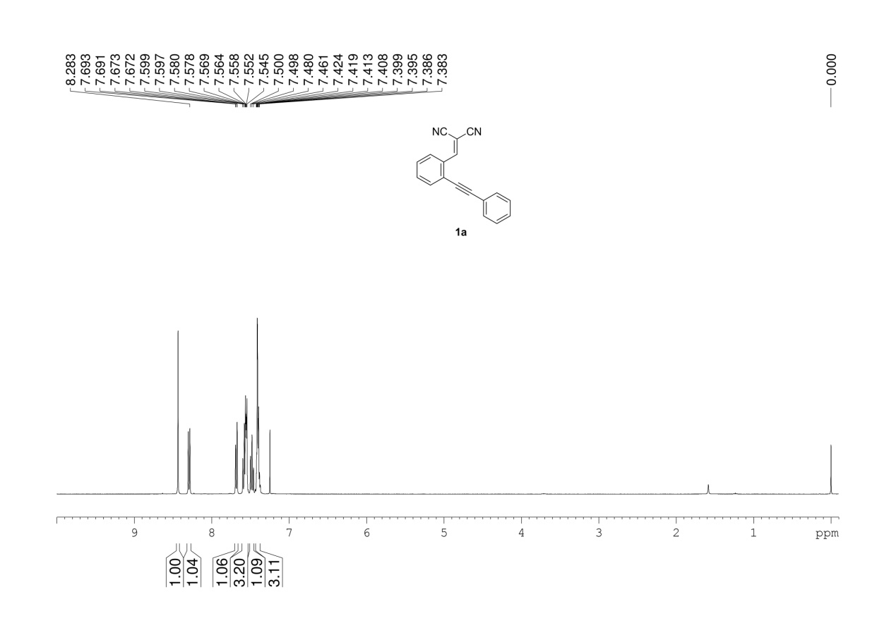
Supplementary Figure 1. ¹H NMR (400 MHz, CDCl3) spectrum of 1a

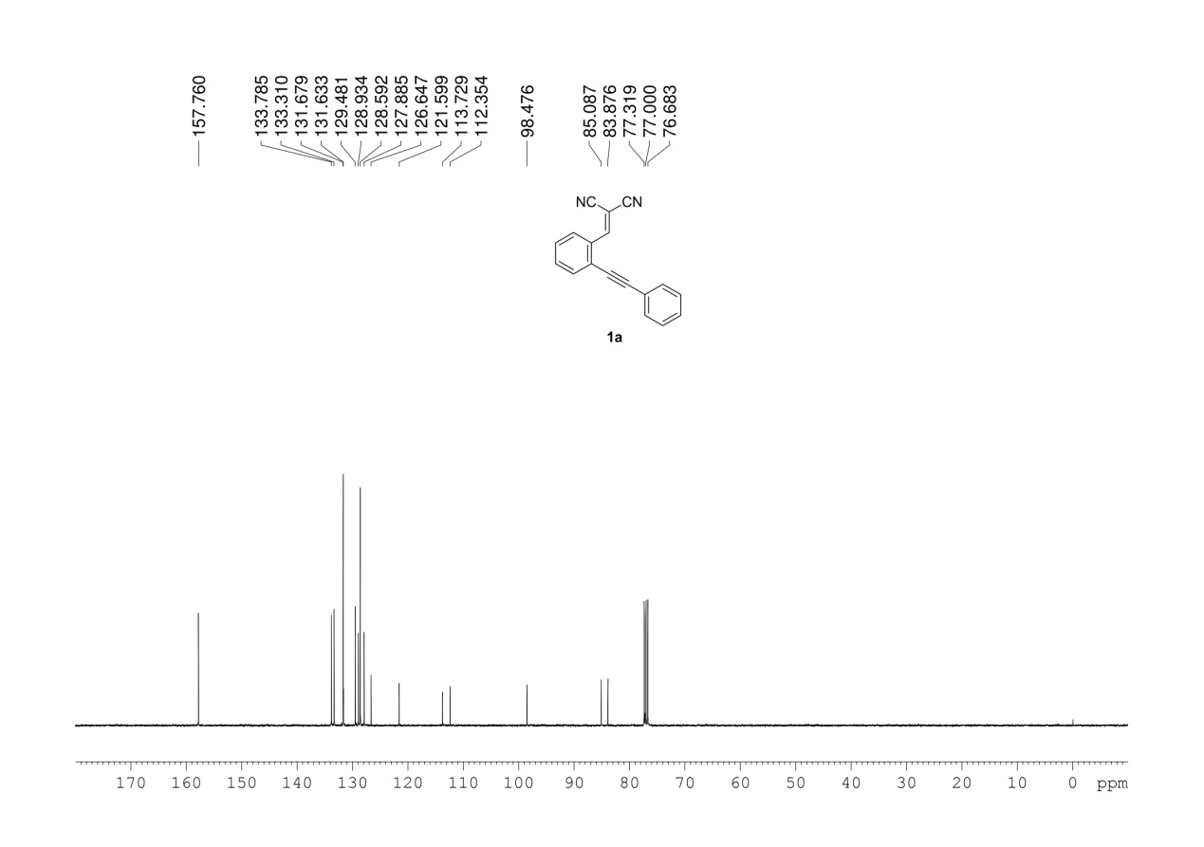
Supplementary Figure 2. ¹³C NMR (100 MHz, CDCl3) spectrum of 1a

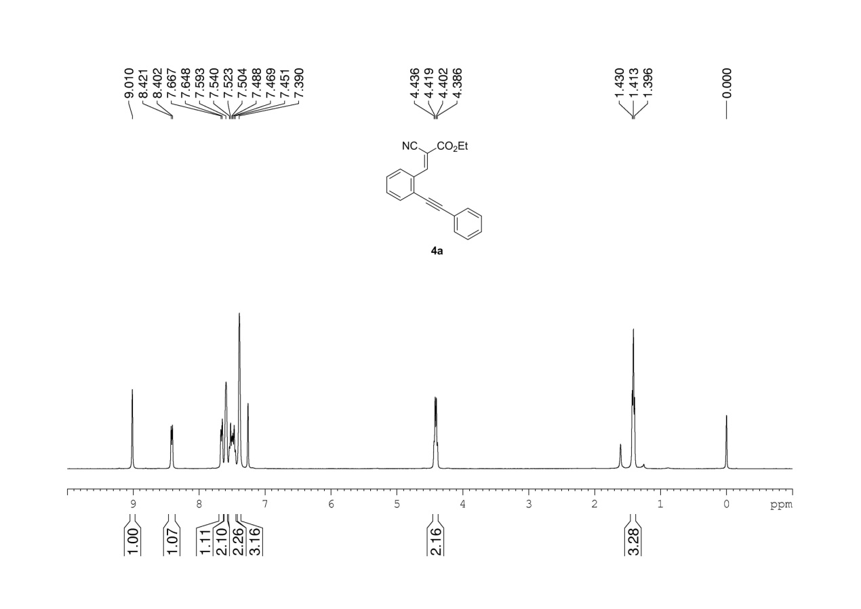
Supplementary Figure 3. ¹H NMR (400 MHz, CDCl3) spectrum of 4a

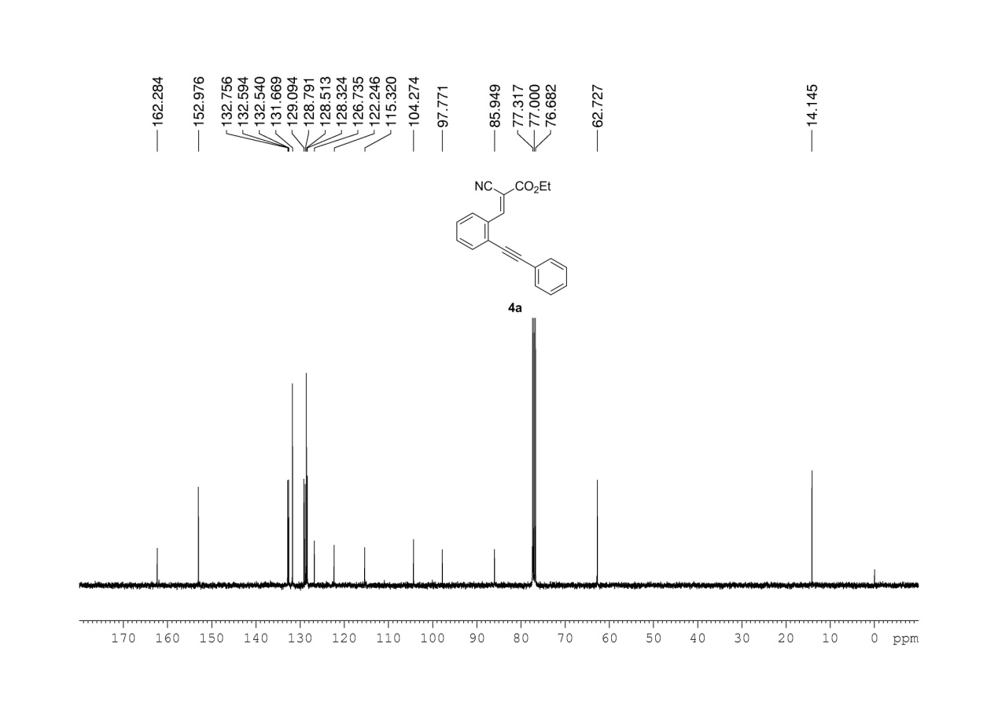
Supplementary Figure 4. ¹³C NMR (100 MHz, CDCl3) spectrum of 4a

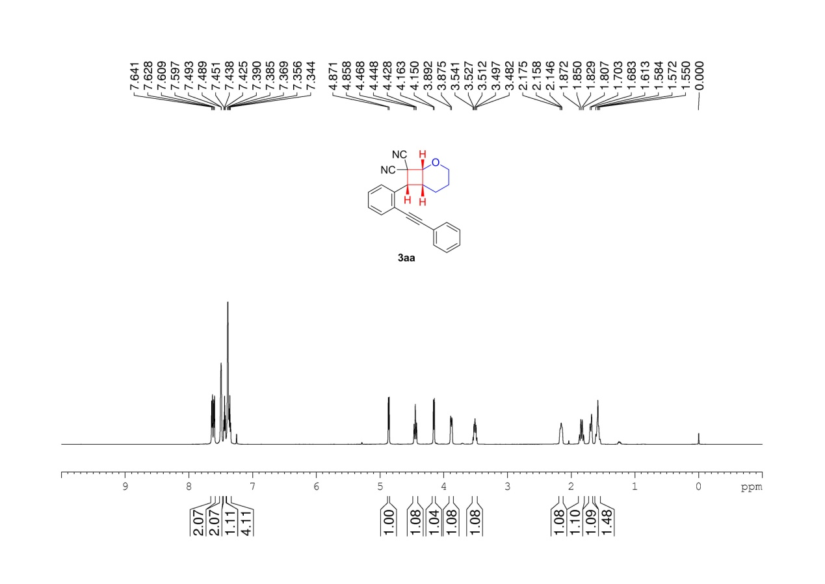
Supplementary Figure 5. ¹H NMR (600 MHz, CDCl3) spectrum of 3aa

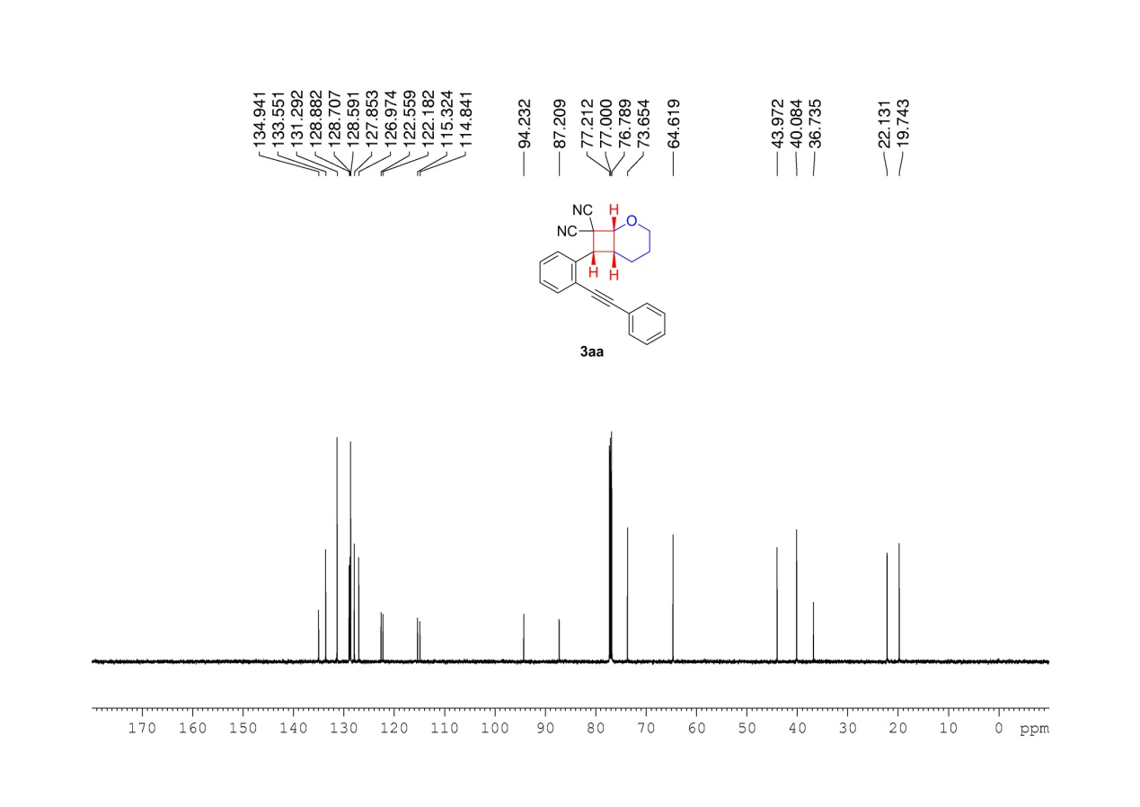
Supplementary Figure 6. ¹³C NMR (150 MHz, CDCl3) spectrum of 3aa

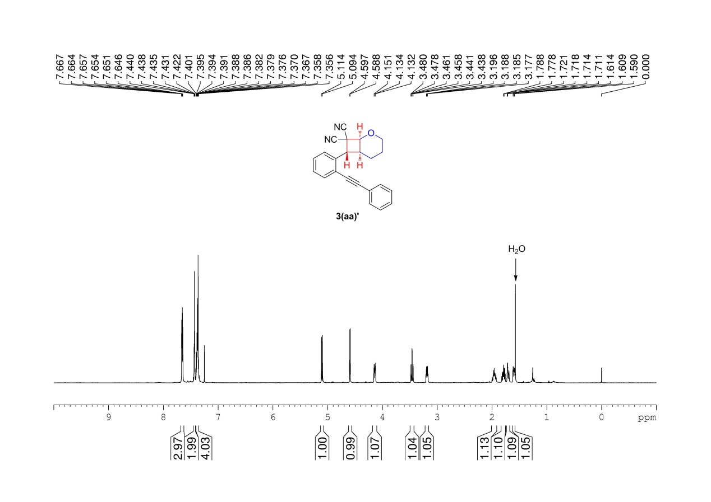
Supplementary Figure 7. ¹H NMR (600 MHz, CDCl3) spectrum of 3(aa)’

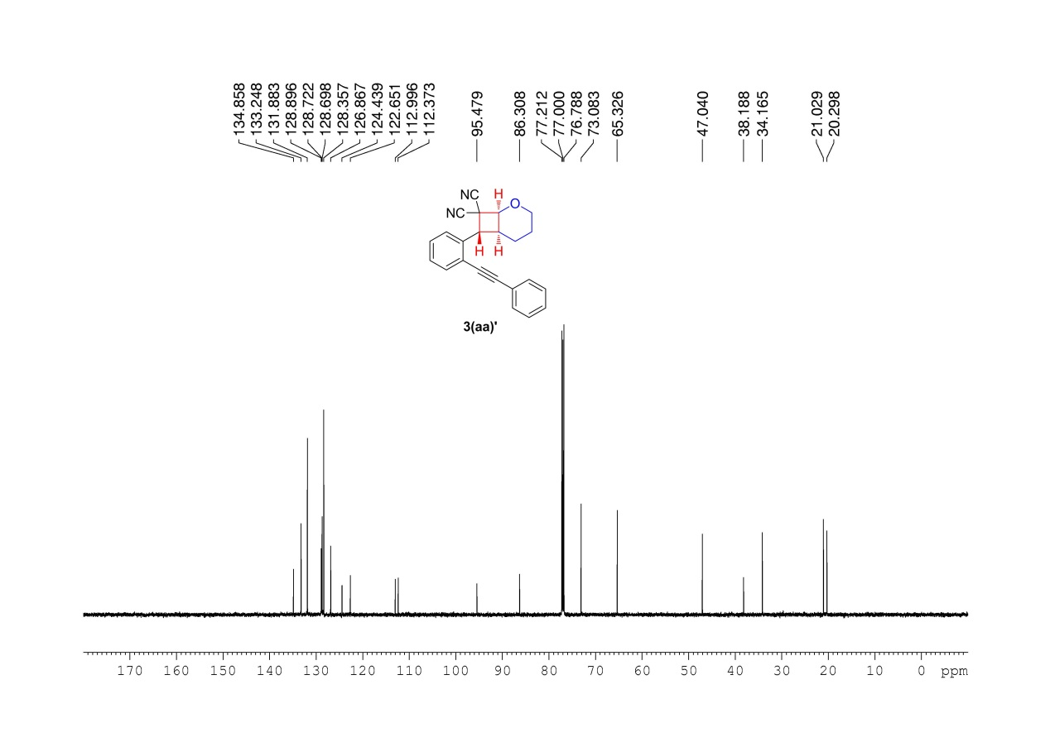
Supplementary Figure 8. ¹³C NMR (150 MHz, CDCl3) spectrum of 3(aa)’

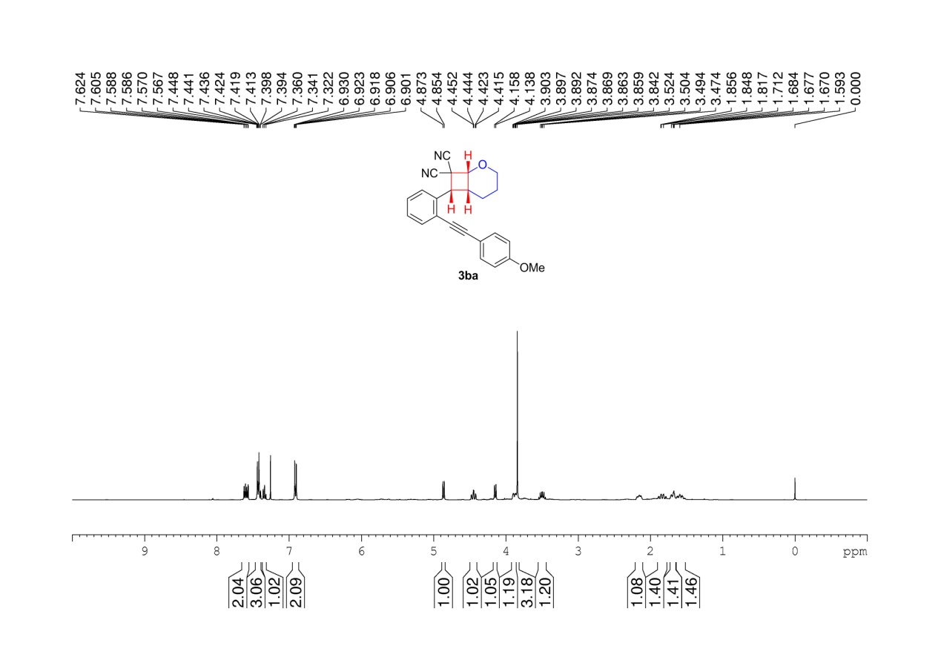
Supplementary Figure 9. ¹H NMR (400 MHz, CDCl3) spectrum of 3ba

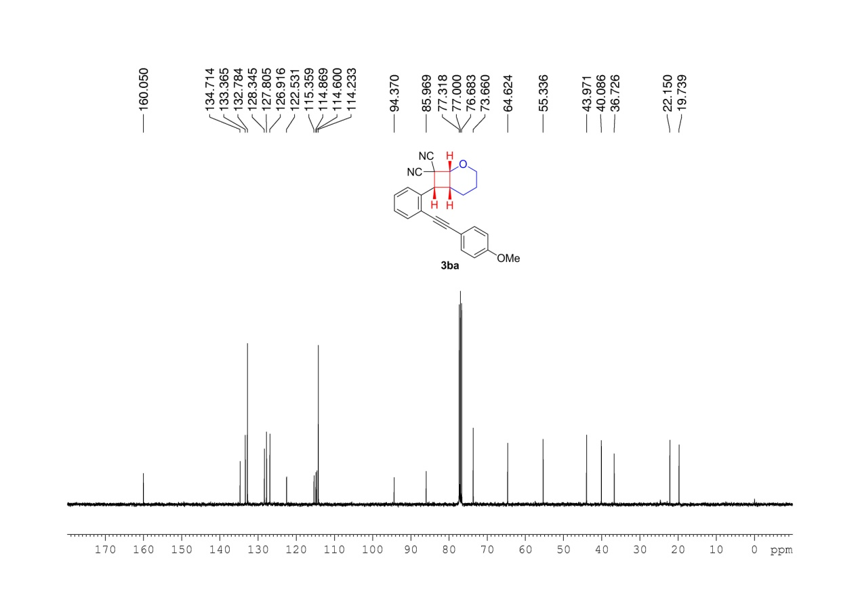
Supplementary Figure 10. ¹³C NMR (100 MHz, CDCl3) spectrum of 3ba

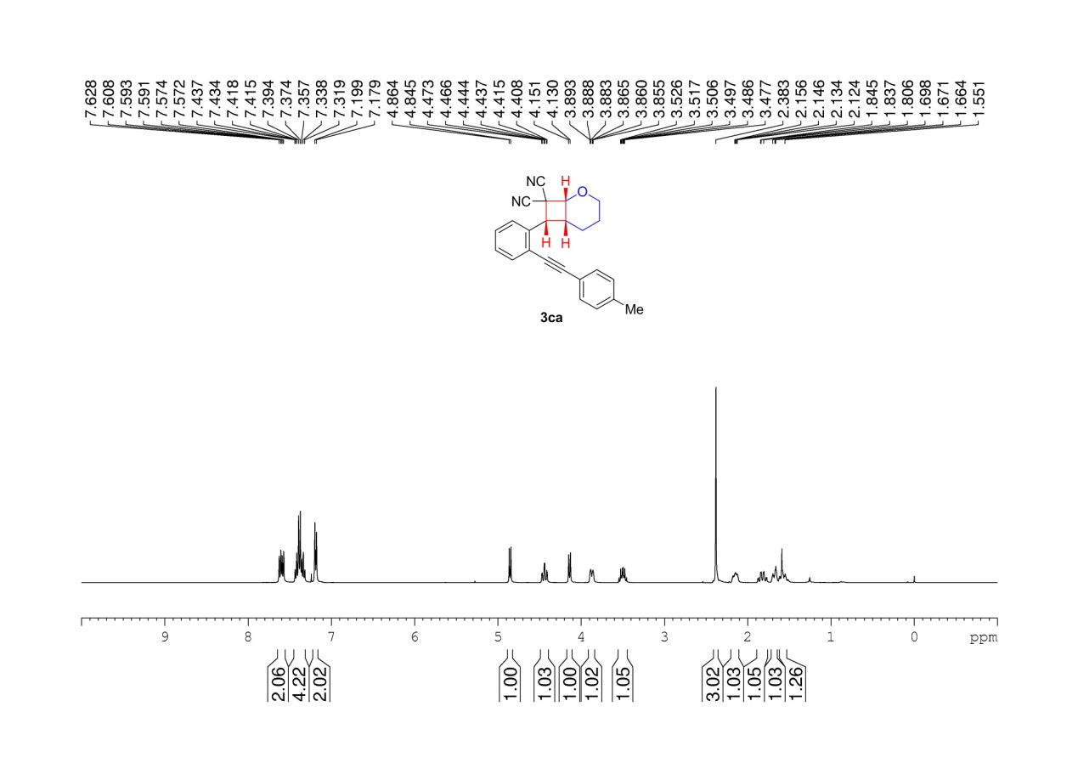
Supplementary Figure 11. ¹H NMR (400 MHz, CDCl3) spectrum of 3ca

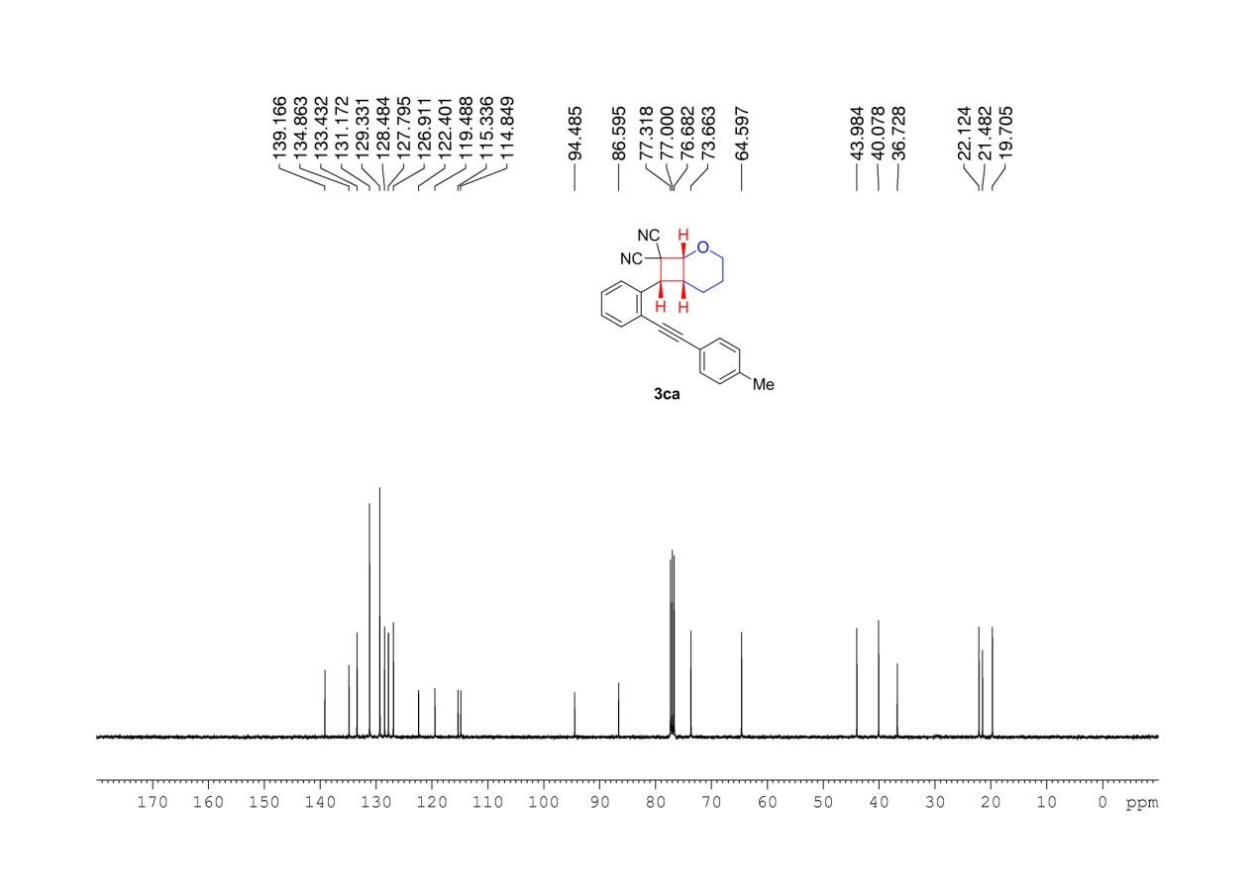
Supplementary Figure 12. ¹³C NMR (100 MHz, CDCl3) spectrum of 3ca

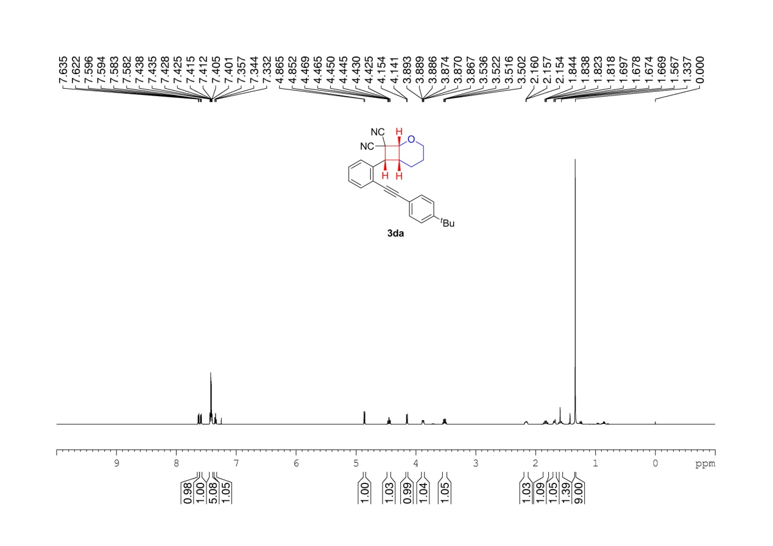
Supplementary Figure 13. ¹H NMR (600 MHz, CDCl3) spectrum of 3da

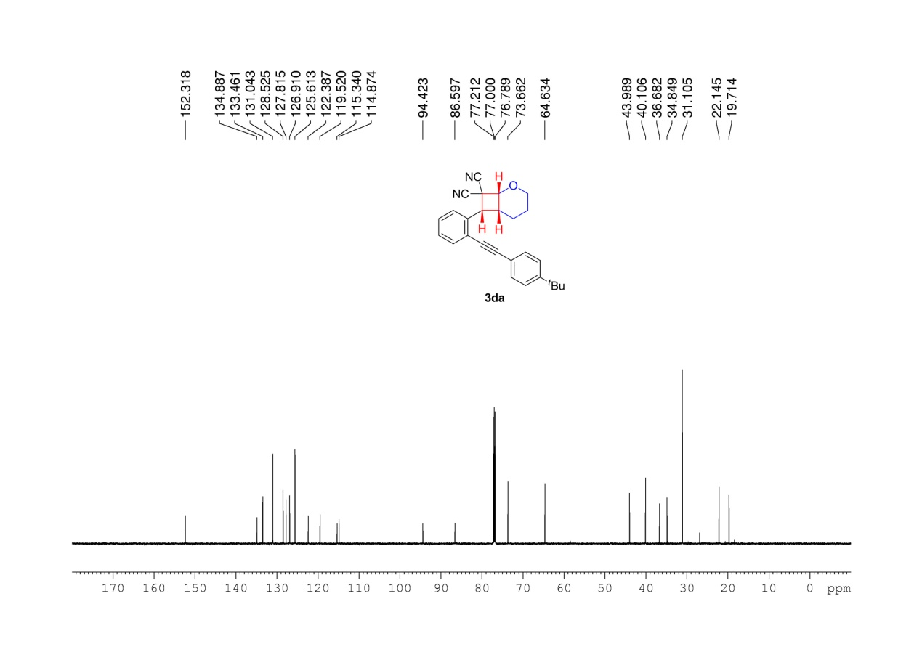
Supplementary Figure 14. ¹³CNMR (150 MHz, CDCl3) spectrum of 3da

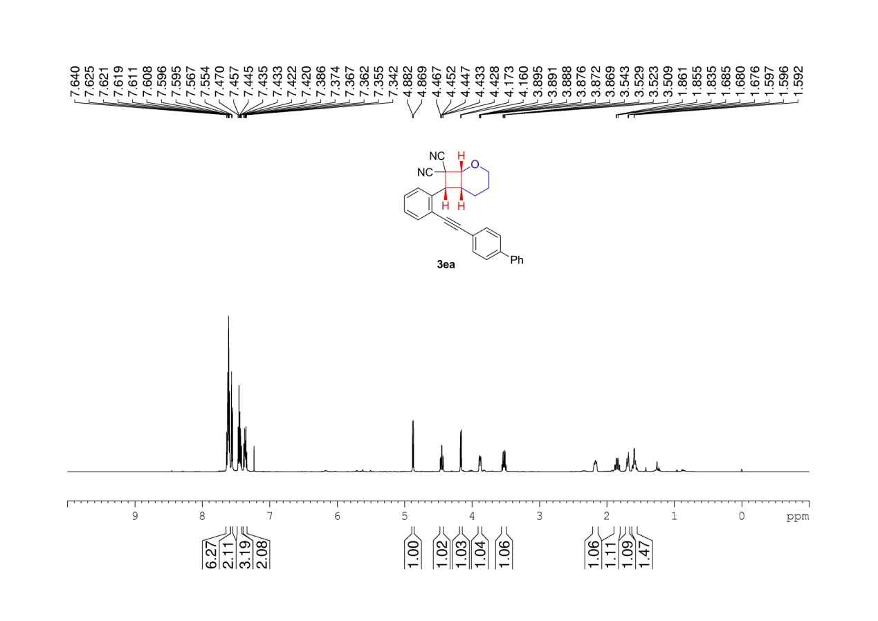
Supplementary Figure 15. ¹H NMR (600 MHz, CDCl3) spectrum of 3ea

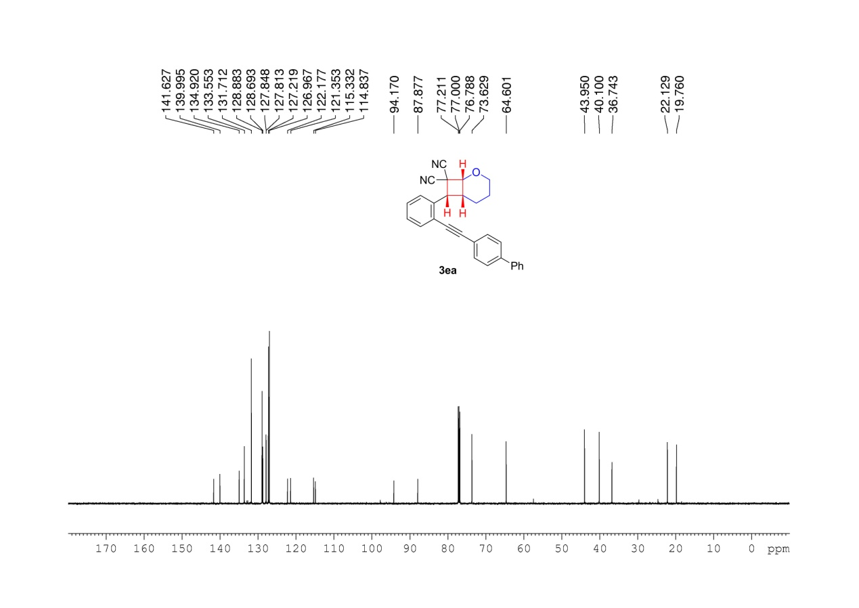
Supplementary Figure 16. ¹³C NMR (150 MHz, CDCl3) spectrum of 3ea

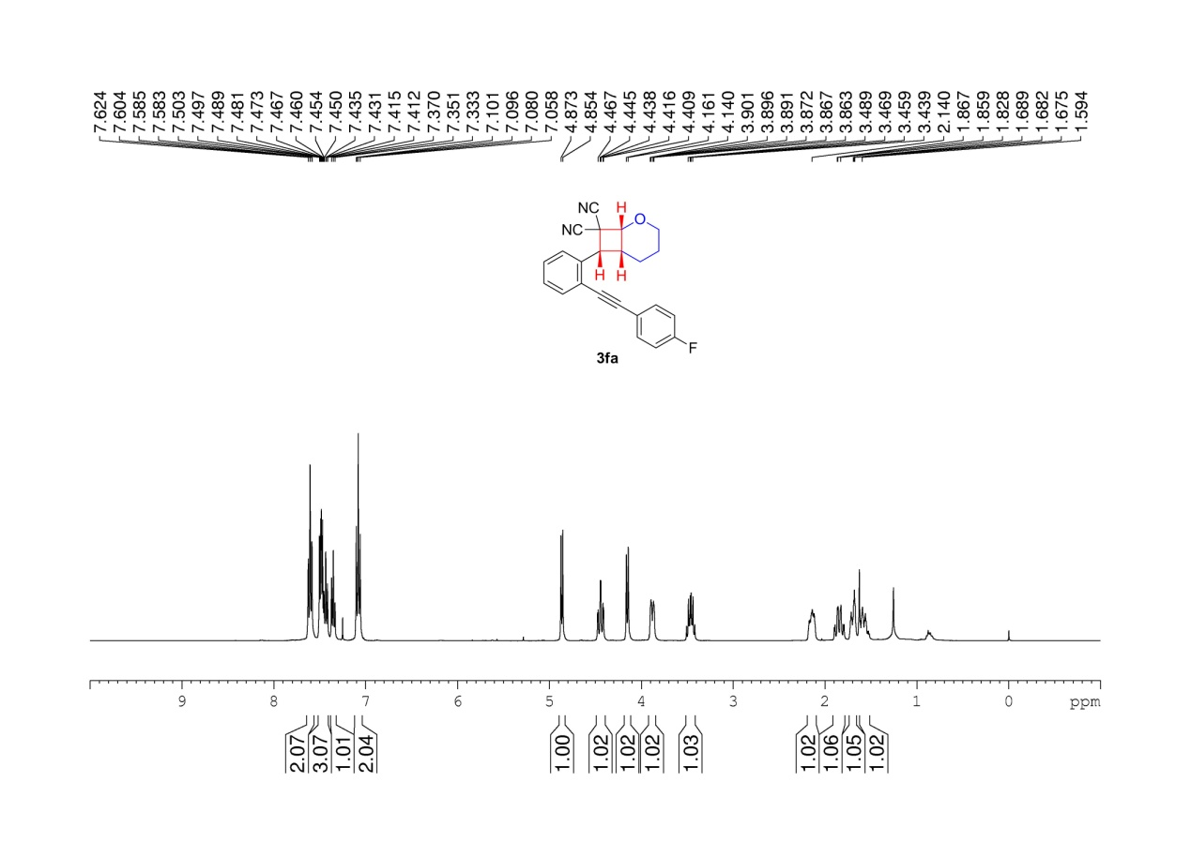
Supplementary Figure 17. ¹H NMR (400 MHz, CDCl3) spectrum of 3fa

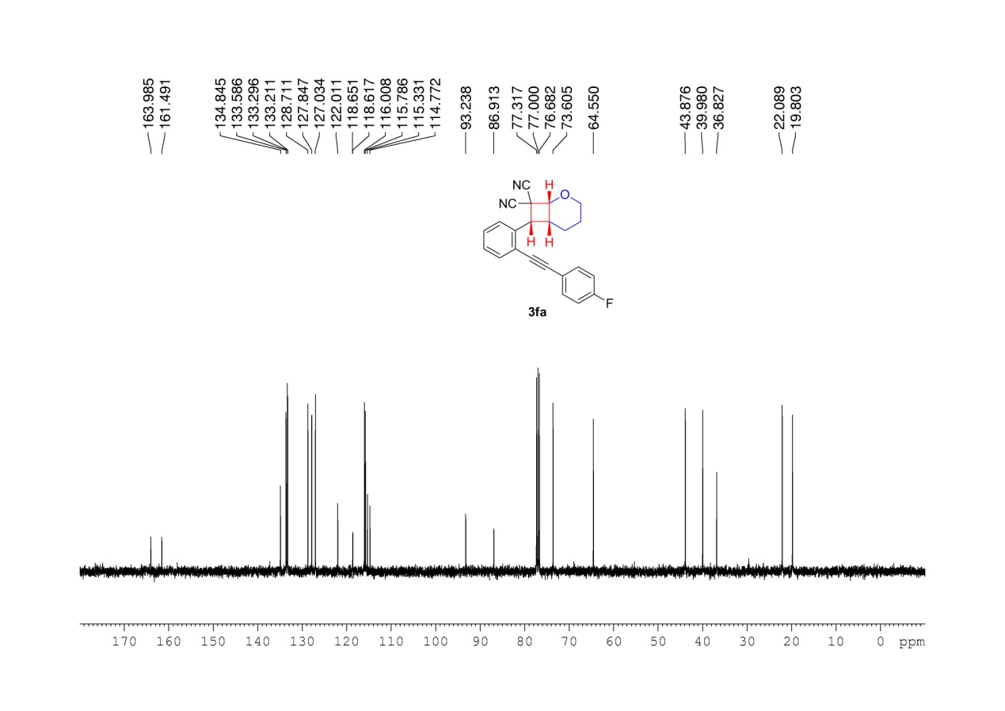
Supplementary Figure 18. ¹³C NMR (100 MHz, CDCl3) spectrum of 3fa

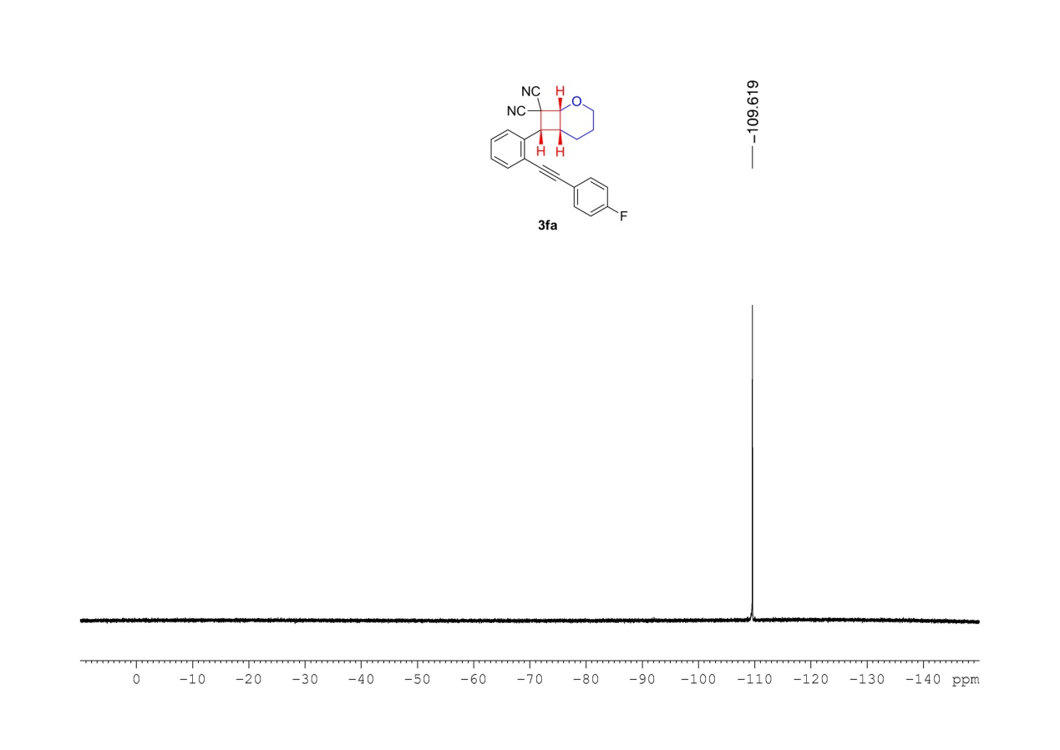
Supplementary Figure 19. ¹⁹F NMR (376 MHz, CDCl3) spectrum of 3fa

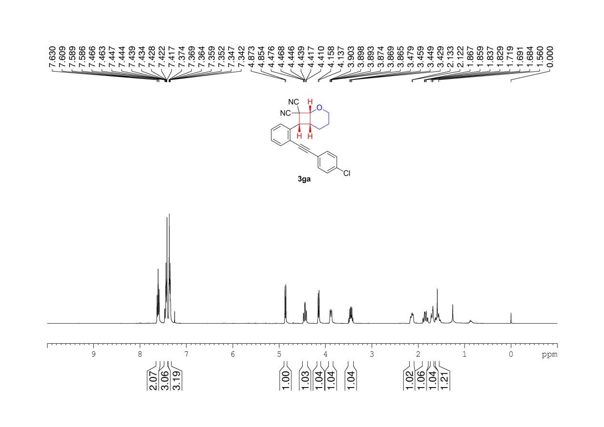
Supplementary Figure 20. ¹H NMR (400 MHz, CDCl3) spectrum of 3ga

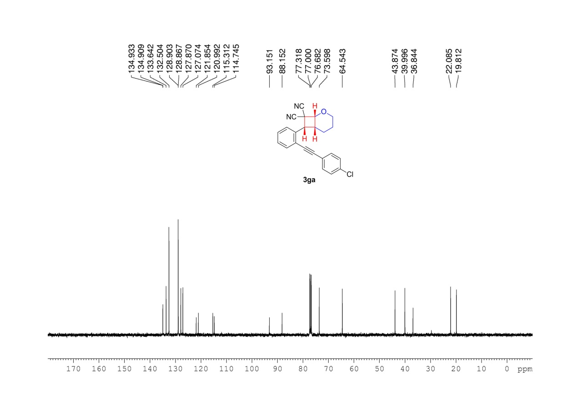
Supplementary Figure 21. ¹³C NMR (100 MHz, CDCl3) spectrum of 3ga

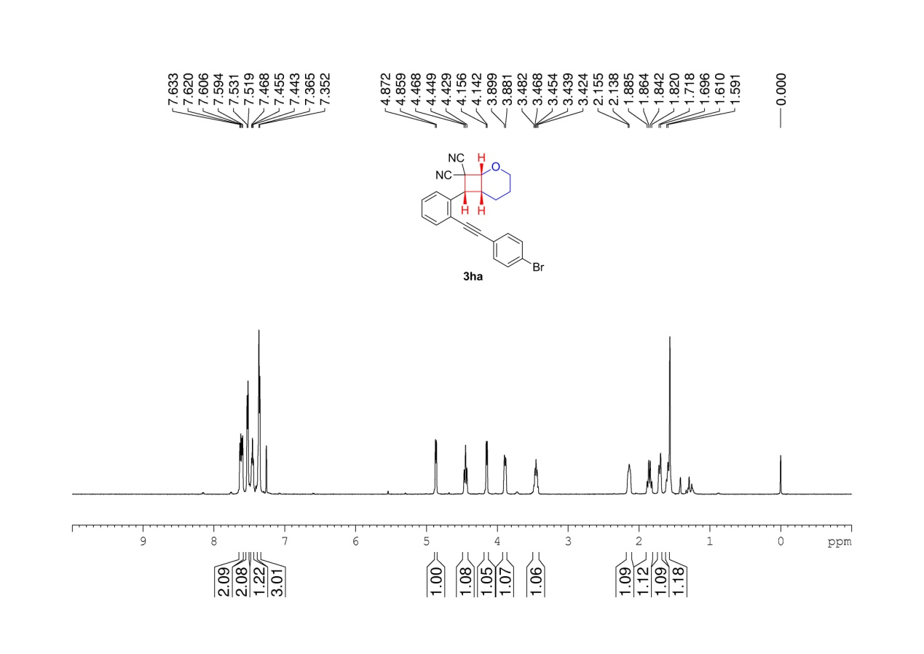
Supplementary Figure 22. ¹H NMR (600 MHz, CDCl3) spectrum of 3ha

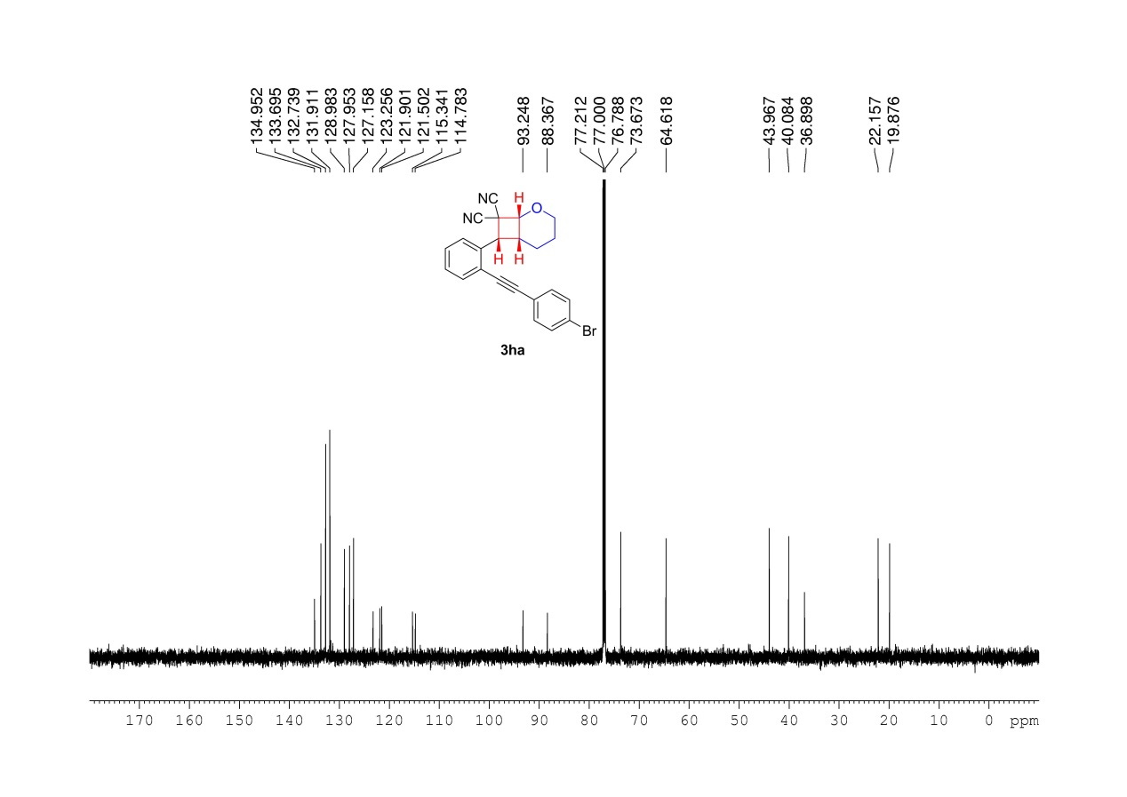
Supplementary Figure 23. ¹³C NMR (150 MHz, CDCl3) spectrum of 3ha

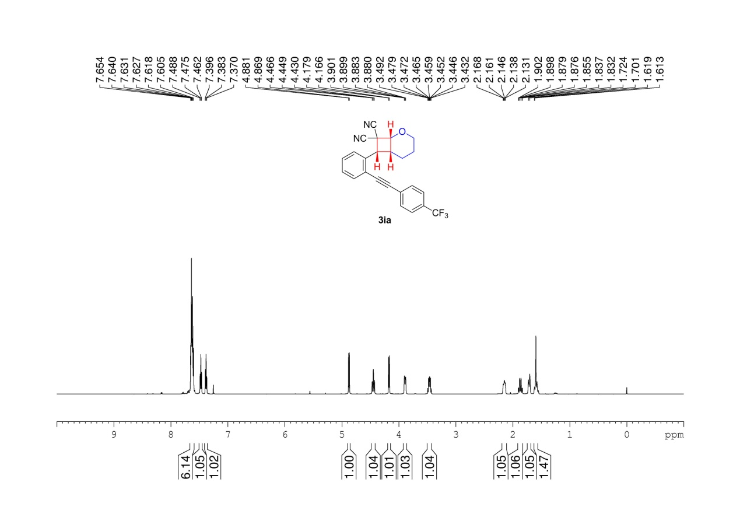
Supplementary Figure 24. ¹H NMR (600 MHz, CDCl3) spectrum of 3ia

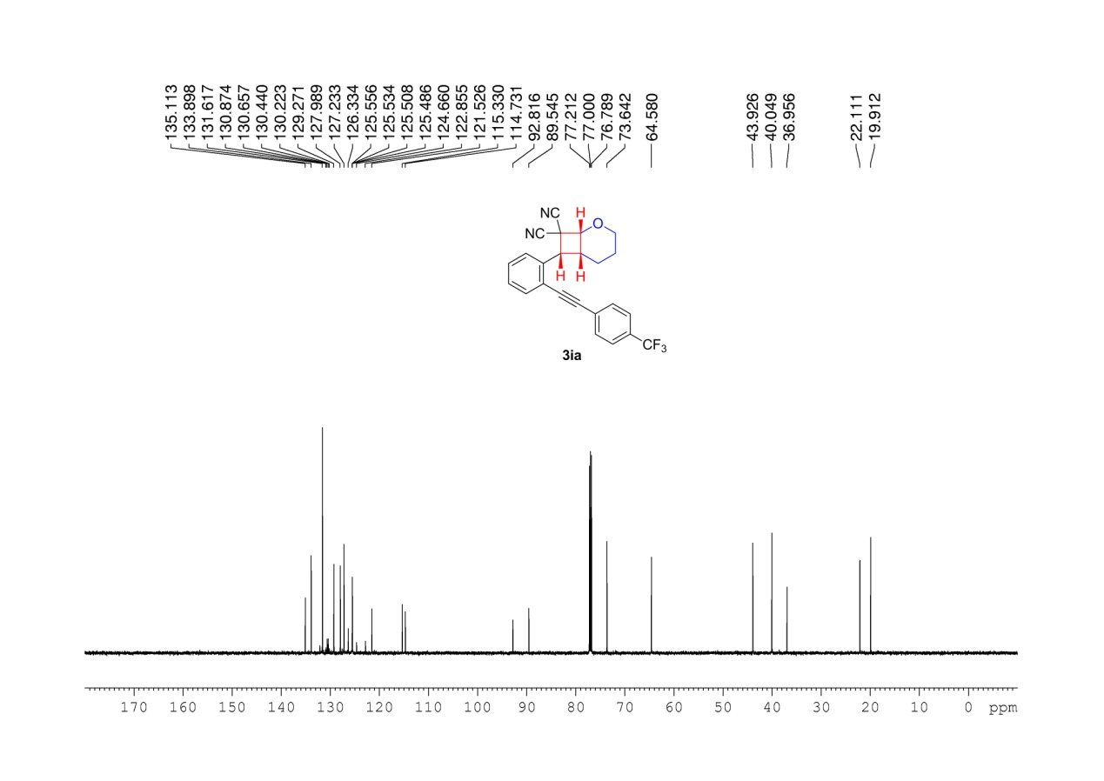
Supplementary Figure 25. ¹³C NMR (150 MHz, CDCl3) spectrum of 3ia

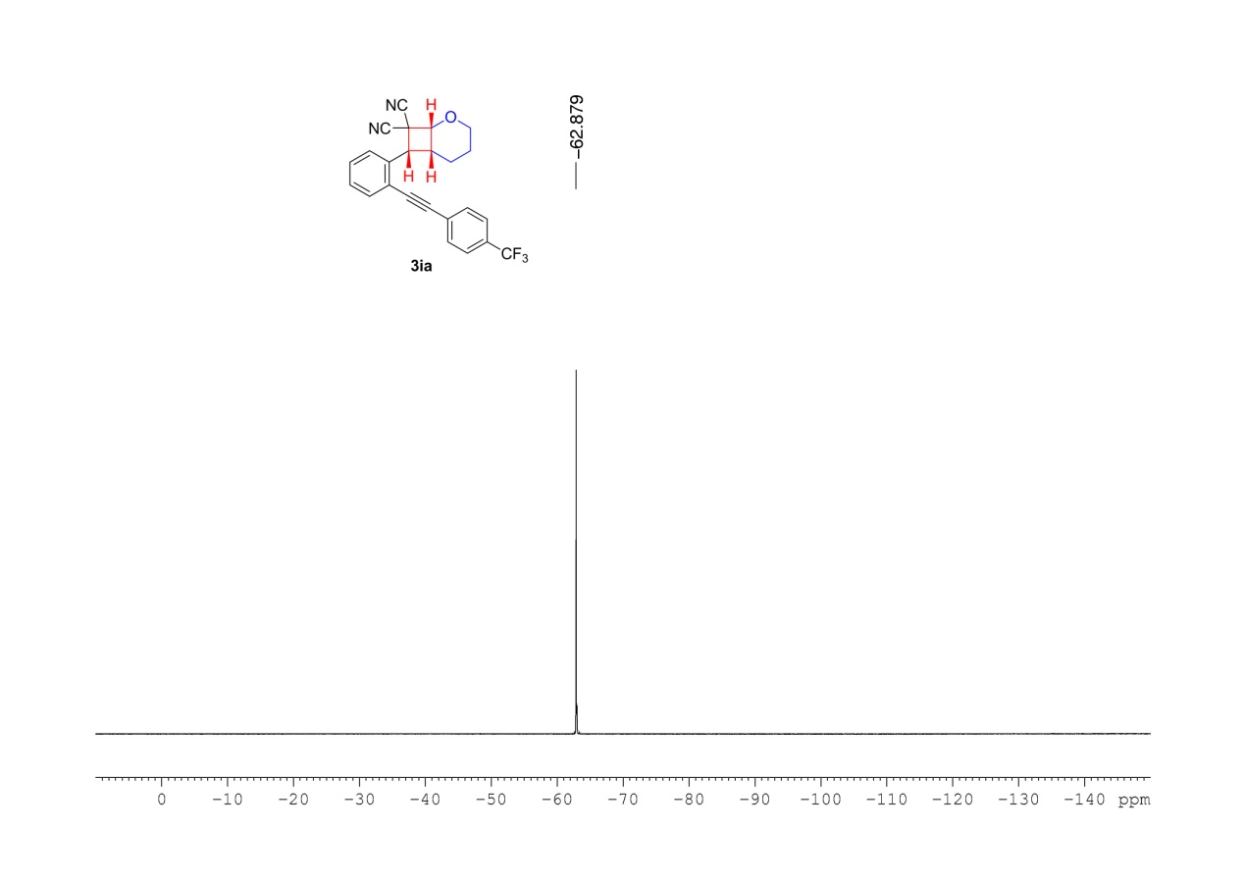
Supplementary Figure 26. ¹⁹F NMR (376 MHz, CDCl3) spectrum of 3ia

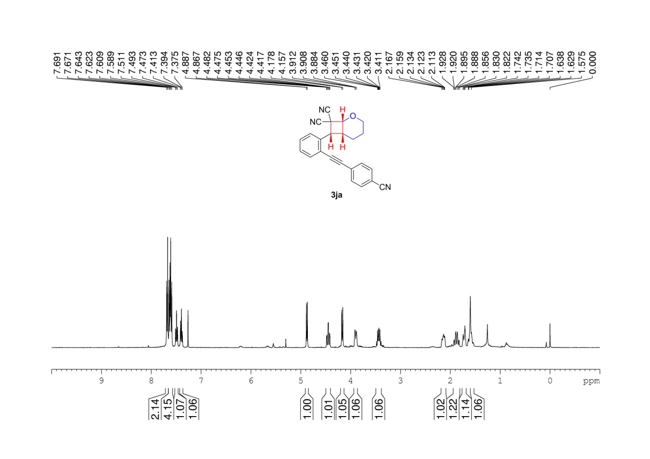
Supplementary Figure 27. ¹H NMR (400 MHz, CDCl3) spectrum of 3ja

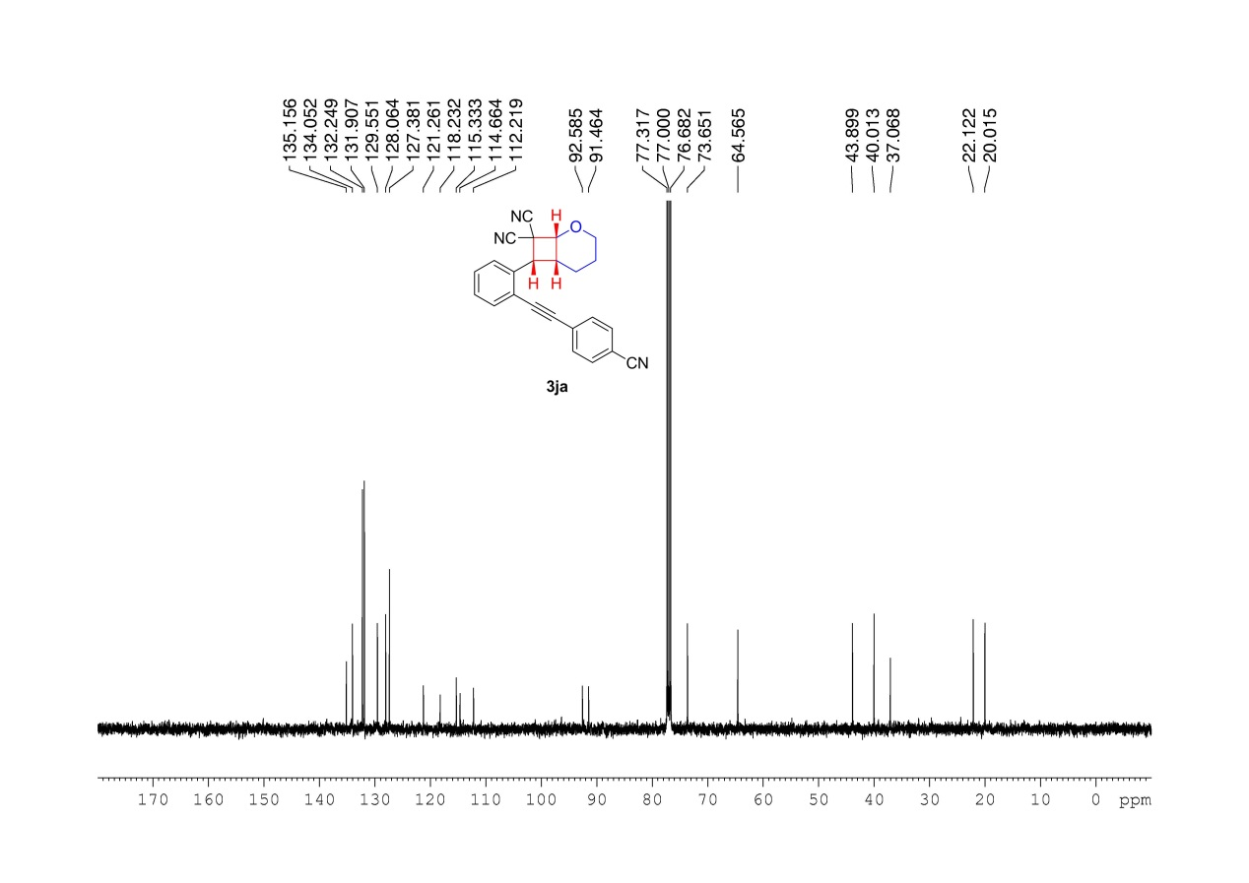
Supplementary Figure 28. ¹³C NMR (100 MHz, CDCl3) spectrum of 3ja

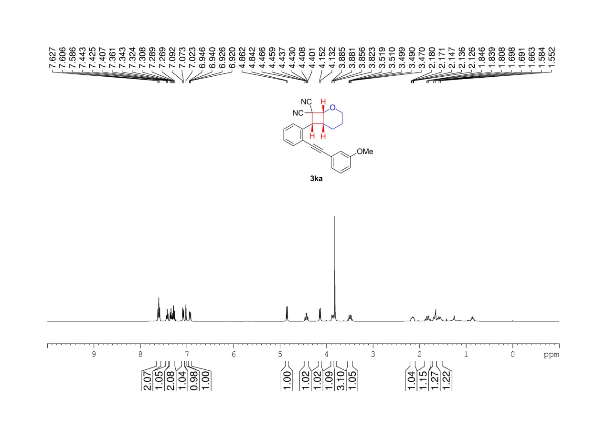
Supplementary Figure 29. ¹H NMR (400 MHz, CDCl3) spectrum of 3ka

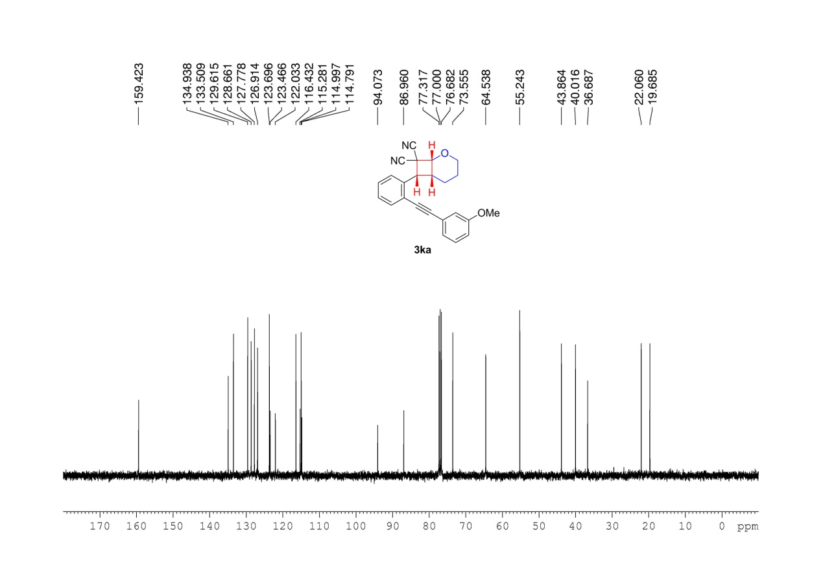
Supplementary Figure 30. ¹³C NMR (100 MHz, CDCl3) spectrum of 3ka

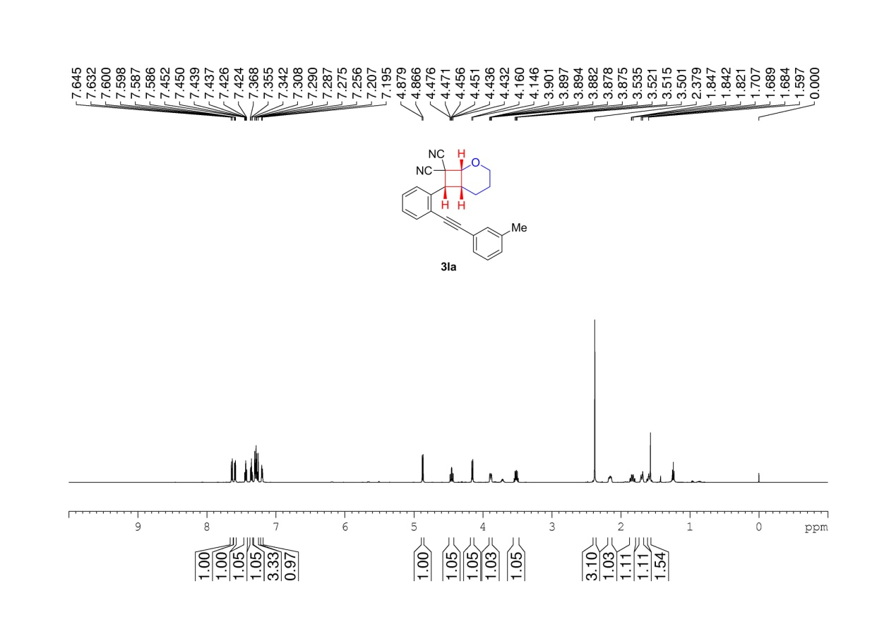
Supplementary Figure 31. ¹H NMR (600 MHz, CDCl3) spectrum of 3la

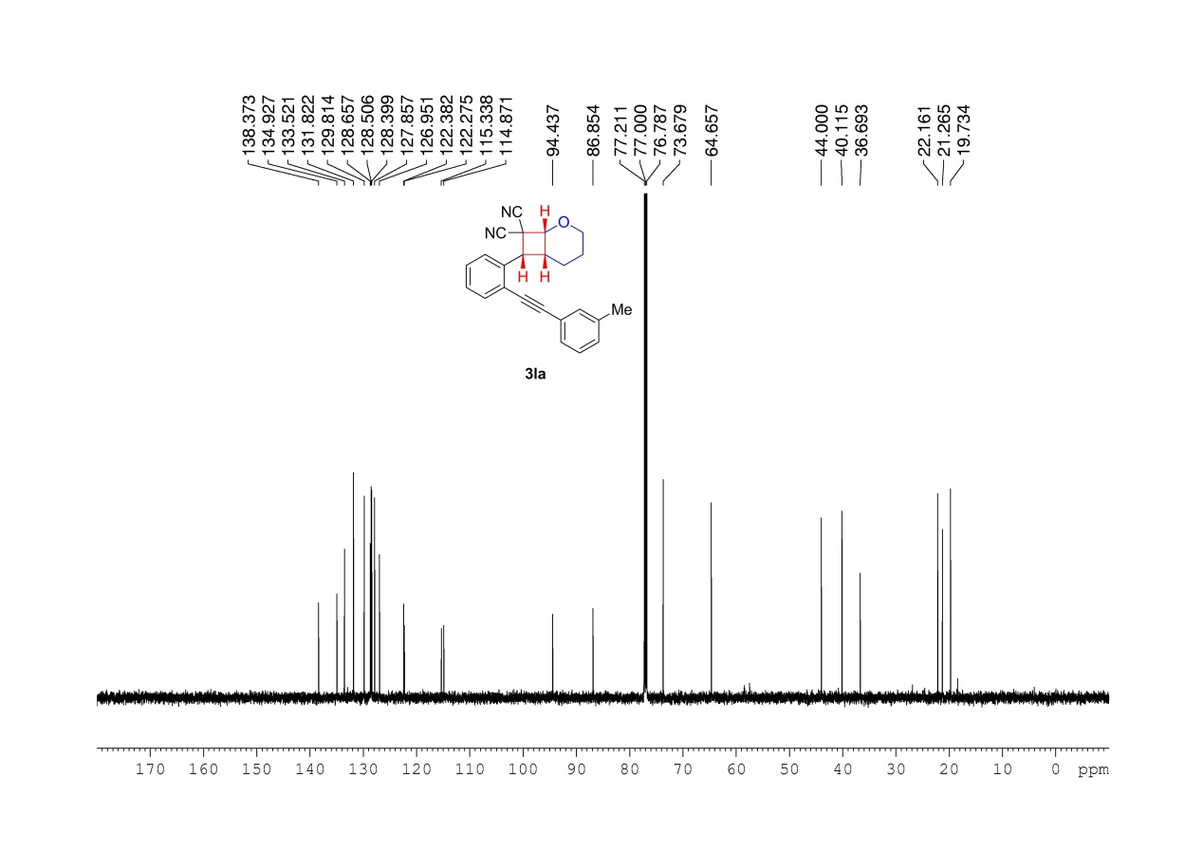
Supplementary Figure 32. ¹³C NMR (150 MHz, CDCl3) spectrum of 3la

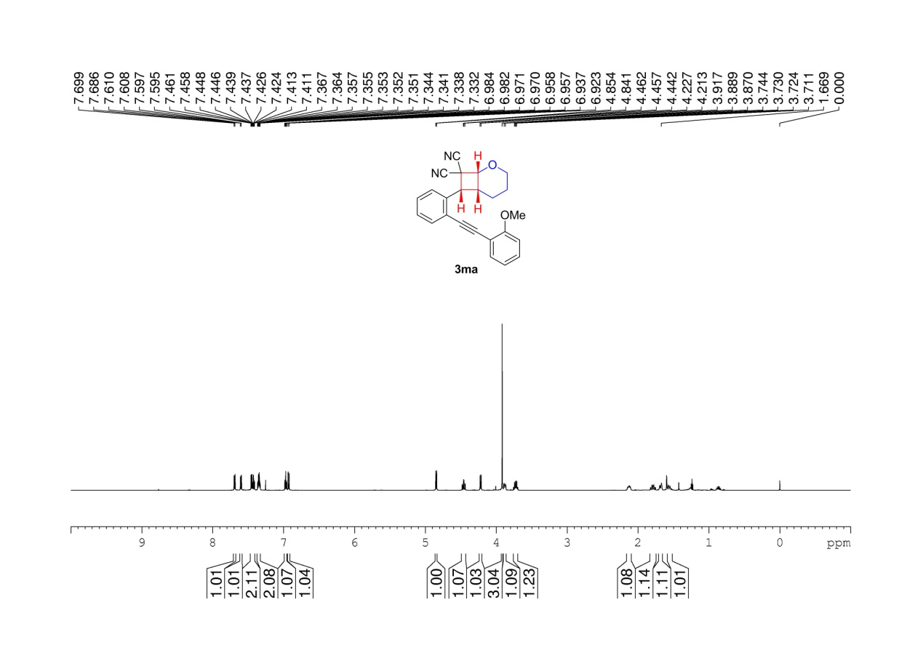
Supplementary Figure 33. ¹H NMR (600 MHz, CDCl3) spectrum of 3ma

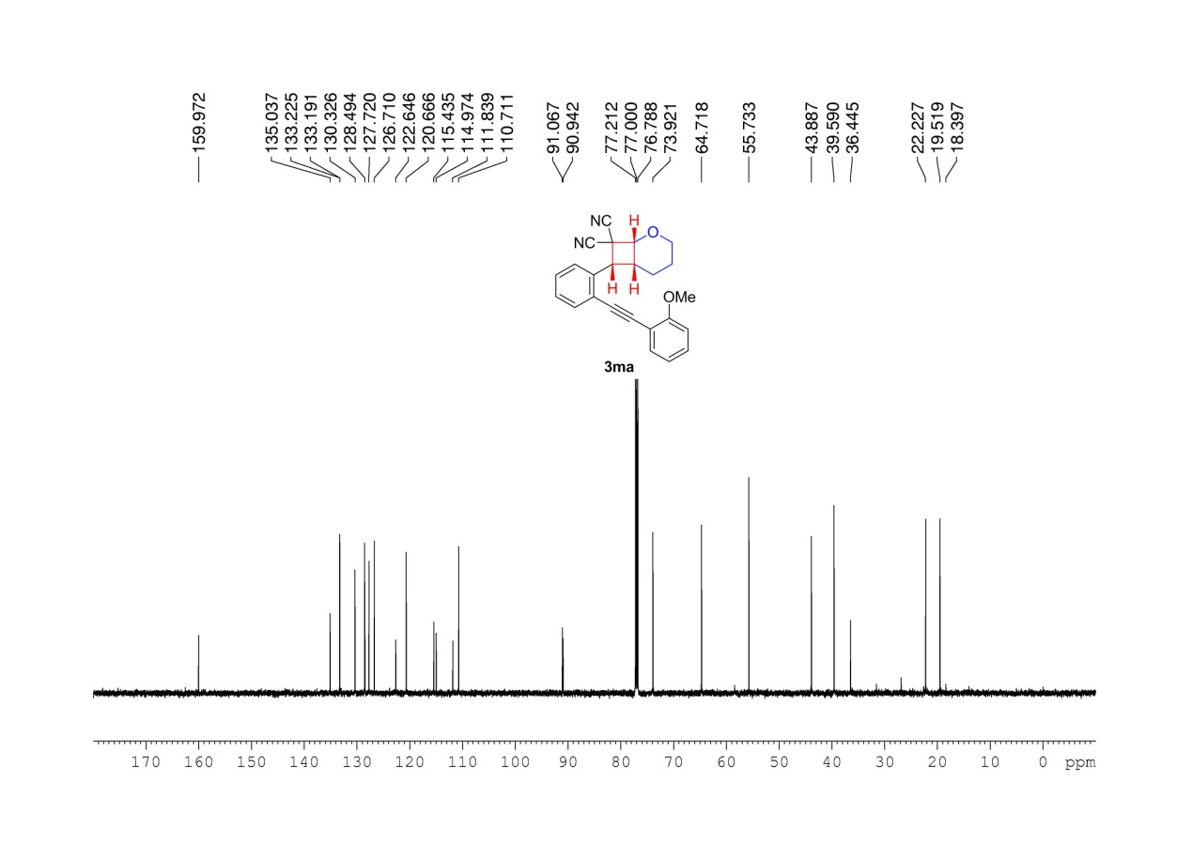
Supplementary Figure 34. ¹³C NMR (150 MHz, CDCl3) spectrum of 3ma

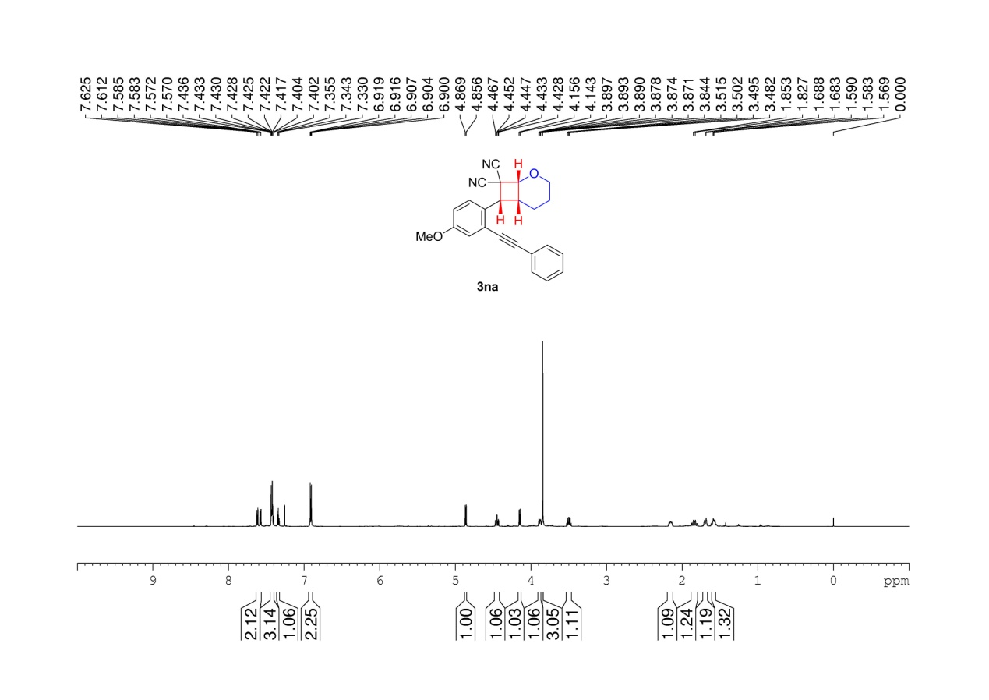
Supplementary Figure 35. ¹H NMR (600 MHz, CDCl3) spectrum of 3na

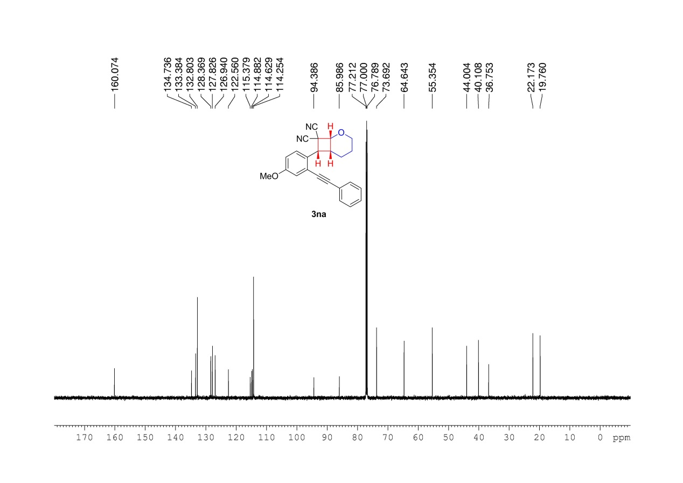
Supplementary Figure 36. ¹³C NMR (150 MHz, CDCl3) spectrum of 3na

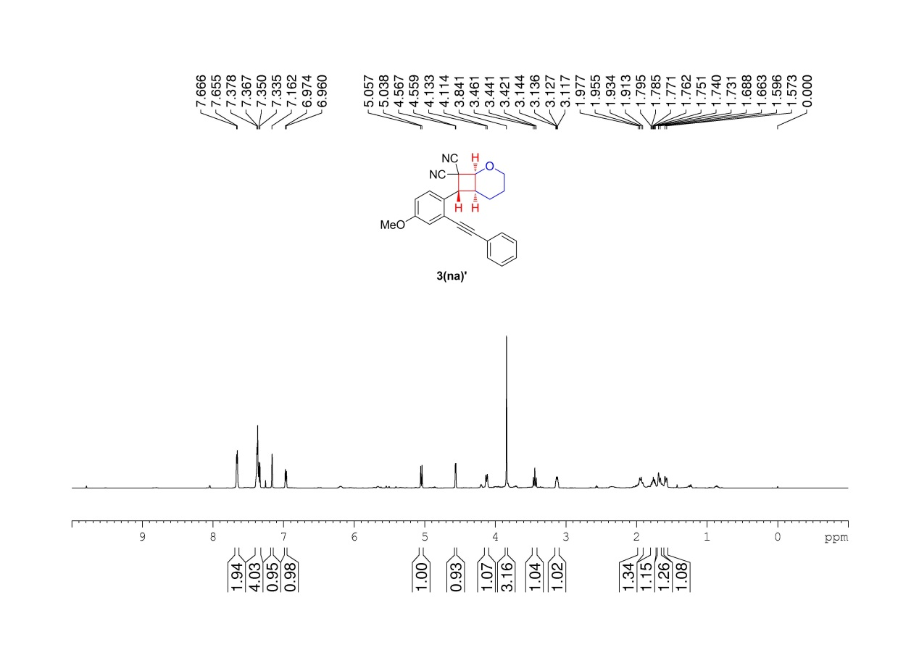
Supplementary Figure 37. ¹H NMR (600 MHz, CDCl3) spectrum of 3(na)’

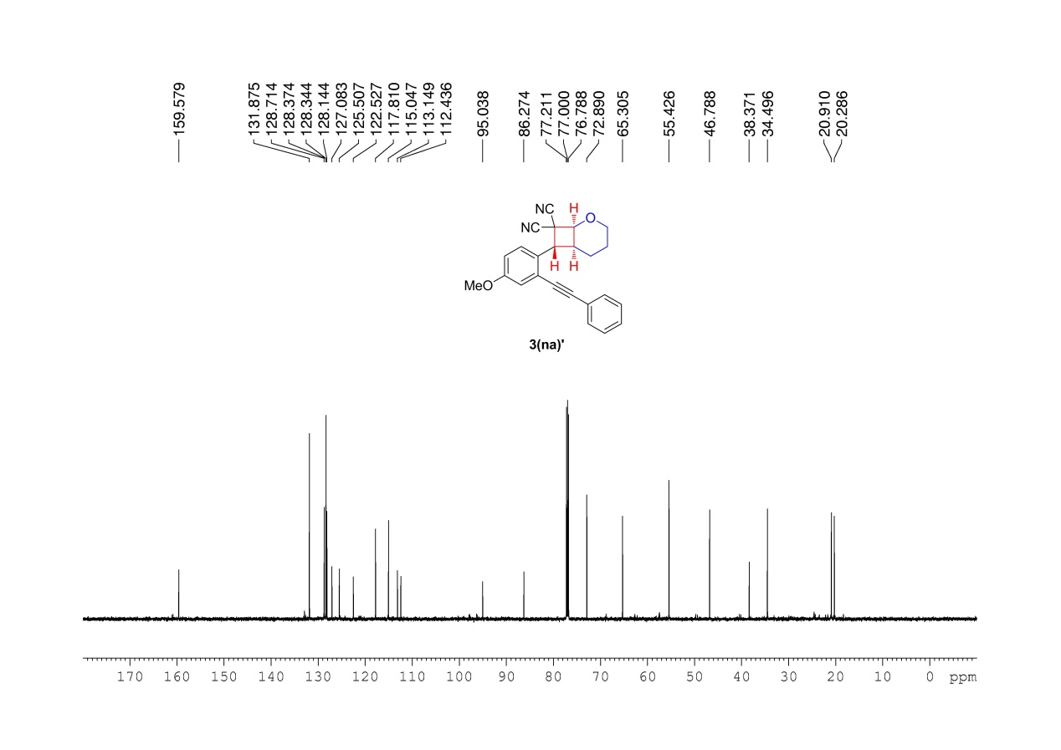
Supplementary Figure 38. ¹³C NMR (150 MHz, CDCl3) spectrum of 3(na)’

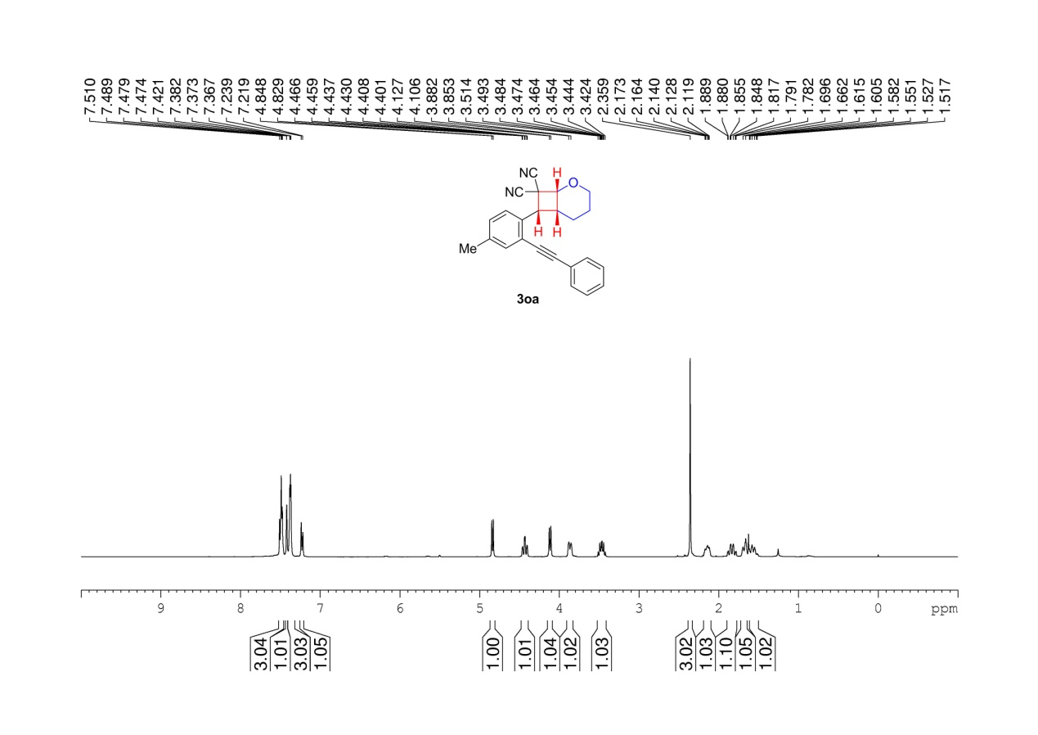
Supplementary Figure 39. ¹H NMR (400 MHz, CDCl3) spectrum of 3oa

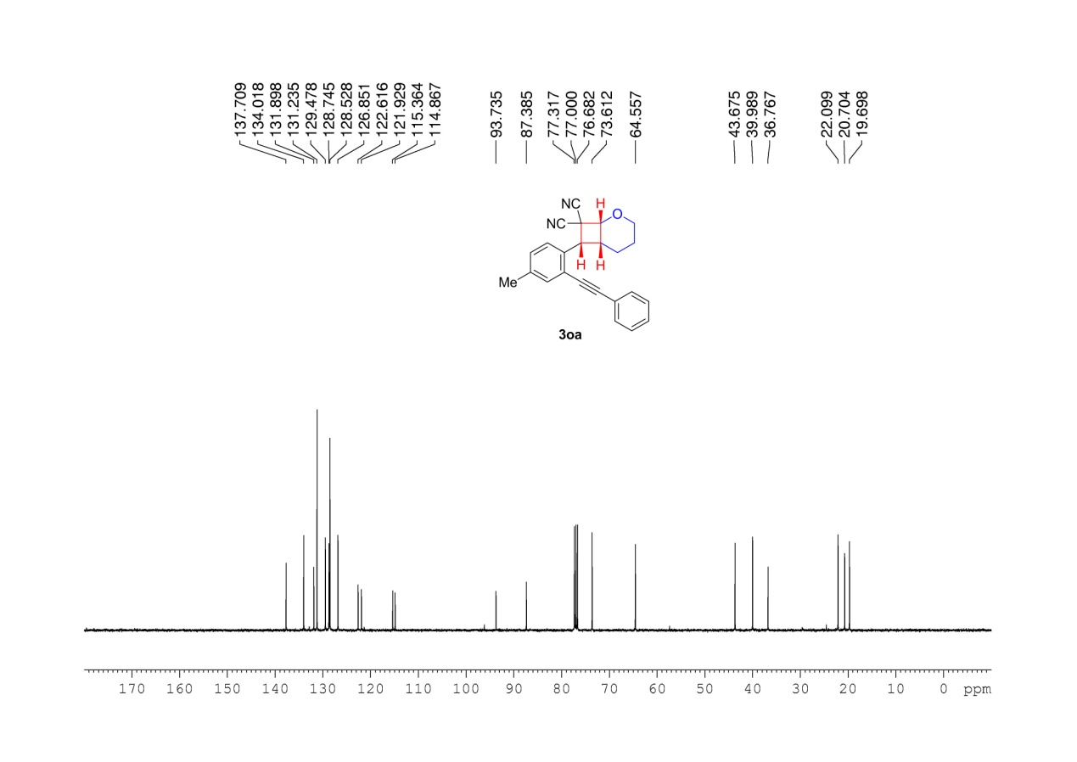
Supplementary Figure 40. ¹³C NMR (100 MHz, CDCl3) spectrum of 3oa

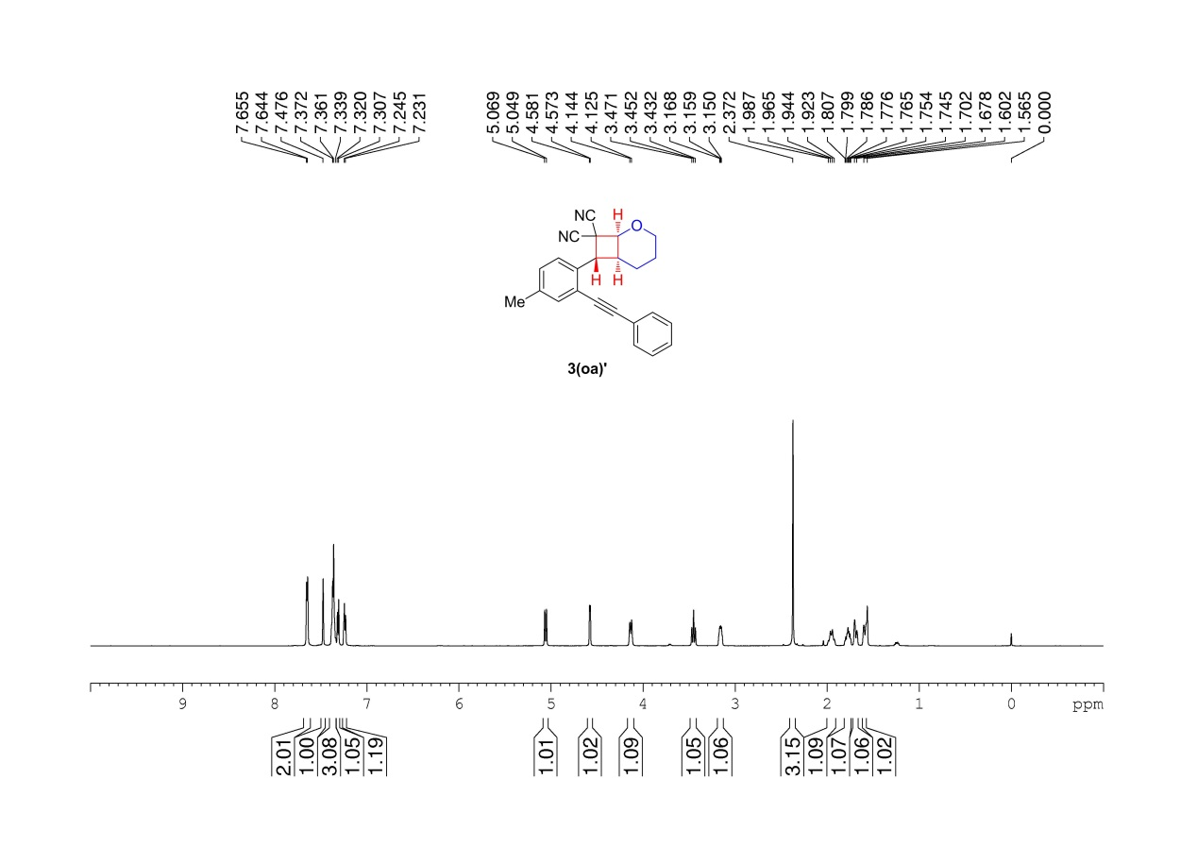
Supplementary Figure 41. ¹H NMR (600 MHz, CDCl3) spectrum of 3(oa)’

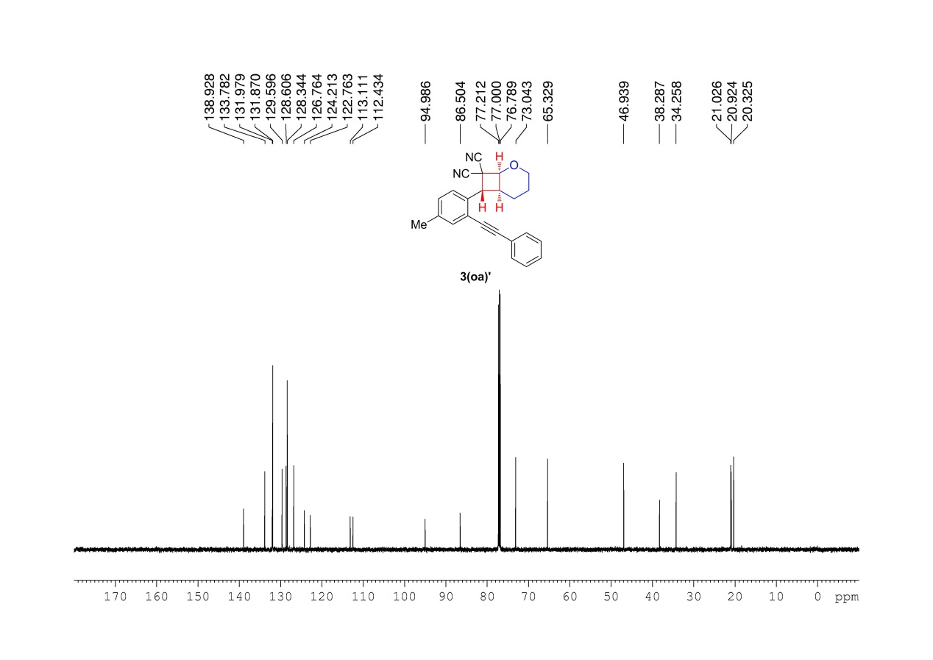
Supplementary Figure 42. ¹³C NMR (150 MHz, CDCl3) spectrum of 3(oa)’

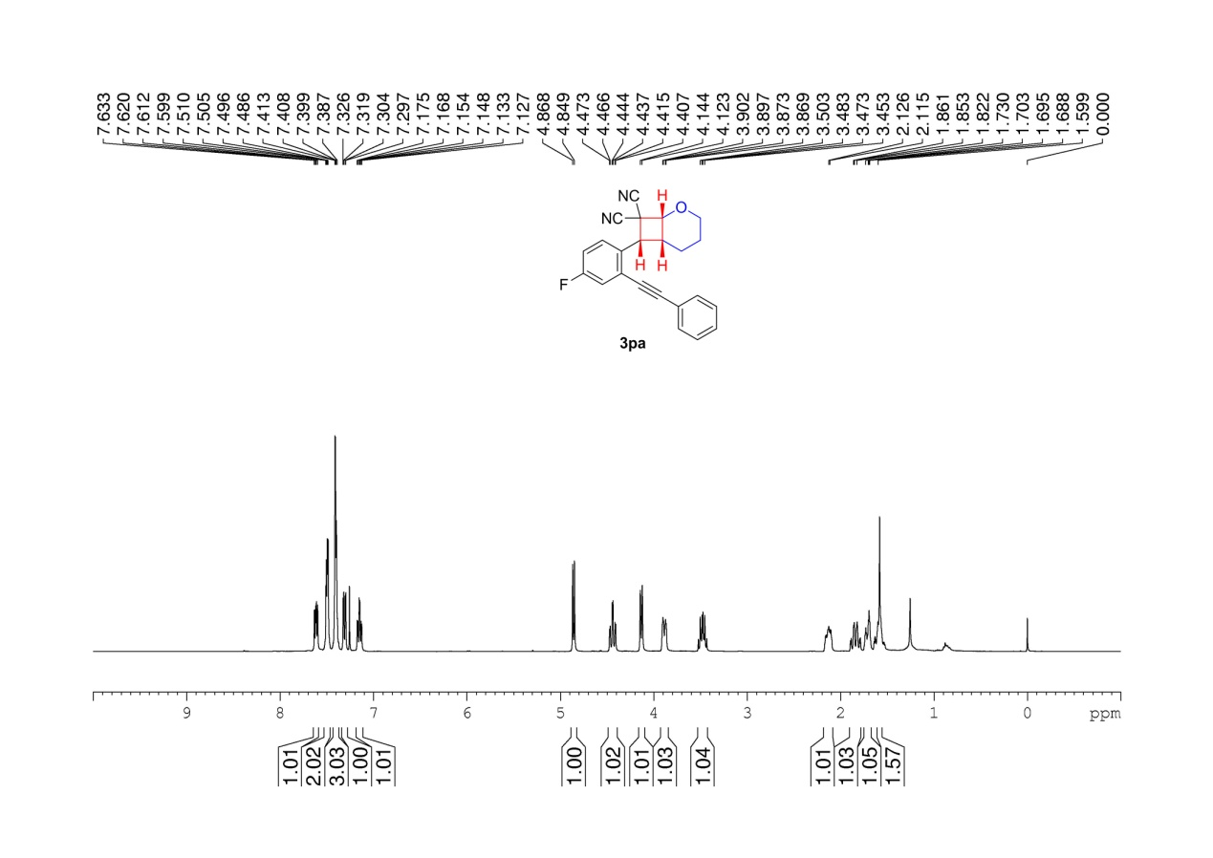
Supplementary Figure 43. ¹H NMR (400 MHz, CDCl3 ) spectrum of 3pa

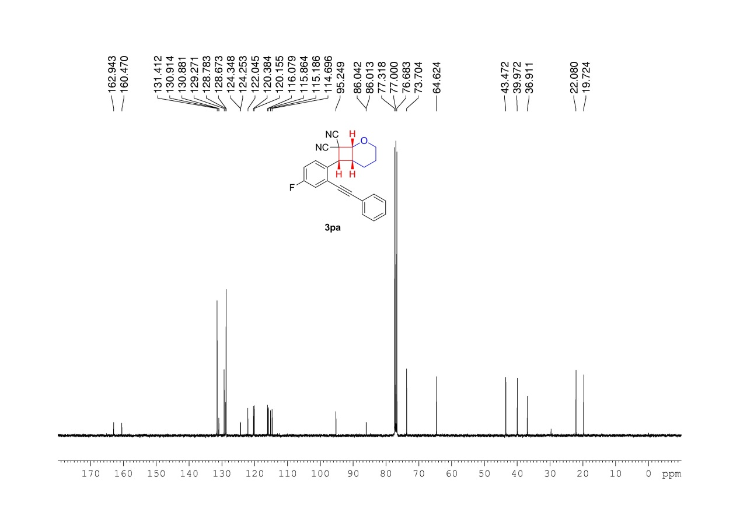
Supplementary Figure 44. ¹³C NMR (100 MHz, CDCl3) spectrum of 3pa

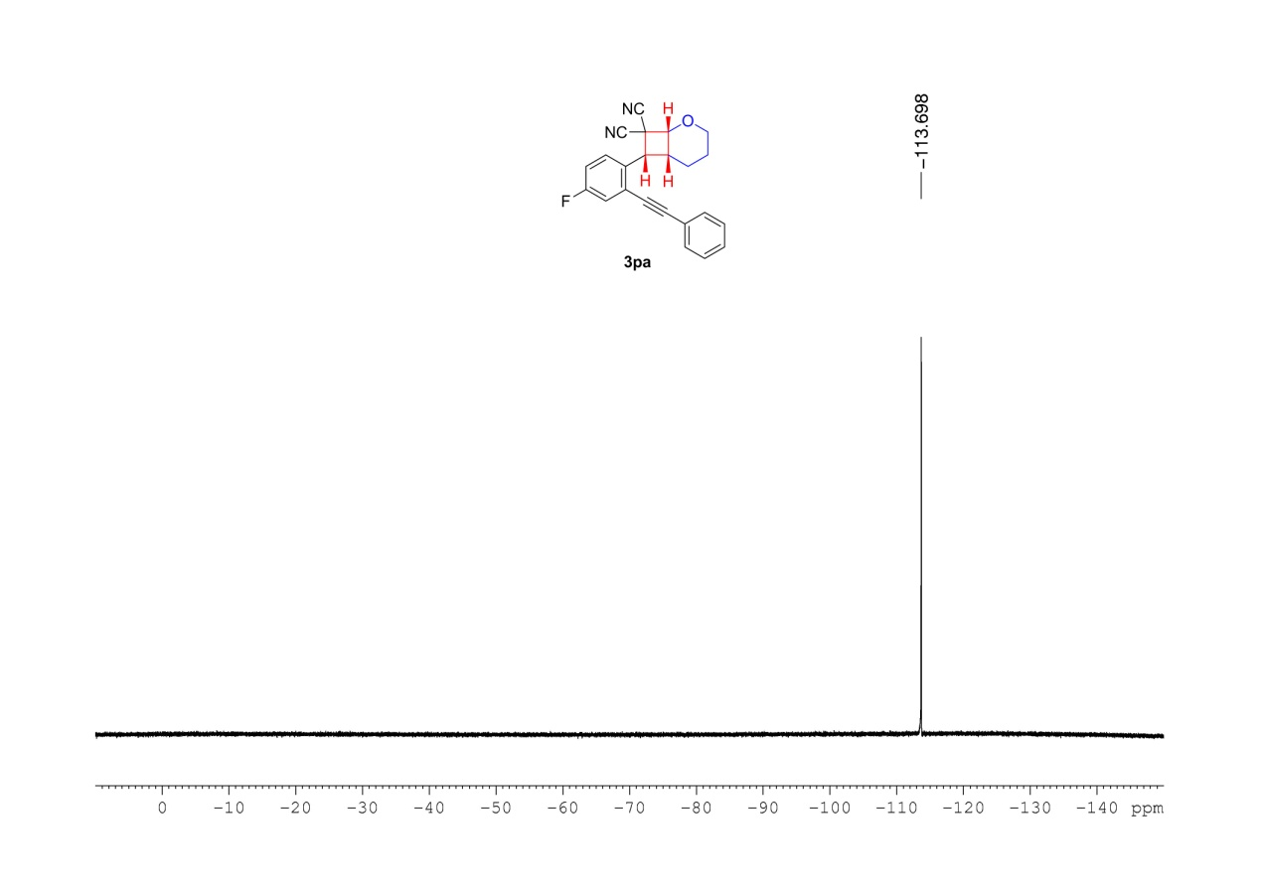
Supplementary Figure 45. ¹⁹F NMR (376 MHz, CDCl3) spectrum of 3pa

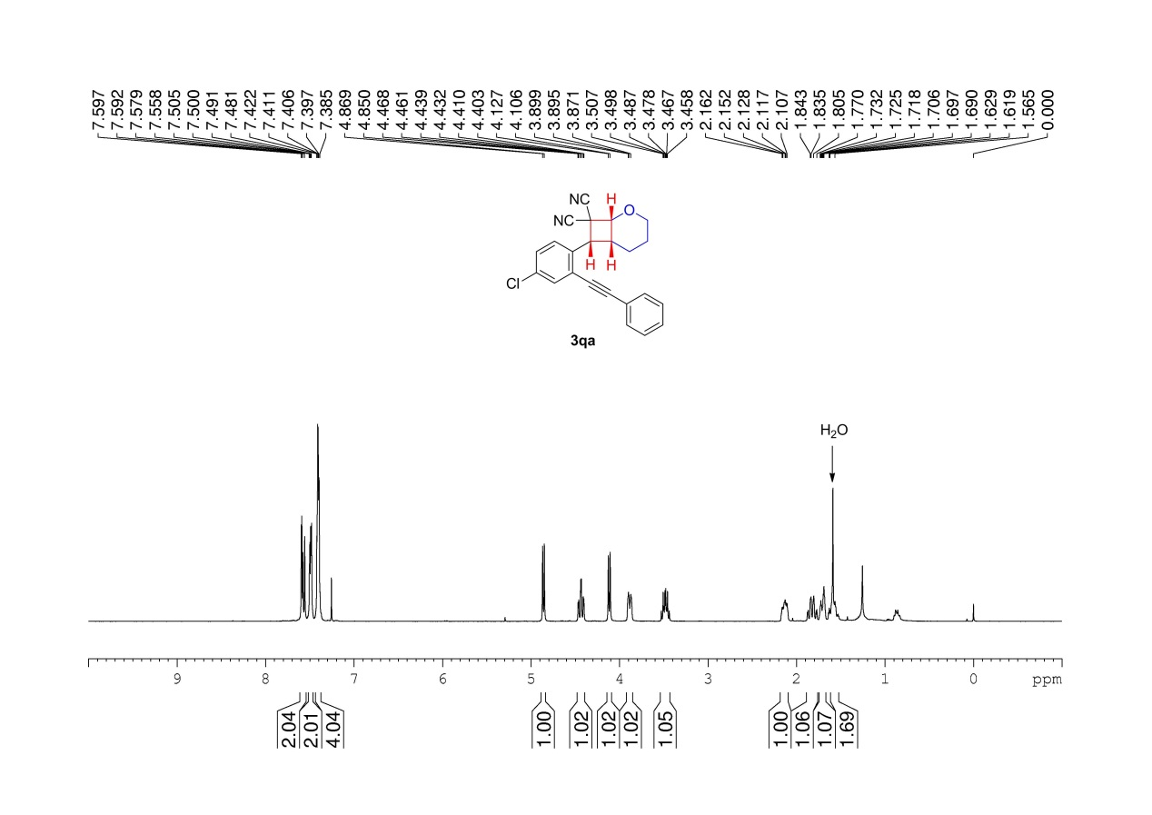
Supplementary Figure 46. ¹H NMR (400 MHz, CDCl3) spectrum of 3qa

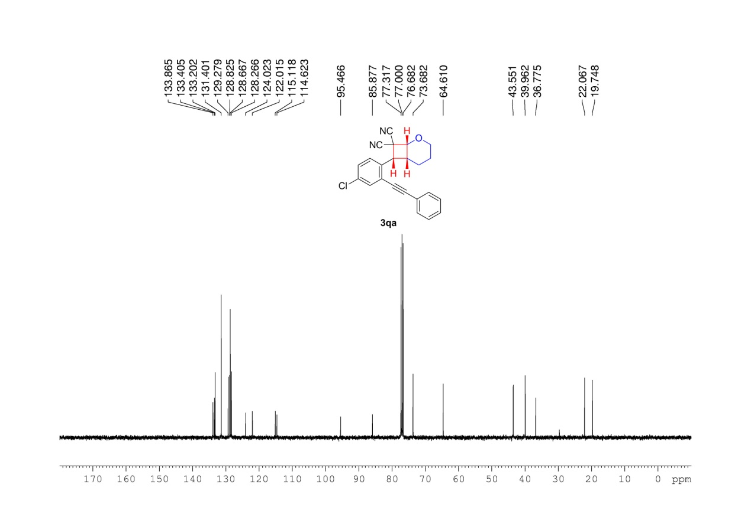
Supplementary Figure 47. ¹³C NMR (100 MHz, CDCl3) spectrum of 3qa

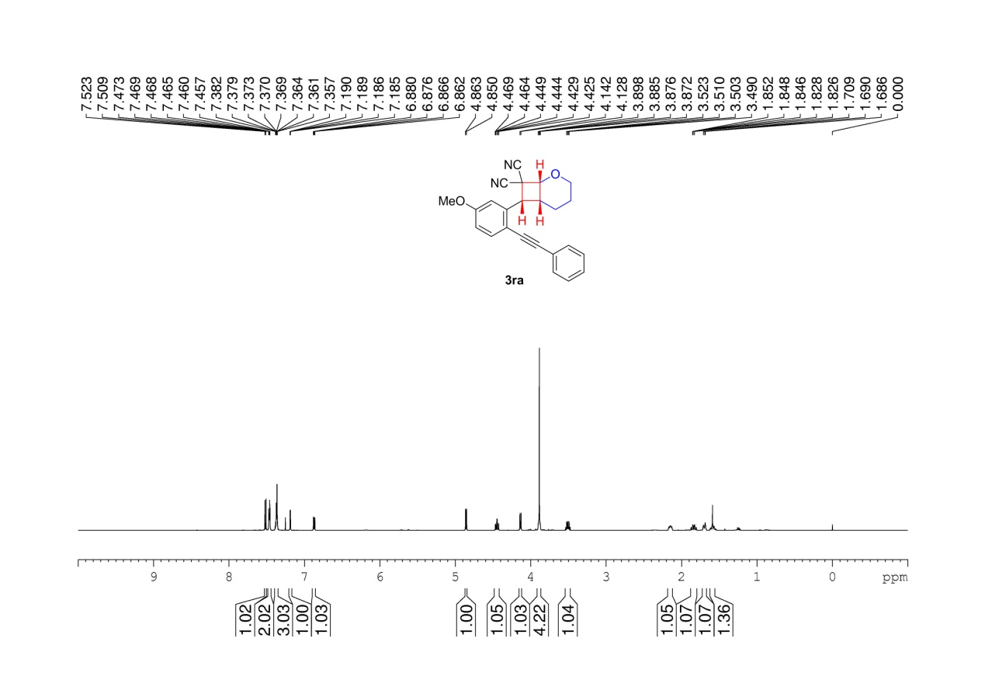
Supplementary Figure 48. ¹H NMR (600 MHz, CDCl3) spectrum of 3ra

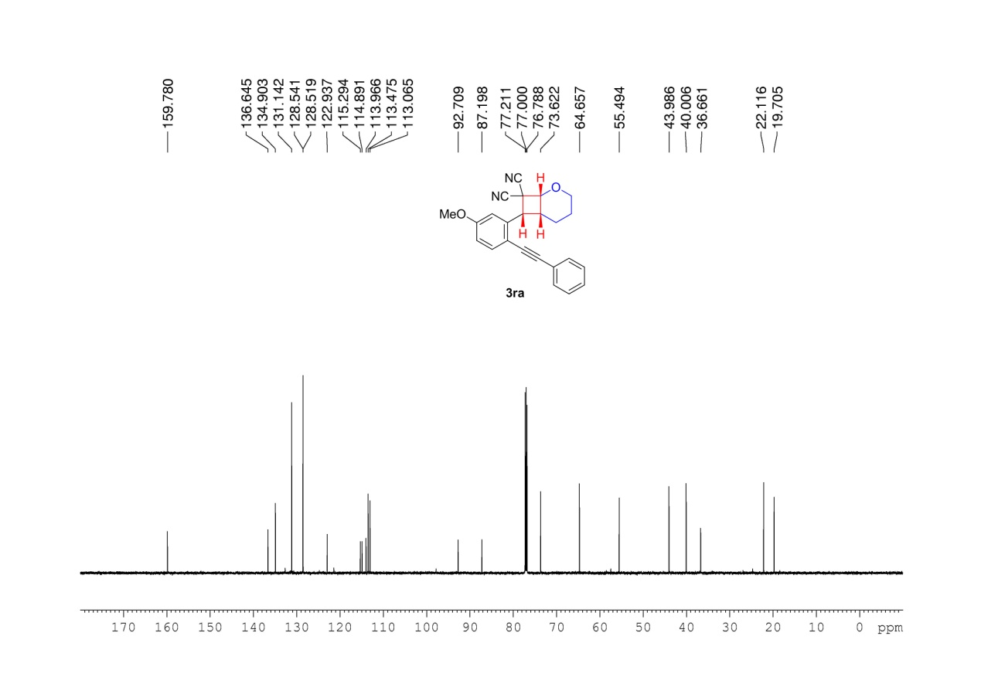
Supplementary Figure 49. ¹³C NMR (150 MHz, CDCl3 ) spectrum of 3ra

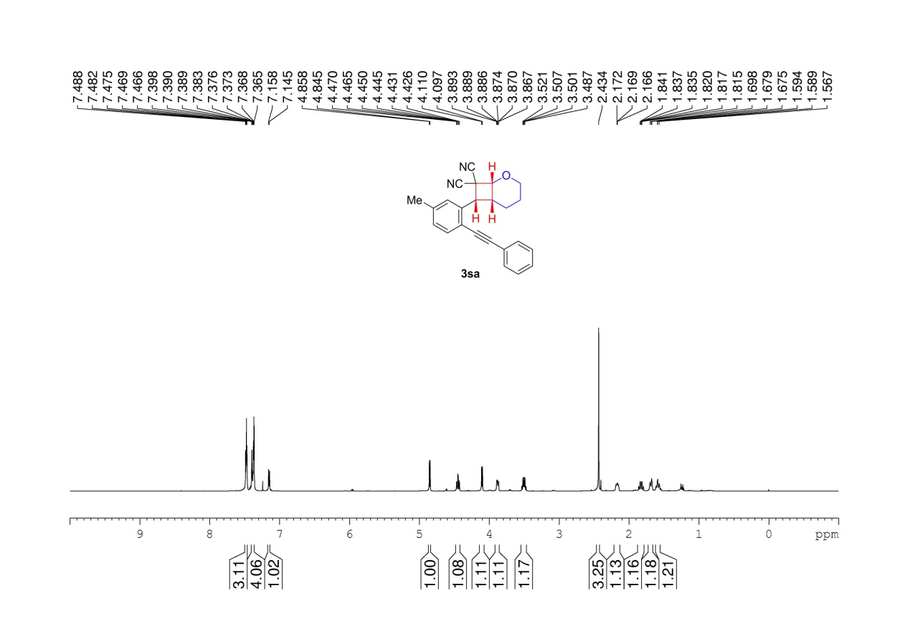
Supplementary Figure 50. ¹H NMR (600 MHz, CDCl3) spectrum of 3sa

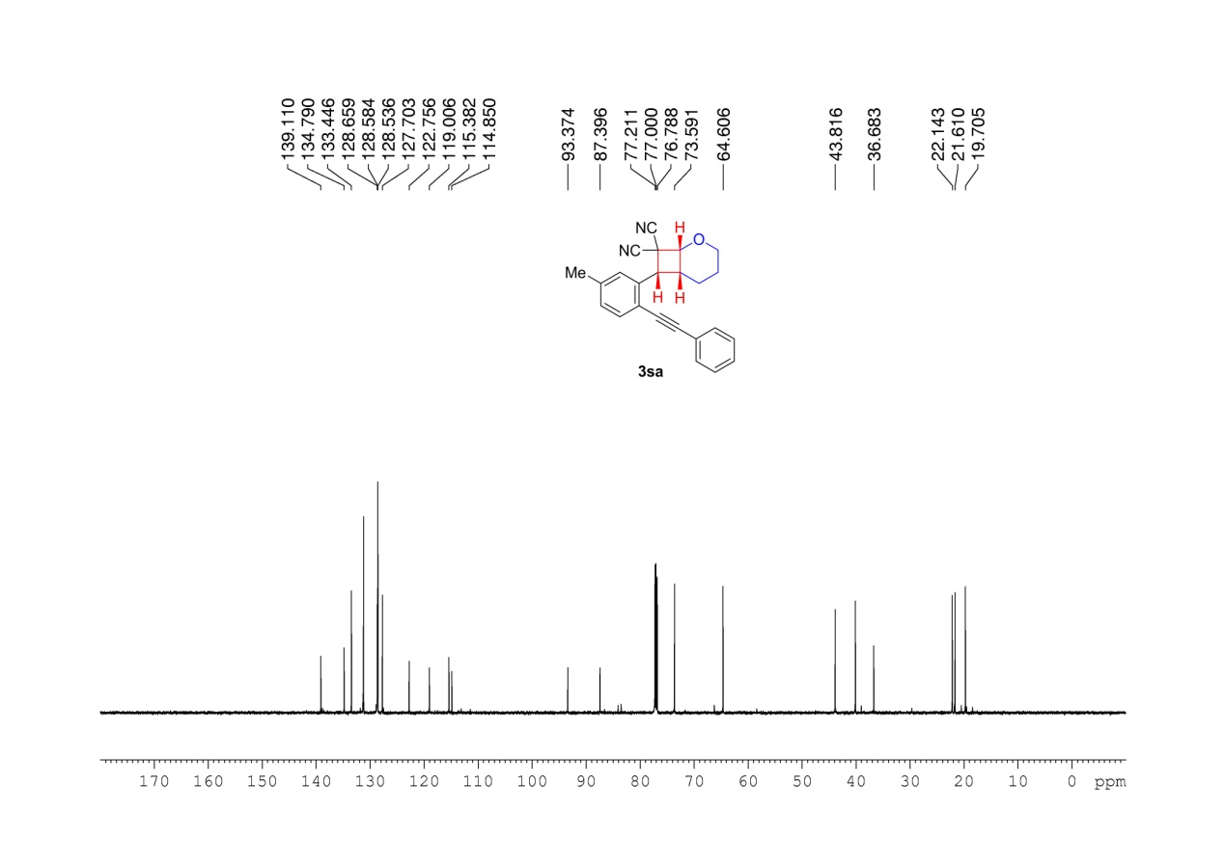
Supplementary Figure 51. ¹³C NMR (150 MHz, CDCl3) spectrum of 3sa

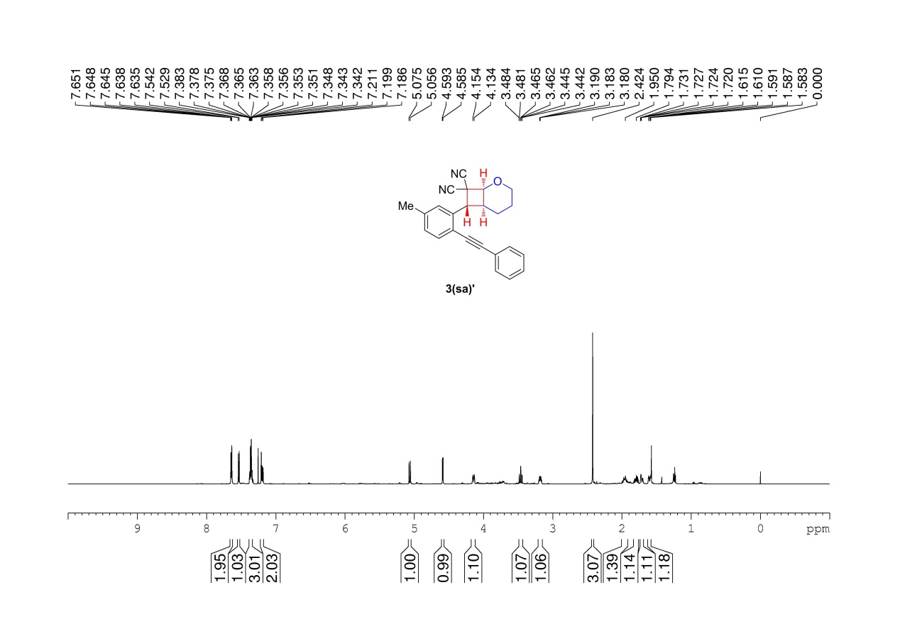
Supplementary Figure 52. ¹H NMR (600 MHz, CDCl3) spectrum of 3(sa)’

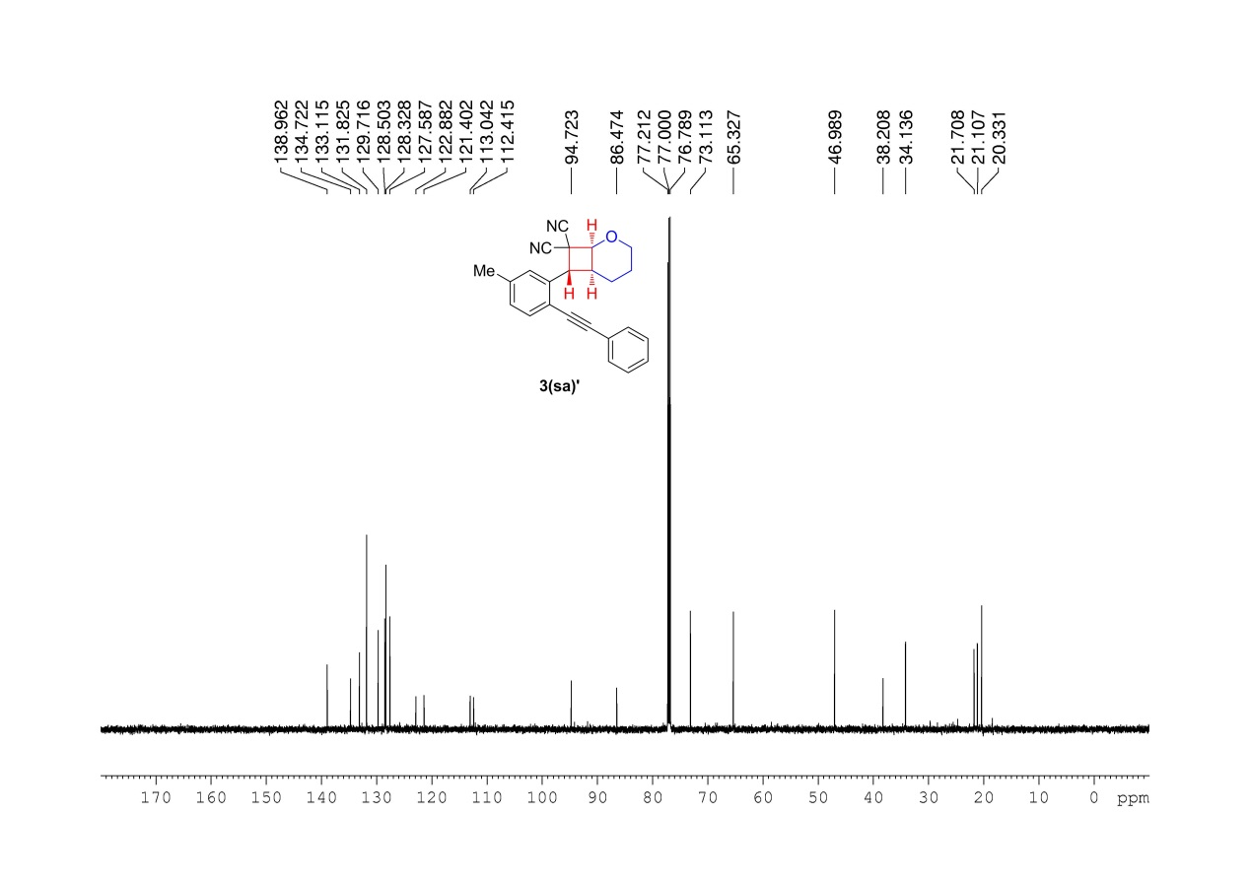
Supplementary Figure 53. ¹³C NMR (150 MHz, CDCl3) spectrum of 3(sa)’

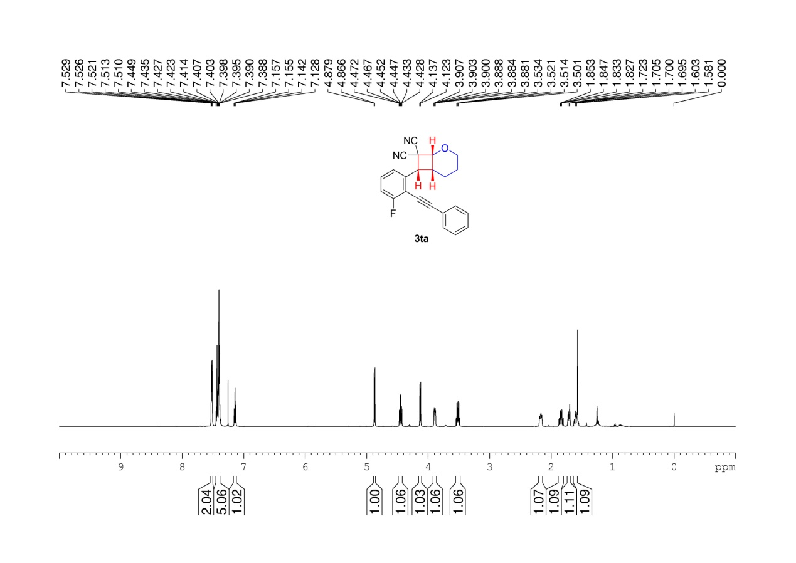
Supplementary Figure 54. ¹H NMR (600 MHz, CDCl3) spectrum of 3ta

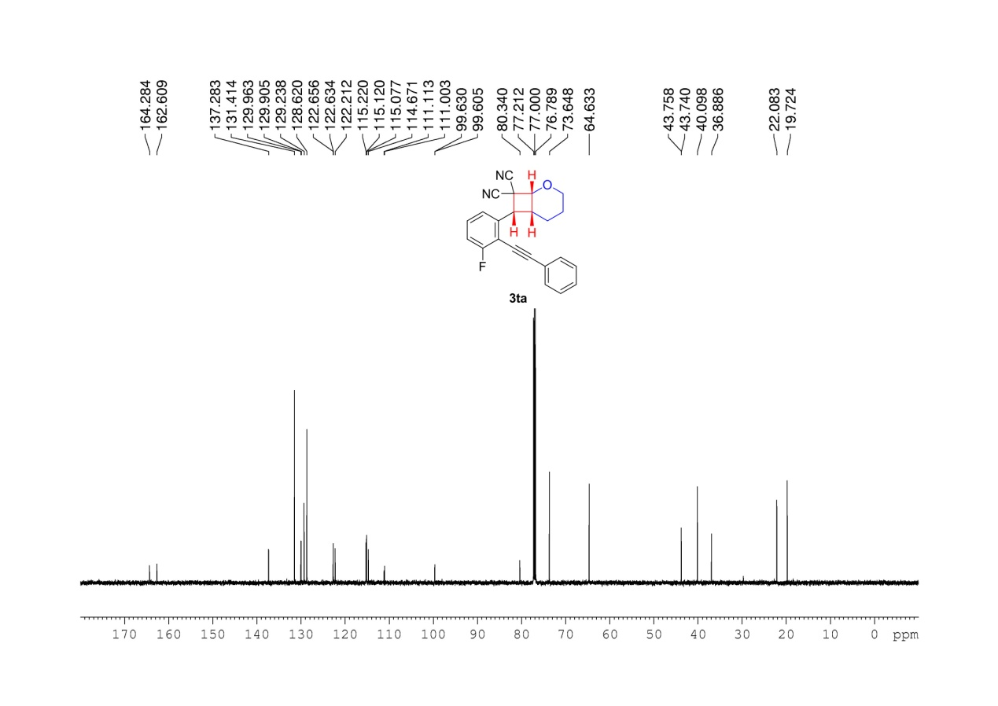
Supplementary Figure 55. ¹³C NMR (150 MHz, CDCl3) spectrum of 3ta

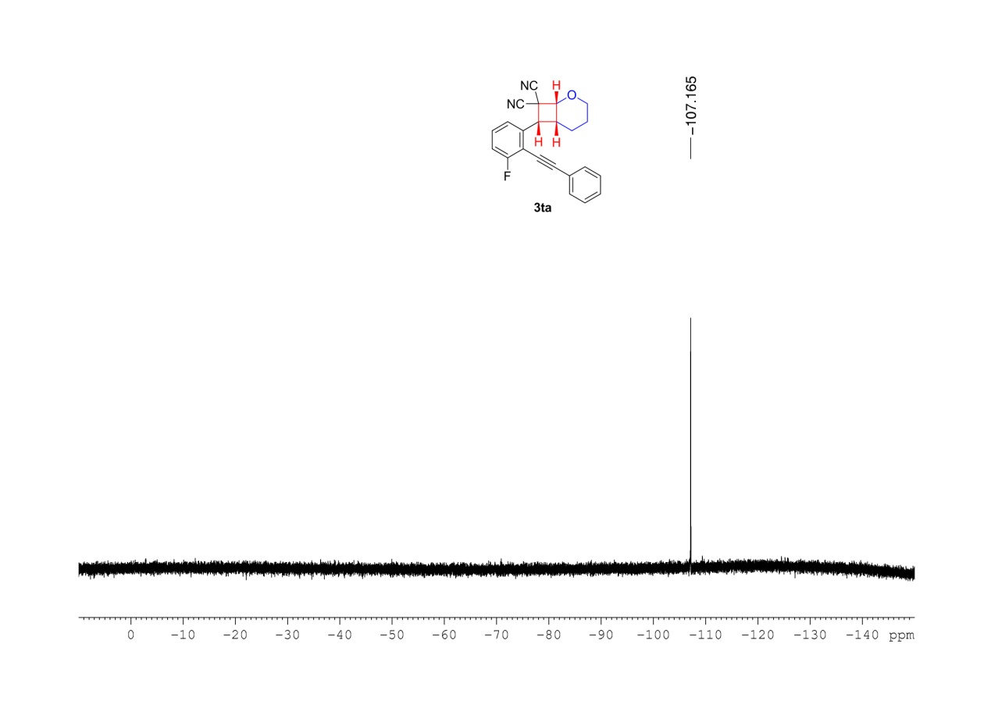
Supplementary Figure 56. ¹⁹F NMR (376MHz, CDCl3) spectrum of 3ta

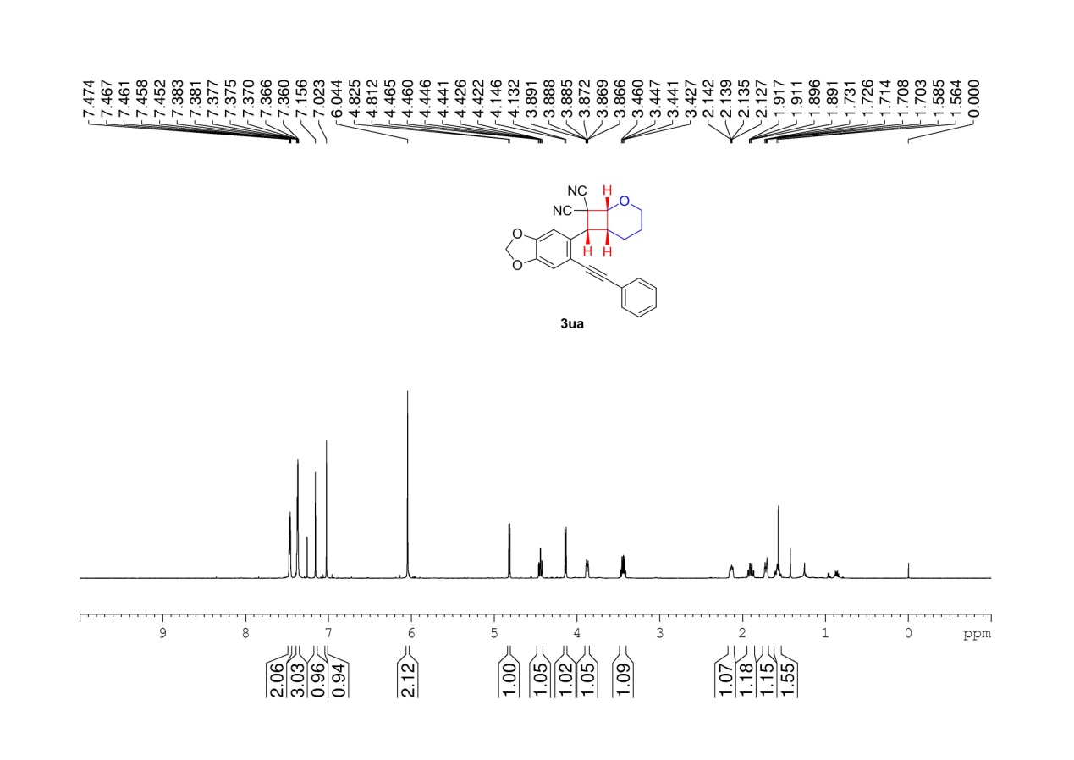
Supplementary Figure 57. ¹H NMR (600 MHz, CDCl3 ) spectrum of 3ua

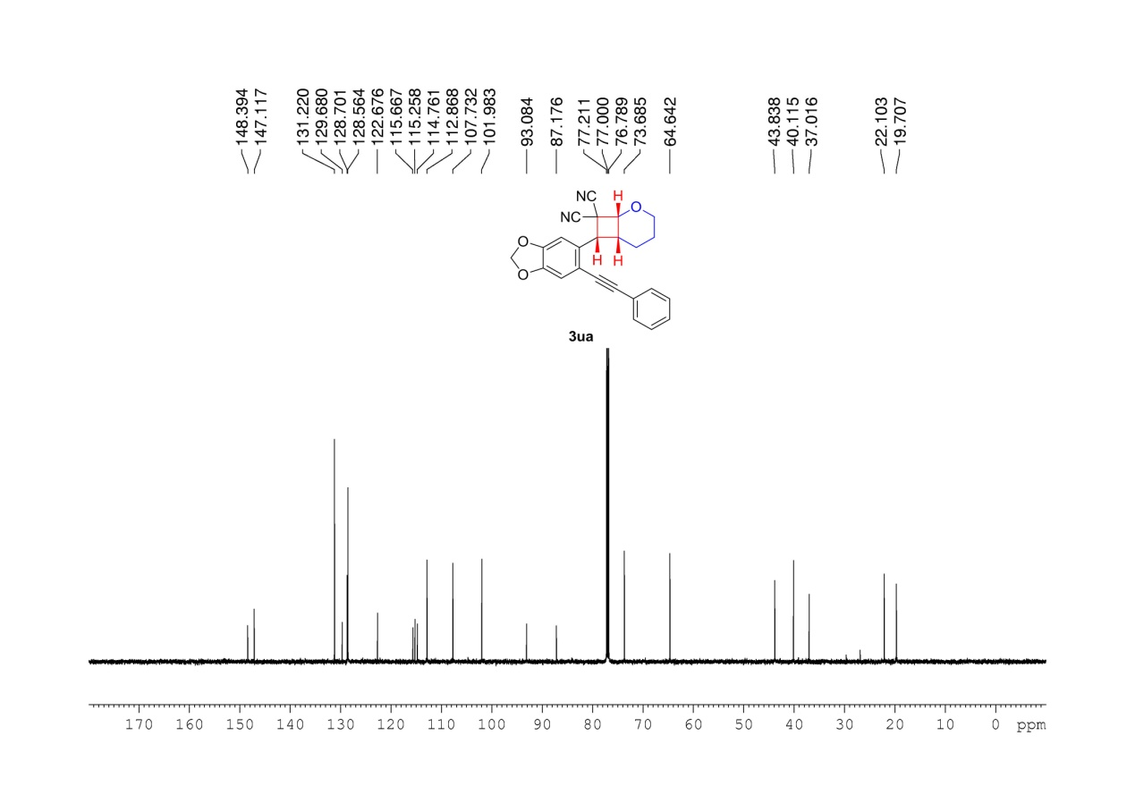
Supplementary Figure 58. ¹³C NMR (150 MHz, CDCl3 ) spectrum of 3ua

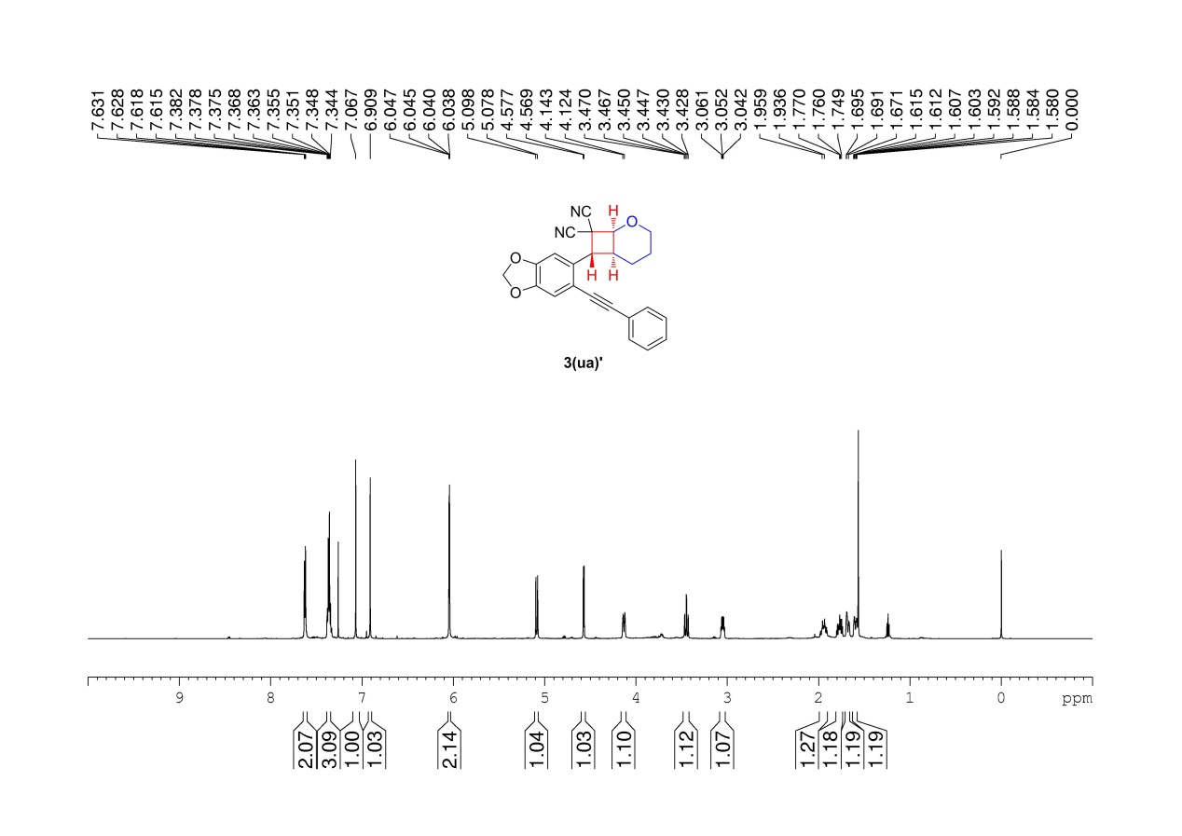
Supplementary Figure 59. ¹H NMR (600 MHz, CDCl₃) spectrum of 3(ua)’

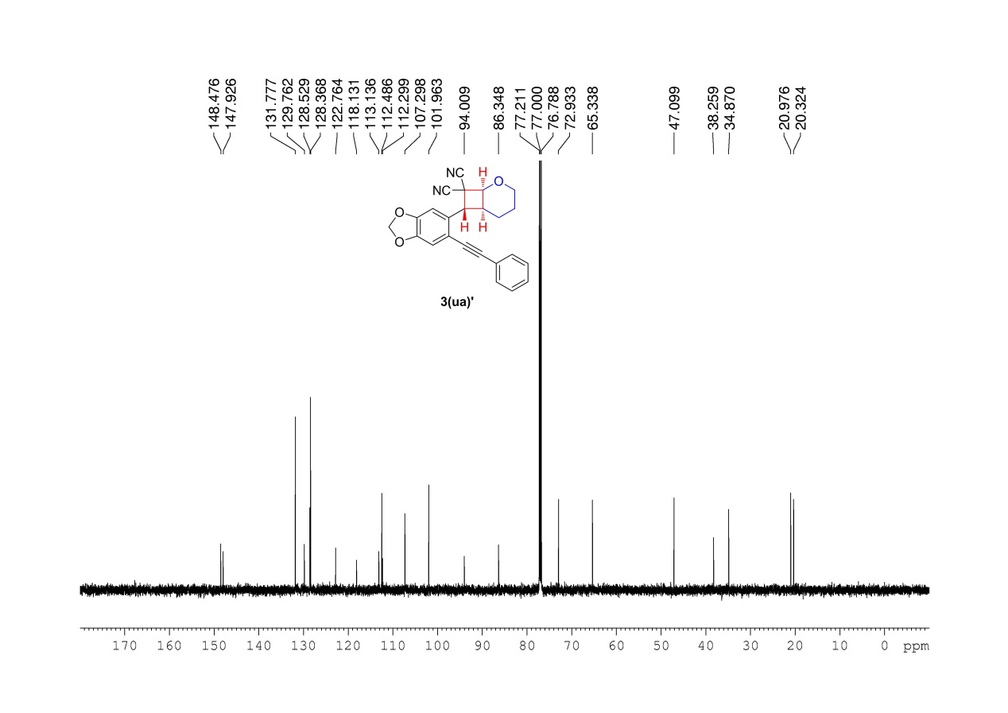
Supplementary Figure 60. ¹³C NMR (150MHz, CDCl₃) spectrum of 3(ua)’

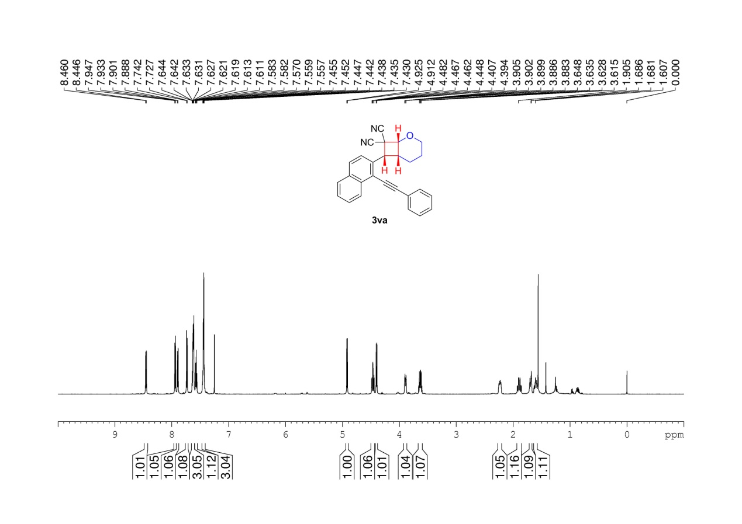
Supplementary Figure 61. ¹H NMR (600 MHz, CDCl₃) spectrum of 3va

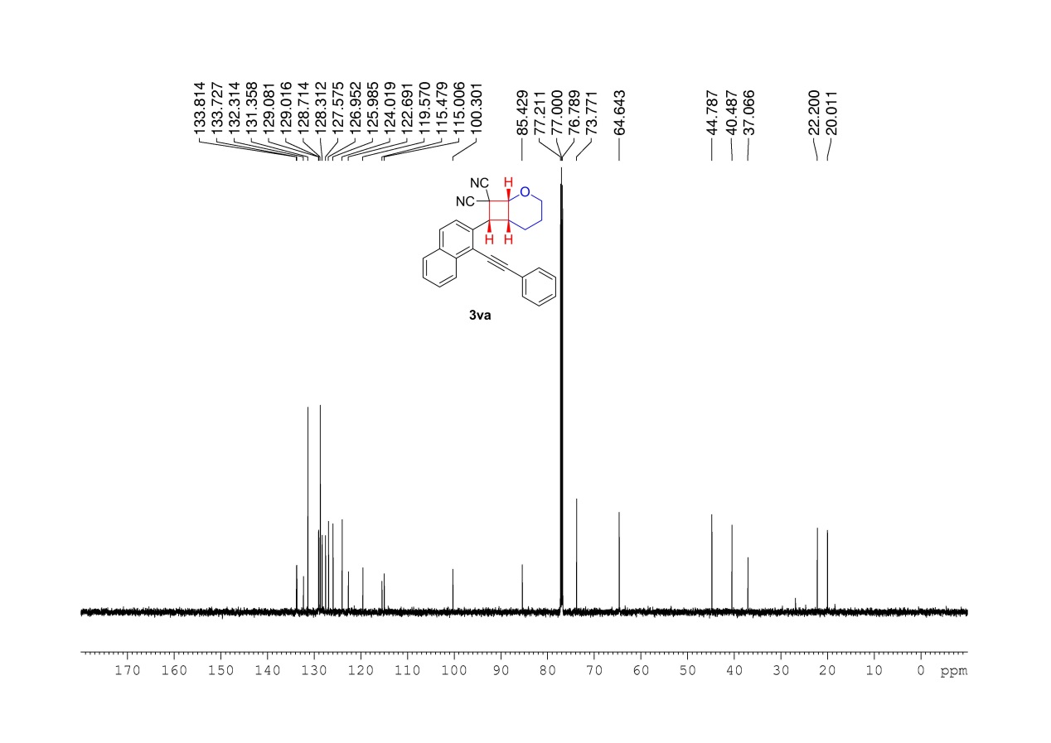
Supplementary Figure 62. ¹³C NMR (150MHz, CDCl₃) spectrum of 3va

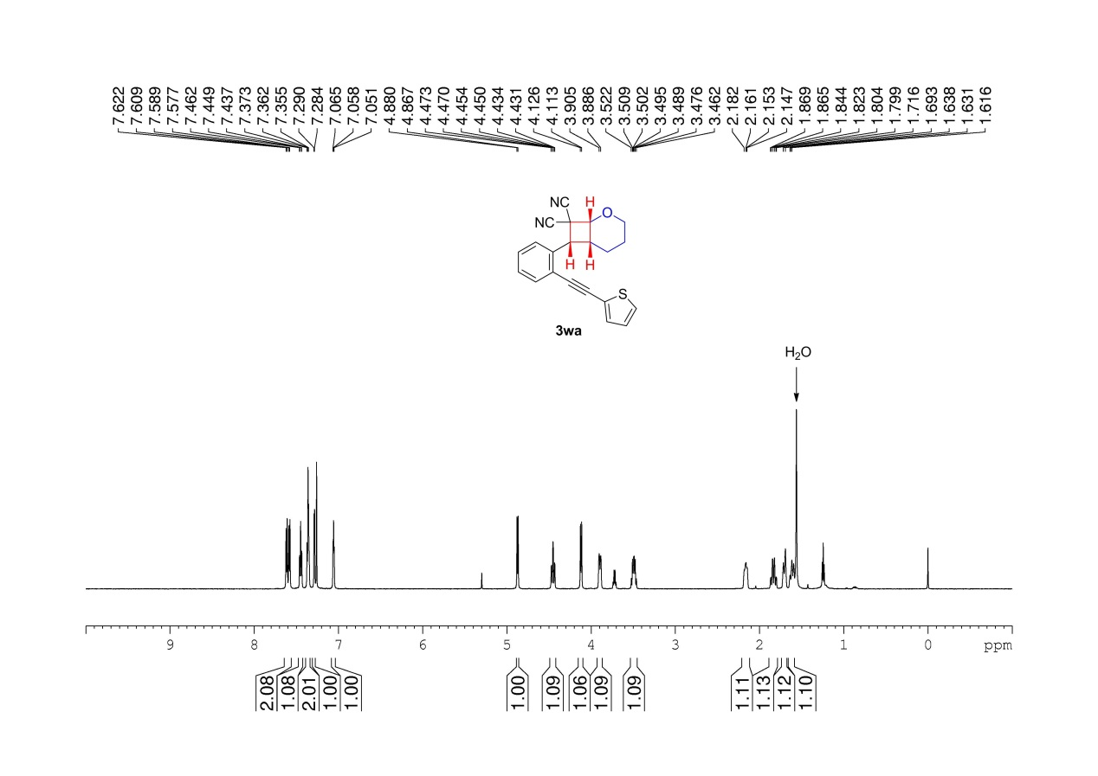
Supplementary Figure 63. ¹H NMR (600 MHz, CDCl₃) spectrum of 3wa

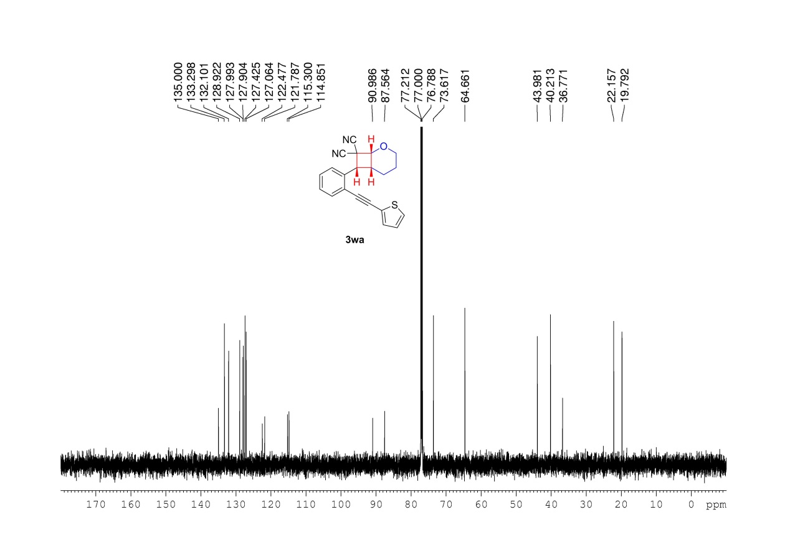
Supplementary Figure 64. ¹³C NMR (150MHz, CDCl₃) spectrum of 3wa

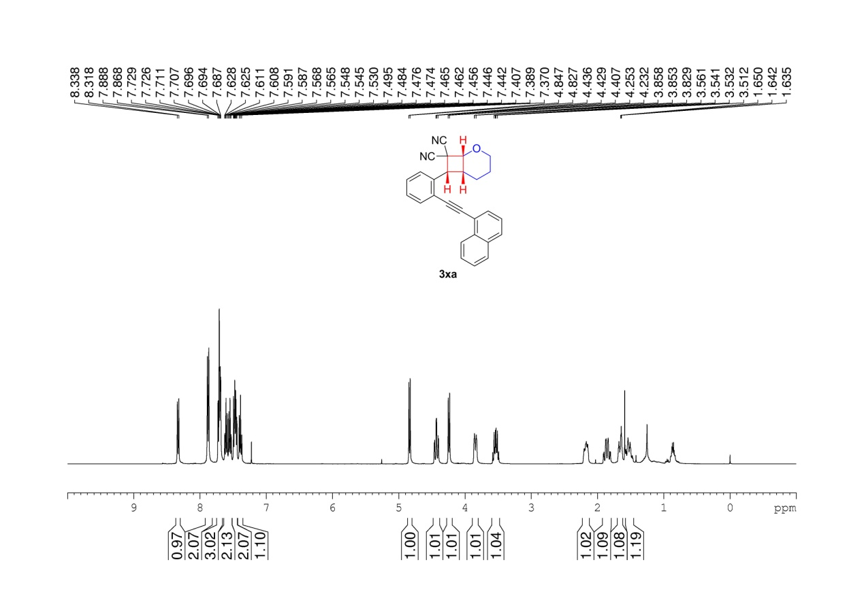
Supplementary Figure 65. ¹H NMR (400 MHz, CDCl₃) spectrum of 3xa

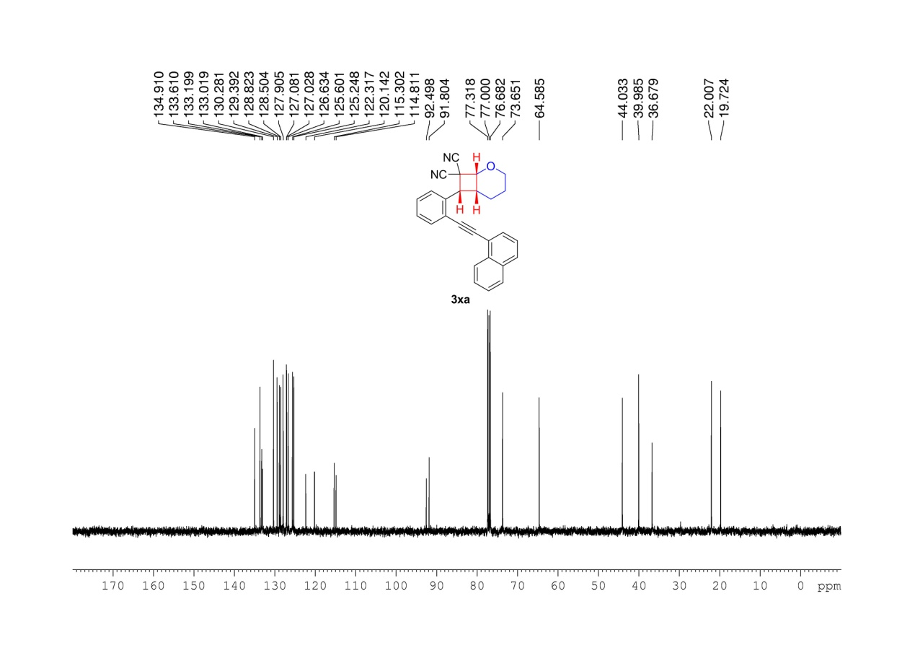
Supplementary Figure 66. ¹³C NMR (100MHz, CDCl₃) spectrum of 3xa

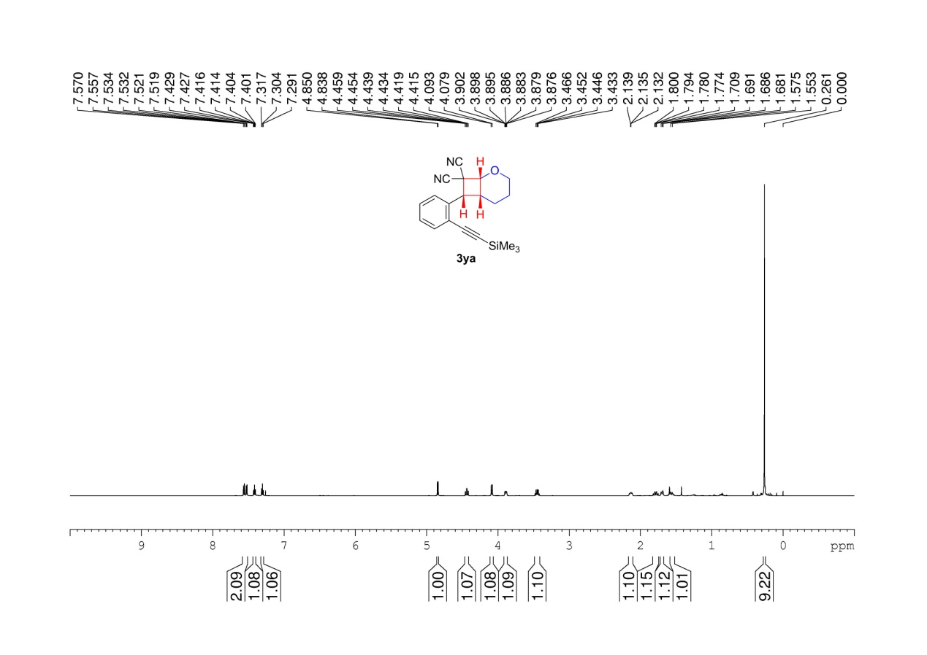
Supplementary Figure 67. ¹H NMR (600 MHz, CDCl₃) spectrum of 3ya

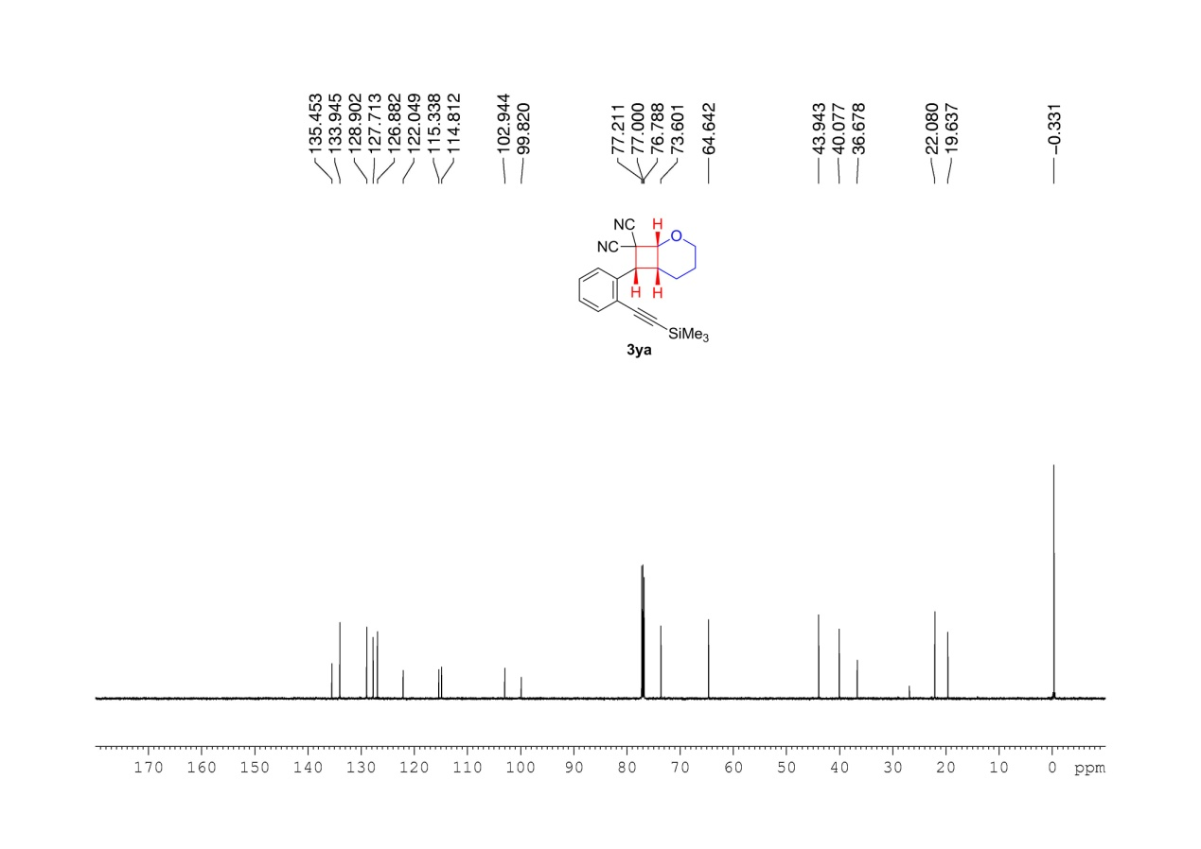
Supplementary Figure 68. ¹³C NMR (150MHz, CDCl₃) spectrum of 3ya

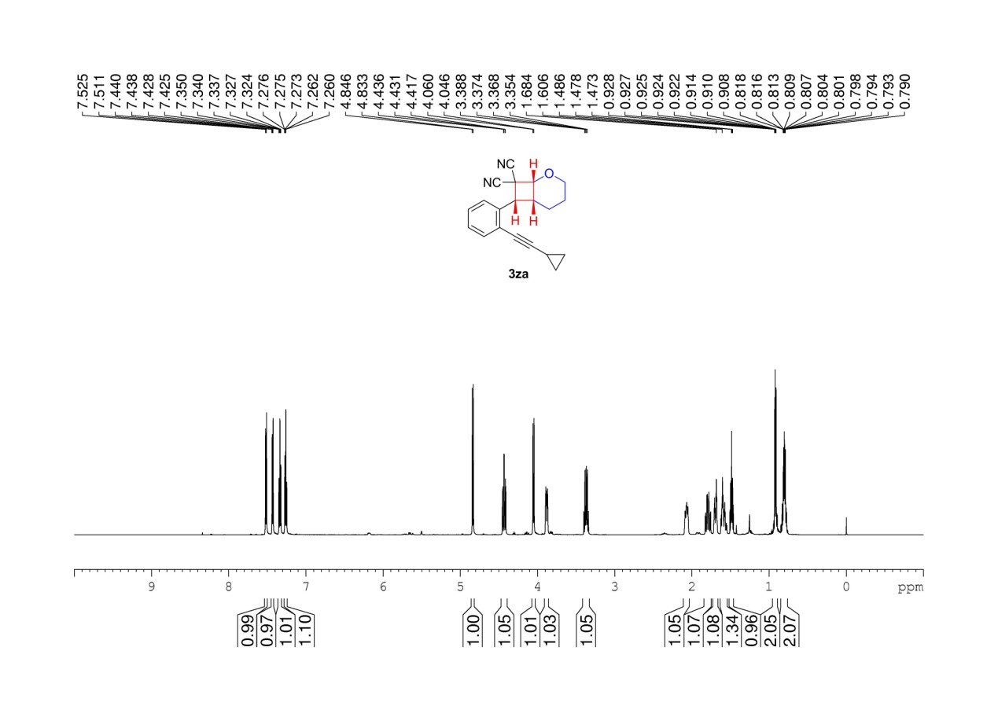
Supplementary Figure 69. ¹H NMR (600 MHz, CDCl₃) spectrum of 3za

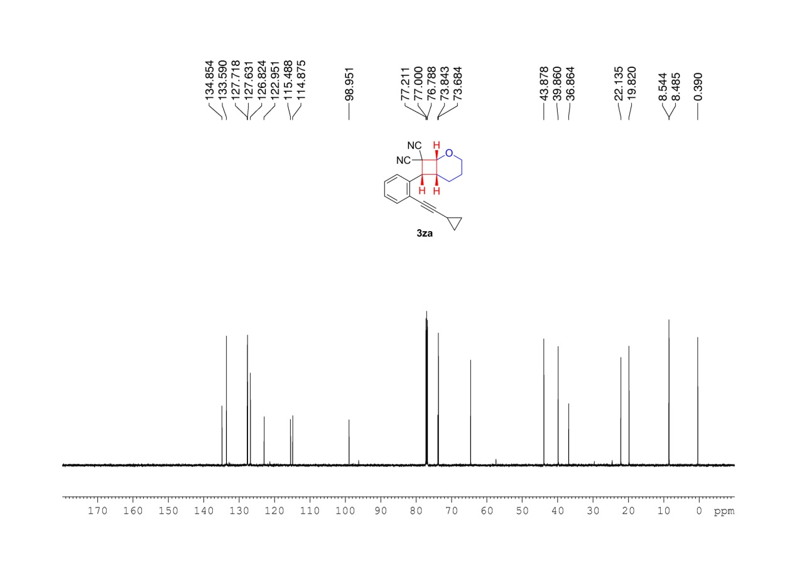
Supplementary Figure 70. ¹³C NMR (150MHz, CDCl₃) spectrum of 3za

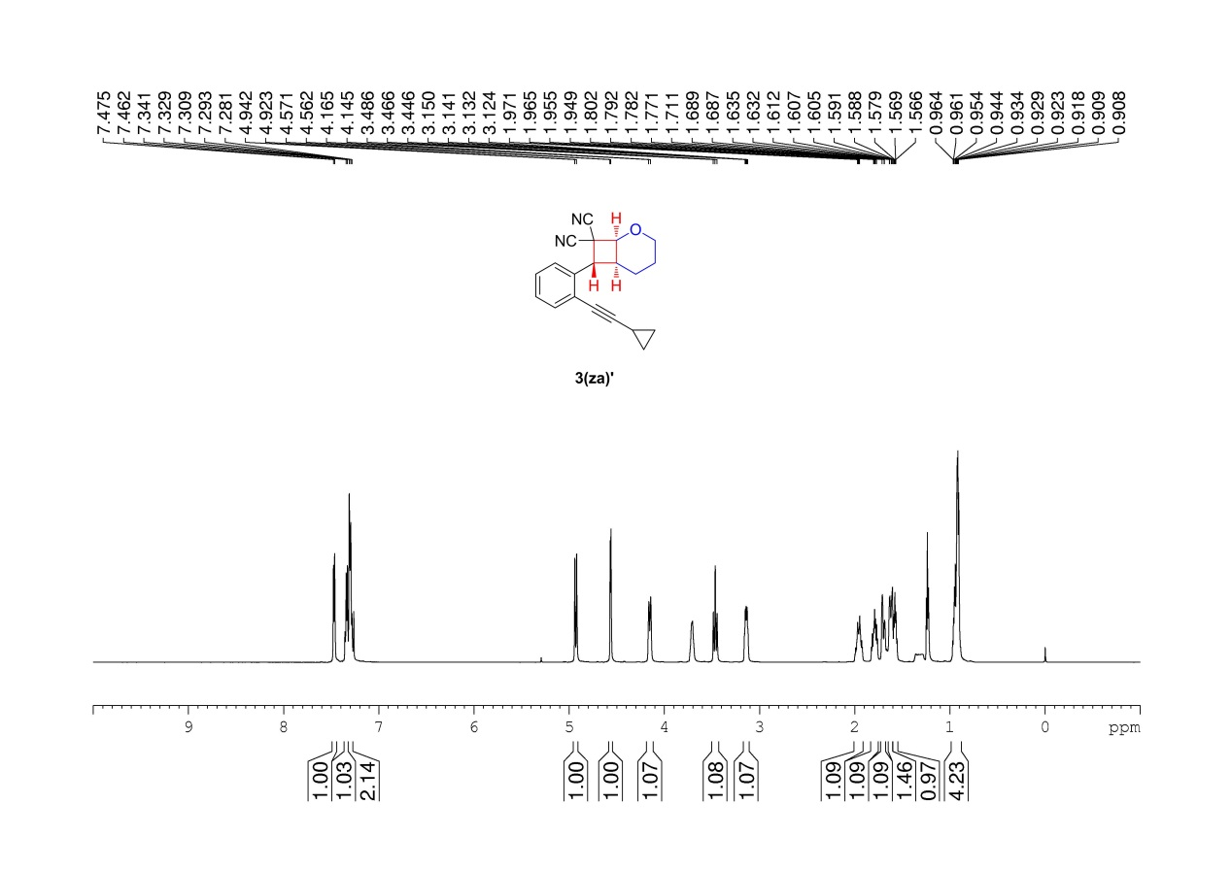
Supplementary Figure 71. ¹H NMR (600 MHz, CDCl₃) spectrum of 3(za)’

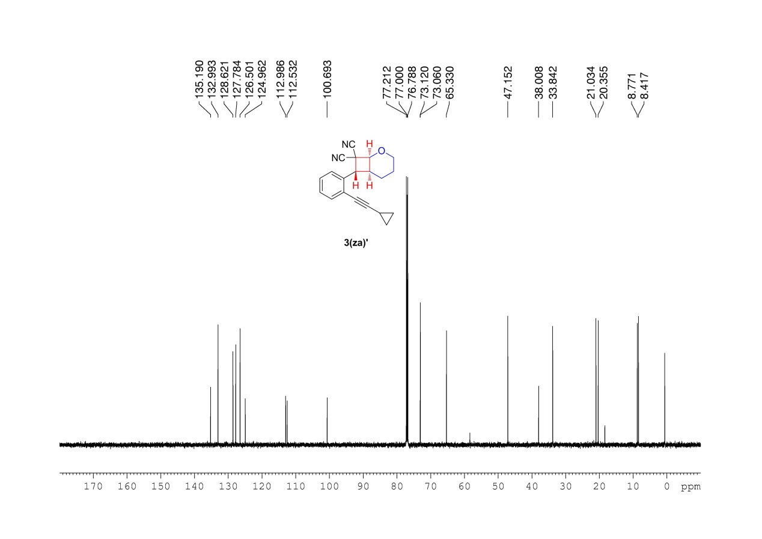
Supplementary Figure 72. ¹³C NMR (150MHz, CDCl₃) spectrum of 3(za)’

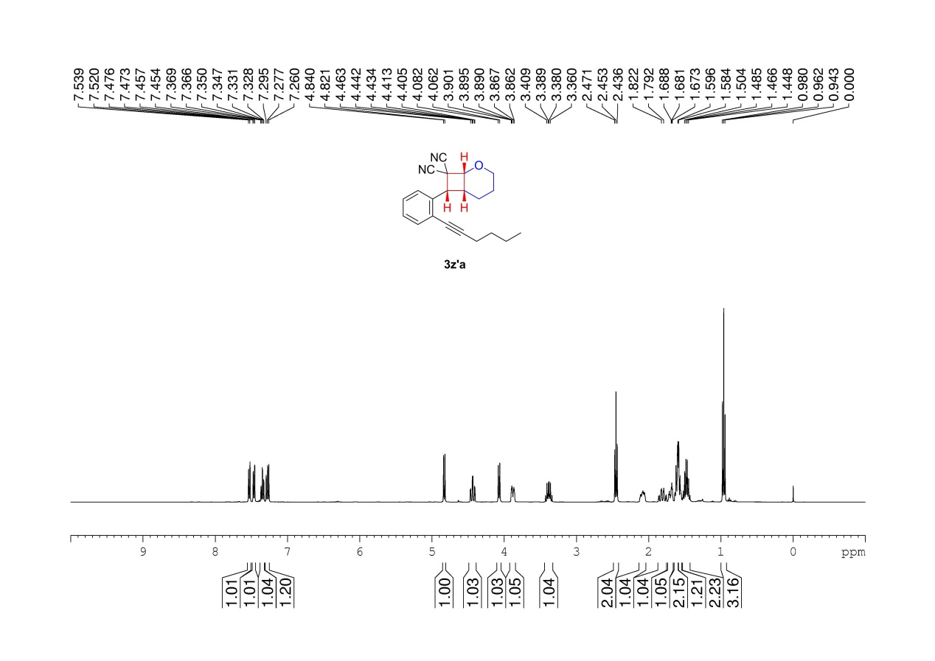
Supplementary Figure 73. ¹H NMR (400 MHz, CDCl₃) spectrum of 3z’a

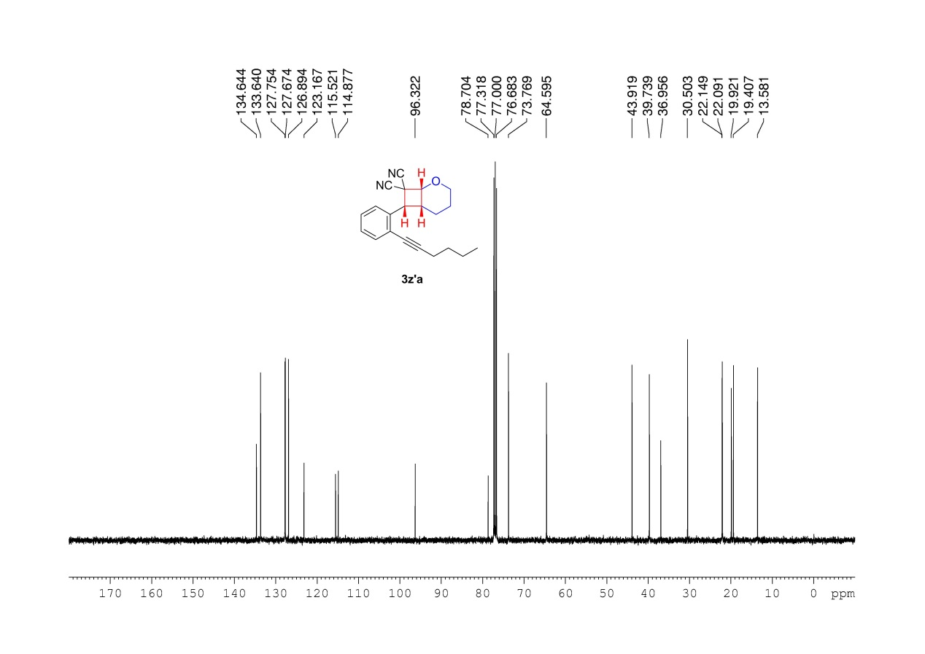
Supplementary Figure 74. ¹³C NMR (100MHz, CDCl₃) spectrum of 3z’a

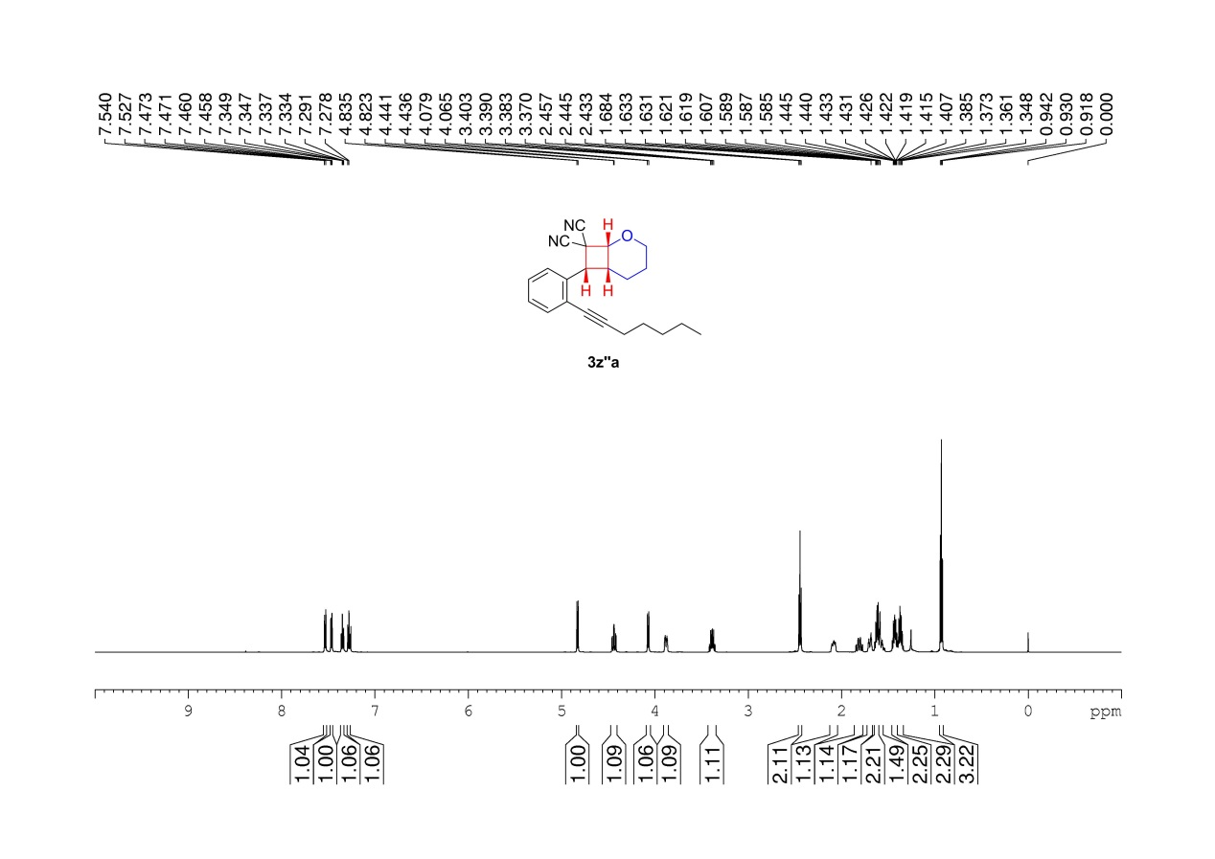
Supplementary Figure 75. ¹H NMR (600 MHz, CDCl₃) spectrum of 3z’’a

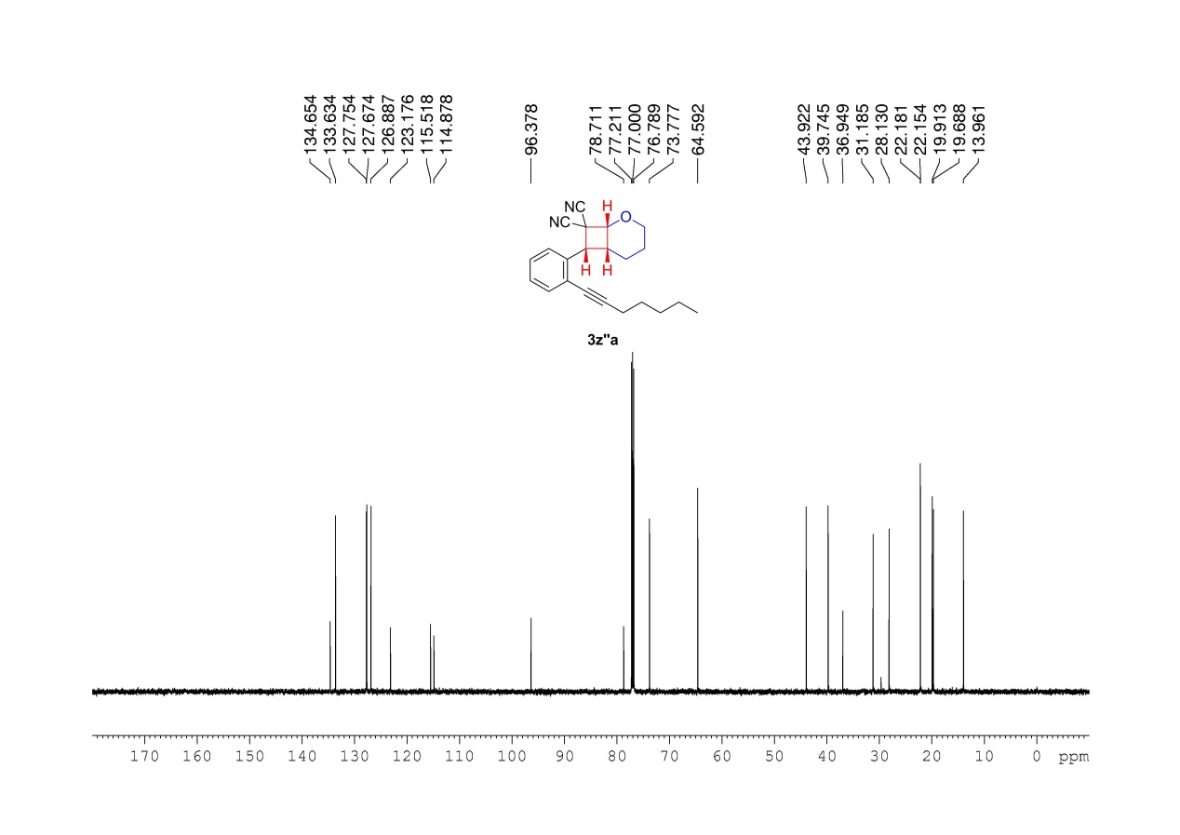
Supplementary Figure 76. ¹³C NMR (150MHz, CDCl₃) spectrum of 3z’’a

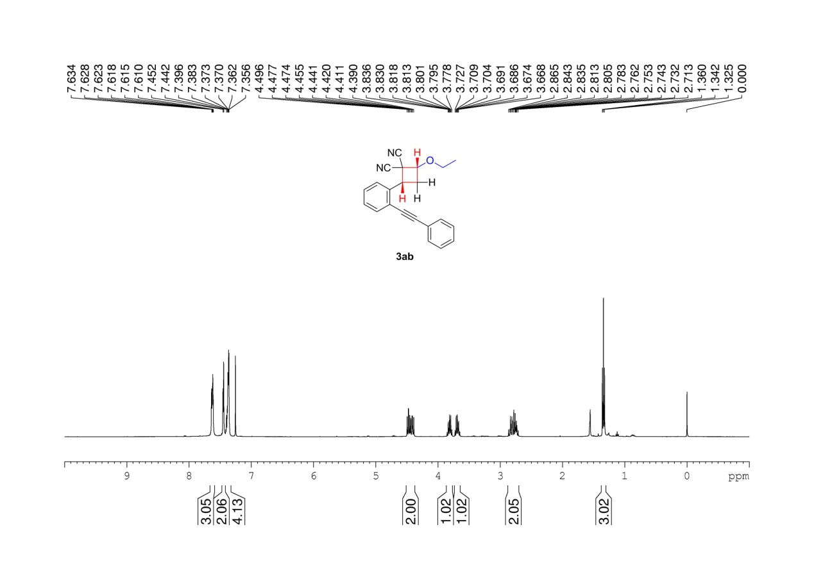
Supplementary Figure 77. ¹H NMR (400 MHz, CDCl₃) spectrum of 3ab

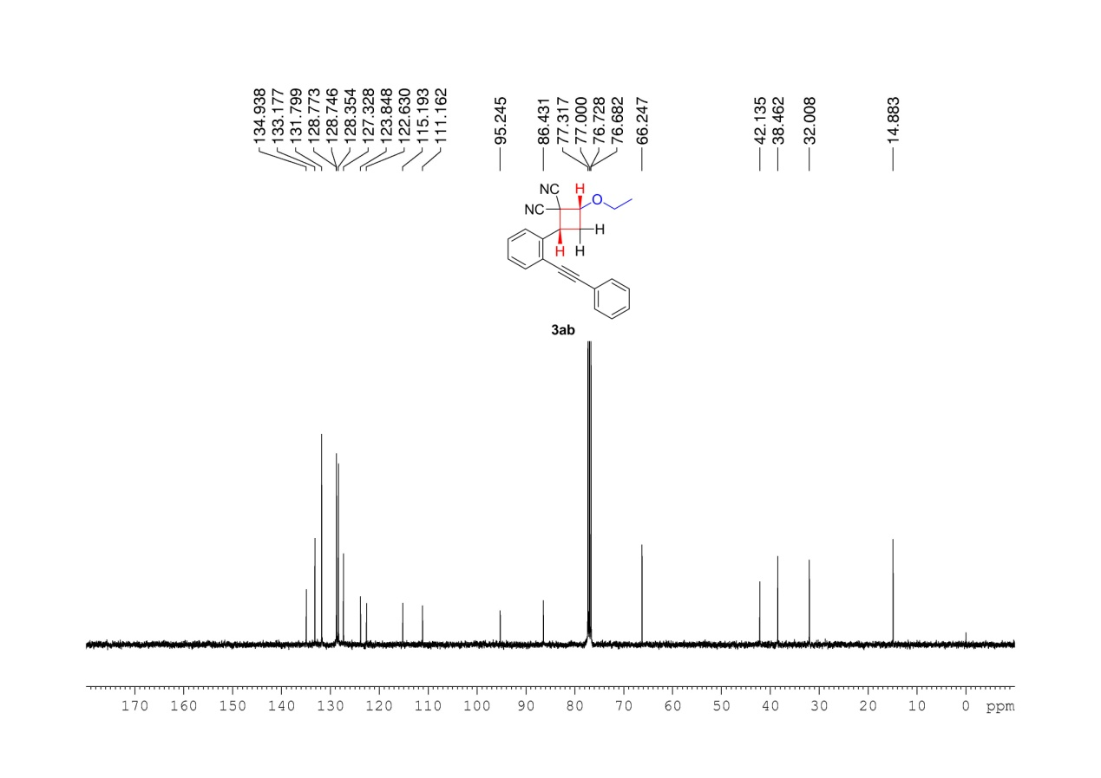
Supplementary Figure 78. ¹³C NMR (100MHz, CDCl₃) spectrum of 3ab

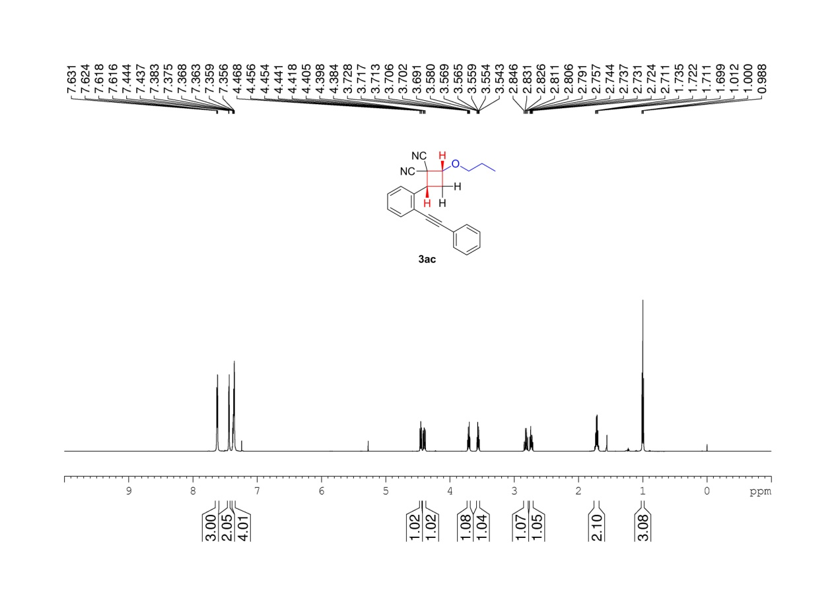
Supplementary Figure 79. ¹H NMR (600 MHz, CDCl₃) spectrum of 3ac

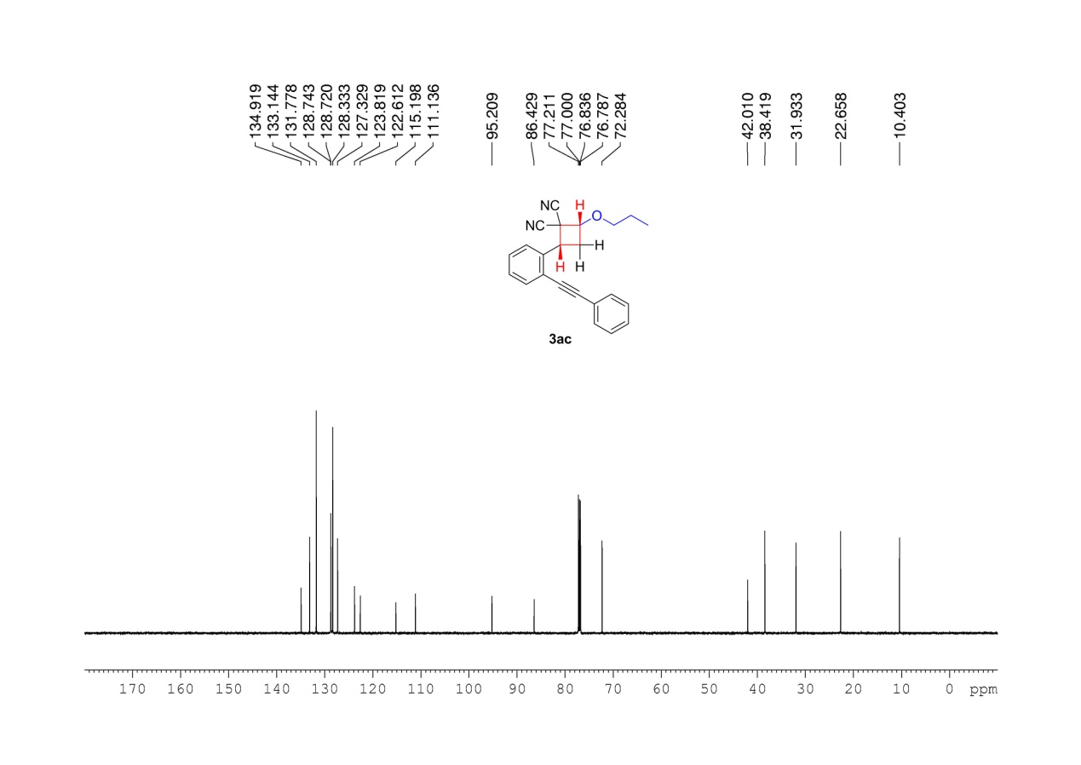
Supplementary Figure 80. ¹³C NMR (150MHz, CDCl₃) spectrum of 3ac

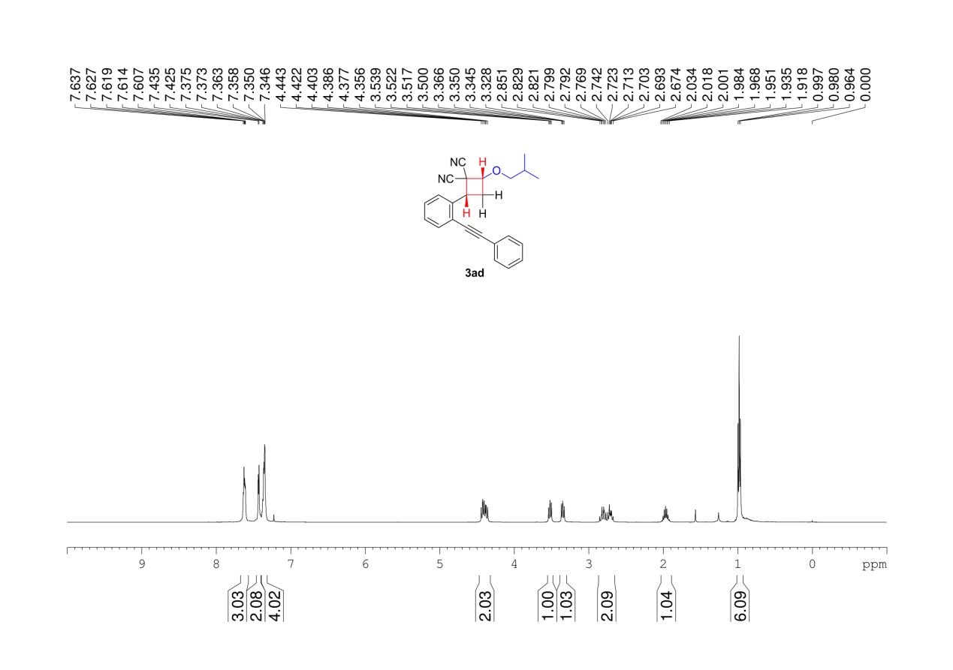
Supplementary Figure 81. ¹H NMR (400 MHz, CDCl₃) spectrum of 3ad

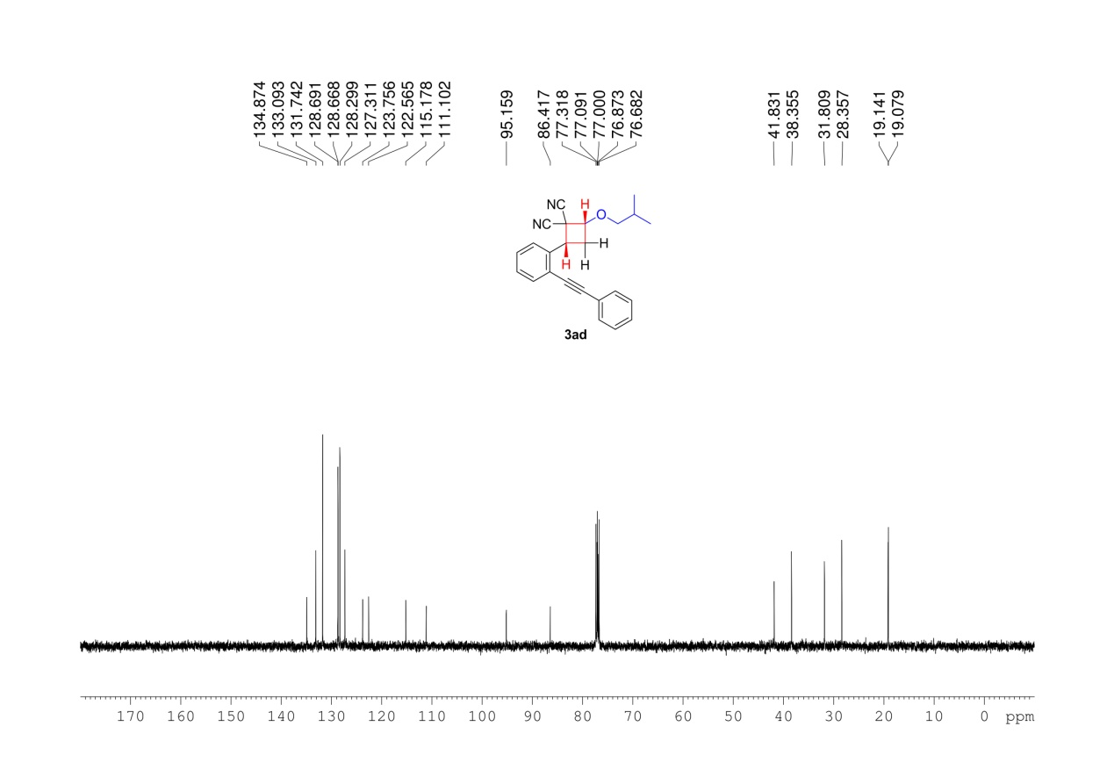
Supplementary Figure 82. ¹³C NMR (100MHz, CDCl₃) spectrum of 3ad

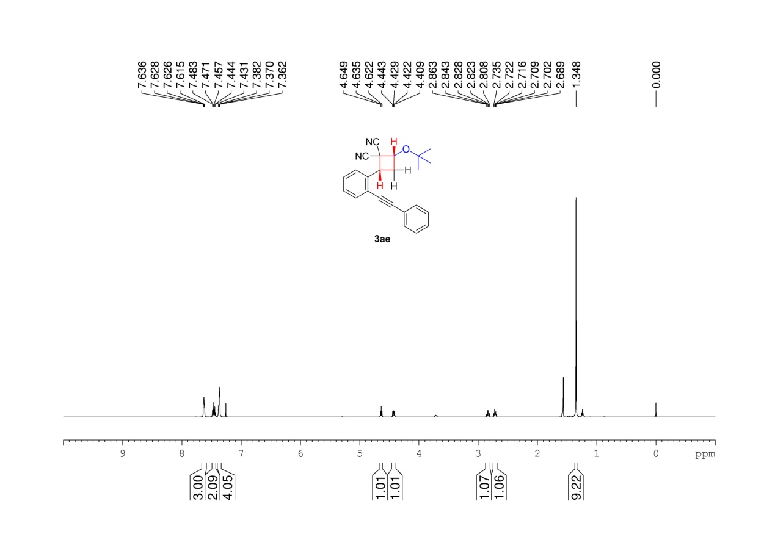
Supplementary Figure 83. ¹H NMR (600 MHz, CDCl₃) spectrum of 3ae

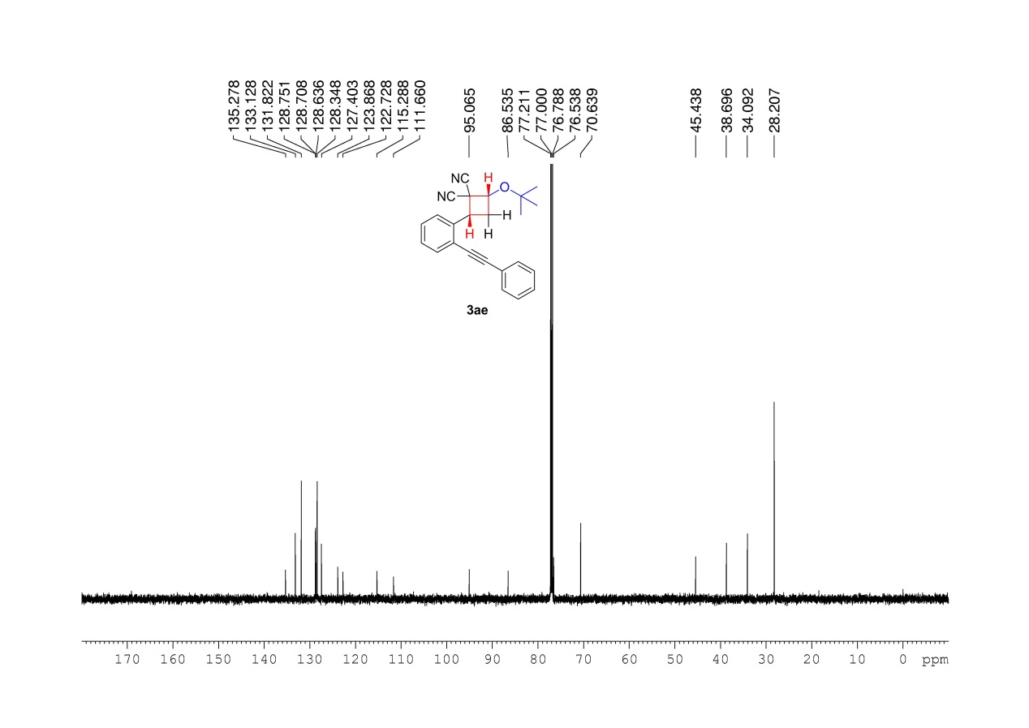
Supplementary Figure 84. ¹³C NMR (150MHz, CDCl₃) spectrum of 3ae

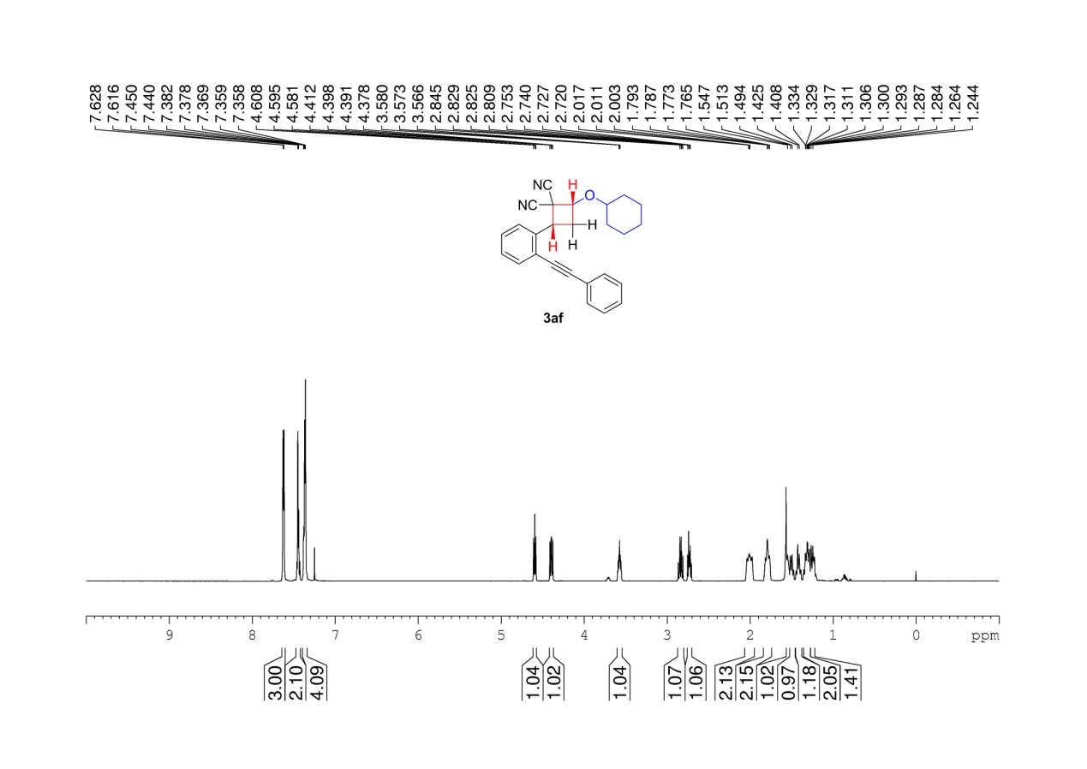
Supplementary Figure 85. ¹H NMR (600 MHz, CDCl₃) spectrum of 3af

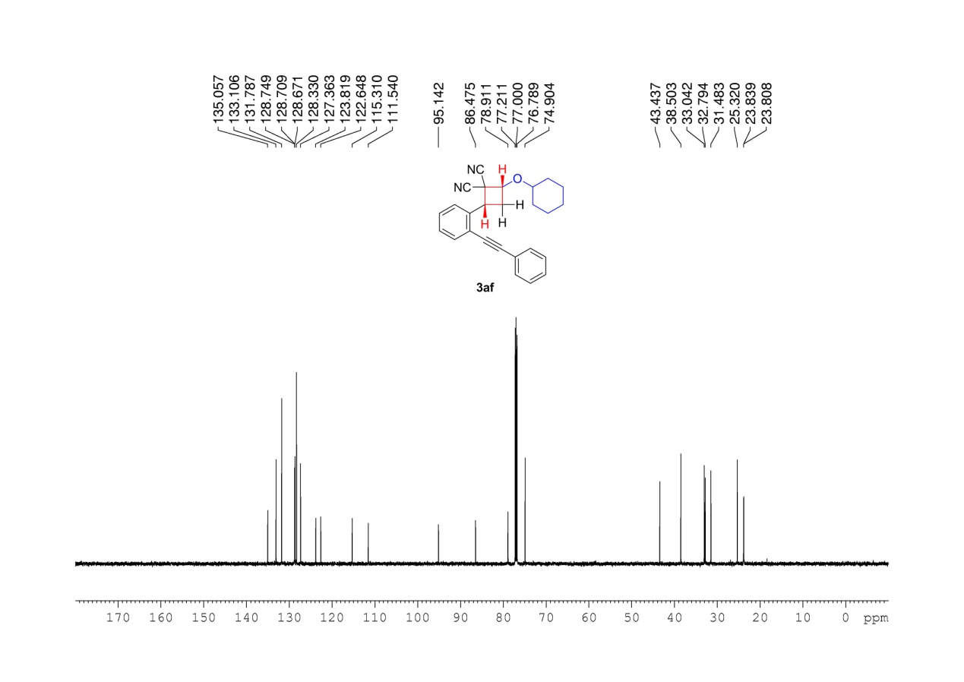
Supplementary Figure 86. ¹³C NMR (150MHz, CDCl₃) spectrum of 3af

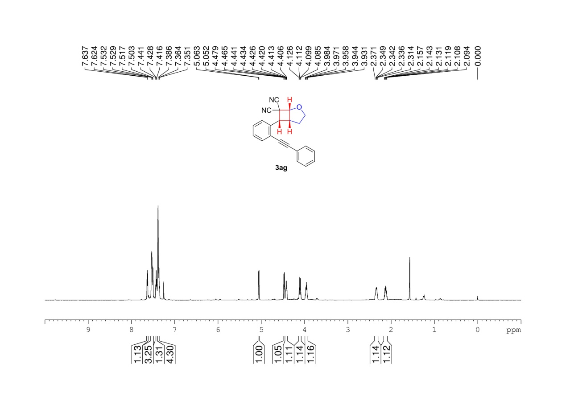
Supplementary Figure 87. ¹H NMR (600 MHz, CDCl₃) spectrum of 3ag

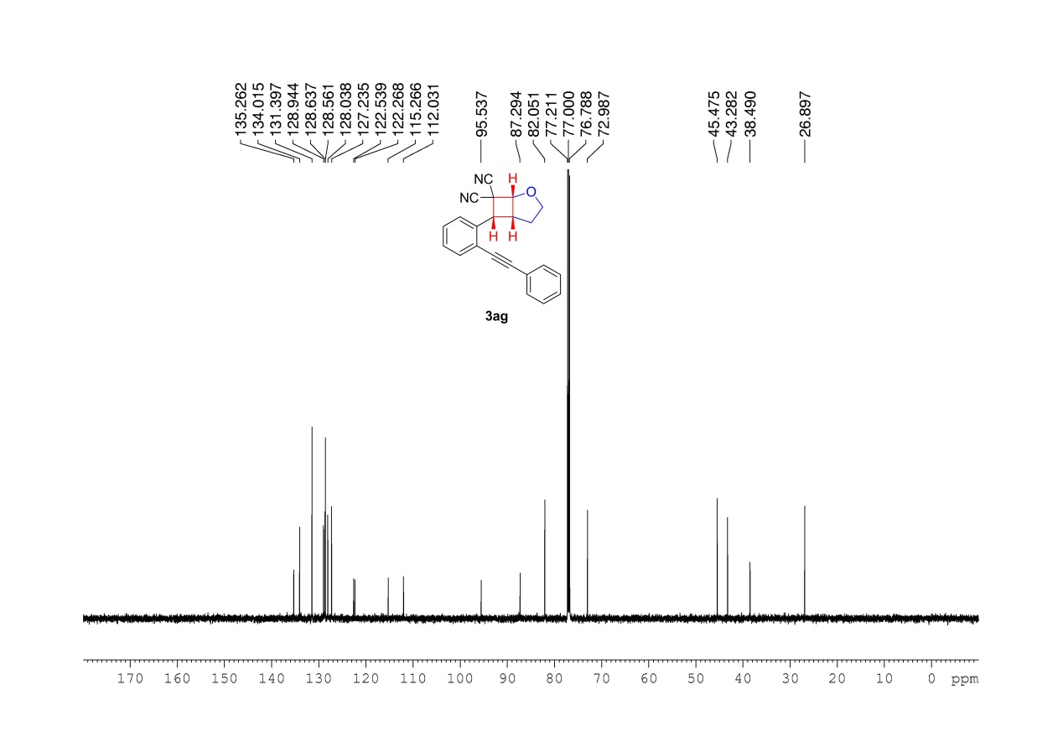
Supplementary Figure 88. ¹³C NMR (150MHz, CDCl₃) spectrum of 3ag

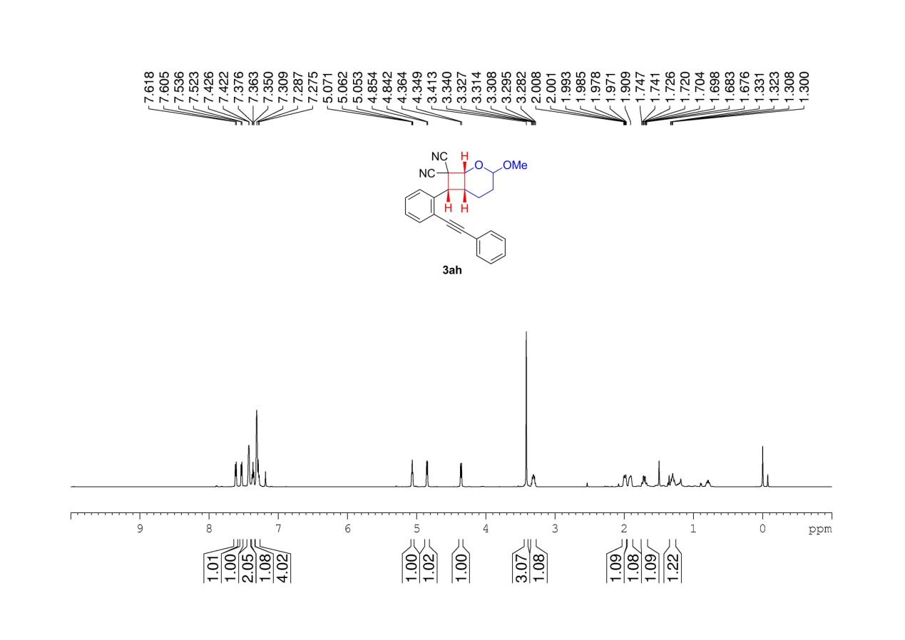
Supplementary Figure 89. ¹H NMR (600 MHz, CDCl₃) spectrum of 3ah

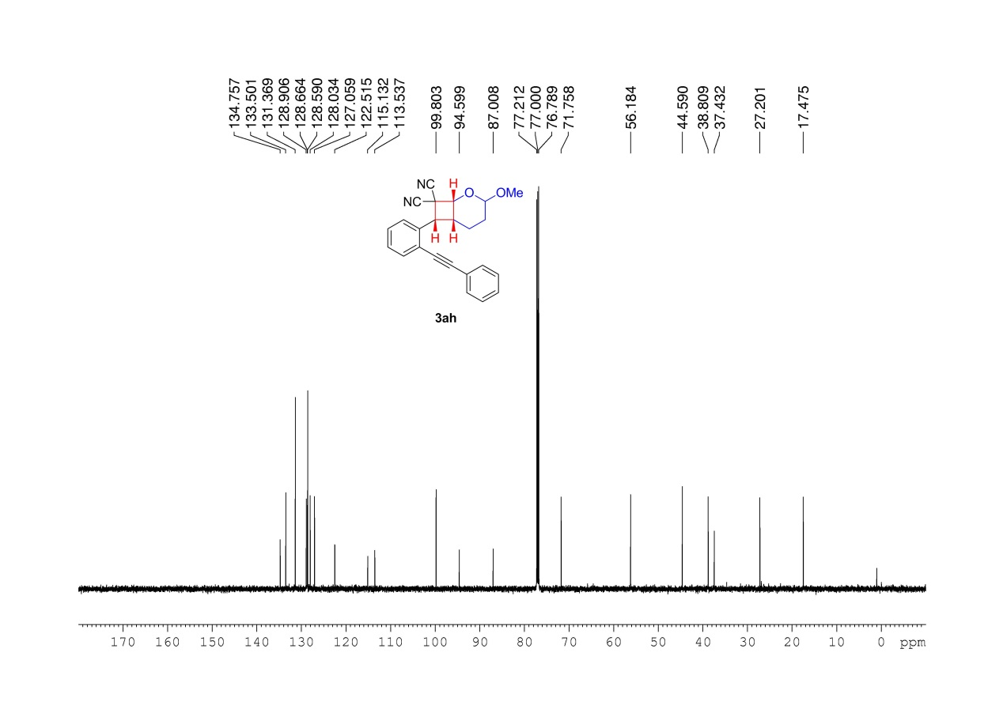
Supplementary Figure 90. ¹³C NMR (150MHz, CDCl₃) spectrum of 3ah

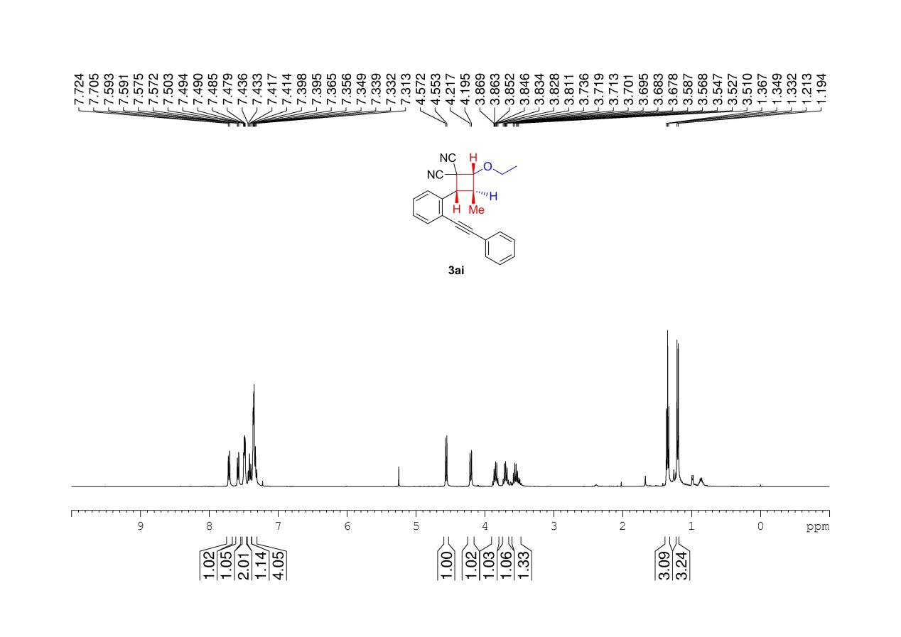
Supplementary Figure 91. ¹H NMR (400 MHz, CDCl₃) spectrum of 3ai

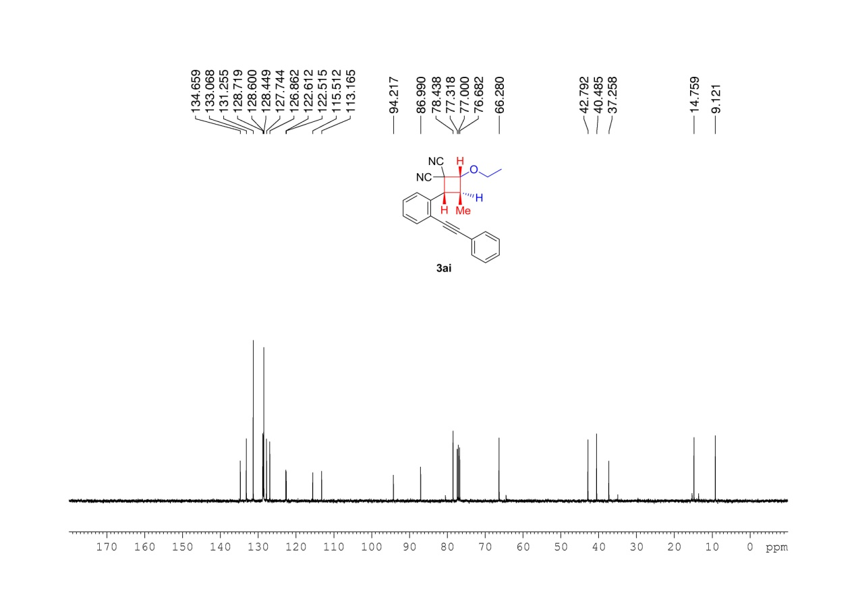
Supplementary Figure 92. ¹³C NMR (100MHz, CDCl₃) spectrum of 3ai

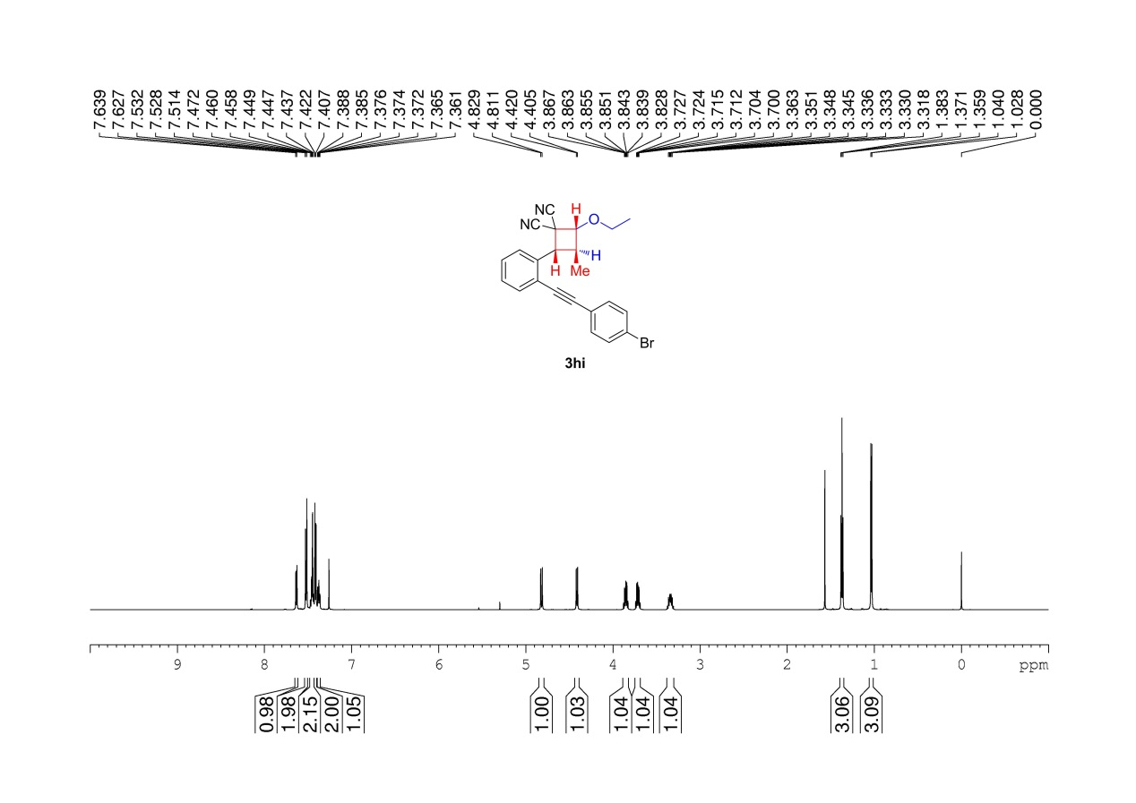
Supplementary Figure 93. ¹H NMR (600 MHz, CDCl₃) spectrum of 3hi

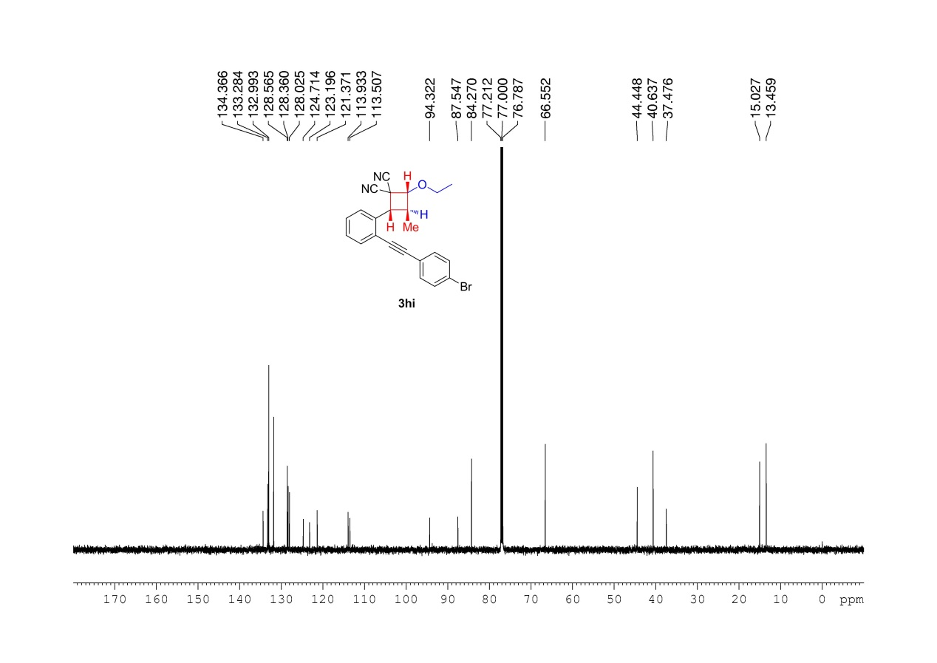
Supplementary Figure 94. ¹³C NMR (150MHz, CDCl₃) spectrum of 3hi

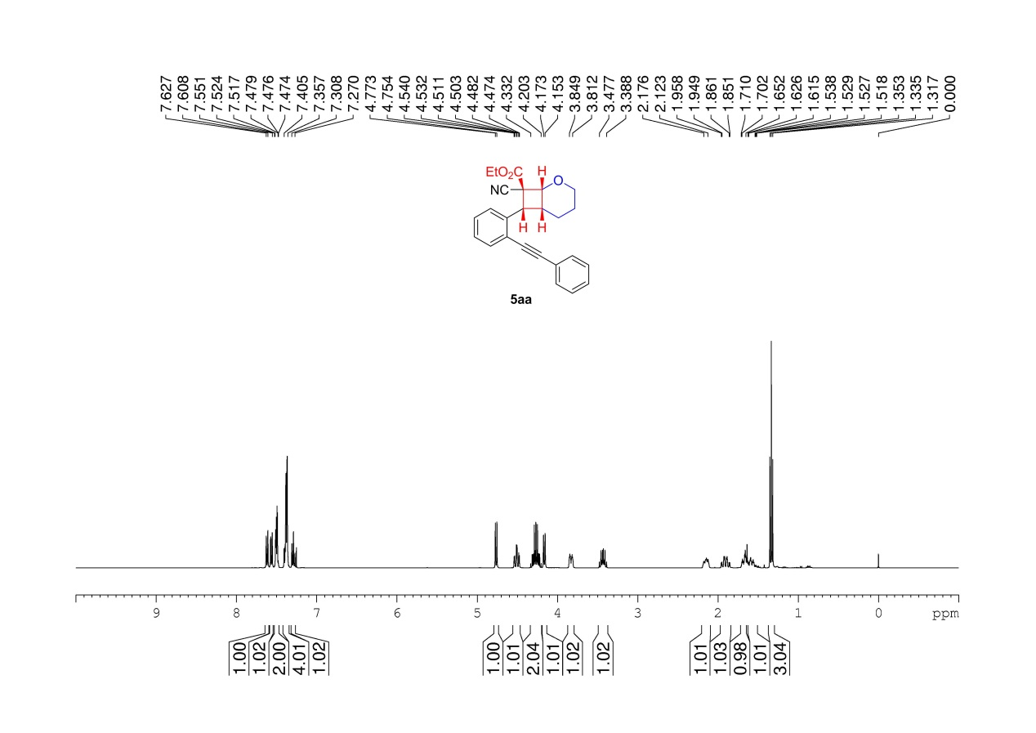
Supplementary Figure 95. ¹H NMR (400 MHz, CDCl₃) spectrum of 5aa

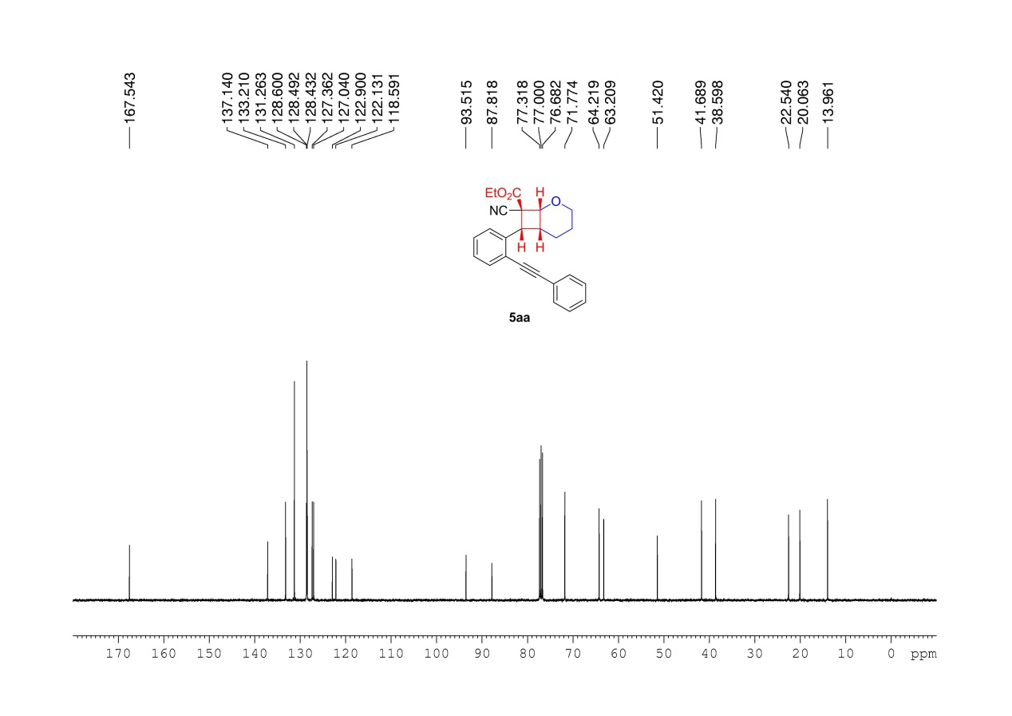
Supplementary Figure 96. ¹³C NMR (100MHz, CDCl₃) spectrum of 5aa

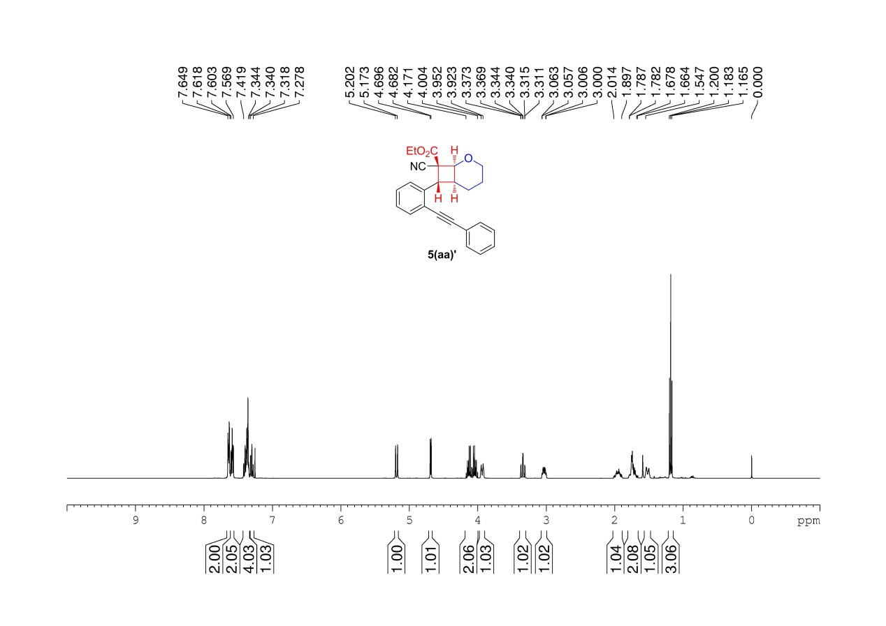
Supplementary Figure 97. ¹H NMR (400 MHz, CDCl₃) spectrum of 5(aa)’

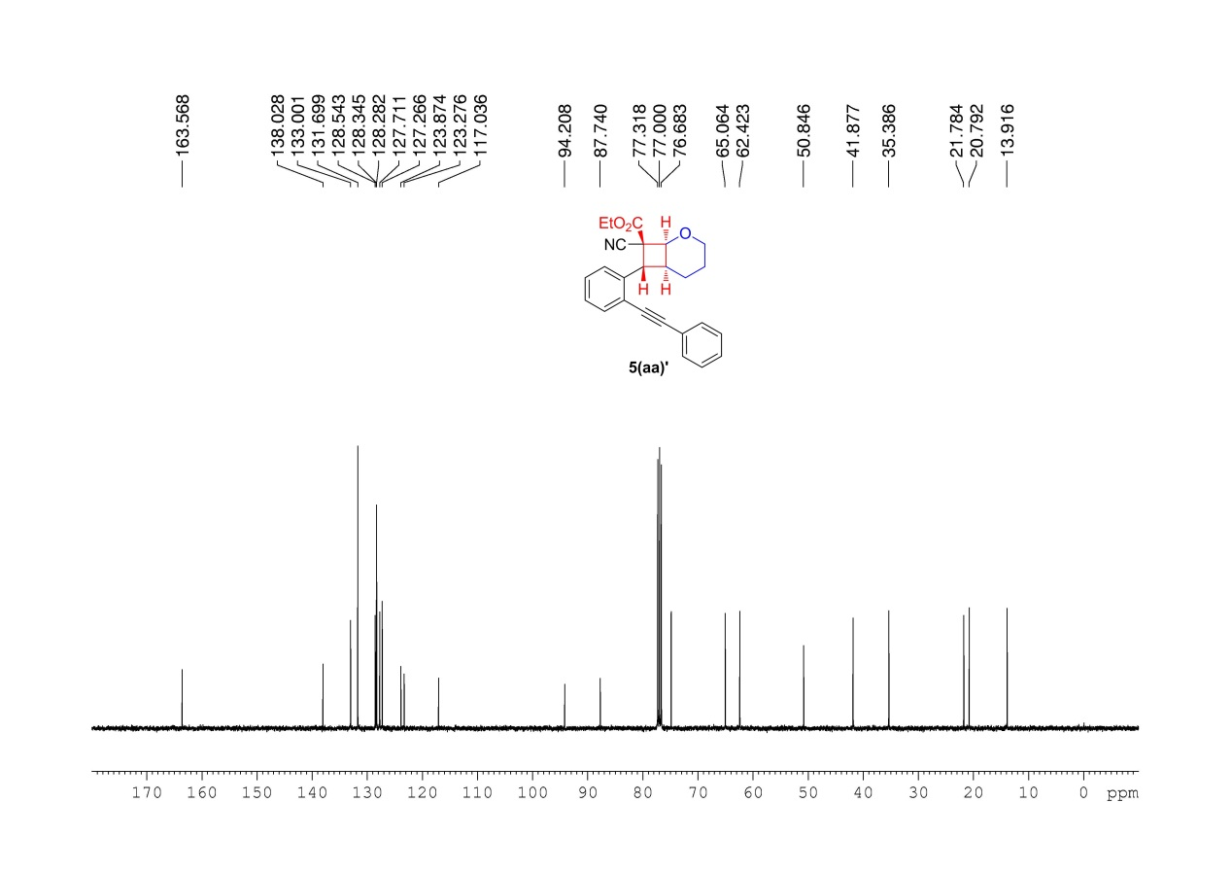
Supplementary Figure 98. ¹³C NMR (100MHz, CDCl₃) spectrum of 5(aa)’

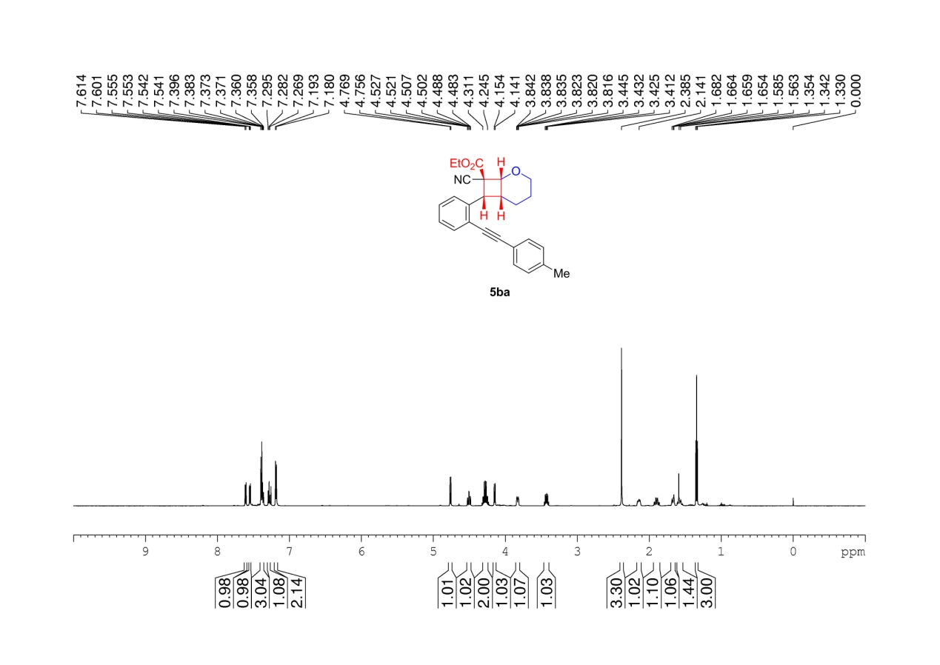
Supplementary Figure 99. ¹H NMR (600 MHz, CDCl₃) spectrum of 5ba

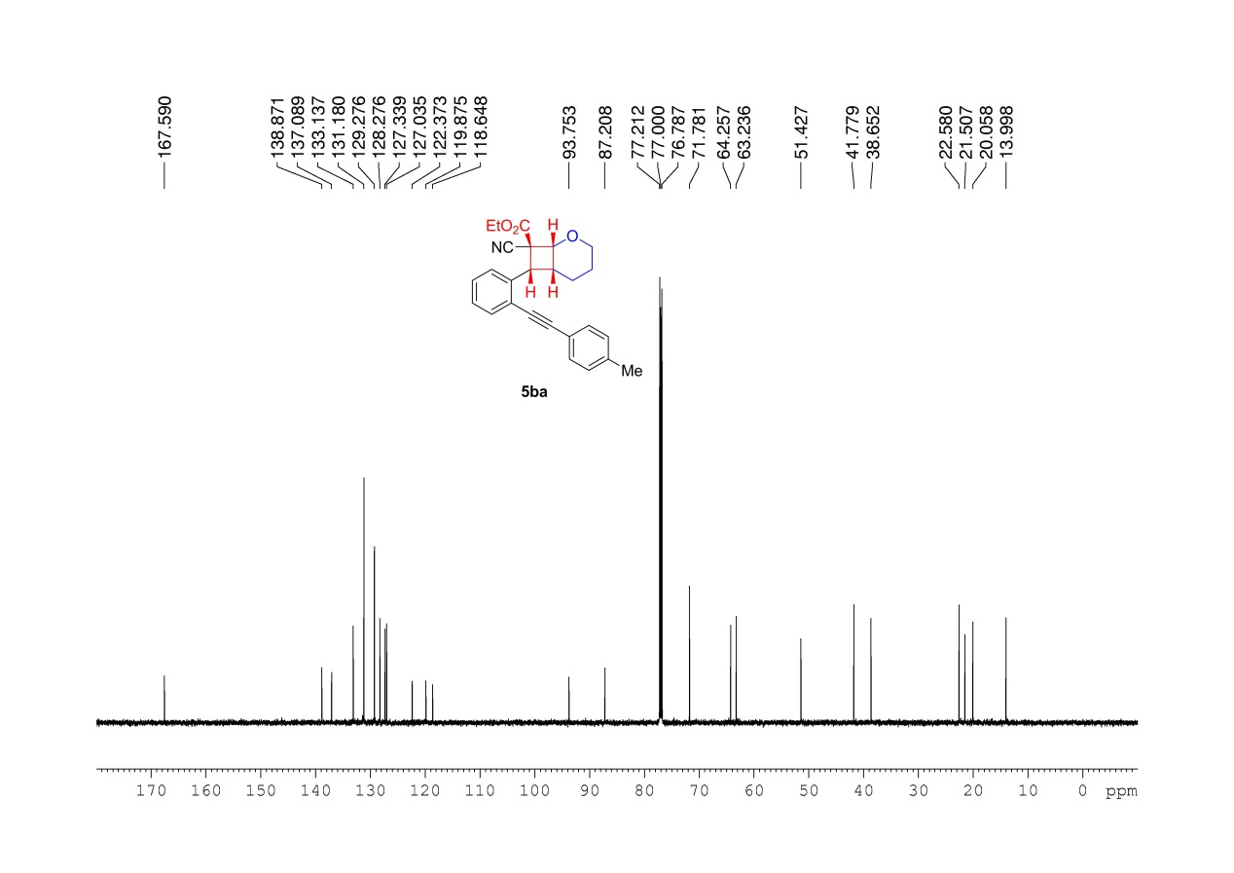
Supplementary Figure 100. ¹³C NMR (150MHz, CDCl₃) spectrum of 5ba

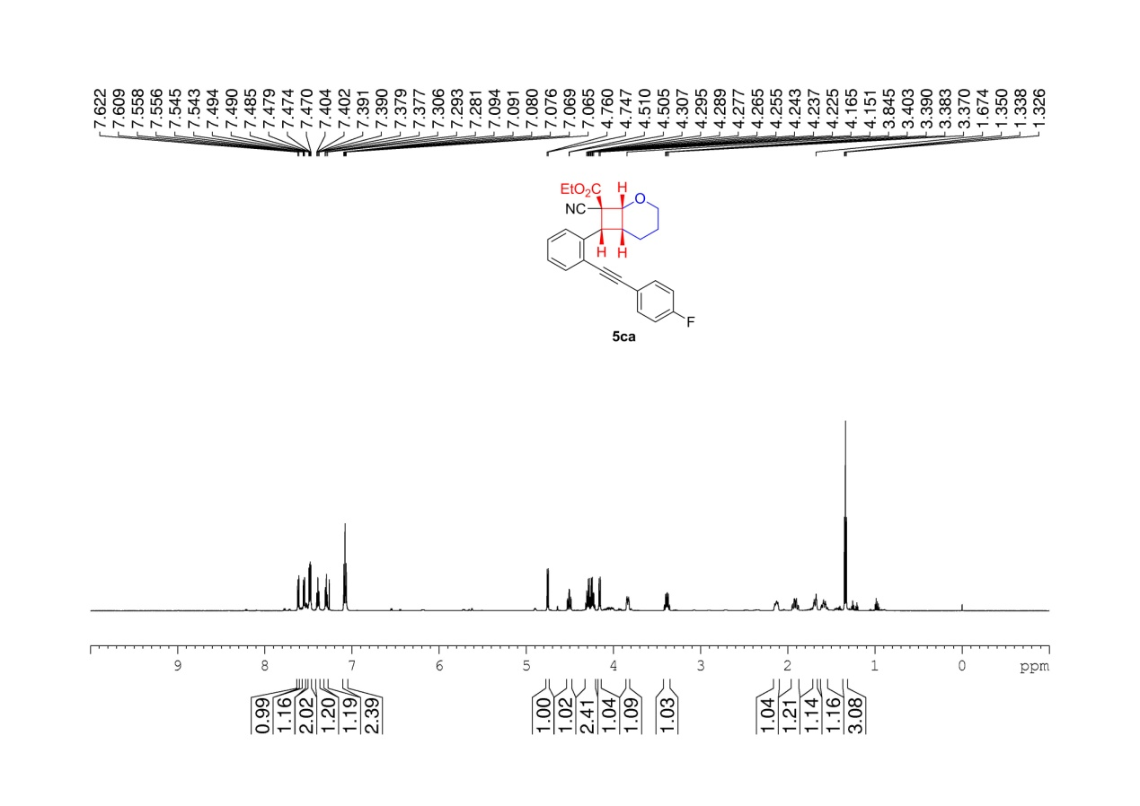
Supplementary Figure 101. ¹H NMR (600 MHz, CDCl₃) spectrum of 5ca

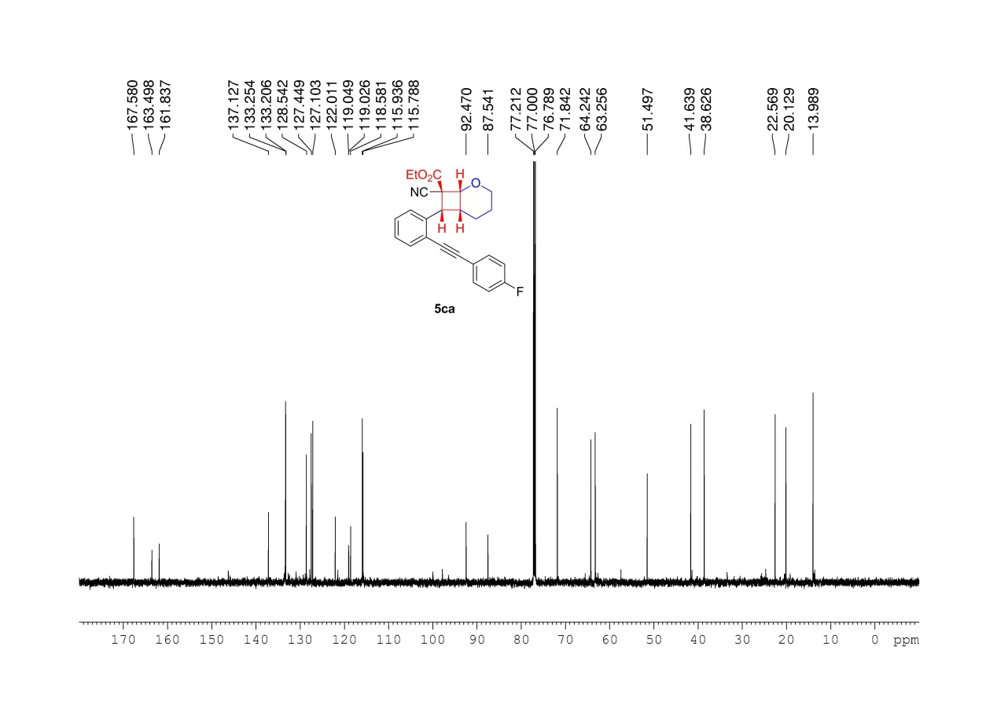
Supplementary Figure 102. ¹³C NMR (150MHz, CDCl₃) spectrum of 5ca

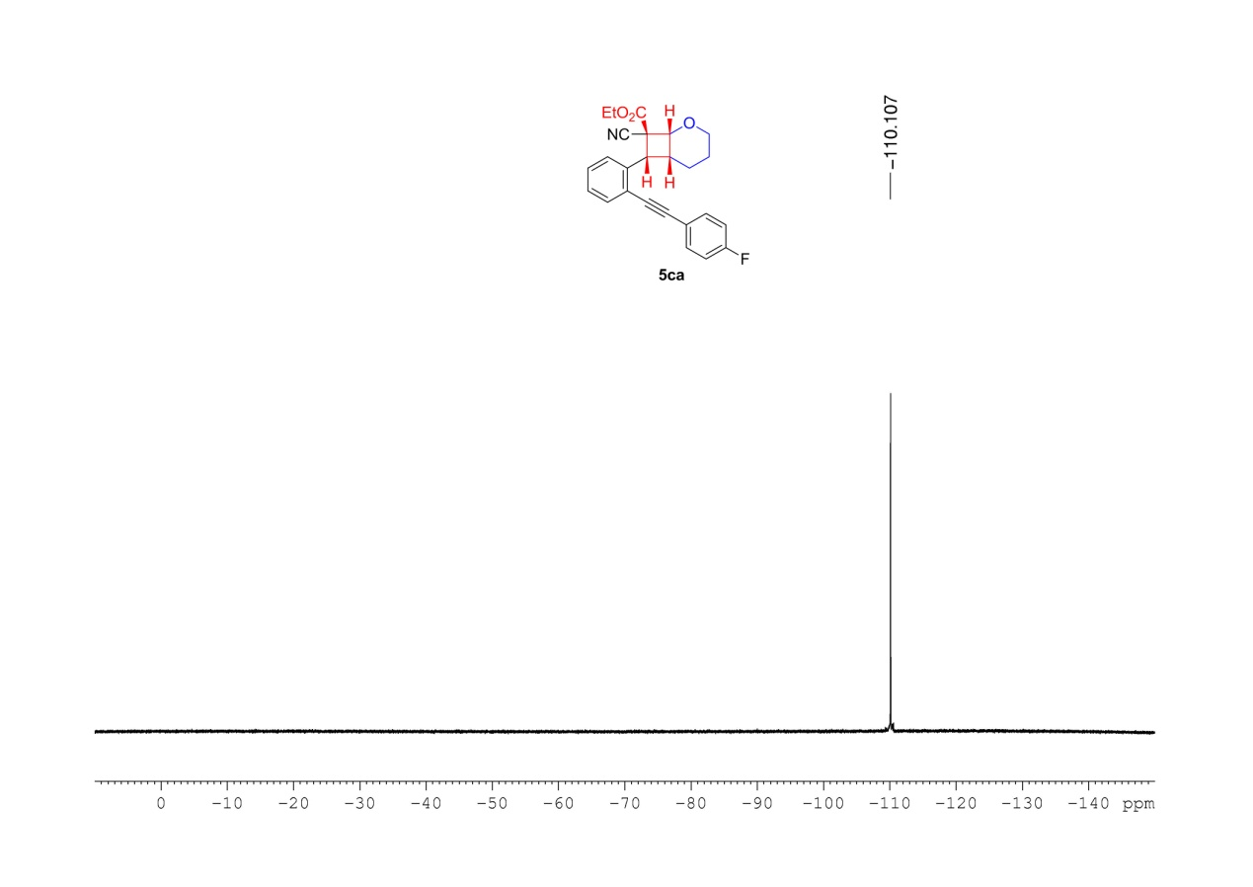
Supplementary Figure 103. ¹⁹F NMR (376MHz, CDCl₃) spectrum of 5ca

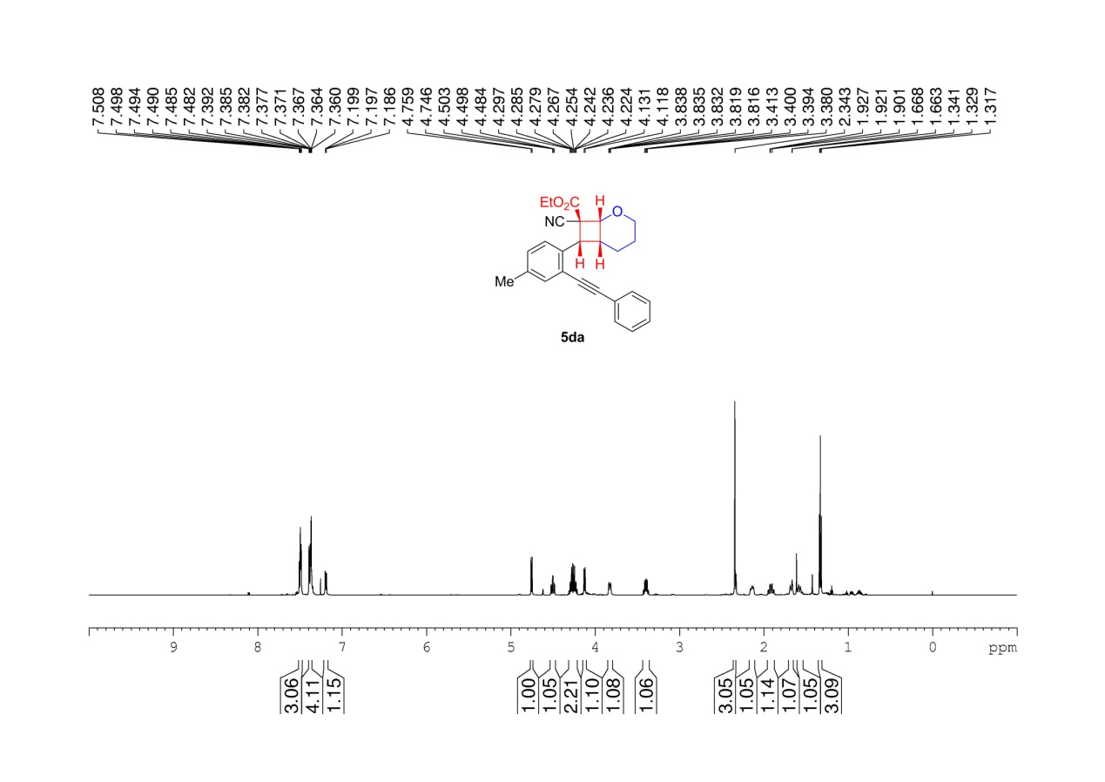
Supplementary Figure 104. ¹H NMR (600 MHz, CDCl₃) spectrum of 5da

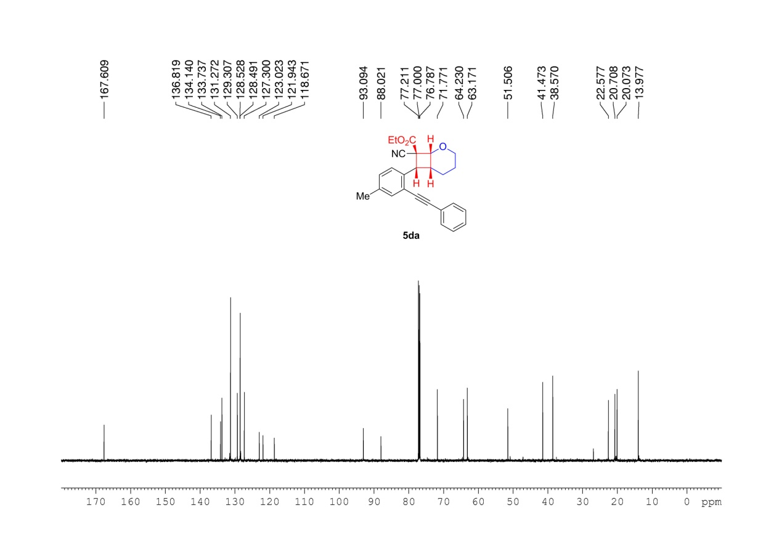
Supplementary Figure 105. ¹³C NMR (150MHz, CDCl₃) spectrum of 5da

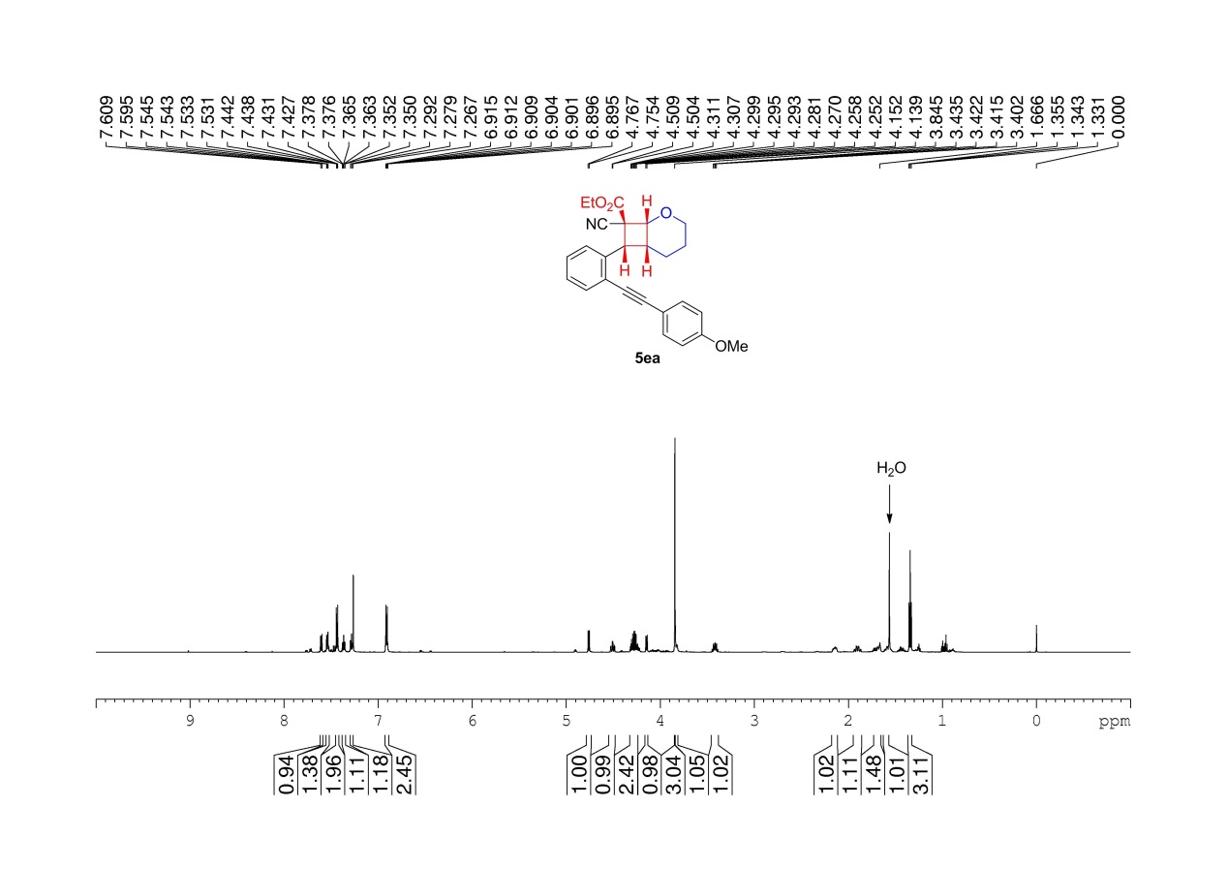
Supplementary Figure 106. ¹H NMR (600 MHz, CDCl₃) spectrum of 5ea

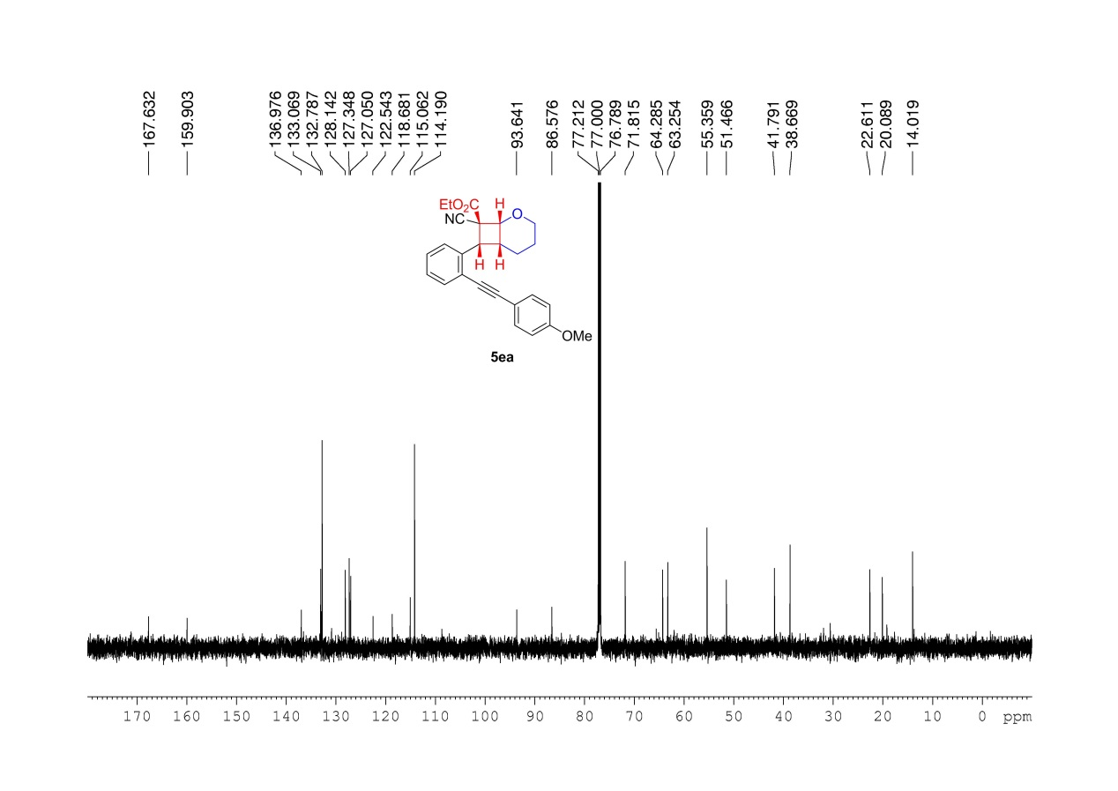
Supplementary Figure 107. ¹³C NMR (150MHz, CDCl₃) spectrum of 5ea

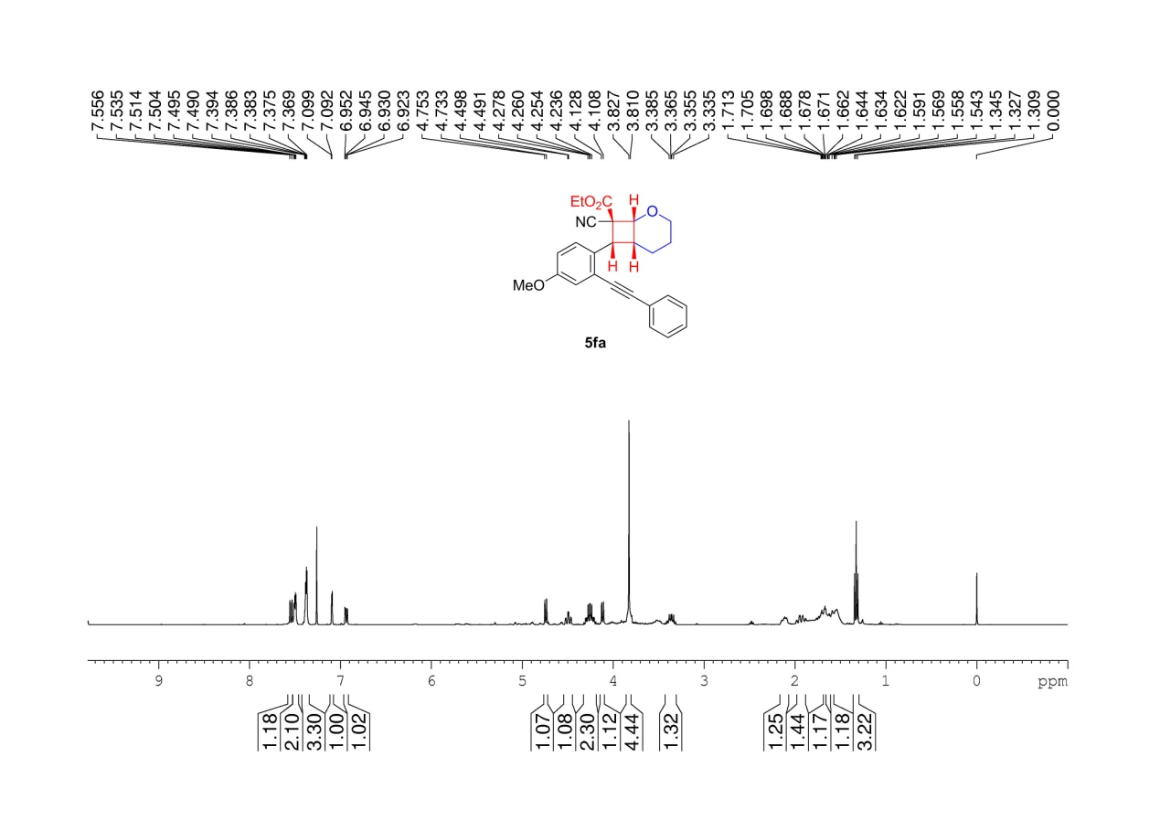
Supplementary Figure 108. ¹H NMR (400 MHz, CDCl₃) spectrum of 5fa

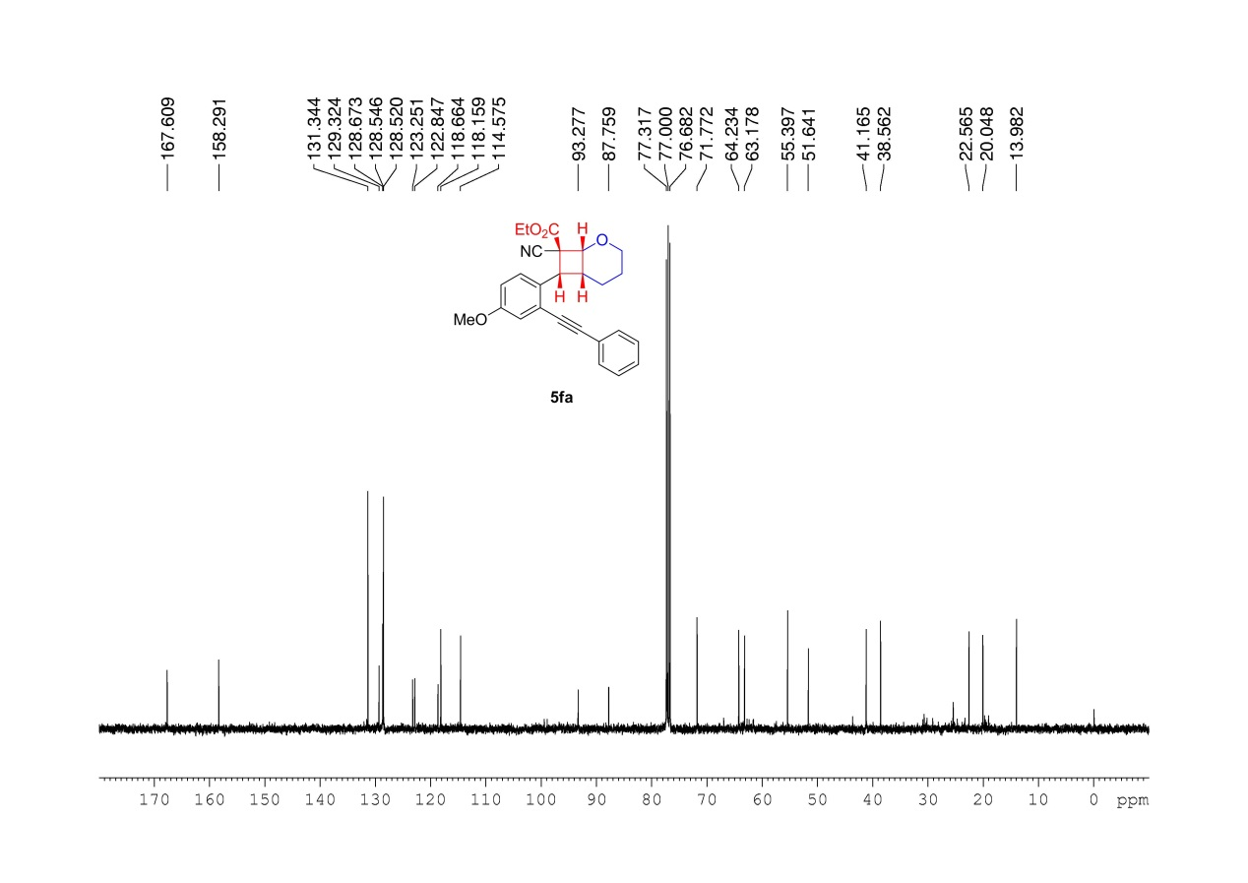
Supplementary Figure 109. ¹³C NMR (100MHz, CDCl₃) spectrum of 5fa

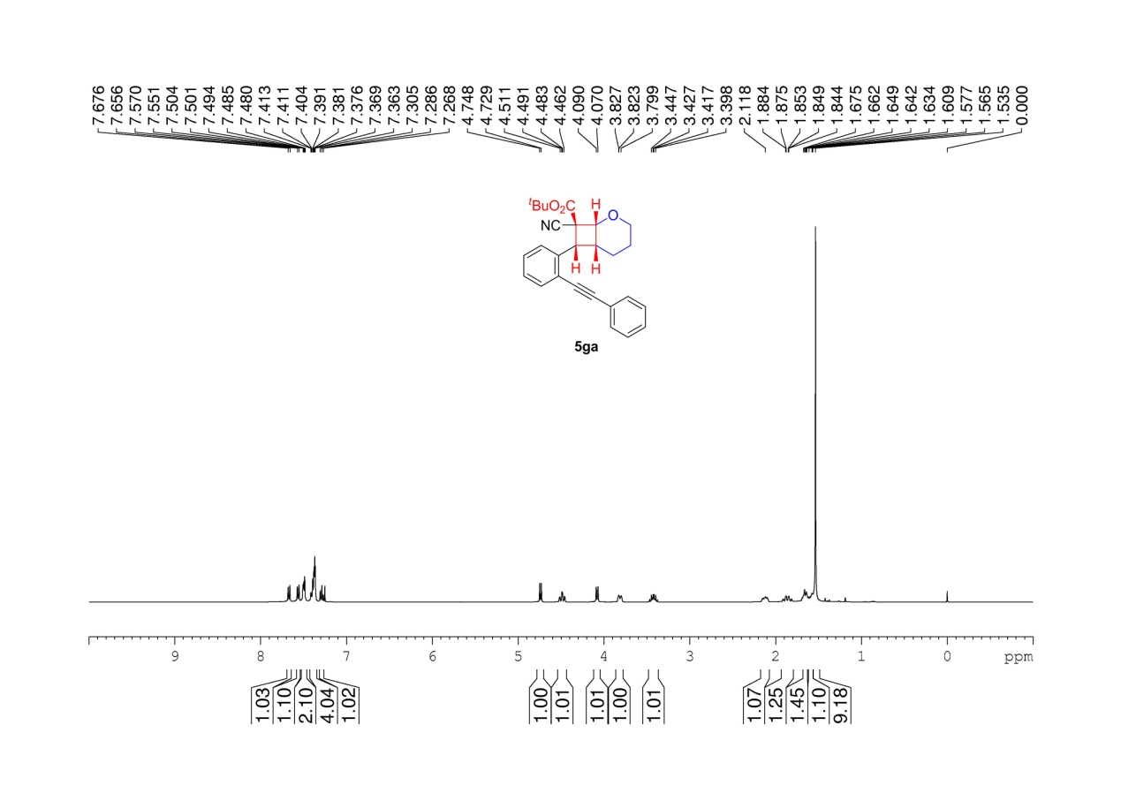
Supplementary Figure 110. ¹H NMR (400 MHz, CDCl₃) spectrum of 5ga

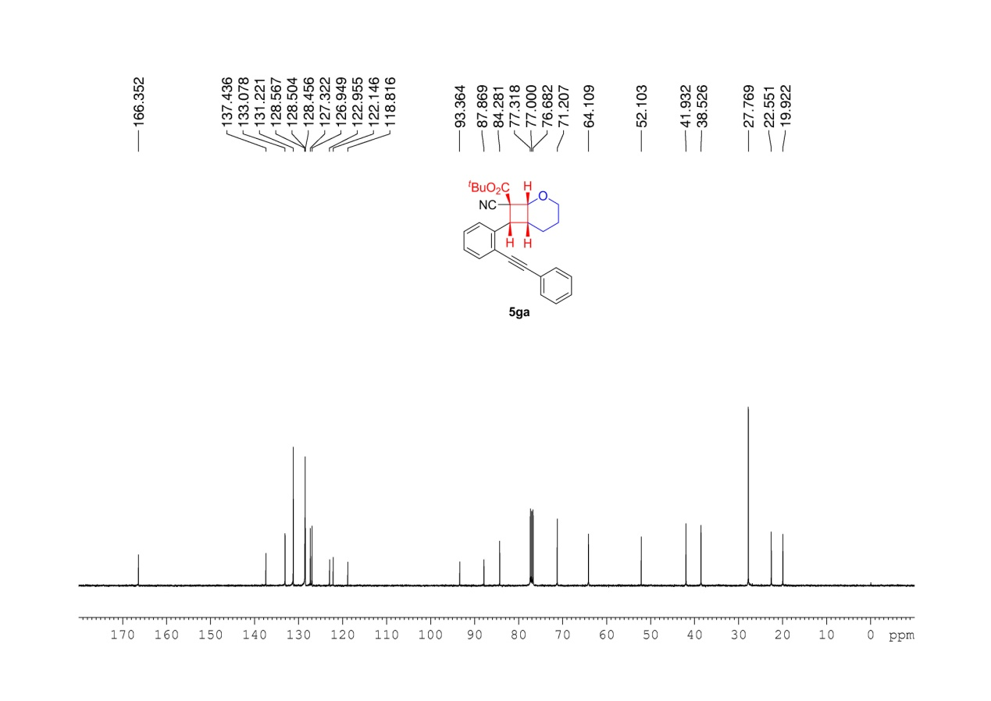
Supplementary Figure 111. ¹³C NMR (100MHz, CDCl₃) spectrum of 5ga

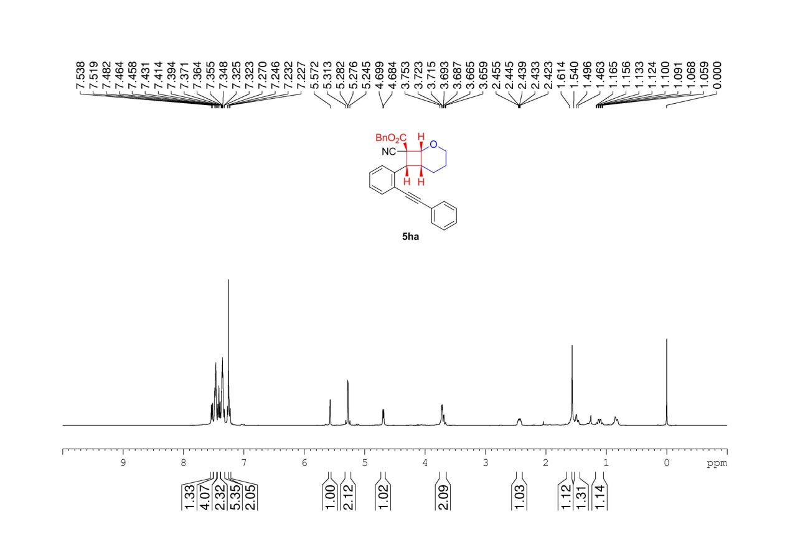
Supplementary Figure 112. ¹H NMR (400 MHz, CDCl₃) spectrum of 5ha

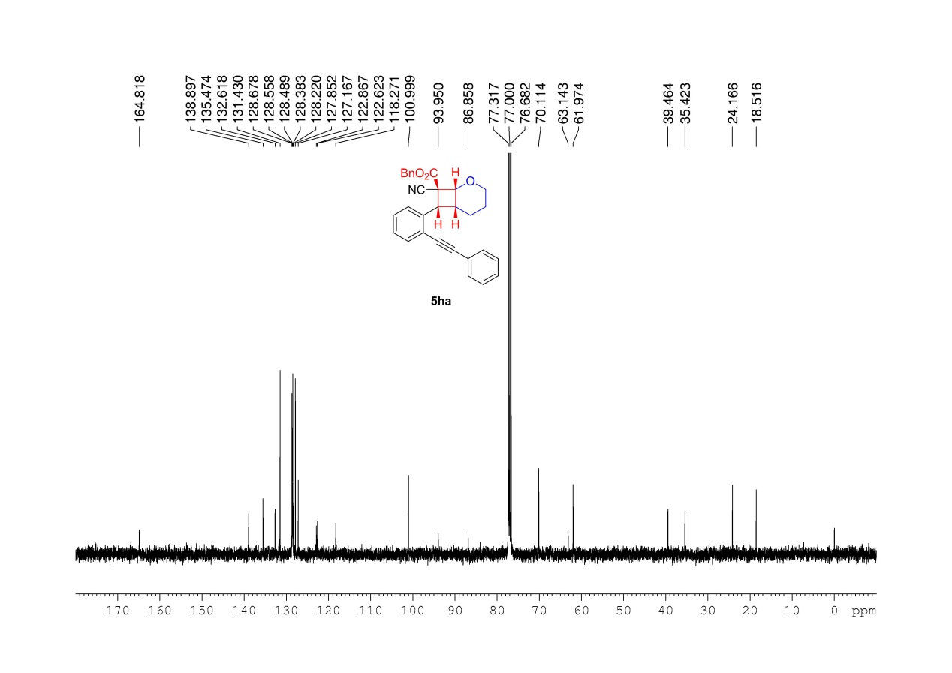
Supplementary Figure 113. ¹³C NMR (100MHz, CDCl₃) spectrum of 5ha

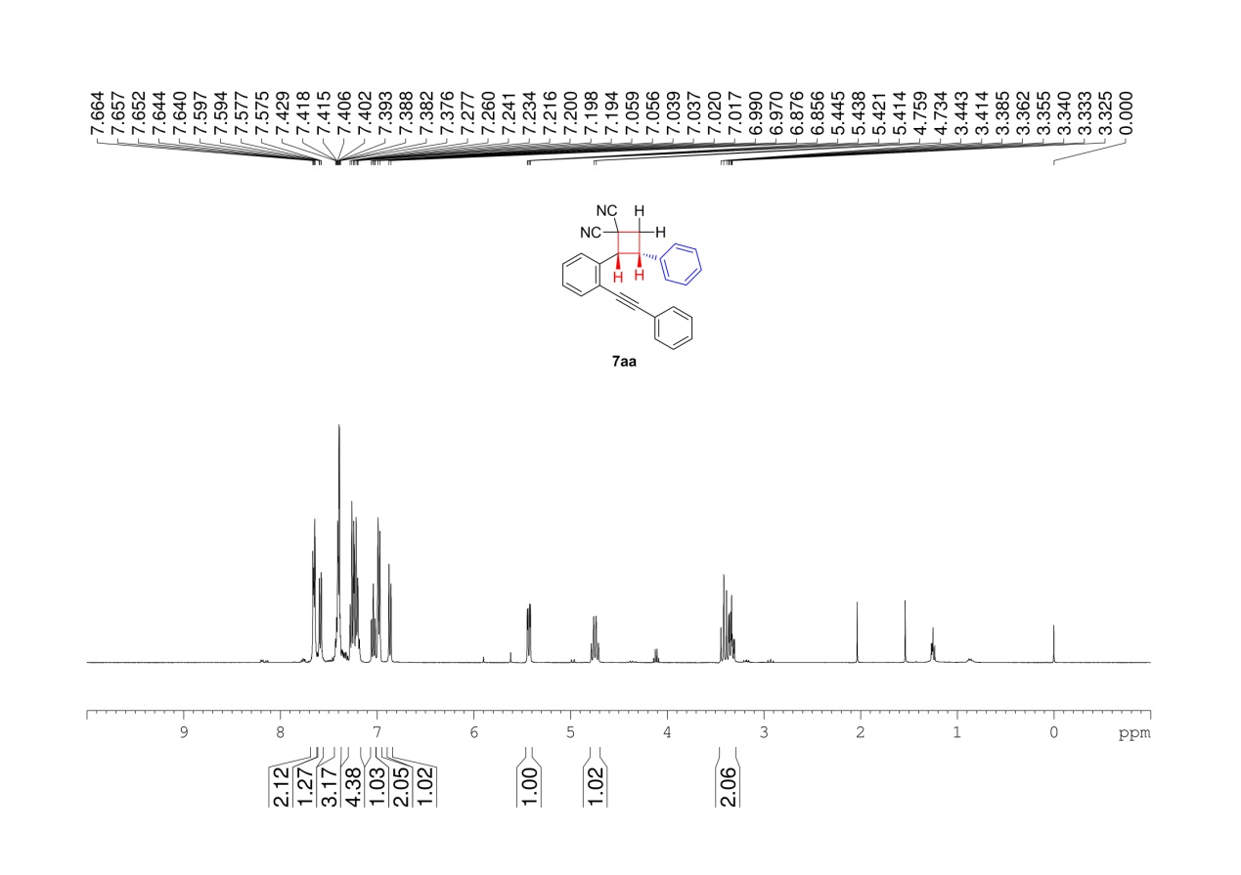
Supplementary Figure 114. ¹H NMR (400 MHz, CDCl₃) spectrum of 7aa

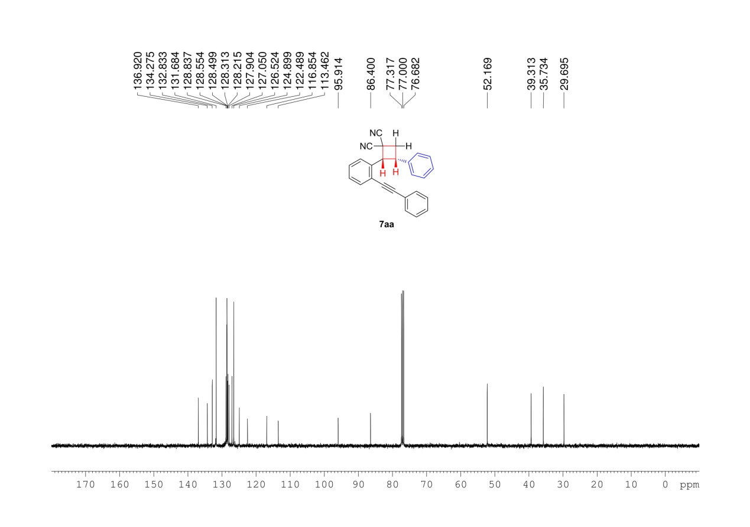
Supplementary Figure 115. ¹³C NMR (100MHz, CDCl₃) spectrum of 7aa

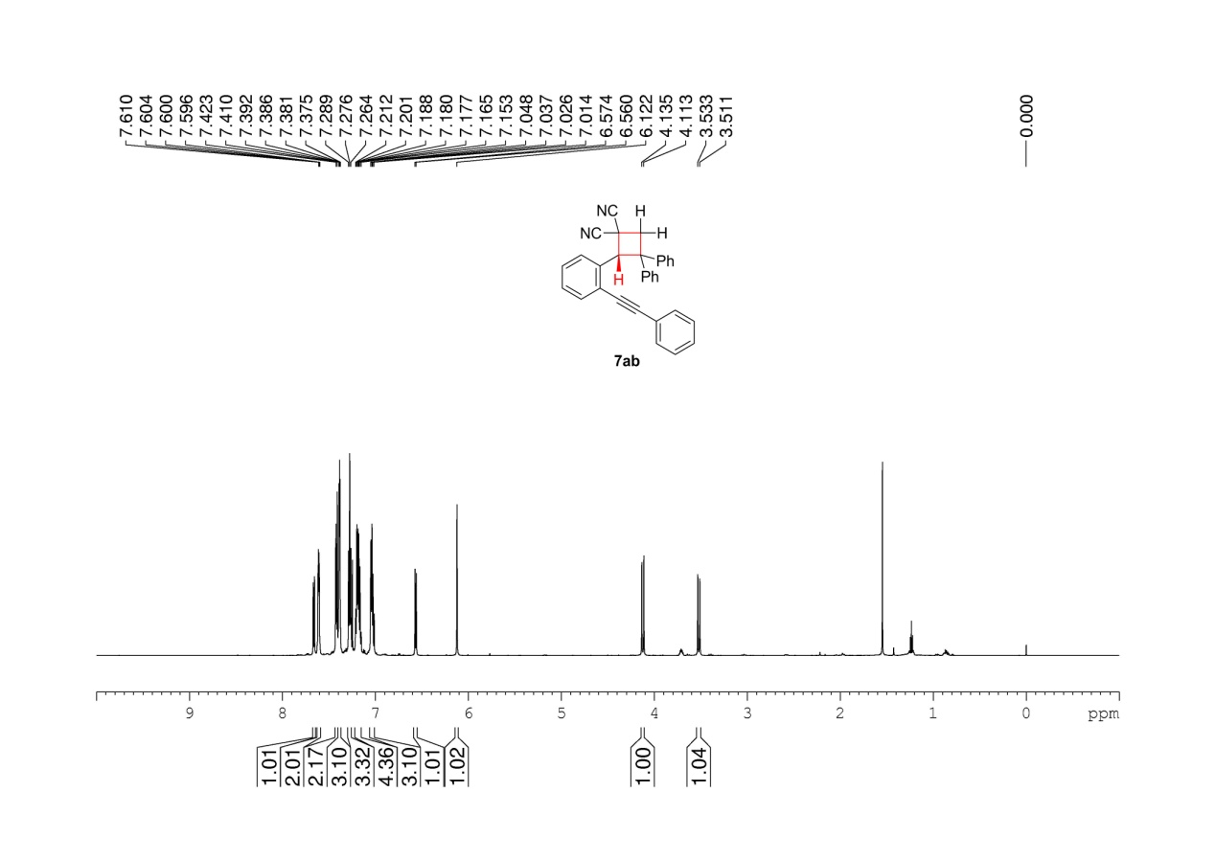
Supplementary Figure 116. ¹H NMR (600 MHz, CDCl₃) spectrum of 7ab

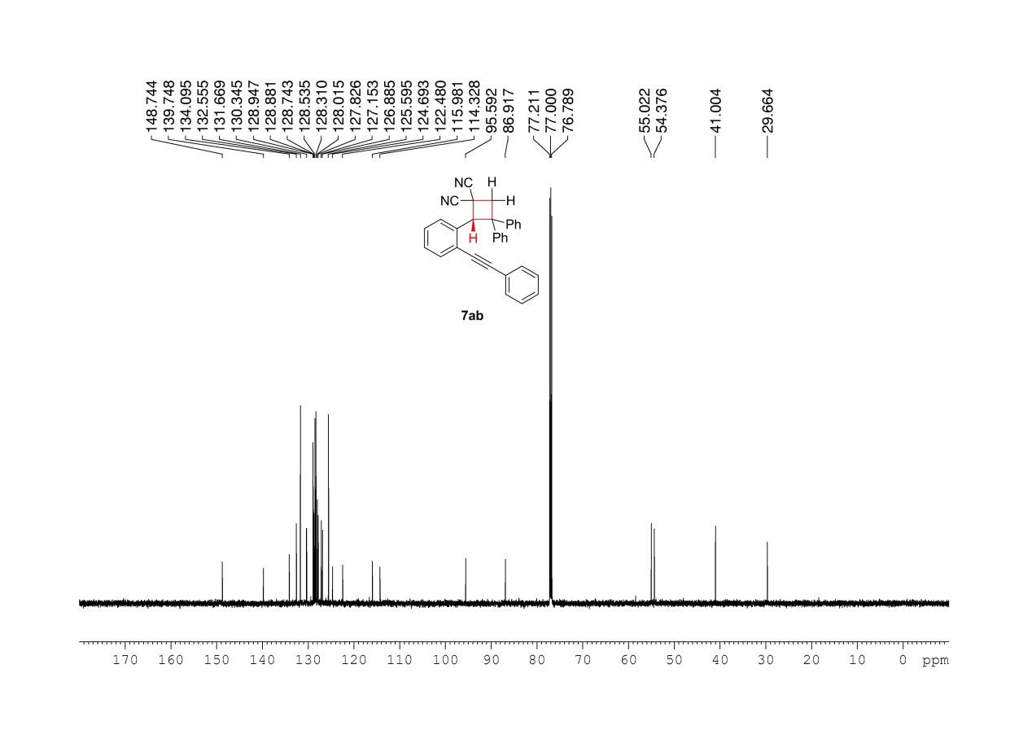
Supplementary Figure 117. ¹³C NMR (150MHz, CDCl₃) spectrum of 7ab

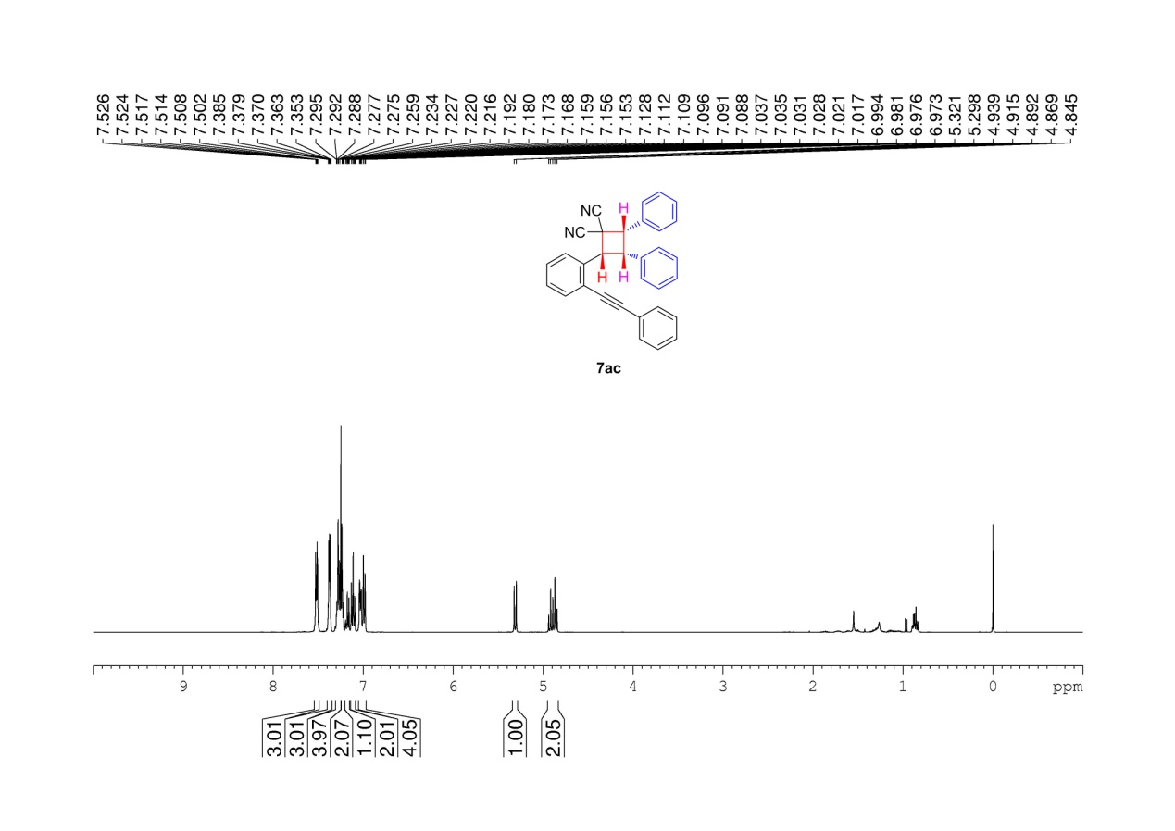
Supplementary Figure 118. ¹H NMR (400 MHz, CDCl₃) spectrum of 7ac

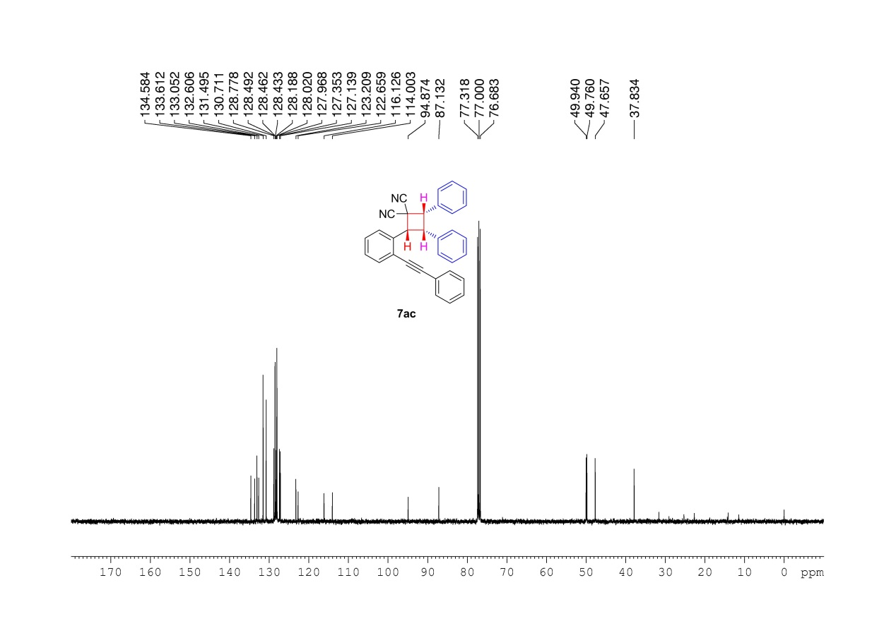
Supplementary Figure 119. ¹³C NMR (100MHz, CDCl₃) spectrum of 7ac

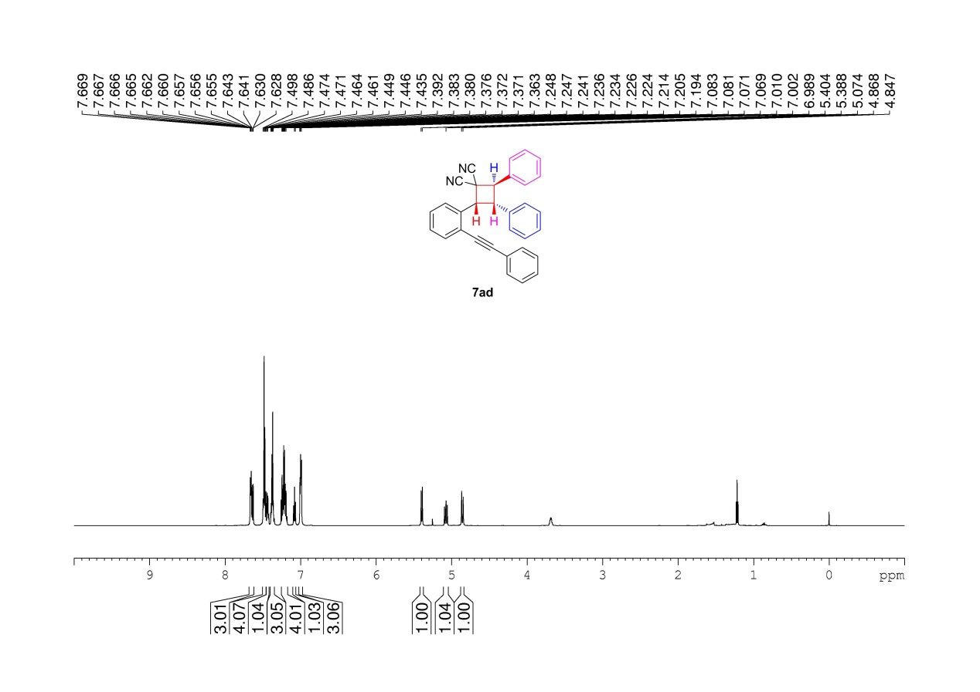
Supplementary Figure 120. ¹H NMR (600 MHz, CDCl₃) spectrum of 7ad

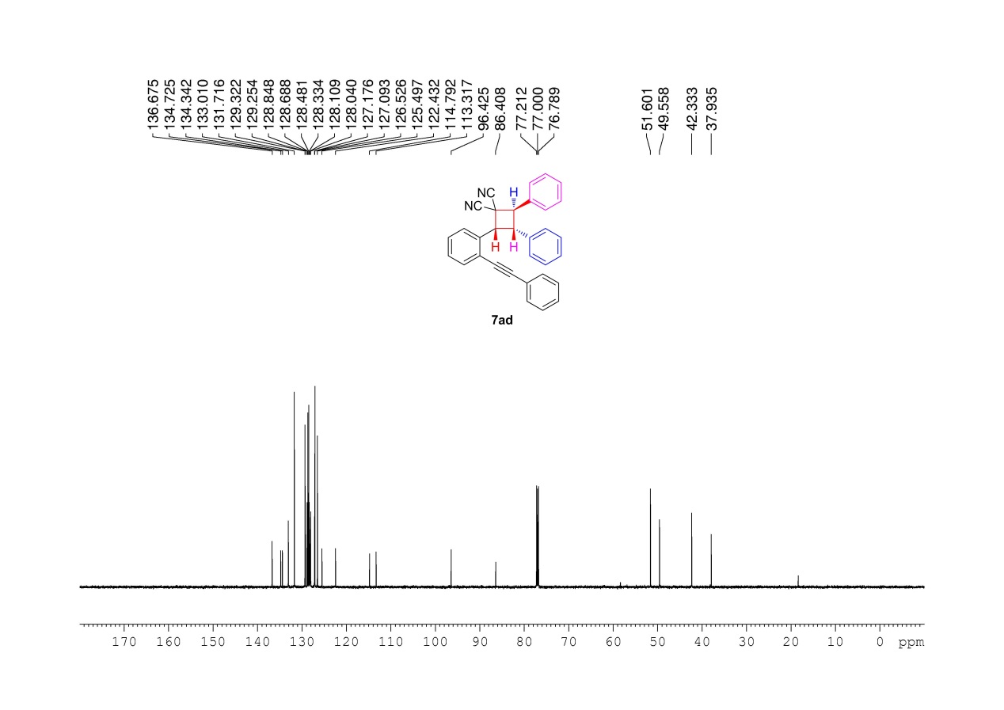
Supplementary Figure 121. ¹³C NMR (150MHz, CDCl₃) spectrum of 7ad

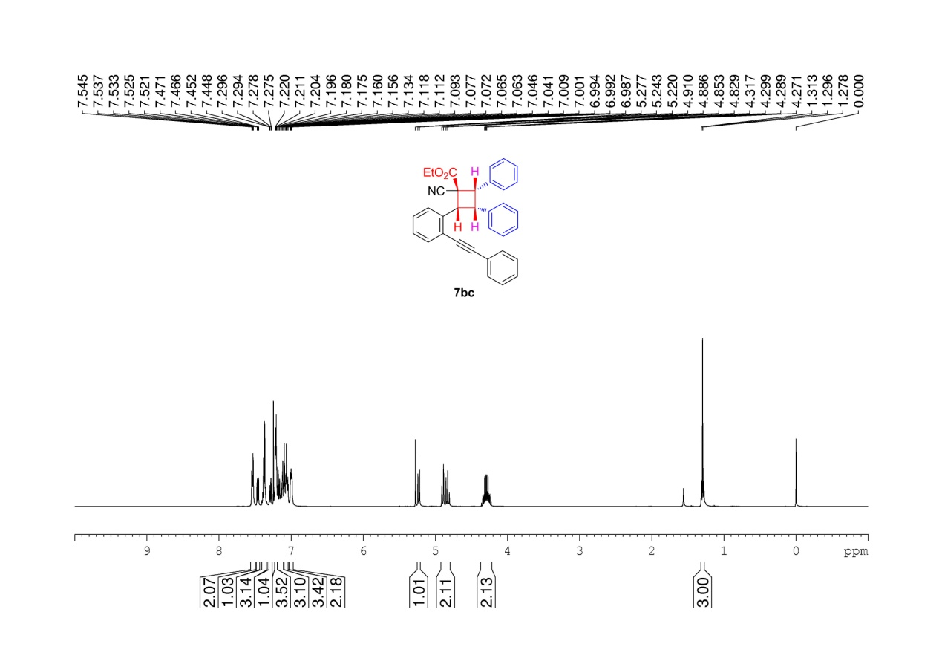
Supplementary Figure 122. ¹H NMR (400 MHz, CDCl₃) spectrum of 7bc

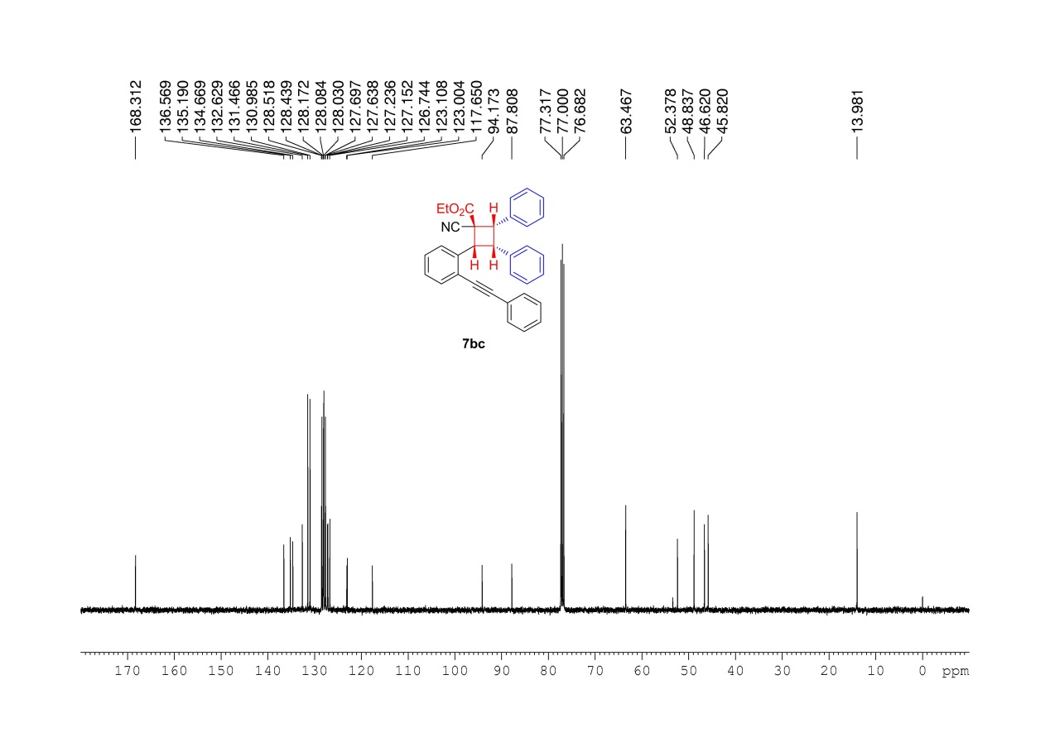
Supplementary Figure 123. ¹³C NMR (100MHz, CDCl₃) spectrum of 7bc

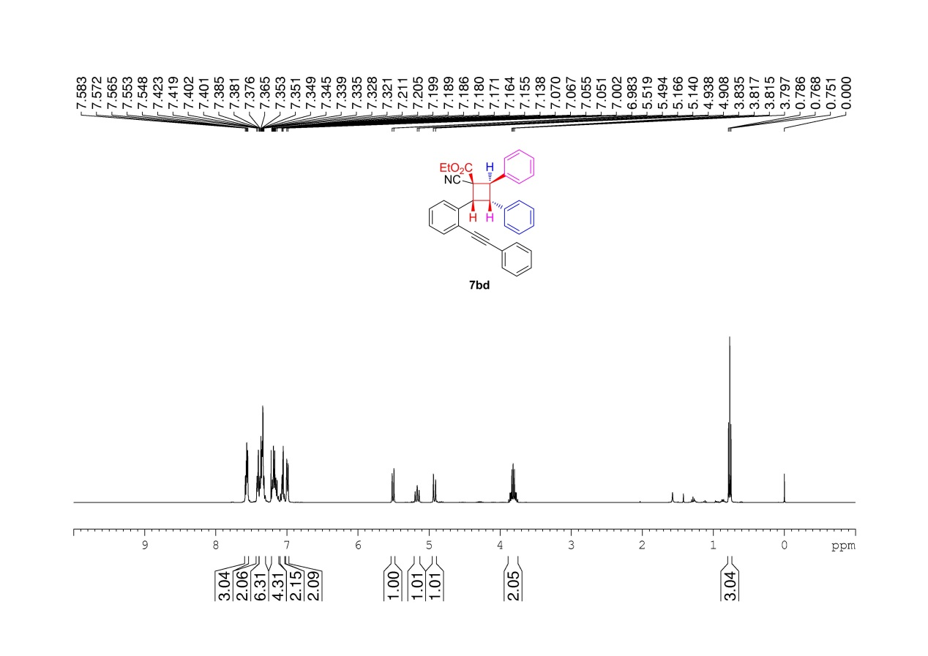
Supplementary Figure 124. ¹H NMR (400 MHz, CDCl₃) spectrum of 7bd

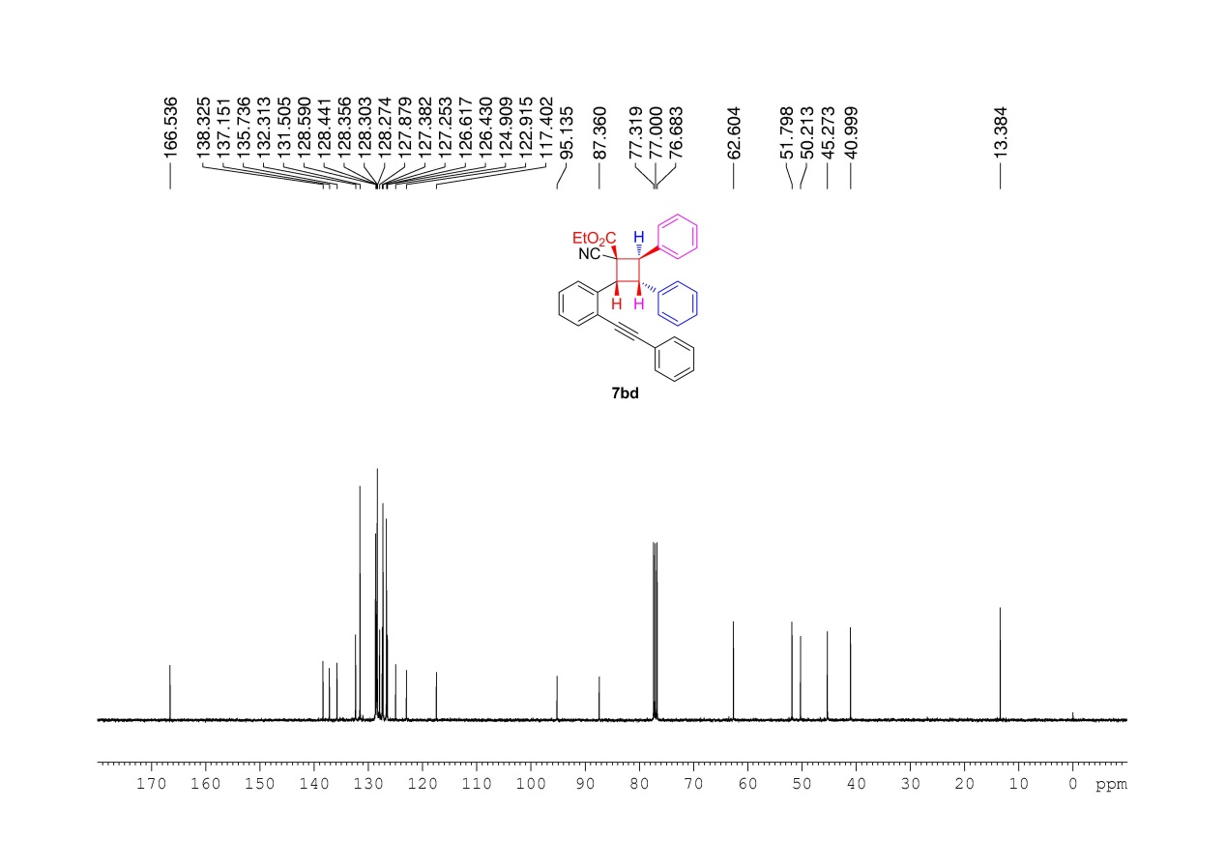
Supplementary Figure 125. ¹³C NMR (100MHz, CDCl₃) spectrum of 7bd

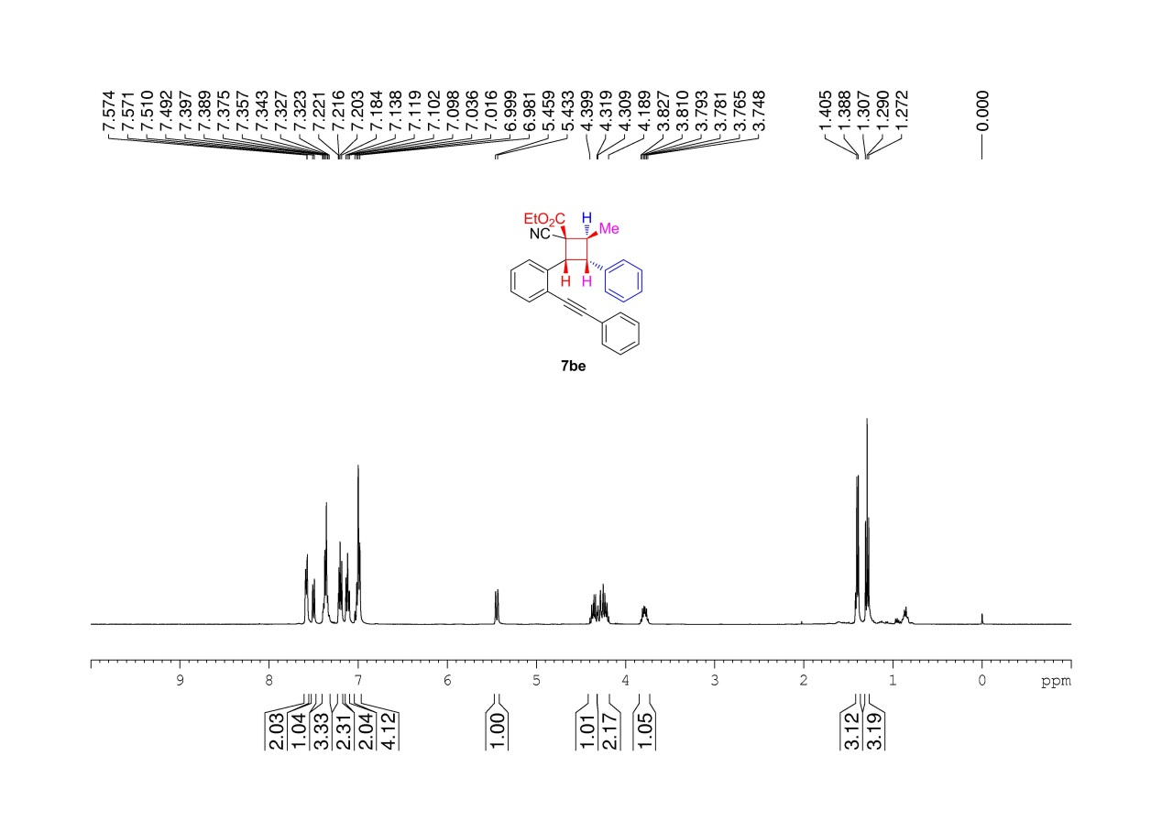
Supplementary Figure 126. ¹H NMR (400 MHz, CDCl₃) spectrum of 7be

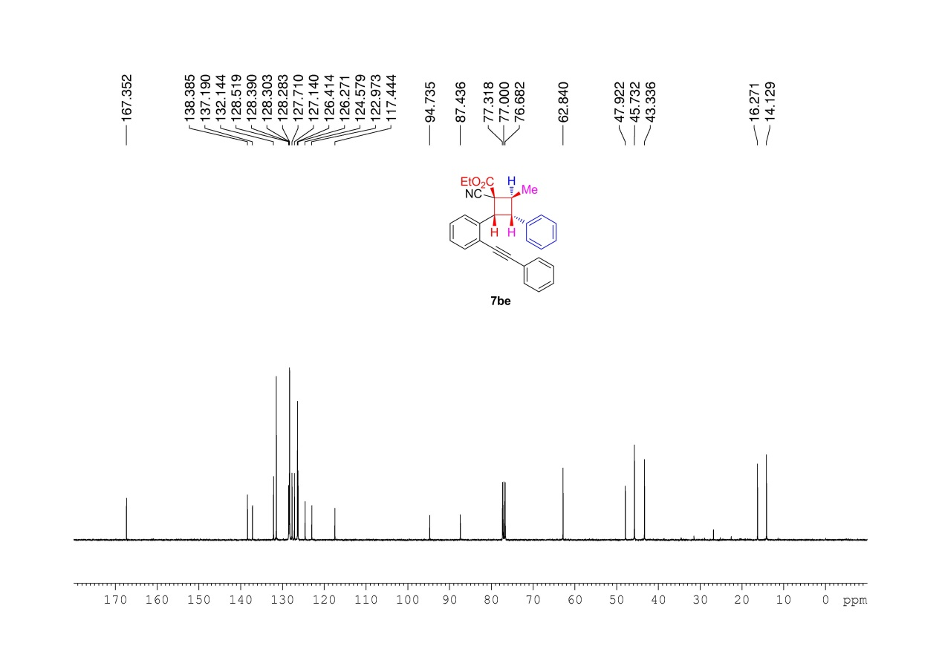
Supplementary Figure 127. ¹³C NMR (100MHz, CDCl₃) spectrum of 7be

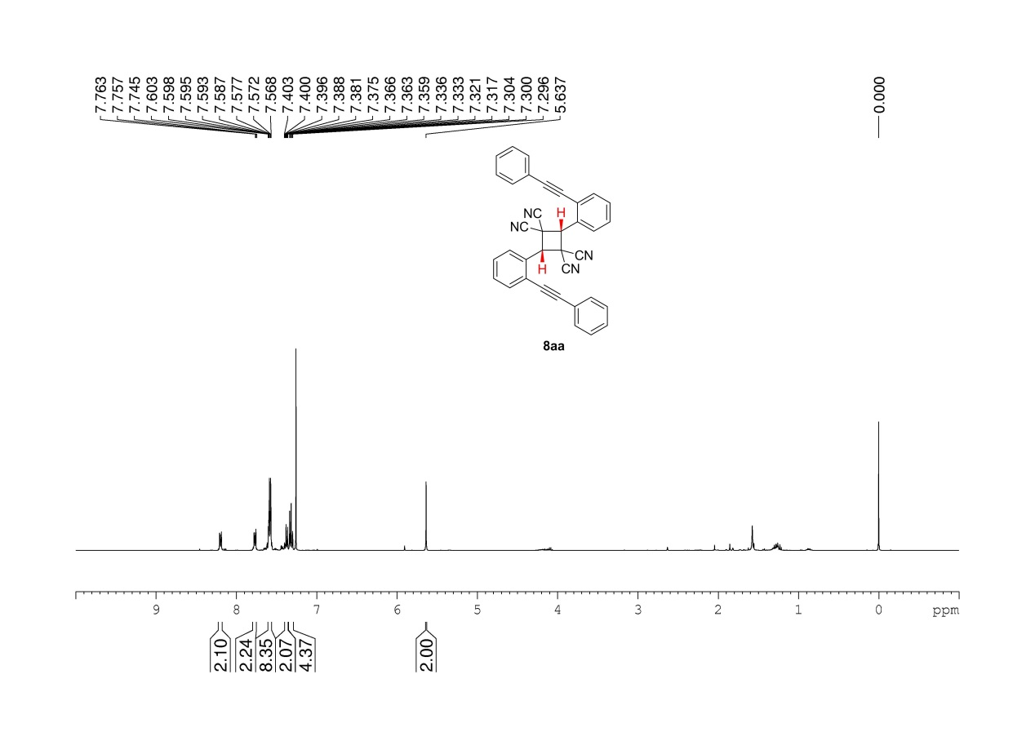
Supplementary Figure 128. ¹H NMR (400 MHz, CDCl₃) spectrum of 8aa

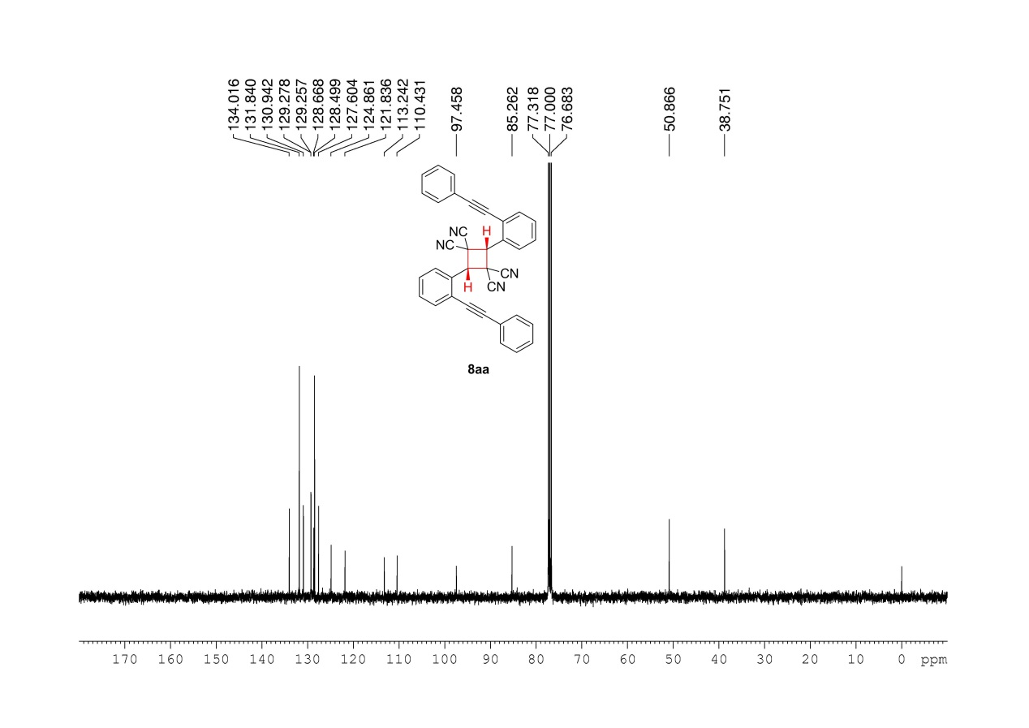
Supplementary Figure 129. ¹³C NMR (100MHz, CDCl₃) spectrum of 8aa

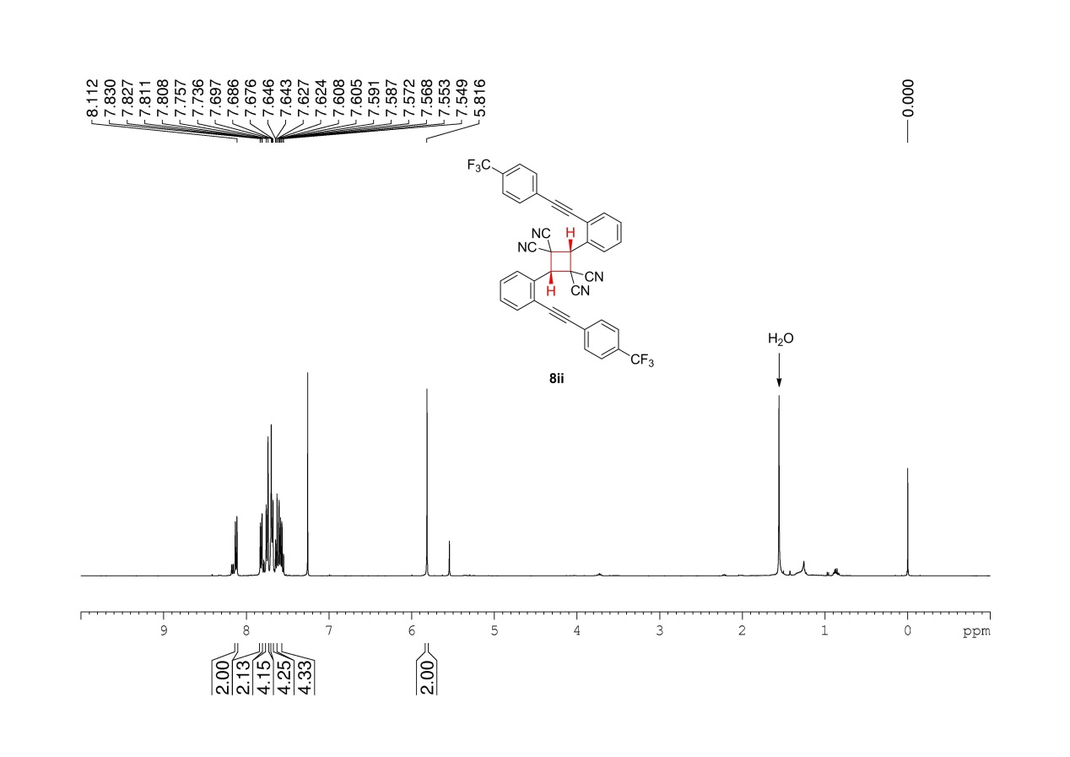
Supplementary Figure 130. ¹H NMR (400 MHz, CDCl₃) spectrum of 8ii

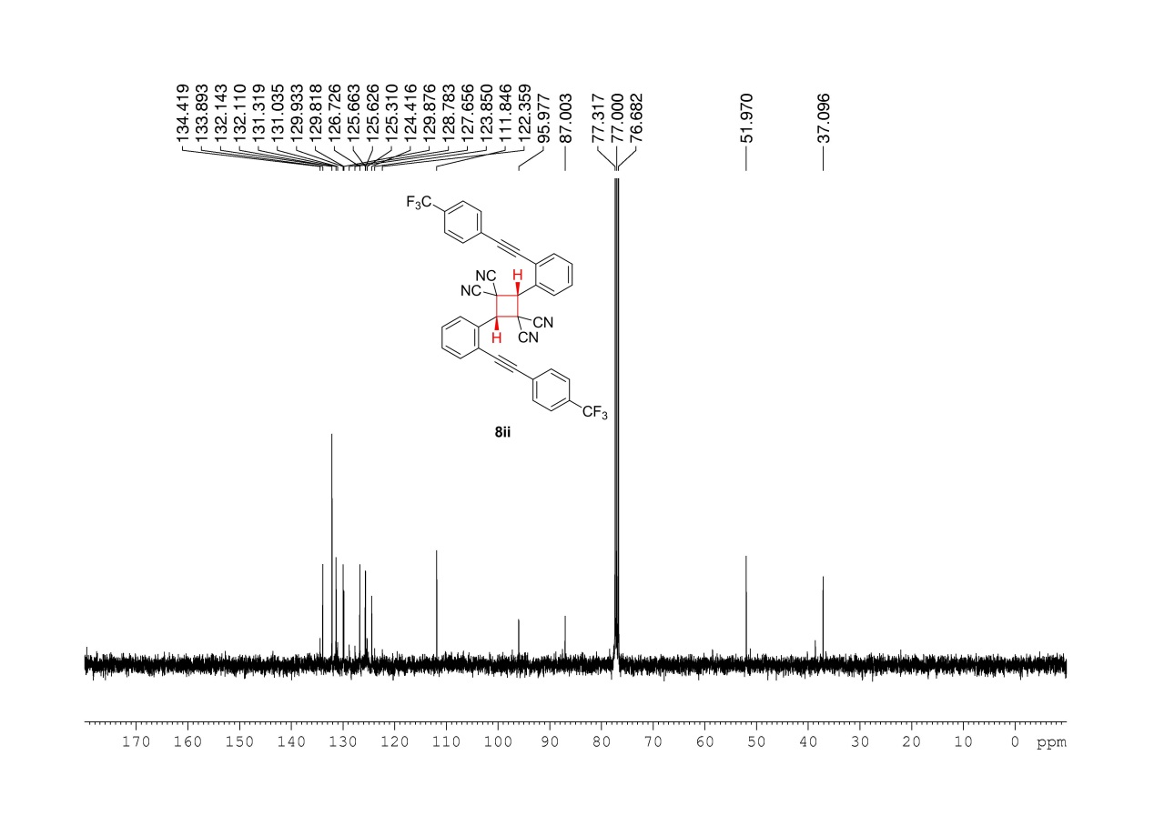
Supplementary Figure 131. ¹³C NMR (100MHz, CDCl₃) spectrum of 8ii

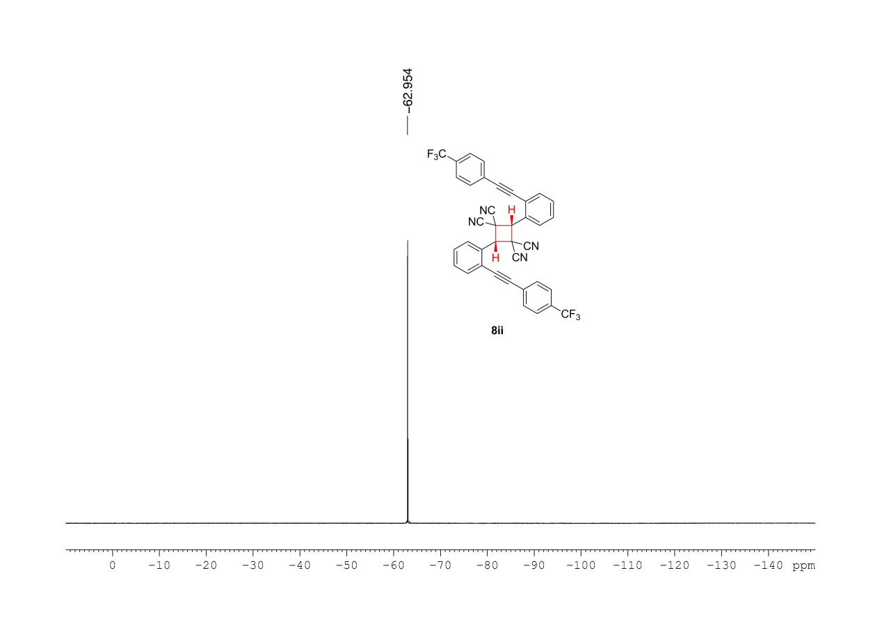
Supplementary Figure 132. ¹⁹F NMR (376MHz, CDCl₃) spectrum of 8ii

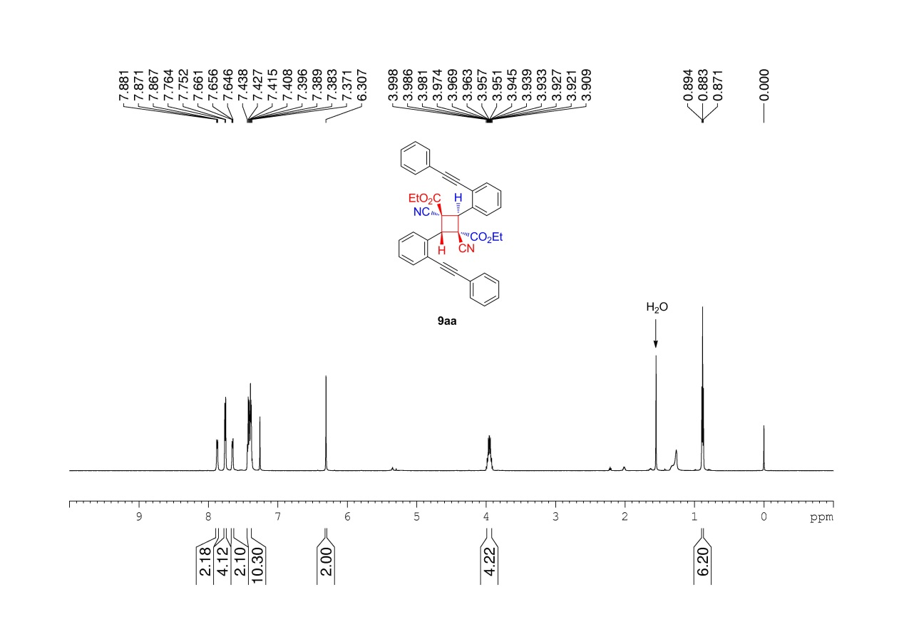
Supplementary Figure 133. ¹H NMR (400 MHz, CDCl₃) spectrum of 9aa

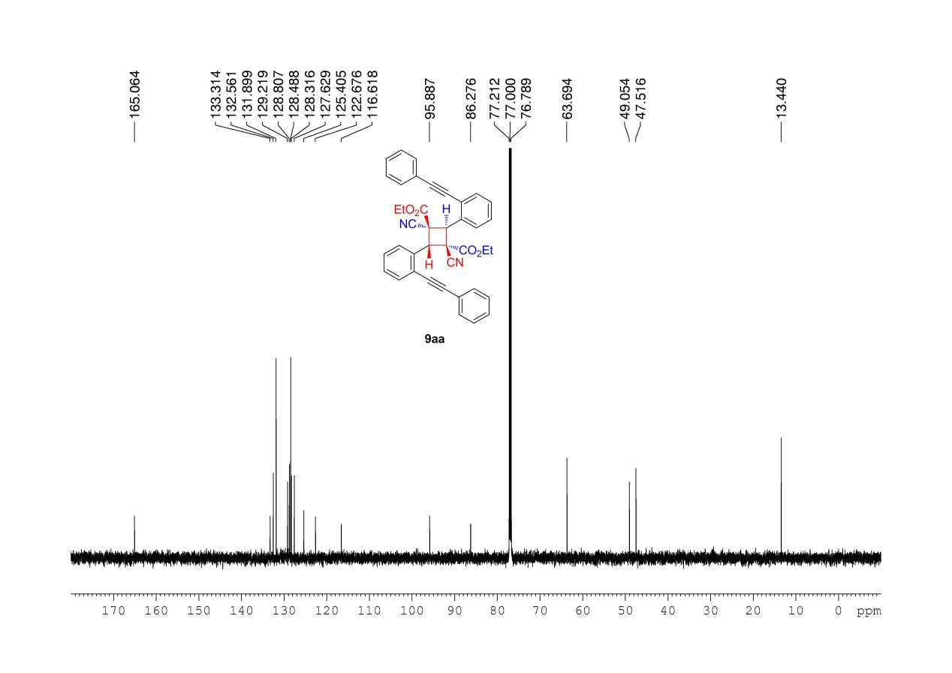
Supplementary Figure 134. ¹³C NMR (100MHz, CDCl₃) spectrum of 9aa

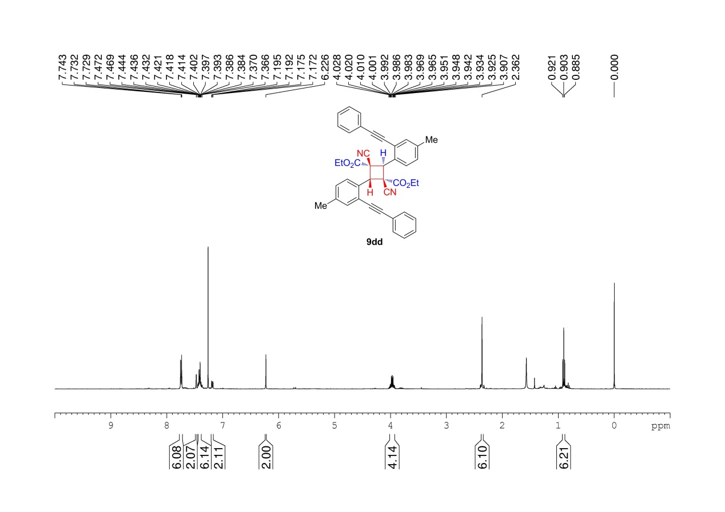
Supplementary Figure 135. ¹H NMR (400 MHz, CDCl₃) spectrum of 9dd

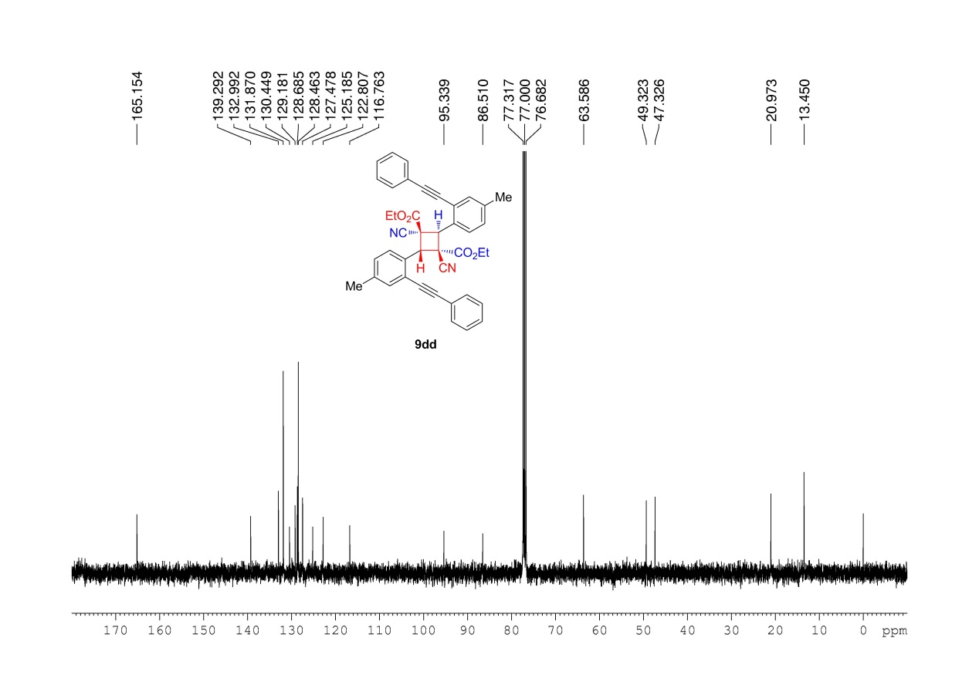
Supplementary Figure 136. ¹³C NMR (100MHz, CDCl₃) spectrum of 9dd

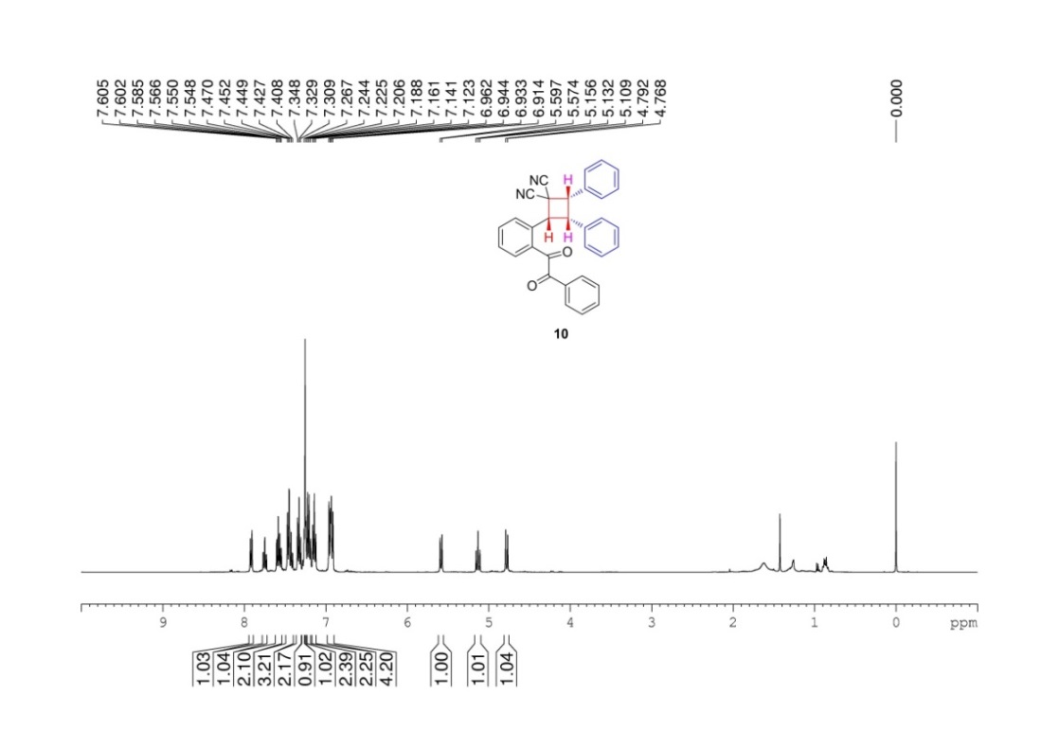
Supplementary Figure 137. ¹H NMR (400 MHz, CDCl₃) spectrum of 10

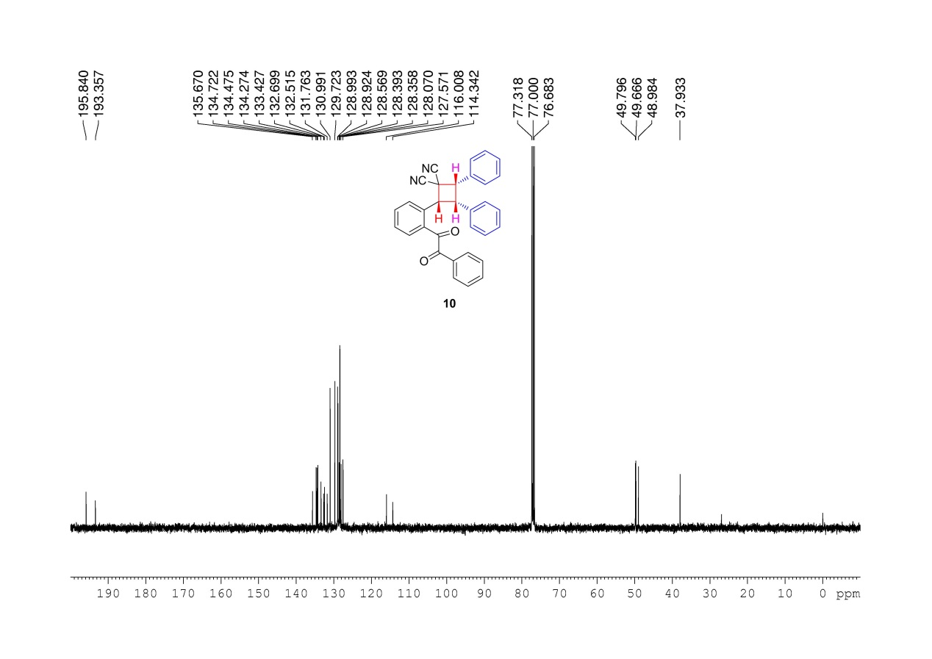
Supplementary Figure 138. ¹³C NMR (100MHz, CDCl₃) spectrum of 10

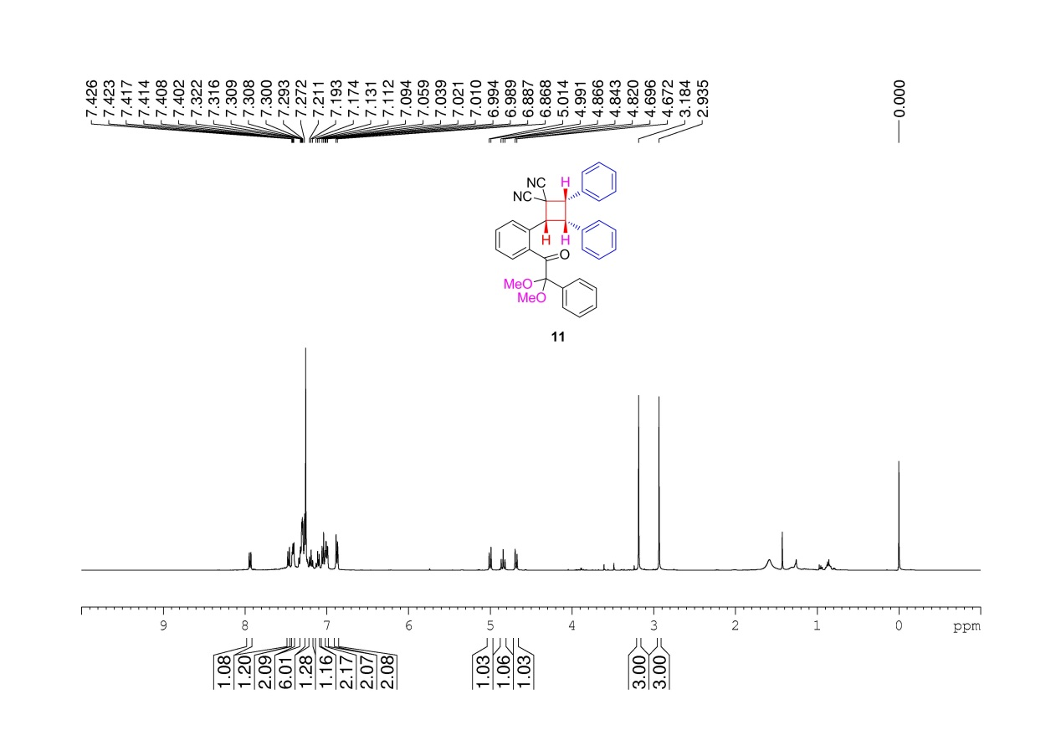
Supplementary Figure 139. ¹H NMR (400 MHz, CDCl₃) spectrum of 11

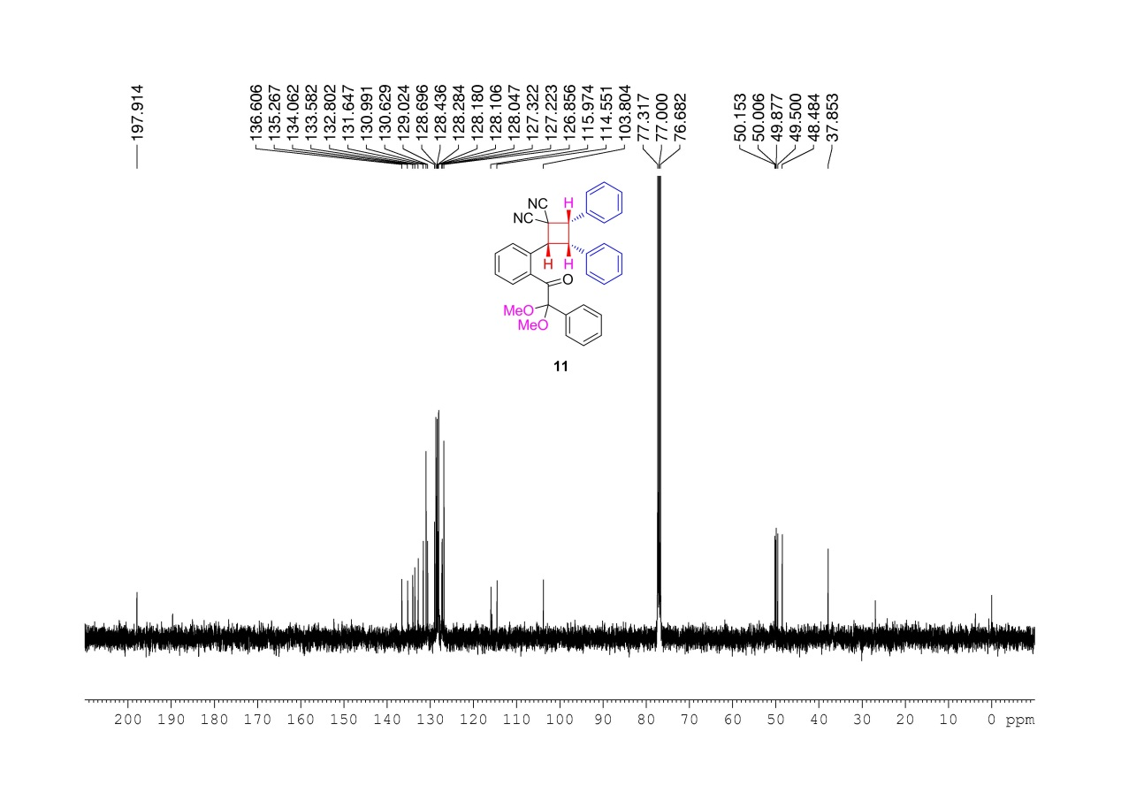
Supplementary Figure 140. ¹³C NMR (100MHz, CDCl₃) spectrum of 11

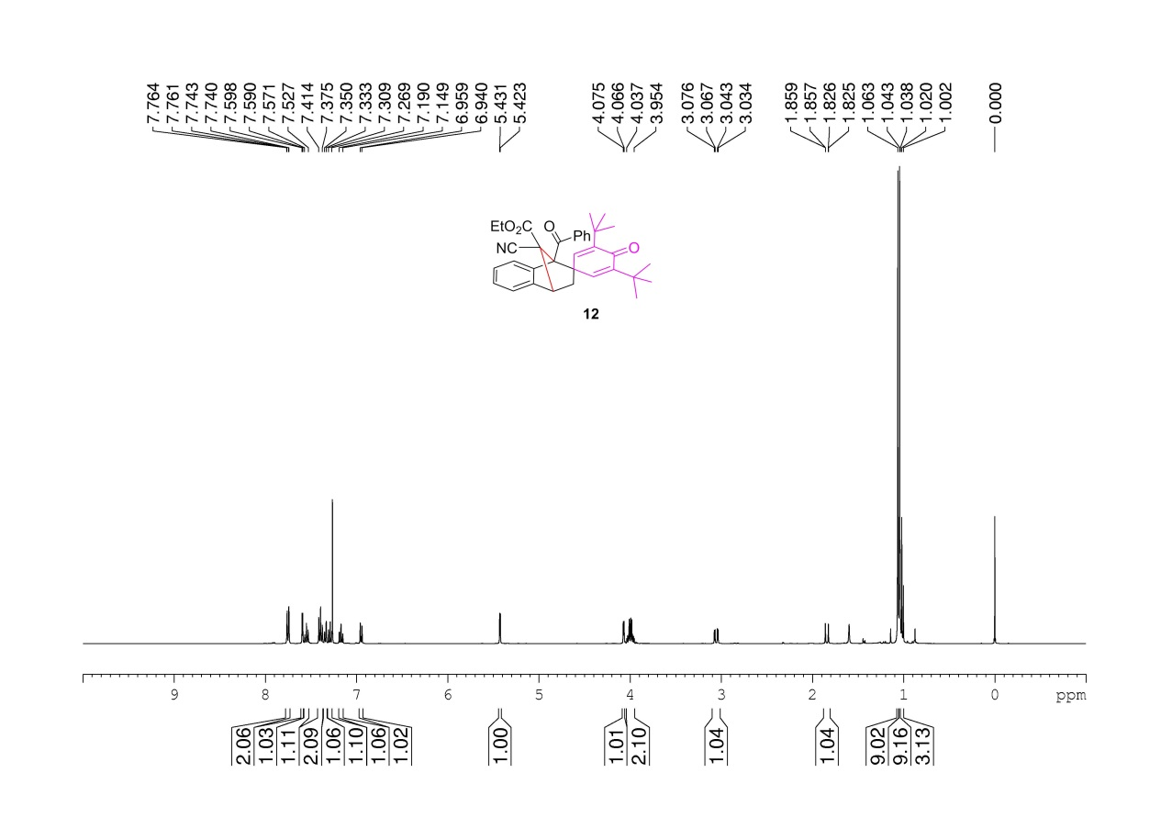
Supplementary Figure 141. ¹H NMR (400 MHz, CDCl₃) spectrum of 12

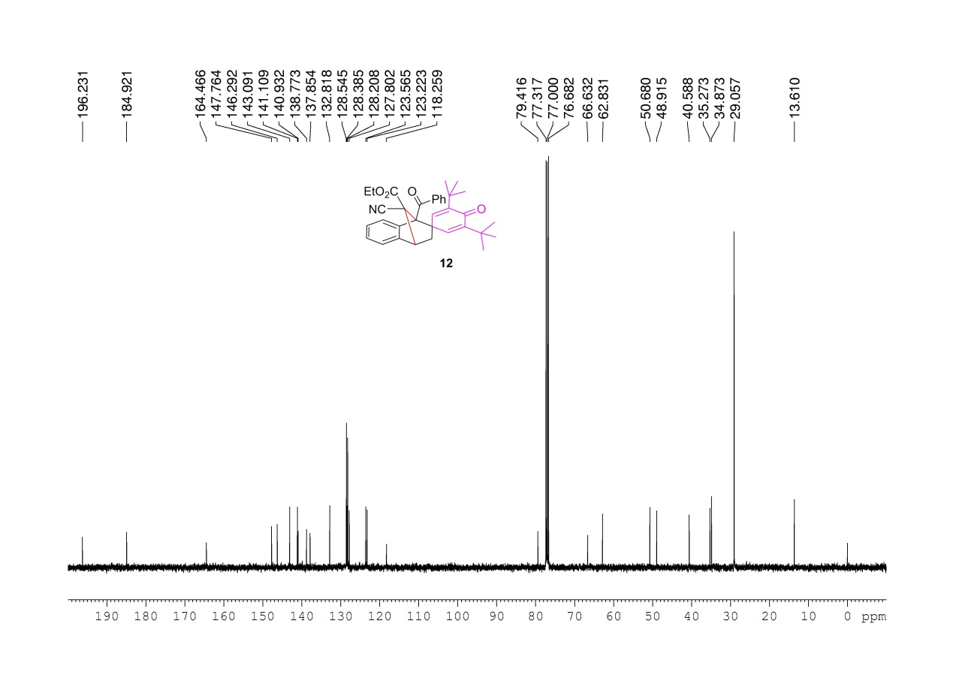
Supplementary Figure 142. ¹³C NMR (100MHz, CDCl₃) spectrum of 12

Supplementary Figure 143. Absorption spectrum of 1a in DCE.
The UV/Vis absorption spectra of 2-(2-(phenylethynyl)benzylidene) malononitrile 1a (0.1 M, 0.05 M, 0.025 M) in 1,2-dichloroethane were recorded in 1 cm path quartz cuvettes by using a UV-Visible U-4100 spectrophotometer.

X-Ray single crystal diffraction analysis of the products
X-Ray single crystal diffraction analysis of 3aa (CCDC: 2035710)
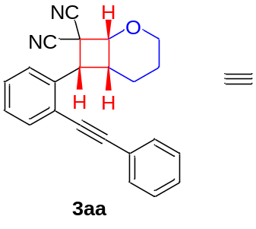 | 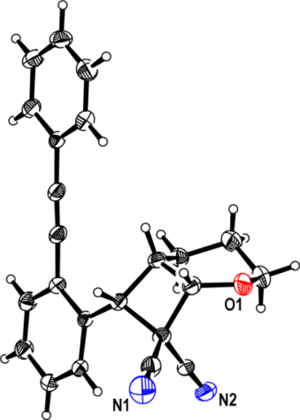

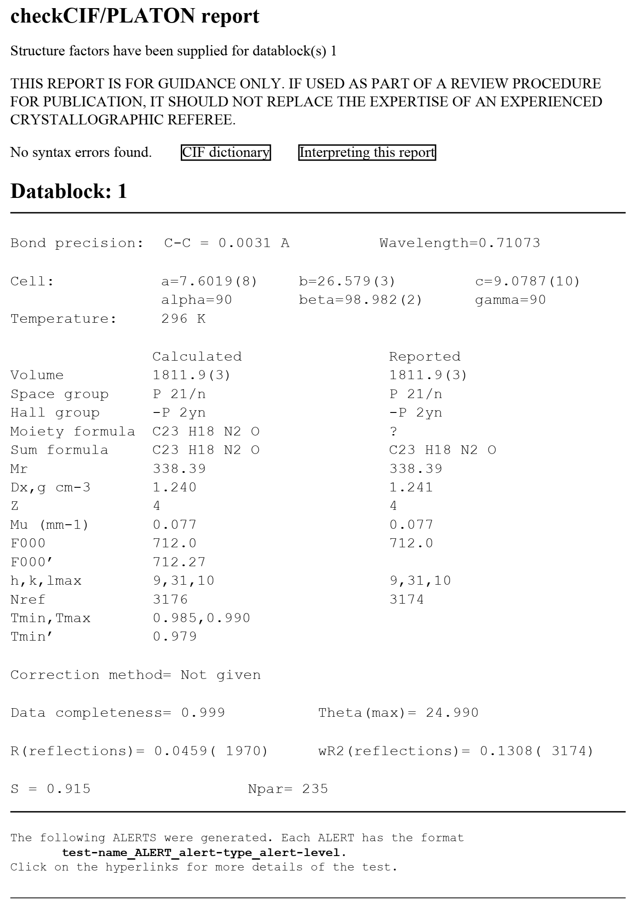

X-Ray single crystal diffraction analysis of 3(aa)' (CCDC: 2035711)
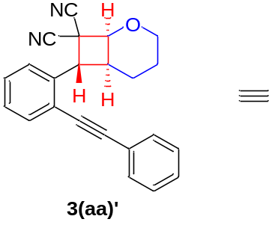

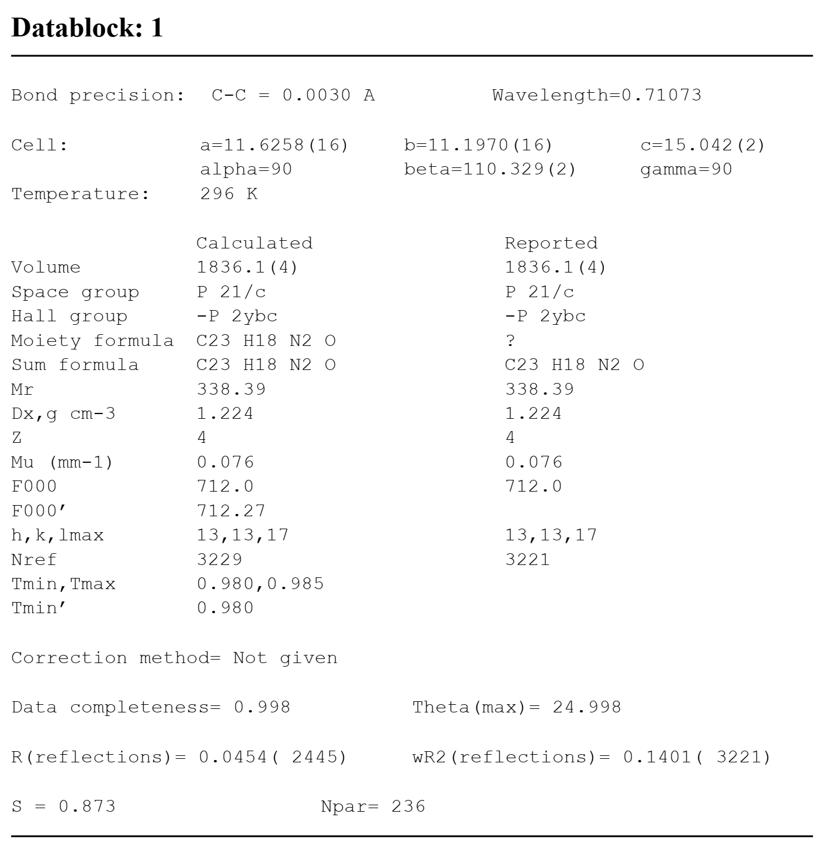

X-Ray single crystal diffraction analysis of 3ab (CCDC: 2035712)
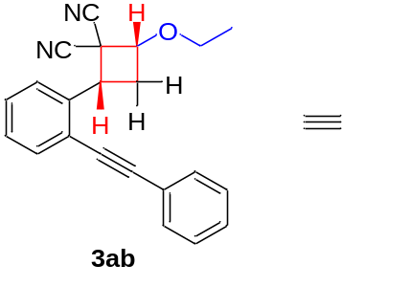

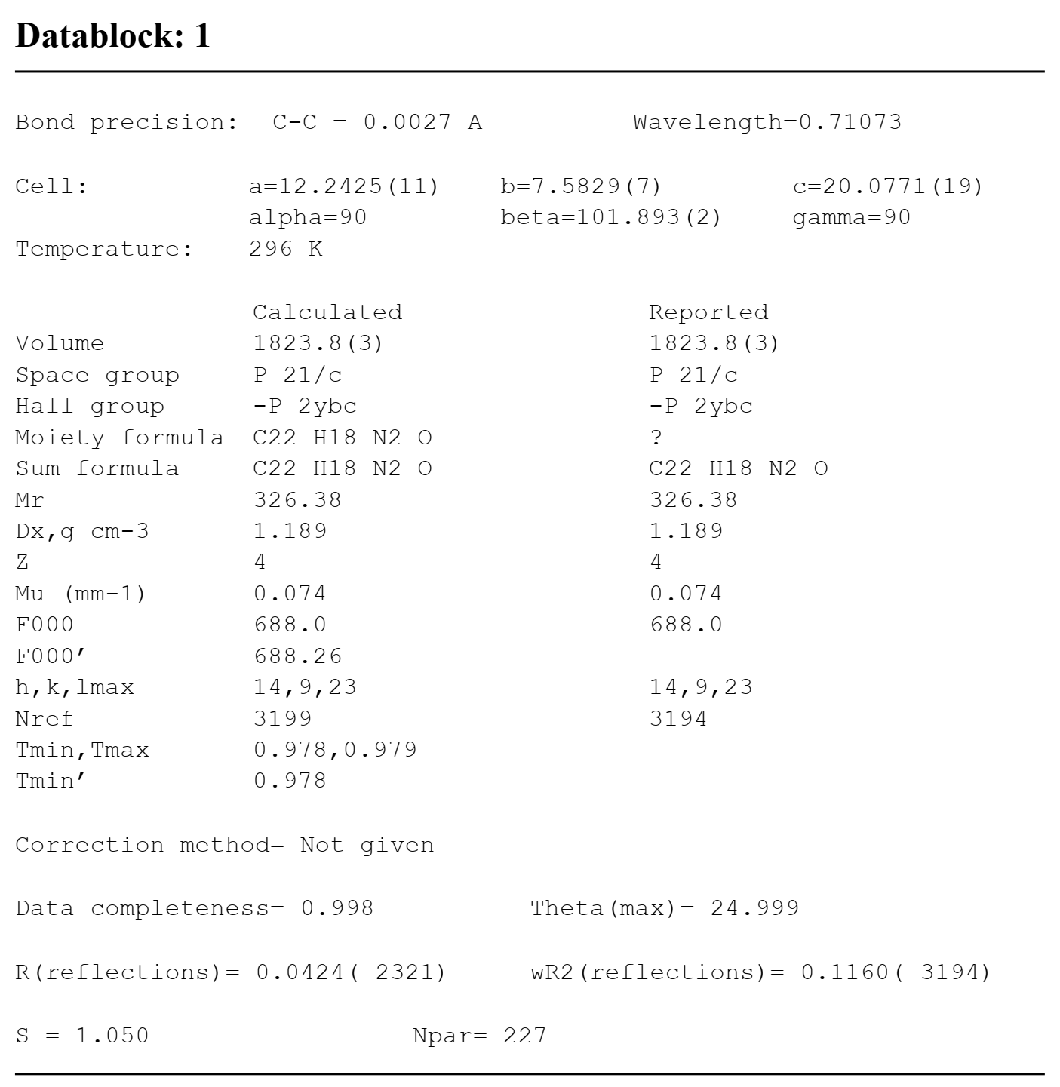

X-Ray single crystal diffraction analysis of 5aa (CCDC: 2035713)
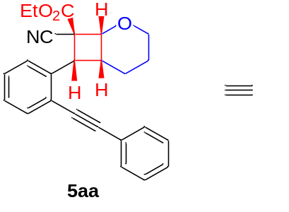
、

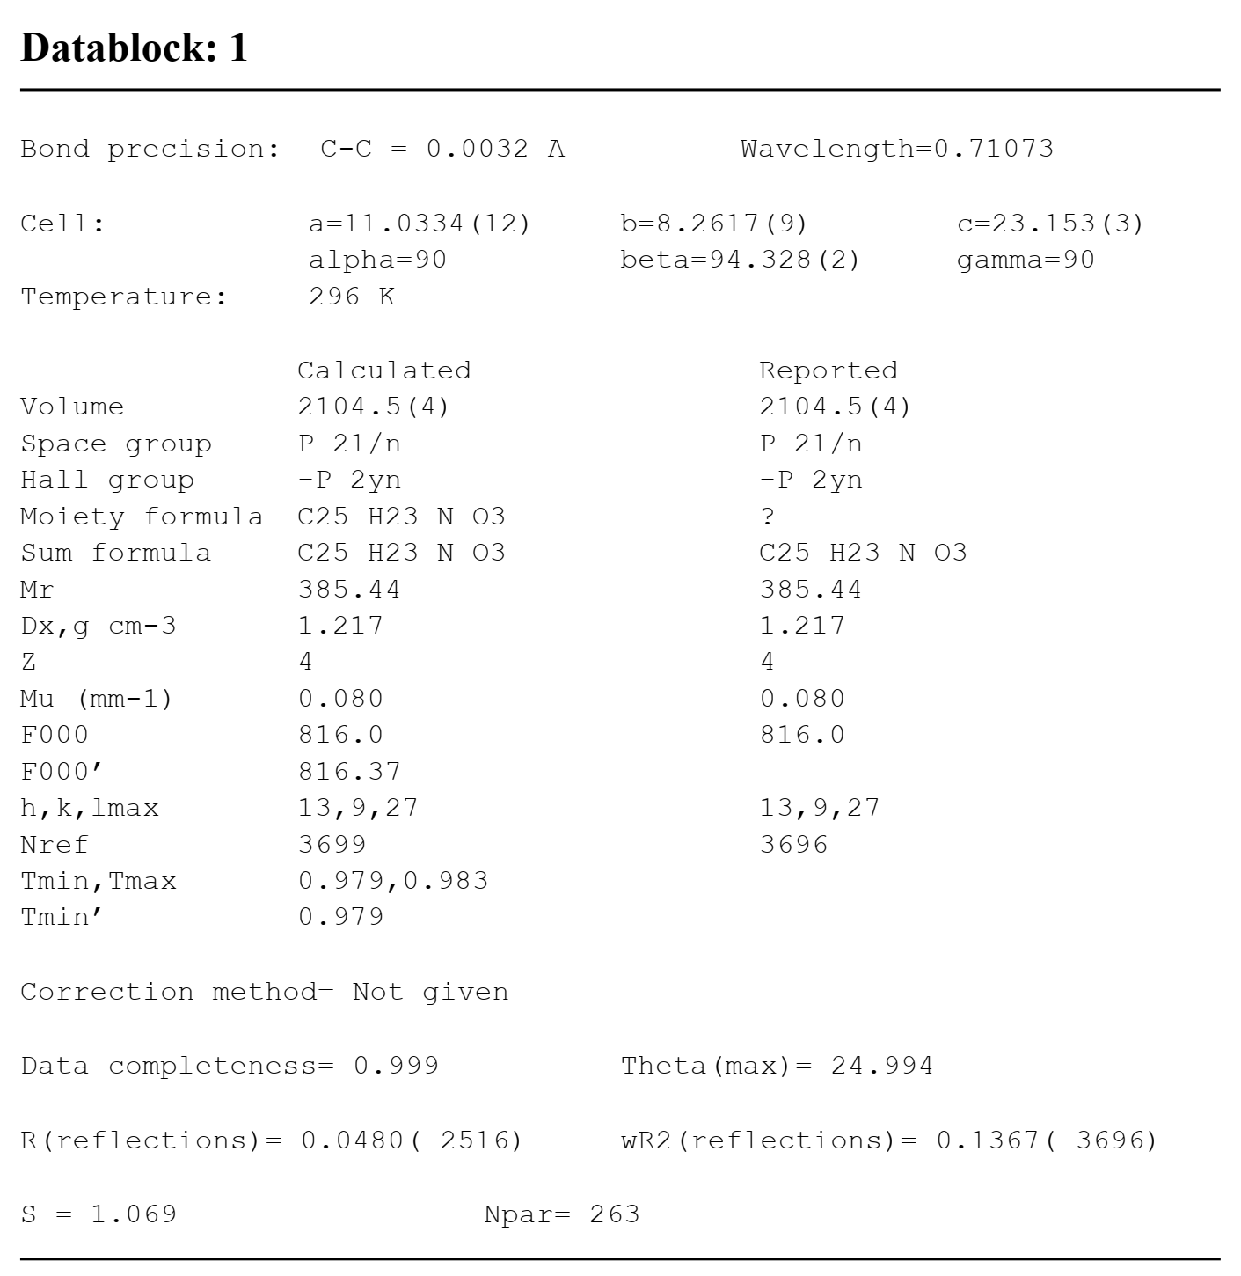

X-Ray single crystal diffraction analysis of 5(aa)’ (CCDC: 2045867)
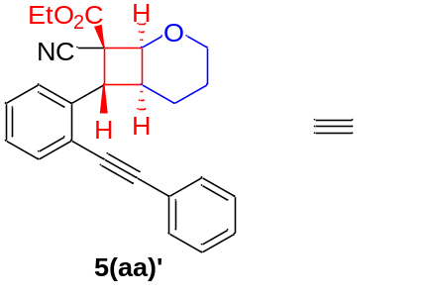

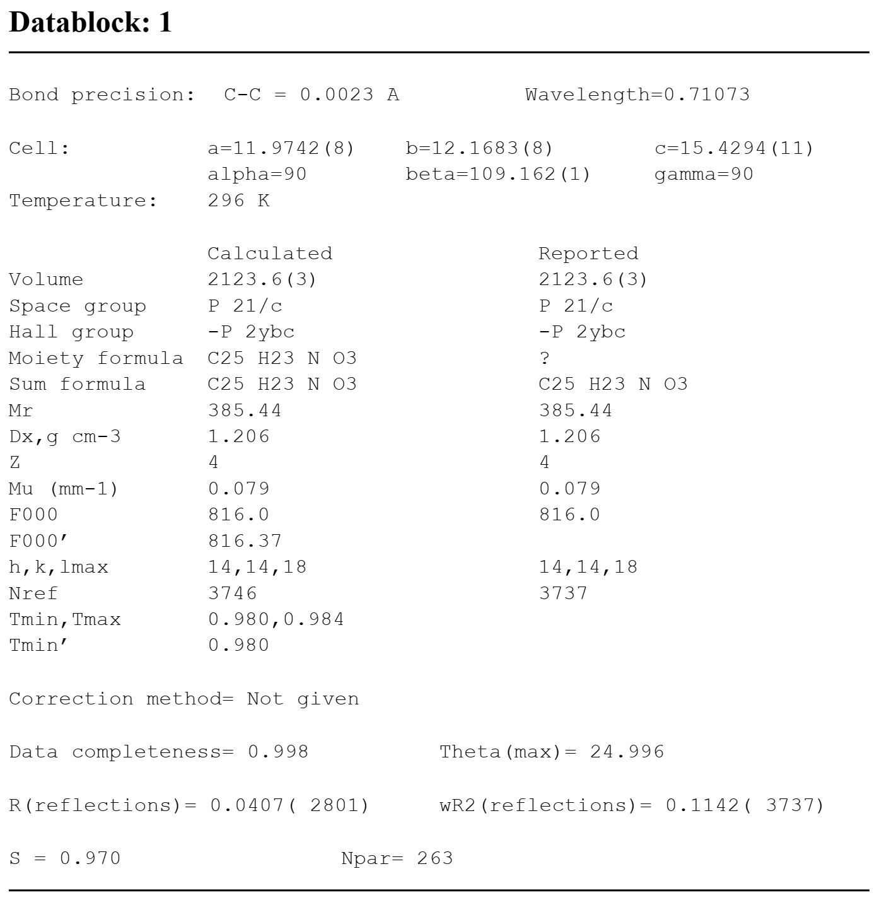

X-Ray single crystal diffraction analysis of 7aa (CCDC: 2035714)
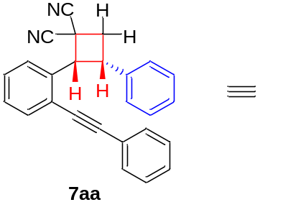

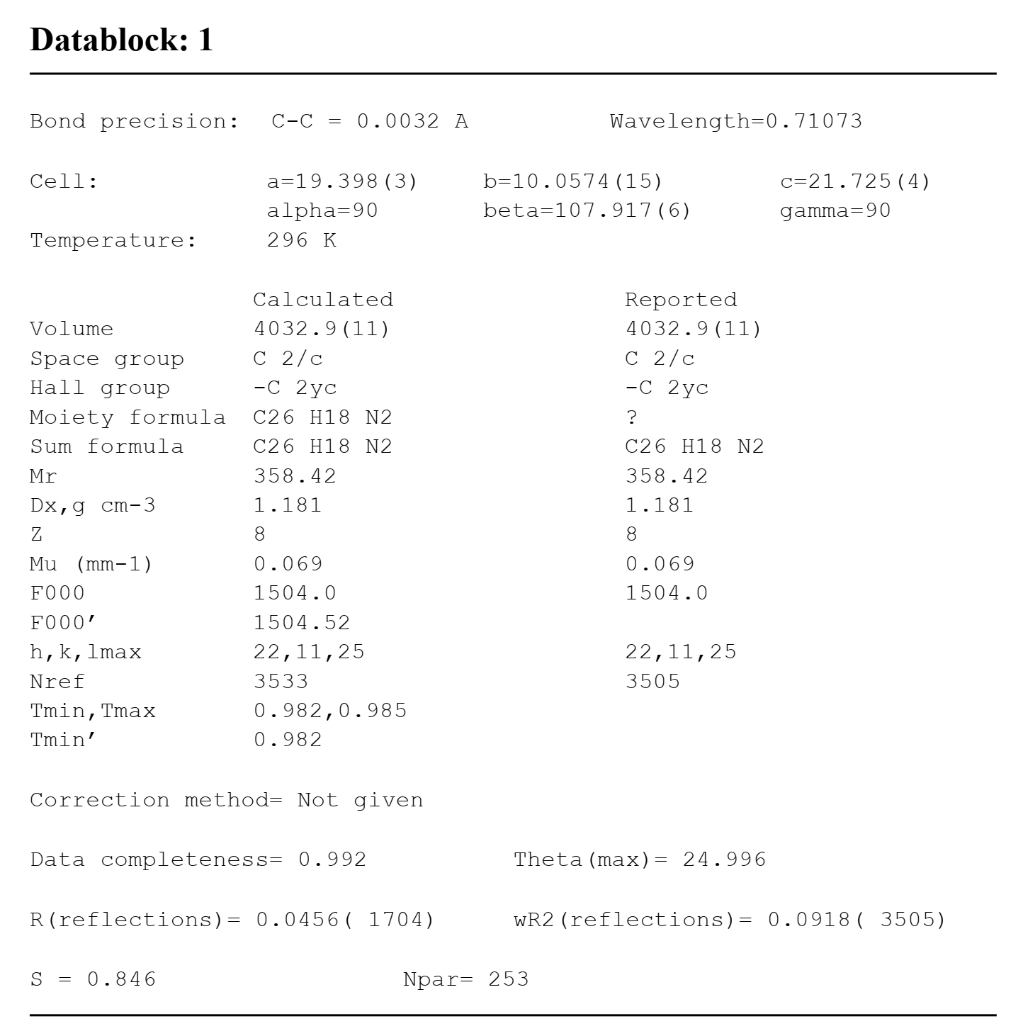

X-Ray single crystal diffraction analysis of 7bc (CCDC: 2035715)
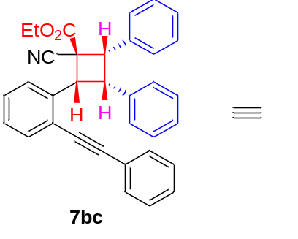
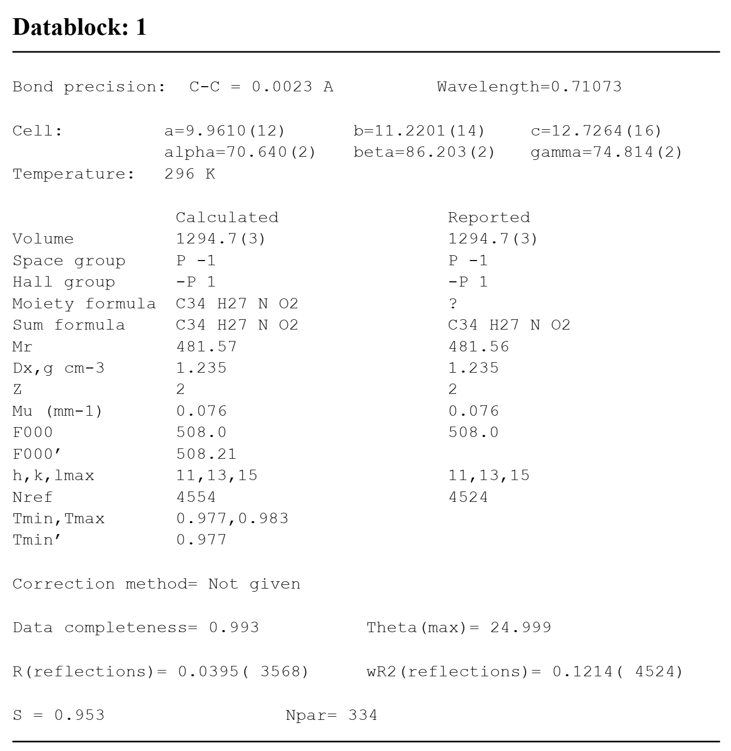

X-Ray single crystal diffraction analysis of 7bd (CCDC: 2035716)
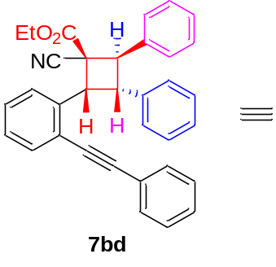

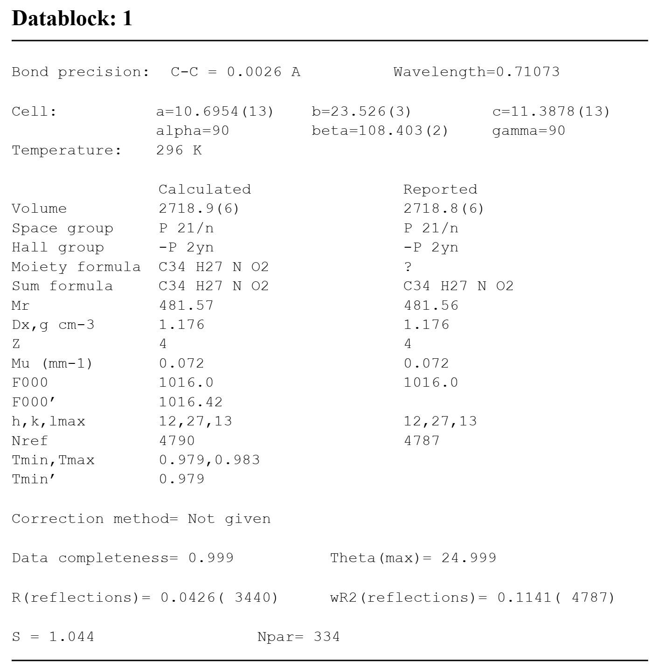

X-Ray single crystal diffraction analysis of 7be (CCDC: 2035717)
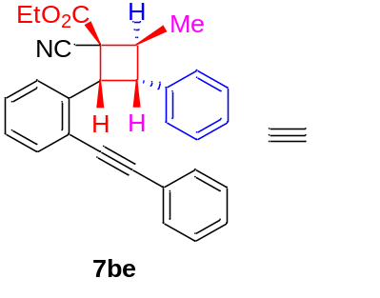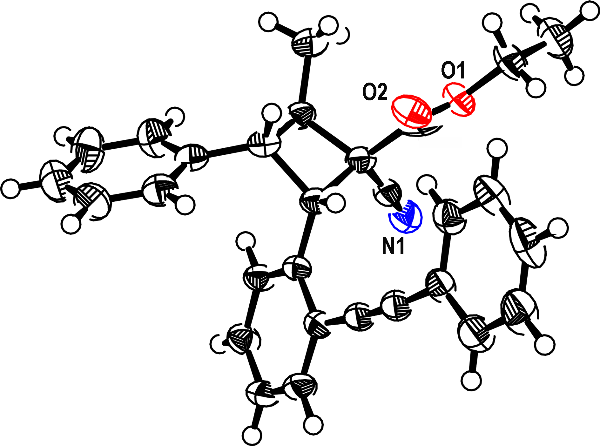

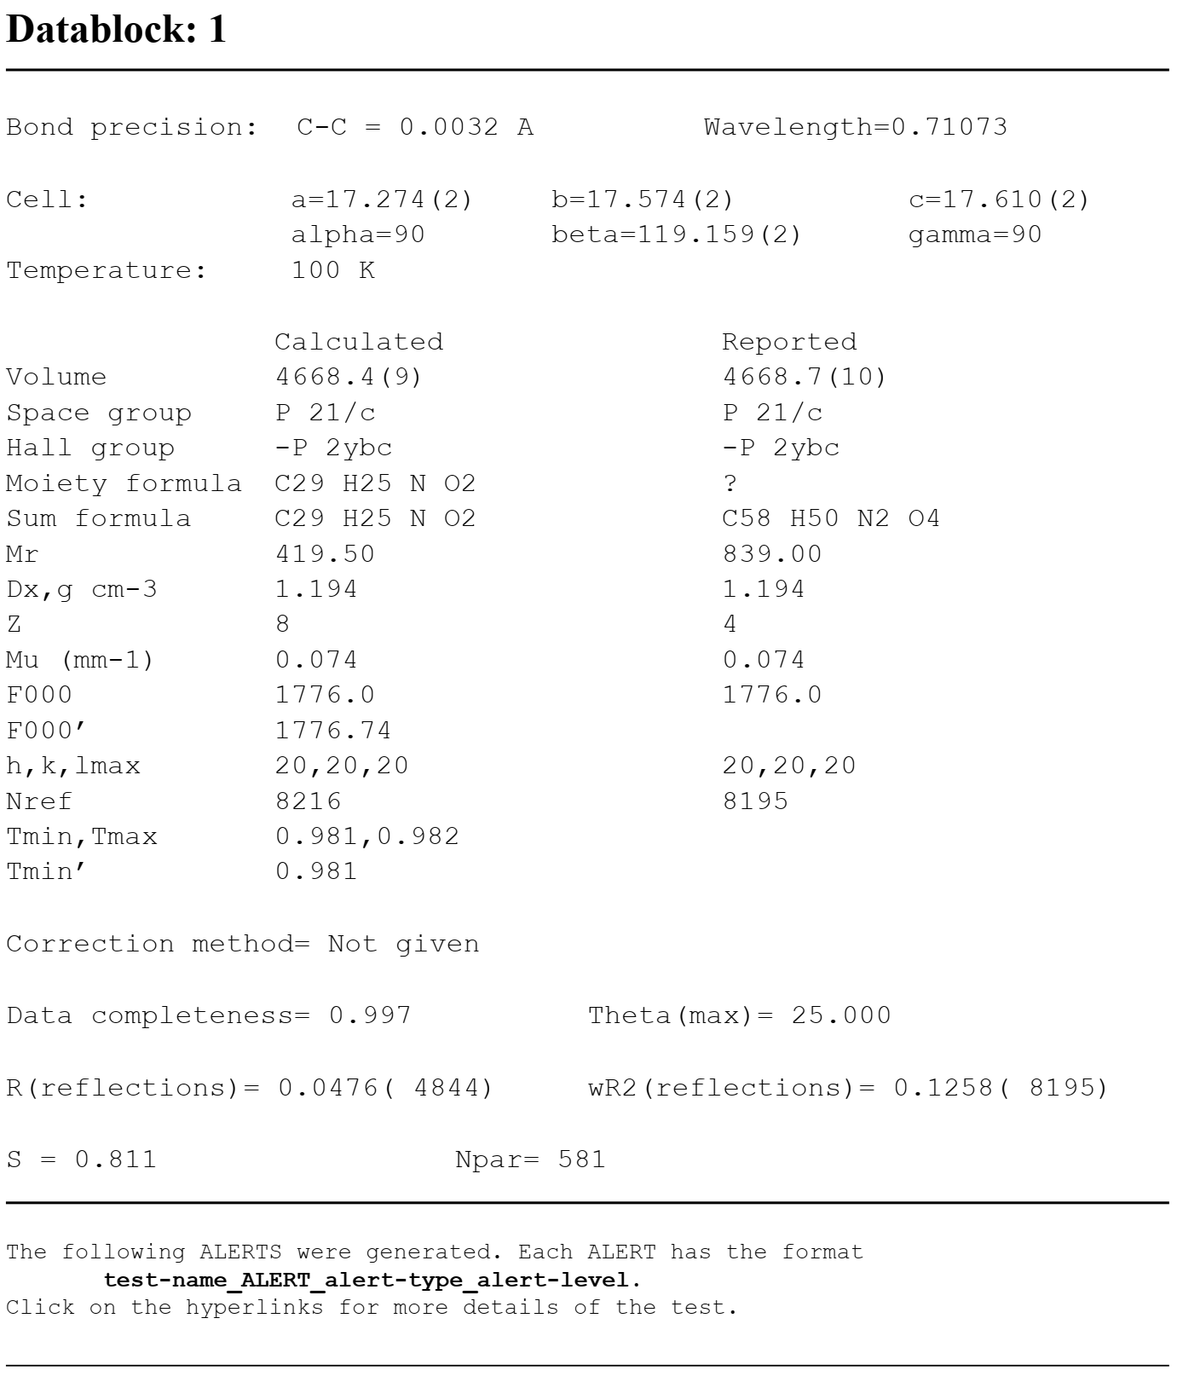

X-Ray single crystal diffraction analysis of 8aa (CCDC: 2035718)
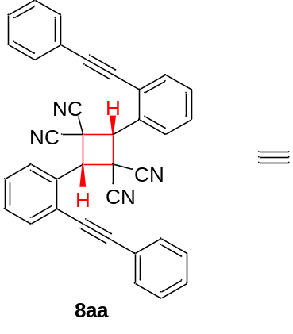

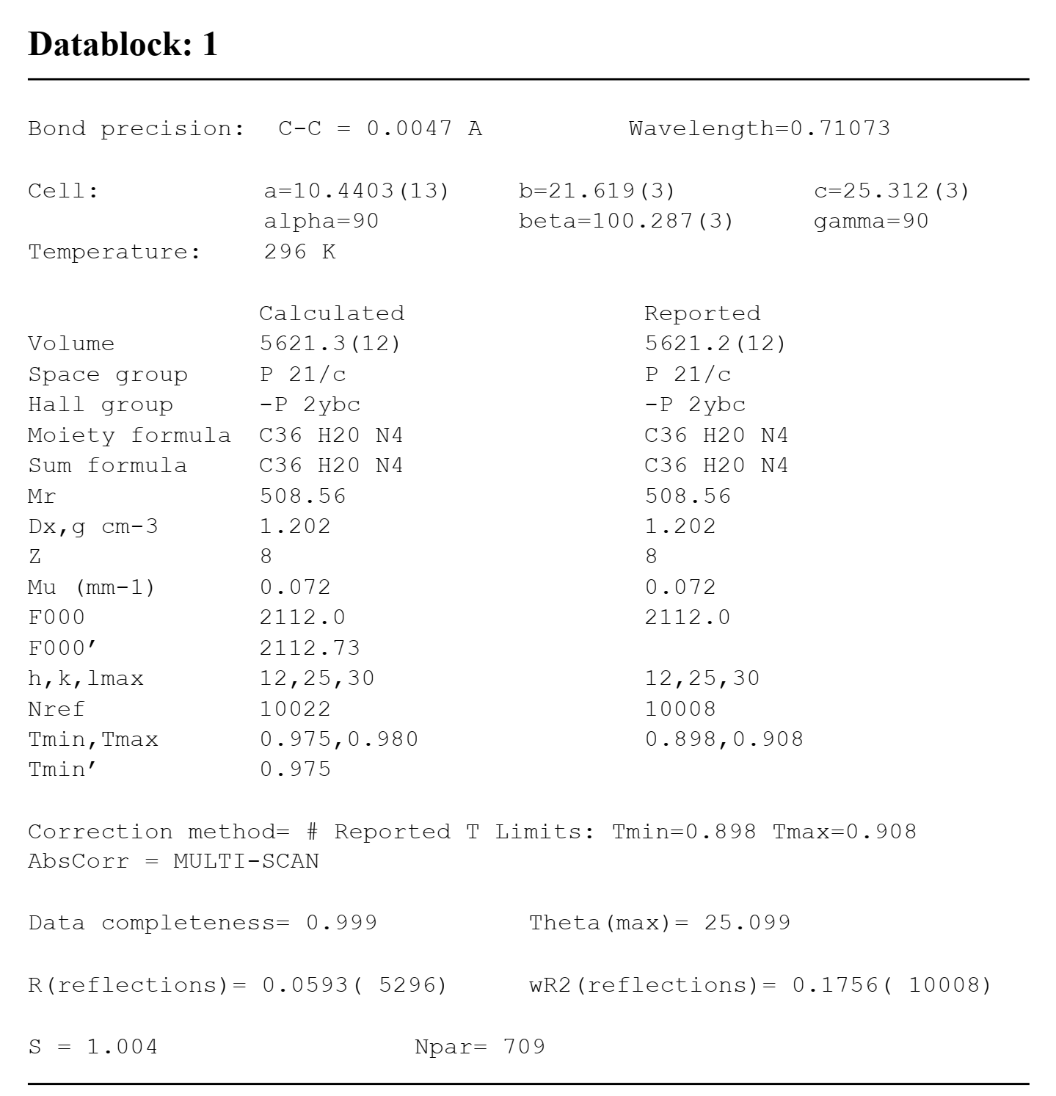

X-Ray single crystal diffraction analysis of 9aa (CCDC: 2035719)
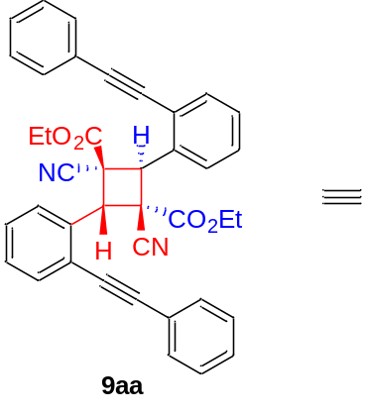

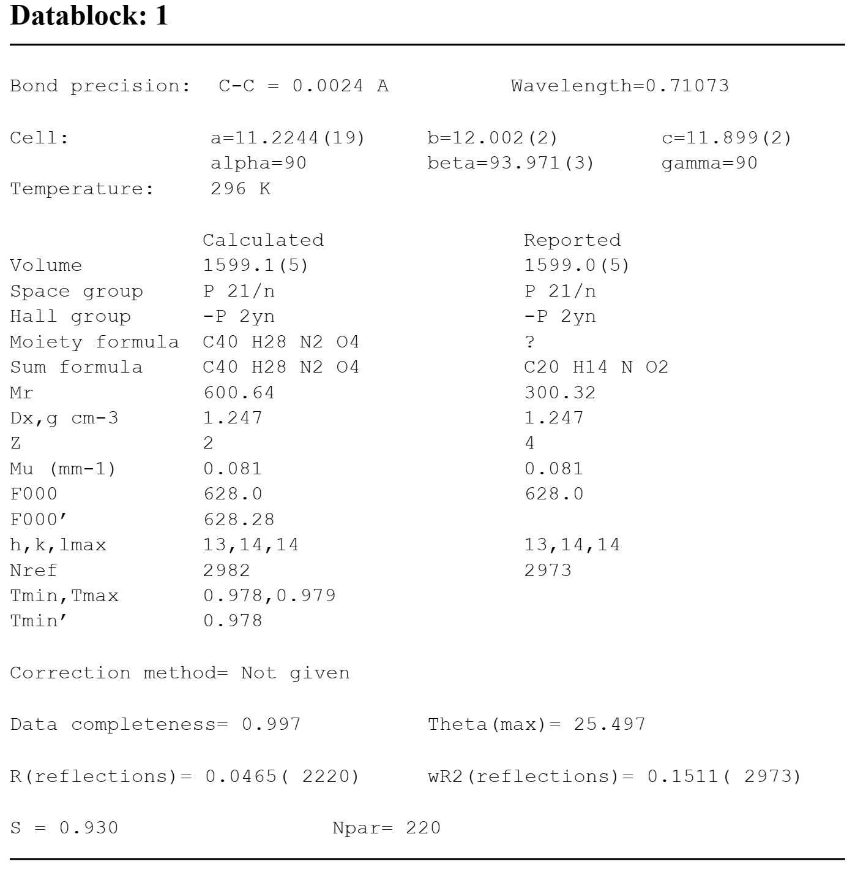

Supplementary Methods
General Information: All ¹H NMR, ¹³C NMR and ¹⁹F NMR spectra were recorded on a 600 MHz or 400 MHz Bruker FT-NMR spectrometers (600/150/564 MHz, or 400/100/376 MHz, respectively). All chemical shifts are given as δ value (ppm) with reference to tetramethylsilane (TMS) as an internal standard. The peak patterns are indicated as follows: s, singlet; d, doublet; t, triplet; m, multiplet; q, quartet. The coupling constants, J, are reported in Hertz (Hz). High resolution mass spectroscopy data of the product were collected on an Agilent Technologies 6540 UHD Accurate-Mass Q-TOF LC/MS (ESI). The chemicals and solvents were purchased from commercial suppliers either Aldrich (USA), or Shanghai Chemical Company (P. R. China). Products were purified by flash chromatography on 200–300 mesh silica gels, SiO₂.
Representative procedure for the synthesis of 1a and 4a
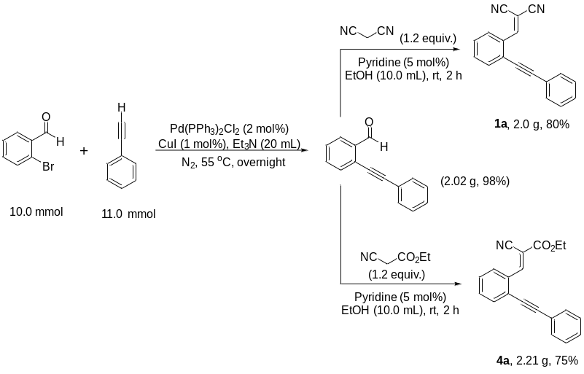
To a solution of 2-bromobenzaldehyde (1.85 g, 10.0 mmol) and ethynylbenzene (1.124g, 11.0 mmol) in Et₃N (20.0 mL) was added Pd(PPh₃)₂Cl₂ (140 mg, 2.0% mol) and CuI (20 mg, 1.0% mol). The mixture was stirred at 55 ºC for overnight. It was then quenched with water and washed with ethyl acetate. After removal of solvent, the crude residue was purified by flash chromatography on silica gel (petroleum ether/ethyl acetate = 100:1, v/v) to afford the desired product 2-(phenylethynyl)benzaldehyde (2.02 g, 98% yield).
To a solution of 2-(phenylethynyl)benzaldehyde (2.02 g, 9.8 mmol) and malononitrile (780 mg, 11.8 mmol) in EtOH (10.0 mL) at room temperature was added pyridine (39 mg, 5% mol) under air. The reaction mixture was stirred at room temperature for 2 h, then mixed solution was suction filtered and washed with ethanol to afford the desired product 1a (yellow solid, 2.0 g, 80% yield).
To a solution of 2-(phenylethynyl)benzaldehyde (2.02 g, 9.8 mmol) and ethyl 2-cyanoacetate (1.34 g, 11.8 mmol) in EtOH (10.0 mL) at room temperature was added pyridine (39 mg, 5% mol) under air. The reaction mixture was stirred at room temperature for 2 h, then mixed solution was suction filtered and washed with ethanol to afford the desired product 4a (yellow solid, 2.21 g, 75% yield).
Synthesis of 7ac in 2.0 mmol scale
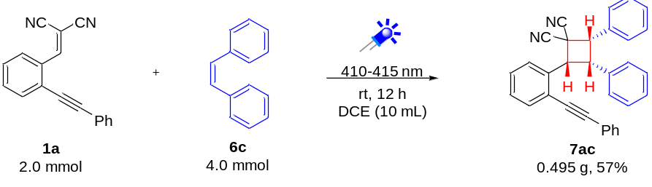
A 20 mL oven-dried reaction vessel equipped with a magnetic stirrer bar was charged with 2-(2-(phenylethynyl)benzylidene)malononitrile (1a, 0.509 g, 2.0 mmol), (Z)-1,2-diphenylethene (6c, 0.721 g, 4.0 mmol) and DCE (10.0 mL). The reaction vessel was exposed to LED (410−415 nm) irradiation at room temperature in air with stirring for 12 h. After completion of the reaction, the mixture was concentrated to yield the crude product, which was further purified by flash chromatography (silica gel, petroleum ether/ethyl acetate = 20:1) to give the desired product 7ac (0.495 g, 57% yield).
Further transformations of 7ac into compound 10
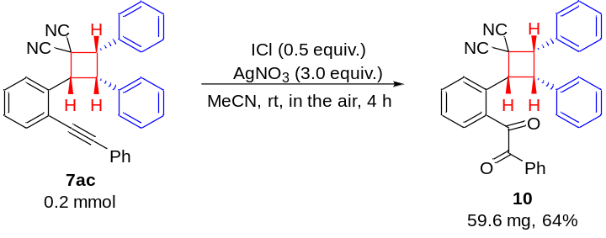
According to a reported procedure [see: W. Yang, Y. Chen, Y. Yao, X. Yang, Q. Lin, D. Yang, J. Org. Chem. 84, 11080–11090 (2019)], a 5 mL oven-dried reaction vessel equipped with a magnetic stirrer bar was charged with (±)-(2S,3S,4R)-2,3-diphenyl-4-(2-(phenylethynyl)phenyl)cyclobutane-1,1-dicarbonitrile (7ac, 86.9 mg, 0.2 mmol), ICl (16.3 mg, 0.10 mmol ), AgNO₃ (101.9 mg, 0.60 mmol) and MeCN (2.0 mL). The reaction vessel was exposed to room temperature in air with stirring for 4 h. After completion of the reaction, the mixture was concentrated to yield the crude product, which was further purified by flash chromatography (silica gel, petroleum ether/ethyl acetate = 10:1, V/V) to give the product 10 (59.6 mg, 64% yield).
Further transformations of 7ac into compound 11
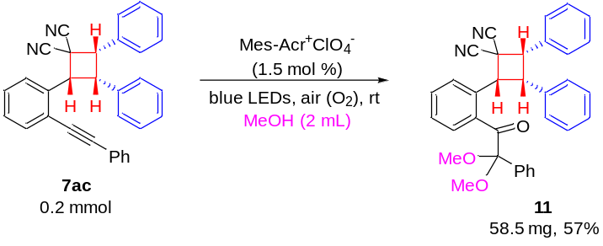
According to a reported procedure [see: W.-L. Lei, B. Yang, Q.-B. Zhang, P.-F. Yuan, L.-Z. Wu, Q. Liu, Green Chem. 20, 5479–5483 (2018)], a 5.0 mL oven-dried reaction vessel equipped with a magnetic stirrer bar was charged with (±)-(2S,3S,4R)-2,3-diphenyl-4-(2-(phenylethynyl)phenyl)cyclobutane-1,1-dicarbonitrile (7ac, 86.9 mg, 0.2 mmol), 9-mesityl-10-methylacridinium perchlorate (1.3 mg, 1.5 mol% ) and MeOH (2.0 mL). The reaction vessel was exposed to LED (450–455 nm, 3 W) irradiation at room temperature in air with stirring for 3 h. After completion of the reaction, the mixture was concentrated to yield the crude product, which was further purified by flash chromatography (silica gel, petroleum ether/ethyl acetate = 20:1, V/V) to give the product 11 (58.5 mg, 57% yield).

Further optimization of the reaction conditions
Table S1. Optimization of the photocatalyst and time on the reactionª
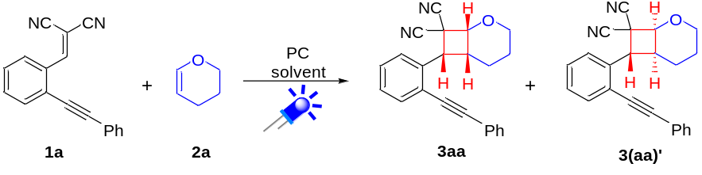
entry | photocatalyst  (PC) | 2a  (equiv.) | light source  (nm) | solvent | time (h) | yield (%)^{b}  3aa/3(aa)’
1 | fac-Ir(ppy)₃ | 2.0 | 380−385 | DCE | 8 | 27/4
2 | Ru(bpy)₃Cl₂ | 2.0 | 450−455 | DCE | 8 | 29/4
3 | Mes-Acr⁺ClO₄⁻ | 2.0 | 420−425 | DCE | 8 | 28/4
4 | TPPT | 2.0 | 410−415 | DCE | 8 | 35/5
5 | rose bengal | 2.0 | 530−535 | DCE | 8 | 28/4
6 | eosin Y | 2.0 | 530−535 | DCE | 8 | 15/trace
7 | − | 55 (1.0 mL) | 410−415 | − | 8 | 79/11
8 | − | 55 (1.0 mL) | 410−415 | − | 2 | 29/4
9 | − | 55 (1.0 mL) | 410−415 | − | 4 | 43/6
10 | − | 55 (1.0 mL) | 410−415 | − | 6 | 64/9
11 | ⁻ | 55 (1.0 mL) | 410−415 | − | 10 | 79/11
12 | − | 55 (1.0 mL) | 410−415 | − | 12 | 79/11
13 | − | 55 (1.0 mL) | 410−415 | − | 20 | 72/10
ªReaction conditions: 1a (0.20 mmol), 2a (0.40 mmol), PC (2.5 mol%), DCE (1.0 mL), room temperature, air, under LED irradiation for the time inducated in Table S1. ^{b}Yield of isolated product. TPPT = 2,4,6-triphenylpyrylium tetrafluoroborate.
Mechanistic investigations
The trapping experiment of key intermediate Int1 using BHT
A 5 mL oven-dried reaction vessel equipped with a magnetic stirrer bar was charged with ethyl (E)-2-cyano-3-(2-(phenylethynyl)phenyl)acrylate (4a, 60.3 mg, 0.20 mmol) in DCE (1.0 mL), and 2,6-di-tert-butyl-4-methylphenol (BHT, 0.40 mmol) as a free-radical trapping agent was added. The reaction vessel was exposed to blue LED (410–415 nm, 3 W) irradiation or in darkness at room temperature in air with stirring for 12 h, providing the corresponding trapping product 12 in 42% yield under blue LED irradiation and 0% yield in darkness.
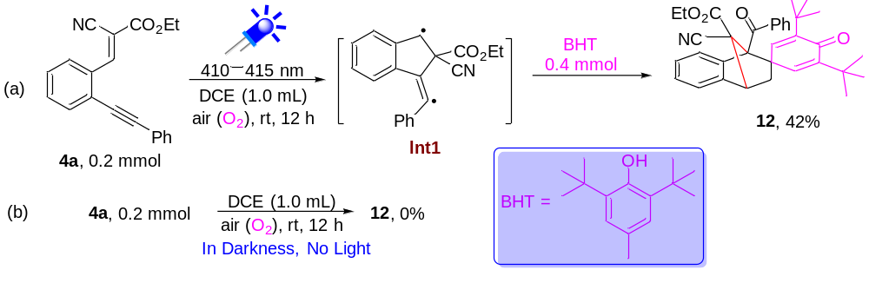
Supplementary Figure 144. Trapping experiment of the Int1 adduct with BHT

X-Ray single crystal diffraction analysis of 12 (CCDC: 2080257)

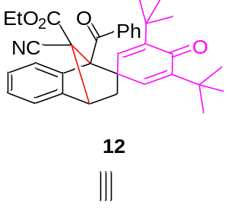
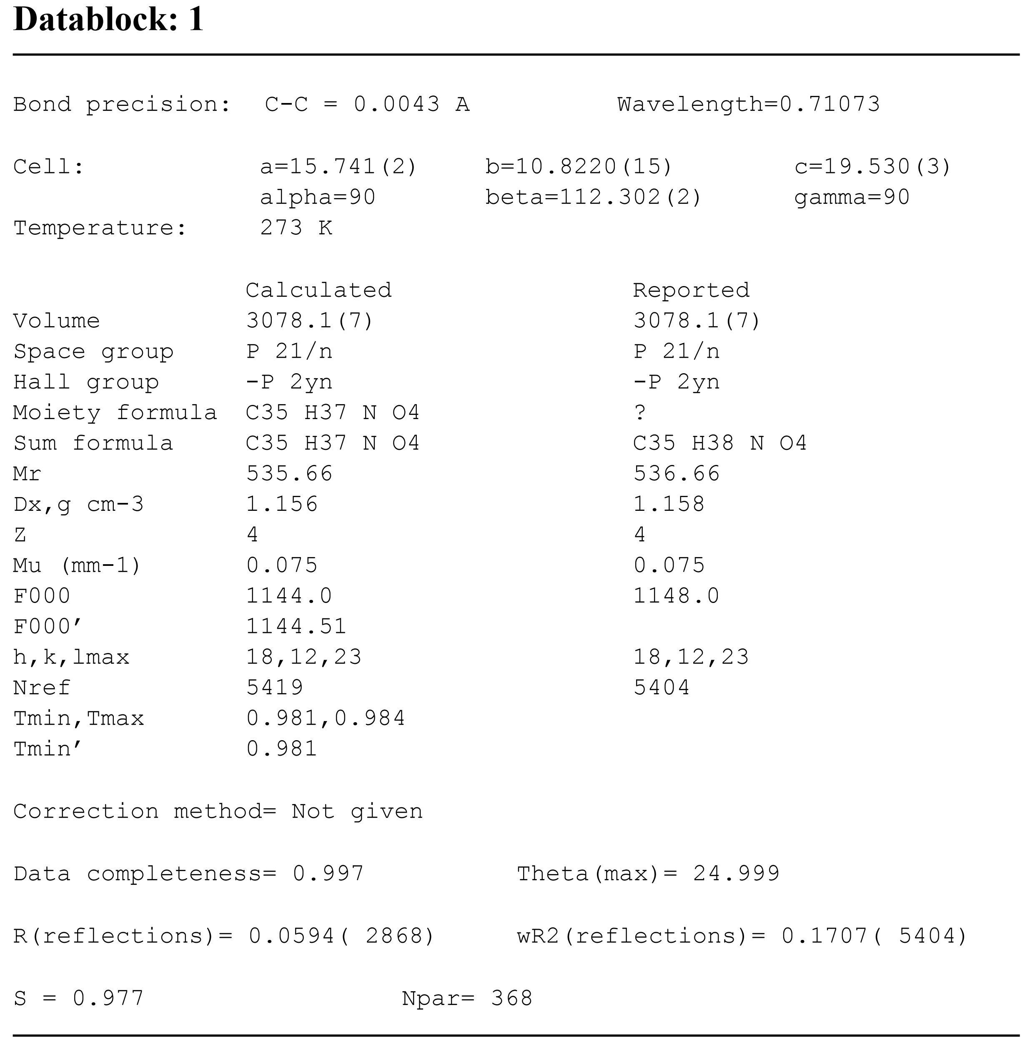
The trapping experiment of key intermediate Int3 using ethyl diazoacetate
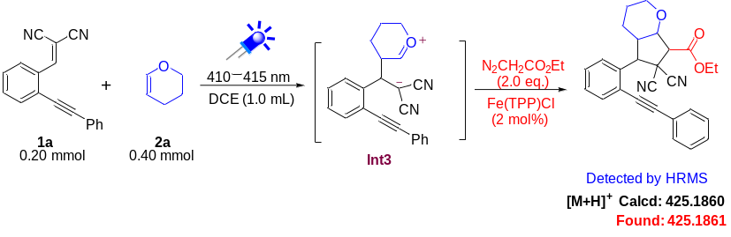
A 5 mL oven-dried reaction vessel equipped with a magnetic stirrer bar was charged with 2-(2-(phenylethynyl)benzylidene)malononitrile (1a, 50.9 mg, 0.20 mmol), 3,4-dihydro-2H-pyran (2a, 33.6 mg, 0.40 mmol) in DCE (1.0 mL), and ethyl diazoacetate (0.40 mmol) with Fe(TPP)Cl (0.0040 mmol, 2 mol%) as a carbanion capturing agent was added. The reaction vessel was exposed to blue LED (410–415 nm, 3 W) irradiation at room temperature in air with stirring for 8 h. After the reaction, their corresponding adduct was detected by HRMS analysis (Supplementary Figure 145).
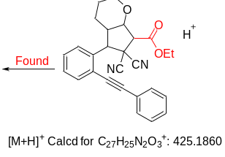
Supplementary Figure 145. HRMS analysis of the Int3 adduct with ethyl diazoacetate
The possible stereoisomers of [2+2]-cycloaddition products
In theory, a crossed [2+2] cycloaddition of two different asymmetric chain olefins can yield sixteen head-to-head and sixteen head-to-tail stereoisomers (Scheme S1). As outlined above, the major products in all cases were found to be the (±)-(trans,trans)-anti-head-to-head (I) isomer derived from an electron-poor and an electron-rich olefin. Importantly, only head-to-head isomers were found and no head-to-tail isomers were observed, illustrating the regiospecificity of the reaction. Moreover, among the isolated head-to-head isomers, I was obtained in the majority and (±)-(trans,cis)-syn-head-to-head (VI = I’) was isolated in the minority with good diastereoselectivity, demonstrating almost no geometric isomerization of the olefins during the [2+2]-cycloaddition.
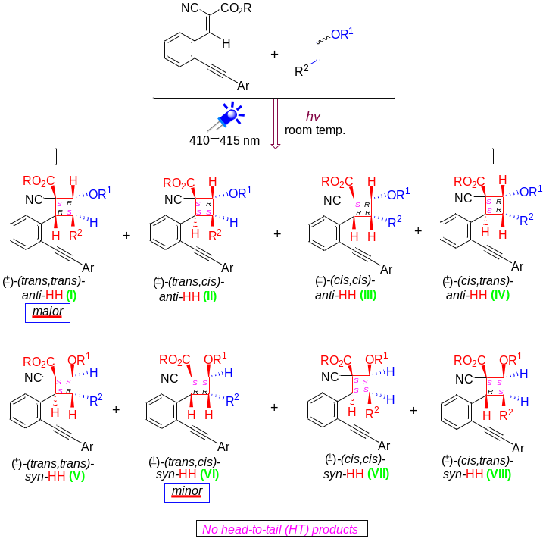
Supplementary Scheme 1. The possible stereoisomers of [2+2]-cycloaddition products
DFT calculations for the [2+2] cross-cycloaddition of 1a and 2a
All density functional theory (DFT) calculations were carried out using the M06-D3 functional^{[1]} (with Grimme’s D3 dispersion^{[2]}) and performed in the Gaussian 16 program.^{[3]} The def2-SVP^{[4]} basis set was used for geometry optimization. Analytical frequency calculations were implemented on all the optimized structures at the same level of theory, to identify all the stationary point as minima (zero imaginary frequency) or transition states (one imaginary frequency) and to obtain Gibbs free energy corrections at 298 K. The final and solvation energies for the fully optimized structures in the dichloromethane were calculated by employing the SMD continuum solvation model^{[5]} with the larger def2-TZVPP^{[6]} basis set. The basis set information is downloaded from the website.^{[7]}

Supplementary References
[1] Zhao,Y.; Truhlar, D. G., The M06 suite of density functionals for main group thermochemistry, thermochemical kinetics, noncovalent interactions, excited states, and transition elements: two new functionals and systematic testing of four M06-class functionals and 12 other functionals. Theor. Chem. Acc., 120, 215-241 (2008).
[2] Grimme, S., Semiempirical GGA‐type density functional constructed with a long‐range dispersion correction. J. Comput. Chem., 27, 1787-1799 (2006).
[3] M. J. Frisch, G. W. Trucks, H. B. Schlegel, G. E. Scuseria, M. A. Robb, J. R. Cheeseman, G. Scalmani, V. Barone, G. A. Petersson, H. Nakatsuji, X. Li, M. Caricato, A. V. Marenich, J. Bloino, B. G. Janesko, R. Gomperts, B. Mennucci, H. P. Hratchian, J. V. Ortiz, A. F. Izmaylov, J. L. Sonnenberg, Williams, F. Ding, F. Lipparini, F. Egidi, J. Goings, B. Peng, A. Petrone, T. Henderson, D. Ranasinghe, V. G. Zakrzewski, J. Gao, N. Rega, G. Zheng, W. Liang, M. Hada, M. Ehara, K. Toyota, R. Fukuda, J. Hasegawa, M. Ishida, T. Nakajima, Y. Honda, O. Kitao, H. Nakai, T. Vreven, K. Throssell, J. A. Montgomery Jr., J. E. Peralta, F. Ogliaro, M. J. Bearpark, J. J. Heyd, E. N. Brothers, K. N. Kudin, V. N. Staroverov, T. A. Keith, R. Kobayashi, J. Normand, K. Raghavachari, A. P. Rendell, J. C. Burant, S. S. Iyengar, J. Tomasi, M. Cossi, J. M. Millam, M. Klene, C. Adamo, R. Cammi, J. W. Ochterski, R. L. Martin, K. Morokuma, O. Farkas, J. B. Foresman, D. J. Fox, Gaussian Inc.: Wallingford, CT, (2016).
[4] Weigend, F.; Ahlrichs, R., Balanced basis sets of split valence, triple zeta valence and quadruple zeta valence quality for H to Rn: Design and assessment of accuracy. Phys. Chem. Chem. Phys., 7, 3297-3305(2005).
[5] Marenich, A. V.; Cramer, C. J.; Truhlar, D. G., Universal Solvation Model Based on Solute Electron Density and on a Continuum Model of the Solvent Defined by the Bulk Dielectric Constant and Atomic Surface Tensions. J. Phys. Chem. B, 113, 6378-6396(2009).
[6] Weigend,F., Accurate Coulomb-fitting basis sets for H to Rn. Phys. Chem. Chem. Phys., 8, 1057-1065(2006).
[7] a) Pritchard, B. P.; Altarawy, D.; Didier, B.; Gibson, T. D.; Windus, T. L., New Basis Set Exchange: An Open, Up-to-Date Resource for the Molecular Sciences Community. J. Chem. Inf. Model., 59, 4814-4820(2019). b) http://www.basissetexchange.org/

Computational structures
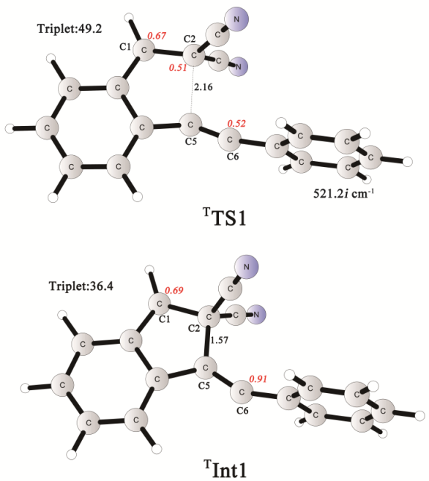
Supplementary Figure 146. Optimized structures of TS1, Int1 (Distances are given in Å. Spin densities on selected atoms are indicated in red italics. Superscripts indicate the multiplicity of the structures)

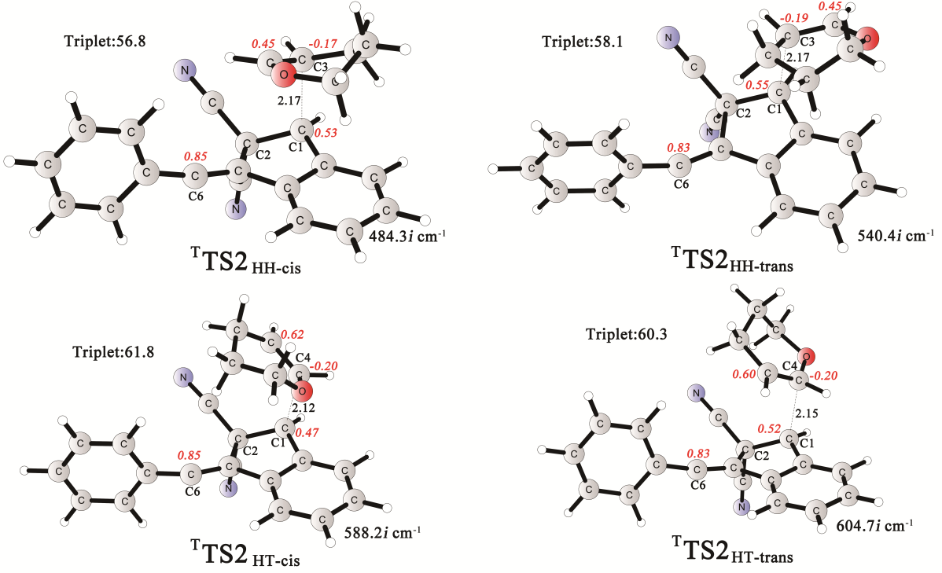

Supplementary Figure 147. Optimized structures of TS2_{HH-cis}, TS2_{HH-trans}, TS2_{HT-cis} and TS2_{HT-trans} (Distances are given in Å. Spin densities on selected atoms are indicated in red italics)

Superscripts indicate the multiplicity of the structures. The imaginary frequencies for transition states are also shown.
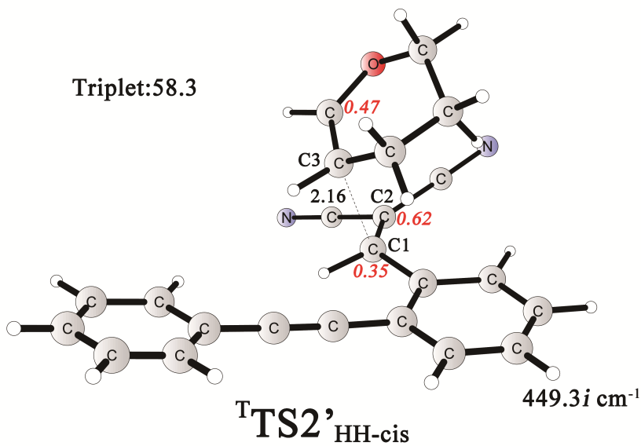

Supplementary Figure 148. Optimized structures of TS2’_{HH-cis} (Distances are given in Å. Spin densities on selected atoms are indicated in red italics. Superscripts indicate the multiplicity of the structures)
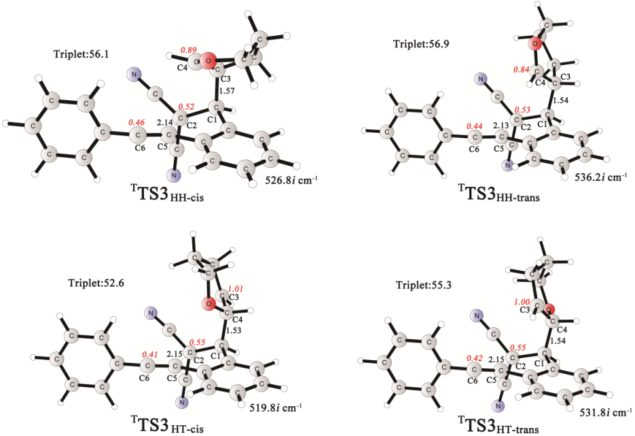
Supplementary Figure 149. Optimized structures of TS3_{HH-cis}, TS3_{HH-trans}, TS3_{HT-cis} and TS_{HT-trans} (Distances are given in Å. Spin densities on selected atoms are indicated in red italics. Superscripts indicate the multiplicity of the structures. The imaginary frequencies for transition states are also shown.
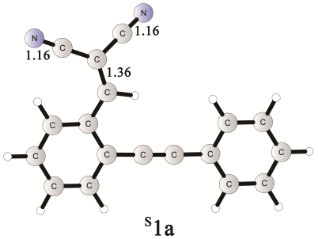 | 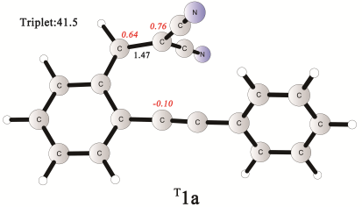 | 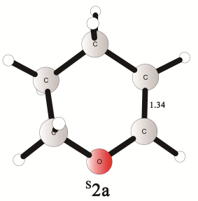
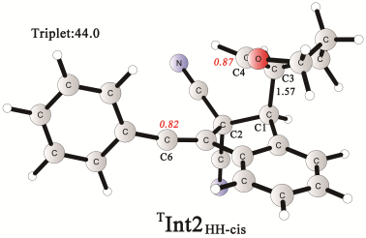 | 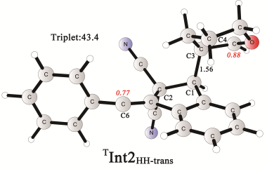 | 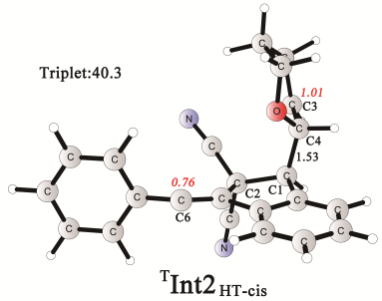
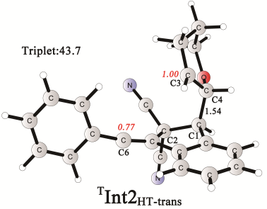 | 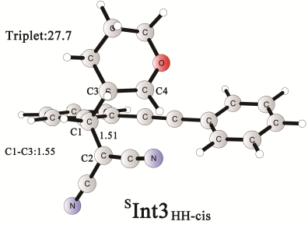 | 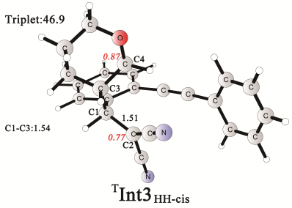
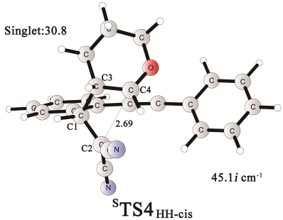 | 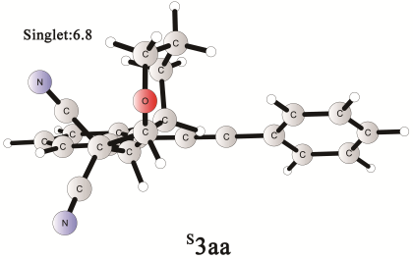 | 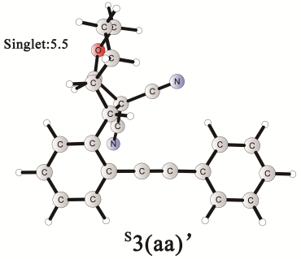

Calculated energies (Table S2)

Table S2. Calculated energies in Hartree and imaginary frequencies
Stationary point | Geometry optimization energy | Gibbs energy correction energy | Large basis energy | Imaginary frequencies
^{S}1a | -800.1491078 | 0.17435 | -801.0534516
^{T}1a | -800.0825673 | 0.170151 | -800.9831834
^{S}2a | -270.1541718 | 0.093198 | -270.4654954
^{T}TS1 | -800.0722321 | 0.17202 | -800.9727379 | 521.2i
^{T}Int1 | -800.0975839 | 0.172406 | -800.9935537
^{T}TS2_{HH-cis} | -1070.251336 | 0.28926 | -1071.450099 | 484.3i
^{T}TS2’_{HH-cis} | -1070.239978 | 0.286748 | -1071.445166 | 449.3i
^{T}TS2_{HH-trans} | -1070.248466 | 0.287897 | -1071.44677 | 540.4i
^{T}TS2_{HT-cis} | -1070.243688 | 0.288427 | -1071.441337 | 588.2i
^{T}TS2_{HT-trans} | -1070.245195 | 0.287819 | -1071.443048 | 604.7i
^{T}Int2_{HH-cis} | -1070.275993 | 0.291296 | -1071.472514
^{T}Int2_{HH-trans} | -1070.279219 | 0.291778 | -1071.473968
^{T}Int2_{HT-cis} | -1070.280389 | 0.289309 | -1071.476434
^{T}Int2_{HT-trans} | -1070.277859 | 0.291104 | -1071.47283
^{T}TS3_{HH-cis} | -1070.250967 | 0.289948 | -1071.451959 | 526.8i
^{T}TS3_{HH-trans} | -1070.249982 | 0.290511 | -1071.451208 | 536.2i
^{T}TS3_{HT-cis} | -1070.255044 | 0.288265 | -1071.455761 | 519.8i
^{T}TS3_{HT-trans} | -1070.252336 | 0.288225 | -1071.451575 | 531.8i
^{S}Int3_{HH-cis} | -1070.273872 | 0.293507 | -1071.500684
^{T}Int3_{HH-cis} | -1070.264610 | 0.290353 | -1071.467087
^{S}TS4_{HH-cis} | -1070.272697 | 0.29469 | -1071.497068 | 45.1i
^{S}3aa | -1070.337302 | 0.296885 | -1071.537505
^{S}3(aa)’ | -1070.33925 | 0.296702 | -1071.539326
Cartesian coordinates of optimized structures

^{S}1a E(opt)= -800.1491078 hartree
---------------------------------------------------------------------
Center Atomic Atomic Coordinates (Angstroms)
Number Number Type X Y Z
---------------------------------------------------------------------
1 6 0 3.497300 -2.531861 0.000063
2 6 0 3.250627 -1.167458 0.000114
3 6 0 1.936990 -0.664936 0.000122
4 6 0 0.852643 -1.592901 0.000082
5 6 0 1.124938 -2.969589 0.000025
6 6 0 2.432174 -3.434822 0.000015
7 1 0 0.284511 -3.668495 -0.000010
8 1 0 2.624765 -4.511185 -0.000028
9 1 0 4.097770 -0.478978 0.000161
10 6 0 -0.500095 -1.154292 0.000092
11 6 0 -1.656238 -0.769512 0.000091
12 6 0 -2.998197 -0.292650 0.000015
13 6 0 -3.256352 1.089651 -0.000012
14 6 0 -4.077422 -1.192820 -0.000030
15 6 0 -4.565148 1.555505 -0.000082
16 1 0 -2.416172 1.791051 0.000023
17 6 0 -5.382838 -0.717788 -0.000100
18 1 0 -3.874004 -2.267335 -0.000007
19 6 0 -5.629950 0.654809 -0.000126
20 1 0 -4.756724 2.632003 -0.000102
21 1 0 -6.217424 -1.424423 -0.000134
22 1 0 -6.658956 1.025167 -0.000182
23 1 0 4.528132 -2.894667 0.000064
24 6 0 1.617142 0.745204 0.000188
25 1 0 0.543676 0.966838 0.000383
26 6 0 2.411357 1.855027 0.000025
27 6 0 1.780891 3.142933 0.000138
28 6 0 3.842218 1.858165 -0.000303
29 7 0 1.248772 4.174643 0.000239
30 7 0 5.003254 1.875933 -0.000534
---------------------------------------------------------------------

^{T}1a E(opt)= -800.0825673 hartree
---------------------------------------------------------------------
Center Atomic Atomic Coordinates (Angstroms)
Number Number Type X Y Z
---------------------------------------------------------------------
1 6 0 4.734161 -1.005588 -0.138835
2 6 0 4.113850 0.216947 0.003836
3 6 0 2.694566 0.338671 0.023555
4 6 0 1.916922 -0.863252 -0.127318
5 6 0 2.577223 -2.091875 -0.264771
6 6 0 3.964772 -2.172324 -0.271039
7 1 0 1.970416 -2.994834 -0.374521
8 1 0 4.453058 -3.144035 -0.382843
9 1 0 4.710156 1.128467 0.112144
10 6 0 0.497346 -0.835093 -0.138794
11 6 0 -0.723723 -0.856317 -0.152904
12 6 0 -2.147860 -0.820196 -0.140112
13 6 0 -2.844175 0.052563 -0.995283
14 6 0 -2.869342 -1.644261 0.741323
15 6 0 -4.232811 0.096223 -0.961284
16 1 0 -2.283832 0.695308 -1.681103
17 6 0 -4.257102 -1.594143 0.764475
18 1 0 -2.322769 -2.316322 1.408721
19 6 0 -4.941227 -0.724681 -0.085032
20 1 0 -4.767508 0.779140 -1.627108
21 1 0 -4.811782 -2.236088 1.454484
22 1 0 -6.034056 -0.686226 -0.062395
23 1 0 5.825841 -1.065218 -0.146750
24 6 0 2.132033 1.614254 0.199773
25 6 0 0.694692 1.926313 0.273544
26 1 0 2.819753 2.466100 0.299180
27 6 0 -0.002352 2.331129 -0.886424
28 6 0 0.021012 1.931040 1.515872
29 7 0 -0.514549 1.921623 2.552062
30 7 0 -0.560764 2.646556 -1.861104
---------------------------------------------------------------------

^{S}2a E(opt)= -270.1541718 hartree
---------------------------------------------------------------------
Center Atomic Atomic Coordinates (Angstroms)
Number Number Type X Y Z
---------------------------------------------------------------------
1 6 0 -0.838587 -1.039830 -0.323980
2 6 0 0.535344 -1.206578 0.291770
3 6 0 0.901208 1.065299 -0.083398
4 6 0 -0.398089 1.356272 0.063121
5 6 0 -1.443051 0.283944 0.126008
6 1 0 0.454666 -1.189800 1.398726
7 1 0 1.008829 -2.157420 0.004108
8 1 0 -0.730803 -1.049945 -1.423871
9 1 0 -1.478050 -1.896525 -0.055760
10 1 0 -1.854807 0.191953 1.150633
11 1 0 -2.305231 0.550466 -0.510746
12 1 0 1.675465 1.830482 -0.199354
13 1 0 -0.688986 2.409846 0.095730
14 8 0 1.422247 -0.180462 -0.112574
---------------------------------------------------------------------

^{T}TS1 E(opt)= -800.0722321 hartree
---------------------------------------------------------------------
Center Atomic Atomic Coordinates (Angstroms)
Number Number Type X Y Z
---------------------------------------------------------------------
1 6 0 3.144317 -1.575206 0.147180
2 6 0 3.685869 -0.330752 0.505544
3 6 0 2.888974 0.820805 0.425880
4 6 0 1.571908 0.745529 -0.007268
5 6 0 0.986586 -0.520629 -0.398071
6 6 0 1.835735 -1.670650 -0.291268
7 7 0 0.773488 1.891934 -0.025785
8 6 0 -0.503955 1.981287 -0.572055
9 6 0 -1.099517 0.713889 -0.939904
10 6 0 -0.348058 -0.557078 -0.822648
11 8 0 -1.066283 3.074157 -0.674747
12 6 0 -2.135554 -2.111608 0.088724
13 6 0 -3.118905 -0.966116 0.388776
14 6 0 -2.500847 0.300468 0.950847
15 6 0 -1.576066 0.313131 1.952972
16 1 0 3.755777 -2.470579 0.211157
17 1 0 4.713172 -0.253259 0.846304
18 1 0 3.296552 1.786060 0.716768
19 1 0 1.438222 -2.640782 -0.567767
20 1 0 1.182827 2.779562 0.234003
21 1 0 -1.953094 0.776261 -1.606573
22 1 0 -2.711244 -3.008515 -0.169847
23 1 0 -1.559277 -2.360873 0.987105
24 1 0 -3.672550 -0.720930 -0.525716
25 1 0 -3.871888 -1.322714 1.106397
26 1 0 -3.004067 1.234253 0.710946
27 1 0 -1.232537 1.249317 2.379665
28 1 0 -1.093761 -0.592051 2.306490
29 6 0 -1.151037 -1.800902 -1.067512
30 1 0 -0.511235 -2.672779 -1.227846
31 1 0 -1.737745 -1.672771 -1.989796
---------------------------------------------------------------------

^{T}Int1 E(opt)= -800.0975839 hartree
---------------------------------------------------------------------
Center Atomic Atomic Coordinates (Angstroms)
Number Number Type X Y Z
---------------------------------------------------------------------
1 6 0 4.591280 -1.232494 0.000379
2 6 0 4.193523 0.090751 0.001226
3 6 0 2.807786 0.388674 0.000761
4 6 0 1.861571 -0.683496 -0.000561
5 6 0 2.281058 -2.009495 -0.001412
6 6 0 3.647336 -2.280762 -0.000940
7 1 0 1.540695 -2.815822 -0.002401
8 1 0 3.995459 -3.317363 -0.001594
9 6 0 2.153093 1.623363 0.001459
10 1 0 4.928357 0.900619 0.002251
11 6 0 0.509409 -0.147509 -0.000607
12 6 0 -0.662832 -0.749480 -0.001086
13 6 0 -2.056906 -0.752656 -0.000782
14 6 0 -2.780544 -0.761461 1.222486
15 6 0 -2.781627 -0.759473 -1.223389
16 6 0 -4.164771 -0.768124 1.211607
17 1 0 -2.224845 -0.744519 2.164704
18 6 0 -4.165873 -0.766147 -1.211229
19 1 0 -2.226823 -0.740967 -2.166104
20 6 0 -4.864248 -0.773298 0.000490
21 1 0 -4.712228 -0.762706 2.158267
22 1 0 -4.714160 -0.759172 -2.157397
23 1 0 -5.957804 -0.777161 0.000991
24 6 0 0.651339 1.414009 0.000449
25 6 0 0.021894 1.967958 -1.207207
26 7 0 -0.460041 2.377888 -2.177681
27 6 0 0.020203 1.966662 1.207760
28 7 0 -0.463195 2.375603 2.177921
29 1 0 2.606225 2.616289 0.002462
30 1 0 5.657625 -1.475767 0.000726
---------------------------------------------------------------------

^{T}TS2_{HH-cis} E(opt)= -1070.251336 hartree
---------------------------------------------------------------------
Center Atomic Atomic Coordinates (Angstroms)
Number Number Type X Y Z
---------------------------------------------------------------------
1 6 0 -3.315942 -1.729492 -1.914916
2 6 0 -3.215288 -1.492967 -0.547912
3 6 0 -1.961735 -1.175245 -0.001256
4 6 0 -0.827834 -1.132139 -0.847433
5 6 0 -0.936628 -1.359985 -2.215297
6 6 0 -2.189868 -1.655430 -2.748176
7 1 0 -0.044183 -1.317284 -2.848012
8 1 0 -2.295226 -1.849335 -3.819122
9 6 0 -1.604414 -0.772930 1.333089
10 6 0 -0.939810 1.980256 0.607330
11 6 0 -2.480751 2.141648 -1.161016
12 1 0 -2.580259 1.093095 -1.502422
13 1 0 -4.097055 -1.572729 0.096292
14 6 0 0.365768 -0.818441 -0.059199
15 6 0 1.575468 -0.488732 -0.442170
16 6 0 2.877147 -0.037180 -0.543296
17 6 0 3.145473 1.361660 -0.610769
18 6 0 3.976634 -0.941253 -0.598995
19 6 0 4.446552 1.818349 -0.716414
20 1 0 2.302546 2.059261 -0.580525
21 6 0 5.269381 -0.460719 -0.705214
22 1 0 3.777627 -2.015372 -0.546880
23 6 0 5.515665 0.915886 -0.764208
24 1 0 4.638590 2.894158 -0.761734
25 1 0 6.105332 -1.165267 -0.739803
26 1 0 6.541370 1.285848 -0.846796
27 6 0 -1.874999 1.376520 1.433390
28 6 0 -3.516988 2.459320 -0.106436
29 1 0 -3.397368 3.516112 0.194086
30 1 0 -4.525460 2.361510 -0.539347
31 8 0 -1.162796 2.340022 -0.661627
32 6 0 -3.341050 1.545873 1.101985
33 1 0 -3.866139 1.965291 1.976240
34 1 0 -3.825037 0.573082 0.903085
35 1 0 -1.590513 1.368694 2.491609
36 1 0 0.090409 2.173698 0.921119
37 1 0 -2.570388 2.791805 -2.043525
38 6 0 -0.088030 -0.958416 1.432353
39 6 0 0.191794 -2.338577 1.864739
40 7 0 0.388282 -3.433979 2.188707
41 6 0 0.617503 -0.031138 2.322038
42 7 0 1.185075 0.705667 3.012508
43 1 0 -2.216524 -1.036886 2.203384
44 1 0 -4.287145 -1.988874 -2.346454
---------------------------------------------------------------------

^{T}TS2’_{HH-cis} E(opt)= -1070.239978 hartree
---------------------------------------------------------------------
Center Atomic Atomic Coordinates (Angstroms)
Number Number Type X Y Z
---------------------------------------------------------------------
1 6 0 -2.452553 3.367550 -0.487463
2 6 0 -2.341202 2.010158 -0.755095
3 6 0 -1.098436 1.348054 -0.699457
4 6 0 0.051462 2.129208 -0.361052
5 6 0 -0.083736 3.499828 -0.095811
6 6 0 -1.324542 4.120953 -0.153321
7 1 0 0.813623 4.070364 0.160260
8 1 0 -1.413734 5.189995 0.056727
9 6 0 -0.923827 -0.070560 -0.921575
10 6 0 -1.350457 -2.265293 0.903576
11 6 0 -3.055983 -1.575285 2.410239
12 1 0 -2.690818 -1.936675 3.391539
13 1 0 -3.241837 1.453306 -1.025591
14 6 0 1.329158 1.513691 -0.258644
15 6 0 2.404292 0.946518 -0.160562
16 6 0 3.640138 0.248398 -0.043935
17 6 0 3.736049 -1.090595 -0.464798
18 6 0 4.775510 0.875696 0.497559
19 6 0 4.935794 -1.780693 -0.341956
20 1 0 2.856116 -1.578005 -0.897515
21 6 0 5.971567 0.178603 0.615445
22 1 0 4.701715 1.917051 0.823482
23 6 0 6.055948 -1.149622 0.198151
24 1 0 4.998917 -2.820663 -0.674358
25 1 0 6.849325 0.676170 1.037592
26 1 0 6.999452 -1.694606 0.292174
27 6 0 -0.652389 -1.047151 0.991386
28 6 0 -2.629217 -0.143896 2.183290
29 1 0 -3.135216 0.260433 1.289513
30 1 0 -2.969335 0.468306 3.033707
31 8 0 -2.560452 -2.473413 1.416456
32 6 0 -1.120919 -0.060118 2.016451
33 1 0 -0.798307 0.964340 1.768849
34 1 0 -0.616493 -0.303849 2.973482
35 1 0 0.426733 -1.106841 0.809837
36 1 0 -0.987381 -3.115613 0.317341
37 1 0 -4.149297 -1.689617 2.390644
38 6 0 -1.933313 -0.973945 -1.475405
39 6 0 -3.308634 -0.931825 -1.162867
40 7 0 -4.437982 -0.901163 -0.868453
41 6 0 -1.490388 -2.061181 -2.262911
42 7 0 -1.078017 -2.956269 -2.887528
43 1 0 0.080280 -0.341877 -1.267393
44 1 0 -3.434075 3.846158 -0.547552
---------------------------------------------------------------------

^{T}TS2_{HH-trans} E(opt)= -1070.248466 hartree
---------------------------------------------------------------------
Center Atomic Atomic Coordinates (Angstroms)
Number Number Type X Y Z
---------------------------------------------------------------------
1 6 0 3.060824 2.725311 -0.540880
2 6 0 2.898782 1.756384 0.442240
3 6 0 1.657266 1.112928 0.562301
4 6 0 0.594860 1.477858 -0.295475
5 6 0 0.765680 2.445966 -1.280773
6 6 0 2.007519 3.066378 -1.402837
7 1 0 -0.071394 2.713646 -1.933800
8 1 0 2.160044 3.834145 -2.166404
9 6 0 1.279326 0.025375 1.428118
10 6 0 3.532827 -1.633965 0.874855
11 6 0 4.114723 -1.556292 -1.397897
12 1 0 4.264625 -2.642172 -1.564195
13 1 0 3.727235 1.485088 1.103648
14 6 0 -0.604530 0.710671 0.038684
15 6 0 -1.788070 0.653519 -0.528144
16 6 0 -3.111100 0.231674 -0.631086
17 6 0 -3.459255 -0.902440 -1.413935
18 6 0 -4.145418 0.936893 0.043071
19 6 0 -4.779335 -1.307270 -1.506720
20 1 0 -2.663039 -1.455952 -1.921071
21 6 0 -5.460064 0.515904 -0.063697
22 1 0 -3.878529 1.803021 0.656266
23 6 0 -5.786023 -0.602262 -0.838111
24 1 0 -5.034023 -2.188663 -2.101992
25 1 0 -6.246184 1.059732 0.467765
26 1 0 -6.826693 -0.929122 -0.916059
27 6 0 2.183171 -1.787123 0.624556
28 6 0 2.695196 -1.164431 -1.738238
29 1 0 2.593890 -0.069454 -1.648997
30 1 0 2.487939 -1.415450 -2.791152
31 8 0 4.441963 -1.268945 -0.043898
32 6 0 1.716612 -1.867070 -0.806739
33 1 0 0.701135 -1.452367 -0.928385
34 1 0 1.623733 -2.934495 -1.085118
35 1 0 1.622516 -2.361608 1.370502
36 1 0 3.954005 -1.674422 1.885475
37 1 0 4.852682 -1.016702 -2.009327
38 6 0 -0.249757 -0.086339 1.342476
39 6 0 -0.859495 0.625123 2.476361
40 7 0 -1.322554 1.216361 3.359505
41 6 0 -0.772880 -1.457100 1.292495
42 7 0 -1.177093 -2.540414 1.222145
43 1 0 1.724311 -0.086298 2.422525
44 1 0 4.024412 3.232837 -0.643785
---------------------------------------------------------------------

^{T}TS2_{HT-cis} E(opt)= -1070.243688 hartree
---------------------------------------------------------------------
Center Atomic Atomic Coordinates (Angstroms)
Number Number Type X Y Z
---------------------------------------------------------------------
1 6 0 -3.725227 -2.387769 -0.935839
2 6 0 -3.485991 -1.606986 0.187336
3 6 0 -2.191641 -1.119513 0.411654
4 6 0 -1.157050 -1.441448 -0.493888
5 6 0 -1.403585 -2.217458 -1.622922
6 6 0 -2.696057 -2.686541 -1.841638
7 1 0 -4.731443 -2.774998 -1.120544
8 1 0 -0.586611 -2.455161 -2.312078
9 1 0 -2.910640 -3.302396 -2.719478
10 6 0 -1.730489 -0.174462 1.399703
11 6 0 -1.794129 2.696707 1.001408
12 6 0 -0.663184 2.632533 -1.186786
13 1 0 -0.176482 3.238065 -1.968454
14 1 0 -4.296172 -1.364878 0.882866
15 6 0 0.103219 -0.855839 -0.041292
16 6 0 1.295135 -0.817343 -0.593493
17 6 0 2.662106 -0.551435 -0.618336
18 6 0 3.181215 0.608987 -1.253553
19 6 0 3.573673 -1.455105 -0.006028
20 6 0 4.543922 0.850732 -1.260997
21 1 0 2.486038 1.309998 -1.724957
22 6 0 4.933509 -1.195444 -0.025402
23 1 0 3.177644 -2.346284 0.490490
24 6 0 5.427290 -0.046496 -0.651344
25 1 0 4.930123 1.752776 -1.744005
26 1 0 5.623132 -1.892655 0.458841
27 1 0 6.502526 0.152560 -0.661034
28 6 0 -2.540320 1.605074 0.567288
29 6 0 -1.991837 2.120897 -1.694699
30 1 0 -1.875853 1.501238 -2.598221
31 1 0 -2.649395 2.975694 -1.955919
32 1 0 -3.447394 1.331851 1.123996
33 1 0 -1.871892 2.981470 2.055894
34 1 0 0.002049 1.771037 -0.990152
35 6 0 -0.200437 -0.276925 1.383407
36 6 0 0.213977 -1.299725 2.359859
37 7 0 0.524095 -2.125124 3.112573
38 6 0 0.561563 0.944926 1.660597
39 7 0 1.227934 1.867685 1.876638
40 1 0 -2.200041 -0.111348 2.388788
41 6 0 -0.869918 3.429201 0.091800
42 8 0 -2.663836 1.305174 -0.750296
43 1 0 0.091408 3.627585 0.597320
44 1 0 -1.294993 4.426739 -0.146472
---------------------------------------------------------------------

^{T}TS2_{HT-trans} E(opt)= -1070.245195 hartree
---------------------------------------------------------------------
Center Atomic Atomic Coordinates (Angstroms)
Number Number Type X Y Z
---------------------------------------------------------------------
1 6 0 -3.076856 -3.307363 -1.089405
2 6 0 -3.188946 -2.216323 -0.233964
3 6 0 -2.028346 -1.526264 0.142860
4 6 0 -0.775672 -1.946707 -0.356344
5 6 0 -0.669718 -3.033600 -1.218651
6 6 0 -1.829343 -3.714560 -1.582214
7 1 0 -3.975423 -3.859345 -1.379985
8 1 0 0.312723 -3.342664 -1.590164
9 1 0 -1.767230 -4.577416 -2.251019
10 6 0 -1.893123 -0.311463 0.912370
11 6 0 -1.494011 1.454012 -1.314712
12 6 0 -1.776203 3.858607 -0.841352
13 1 0 -1.247169 4.811642 -0.682131
14 1 0 -4.166249 -1.904340 0.149000
15 6 0 0.279245 -1.071072 0.157314
16 6 0 1.538986 -0.948671 -0.186616
17 6 0 2.838360 -0.481544 -0.292397
18 6 0 3.138519 0.621952 -1.141891
19 6 0 3.904856 -1.093757 0.424771
20 6 0 4.437095 1.084359 -1.254362
21 1 0 2.320110 1.098218 -1.690865
22 6 0 5.196739 -0.614999 0.296323
23 1 0 3.680336 -1.939007 1.081514
24 6 0 5.473566 0.471603 -0.540779
25 1 0 4.652170 1.938254 -1.903116
26 1 0 6.006178 -1.089758 0.858191
27 1 0 6.497577 0.843483 -0.634904
28 6 0 -2.560808 1.211977 -0.455592
29 6 0 -2.373467 3.389379 0.467024
30 1 0 -3.088698 4.118390 0.875886
31 1 0 -1.578709 3.238746 1.220320
32 1 0 -3.310111 0.458024 -0.725280
33 1 0 -1.168722 0.626275 -1.954729
34 1 0 -2.596344 4.057461 -1.555131
35 6 0 -0.407297 -0.222585 1.277145
36 6 0 -0.203988 -0.917937 2.560547
37 7 0 -0.066060 -1.487202 3.560808
38 6 0 0.173573 1.117186 1.375646
39 7 0 0.673908 2.158400 1.463766
40 1 0 -2.623721 -0.017822 1.675195
41 6 0 -0.843935 2.792517 -1.405850
42 8 0 -3.111034 2.181943 0.306525
43 1 0 -0.588840 3.008604 -2.458433
44 1 0 0.120093 2.808848 -0.857770
---------------------------------------------------------------------

^{T}Int2_{HH-cis} E(opt)= -1070.275993 hartree
---------------------------------------------------------------------
Center Atomic Atomic Coordinates (Angstroms)
Number Number Type X Y Z
---------------------------------------------------------------------
1 6 0 -3.197664 2.468626 1.119831
2 6 0 -3.097776 1.658932 -0.012198
3 6 0 -1.879585 1.051983 -0.304278
4 6 0 -0.761367 1.304574 0.502386
5 6 0 -0.862040 2.095571 1.644457
6 6 0 -2.092890 2.668063 1.953015
7 1 0 0.022055 2.273839 2.264723
8 1 0 -2.190718 3.301560 2.839096
9 6 0 -1.549663 0.041016 -1.368387
10 6 0 -1.147051 -1.880652 0.263514
11 6 0 -3.042175 -1.585689 1.647629
12 1 0 -3.240192 -0.493991 1.663914
13 1 0 -3.966469 1.514681 -0.662888
14 6 0 0.434818 0.681210 -0.074262
15 6 0 1.650982 0.558559 0.398031
16 6 0 2.974972 0.178754 0.544168
17 6 0 3.299539 -1.118966 1.033834
18 6 0 4.039321 1.069040 0.226735
19 6 0 4.621141 -1.497498 1.185749
20 1 0 2.483625 -1.807243 1.274782
21 6 0 5.354313 0.669350 0.387296
22 1 0 3.796112 2.065625 -0.152705
23 6 0 5.655588 -0.610330 0.866749
24 1 0 4.856673 -2.500142 1.553803
25 1 0 6.163249 1.360182 0.132828
26 1 0 6.697846 -0.917873 0.989050
27 6 0 -1.893491 -1.429276 -0.945000
28 6 0 -3.805739 -2.247927 0.523366
29 1 0 -3.568633 -3.327667 0.532293
30 1 0 -4.890137 -2.158915 0.699336
31 8 0 -1.651466 -1.817895 1.513568
32 6 0 -3.421229 -1.626870 -0.812637
33 1 0 -3.793316 -2.245272 -1.645121
34 1 0 -3.936033 -0.656203 -0.909611
35 1 0 -1.524226 -2.054696 -1.778801
36 1 0 -0.173100 -2.373589 0.211315
37 1 0 -3.326640 -1.985681 2.633110
38 6 0 -0.003298 0.238987 -1.508679
39 6 0 0.255407 1.360418 -2.423146
40 7 0 0.445987 2.258246 -3.130110
41 6 0 0.733893 -0.938433 -1.968794
42 7 0 1.326312 -1.874888 -2.306184
43 1 0 -2.052588 0.251571 -2.329826
44 1 0 -4.147901 2.956806 1.353941
---------------------------------------------------------------------

^{T}Int2_{HH-trans} E(opt)= -1070.279219 hartree
---------------------------------------------------------------------
Center Atomic Atomic Coordinates (Angstroms)
Number Number Type X Y Z
---------------------------------------------------------------------
1 6 0 3.046880 2.759458 -0.431314
2 6 0 2.938980 1.654488 0.411253
3 6 0 1.719164 0.988581 0.492396
4 6 0 0.615648 1.449434 -0.234139
5 6 0 0.722866 2.549692 -1.084064
6 6 0 1.950205 3.197681 -1.181776
7 1 0 -0.151366 2.892839 -1.646569
8 1 0 2.055720 4.066501 -1.837581
9 6 0 1.405511 -0.277312 1.242602
10 6 0 3.506495 -1.570821 0.816321
11 6 0 4.036159 -1.534083 -1.476902
12 1 0 4.180830 -2.629434 -1.584845
13 1 0 3.803350 1.304459 0.983078
14 6 0 -0.570715 0.639751 0.055956
15 6 0 -1.773313 0.650666 -0.465933
16 6 0 -3.109721 0.283588 -0.576950
17 6 0 -3.522154 -0.733833 -1.480253
18 6 0 -4.097225 0.933212 0.214678
19 6 0 -4.858282 -1.080454 -1.575968
20 1 0 -2.763112 -1.244202 -2.080729
21 6 0 -5.428565 0.571434 0.102671
22 1 0 -3.780322 1.708344 0.919159
23 6 0 -5.818133 -0.431292 -0.791442
24 1 0 -5.163200 -1.872103 -2.266149
25 1 0 -6.177991 1.070563 0.723442
26 1 0 -6.871874 -0.711945 -0.873338
27 6 0 2.025679 -1.561212 0.619134
28 6 0 2.614577 -1.165003 -1.830459
29 1 0 2.507780 -0.066484 -1.826519
30 1 0 2.396322 -1.498027 -2.858825
31 8 0 4.362225 -1.163023 -0.148761
32 6 0 1.653493 -1.820207 -0.848417
33 1 0 0.613194 -1.517520 -1.057105
34 1 0 1.679790 -2.913612 -1.009081
35 1 0 1.614391 -2.392053 1.226019
36 1 0 3.931036 -1.469570 1.821906
37 1 0 4.770043 -1.030991 -2.124099
38 6 0 -0.168531 -0.271313 1.262405
39 6 0 -0.640866 0.402570 2.478409
40 7 0 -1.006482 0.964379 3.423696
41 6 0 -0.789171 -1.594678 1.177703
42 7 0 -1.288498 -2.635302 1.080036
43 1 0 1.768895 -0.229349 2.285210
44 1 0 3.999673 3.291150 -0.505468
---------------------------------------------------------------------

^{T}Int2_{HT-cis} E(opt)= -1070.280389 hartree
---------------------------------------------------------------------
Center Atomic Atomic Coordinates (Angstroms)
Number Number Type X Y Z
---------------------------------------------------------------------
1 6 0 -2.855271 -3.549542 -0.676484
2 6 0 -2.982936 -2.389597 0.086532
3 6 0 -1.869007 -1.577040 0.267078
4 6 0 -0.643809 -1.921760 -0.307374
5 6 0 -0.512703 -3.078121 -1.074926
6 6 0 -1.628506 -3.888911 -1.255941
7 1 0 -3.721356 -4.201496 -0.821277
8 1 0 0.456264 -3.333208 -1.516028
9 1 0 -1.545551 -4.803207 -1.850356
10 6 0 -1.806511 -0.256204 0.984862
11 6 0 -2.601275 2.127461 0.987546
12 6 0 -2.151973 3.353597 -1.134967
13 1 0 -2.509999 4.190014 -1.757551
14 1 0 -3.945263 -2.124348 0.537615
15 6 0 0.384647 -0.937395 0.032781
16 6 0 1.631021 -0.830808 -0.355161
17 6 0 2.925303 -0.331704 -0.404650
18 6 0 3.304411 0.635329 -1.376712
19 6 0 3.907889 -0.791411 0.516694
20 6 0 4.601961 1.113702 -1.414267
21 1 0 2.547550 1.000549 -2.076870
22 6 0 5.200328 -0.299634 0.460572
23 1 0 3.615605 -1.525603 1.273707
24 6 0 5.557330 0.650085 -0.502710
25 1 0 4.879420 1.864511 -2.159651
26 1 0 5.944466 -0.653831 1.179668
27 1 0 6.580620 1.034071 -0.539796
28 6 0 -2.567893 0.839160 0.240461
29 6 0 -2.486185 2.030736 -1.789958
30 1 0 -2.036764 1.943777 -2.791193
31 1 0 -3.588152 1.922703 -1.910680
32 1 0 -3.617932 0.453690 0.120661
33 1 0 -2.788428 2.080121 2.067436
34 1 0 -1.054218 3.441555 -1.063017
35 6 0 -0.262332 0.016724 1.092402
36 6 0 0.217215 -0.418164 2.411273
37 7 0 0.590945 -0.794030 3.441743
38 6 0 0.173933 1.401307 0.876188
39 7 0 0.617746 2.457281 0.699702
40 1 0 -2.239505 -0.320064 1.999549
41 6 0 -2.762811 3.414191 0.262059
42 8 0 -1.987524 0.952115 -1.032587
43 1 0 -2.327577 4.241403 0.850158
44 1 0 -3.846786 3.657681 0.176404
---------------------------------------------------------------------

^{T}Int2_{HT-trans} E(opt)= -1070.277859 hartree
---------------------------------------------------------------------
Center Atomic Atomic Coordinates (Angstroms)
Number Number Type X Y Z
---------------------------------------------------------------------
1 6 0 -2.824880 -3.504423 -0.992924
2 6 0 -3.023751 -2.346826 -0.240933
3 6 0 -1.920615 -1.575174 0.109415
4 6 0 -0.635908 -1.958587 -0.289231
5 6 0 -0.434000 -3.111162 -1.046872
6 6 0 -1.539645 -3.881444 -1.394926
7 1 0 -3.681716 -4.125634 -1.268490
8 1 0 0.578827 -3.396540 -1.348883
9 1 0 -1.402740 -4.794057 -1.981845
10 6 0 -1.909223 -0.260676 0.835338
11 6 0 -1.657884 1.161548 -1.236365
12 6 0 -2.634186 3.419297 -1.117181
13 1 0 -2.520220 4.472800 -1.419363
14 1 0 -4.030855 -2.051912 0.072186
15 6 0 0.357309 -0.986894 0.182080
16 6 0 1.619422 -0.844914 -0.135846
17 6 0 2.902592 -0.344243 -0.266789
18 6 0 3.173251 0.694896 -1.203578
19 6 0 3.981376 -0.856779 0.508134
20 6 0 4.456663 1.189230 -1.345772
21 1 0 2.342538 1.100778 -1.789401
22 6 0 5.257615 -0.346859 0.348457
23 1 0 3.778551 -1.650232 1.232993
24 6 0 5.506242 0.673552 -0.576430
25 1 0 4.649145 1.994019 -2.060943
26 1 0 6.076815 -0.744164 0.954573
27 1 0 6.518157 1.070894 -0.694400
28 6 0 -2.464990 0.889918 -0.015439
29 6 0 -2.464248 3.306266 0.380488
30 1 0 -3.209980 3.918896 0.914826
31 1 0 -1.460148 3.681993 0.665591
32 1 0 -3.485595 0.545181 -0.328283
33 1 0 -1.294715 0.301988 -1.811222
34 1 0 -3.658764 3.114396 -1.401815
35 6 0 -0.397117 -0.073841 1.205275
36 6 0 -0.158350 -0.620933 2.547354
37 7 0 0.019487 -1.086607 3.593116
38 6 0 0.114040 1.299240 1.143255
39 7 0 0.610388 2.344601 1.077757
40 1 0 -2.516878 -0.275714 1.756396
41 6 0 -1.613186 2.530313 -1.811571
42 8 0 -2.607967 1.981618 0.859372
43 1 0 -1.772322 2.504157 -2.905348
44 1 0 -0.598649 2.965232 -1.673286
---------------------------------------------------------------------

^{T}TS3_{HH-cis} E(opt)= -1070.250967 hartree
---------------------------------------------------------------------
Center Atomic Atomic Coordinates (Angstroms)
Number Number Type X Y Z
---------------------------------------------------------------------
1 6 0 3.418796 2.442732 -0.815976
2 6 0 3.118961 1.613104 0.263031
3 6 0 1.865229 1.012851 0.358958
4 6 0 0.885504 1.302648 -0.606117
5 6 0 1.194485 2.121800 -1.698239
6 6 0 2.463339 2.680535 -1.804689
7 1 0 0.423326 2.329474 -2.445082
8 1 0 2.701637 3.329674 -2.651706
9 6 0 1.465239 0.010907 1.408527
10 6 0 1.148619 -1.901126 -0.252398
11 6 0 3.136014 -1.640221 -1.507020
12 1 0 3.358716 -0.552703 -1.500846
13 1 0 3.865684 1.442899 1.045666
14 6 0 -0.436147 0.770888 -0.390777
15 6 0 -1.629683 0.564124 -0.687589
16 6 0 -2.988793 0.200512 -0.708952
17 6 0 -3.394067 -1.036115 -1.256641
18 6 0 -3.958357 1.055955 -0.141507
19 6 0 -4.732092 -1.398429 -1.237759
20 1 0 -2.635496 -1.700118 -1.681415
21 6 0 -5.293041 0.678694 -0.127156
22 1 0 -3.634365 2.005253 0.295595
23 6 0 -5.683780 -0.544366 -0.675999
24 1 0 -5.040146 -2.359708 -1.657994
25 1 0 -6.039148 1.340919 0.320567
26 1 0 -6.737466 -0.837042 -0.660971
27 6 0 1.821774 -1.462972 1.003145
28 6 0 3.807643 -2.323652 -0.338141
29 1 0 3.542949 -3.396672 -0.364080
30 1 0 4.903186 -2.262551 -0.442049
31 8 0 1.734888 -1.840877 -1.465875
32 6 0 3.350824 -1.688317 0.967448
33 1 0 3.659335 -2.306389 1.825763
34 1 0 3.877276 -0.726843 1.088061
35 1 0 1.391232 -2.085332 1.809546
36 1 0 0.143660 -2.328944 -0.274238
37 1 0 3.475731 -2.039972 -2.474918
38 6 0 -0.033319 0.172967 1.620229
39 6 0 -0.462084 1.372238 2.268934
40 7 0 -0.806038 2.365547 2.767419
41 6 0 -0.873368 -0.957154 1.836722
42 7 0 -1.576946 -1.874892 1.968408
43 1 0 1.992364 0.240307 2.357709
44 1 0 4.403124 2.914550 -0.881597
---------------------------------------------------------------------

^{T}TS3_{HH-trans} E(opt)= -1070.249982 hartree
---------------------------------------------------------------------
Center Atomic Atomic Coordinates (Angstroms)
Number Number Type X Y Z
---------------------------------------------------------------------
1 6 0 2.944298 3.520851 -0.604767
2 6 0 2.962871 2.341832 0.134688
3 6 0 1.811919 1.564788 0.244434
4 6 0 0.629309 1.981889 -0.381380
5 6 0 0.614609 3.167688 -1.129644
6 6 0 1.769891 3.930907 -1.239390
7 1 0 -0.315507 3.479646 -1.613122
8 1 0 1.754897 4.859614 -1.816387
9 6 0 1.772389 0.251804 0.991532
10 6 0 1.961547 -1.096490 -1.084025
11 6 0 3.044159 -3.183186 -1.159550
12 1 0 4.115037 -2.889950 -1.163703
13 1 0 3.881403 2.021304 0.639717
14 6 0 -0.545032 1.158401 -0.228555
15 6 0 -1.735284 0.866219 -0.464795
16 6 0 -3.031115 0.317113 -0.478020
17 6 0 -3.384458 -0.689102 -1.403391
18 6 0 -3.988986 0.752944 0.464413
19 6 0 -4.659234 -1.234046 -1.384638
20 1 0 -2.633493 -1.038539 -2.117451
21 6 0 -5.259499 0.196671 0.472214
22 1 0 -3.705497 1.521041 1.190065
23 6 0 -5.600245 -0.793457 -0.451417
24 1 0 -4.923895 -2.017759 -2.099868
25 1 0 -5.993725 0.533912 1.209137
26 1 0 -6.603310 -1.229223 -0.440016
27 6 0 2.558866 -0.842949 0.249767
28 6 0 2.549227 -3.396452 0.249435
29 1 0 1.475096 -3.648249 0.201957
30 1 0 3.064547 -4.257892 0.703060
31 8 0 2.289750 -2.168955 -1.809716
32 6 0 2.758395 -2.135249 1.079906
33 1 0 2.075675 -2.145051 1.945938
34 1 0 3.778475 -2.124268 1.501558
35 1 0 3.571070 -0.395191 0.101186
36 1 0 1.468231 -0.315919 -1.670686
37 1 0 2.942753 -4.083082 -1.783226
38 6 0 0.315896 -0.109530 1.247865
39 6 0 -0.288479 0.513940 2.383552
40 7 0 -0.772024 1.052162 3.294885
41 6 0 -0.215289 -1.393735 0.926626
42 7 0 -0.700265 -2.422446 0.675437
43 1 0 2.272314 0.398563 1.971070
44 1 0 3.849422 4.129571 -0.682916
---------------------------------------------------------------------

^{T}TS3_{HT-cis} E(opt)= -1070.255044 hartree
---------------------------------------------------------------------
Center Atomic Atomic Coordinates (Angstroms)
Number Number Type X Y Z
---------------------------------------------------------------------
1 6 0 -3.418285 -3.136493 -0.669498
2 6 0 -3.292833 -1.993452 0.116057
3 6 0 -2.060388 -1.357004 0.229858
4 6 0 -0.943767 -1.874076 -0.439478
5 6 0 -1.072978 -3.021528 -1.232475
6 6 0 -2.308908 -3.646717 -1.345661
7 1 0 -4.386984 -3.637168 -0.752131
8 1 0 -0.193520 -3.415436 -1.749477
9 1 0 -2.408300 -4.546044 -1.959688
10 6 0 -1.858357 -0.074002 0.993278
11 6 0 -2.293310 2.388654 1.011505
12 6 0 -1.487623 3.574100 -1.028369
13 1 0 -1.653867 4.477537 -1.637896
14 1 0 -4.160870 -1.591629 0.650670
15 6 0 0.315416 -1.197316 -0.268675
16 6 0 1.526681 -0.995750 -0.479284
17 6 0 2.870810 -0.576712 -0.477987
18 6 0 3.311694 0.432725 -1.360599
19 6 0 3.785935 -1.143928 0.435361
20 6 0 4.631969 0.854250 -1.329092
21 1 0 2.591711 0.881778 -2.050377
22 6 0 5.103903 -0.711743 0.456044
23 1 0 3.433470 -1.913801 1.128208
24 6 0 5.530765 0.283602 -0.425114
25 1 0 4.967005 1.641385 -2.010095
26 1 0 5.807277 -1.149827 1.169508
27 1 0 6.570617 0.621933 -0.403171
28 6 0 -2.410886 1.129224 0.224419
29 6 0 -2.006067 2.348802 -1.749772
30 1 0 -1.520586 2.213724 -2.728695
31 1 0 -3.101410 2.438102 -1.932661
32 1 0 -3.495788 0.906693 0.032014
33 1 0 -2.570586 2.344990 2.072055
34 1 0 -0.398144 3.463891 -0.889172
35 6 0 -0.377971 0.070651 1.321213
36 6 0 0.109608 -0.720053 2.405937
37 7 0 0.501626 -1.392520 3.270836
38 6 0 0.347813 1.278879 1.093294
39 7 0 1.023726 2.204666 0.891045
40 1 0 -2.426706 -0.122254 1.943535
41 6 0 -2.166405 3.703547 0.332090
42 8 0 -1.743433 1.180383 -1.008769
43 1 0 -1.625214 4.415901 0.980157
44 1 0 -3.179000 4.148172 0.195885
---------------------------------------------------------------------

^{T}TS3_{HT-trans} E(opt)= -1070.252336 hartree
---------------------------------------------------------------------
Center Atomic Atomic Coordinates (Angstroms)
Number Number Type X Y Z
---------------------------------------------------------------------
1 6 0 3.066706 3.474362 -0.568632
2 6 0 3.041261 2.289496 0.162066
3 6 0 1.868360 1.542281 0.242249
4 6 0 0.709222 1.995344 -0.404913
5 6 0 0.739104 3.186940 -1.142579
6 6 0 1.916652 3.919885 -1.222913
7 1 0 3.988667 4.059723 -0.624516
8 1 0 -0.172281 3.529154 -1.640801
9 1 0 1.937596 4.853062 -1.792400
10 6 0 1.781899 0.219787 0.954722
11 6 0 1.916066 -1.165071 -1.152335
12 6 0 2.952307 -3.388044 -0.921801
13 1 0 2.927585 -4.434632 -1.265520
14 1 0 3.939841 1.941384 0.683137
15 6 0 -0.486738 1.202721 -0.276174
16 6 0 -1.679367 0.915910 -0.498547
17 6 0 -2.984794 0.387793 -0.483021
18 6 0 -3.392982 -0.576057 -1.429363
19 6 0 -3.891250 0.802225 0.517596
20 6 0 -4.674911 -1.101577 -1.375152
21 1 0 -2.678987 -0.909155 -2.187731
22 6 0 -5.170236 0.267211 0.559496
23 1 0 -3.560020 1.533927 1.260485
24 6 0 -5.566322 -0.680938 -0.385587
25 1 0 -4.984575 -1.853353 -2.106256
26 1 0 -5.866077 0.586352 1.340214
27 1 0 -6.575346 -1.101111 -0.346893
28 6 0 2.508533 -0.894975 0.184390
29 6 0 2.490482 -3.315087 0.515736
30 1 0 3.110452 -3.949442 1.170962
31 1 0 1.447094 -3.686760 0.582782
32 1 0 3.554163 -0.514916 0.045033
33 1 0 1.529063 -0.318246 -1.730004
34 1 0 4.004597 -3.053733 -0.990738
35 6 0 0.322007 -0.113914 1.216800
36 6 0 -0.288698 0.514335 2.344320
37 7 0 -0.792271 1.062553 3.238521
38 6 0 -0.233807 -1.377974 0.857526
39 7 0 -0.757982 -2.368727 0.543022
40 1 0 2.298952 0.290116 1.931525
41 6 0 2.059241 -2.503061 -1.778203
42 8 0 2.554809 -2.005327 1.048997
43 1 0 2.438895 -2.419545 -2.814230
44 1 0 1.057266 -2.976542 -1.871906
---------------------------------------------------------------------

^{S}Int3_{HH-cis} E(opt)= -1070.273872 hartree
---------------------------------------------------------------------
Center Atomic Atomic Coordinates (Angstroms)
Number Number Type X Y Z
---------------------------------------------------------------------
1 6 0 4.123120 0.059292 1.967252
2 6 0 3.687188 -0.086958 0.652019
3 6 0 2.330519 -0.140881 0.337012
4 6 0 1.395314 -0.057925 1.389006
5 6 0 1.837153 0.112474 2.711055
6 6 0 3.194926 0.168643 2.999621
7 1 0 1.092917 0.181695 3.509667
8 1 0 3.528452 0.284571 4.034315
9 6 0 1.900852 -0.311109 -1.104154
10 6 0 -0.407029 0.894631 -1.203957
11 6 0 -0.386991 3.201420 -0.648465
12 1 0 -0.071316 3.131271 0.407897
13 1 0 4.418198 -0.181324 -0.158280
14 6 0 -0.006115 -0.149210 1.136521
15 6 0 -1.221737 -0.269705 1.048614
16 6 0 -2.633241 -0.375859 0.897516
17 6 0 -3.484231 0.300735 1.790721
18 6 0 -3.185845 -1.138208 -0.149464
19 6 0 -4.861944 0.212652 1.642851
20 1 0 -3.045523 0.889119 2.601995
21 6 0 -4.567312 -1.209856 -0.289706
22 1 0 -2.527405 -1.659319 -0.857421
23 6 0 -5.405021 -0.541179 0.601713
24 1 0 -5.519246 0.736036 2.342829
25 1 0 -4.992159 -1.799854 -1.106216
26 1 0 -6.490689 -0.607275 0.485666
27 6 0 1.023108 0.877410 -1.582867
28 6 0 0.777310 3.389665 -1.581220
29 1 0 0.402929 3.462020 -2.618798
30 1 0 1.272105 4.347349 -1.356181
31 8 0 -1.068495 1.955778 -0.949130
32 6 0 1.730307 2.220684 -1.416131
33 1 0 2.564331 2.273834 -2.133911
34 1 0 2.188174 2.265322 -0.411497
35 1 0 0.871074 0.664895 -2.671979
36 1 0 -1.030192 0.020860 -1.453461
37 1 0 -1.166327 3.968747 -0.735393
38 6 0 1.314241 -1.684207 -1.360314
39 6 0 2.080196 -2.782930 -0.926521
40 7 0 2.768115 -3.646363 -0.540439
41 6 0 0.119746 -1.850956 -2.048513
42 7 0 -0.925006 -1.863323 -2.594686
43 1 0 2.829476 -0.170490 -1.701315
44 1 0 5.194319 0.082374 2.185475
---------------------------------------------------------------------

^{T}Int3_{HH-cis} E(opt)= -1070.26461 hartree
---------------------------------------------------------------------
Center Atomic Atomic Coordinates (Angstroms)
Number Number Type X Y Z
---------------------------------------------------------------------
1 6 0 3.418796 2.442732 -0.815976
2 6 0 3.118961 1.613104 0.263031
3 6 0 1.865229 1.012851 0.358958
4 6 0 0.885504 1.302648 -0.606117
5 6 0 1.194485 2.121800 -1.698239
6 6 0 2.463339 2.680535 -1.804689
7 1 0 0.423326 2.329474 -2.445082
8 1 0 2.701637 3.329674 -2.651706
9 6 0 1.465239 0.010907 1.408527
10 6 0 1.148619 -1.901126 -0.252398
11 6 0 3.136014 -1.640221 -1.507020
12 1 0 3.358716 -0.552703 -1.500846
13 1 0 3.865684 1.442899 1.045666
14 6 0 -0.436147 0.770888 -0.390777
15 6 0 -1.629683 0.564124 -0.687589
16 6 0 -2.988793 0.200512 -0.708952
17 6 0 -3.394067 -1.036115 -1.256641
18 6 0 -3.958357 1.055955 -0.141507
19 6 0 -4.732092 -1.398429 -1.237759
20 1 0 -2.635496 -1.700118 -1.681415
21 6 0 -5.293041 0.678694 -0.127156
22 1 0 -3.634365 2.005253 0.295595
23 6 0 -5.683780 -0.544366 -0.675999
24 1 0 -5.040146 -2.359708 -1.657994
25 1 0 -6.039148 1.340919 0.320567
26 1 0 -6.737466 -0.837042 -0.660971
27 6 0 1.821774 -1.462972 1.003145
28 6 0 3.807643 -2.323652 -0.338141
29 1 0 3.542949 -3.396672 -0.364080
30 1 0 4.903186 -2.262551 -0.442049
31 8 0 1.734888 -1.840877 -1.465875
32 6 0 3.350824 -1.688317 0.967448
33 1 0 3.659335 -2.306389 1.825763
34 1 0 3.877276 -0.726843 1.088061
35 1 0 1.391232 -2.085332 1.809546
36 1 0 0.143660 -2.328944 -0.274238
37 1 0 3.475731 -2.039972 -2.474918
38 6 0 -0.033319 0.172967 1.620229
39 6 0 -0.462084 1.372238 2.268934
40 7 0 -0.806038 2.365547 2.767419
41 6 0 -0.873368 -0.957154 1.836722
42 7 0 -1.576946 -1.874892 1.968408
43 1 0 1.992364 0.240307 2.357709
44 1 0 4.403124 2.914550 -0.881597
---------------------------------------------------------------------

^{S}TS4_{HH-cis} E(opt)= -1070.272697 hartree
---------------------------------------------------------------------
Center Atomic Atomic Coordinates (Angstroms)
Number Number Type X Y Z
---------------------------------------------------------------------
1 6 0 -4.389111 -1.508601 -0.709884
2 6 0 -3.810262 -0.420964 -0.059909
3 6 0 -2.426314 -0.272927 0.038947
4 6 0 -1.607967 -1.271518 -0.538072
5 6 0 -2.197628 -2.361243 -1.198480
6 6 0 -3.578411 -2.482284 -1.284978
7 1 0 -1.543199 -3.121821 -1.633372
8 1 0 -4.020524 -3.342527 -1.794681
9 6 0 -1.879948 0.941551 0.754373
10 6 0 0.418314 1.699689 0.046063
11 6 0 0.897703 1.768536 -2.284282
12 1 0 0.778334 0.705993 -2.564524
13 1 0 -4.452893 0.339176 0.396550
14 6 0 -0.184312 -1.205501 -0.475032
15 6 0 1.033335 -1.211380 -0.416882
16 6 0 2.443921 -1.127642 -0.233412
17 6 0 3.333746 -1.251223 -1.312968
18 6 0 2.950693 -0.877939 1.054402
19 6 0 4.702709 -1.123235 -1.107201
20 1 0 2.935648 -1.453990 -2.312373
21 6 0 4.320513 -0.751053 1.249620
22 1 0 2.250782 -0.794768 1.892456
23 6 0 5.197894 -0.871329 0.171802
24 1 0 5.391155 -1.222920 -1.951231
25 1 0 4.708092 -0.558201 2.253712
26 1 0 6.275403 -0.771278 0.330390
27 6 0 -1.045650 1.875060 -0.159365
28 6 0 -0.370305 2.556470 -2.476204
29 1 0 -0.190232 3.612130 -2.200673
30 1 0 -0.639956 2.549709 -3.544036
31 8 0 1.288164 1.770575 -0.887141
32 6 0 -1.466275 1.939010 -1.624739
33 1 0 -2.413308 2.496113 -1.708543
34 1 0 -1.676249 0.923456 -2.001662
35 1 0 -1.158108 2.899989 0.275376
36 1 0 0.855936 1.760745 1.049725
37 1 0 1.768515 2.179830 -2.810811
38 6 0 -1.062303 0.579671 1.995114
39 6 0 -1.159716 -0.691983 2.590364
40 7 0 -1.215673 -1.767488 3.044812
41 6 0 -0.514400 1.658937 2.694624
42 7 0 -0.007093 2.646836 3.076926
43 1 0 -2.774757 1.532079 1.046731
44 1 0 -5.477933 -1.594373 -0.761482
---------------------------------------------------------------------

^{S}3aa E(opt)= -1070.337302 hartree
---------------------------------------------------------------------
Center Atomic Atomic Coordinates (Angstroms)
Number Number Type X Y Z
---------------------------------------------------------------------
1 6 0 -2.493291 -3.523779 -0.490508
2 6 0 -2.452695 -2.229390 0.022086
3 6 0 -1.249890 -1.531732 0.139399
4 6 0 -0.052790 -2.178954 -0.248268
5 6 0 -0.106515 -3.482798 -0.766877
6 6 0 -1.317523 -4.150169 -0.893568
7 1 0 0.829390 -3.963273 -1.065455
8 1 0 -1.342549 -5.164303 -1.301228
9 6 0 -1.193865 -0.162286 0.746169
10 6 0 -1.492087 1.960309 0.722308
11 6 0 -1.765763 3.198328 -1.322598
12 1 0 -1.797337 4.274854 -1.549030
13 1 0 -3.388452 -1.763552 0.344404
14 6 0 1.216159 -1.544100 -0.099514
15 6 0 2.305357 -1.011706 0.017647
16 6 0 3.566384 -0.357154 0.145743
17 6 0 3.679594 1.020684 -0.109189
18 6 0 4.712263 -1.075506 0.526562
19 6 0 4.906741 1.660583 0.017830
20 1 0 2.791013 1.582230 -0.415667
21 6 0 5.935932 -0.428627 0.651135
22 1 0 4.624732 -2.147415 0.724952
23 6 0 6.037384 0.939011 0.398509
24 1 0 4.982740 2.732729 -0.184008
25 1 0 6.821261 -0.997227 0.949464
26 1 0 7.002080 1.444464 0.497846
27 6 0 -0.446785 1.024834 0.094314
28 6 0 -0.498924 2.555845 -1.842602
29 1 0 -0.465004 2.662130 -2.938937
30 1 0 0.381749 3.093560 -1.440712
31 8 0 -1.883698 3.111352 0.094123
32 6 0 -0.449416 1.094022 -1.426669
33 1 0 -1.321428 0.562064 -1.850645
34 1 0 0.442271 0.581999 -1.824722
35 1 0 0.575329 1.190276 0.473156
36 1 0 -1.209260 2.222122 1.757366
37 1 0 -2.647646 2.735798 -1.804594
38 6 0 -2.486724 0.721009 0.853797
39 6 0 -3.411281 0.638991 -0.272183
40 7 0 -4.152440 0.598970 -1.162046
41 6 0 -3.217061 0.613117 2.109771
42 7 0 -3.746185 0.523653 3.136964
43 1 0 -0.817536 -0.257504 1.783363
44 1 0 -3.452617 -4.041321 -0.572744
---------------------------------------------------------------------

^{S}3(aa)’ E(opt)= -1070.33925 hartree
---------------------------------------------------------------------
Center Atomic Atomic Coordinates (Angstroms)
Number Number Type X Y Z
---------------------------------------------------------------------
1 6 0 -2.186758 3.913558 -0.303266
2 6 0 -2.308874 2.533529 -0.453096
3 6 0 -1.187215 1.706250 -0.462988
4 6 0 0.093108 2.290786 -0.306458
5 6 0 0.204292 3.681531 -0.158657
6 6 0 -0.926961 4.487661 -0.157698
7 1 0 -3.082750 4.540023 -0.298457
8 1 0 1.199829 4.116859 -0.037540
9 1 0 -0.824708 5.569535 -0.037444
10 6 0 -1.269571 0.216355 -0.591840
11 6 0 -2.793147 -0.775879 0.588658
12 6 0 -3.356706 -3.062933 0.140759
13 1 0 -4.129629 -3.748507 0.519291
14 1 0 -3.307314 2.099917 -0.564561
15 6 0 1.261613 1.475386 -0.280317
16 6 0 2.257987 0.773647 -0.248887
17 6 0 3.446513 -0.014002 -0.216963
18 6 0 3.380180 -1.416682 -0.157727
19 6 0 4.705108 0.612370 -0.244272
20 6 0 4.548946 -2.168409 -0.127270
21 1 0 2.405183 -1.911735 -0.122654
22 6 0 5.867281 -0.148298 -0.214814
23 1 0 4.753883 1.704187 -0.287879
24 6 0 5.792871 -1.539833 -0.157009
25 1 0 4.485702 -3.258974 -0.076711
26 1 0 6.841472 0.348498 -0.236016
27 1 0 6.709348 -2.136443 -0.132853
28 6 0 -1.237545 -0.548267 0.810092
29 6 0 -2.621997 -0.450426 -0.902308
30 6 0 -3.592343 -2.698597 -1.308860
31 1 0 -3.571071 -3.614467 -1.921414
32 1 0 -4.601727 -2.259374 -1.420752
33 8 0 -3.406483 -1.930534 0.999108
34 6 0 -2.532763 -1.707172 -1.762308
35 1 0 -1.537615 -2.178981 -1.659474
36 1 0 -2.639769 -1.445234 -2.827575
37 1 0 -2.381668 -3.577472 0.245709
38 1 0 -0.445905 -0.137992 -1.234054
39 6 0 -0.897352 0.234012 1.989412
40 6 0 -0.429188 -1.756009 0.744892
41 7 0 -0.679399 0.889023 2.919908
42 7 0 0.217062 -2.713508 0.647954
43 1 0 -3.407413 0.211036 -1.304619
44 1 0 -3.282495 0.063324 1.114670
---------------------------------------------------------------------
Analytical Data of Compounds
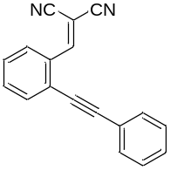
2-(2-(Phenylethynyl)benzylidene)malononitrile (1a): Yellow solid. m.p. 105.7–106.3 ºC. ¹H NMR (400 MHz, CDCl₃) δ: 8.44 (s, 1H), 8.30–8.28 (m, 1H), 7.69–7.67 (m, 1H), 7.60–7.54 (m, 3H), 7.50–7.46 (m, 1H), 7.42–7.38 (m, 1H); ¹³C NMR (100 MHz, CDCl₃) δ: 157.8, 133.8, 133.3, 131.7, 131.6, 129.5, 128.9, 128.6, 127.9, 126.6, 121.6, 113.7, 112.4, 98.5, 85.1, 83.9. HRMS (ESI) [M+H]⁺ Calcd. for [C₁₈H₁₁N₂]⁺: 255.0917, Found: 255.0920.

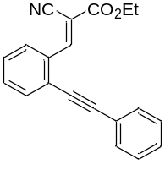
Ethyl (E)-2-cyano-3-(2-(phenylethynyl)phenyl)acrylate (4a): Yellow solid. m.p. 56.2–58.1 ºC. ¹H NMR (400 MHz, CDCl₃) δ: 9.01 (s, 1H), 8.42–8.40 (m, 1H), 7.67–7.65 (m, 1H), 7.59 (s, 2H), 7.54–7.45 (m, 2H), 7.39 (s, 3H), 4.44–4.39 (m, 2H), 1.41 (t, J = 8.0 Hz, 3H); ¹³C NMR (100 MHz, CDCl₃) δ: 162.3, 153.0, 132.8, 132.6, 132.5, 131.7, 129.1, 128.8, 128.5, 128.3, 126.7, 122.2, 115.3, 104.3, 97.8, 85.9, 62.7, 14.1. HRMS (ESI) [M+Na]⁺ Calcd. for [C₂₀H₁₅NNaO₂]⁺: 324.0995, Found: 324.0999.

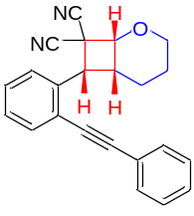
(±)-(1R,6R,7R)-7-(2-(Phenylethynyl)phenyl)-2-oxabicyclo[4.2.0]octane-8,8-dicarbonitrile (3aa): White solid. m.p. 143.8–144.6 ºC. ¹H NMR (600 MHz, CDCl₃) δ 7.64–7.60 (m, 2H), 7.493–7.489 (m, 2H), 7.45–7.43 (m, 1H), 7.39–7.34 (m, 4H), 4.86 (d, J = 7.8 Hz, 1H), 4.45 (t, J = 12.0 Hz, 1H), 4.16 (d, J=7.8 Hz, 1H), 3.89–3.87 (m, 1H), 3.54–3.48 (m, 1H), 2.18–2.15 (m, 1H), 1.87–1.81 (m, 1H), 1.70–1.68 (m, 1H), 1.61–1.55 (m, 1H); ¹³C NMR (150 MHz, CDCl₃) δ 134.9, 133.6, 131.3, 128.9, 128.7, 128.6, 127.9, 127.0, 122.6, 122.2, 115.3, 114.8, 94.2, 87.2, 73.7, 64.6, 44.0, 40.1, 36.7, 22.1, 19.7. HRMS (ESI) [M+Na]⁺ Calcd. for [C₂₃H₁₈N₂NaO]⁺: 361.1311, Found: 361.1315.

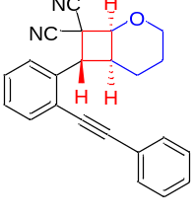
(±)-(1S,6S,7R)-7-(2-(phenylethynyl)phenyl)-2-oxabicyclo[4.2.0]octane-8,8-dicarbonitrile [3(aa)']: White solid. m.p. 145.1–145.6 ºC. ¹H NMR (600 MHz, CDCl₃) δ 7.67–7.65 (m, 3H), 7.44–7.42 (m, 2H), 7.40–7.36 (m, 4H), 5.10 (d, J = 11.4 Hz, 1H), 4.59 (t, J = 5.4 Hz, 1H), 4.15–4.13 (m, 1H), 3.46 (td, J₁ = 1.8 Hz, J₂ = 12.0 Hz 1H), 3.21–3.17 (m, 1H), 2.00–1.92 (m, 1H), 1.82–1.76 (m, 1H), 1.72–1.69 (m, 1H), 1.62–1.58 (m, 1H); ¹³C NMR (150 MHz, CDCl₃) δ 134.9, 133.2, 131.9, 128.9, 128.72, 128.70, 128.4, 126.9, 124.4, 122.7, 113.0, 112.4, 95.5, 86.3, 73.1, 65.3, 47.0, 38.2, 34.2, 21.0, 20.3. HRMS (ESI) [M+Na]⁺ Calcd. for [C₂₃H₁₈N₂NaO]⁺: 361.1311, Found: 361.1315.

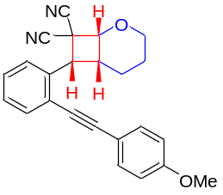
(±)-(1R,6R,7R)-7-(2-((4-Methoxyphenyl)ethynyl)phenyl)-2-oxabicyclo[4.2.0]octane-8,8-dicarbonitrile (3ba): White solid. m.p. 142.7–143.9 ºC. ¹H NMR (400 MHz, CDCl₃) δ 7.62–7.57 (m, 2H), 7.45–7.39 (m, 3H), 7.36–7.32 (m, 1H), 6.93–6.89 (m, 2H), 4.86 (d, J = 7.6 Hz, 1H), 4.45 (td, J₁ = 3.2 Hz, J₂ = 11.6 Hz, 1H), 4.15 (d, J = 8.0 Hz, 1H), 3.90–3.86 (m, 1H), 3.84 (s, 3H), 3.54–3.45 (m, 1H), 2.19–2.13 (m, 1H), 1.89–1.78 (m, 1H), 1.72–1.67 (m, 1H), 1.64–1.52 (m, 1H); ¹³C NMR (100 MHz, CDCl₃) δ 160.0, 134.7, 133.4, 132.8, 128.3, 127.8, 126.9, 122.5, 115.4, 114.9, 114.6, 114.2, 94.4, 86.0, 73.7, 64.6, 55.3, 44.0, 40.1, 36.7, 22.1, 19.7. HRMS (ESI) [M+Na]⁺ Calcd. for [C₂₄H₂₀N₂NaO₂]⁺: 391.1417, Found: 391.1417.

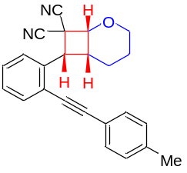
(±)-(1R,6R,7R)-7-(2-(p-Tolylethynyl)phenyl)-2-oxabicyclo[4.2.0]octane-8,8-dicarbonitrile (3ca): White solid. m.p. 123.8–125.4 ºC. ¹H NMR (400 MHz, CDCl₃) δ 7.63–7.57 (m, 2H), 7.44–7.32 (m, 4H), 7.20–7.18 (m, 2H), 4.85 (d, J = 7.6 Hz, 1H), 4.44 (td, J₁ = 2.8 Hz, J₂ = 11.6 Hz, 1H), 4.14 (d, J = 8.0 Hz, 1H), 3.89–3.85 (m, 1H), 3.55–3.46 (m, 1H), 2.38 (s, 3H), 2.18–2.12 (m, 1H), 1.88–1.77 (m, 1H), 1.71–1.66 (m, 1H), 1.62–1.51 (m, 1H); ¹³C NMR (100 MHz, CDCl₃) δ 139.2, 134.9, 133.4, 131.2, 129.3, 128.5, 127.8, 126.9, 122.4, 119.5, 115.3, 114.8. 94.5, 86.6, 73.7, 64.6, 44.0, 40.1, 36.7, 22.1, 21.5, 19.7. HRMS (ESI) [M+Na]⁺ Calcd. for [C₂₄H₂₀N₂NaO]⁺: 375.1468, Found: 375.1473.

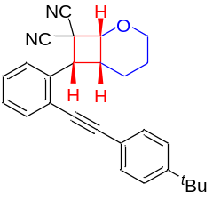
(±)-(1R,6R,7R)-7-(2-((4-(tert-Butyl)phenyl)ethynyl)phenyl)-2-oxabicyclo[4.2.0]octane-8,8-dicarbonitrile (3da): White solid. m.p. 143.6–144.8 ºC. ¹H NMR (600 MHz, CDCl₃) δ 7.64–7.62 (m, 1H), 7.60–7.58 (m, 1H), 7.44–7.40 (m, 5H), 7.36–7.33 (m, 1H), 4.86 (d, J = 7.8 Hz, 1H), 4.45 (td, J₁ = 3.0 Hz, J₂ = 12.0 Hz, 1H), 4.15 (d, J = 7.8 Hz, 1H), 3.89–3.87 (m, 1H), 3.55–3.49 (m, 1H), 2.18–2.14 (m, 1H), 1.87–1.79 (m, 1H), 1.70–1.67 (m, 1H), 1.62–1.54 (m, 1H), 1.34 (s, 9H); ¹³C NMR (150 MHz, CDCl₃) δ 152.3, 134.9, 133.5, 131.0, 128.5, 127.8, 126.9, 125.6, 122.4, 119.5, 115.3, 114.9, 94.4, 86.6, 73.7, 64.6, 44.0, 40.1, 36.7, 34.8, 22.1, 19.7. HRMS (ESI) [M+Na]⁺ Calcd. for [C₂₇H₂₆N₂NaO]⁺: 417.1937, Found: 417.1939.

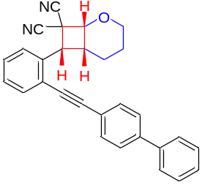
(±)-(1R,6R,7R)-7-(2-([1,1'-Biphenyl]-4-ylethynyl)phenyl)-2-oxabicyclo[4.2.0]octane-8,8-dicarbonitrile (3ea): White solid. m.p. 144.4–145.3 ºC. ¹H NMR (600 MHz, CDCl₃) δ 7.64–7.60 (m, 6H), 7.57–7.55 (m, 2H), 7.47–7.42 (m, 3H), 7.39–7.34 (m, 2H), 4.88 (d, J = 7.8 Hz, 1H), 4.45 (td, J₁ = 3.0 Hz, J₂ = 12.0 Hz, 1H), 4.17 (d, J = 7.8 Hz, 1H), 3.89–3.87 (m, 1H), 3.56–3.50 (m, 1H), 2.19–2.15 (m, 1H), 1.88–1.81 (m, 1H), 1.71–1.68 (m, 1H), 1.63–1.55 (m, 1H); ¹³C NMR (150 MHz, CDCl₃) δ 141.6, 140.0, 134.9, 133.6, 131.7, 128.9, 128.7, 127.85, 127.81, 127.2, 127.0, 122.2, 121.4, 115.3, 114.8, 94.2, 87.9, 73.6, 64.6, 44.0, 40.1, 36.7, 22.1, 19.8. HRMS (ESI) [M+Na]⁺ Calcd. for [C₂₉H₂₂N₂NaO]⁺: 437.1624, Found: 437.1624.

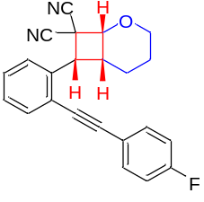
(±)-(1R,6R,7R)-7-(2-((4-Fluorophenyl)ethynyl)phenyl)-2-oxabicyclo[4.2.0]octane-8,8-dicarbonitrile (3fa): White solid. m.p. 144.6–145.2 ºC. ¹H NMR (400 MHz, CDCl₃) δ 7.62–7.58 (m, 2H), 7.50–7.41 (m, 3H), 7.37–7.33 (m, 1H), 7.10–7.05 (m, 2H), 4.86 (d, J = 7.6 Hz, 1H), 4.44 (td, J₁ = 2.8 Hz, J₂ = 11.6 Hz, 1H), 4.15 (d, J = 8.0 Hz, 1H), 3.90–3.86 (m, 1H), 3.51–3.42 (m, 1H), 2.17–2.12 (m, 1H), 1.90–1.79 (m, 1H), 1.72–1.68 (m, 1H), 1.62–1.52 (m, 1H); ¹⁹F NMR (376 MHz, CDCl₃) δ −109.6; ¹³C NMR (100 MHz, CDCl₃) δ 162.7 (d, J = 249.4 Hz), 134.8, 133.6, 133.3 (d, J = 8.5 Hz), 128.7, 127.8, 127.0, 122.0, 118.6 (d, J = 3.4 Hz), 115.9 (d, J = 22.1 Hz), 115.3, 114.8, 93.2, 86.9, 73.6, 64.6, 43.9, 40.0, 36.8, 22.1, 19.8. HRMS (ESI) [M+Na]⁺ Calcd. for [C₂₃H₁₇FN₂NaO]⁺: 379.1217, Found: 379.1218.

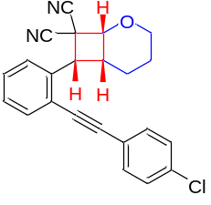
(±)-(1R,6R,7R)-7-(2-((4-Chlorophenyl)ethynyl)phenyl)-2-oxabicyclo[4.2.0]octane-8,8-dicarbonitrile (3ga): White solid. m.p. 147.8–148.5 ºC. ¹H NMR (400 MHz, CDCl₃) δ 7.63–7.59 (m, 2H), 7.47–7.42 (m, 3H), 7.37–7.34 (m, 3H), 4.86 (d, J = 7.6 Hz, 1H), 4.44 (td, J₁ = 2.8 Hz, J₂ = 11.6 Hz, 1H), 4.15 (d, J = 8.0 Hz, 1H), 3.90–3.86 (m, 1H), 3.50–3.41 (m, 1H), 2.17–2.11 (m, 1H), 1.90–1.79 (m, 1H), 1.73–1.68 (m, 1H), 1.63–1.52 (m, 1H); ¹³C NMR (100 MHz, CDCl₃) δ 134.93, 134.91, 133.6, 132.5, 128.90, 128.87, 127.9, 127.1, 121.9, 121.0, 115.3, 114.7, 93.2, 88.2, 73.6, 64.5, 43.9, 40.0, 36.8, 22.1, 19.8. HRMS (ESI) [M+Na]⁺ Calcd. for [C₂₃H₁₇ClN₂NaO]⁺: 395.0922, Found: 395.0924.

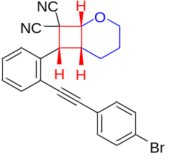
(±)-(1R,6R,7R)-7-(2-((4-Bromophenyl)ethynyl)phenyl)-2-oxabicyclo[4.2.0]octane-8,8-dicarbonitrile (3ha): White solid. m.p. 147.1–147.4 ºC. ¹H NMR (600 MHz, CDCl₃) δ 7.63–7.59 (m, 2H), 7.53–7.52 (m, 2H), 7.47–7.44 (m, 1H), 7.36–7.35 (m, 3H), 4.87 (d, J = 7.8 Hz, 1H), 4.45 (t, J = 12.0 Hz, 1H), 4.15 (d, J = 7.8 Hz, 1H), 3.90–3.88 (m, 1H), 3.48–3.42 (m, 1H), 2.15–2.14 (m, 1H), 1.88–1.82 (m, 1H), 1.72–1.70 (m, 1H), 1.61–1.59 (m, 1H); ¹³C NMR (150 MHz, CDCl₃) δ 135.0, 133.7, 132.7, 131.9, 129.0, 128.0, 127.2, 123.3, 121.9, 121.5, 115.3, 114.8, 93.2, 88.4, 73.7, 64.6, 44.0, 40.1, 36.9, 22.2, 19.9. HRMS (ESI) [M+Na]⁺ Calcd. for [C₂₃H₁₇⁷⁹BrN₂NaO]⁺: 417.0597, Found: 417.0599.

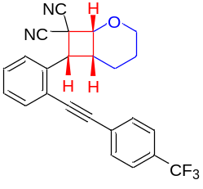
(±)-(1R,6R,7R)-7-(2-((4-(Trifluoromethyl)phenyl)ethynyl)phenyl)-2-oxabicyclo[4.2.0] octane-8,8-dicarbonitrile (3ia): White solid. m.p. 134.8–146.4 ºC. ¹H NMR (600 MHz, CDCl₃) δ 7.65–7.60 (m, 6H), 7.49–7.46 (m, 1H), 7.40–7.37 (m, 1H), 4.87 (d, J = 7.8 Hz, 1H), 4.45 (t, J = 11.4 Hz, 1H), 4.17 (d, J = 7.8 Hz, 1H), 3.90–3.88 (m, 1H), 3.49–3.43 (m, 1H), 2.17–2.13 (m, 1H), 1.90–1.83 (m, 1H), 1.72–1.70 (m, 1H), 1.62–1.55 (m, 1H); ¹⁹F NMR (376 MHz, CDCl₃) δ −62.9; ¹³C NMR (150 MHz, CDCl₃) δ 135.1, 133.9, 132.1, 131.6, 130.5 (q, J = 32.6 Hz), 129.3, 127.2, 125.52 (q, J = 3.3 Hz), 125.46 (q, J = 249.8 Hz), 121.5, 115.3, 114.7, 92.8, 89.5, 73.6, 64.6, 43.9, 40.0, 37.0, 22.1, 19.9. HRMS (ESI) [M+Na]⁺ Calcd. for [C₂₄H₁₇F₃N₂NaO]⁺: 429.1185, Found: 429.1183.

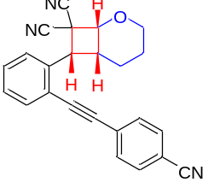
(±)-(1R,6R,7R)-7-(2-((4-Cyanophenyl)ethynyl)phenyl)-2-oxabicyclo[4.2.0]octane-8,8-dicarbonitrile (3ja): White solid. m.p. 138.3–138.8 ºC. ¹H NMR (400 MHz, CDCl₃) δ 7.69–7.67 (m, 2H), 7.64–7.59 (m, 4H), 7.51–7.47 (m, 1H), 7.41–7.38 (m, 1H), 4.88 (d, J = 7.6 Hz, 1H), 4.45 (td, J₁ = 2.8 Hz, J₂ = 11.6 Hz, 1H), 4.17 (d, J = 8.0 Hz, 1H), 3.91–3.88 (m, 1H), 3.48–3.39 (m, 1H), 2.17–2.11 (m, 1H), 1.93–1.82 (m, 1H), 1.74–1.71 (m, 1H), 1.65–1.53 (m, 1H); ¹³C NMR (100 MHz, CDCl₃) δ 135.2, 134.1, 132.2, 131.9, 129.6, 128.1, 127.4, 121.3, 118.2, 115.3, 114.7, 112.2, 92.6, 91.5, 73.7, 64.6, 43.9, 40.0, 37.1, 22.1, 20.0. HRMS (ESI) [M+Na]⁺ Calcd. for [C₂₄H₁₇N₃NaO]⁺: 386.1264, Found: 386.1269.

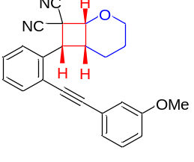
(±)-(1R,6R,7R)-7-(2-((3-Methoxyphenyl)ethynyl)phenyl)-2-oxabicyclo[4.2.0]octane-8,8-dicarbonitrile (3ka): White solid. m.p. 152.7–152.9 ºC. ¹H NMR (400 MHz, CDCl₃) δ 7.63–7.59 (m, 2H), 7.44–7.41 (m, 1H), 7.36–7.27 (m, 2H), 7.09–7.07 (m, 1H), 7.02 (s, 1H), 6.95–6.92 (m, 1H), 4.85 (d, J = 7.6 Hz, 1H), 4.43 (td, J₁ = 2.8 Hz, J₂ = 11.6 Hz, 1H), 4.14 (d, J = 8.0 Hz, 1H), 3.88–3.86 (m, 1H), 3.82 (s, 3H), 3.54–3.45 (m, 1H), 2.18–2.13 (m, 1H), 1.88–1.77 (m, 1H), 1.70–1.66 (m, 1H), 1.63–1.51 (m, 1H); ¹³C NMR (100 MHz, CDCl₃) δ 159.4, 134.9, 133.5, 129.6, 128.7, 127.8, 126.9, 123.7, 123.5, 122.0, 116.4, 115.3, 115.0, 114.8, 94.1, 87.0, 73.6, 64.5, 55.2, 43.9, 40.0, 36.7, 22.1, 19.7. HRMS (ESI) [M+Na]⁺ Calcd. for [C₂₄H₂₀N₂NaO₂]⁺: 391.1417, Found: 391.1422.

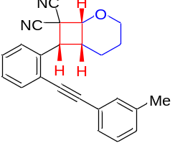
(±)-(1R,6R,7R)-7-(2-(m-Tolylethynyl)phenyl)-2-oxabicyclo[4.2.0]octane-8,8-dicarbonitrile (3la): White solid. m.p. 131.5–132.1 ºC. ¹H NMR (600 MHz, CDCl₃) δ 7.65–7.63 (m, 1H), 7.60–7.59 (m, 1H), 7.45–7.42 (m, 1H), 7.37–7.34 (m, 1H), 7.31–7.26 (m, 3H), 7.21–7.20 (m, 1H), 4.87 (d, J = 7.8 Hz, 1H), 4.45 (td, J₁ = 3.0 Hz, J₂ = 12.0 Hz, 1H), 4.15 (d, J = 8.4 Hz, 1H), 3.90–3.87 (m, 1H), 3.55–3.49 (m, 1H), 2.38 (s, 3H), 2.18–2.14 (m, 1H), 1.87–1.80 (m, 1H), 1.71–1.68 (m, 1H), 1.63–1.55 (m, 1H); ¹³C NMR (150 MHz, CDCl₃) δ 138.4, 134.9, 133.5, 131.8, 129.8, 128.7, 128.5, 128.4, 127.9, 127.0, 122.4, 122.3, 115.3, 114.9, 94.4, 86.9, 73.7, 64.7, 44.0, 40.1, 36.7, 22.2, 21.3, 19.7. HRMS (ESI) [M+Na]⁺ Calcd. for [C₂₄H₂₀N₂NaO]⁺: 375.1468, Found: 375.1469.

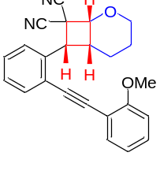
(±)-(1R,6R,7R)-7-(2-((2-Methoxyphenyl)ethynyl)phenyl)-2-oxabicyclo[4.2.0]octane-8,8-dicarbonitrile (3ma): White solid. m.p. 156.4–157.8 ºC. ¹H NMR (600 MHz, CDCl₃) δ 7.70–7.69 (m, 1H), 7.61–7.59 (m, 1H), 7.46–7.41 (m, 2H), 7.37–7.33 (m, 2H), 6.98–6.96 (m, 1H), 6.94–6.92 (m, 1H), 4.85 (d, J = 7.8 Hz, 1H), 4.46 (td, J₁ = 3.0 Hz, J₂ = 12.0 Hz, 1H), 4.22 (d, J = 8.4 Hz, 1H), 3.92 (s, 3H), 3.89–3.87 (m, 1H), 3.76–3.70 (m, 1H), 2.15–2.11 (m, 1H), 1.83–1.75 (m, 1H), 1.70–1.66 (m, 1H), 1.59–1.52 (m, 1H); ¹³C NMR (150 MHz, CDCl₃) δ 160.0, 135.0, 133.22, 133.19, 130.3, 128.5, 127.7, 126.7, 122.6, 120.7, 115.4, 115.0, 111.8, 110.7, 91.1, 90.9, 73.9, 64.7, 55.7, 43.9, 39.6, 36.4, 22.2, 19.5. HRMS (ESI) [M+Na]⁺ Calcd. for [C₂₄H₂₀N₂NaO₂]⁺: 391.1417, Found: 391.1422.

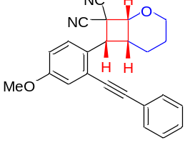
(±)-(1R,6R,7R)-7-(4-Methoxy-2-(phenylethynyl)phenyl)-2-oxabicyclo[4.2.0]octane-8,8-dicarbonitrile (3na): White solid. m.p. 145.1–145.6 ºC. ¹H NMR (600 MHz, CDCl₃) δ 7.63–7.61 (m, 1H), 7.58–7.57 (m, 1H), 7.44–7.40 (m, 3H), 7.36–7.33 (m, 1H), 6.92–6.90 (m, 2H), 4.86 (d, J=7.8 Hz, 1H), 4.45 (td, J₁ = 3.0 Hz, J₂ = 12.0 Hz, 1H), 4.15 (d, J = 7.8 Hz, 1H), 3.90–3.87 (m, 1H), 3.84 (s, 3H), 3.53–3.47 (m, 1H), 2.17–2.14 (m, 1H), 1.88–1.80 (m, 1H), 1.71–1.68 (m, 1H), 1.62–1.54 (m, 1H); ¹³C NMR (150 MHz, CDCl₃) δ 160.1, 134.7, 133.4, 132.8, 128.4, 127.8, 126.9, 122.6, 115.4, 114.9, 114.6, 114.3, 94.4, 86.0, 73.7, 64.6, 55.4, 44.0, 40.1, 36.8, 22.2, 19.8. HRMS (ESI) [M+Na]⁺ Calcd. For [C₂₄H₂₀N₂NaO₂]⁺: 391.1417, Found: 391.1417.

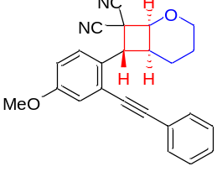
(±)-(1S,6S,7R)-7-(4-Methoxy-2-(phenylethynyl)phenyl)-2-oxabicyclo [4.2.0]octane-8,8-dicarbonitrile [3(na)']: White solid. m.p. 144.3–145.6 ºC. ¹H NMR (600 MHz, CDCl₃) δ 7.67–7.65 (m, 2H), 7.38–7.34 (m, 4H), 7.16 (s, 1H), 6.97–6.96 (m, 1H), 5.05 (d, J = 11.4 Hz, 1H), 4.57–4.56 (m, 1H), 4.12 (d, J = 11.4 Hz, 1H), 3.84 (s, 3H), 3.44 (t, J = 12.0 Hz, 1H ), 3.14–3.12 (m, 1H), 1.98–1.91 (m, 1H), 1.79–1.73 (m, 1H), 1.69–1.66 (m, 1H), 1.60–1.57 (m, 1H); ¹³C NMR (150 MHz, CDCl₃) δ 159.6, 131.9, 128.7, 128.4, 128.3, 128.1, 127.1, 125.5, 122.5, 117.8, 115.0, 113.1, 112.4, 95.0, 86.3, 72.9, 65.3, 55.4, 46.8, 38.4, 34.5, 20.9, 20.3. HRMS (ESI) [M+Na]⁺ Calcd. For [C₂₄H₂₀N₂NaO₂]⁺: 391.1417, Found: 391.1418.

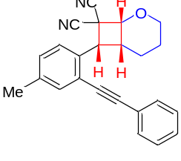
(±)-(1R,6R,7R)-7-(4-Methyl-2-(phenylethynyl)phenyl)-2-oxabicyclo[4.2.0]octane-8,8-dicarbonitrile (3oa): White solid. m.p. 143.9–144.4 ºC. ¹H NMR (400 MHz, CDCl₃) δ 7.51–7.47 (m, 3H), 7.42 (s, 1H), 7.38–7.37 (m, 3H), 7.24–7.22 (m, 1H), 4.84 (d, J = 7.6 Hz, 1H), 4.43 (td, J₁ = 2.8 Hz, J₂ = 11.6 Hz, 1H), 4.12 (d, J = 8.0 Hz, 1H), 3.88–3.85 (m, 1H), 3.51–3.42 (m, 1H), 2.36 (s, 3H), 2.17–2.12 (m, 1H), 1.89–1.78 (m, 1H), 1.70–1.66 (m, 1H), 1.62–1.51 (m, 1H); ¹³C NMR (100 MHz, CDCl₃) δ 137.7, 134.0, 131.9, 131.2, 129.5, 128.7, 128.5, 126.9, 122.6, 121.9, 115.4, 114.9, 93.7, 87.4, 73.6, 64.6, 43.7, 40.0, 36.8, 22.1, 20.7, 19.7. HRMS (ESI) [M+Na]⁺ Calcd. for [C₂₄H₂₀N₂NaO]⁺: 375.1468, Found: 375.1469.

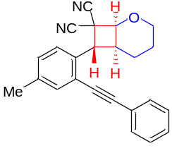
(±)-(1S,6S,7R)-7-(4-Methyl-2-(phenylethynyl)phenyl)-2-oxabicyclo [4.2.0]octane-8,8-dicarbonitrile [3(oa)']: White solid. m.p. 175.8–176.2 ºC. ¹H NMR (600 MHz, CDCl₃) δ 7.66–7.64 (m, 2H), 7.48 (s, 1H), 7.37–7.34 (m, 3H), 7.32–7.31 (m, 1H), 7.24–7.23 (m, 1H), 5.06 (d, J = 11.4 Hz, 1H), 4.58–4.57 (m, 1H), 4.13 (d, J = 11.4 Hz, 1H), 3.45 (t, J = 12.0 Hz, 1H), 3.17–3.15 (m, 1H), 2.37 (s, 3H), 1.99–1.92 (m, 1H), 1.81–1.75 (m, 1H), 1.70–1.68 (m, 1H), 1.60–1.57 (m, 1H); ¹³C NMR (150 MHz, CDCl₃) δ 138.9, 133.8, 132.0, 131.9, 129.6, 128.6, 128.3, 126.8, 124.2, 122.8, 113.1, 112.4, 95.0, 86.5, 73.0, 65.3, 46.9, 38.3, 34.3, 21.0, 20.9, 20.3. HRMS (ESI) [M+Na]⁺ Calcd. for [C₂₄H₂₀N₂NaO]⁺: 375.1468, Found: 375.1467.

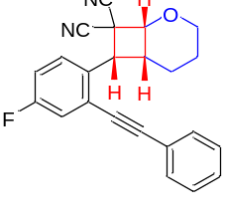
(±)-(1R,6R,7R)-7-(4-Fluoro-2-(phenylethynyl)phenyl)-2-oxabicyclo[4.2.0]octane-8,8-dicarbonitrile (3pa): White solid. m.p. 148.8–150.6 ºC. ¹H NMR (400 MHz, CDCl₃) δ 7.63–7.60 (m, 1H), 7.51–7.49 (m, 2H), 7.41–7.39 (m, 3H), 7.33–7.30 (m, 1H), 7.17–7.13 (m, 1H), 4.86 (d, J = 7.6 Hz, 1H), 4.44 (td, J₁ = 2.8 Hz, J₂ = 11.6 Hz, 1H), 4.13 (d, J = 8.0 Hz, 1H), 3.90–3.87 (m, 1H), 3.52–3.43 (m, 1H), 2.16–2.10 (m, 1H), 1.89–1.79 (m, 1H), 1.74–1.69 (m, 1H), 1.64–1.53 (m, 1H); ¹⁹F NMR (376 MHz, CDCl₃) δ −113.7; ¹³C NMR (100 MHz, CDCl₃) δ 161.7 (d, J = 247.3 Hz), 131.4, 130.9 (d, J = 3.3 Hz), 129.3, 128.8, 128.7, 124.3 (d, J = 9.4 Hz), 122.0, 120.3 (d, J = 22.9 Hz), 116.0 (d, J = 21.5 Hz), 115.2, 114.7, 95.2, 86.0 (d, J = 2.9 Hz), 73.7, 64.6, 43.5, 40.0, 36.9, 22.1, 19.7. HRMS (ESI) [M+Na]⁺ Calcd. for [C₂₃H₁₈FN₂NaO]⁺: 357.1398, Found: 357.1399.
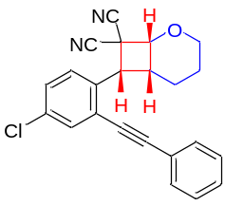
(±)-(1R,6R,7R)-7-(4-Chloro-2-(phenylethynyl)phenyl)-2-oxabicyclo[4.2.0]octane-8,8-dicarbonitrile (3qa): White solid. m.p. 149.3–149.5 ºC. ¹H NMR (400 MHz, CDCl₃) δ 7.60–7.56 (m, 2H), 7.51–7.48 (m, 2H), 7.42–7.38 (m, 4H), 4.86 (d, J = 7.6 Hz, 1H), 4.44 (td, J₁ = 2.8 Hz, J₂ = 11.6 Hz, 1H), 4.12 (d, J = 8.0 Hz, 1H), 3.90–3.87 (m, 1H), 3.53–3.44 (m, 1H), 2.16–2.11 (m, 1H), 1.88–1.77 (m, 1H), 1.73–1.69 (m, 1H), 1.64–1.52 (m, 1H); ¹³C NMR (100 MHz, CDCl₃) δ 133.9, 133.4, 133.2, 131.4, 129.3, 128.8, 128.7, 128.3, 124.0, 122.0, 115.1, 114.6, 95.5, 85.9, 73.7, 64.6, 43.6, 40.0, 36.8, 22.1, 19.7. HRMS (ESI) [M+Na]⁺ Calcd. for [C₂₃H₁₇ClN₂NaO]⁺: 395.0922, Found: 395.0926.

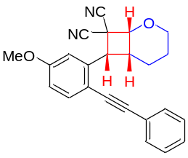
(±)-(1R,6R,7R)-7-(5-Methoxy-2-(phenylethynyl)phenyl)-2-oxabicyclo[4.2.0]octane-8,8-dicarbonitrile (3ra): White solid. m.p. 130.8–132.2 ºC. ¹H NMR (600 MHz, CDCl₃) δ 7.52–7.51 (m, 1H), 7.47–7.46 (m, 2H), 7.39–7.35 (m, 3H), 7.19–7.18 (m, 1H), 6.88–6.86 (m, 1H), 4.86 (d, J = 7.8 Hz, 1H), 4.45 (td, J₁ = 3.0 Hz, J₂ = 12.0 Hz, 1H), 4.14 (d, J = 8.4 Hz, 1H), 3.90–3.87 (m, 4H), 3.54–3.48 (m, 1H), 2.17–2.13 (m, 1H), 1.87–1.80 (m, 1H), 1.71–1.68 (m, 1H), 1.62–1.54 (m, 1H); ¹³C NMR (150 MHz, CDCl₃) δ 159.8, 136.6, 134.9, 131.1, 128.54, 128.52, 122.9, 115.3, 114.9, 114.0, 113.5, 113.1, 92.7, 87.2, 73.6, 64.7, 55.5, 44.0, 40.0, 36.7, 22.1, 19.7. HRMS (ESI) [M+Na]⁺ Calcd. for [C₂₄H₂₀N₂NaO₂]⁺: 391.1417, Found: 391.1422.

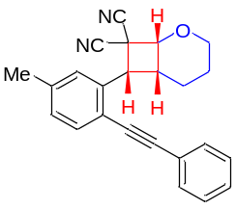
(±)-(1R,6R,7R)-7-(5-Methyl-2-(phenylethynyl)phenyl)-2-oxabicyclo[4.2.0]octane-8,8-dicarbonitrile (3sa): White solid. m.p. 139.2–140.6 ºC. ¹H NMR (600 MHz, CDCl₃) δ 7.49–7.47 (m, 3H), 7.40–7.36 (m, 4H), 7.16–7.14 (m, 1H), 4.85 (d, J = 7.8 Hz, 1H), 4.45 (td, J₁ = 3.0 Hz, J₂ = 12.0 Hz, 1H), 4.10 (d, J = 7.8 Hz, 1H), 3.89–3.87 (m, 1H), 3.53–3.47 (m, 1H), 2.43 (s, 3H), 2.19–2.15 (m, 1H), 1.86–1.79 (m, 1H), 1.70–1.67 (m, 1H), 1.62–1.56 (m, 1H); ¹³C NMR (150 MHz, CDCl₃) δ 139.1, 134.8, 133.4, 131.2, 128.7, 128.6, 128.5, 127.7, 122.8, 119.0, 115.4, 114.8, 93.4, 87.4, 73.6, 64.6, 43.8, 40.1, 36.7, 22.1, 21.6, 19.7. HRMS (ESI) [M+Na]⁺ Calcd. for [C₂₄H₂₀N₂NaO]⁺: 375.1468, Found: 375.1473.

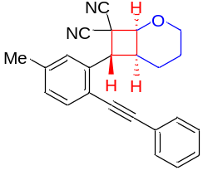
(±)-(1S,6S,7R)-7-(5-Methyl-2-(phenylethynyl)phenyl)-2-oxabicyclo [4.2.0]octane-8,8-dicarbonitrile [3(sa)']: White solid. m.p. 144.4–145.5 ºC. ¹H NMR (600 MHz, CDCl₃) δ 7.65–7.63 (m, 2H), 7.54–7.53 (m, 1H), 7.38–7.34 (m, 3H), 7.21–7.19 (m, 2H), 5.07 (d, J = 11.4 Hz, 1H), 4.59 (d, J = 4.8 Hz, 1H), 4.15–4.13 (m, 1H), 3.46 (td, J₁ = 1.8 Hz, J₂ = 12.0 Hz, 1H), 3.20–3.16 (m, 1H), 2.42 (s, 3H), 1.99–1.91 (m, 1H), 1.83–1.76 (m, 1H), 1.73–1.68 (m, 1H), 1.62–1.58 (m, 1H); ¹³C NMR (150 MHz, CDCl₃) δ 139.0, 134.7, 133.1, 131.8, 129.7, 128.5, 128.3, 127.6, 122.9, 121.4, 113.0, 112.4, 94.7, 86.5, 73.1, 65.3, 47.0, 38.2, 34.1, 21.7, 21.1, 20.3. HRMS (ESI) [M+Na]⁺ Calcd. for [C₂₄H₂₀N₂NaO]⁺: 375.1468, Found: 375.1469.

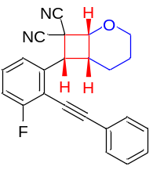
(±)-(1R,6R,7R)-7-(3-Fluoro-2-(phenylethynyl)phenyl)-2-oxabicyclo[4.2.0]octane-8,8-dicarbonitrile (3ta): White solid. m.p. 158.7–158.8 ºC. ¹H NMR (600 MHz, CDCl₃) δ 7.53–7.51 (m, 2H), 7.45–7.39 (m, 5H), 7.16–7.13 (m, 1H), 4.87 (d, J = 7.8 Hz, 1H), 4.45 (td, J₁ = 3.0 Hz, J₂ = 12.0 Hz, 1H), 4.13 (d, J = 8.4 Hz, 1H), 3.91–3.88 (m, 1H), 3.55–3.49 (m, 1H), 2.19–2.15 (m, 1H), 1.88–1.80 (m, 1H), 1.73–1.69 (m, 1H), 1.63–1.55 (m, 1H); ¹⁹F NMR (376 MHz, CDCl₃) δ −107.2; ¹³C NMR (150 MHz, CDCl₃) δ 163.4 (d, J = 251.4 Hz), 137.3, 131.4, 129.9 (d, J = 8.7 Hz), 129.2, 128.6, 122.6 (d, J = 3.3 Hz), 122.2, 115.2 (d, J = 15.0 Hz), 115.1, 114.7, 111.1, 111.0, 99.6 (d, J = 3.8 Hz), 80.3, 73.6, 64.6, 43.7 (d, J = 2.7 Hz), 40.1, 36.9, 22.1, 19.7. HRMS (ESI) [M+Na]⁺ Calcd. for [C₂₃H₁₇FN₂NaO]⁺: 379.1217, Found: 379.1216.

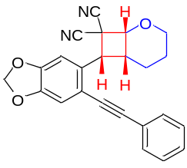
(±)-(1R,6R,7R)-7-(6-(Phenylethynyl)benzo[d][1,3]dioxol-5-yl)-2-oxabicyclo[4.2.0] octane-8,8-dicarbonitrile (3ua): White solid. m.p. 178.2–178.8 ºC. ¹H NMR (600 MHz, CDCl₃) δ 7.47–7.45 (m, 2H), 7.38–7.36 (m, 3H), 7.16 (s, 1H), 7.02 (s, 1H), 6.04 (s, 2H), 4.82 (d, J = 7.8 Hz, 1H), 4.44 (td, J₁ = 3.0 Hz, J₂ = 12.0 Hz, 1H), 4.14 (d, J = 8.4 Hz, 1H), 3.89–3.87 (m, 1H), 3.47–3.41 (m, 1H), 2.16–2.12 (m, 1H), 1.94–1.87 (m, 1H), 1.74–1.70 (m, 1H), 1.61–1.54 (m, 1H); ¹³C NMR (150 MHz, CDCl₃) δ 148.4, 147.1, 131.2, 129.7, 128.7, 128.6, 122.7, 115.7, 115.3, 114.8, 112.9, 107.7, 102.0, 93.1, 87.2, 73.7, 64.6, 43.8, 40.1, 37.0, 22.1, 19.7. HRMS (ESI) [M+Na]⁺ Calcd. for [C₂₄H₁₈N₂NaO₃]⁺: 405.1210, Found: 405.1212.

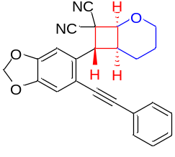
(±)-(1S,6S,7R)-7-(6-(Phenylethynyl)benzo[d][1,3]dioxol-5-yl)-2-oxabicyclo[4.2.0] octane-8,8-dicarbonitrile [3(ua)']: White solid. m.p. 182.8–183.0 ºC. ¹H NMR (600 MHz, CDCl₃) δ 7.63–7.61 (m, 2H), 7.38–7.34 (m, 3H), 7.07 (s, 1H), 6.91 (s, 1H), 6.05–6.04 (s, 2H), 5.09 (d, J = 11.4 Hz, 1H), 4.58–4.57 (m, 1H), 4.13 (d, J = 11.4 Hz, 1H), 3.45 (td, J₁ = 1.8 Hz, J₂ = 12.0 Hz, 1H), 3.07–3.03 (m, 1H), 1.99–1.91 (m, 1H), 1.80–1.74 (m, 1H), 1.70–1.67 (m, 1H), 1.62–1.58 (m, 1H); ¹³C NMR (150 MHz, CDCl₃) δ 148.5, 147.9, 131.8, 129.8, 128.5, 128.4, 122.8, 118.1, 113.1, 112.5, 112.3, 107.3, 102.0, 94.0, 86.3, 72.9, 65.3, 47.1, 38.3, 34.9, 21,0, 20.3. HRMS (ESI) [M+Na]⁺ Calcd. for [C₂₄H₁₈N₂NaO₃]⁺: 405.1210, Found: 405.1212.

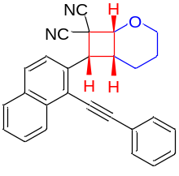
(±)-(1R,6R,7R)-7-(1-(Phenylethynyl)naphthalen-2-yl)-2-oxabicyclo[4.2.0]octane-8,8-dicarbonitrile (3va): White solid. m.p. 132.6–133.2 ºC. ¹H NMR (600 MHz, CDCl₃) δ 8.46–8.45 (m, 1H), 7.95–7.93 (m, 1H), 7.90–7.89 (m, 1H), 7.74–7.73 (m, 1H), 7.64–7.61 (m, 3H), 7.58–7.56 (m, 1H), 7.46–7.43 (m, 3H), 4.92 (d, J = 7.8 Hz, 1H), 4.46 (td, J₁ = 3.0 Hz, J₂ = 12.0 Hz, 1H), 4.40 (d, J = 8.4 Hz, 1H), 3.91–3.88 (m, 1H), 3.66–3.60 (m, 1H), 2.25–2.21 (m, 1H), 1.93–1.86 (m, 1H), 1.73–1.68 (m, 1H), 1.64–1.57 (m, 1H); ¹³C NMR (150 MHz, CDCl₃) δ 133.8, 133.7, 132.3, 131.4, 129.1, 129.0, 128.7, 128.3, 127.6, 127.0, 126.0, 124.0, 122.7, 119.6, 115.5, 115.0, 100.3, 85.4, 73.8, 64.6, 44.8, 40.5, 37.1, 22.2, 20.0. HRMS (ESI) [M+Na]⁺ Calcd. for [C₂₇H₂₀N₂NaO]⁺: 411.1468, Found: 411.1467.

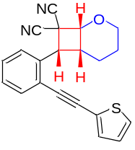
(±)-(1R,6R,7R)-7-(2-(Thiophen-2-ylethynyl)phenyl)-2-oxabicyclo[4.2.0]octane-8,8-dicarbonitrile (3wa): White solid. m.p. 113.8–115.0 ºC. ¹H NMR (600 MHz, CDCl₃) δ 7.62–7.58 (m, 2H), 7.46–7.44 (m, 1H), 7.37–7.36 (m, 2H), 7.29–7.28 (m, 1H), 7.06–7.05 (m, 1H), 4.87 (d, J = 7.8 Hz, 1H), 4.45 (td, J₁ = 1.8 Hz, J₂ = 12.0 Hz, 1H), 4.12 (d, J = 7.8 Hz, 1H), 3.90–3.89 (m, 1H), 3.52–3.46 (m, 1H), 2.18–2.15 (m, 1H), 1.87–1.80 (m, 1H), 1.72–1.69 (m, 1H), 1.64–1.59 (m, 1H); ¹³C NMR (150 MHz, CDCl₃) δ 135.0, 133.3, 132.1, 128.9, 128.0, 127.9, 127.4, 127.1, 122.5, 121.8, 115.3, 114.9, 91.0, 87.6, 73.6, 64.7, 44.0, 40.2, 36.8, 22.2, 19.8. HRMS (ESI) [M+Na]⁺ Calcd. for [C₂₁H₁₆N₂NaOS]⁺: 367.0876, Found: 367.0878.

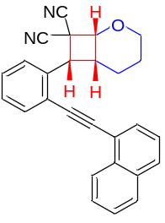
(±)-(1R,6R,7R)-7-(2-(Naphthalen-1-ylethynyl)phenyl)-2-oxabicyclo[4.2.0]octane-8,8-dicarbonitrile (3xa): White solid. m.p. 129.2–130.8 ºC. ¹H NMR (400 MHz, CDCl₃) δ 8.34–8.32 (m, 1H), 7.89–7.87 (m, 2H), 7.73–7.69 (m, 3H), 7.63–7.53 (m, 2H), 7.49–7.44 (m, 2H), 7.41–7.37 (m, 1H), 4.84 (d, J = 7.6 Hz, 1H), 4.43 (td, J₁ = 2.8 Hz, J₂=11.6 Hz, 1H), 4.24 (d, J = 8.0 Hz, 1H), 3.86–3.83 (m, 1H), 3.58–3.49 (m, 1H), 2.20–2.15 (m, 1H), 1.91–1.80 (m, 1H), 1.68–1.64 (m, 1H), 1.57–1.46 (m, 1H); ¹³C NMR (100 MHz, CDCl₃) δ 134.9, 133.6, 133.2, 133.0, 130.3, 129.4, 128.8, 128.5, 127.9, 127.1, 127.0, 126.6, 125.6, 125.2, 122.3, 120.1, 115.3, 114.8, 92.5, 91.8, 73.7, 64.6, 44.0, 40.0, 36.7, 22.0, 19.7. HRMS (ESI) [M+Na]⁺ Calcd. for [C₂₇H₂₀N₂NaO]⁺: 411.1468, Found: 411.1469.

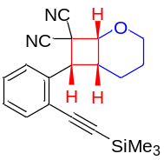
(±)-(1R,6R,7R)-7-(2-((Trimethylsilyl)ethynyl)phenyl)-2-oxabicyclo[4.2.0]octane-8,8-dicarbonitrile (3ya): White solid. m.p. 126.9–128.0 ºC. ¹H NMR (600 MHz, CDCl₃) δ 7.57–7.52 (m, 2H), 7.43–7.40 (m, 1H), 7.32–7.29 (m, 1H), 4.84 (d, J = 7.8 Hz, 1H), 4.44 (td, J₁ = 3.0 Hz, J₂ = 12.0 Hz, 1H), 4.09 (d, J = 8.4 Hz, 1H), 3.90–3.88 (m, 1H), 3.48–3.42 (m, 1H), 2.15–2.12 (m, 1H), 1.82–1.75 (m, 1H), 1.71–1.68 (m, 1H), 1.58–1.52 (m, 1H), 0.26 (s, 9H); ¹³C NMR (150 MHz, CDCl₃) δ 135.5, 133.9, 128.9, 127.7, 126.9, 122.0, 115.3, 114.8, 102.9, 99.8, 73.6, 64.6, 43.9, 40.1, 36.7, 22.1, 19.6, -0.3. HRMS (ESI) [M+H]⁺ Calcd. for [C₂₀H₂₃N₂OSi]⁺: 335.1574, Found: 335.1579.

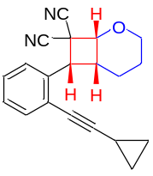
(±)-(1R,6R,7R)-7-(2-(Cyclopropylethynyl)phenyl)-2-oxabicyclo[4.2.0]octane-8,8-dicarbonitrile (3za): White solid. m.p. 127.5–128.8 ºC. ¹H NMR (600 MHz, CDCl₃) δ 7.52–7.51 (m, 1H), 7.44–7.43 (m, 1H), 7.35–7.32 (m, 1H), 7.28–7.25 (m, 1H), 4.84 (d, J = 7.8 Hz, 1H), 4.43 (td, J₁ = 3.0 Hz, J₂ = 12.0 Hz, 1H), 4.05 (d, J = 8.4 Hz, 1H), 3.90–3.87 (m, 1H), 3.40–3.34 (m, 1H), 2.09–2.05 (m, 1H), 1.83–1.76 (m, 1H), 1.72–1.67 (m, 1H), 1.63–1.55 (m, 1H), 1.51–1.46 (m, 1H), 0.93–0.91 (m, 2H), 0.83–0.77 (m, 2H); ¹³C NMR (150 MHz, CDCl₃) δ 134.9, 133.6, 127.7, 127.6, 126.8, 123.0, 115.5, 114.9, 99.0, 73.8, 73.7, 64.6, 43.9, 39.9, 36.9, 22.1, 19.8, 8.54, 8.49, 0.4. HRMS (ESI) [M+Na]⁺ Calcd. for [C₂₀H₁₈N₂NaO]⁺: 325.1311, Found: 325.1314.

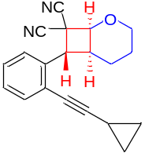
(±)-(1S,6S,7R)-7-(2-(Cyclopropylethynyl)phenyl)-2-oxabicyclo [4.2.0]octane-8,8-dicarbonitrile [3(za)']: White solid. m.p. 172.5–173.5 ºC. ¹H NMR (600 MHz, CDCl₃) δ 7.47–7.46 (m, 1H), 7.35–7.33 (m, 1H), 7.31–7.28 (m, 1H), 4.93 (d, J = 11.4 Hz, 1H), 4.57–4.56 (m, 1H), 4.16 (d, J = 11.4 Hz, 1H), 3.47 (t, J = 12.0 Hz, 1H), 3.16–3.12 (m, 1H), 2.00–1.92 (m, 1H), 1.83–1.76 (m, 1H), 1.71–1.69 (m, 1H), 1.64–1.60 (m, 1H), 1.59–1.56 (m, 1H), 0.97–0.89 (m, 4H); ¹³C NMR (150 MHz, CDCl₃) δ 135.2, 133.0, 128.6, 127.8, 126.5, 125.0, 113.0, 112.5, 100.7, 73.12, 73.06, 65.3, 47.2, 38.0, 33.8, 21.0, 20.4, 8.8, 8.4, 0.6. HRMS (ESI) [M+Na]⁺ Calcd. for [C₂₀H₁₈N₂NaO]⁺: 325.1311, Found: 325.1313.

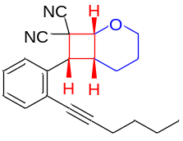
(±)-(1R,6R,7R)-7-(2-(Hex-1-yn-1-yl)phenyl)-2-oxabicyclo[4.2.0]octane-8,8-dicarbonitrile (3z'a): Light yellow oil. ¹H NMR (400 MHz, CDCl₃) δ 7.54–7.52 (m, 1H), 7.48–7.45 (m, 1H), 7.37–7.32 (m, 1H), 7.30–7.26 (m, 1H), 4.83 (d, J = 7.6 Hz, 1H), 4.43 (td, J₁ = 2.8 Hz, J₂ = 11.6 Hz, 1H), 4.07 (d, J = 8.0 Hz, 1H), 3.90–3.86 (m, 1H), 3.43–3.34 (m, 1H), 2.45 (t, J = 7.2 Hz, 2H), 2.11–2.06 (m, 1H), 1.86–1.76 (m, 1H), 1.72–1.67 (m, 1H), 1.64–1.60 (m, 2H), 1.58–1.55 (m, 1H), 1.52–1.43 (m, 2H), 0.96 (t, J = 7.2 Hz, 3H); ¹³C NMR (100 MHz, CDCl₃) δ 134.6, 133.6, 127.8, 127.7, 126.9, 123.2, 115.5, 114.9, 96.3, 78.7, 73.8, 64.6, 43.9, 39.7, 37.0, 30.5, 22.15, 22.10, 19.9, 13.6. HRMS (ESI) [M+Na]⁺ Calcd. for [C₂₁H₂₂N₂NaO]⁺: 341.1624, Found: 341.1619.

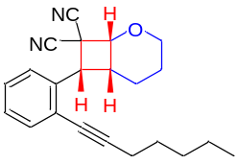
(±)-(1R,6R,7R)-7-(2-(Hept-1-yn-1-yl)phenyl)-2-oxabicyclo[4.2.0]octane-8,8-dicarbonitrile (3z''a): Light yellow oil. ¹H NMR (600 MHz, CDCl₃) δ: 7.54–7.53 (m, 1H), 7.47–7.46 (m, 1H), 7.36–7.33 (m, 1H), 7.29–7.27 (m, 1H), 4.83 (d, J = 7.8 Hz, 1H), 4.44 (td, J₁ = 3.0 Hz, J₂ = 12.0 Hz, 1H), 4.07 (d, J = 8.4 Hz, 1H), 3.90–3.86 (m, 1H), 3.42–3.36 (m, 1H), 2.44 (t, J = 7.2 Hz, 2H), 2.10–2.07 (m, 1H), 1.85–1.77 (m, 1H), 1.72–1.67 (m, 1H), 1.64–1.60 (m, 2H), 1.59–1.56 (m, 1H), 1.46–1.41 (m, 2H), 1.40–1.34 (m, 2H), 0.93 (t, J = 7.2 Hz, 3H); ¹³C NMR (150 MHz, CDCl₃) δ: 134.7, 133.6, 127.8, 127.7, 126.9, 123.2, 115.5, 114.9, 96.4, 78.7, 73.8, 64.6, 43.9, 39.7, 36.9, 31.2, 28.1, 22.18, 22.15, 19.9, 19.7, 14.0. HRMS (ESI) [M+Na]⁺ Calcd. for [C₂₂H₂₄N₂NaO]⁺: 355.1781, Found: 355.1777.

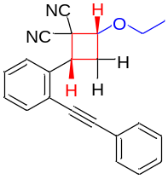
(±)-(2R,4R)-2-Ethoxy-4-(2-(phenylethynyl)phenyl)cyclobutane-1,1-dicarbonitrile (3ab): White solid. m.p. 171.5–176.7 ºC. ¹H NMR (400 MHz, CDCl₃) δ 7.64–7.61 (m, 3H), 7.45–7.44 (m, 2H), 7.39–7.36 (m, 4H), 4.49–4.39 (m, 2H), 3.85–3.77 (m, 1H), 3.72–3.65 (m, 1H), 2.86–2.71 (m, 2H), 1.34 (t, J = 7.2 Hz, 3H); ¹³C NMR (100 MHz, CDCl₃) δ 134.9, 133.2, 131.8, 131.6, 128.8, 128.7, 128.3, 127.3, 123.8, 122.6, 115.2, 111.2, 95.2, 86.4, 76.7, 66.2, 42.1, 38.4, 32.0, 14.9. HRMS (ESI) [M+Na]⁺ Calcd. for [C₂₂H₁₈N₂NaO]⁺: 349.1311, Found: 349.1310.

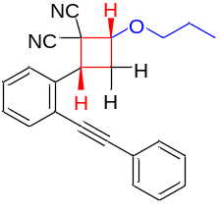
(±)-(2R,4R)-2-(2-(Phenylethynyl)phenyl)-4-propoxycyclobutane-1,1-dicarbonitrile (3ac): White solid. m.p. 133.8–134.2 ºC. ¹H NMR (600 MHz, CDCl₃) δ 7.63–7.62 (m, 3H), 7.444–7.437 (m, 2H), 7.38–7.36 (m, 4H), 4.47–4.44 (m, 1H), 4.42–4.38 (m, 1H), 3.73–3.69 (m, 1H), 3.58–3.54 (m, 1H), 2.85–2.79 (m, 1H), 2.76–2.71 (m, 1H), 1.75–1.69 (m, 2H), 1.00 (t, J = 4.8 Hz, 3H); ¹³C NMR (150 MHz, CDCl₃) δ 134.9, 133.1, 131.8, 128.74, 128.72, 128.3, 127.3, 123.8, 122.6, 115.2, 111.1, 95.2, 86.4, 76.8, 72.3, 42.0, 38.4, 31.9, 22.7, 10.4. HRMS (ESI) [M+Na]⁺ Calcd. for [C₂₃H₂₀N₂NaO]⁺: 363.1468, Found: 363.1471.

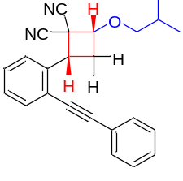
(±)-(2R,4R)-2-(iso-Butoxy)-4-(2-(phenylethynyl)phenyl)cyclobutane-1,1-dicarbonitrile (3ad): White solid. m.p. 125.8–126.4 ºC. ¹H NMR (400 MHz, CDCl₃) δ 7.64–7.61 (m, 3H), 7.44–7.43 (m, 2H), 7.38–7.35 (m, 4H), 4.44–4.36 (m, 2H), 3.54–3.50 (m, 1H), 3.37–3.33 (m, 1H), 2.88–2.67 (m, 2H), 2.05–1.92 (m, 1H), 0.98 (t, J = 6.4 Hz, 6H); ¹³C NMR (100 MHz, CDCl₃) δ 134.9, 133.1, 131.7, 128.69, 128.67, 128.3, 127.3, 123.8, 122.6, 115.2, 111.1, 95.2, 86.4, 77.1, 76.9, 41.8, 38.4, 31.8, 28.4, 19.14, 19.08. HRMS (ESI) [M+Na]⁺ Calcd. for [C₂₄H₂₂N₂NaO]⁺: 377.1624, Found: 377.1629.

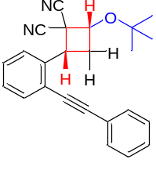
(±)-(2R,4R)-2-(tert-Butoxy)-4-(2-(phenylethynyl)phenyl)cyclobutane-1,1-dicarbonitrile (3ae): White solid. m.p. 137.6–138.9 ºC. ¹H NMR (600 MHz, CDCl₃) δ 7.64–7.62 (m, 3H), 7.48–7.43 (m, 2H), 7.38–7.36 (m, 4H), 4.64 (t, J = 8.4 Hz, 1H), 4.43 (dd, J₁ = 8.4 Hz, J₂ = 12.0 Hz, 1H), 2.86–2.81 (m, 1H), 2.74–2.69 (m, 1H), 1.35 (s, 9H); ¹³C NMR (150 MHz, CDCl₃) δ 135.3, 133.1, 131.8, 128.8, 128.7, 128.6, 128.3, 127.4, 123.9, 122.7, 115.3, 111.7, 95.1, 86.5, 76.5, 70.6, 45.4, 38.7, 34.1, 28.2. HRMS (ESI) [M+Na]⁺ Calcd. for [C₂₄H₂₂N₂NaO]⁺: 377.1624, Found: 377.1625.

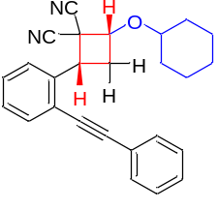
(±)-(2R,4R)-2-(Cyclohexyloxy)-4-(2-(phenylethynyl)phenyl)cyclobutane-1,1-dicarbonitrile (3af): White solid. m.p. 122.6–124.4 ºC. ¹H NMR (600 MHz, CDCl₃) δ 7.63–7.62 (m, 3H), 7.46–7.43 (m, 2H), 7.38–7.36 (m, 4H), 4.59 (t, J = 8.4 Hz, 1H), 4.39 (dd, J₁ = 8.4 Hz, J₂ = 12.0 Hz, 1H), 3.59–3.55 (m, 1H), 2.86–2.81 (m, 1H), 2.75–2.71 (m, 1H), 2.03–1.97 (m, 2H), 1.81–1.77 (m, 2H), 1.55–1.53 (m, 1H), 1.51–1.47 (m, 1H), 1.45–1.39 (m, 1H), 1.36–1.28 (m, 2H), 1.26–1.21 (m, 1H); ¹³C NMR (150 MHz, CDCl₃) δ 135.1, 133.1, 131.8, 128.75, 128.71, 128.7, 128.3, 127.4, 123.8, 122.6, 115.3, 111.5, 95.1, 86.5, 78.9, 74.9, 43.4, 38.5, 33.0, 32.8, 31.5, 25.3, 23.84, 23.81. HRMS (ESI) [M+Na]⁺ Calcd. for [C₂₆H₂₄N₂NaO]⁺: 403.1781, Found: 403.1786.

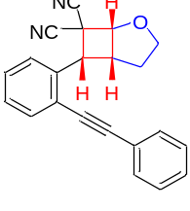
(±)-(1R,5R,6R)-6-(2-(Phenylethynyl)phenyl)-2-oxabicyclo[3.2.0]heptane-7,7-dicarbonitrile (3ag): Lightless oil. ¹H NMR (600 MHz, CDCl₃) δ 7.64–7.62 (m, 1H), 7.53–7.50 (m, 3H), 7.44–7.42 (m, 1H), 7.39–7.35 (m, 4H), 5.06 (d, J = 6.6 Hz, 1H), 4.47 (d, J = 8.4 Hz, 1H), 4.44–4.41 (m, 1H), 4.11 (q, J = 8.4 Hz, 1H), 3.98–3.93 (m, 1H), 2.37–2.31 (m, 1H), 2.16–2.09 (m, 1H); ¹³C NMR (150 MHz, CDCl₃) δ 135.3, 134.0, 131.4, 128.9, 128.64, 128.56, 128.0, 127.2, 122.5, 115.3, 112.0, 95.5, 87.3, 82.1, 73.0, 45.5, 43.3, 38.5, 26.9. HRMS (ESI) [M+Na]⁺ Calcd. for [C₂₂H₁₆N₂NaO]⁺: 347.1155, Found: 347.1159.

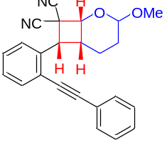
(±)-(1R,6R,7R)-3-Methoxy-7-(2-(phenylethynyl)phenyl)-2-oxabicyclo[4.2.0]octane-8,8-dicarbonitrile (3ah): White solid. m.p. 149.4–150.3 ºC. ¹H NMR (600 MHz, CDCl₃) δ 7.62–7.60 (m, 1H), 7.54–7.52 (m, 1H), 7.43–7.42 (m, 2H), 7.38–7.35 (m, 1H), 7.31–7.27 (m, 4H), 5.07–5.05 (m, 1H), 4.85 (d, J = 7.2 Hz, 1H), 4.36 (d, J = 8.4 Hz, 1H), 3.41 (s, 3H), 3.34–3.28 (m, 1H), 2.01–1.97 (m, 1H), 1.94–1.89 (m, 1H), 1.75–1.68 (m, 1H), 1.33–1.27 (m, 1H); ¹³C NMR (150 MHz, CDCl₃) δ 134.8, 133.5, 131.4, 128.9, 128.7, 128.6, 128.0, 127.1, 122.5, 115.1, 113.5, 99.8, 94.6, 87.0, 71.8, 56.2, 44.6, 38.8, 37.4, 27.2, 17.5. HRMS (ESI) [M+Na]⁺ Calcd. for [C₂₄H₂₀N₂NaO₂]⁺: 391.1417, Found: 391.1422.

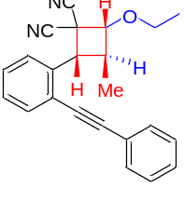
(±)-(2R,3S,4R)-2-Ethoxy-3-methyl-4-(2-(phenylethynyl)phenyl) cyclobutane-1,1-dicarbonitrile (3ai): White solid. m.p. 139.6–140.1 ºC. ¹H NMR (400 MHz, CDCl₃) δ 7.72–7.70 (m, 1H), 7.59–7.57 (m, 1H), 7.50–7.48 (m, 2H), 7.44–7.39 (m, 1H), 7.37–7.31 (m, 4H), 4.56 (d, J = 7.6 Hz, 1H), 4.21 (d, J = 8.8 Hz, 1H), 3.89–3.81 (m, 1H), 3.74–3.66 (m, 1H), 3.61–3.48 (m, 1H), 1.35 (t, J = 6.8 Hz, 3H), 1.20 (d, J = 7.6 Hz, 3H); ¹³C NMR (100 MHz, CDCl₃) δ 134.7, 133.1, 131.3, 128.7, 128.6, 128.4, 127.7, 126.9, 122.6, 122.5, 115.5, 113.2, 94.2, 87.0, 78.4, 66.3, 42.8, 40.5, 37.3, 14.8, 9.1. HRMS (ESI) [M+Na]⁺ Calcd. for [C₂₃H₂₀N₂NaO]⁺: 363.1468, Found: 363.1472.

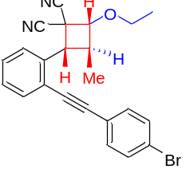
(±)-(2R,3S,4R)-2-(2-((4-Bromophenyl)ethynyl)phenyl)-4-ethoxy-3-methylcyclobutane-1,1-dicarbonitrile (3hi): White solid. m.p. 142.4–143.1 ºC. ¹H NMR (600 MHz, CDCl₃) δ 7.64–7.63 (m, 1H), 7.53–7.51 (m, 2H), 7.47–7.44 (m, 2H), 7.42–7.41 (m, 2H), 7.39–7.36 (m, 1H), 4.82 (d, J = 10.8 Hz, 1H), 4.41 (d, J = 9.0 Hz, 1H), 3.88–3.83 (m, 1H), 3.74–3.69 (m, 1H), 3.37–3.31 (m, 1H), 1.37 (t, J = 7.2 Hz, 3H), 1.03 (d, J = 7.2 Hz, 3H); ¹³C NMR (150 MHz, CDCl₃) δ 134.4, 133.3, 133.0, 128.6, 128.4, 128.0, 124.7, 123.2, 121.4, 113.9, 113.5, 94.3, 87.5, 84.3, 66.6, 44.4, 40.6, 37.5, 15.0, 13.5. HRMS (ESI) [M+Na]⁺ Calcd. for [C₂₃H₁₉⁷⁹BrN₂NaO]⁺: 441.0573, Found: 441.0577; for [C₂₃H₁₉⁸¹BrN₂NaO]⁺: 443.0553, Found: 443.0558.

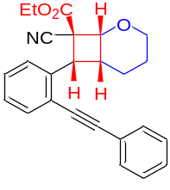
(±)-Ethyl (1R,6R,7R,8S)-8-cyano-7-(2-(phenylethynyl)phenyl)-2-oxabicyclo[4.2.0] octane-8-carboxylate (5aa): White solid. m.p. 141.7–142.7 ºC. ¹H NMR (400 MHz, CDCl₃) δ 7.63–7.61 (m, 1H), 7.57–7.55 (m, 1H), 7.52–7.48 (m, 2H), 7.41–7.36 (m, 4H), 7.31–7.27 (m, 1H), 4.76 (d, J = 7.6 Hz, 1H), 4.51 (td, J₁ = 3.2 Hz, J₂ = 11.6 Hz, 1H), 4.33–4.20 (m, 2H), 4.16 (d, J = 8.0 Hz, 1H), 3.85–3.81 (m, 1H), 3.48–3.39 (m, 1H), 2.18–2.12 (m, 1H), 1.96–1.85 (m, 1H), 1.71–1.63 (m, 1H), 1.61–1.52 (m, 1H), 1.33 (t, J = 7.2 Hz, 3H); ¹³C NMR (100 MHz, CDCl₃) δ 167.5, 137.1, 133.2, 131.3, 128.6, 128.5, 128.4, 127.4, 127.0, 122.9, 122.1, 118.6, 93.5, 87.8, 71.8, 64.2, 63.2, 51.4, 41.7, 38.6, 22.5, 20.1, 14.0. HRMS (ESI) [M+Na]⁺ Calcd. for [C₂₅H₂₃NNaO₃]⁺: 408.1570, Found: 408.1574.

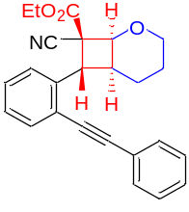
(±)-Ethyl (1S,6S,7R,8S)-8-cyano-7-(2-(phenylethynyl)phenyl)-2-oxabicyclo[4.2.0]octane-8-carboxylate [5(aa)']: White solid. m.p. 142.8–143.2 ºC. ¹H NMR (400 MHz, CDCl₃) δ 7.65–7.62 (m, 2H), 7.60–7.57 (m, 2H), 7.42–7.34 (m, 4H), 7.33–7.28 (m, 1H), 5.19 (d, J = 11.6 Hz, 1H), 4.69 (d, J = 5.6 Hz, 1H), 4.17–4.00 (m, 2H), 3.95–3.92 (m, 1H), 3.34 (td, J₁ = 3.2 Hz, J₂ = 11.6 Hz, 1H), 3.06–3.00 (m, 1H), 2.01–1.90 (m, 1H), 1.79–1.68 (m, 2H), 1.55–1.50 (m, 1H), 1.18 (t, J = 7.2 Hz, 3H); ¹³C NMR (100 MHz, CDCl₃) δ 163.6, 138.1, 133.1, 131.8, 128.6, 128.4, 128.3, 127.8, 127.3, 123.9, 123.3, 117.1, 94.3, 87.8, 74.9, 65.1, 62.5, 50.9, 41.9, 35.4, 21.8, 20.8, 14.0. HRMS (ESI) [M+Na]⁺ Calcd. for [C₂₅H₂₃NNaO₃]⁺: 408.1570, Found: 408.1574.
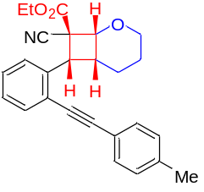
(±)-Ethyl (1R,6R,7R,8S)-8-cyano-7-(2-(p-tolylethynyl)phenyl)-2-oxabicyclo[4.2.0]octane-8-carboxylate (5ba): White solid. m.p. 122.3–123.0 ºC. ¹H NMR (600 MHz, CDCl₃) δ 7.61–7.60 (m, 1H), 7.56–7.54 (m, 1H), 7.40–7.36 (m, 3H), 7.29–7.27 (m, 1H), 7.19–7.18 (m, 2H), 4.76 (d, J = 7.8 Hz, 1H), 4.50 (td, J₁ = 3.0 Hz, J₂ = 12.0 Hz, 1H), 4.32–4.23 (m, 2H), 4.15 (d, J = 7.8 Hz, 1H), 3.84–3.82 (m, 1H), 3.46–3.40 (m, 1H), 2.39 (s, 3H), 2.16–2.13 (m, 1H), 1.93–1.86 (m, 1H), 1.69–1.65 (m, 1H), 1.61–1.53 (m, 1H), 1.34 (t, J = 7.2 Hz, 3H); ¹³C NMR (150 MHz, CDCl₃) δ 167.6, 138.9, 137.1, 133.1, 131.2, 129.3, 128.3, 127.3, 127.0, 122.4, 119.9, 118.6, 93.8, 87.2, 71.8, 64.3, 63.2, 51.4, 41.8, 38.7, 22.6, 21.5, 20.1, 14.0. HRMS (ESI) [M+Na]⁺ Calcd. for [C₂₆H₂₅NNaO₃]⁺: 422.1727, Found: 422.1731.

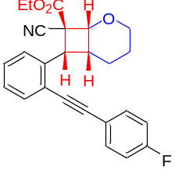
(±)-Ethyl (1R,6R,7R,8S)-8-cyano-7-(2-((4-fluorophenyl)ethynyl)phenyl)-2-oxabicyclo [4.2.0]octane-8-carboxylate (5ca): White solid. m.p. 142.8–142.3 ºC. ¹H NMR (600 MHz, CDCl₃) δ 7.62–7.61 (m, 1H), 7.56–7.54 (m, 1H), 7.50–7.47 (m, 2H), 7.40–7.38 (m, 1H), 7.31–7.28 (m, 1H), 7.10–7.06 (m, 2H), 4.75 (d, J = 7.8 Hz, 1H), 4.50 (td, J₁ = 3.0 Hz, J₂ = 12.0 Hz, 1H), 4.32–4.21 (m, 2H), 4.16 (d, J = 7.8 Hz, 1H), 3.85–3.82 (m, 1H), 3.42–3.36 (m, 1H), 2.15–2.11 (m, 1H), 1.95–1.88 (m, 1H), 1.70–1.67 (m, 1H), 1.62–1.54 (m, 1H), 1.34 (t, J = 7.2 Hz, 3H); ¹⁹F NMR (376 MHz, CDCl₃) δ −110.1; ¹³C NMR (150 MHz, CDCl₃) δ 167.6, 162.7 (d, J = 249.2 Hz), 137.1, 133.2 (d, J = 7.2 Hz), 128.5, 127.4, 127.1, 122.0, 119.0 (d, J = 3.5 Hz), 118.6, 115.9 (d, J = 22.2 Hz), 92.5, 87.5, 71.8, 64.2, 63.3, 51.5, 41.6, 38.6, 22.6, 20.1, 14.0. HRMS (ESI) [M+Na]⁺ Calcd. for [C₂₅H₂₂FNNaO₃]⁺: 426.1476, Found: 426.1481.

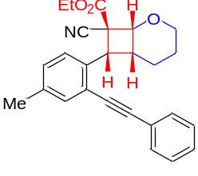
(±)-Ethyl (1R,6R,7R,8S)-8-cyano-7-(4-methyl-2-(phenylethynyl)phenyl)-2-oxabicyclo [4.2.0]octane-8-carboxylate (5da): White solid. m.p. 142.5–143.2 ºC. ¹H NMR (600 MHz, CDCl₃) δ 7.51–7.48 (m, 3H), 7.39–7.36 (m, 4H), 7.20–7.19 (m, 1H), 4.75 (d, J = 7.8 Hz, 1H), 4.50 (td, J₁ = 3.0 Hz, J₂ = 12.0 Hz, 1H), 4.31–4.21 (m, 2H), 4.12 (d, J = 7.8 Hz, 1H), 3.84–3.81 (m, 1H), 3.43–3.37 (m, 1H), 2.34 (s, 3H), 2.16–2.12 (m, 1H), 1.95–1.88 (m, 1H), 1.69–1.66 (m, 1H), 1.60–1.54 (m, 1H), 1.33 (t, J = 7.2 Hz, 1H); ¹³C NMR (150 MHz, CDCl₃) δ 167.6, 136.8, 134.1, 133.7, 131.3, 129.3, 128.53, 128.49, 127.3, 123.0, 121.9, 118.7, 93.1, 88.0, 71.8, 64.2, 63.2, 51.5, 41.5, 38.6, 22.6, 20.7, 20.3, 20.1, 14.0. HRMS (ESI) [M+Na]⁺ Calcd. for [C₂₆H₂₅NNaO₃]⁺: 422.1727, Found: 422.1730.

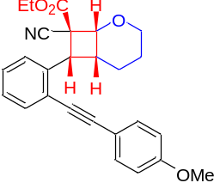
(±)-Ethyl (1R,6R,7R,8S)-8-cyano-7-(2-((4-methoxyphenyl)ethynyl)phenyl)-2-oxabicyclo[4.2.0] octane-8-carboxylate (5ea): White solid. m.p. 141.4–142.5 ºC. ¹H NMR (600 MHz, CDCl₃) δ 7.61–7.60 (m, 1H), 7.55–7.52 (m, 1H), 7.45–7.42 (m, 2H), 7.38–7.35 (m, 1H), 7.29–7.27 (m, 1H), 6.92–6.89 (m, 2H), 4.76 (d, J = 7.8 Hz, 1H), 4.51 (td, J₁ = 3.0 Hz, J₂ = 12.0 Hz, 1H), 4.32–4.22 (m, 2H), 4.15 (d, J = 7.8 Hz, 1H), 3.85 (s, 3H), 3.83–3.82 (m, 1H), 3.45–3.39 (m, 1H), 2.16–2.13 (m, 1H), 1.94–1.87 (m, 1H), 1.72–1.66 (m, 1H), 1.62–1.58 (m, 1H), 1.34 (t, J = 7.2 Hz, 3H); ¹³C NMR (150 MHz, CDCl₃) δ 167.6, 159.9, 137.0, 133.1, 132.8, 128.1, 127.3, 127.0, 122.5, 118.7, 115.1, 114.2, 93.6, 86.6, 71.8, 64.3, 63.3, 55.4, 51.5, 41.8, 38.7, 22.6, 20.1, 14.0. HRMS (ESI) [M+Na]⁺ Calcd. for [C₂₆H₂₅NNaO₄]⁺: 438.1676, Found: 438.1680.

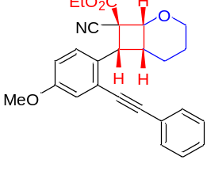
(±)-Ethyl (1R,6R,7R,8S)-8-cyano-7-(4-methoxy-2-(phenylethynyl)phenyl)-2-oxabicyclo[4.2.0] octane-8-carboxylate (5fa): White solid. m.p. 143.5–144.3 ºC. ¹H NMR (400 MHz, CDCl₃) δ 7.56–7.53 (m, 1H), 7.51–7.48 (m, 2H), 7.39–7.37 (m, 3H), 7.10–7.09 (m, 1H), 6.95–6.92 (m, 1H), 4.74 (d, J = 7.6 Hz, 1H), 4.49 (td, J₁ = 2.8 Hz, J₂ = 11.6 Hz, 1H), 4.32–4.19 (m, 2H), 4.14–4.11 (m, 1H), 3.83 (s, 3H), 3.81–3.79 (m, 1H), 3.42–3.32 (m, 1H), 2.15–2.09 (m, 1H), 1.99–1.88 (m, 1H), 1.74–1.62 (m, 1H), 1.59–1.54 (m, 1H), 1.33 (t, J = 7.2 Hz, 3H); ¹³C NMR (100 MHz, CDCl₃) δ 167.6, 158.3, 131.3, 129.3, 128.7, 128.55, 128.52, 123.3, 122.8, 118.7, 118.2, 114.6, 93.3, 87.8, 71.8, 64.2, 63.2, 55.4, 51.6, 41.2, 38.6, 22.6, 20.0, 14.0. HRMS (ESI) [M+Na]⁺ Calcd. for [C₂₆H₂₅NNaO₄]⁺: 438.1676, Found: 438.1680.

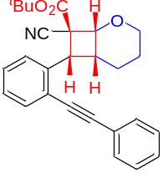
(±)-tert-Butyl (1R,6R,7R,8S)-8-cyano-7-(2-(phenylethynyl)phenyl)-2-oxabicyclo[4.2.0] octane-8-carboxylate (5ga): White solid. m.p. 139.2–140.5 ºC. ¹H NMR (400 MHz, CDCl₃) δ 7.68–7.66 (m, 1H), 7.57–7.55 (m, 1H), 7.50–7.48 (m, 2H), 7.41–7.36 (m, 4H), 7.31–7.27 (m, 1H), 4.74 (d, J = 7.6 Hz, 1H), 4.49 (td, J₁ = 3.2 Hz, J₂ = 11.6 Hz, 1H), 4.08 (d, J = 8.0 Hz, 1H), 3.83–3.80 (m, 1H), 3.47–3.38 (m, 1H), 2.15–2.10 (m, 1H), 1.92–1.81 (m, 1H), 1.68–1.63 (m, 1H), 1.62–1.57 (m, 1H), 1.53 (s, 9H); ¹³C NMR (100 MHz, CDCl₃) δ 166.4, 137.4, 133.1, 131.2, 128.6, 128.50, 128.46, 127.3, 126.9, 123.0, 122.1, 118.8, 93.4, 87.9, 84.3, 71.2, 64.1, 52.1, 41.9, 38.5, 27.8, 22.6, 19.9. HRMS (ESI) [M+Na]⁺ Calcd. for [C₂₇H₂₇NNaO₃]⁺: 436.1883, Found: 436.1886.

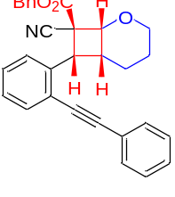
(±)-Benzyl (1R,6R,7R,8S)-8-cyano-7-(2-(phenylethynyl)phenyl)-2-oxabicyclo[4.2.0] octane-8-carboxylate (5ha): White solid. m.p. 150.3–150.9 ºC. ¹H NMR (400 MHz, CDCl₃) δ 7.54–7.52 (m, 1H), 7.48–7.46 (m, 4H), 7.43–7.39 (m, 2H), 7.37–7.32 (m, 5H), 7.27–7.23 (m, 2H), 5.57 (s, 1H), 5.31–5.25 (m, 2H), 4.69 (d, J = 6.0 Hz, 1H), 3.75–3.66 (m, 2H), 2.45–2.42 (m, 1H), 1.61–1.54 (m, 1H), 1.50–1.46 (m, 1H), 1.17–1.06 (m, 1H); ¹³C NMR (100 MHz, CDCl₃) δ 164.8, 138.9, 135.5, 132.6, 131.4, 128.7, 128.6, 128.5, 128.4, 128.2, 127.9, 127.2, 122.9, 122.6, 118.3, 101.0, 94.0, 86.9, 70.1, 63.1, 62.0, 39.5, 35.4, 24.2, 18.5. HRMS (ESI) [M+Na]⁺ Calcd. for [C₃₀H₂₅NNaO₃]⁺: 470.1727, Found: 470.1726.

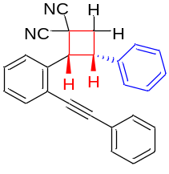
(±)-(2R,3S)-3-Phenyl-2-(2-(phenylethynyl)phenyl)cyclobutane-1,1-dicarbonitrile (7aa): White solid. m.p. 169.6–170.1 ºC. ¹H NMR (400 MHz, CDCl₃) δ 7.66–7.63 (m, 2H), 7.60–7.57 (m, 1H), 7.43–7.38 (m, 3H), 7.28–7.18 (m, 4H), 7.06–7.02 (m, 1H), 6.99–6.97 (m, 2H), 6.88–6.86 (m, 1H), 5.43 (dd, J₁ = 2.8 Hz, J₂ = 9.6 Hz, 1H), 4.75 (q, J = 9.6 Hz, 1H), 3.44–3.30 (m, 2H); ¹³C NMR (100 MHz, CDCl₃) δ 136.9, 134.3, 132.8, 131.7, 128.8, 128.6, 128.5, 128.3, 128.2, 127.9, 127.1, 126.5, 124.9, 122.5, 116.9, 113.5, 95.9, 86.4, 52.2, 39.3, 35.7, 29.7. HRMS (ESI) [M+Na]⁺ Calcd. for [C₂₆H₁₈N₂Na]⁺: 381.1362, Found: 381.1366.
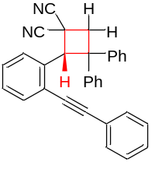
(±)-(S)-3,3-Diphenyl-2-(2-(phenylethynyl)phenyl)cyclobutane-1,1-dicarbonitrile (7ab): White solid. m.p. 194.9–196.1 ºC. ¹H NMR (600 MHz, CDCl₃) δ 7.67–7.65 (m, 1H), 7.62–7.60 (m, 2H), 7.42–7.41 (m, 2H), 7.39–7.38 (m, 3H), 7.29–7.26 (m, 3H), 7.21–7.15 (m, 4H), 7.05–7.01 (m, 3H), 6.57 (d, J = 7.8 Hz, 1H), 6.12 (s, 1H), 4.12 (d, J = 13.2 Hz, 1H), 3.52 (d, J = 13.2 Hz, 1H); ¹³C NMR (150 MHz, CDCl₃) δ 148.7, 139.7, 134.1, 132.6, 131.7, 130.3, 128.95, 128.88, 128.7, 128.5, 128.3, 128.0, 127.8, 127.2, 126.9, 125.6, 124.7, 122.5, 116.0, 114.3, 95.6, 86.9, 55.0, 54.4, 41.0, 29.7. HRMS (ESI) [M+Na]⁺ Calcd. for [C₃₂H₂₂N₂Na]⁺: 457.1675, Found: 457.1672.

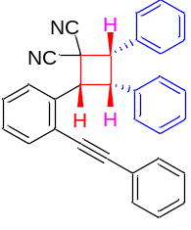
(±)-(2S,3S,4R)-2,3-Diphenyl-4-(2-(phenylethynyl)phenyl)cyclobutane-1,1-dicarbonitrile (7ac): White solid. m.p. 183.6–184.3 ºC. ¹H NMR (400 MHz, CDCl₃) δ 7.53–7.50 (m, 3H), 7.39–7.35 (m, 3H), 7.30–7.26 (m, 4H), 7.23–7.22 (m, 2H), 7.20–7.15 (m, 1H), 7.13–7.09 (m, 2H), 7.04–6.97 (m, 4H), 5.31 (d, J = 9.2 Hz, 1H), 4.94–4.84 (m, 2H); ¹³C NMR (100 MHz, CDCl₃) δ 134.6, 133.6, 133.1, 132.6, 131.5, 130.7, 128.8, 128.49, 128.46, 128.43, 128.2, 128.02, 127.97, 127.4, 127.1, 123.2, 122.7, 116.1, 114.0, 94.9, 87.1, 49.9, 49.8, 47.7, 37.8. HRMS (ESI) [M+Na]⁺ Calcd. for [C₃₂H₂₂N₂Na]⁺: 457.1675, Found: 457.1677.

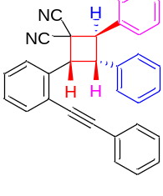
(±)-(2S,3R,4R)-2,3-Diphenyl-4-(2-(phenylethynyl)phenyl)cyclobutane-1,1-dicarbonitrile (7ad): White solid. m.p. 195.3–197.2 ºC. ¹H NMR (600 MHz, CDCl₃) δ 7.67–7.63 (m, 3H), 7.50–7.46 (m, 4H), 7.45–7.42 (m, 1H), 7.40–7.35 (m, 3H), 7.25–7.18 (m, 4H), 7.10–7.07 (m, 1H), 7.01–6.99 (m, 3H), 5.40 (d, J = 9.6 Hz, 1H), 5.10–5.06 (m, 1H), 4.86 (d, J = 12.6 Hz, 1H); ¹³C NMR (150 MHz, CDCl₃) δ 136.7, 134.7, 134.3, 133.0, 131.7, 129.32, 129.25, 128.8, 128.7, 128.5, 128.3, 128.1, 128.0, 127.2, 127.1, 126.5, 125.5, 122.4, 114.8, 113.3, 96.4, 86.4, 51.6, 49.6, 42.3, 37.9. HRMS (ESI) [M+Na]⁺ Calcd. for [C₃₂H₂₂N₂Na]⁺: 457.1675, Found: 457.1678.

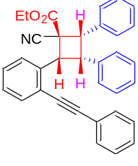
(±)-Ethyl (1S,2S,3S,4R)-1-cyano-2,3-diphenyl-4-(2-(phenylethynyl)phenyl)cyclobutane-1-carboxylate (7bc): White solid. m.p. 179.6–179.9 ºC. ¹H NMR (400 MHz, CDCl₃) δ 7.55–7.51 (m, 2H), 7.47–7.45 (m, 1H), 7.40–7.35 (m, 3H), 7.30–7.27 (m, 1H), 7.22–7.20 (m, 3H), 7.18–7.11 (m, 3H), 7.09–7.04 (m, 3H), 7.01–6.99 (m, 2H), 5.28–5.22 (m, 1H), 4.91–4.81 (m, 2H), 4.36–4.23 (m, 2H), 1.30 (t, J = 7.2 Hz, 3H); ¹³C NMR (100 MHz, CDCl₃) δ 168.3, 136.6, 135.2, 134.7, 132.6, 131.5, 131.0, 128.5, 128.4, 128.2, 128.1, 128.0, 127.7, 127.24, 127.15, 126.7, 123.1, 123.0, 117.7, 94.2, 87.8, 63.5, 52.4, 48.8, 46.6, 45.8, 14.0. HRMS (ESI) [M+Na]⁺ Calcd. for [C₃₄H₂₇NNaO₂]⁺: 504.1934, Found: 504.1935.

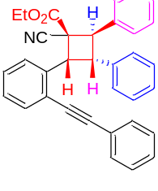
(±)-Ethyl (1S,2R,3S,4R)-1-cyano-2,3-diphenyl-4-(2-(phenylethynyl)phenyl)cyclobutane-1-carboxylate (7bd): White solid. m.p. 185.2–185.9 ºC. ¹H NMR (400 MHz, CDCl₃) δ 7.58–7.55 (m, 3H), 7.42–7.40 (m, 2H), 7.39–7.32 (m, 6H), 7.21–7.14 (m, 4H), 7.09–7.03 (m, 2H), 7.00–6.98 (m, 2H), 5.51 (d, J = 10.0 Hz, 1H), 5.17 (t, J = 11.2 Hz, 1H), 4.92 (d, J = 12.0 Hz, 1H), 3.88–3.75 (m, 2H), 0.77 (t, J=7.2 Hz, 3H); ¹³C NMR (100 MHz, CDCl₃) δ 166.5, 138.3, 137.2, 135.7, 132.3, 131.5, 128.6, 128.44, 128.36, 128.30, 128.27, 127.9, 127.4, 127.3, 126.6, 124.9, 122.9, 117.4, 95.1, 87.4, 62.6, 51.8, 50.2, 45.3, 41.0, 13.4. HRMS (ESI) [M+Na]⁺ Calcd. for [C₃₄H₂₇NNaO₂]⁺: 504.1934, Found: 504.1938.

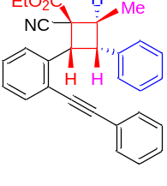
(±)-Ethyl (1S,2R,3R,4R)-1-cyano-2-methyl-3-phenyl-4-(2-(phenylethynyl)phenyl)cyclobutane-1-carboxylate (7be): White solid. m.p. 173.5–184.2 ºC. ¹H NMR (400 MHz, CDCl₃) δ 7.59–7.57 (m, 2H), 7.51–7.49 (m, 1H), 7.40–7.32 (m, 3H), 7.22–7.18 (m, 2H), 7.14–7.10 (m, 2H), 7.04–6.98 (m, 4H), 5.45 (d, J = 10.0 Hz, 1H), 4.40–4.32 (m, 1H), 4.31–4.19 (m, 2H), 3.83–3.75 (m, 1H), 1.40 (d, J = 6.8 Hz, 3H), 1.29 (t, J = 7.2 Hz, 3H); ¹³C NMR (100 MHz, CDCl₃) δ 167.4, 138.4, 137.2, 132.1, 128.5, 128.4, 128.30, 128.28, 127.7, 127.1, 126.4, 126.3, 124.6, 123.0, 117.4, 94.7, 87.4, 62.8, 47.9, 45.7, 43.3, 16.3, 14.1. HRMS (ESI) [M+Na]⁺ Calcd. for [C₂₉H₂₅NNaO₂]⁺: 442.1778, Found: 442.1777.

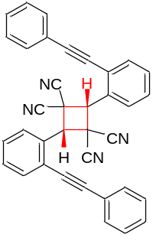
(±)-(2S,4S)-2,4-Bis(2-(phenylethynyl)phenyl)cyclobutane-1,1,3,3-tetracarbonitrile (8aa): White solid. m.p. 212.5–212.9 ºC. ¹H NMR (400 MHz, CDCl₃) δ 8.21–8.19 (m, 2H), 7.79–7.75 (m, 2H), 7.60–7.57 (m, 8H), 7.40–7.36 (m, 2H), 7.34–7.30 (m, 4H), 5.64 (s, 2H); ¹³C NMR (100 MHz, CDCl₃) δ 134.0, 131.8, 130.9, 129.28, 129.26, 128.7, 128.5, 127.6, 124.9, 121.8, 113.2, 110.4, 97.5, 85.3, 50.9, 38.8. HRMS (ESI) [M+Na]⁺ Calcd. for [C₃₆H₂₀N₄Na]⁺: 531.1580, Found: 531.1585.

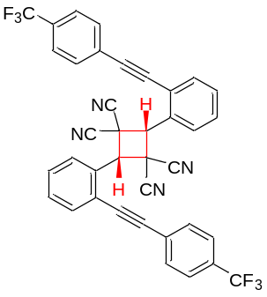
(±)-(2S,4S)-2,4-Bis(2-((4-(trifluoromethyl)phenyl)ethynyl)phenyl) cyclobutane-1,1,3,3-tetracarbonitrile (8ii): White solid. m.p. 203.6–204.9 ºC. ¹H NMR (400 MHz, CDCl₃) δ 8.13–8.11 (m, 2H), 7.83–7.81 (m, 2H), 7.76–7.74 (m, 4H), 7.70–7.68 (m, 4H), 7.65–7.55 (m, 4H), 5.82 (s, 2H); ¹⁹F NMR (376 MHz, CDCl₃) δ −63.0; ¹³C NMR (100 MHz, CDCl₃) δ 134.4, 133.9, 132.14, 132.11, 131.3, 129.9, 129.8, 129.3 (q, J = 112.6 Hz), 125.6 (q, J = 3.7 Hz), 124.6 (q, J = 145.5 Hz), 124.4, 111.8, 96.0, 87.0, 52.0, 37.1. HRMS (ESI) [M+Na]⁺ Calcd. for [C₃₈H₁₈F₆N₄Na]⁺: 667.1328, Found: 667.1328.

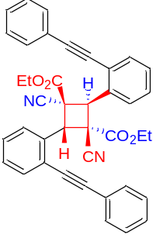
(±)-Diethyl (1R,2R,3S,4S)-1,3-dicyano-2,4-bis(2-(phenylethynyl)phenyl)cyclobutane-1,3-dicarboxylate (9aa): White solid. m.p. 191.4–192.8 ºC. ¹H NMR (600 MHz, CDCl₃) δ 7.88–7.87 (m, 2H), 7.76–7.75 (m, 4H), 7.66–7.65 (m, 2H), 7.44–7.37 (m, 10H), 6.31 (s, 2H), 4.00–3.91 (m, 4H), 0.88 (t, J = 7.2 Hz, 6H); ¹³C NMR (150 MHz, CDCl₃) δ165.1, 133.3, 132.6, 131.9, 129.2, 128.8, 128.5, 128.3, 127.6, 125.4, 122.7, 116.6, 95.9, 86.3, 63.7, 49.1, 47.5, 13.4. HRMS (ESI) [M+Na]⁺ Calcd. for [C₄₀H₃₀N₂NaO₄]⁺: 625.2098, Found: 625.2100.

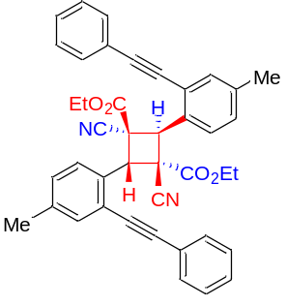
(±)-Diethyl (1R,2R,3S,4S)-1,3-dicyano-2,4-bis(4-methyl-2-(phenylethynyl)phenyl)cyclobutane-1,3-dicarboxylate (9dd): White solid. m.p. 191.8–192.3 ºC. ¹H NMR (400 MHz, CDCl₃) δ 7.75–7.73 (m, 6H), 7.472–7.469 (m, 2H), 7.44–7.38 (m, 6H), 7.20–7.17 (m, 2H), 6.23 (s, 2H), 4.01–3.92 (m, 4H), 2.36 (s, 6H), 0.90 (t, J = 7.2 Hz, 6H); ¹³C NMR (100 MHz, CDCl₃) δ 165.2, 139.3, 133.0, 131.9, 130.4, 129.2, 128.7, 128.5, 127.5, 125.2, 122.8, 116.8, 95.3, 86.5, 63.6, 49.3, 47.3, 21.0, 13.4. HRMS (ESI) [M+Na]⁺ Calcd. for [C₄₂H₃₄N₂NaO₄]⁺: 653.2411, Found: 653.2412.

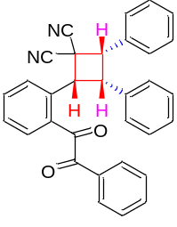
(±)-(2R,3S,4S)-2-(2-(2-Oxo-2-phenylacetyl)phenyl)-3,4-diphenylcyclobutane-1,1-dicarbonitrile (10): Brown oil. ¹H NMR (400 MHz, CDCl₃) δ 7.93–7.91 (m, 1H), 7.77–7.73 (m, 1H), 7.61–7.55 (m, 2H), 7.47–7.41 (m, 3H), 7.35–7.31 (m, 2H), 7.27–7.24 (m, 2H), 7.23–7.19 (m, 2H), 7.16–7.12 (m, 2H), 6.96–6.91 (m, 4H), 5.58 (d, J = 9.2 Hz, 1H), 5.13 (t, J = 9.6 Hz, 1H), 4.78 (d, J = 9.6 Hz, 1H); ¹³C NMR (100 MHz, CDCl₃) δ 195.8, 193.4, 135.7, 134.7, 134.5, 134.3, 133.4, 132.7, 132.5, 131.8, 131.0, 129.7, 129.0, 128.9, 128.6, 128.39, 128.36, 128.1, 127.6, 116.0, 114.3, 49.8, 49.7, 49.0, 37.9. HRMS (ESI) [M+Na]⁺ Calcd. for [C₃₂H₂₂N₂NaO₂]⁺: 489.1573, Found: 489.1573.

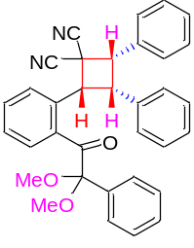
(±)-(2R,3S,4S)-2-(2-(2,2-Dimethoxy-2-phenylacetyl)phenyl)-3,4-diphenyl cyclobutane-1,1-dicarbonitrile (11): Brown oil. ¹H NMR (400 MHz, CDCl₃) δ 7.95–7.93 (m, 1H), 7.48–7.46 (m, 1H), 7.43–7.40 (m, 2H), 7.32–7.27 (m, 6H), 7.21–7.17 (m, 1H), 7.13–7.09 (m, 1H), 7.06–7.02 (m, 2H), 7.01–6.99 (m, 2H), 6.89–6.87 (m, 2H), 5.00 (d, J = 9.2 Hz, 1H), 4.84 (t, J = 9.2 Hz, 1H), 4.68 (d, J = 9.6 Hz, 1H), 3.18 (s, 3H), 2.94 (s, 3H); ¹³C NMR (100 MHz, CDCl₃) δ 197.9, 136.6, 135.3, 134.1 133.6, 132.8, 131.6, 131.0, 129.0, 128.7, 128.4, 128.3, 128.2, 128.1, 128.0, 127.3, 127.2, 126.8, 116.0, 114.5, 103.8, 50.1, 50.0, 49.9, 49.5, 48.5, 37.8. HRMS (ESI) [M+Na]⁺ Calcd. for [C₃₄H₂₈N₂NaO₃]⁺: 535.1992, Found: 535.1995.

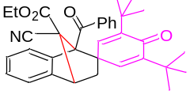
Ethyl 1'-benzoyl-3,5-di-tert-butyl-9'-cyano-4-oxo-3',4'-dihydro-1'H-spiro[cyclo hexane-1,2'-[1,4]methanonaphthalene]-2,5-diene-9'-carboxylate (12). White solid. m.p. 177.2–178.4 ºC. ¹H NMR (400 MHz, CDCl₃) δ 7.76–7.74 (m, 2H), 7.59 (d, J = 3.2 Hz, 1H), 7.57–7.53 (m, 1H), 7.41–7.38 (m, 2H), 7.35–7.33 (m, 1H), 7.31–7.27 (m, 1H), 7.19–7.15 (m, 1H), 6,96–6.94 (m, 1H), 5.43 (d, J = 3.2 Hz, 1H), 4.07 (d, J = 3.2 Hz, 1H), 4.04–3.95 (m, 2H), 3.06 (dd, J₁ = 3.6 Hz, J₂ = 13.2 Hz, 1H), 1.84 (dd, J₁ = 4.0 Hz, J₂ = 13.2 Hz, 1H), 1.06 (s, 9H), 1.04 (s, 9H), 1.02 (t, J = 7.2 Hz, 3H); ¹³C NMR (100 MHz, CDCl₃) δ 196.2, 184.9, 164.5, 147.8, 146.3, 143.1, 141.1, 140.9, 138.8, 137.9, 132.8, 128.5, 128.4, 128.2, 127.8, 123.6, 123.2, 118.3, 79.4, 66.6, 62.8, 50.7, 48.9, 40.6, 35.3, 34.9, 29.1, 13.6. HRMS (ESI) [M+Na]⁺ Calcd. for [C₃₅H₃₇NNaO₄]⁺: 558.2615, Found: 558.2620.

HRMS spectra for the compounds
