ERF1 of Plumbago indica L. receives ethylene signaling and regulates cold tolerance through the DREB-COR pathway
Zi-An Zhao¹& Yi-Rui Li¹ , Ting Lei¹, Cai-Lei Liu ¹,Qing-Xiao Zeng¹ , Xuan Liu¹, Li-Juan Yang¹, Jia-Ni Li¹ , Su-Ping Gao¹*
¹College of Landscape Architecture, Sichuan Agricultural University, Chengdu, 611130, China
Note: Yi-Rui Li is co-first author.
* Corresponding author's e-mail
Su-Ping Gao
gao_suping@sicau.edu.cn
Other authors' e-mail
Zi-An Zhao
scnydxzza@163.com
Yi-Rui Li
rui_xx@163.com
Ting Lei
ting_lei85@sicau.edu.cn
Cai-Lei Liu
liu_cailei@163.com
Qing-Xiao Zeng
zengqinxiao@stu.sicau.edu.cn
Xuan Liu
liuxuan@stu.sicau.edu.cn
Li-Juan Yang
71044@sicau.edu.cn
Jia-Ni Li
zaq135@126.com
Table. S1 List of primers used in qRT-PCR
NO. | Name | Primers
1 | ACTIN-F | CTGGAATTGCTGACCGTATGAG
1 | ACTIN-R | GCCAAGATGGATCCTCCAATC
2 | ETR1-F | GGCTATTCGTGCTCGTGATGAC
2 | ETR1-R | TTGCTCGGGTGATAACCTAGTCTC
3 | EIN3-F | CGCCTCAAACGCCTTAAAGAAGAG
3 | EIN3-R | AGCCAACACTGCCTCCAACTC
4 | ERF1-F | GAATCAGCAGTATCCGCCTCATCAC
4 | ERF1-R | CCAGACCCTCACTCCGTTCCTC
5 | DREB1A-F | GGTCCGCCTGCCTCAACTTC
5 | DREB1A-R | ACATTTCAGCCGCCTCAGTCG
6 | ACS6-F | TCGTCGTCGTCTTCCTCTTCCTC
6 | ACS6-R | TGTTGTTCGTCGTCGTCGTCTTC
7 | Unigene79700-F | AGGGTACTCGGATTCCACCAGATG
7 | Unigene79700-R | CAACCTCATCCTCCTTCGGCATTC
8 | Unigene08110-F | ACCTGTTGAGTTCCATGCTGTTCC
8 | Unigene08110-R | TCTCTCGGGTTCGTCACATCCAC
9 | Unigene03061-F | CCGACGACCAAACGAAAGAGAGG
9 | Unigene03061-R | CGAATAAGGAGGCAGCACGAGAC
10 | Unigene30052-F | TCGCCGTCTACCTCTTCAAGTCC
10 | Unigene30052-R | GCTCGAATGTGAAGGGCTCCAAG
11 | Unigene82860-F | AATGCGGGTGAAGAAGCGAGATG
11 | Unigene82860-R | CCTGCCACTTGAACTGCTCATACC
12 | Unigene64040-F | TGCTGTGGCTGTGGAGGGTAG
12 | Unigene64040-R | TGTAGGGGAAGGTCACGGCTATG
13 | Unigene69681-F | CCTCTGTGGTGTTCCTCTGCTTTG
13 | Unigene69681-R | TCCCGCTGCTGCCGAAGG
14 | Unigene40972-F | GCGGCTGTGGACGAAGACTG
14 | Unigene40972-R | TCAACGGAAGGGACGATGTTCAG
15 | Unigene44592-F | CTCTGGCACCGCTCACTTACTC
15 | Unigene44592-R | AGTTCTCGTCGTCTAGGATGTCAAG
16 | Unigene11281-F | CCCTCCTCCTCGTCCTTCTCTC
16 | Unigene11281-R | GGTCCGTGAAGGTGCGATGG
17 | Unigene51682-F | ACTCCGACTCTGACTCCGACTC
17 | Unigene51682-R | TTGGCTGCTTGGATGGTTAGGG
18 | Unigene43750-F | TCGTAGAGCCAGTCACCTATTTAGC
18 | Unigene43750-R | CGAGCAATGAACAGCGAACAGAG
19 | MPK3-78362-F | TTGAGCAACAGGATTTGGGACAGG
19 | MPK3-78362-R | TGGATTGAATGCCAGTGCCTCTTG
20 | MPK3-64590-F | TGGTCGTGGAGCGTATGGGATC
20 | MPK3-64590-R | CTTCATTGCCACCATTTCGTTCGTC

Table. S2 Statistics of P. indica sequencing data evaluation
Sample ID | Read Number | Base Number | GC Content | %≥Q30
Z1-A | 20274283 | 6056809130 | 48.03 | 94.42
Z1-B | 24229211 | 7233136496 | 48.01 | 94.46
Z1-C | 27685916 | 8267688622 | 47.97 | 94.85
Z2-A | 29106839 | 8696999620 | 47.97 | 94.49
Z2-C | 19159072 | 5728793462 | 48.15 | 94.39
Z3-A | 21473051 | 6420801882 | 47.50 | 94.55
Z3-B | 24182205 | 7227553266 | 47.56 | 94.18
Z3-C | 23965671 | 7164177450 | 47.70 | 94.49
Z4-A | 21777546 | 6509981790 | 49.16 | 94.50
Z4-B | 30281132 | 9037224572 | 47.62 | 94.87
Z4-C | 22598440 | 6750019416 | 47.68 | 94.59
Z5-A | 24777218 | 7403071546 | 47.36 | 94.53
Z5-B | 24093321 | 7202117050 | 47.85 | 94.32
Z5-C | 21903090 | 6547853004 | 47.48 | 94.46
Z6-A | 21863085 | 6536384628 | 48.11 | 94.14
Z6-B | 23335919 | 6976563084 | 47.62 | 94.28
Z6-C | 22501053 | 6727950636 | 47.03 | 93.42

Table. S3 Unigene annotation statistics
Anno_Database | Annotated_Number | 300<=length<1000 | length>=1000
COG_Annotation | 12,429 | 1,293 | 9,975
GO_Annotation | 33,538 | 5,283 | 24,132
KEGG_Annotation | 27,748 | 3,983 | 20,849
KOG_Annotation | 25,321 | 3,771 | 17,783
Pfam_Annotation | 30,318 | 4,023 | 23,085
Swissprot_Annotation | 27,948 | 4,120 | 21,282
TrEMBL_Annotation | 38,152 | 6,100 | 27,798
eggNOG_Annotation | 32,933 | 5,109 | 24,574
nr_Annotation | 39,087 | 6,248 | 27,820
All_Annotation | 41,111 | 6,829 | 27,946
Note: Annotated databases: indicates the functional databases; Annotated_Number: indicates the number of Unigene annotated to the database; 300≤length<1000: indicates the number of Unigene annotated to the database whose length is greater than or equal to 300 and less than 1000 bases; length≥1000: indicates the number of Unigenes annotated to the database with length greater than 1000 bases.

Table. S4 Gene name and function prediction
Gene name | KEGG_annotation | Names of orthologs | Predicted gene function
PiERF1 | K14516, ethylene-responsive transcription factor 1 | Ethylene-response factor [Ipomoea triloba] | Biotic and abiotic stresses
PiDREB1A | K23553, post-GPI attachment to proteins factor 3 | Dehydration-responsive element-binding protein 1A  [Plumbago auriculata L.] | Cold tolerance
PiETR1 | K14509, ethylene receptor | Probable ethylene response sensor 1 [Chenopodium quinoa] | Ethylene response sensor
PiEIN3 | K14514, ethylene-insensitive protein 3 | Protein ethylene-insensitive protein 3 [Capsicum baccatum] | Transduction processes in response to ethylene signalling
PiACS6 | K20772, 1-aminocyclopropane-1-carboxylate synthase 1/2/6 | 1-aminocyclopropane-1-carboxylate synthase 6 [Nicotiana tabacum] | Negative feedback regulation of system-1 ethylene production
PiMPK3 | K20536, mitogen-activated protein kinase 3 | Mitogen-activated protein kinase 3 [Gossypium hirsutum] | Biotic and abiotic stresses
PiCOR | - | Cold-regulated 413 plasma membrane protein 4 [Eucalyptus grandis] | Cold-regulated gene

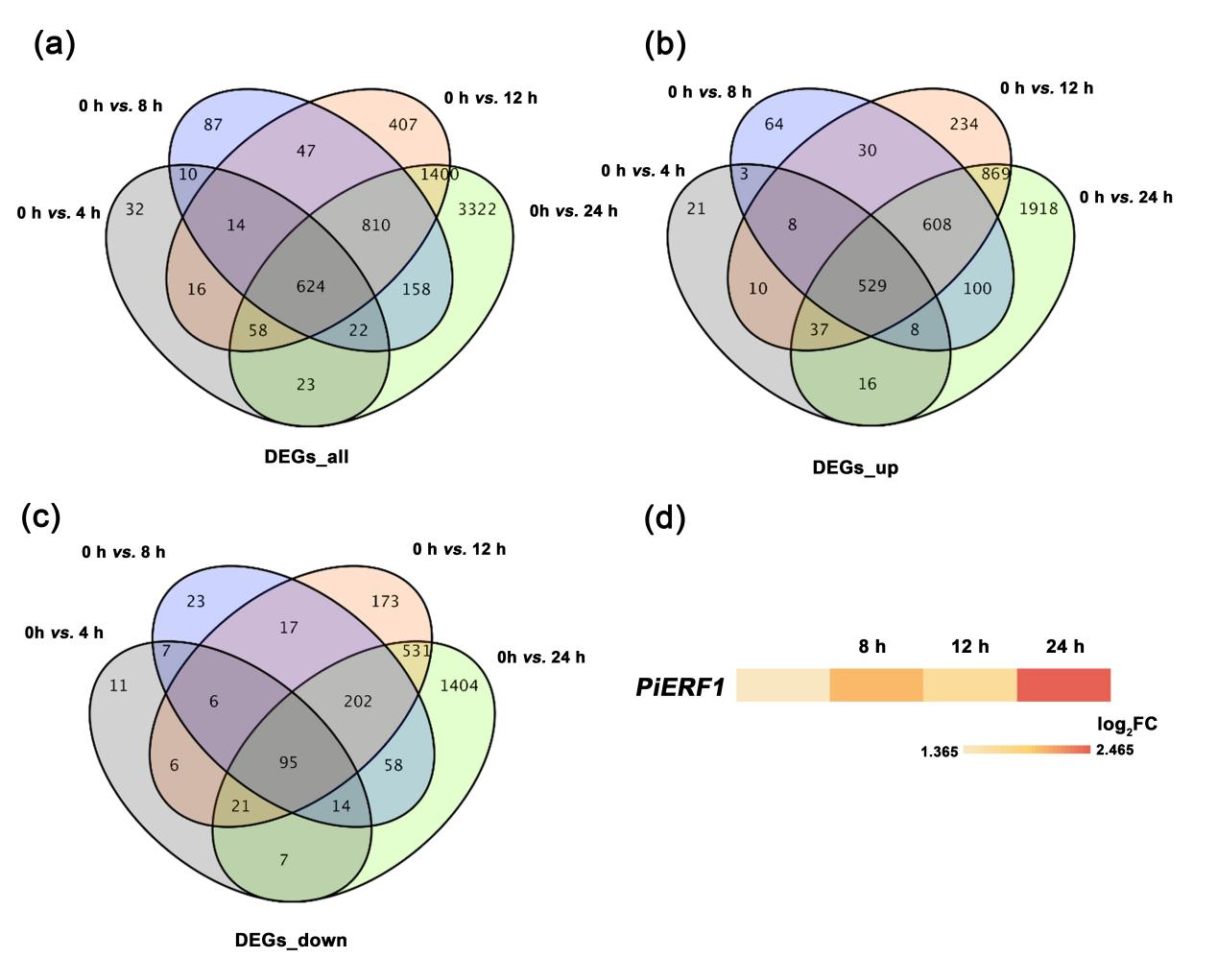
Fig. S1. Screening of differentially expressed genes in response to cold in P. indica. (a) Venn diagram representing the set of the number of all differentially expressed genes (|log₂FC| ≥1.2) within 24 hours; (b) the set of the number of all up-expressed differentially expressed genes (|log₂FC| ≥1.2) within 24 hours; and (c) the set of the number of all down-expressed differentially expressed genes (|log₂FC| ≥1.2) within 24 hours; (b) PiERF1 differentially expressed at 24h, |log₂FC| values normalized to the calculation.

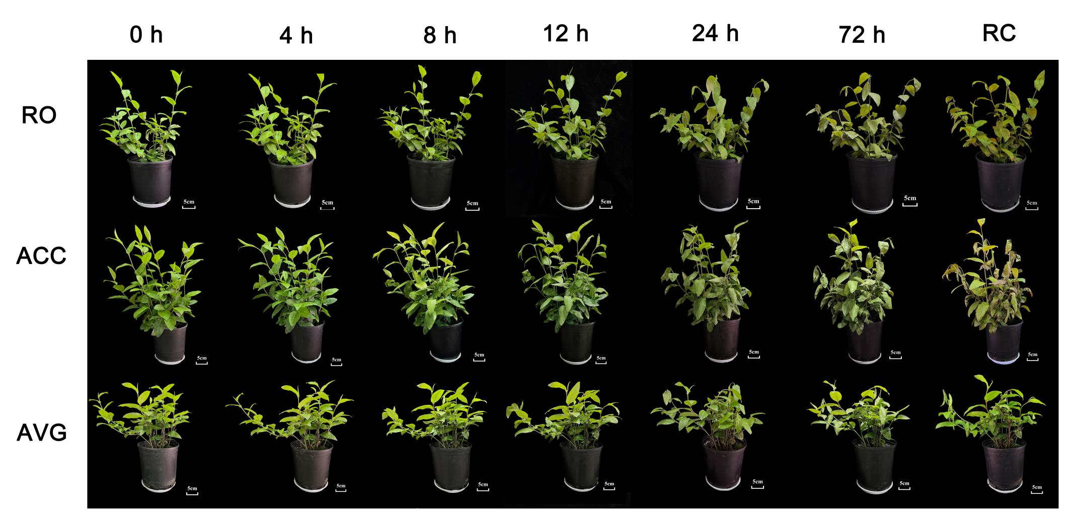
Fig. S2. Effect of different spray treatments on cold hardiness of P. indica.
Note: From top to bottom are the different spray treatment groups, and from left to right are the status of P. indica under 4℃ low-temperature stress during 72 hours, and the recovery group (RC) after 72 hours of recovery.
The URL and the software version of the software used in the research:
- HMMER v3.4: http://hmmer.org/
- PEA Plus 1.12 software package provided with the purchase of the product from Hansha Scientific Instruments Company:
https://www.hansatech-instruments.com/download/handy-pea-rlc-application-note/
- IBM SPSS 27 statistical software, provided by Sichuan Agricultural University Library:
https://lib.sicau.edu.cn/LibSicau/lanmu/neirong.asp?m=5&d=112
- Origin 2020, only the latest version of the software is available on this site (Origin 2025) : https://store.originlab.com/store/Default.aspx?CategoryID=53

