Supplementary material (S2)
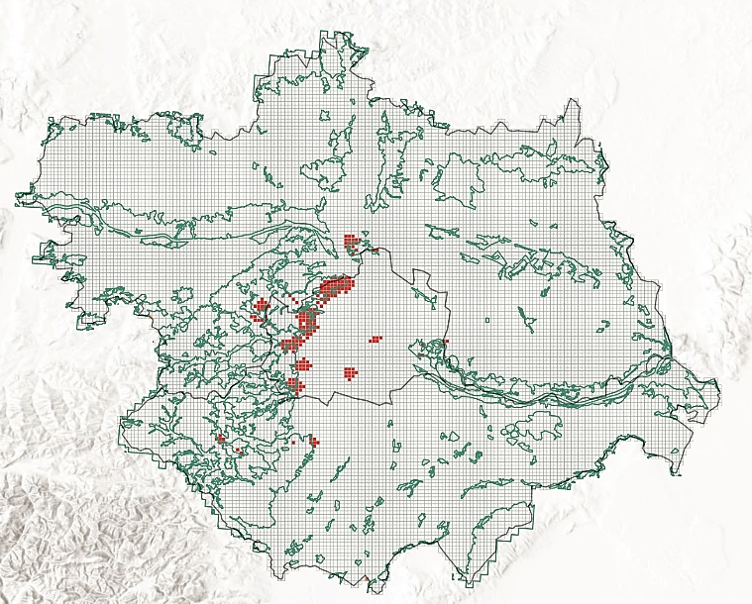
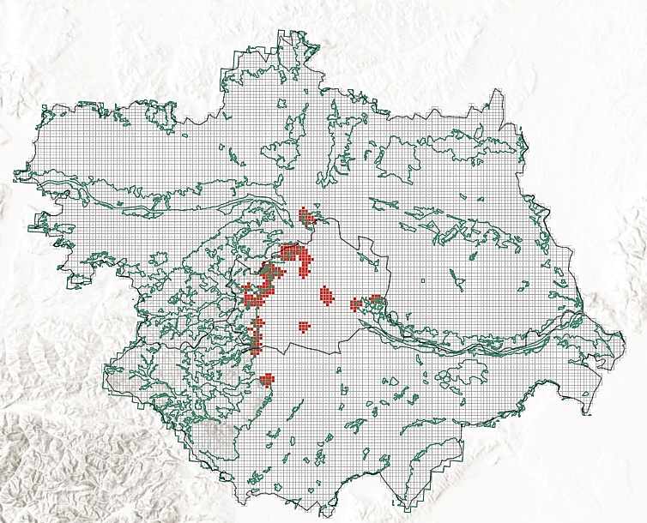
Figures S33-S37. Hot spot maps of the forest recreation starting points by generation: Generation Z; Generation Y; Generation X; Baby Boomers; Traditionalists.
Figure S33: Generation Z
Figure S34: Generation Y

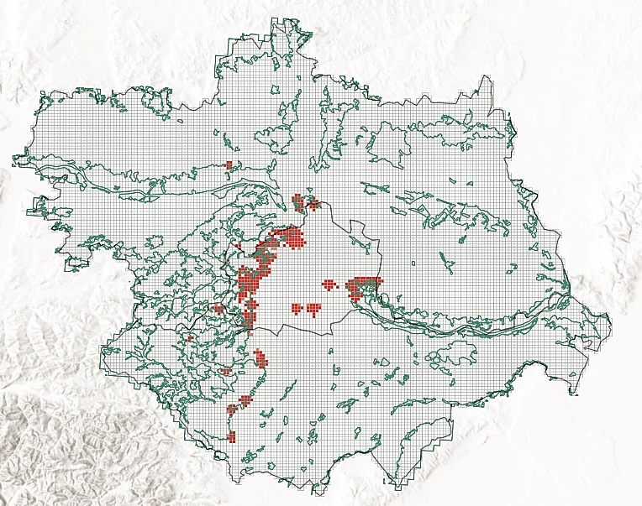
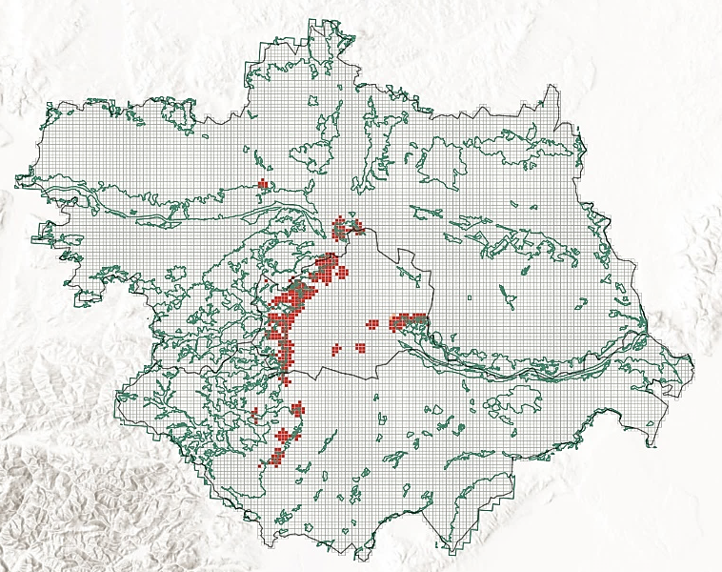
Figure S37: Traditionalists
Figure S36: Baby Boomers
Figure S35: Generation X
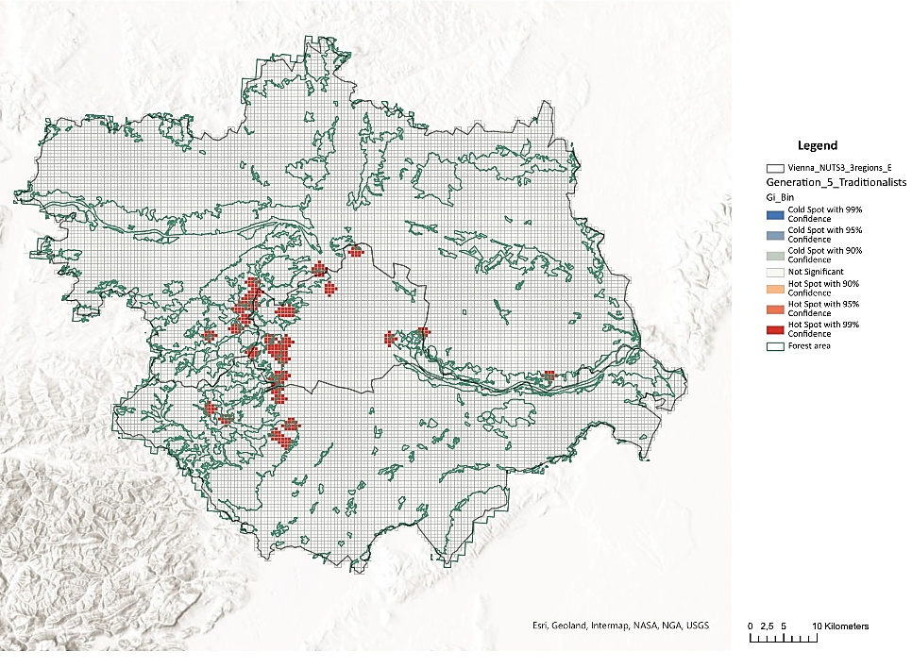
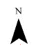

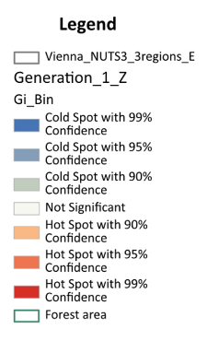

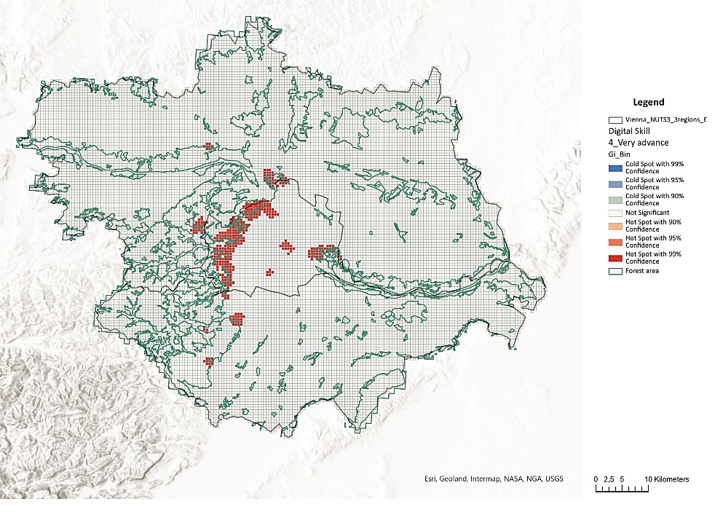
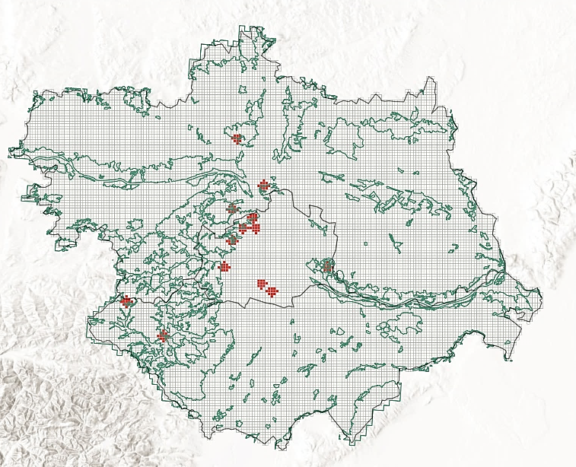
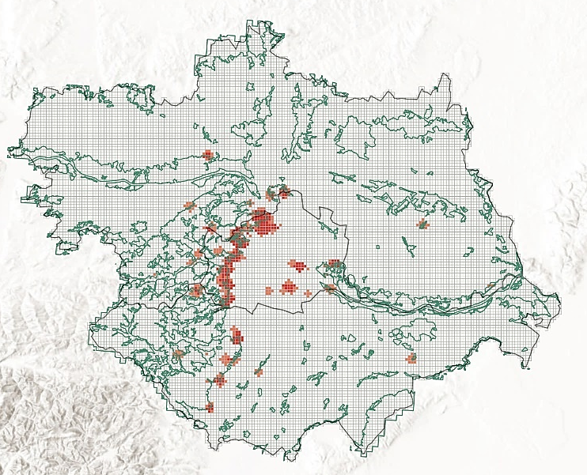
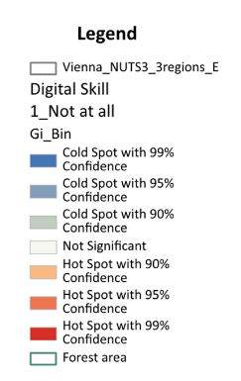
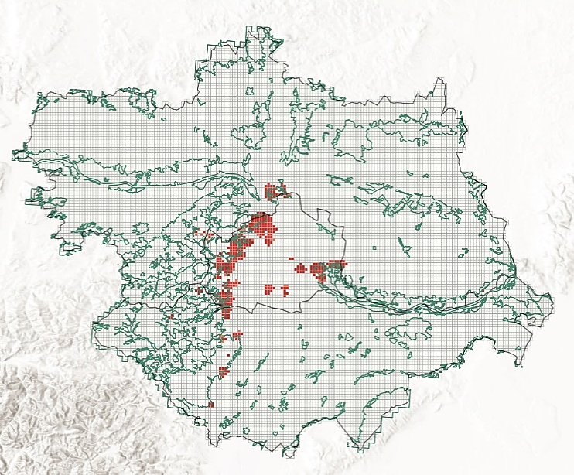
Figures S38-41: Hot spot maps of the forest recreation starting points by self-reported digital competency levels: "not at all," "basic," "advanced," and "very advanced."
Figure S41: Digital Competency Level: “very advanced”

Figure S40: Digital Competency Level: “advanced”
Figure S39: Digital Competency Level: “basic”
Figure S38: Digital Competency Level: “not at all”
Supplementary Material (S2) presents a series of hot spot maps generated using QGIS's Ord Gi* analysis, with a distance band of 500-1000 meters. These maps depict the spatial distribution of forest visitation starting points (n=1116) across different generations (Figures S33-S37) and levels of digital competency (Figures S38-S41). The maps highlight significant clusters (hot spots) where visitation rates are notably higher.

The first set of maps (Figures S33-S37) focuses on generational differences, illustrating a marked contrast between younger and older visitors. Younger generations show more dispersed hot spots, indicating a preference for a broader range of recreational locations. In contrast, older generations exhibit more concentrated hot spots, suggesting a tendency to visit familiar, well-known areas.

The second set of maps (Figures S38-S41) examines the influence of digital competency on recreational behavior. Areas with higher levels of digital skills are associated with a greater diversity and frequency of forest visits, particularly among digitally proficient groups. This finding suggests that digital competencies may enhance individuals' ability to discover and engage with a wider variety of outdoor spaces.

