Supplementary material (S1)
Table S1. Comparative analysis of generational trends in forest visits, changes in visit frequency before and during COVID-19, and digital tool usage in the urban and suburban forest of the Vienna Metropolitan Area. Note: Each numbered entry in the table (e.g., 1, 2, 3) corresponds to a mosaic plot figure with the same number in the supplementary material (e.g., Figure S1, Figure S2, Figure S3), which visualizes the data for that variable. The SPSS variable name for each entry is indicated in parentheses (e.g., F002) to link the data back to the original survey variable shown in Supplementary Material 3 (S3).
Generation | Generation Z  n (%) | Generation Y  n (%) |  | Generation X  n (%) | Baby Boomers  n (%) | Traditionalists  n (%) |  | Statistical test ^{a,b}
1 (F002). Frequency of forest visits n (%)
Rarely | 93 (49) | 158 (84) |  | 172 (91) | 180 (95) | 20 (11) |  | p-value = 0.08258
Monthly | 26 (14) | 38 (20) |  | 45 (24) | 30 (16) | 4 (2) |  | n = 989
Weekly | 26 (14) | 38 (20) |  | 61 (32) | 47 (25) | 5 (3)
Several times a week | 10 (5) | 8 (4) |  | 7 (4) | 5 (3) | 1 (1)
Daily | 19 (10) | 27 (14) |  | 54 (28) | 56 (29) | 7 (4)
2 (F005). Change of frequency of the forest visit change compared to BEFORE the COVID-19 pandemic n (%)
Never visited before the pandemic | 17 (10.2) | 12 (4.8) |  | 32 (10.1) | 37 (12.3) | 3 (9.7) |  | p = 9.99e-08
Never visited during the pandemic, but visited before | 6 (3.7) | 2 (0.5) |  | 7 (1.2) | 10 (2.1) | 2 (2.0) |  | n = 1062
Visited less often during the pandemic | 18 (10.8) | 19 (7.6) |  | 33 (10.4) | 42 (14.0) | 8 (25.8)
Unchanged during the pandemic | 98 (59.0) | 166 (66.7) |  | 218 (69.0) | 196 (65.3) | 18 (58.1)
Visited more often during the pandemic | 27 (16.3) | 50 (20.1) |  | 26 (8.2) | 15 (5.0) | 0 (0.0)
3 (F006). Change of frequency of visits to the forests DURING the COVID-19 pandemic (2020-2021) compared to BEFORE the pandemic n (%)
Never visited before the pandemic | 24 (6.9) | 20 (3.5) |  | 44 (6.4) | 38 (5.7) | 3 (3.1) |  | p-value = 9.99e-08
Never visited during the pandemic, but visited before | 32 (9.1) | 21 (3.7) |  | 24 (3.5) | 32 (4.8) | 16 (16.5) |  | n = 2371
Visited less often during the pandemic | 57 (16.3) | 81 (14.2) |  | 90 (13.1) | 97 (14.6) | 20 (20.6)
Unchanged during the pandemic | 114 (32.6) | 224 (39.2) |  | 340 (49.5) | 348 (52.3) | 43 (44.3)
Visited more often during the pandemic | 123 (35.1) | 226 (39.5) |  | 189 (27.5) | 150 (22.6) | 15 (15.5)
4 (F015). Planning timing before forest visits n (%)
Not at all | 22 (10.1) | 46 (10.9) |  | 91 (18.3) | 145 (27.6) | 21 (33.0) |  | Χ² (20) = 118.955
Varies by trip | 37 (17.0) | 60 (14.6) |  | 58 (11.3) | 69 (13.1) | 6 (10.0) |  | p = 4.450066e-16
About a week in advance | 26 (12.2) | 23 (5.4) |  | 18 (3.4) | 11 (2.1) | 5 (9.6) |  | n = 2139
Several days in advance | 74 (34.9) | 109 (26.3) |  | 107 (21.1) | 75 (14.3) | 13 (21.0)
The day before | 89 (17.1) | 155 (36.6) |  | 183 (36.6) | 140 (27.6) | 25 (39.0)
The day of the trip | 66 (25.2) | 142 (34.5) |  | 149 (28.6) | 152 (29.2) | 22 (38.0)
5 (F016a). Own knowledge usage before forest visits n (%)
Never | 16 (5.5) | 29 (5.0) |  | 22 (3.2) | 19 (2.9) | 3 (3.4) |  | p-value = 3.7e-06
Rarely | 30 (10.3) | 28 (4.8) |  | 22 (3.2) | 17 (2.6) | 5 (5.6) |  | n = 2110
Sometimes | 68 (23.3) | 100 (17.3) |  | 93 (13.4) | 80 (12.0) | 13 (14.6)
Often | 84 (28.8) | 169 (29.2) |  | 170 (24.4) | 193 (28.9) | 26 (29.2)
Very often | 109 (37.4) | 198 (34.2) |  | 294 (42.2) | 279 (41.8) | 43 (48.3)
6 (F016b). Recommendations for Friends, Family before forest visits: n (%)
Never | 16 (5.3) | 19 (3.0) |  | 57 (8.2) | 81 (12.1) | 13 (14.4)
Rarely | 39 (12.8) | 76 (11.9) |  | 122 (17.5) | 154 (23.0) | 32 (35.6) |  | p-value < 2.2e-16
Sometimes | 94 (30.8) | 231 (36.2) |  | 243 (34.9) | 234 (35.0) | 21 (23.3) |  | n = 2111
Often | 113 (37.0) | 147 (23.0) |  | 140 (20.1) | 94 (14.1) | 19 (21.1)
Very often / always | 46 (15.1) | 55 (8.6) |  | 35 (5.0) | 23 (3.4) | 7 (7.8)
7 (F016c). Printed map usage before forest visits: n (%)
Never | 161 (52.5) | 235 (39.6) |  | 245 (35.5) | 217 (32.7) | 36 (37.9)
Rarely | 76 (24.8) | 149 (25.1) |  | 182 (26.4) | 186 (28.0) | 19 (20.0) |  | p = 0.0001576
Sometimes | 40 (13.0) | 84 (14.1) |  | 117 (17.0) | 126 (19.0) | 17 (17.9) |  | n = 2105
Often | 25 (8.1) | 34 (5.7) |  | 40 (5.8) | 48 (7.2) | 12 (12.6)
Very often / Always | 7 (2.3) | 22 (3.7) |  | 10 (1.4) | 12 (1.8) | 5 (5.3)
8 (F016d). Digital Maps Usage before forest visits: n (%)
Never | 38 (12.5) | 82 (13.4) |  | 139 (20.0) | 200 (30.1) | 45 (47.4) |  | p = 6.048557e-30
Rarely | 64 (21.1) | 92 (15.1) |  | 118 (17.0) | 146 (22.0) | 20 (21.1) |  | n = 2111
Sometimes | 88 (29.0) | 149 (24.3) |  | 190 (27.4) | 140 (21.0) | 11 (11.6)
Often | 68 (22.4) | 139 (22.7) |  | 107 (15.4) | 77 (11.6) | 12 (12.6)
Very often / Always | 51 (16.8) | 63 (10.3) |  | 45 (6.5) | 23 (3.5) | 4 (4.2)
9 (F016e). Internet Research Usage before forest visits n (%)
Never | 32 (10.5) | 45 (7.1) |  | 96 (13.4) | 158 (23.7) | 35 (36.8) |  | p-value = 9.99e-08
Rarely | 43 (14.1) | 72 (11.4) |  | 116 (16.1) | 138 (20.7) | 22 (23.2) |  | n = 2110
Sometimes | 86 (28.2) | 174 (27.5) |  | 202 (28.0) | 185 (27.7) | 18 (18.9)
Often | 86 (28.2) | 159 (25.2) |  | 134 (18.6) | 76 (11.4) | 13 (13.7)
Very often / Always | 61 (20.0) | 78 (12.3) |  | 50 (6.9) | 27 (4.0) | 4 (4.2)
10 (F016). Tourist Info Usage before forest visits n (%)
Never | 193 (63.0) | 321 (53.5) |  | 400 (57.2) | 404 (61.2) | 52 (55.3) |  | p-value = 0.0001304
Rarely | 60 (19.6) | 98 (16.3) |  | 100 (14.3) | 106 (16.0) | 17 (18.1) |  | n = 2082
Sometimes | 33 (10.8) | 50 (8.3) |  | 59 (8.4) | 50 (7.6) | 8 (8.5)
Often | 16 (5.2) | 26 (4.3) |  | 21 (3.0) | 12 (1.8) | 8 (8.5)
Very often / Always | 6 (2.0) | 26 (4.3) |  | 7 (1.0) | 5 (0.8) | 4 (4.3)
11 (F016g): Journalistic reports before forest visits n (%)
Never | 164 (53.0) | 242 (40.3) |  | 260 (37.2) | 236 (35.7) | 30 (31.6)
Rarely | 78 (25.2) | 155 (25.8) |  | 178 (25.5) | 174 (26.4) | 21 (22.1) |  | p = 0.0001218
Sometimes | 41 (13.3) | 82 (13.6) |  | 121 (17.3) | 149 (22.5) | 30 (31.6) |  | n = 2111
Often | 18 (5.8) | 27 (4.5) |  | 23 (3.3) | 19 (2.9) | 6 (6.3)
Very often/Always | 7 (2.3) | 13 (2.2) |  | 9 (1.3) | 6 (0.9) | 4 (4.2)
12 (F028). Route Planning Preferences n (%)
Both | 63 (28.4) | 105 (24.6) |  | 125 (23.8) | 121 (22.8) | 7 (10.6) |  | Χ² (8) = 25.208
Plan myself | 74 (33.5) | 144 (33.2) |  | 143 (27.2) | 137 (24.8) | 24 (34.0) |  | p = 0.001432764
Use suggestions | 94 (38.1) | 163 (42.2) |  | 146 (49.1) | 106 (46.8) | 8 (55.4) |  | n = 1460
13 (F020). Carrying Mobile Phone during forest visits n (%)
Never | 4 (1.3) | 3 (0.5) |  | 2 (0.3) | 1 (0.2) | 1 (1.1)
Rarely | 0 (0.0) | 2 (0.3) |  | 2 (0.3) | 2 (0.3) | 3 (3.3) |  | p-value = 7.669e-05
Sometimes | 51 (16.0) | 70 (11.5) |  | 74 (10.7) | 49 (7.5) | 18 (19.6) |  | n = 1460
Always | 259 (82.7) | 460 (75.6) |  | 528 (76.4) | 540 (82.0) | 70 (76.1)
14 (F022). Digital tool usage in the forest (e.g. smart phone, mobile phone, GPS) n (%)
No, never | 24 (11.0) | 53 (20.8) |  | 94 (29.6) | 108 (34.6) | 24 (34.0) |  | χ² (8) = 111.269
Yes, sometimes | 120 (55.0) | 227 (55.5) |  | 266 (49.1) | 324 (46.8) | 47 (47.2) |  | p = 2.087405e-20
Yes, frequently | 163 (34.0) | 247 (23.7) |  | 239 (21.3) | 150 (18.6) | 16 (18.8) |  | n = 2102
15 (F019a). Own knowledge usage during forest visits
Never | 4 (1.3) | 9 (1.5) |  | 5 (0.8) | 9 (1.4) | 2 (2.1) |  | p-value = 3.8e-06
Rarely | 22 (7.1) | 23 (3.9) |  | 18 (2.9) | 13 (2.0) | 7 (7.4) |  | n = 2118
Sometimes | 70 (22.6) | 96 (16.1) |  | 96 (15.2) |  | 7 (7.4)
  72 (10.9)
Often | 105 (33.9) | 209 (35.0) |  | 209 (33.1) | 224 (33.9) | 36 (38.3)
Very often/Always | 108 (34.9) | 191 (32.0) |  | 272 (43.1) | 271 (41.0) | 40 (42.6)
16 (F019b). Recommendations from friends and family during forest visits
Never | 19 (6.1) | 50 (8.2) |  | 101 (14.5) | 86 (13.1) | 11 (11.6) |  | χ² (16) = 120.0797
Rarely | 51 (16.3) | 80 (13.1) |  | 108 (15.5) | 153 (23.4) | 26 (27.4) |  | p = 5.302399e-18
Sometimes | 98 (31.3) | 196 (32.1) |  | 220 (31.7) | 228 (34.6) | 30 (31.6) |  | n = 2087
Often | 98 (31.3) | 137 (22.4) |  | 129 (18.6) | 94 (14.3) | 18 (18.9)
Very often/Always | 40 (12.8) | 59 (9.7) |  | 31 (4.5) | 18 (2.7) | 6 (6.3)
17 (F019c). Signage usage during forest visits
Never | 11 (3.5) | 19 (3.1) |  | 20 (2.9) | 20 (3.0) | 2 (2.1) |  | p-value = 0.2162
Rarely | 13 (4.2) | 21 (3.6) |  | 37 (5.3) | 36 (5.4) | 8 (8.4) |  | n = 2108
Sometimes | 70 (22.4) | 141 (24.3) |  |  | 142 (21.3) | 26 (27.4)
  134 (19.0)
Often | 99 (31.6) | 198 (34.1) |  | 216 (30.7) | 211 (31.7) | 34 (35.8)
Very often/Always | 117 (37.3) | 144 (24.8) |  | 192 (27.3) | 175 (26.3) | 22 (23.2)
18 (F019d) Printed map usage during forest visits
Never | 133 (42.9) | 219 (35.1) |  | 230 (33.3) | 188 (28.5) | 25 (26.3) |  | χ² (16) = 35.22407
Rarely | 82 (26.5) | 141 (22.6) |  | 156 (22.6) | 166 (25.7) | 24 (25.3) |  | p = 0.003702967
Sometimes | 50 (16.1) | 94 (15.1) |  | 145 (21.0) | 152 (23.0) | 25 (26.3) |  | n = 2103
Often | 30 (9.7) | 47 (7.5) |  | 42 (6.1) | 56 (8.5) | 12 (12.6)
Very often/Always | 13 (4.2) | 26 (4.2) |  | 20 (2.9) | 22 (3.4) | 5 (5.3)
19 (F019e). Digital maps / Apps for smartphone, tablet, and smartwatch usage during forest visits
Never | 29 (9.4) | 49 (8.1) |  | 100 (14.5) | 170 (26.2) | 33 (34.7) |  | χ² (16) = 202.4417
Rarely | 46 (14.9) | 85 (14.1) |  | 90 (13.1) | 129 (19.6) | 25 (26.3) |  | p = 2.544478e-34
Sometimes | 80 (25.8) | 157 (26.1) |  | 211 (30.6) | 155 (23.5) | 11 (11.6) |  | n = 2102
Often | 98 (31.6) | 143 (23.7) |  | 118 (17.1) | 98 (14.7) | 13 (13.7)
Very often/Always | 55 (17.7) | 95 (15.7) |  | 73 (10.6) | 31 (4.8) | 8 (8.4)
20 (F019f). Mobile Internet Search during forest visits |  |  |  |  |  |  |  | χ² (16) = 199.642
Never | 43 (15.0) | 60 (15.0) |  | 127 (25.0) | 199 (27.3) | 32 (47.2) |  | p = 9.368575e-34
Rarely | 54 (18.1) | 86 (20.1) |  | 112 (18.3) | 138 (14.2) | 24 (22.1) |  | n = 2090
Sometimes | 88 (31.0) | 166 (28.1) |  | 205 (27.3) | 153 (15.6) | 16 (25.1)
Often | 72 (19.3) | 154 (23.6) |  | 108 (14.1) | 70 (9.3) | 11 (11.3)
Very often/Always | 47 (16.5) | 62 (19.9) |  | 37 (20.6) | 19 (20.2) | 7 (14.5)
21 (F019g). A GPS device (not GPS via smartphone) use during forest visits
Never | 172 (76.0) | 296 (69.6) |  | 370 (73.5) | 392 (78.2) | 54 (79.4) |  | χ² (16) = 52.790
Rarely | 39 (17.0) | 61 (14.3) |  | 66 (13.1) | 80 (14.3) | 10 (14.4) |  | p = 8.161019e-06
Sometimes | 45 (19.3) | 72 (17.1) |  | 82 (17.3) | 62 (15.6) | 11 (21.1) |  | n = 2082
Often | 30 (14.1) | 70 (14.3) |  | 44 (11.1) | 26 (8.3) | 7 (5.3)
Very often/Always | 19 (8.0) | 26 (6.2) |  | 31 (4.8) | 11 (3.2) | 6 (4.8)
22 (F019h). Printouts from the internet, digital maps usage during forest visits
Never | 177 (57.1) | 298 (46.8) |  | 329 (48.2) | 310 (47.0) | 44 (46.3)
Rarely | 48 (15.5) | 76 (11.9) |  | 101 (14.8) | 134 (20.3) | 17 (17.9)
Sometimes | 45 (14.5) | 93 (14.6) |  | 116 (17.0) | 92 (14.0) | 16 (16.8) |  | p-value = 9.99e-07
Often | 30 (9.7) | 29 (4.6) |  | 36 (5.3) | 16 (2.4) | 9 (9.5) |  | n = 2065
Very often/Always | 8 (2.6) | 25 (3.9) |  | 8 (1.2) | 6 (0.9) | 2 (2.1)
23 (F030a). Photo sharing after forest visits
No, I don't use it | 0 (0.0) | 0 (0.0) |  | 0 (0.0) | 0 (0.0) | 0 (0.0) |  | p-value = 1e-07
No, I keep it private | 78 (30.1) | 124 (28.3) |  | 130 (30.4) | 112 (25.3) | 13 (21.3) |  | n = 1340
Yes, visible to friends/family only | 130 (50.2) | 221 (50.5) |  | 249 (58.2) | 290 (65.4) | 33 (54.1)
Yes, publicly visible | 61 (19.7) | 92 (21.0) |  | 76 (17.8) | 34 (9.3) | 7 (24.6)
24 (F030b). Sharing route (GPS / GNSS tracks) or finished tours after forest visits
No, I don't use | 133 (48.6) | 237 (49.7) |  | 276 (53.8) | 314 (59.6) | 29 (51.8) |  | Χ2 (12) = 50.900
No, I Keep it private | 82 (30.2) | 135 (28.3) |  | 124 (24.2) | 99 (18.8) | 13 (23.2) |  | p = 9.700319e-07
Yes, visible to friends/family only | 60 (22.2) | 75 (15.8) |  | 70 (13.6) | 47 (8.9) | 14 (22.8) |  | n = 1782
Yes, publicly visible | 8 (3.5) | 22 (6.2) |  | 29 (8.4) | 12 (2.7) | 3 (4.0)
25 (F030c). Text, Messaging/Chat Usage after forest visits
No, I don't use it | 38 (14.3) | 101 (21.6) |  | 154 (23.9) | 165 (31.2) | 20 (28.6) |  | Χ2 (12) = 77.21973
No, I keep it private | 84 (31.6) | 125 (26.8) |  | 86 (13.3) | 71 (13.4) | 12 (17.1) |  | p = 1.395373e-11
Yes, visible to friends/family only | 139 (52.3) | 225 (48.2) |  | 240 (37.2) | 230 (43.5) | 30 (42.9) |  | n = 1773
Yes, publicly visible | 16 (1.8) | 11 (3.4) |  | 13 (1.6) | 10 (1.9) | 3 (11.4)
26 (F030d). Tour Rating after forest visits.
No, I don't use it | 165 (60.6) | 275 (66.4) |  | 345 (70.1) |  | 31 (53.4) |  | p-value = 2e-07
  343 (69.8)
No, I keep it private | 56 (20.5) | 72 (17.4) |  | 61 (12.4) | 59 (12.0) | 16 (27.6) |  | n = 1790
Yes, visible to friends/family only | 42 (15.4) | 65 (15.7) |  | 39 (7.9) | 44 (8.9) | 13 (15.9)
Yes, publicly visible | 19 (3.5) | 57 (4.1) |  | 56 (9.6) | 29 (5.3) | 3 (3.1)
27 (F030e). Forums, giving feedback after forest visits
No, I don't use it | 197 (69.8) | 317 (69.5) |  | 372 (72.2) | 383 (75.5) | 34 (56.7) |  | p-value = 9.99e-08
No. I keep it private | 41 (14.5) | 63 (13.8) |  | 50 (9.7) | 48 (9.5) | 17 (28.3) |  | n = 1795
Yes, visible to friends/family only | 32 (11.3) | 30 (6.6) |  | 35 (6.8) | 25 (4.9) | 11 (18.3)
Yes, publicly visible | 16 (4.4) | 56 (10.1) |  | 45 (11.3) | 22 (10.1) | 1 (3.2)
28 (F030f). Reports and summaries sharing after forest visits
No, I don't use it | 195 (68.6) | 315 (73.4) |  | 378 (79.2) | 359 (76.6) | 31 (55.4) |  | p-value = 1.26e-05
No. I keep it private | 44 (15.5) | 58 (13.5) |  | 66 (13.8) | 71 (15.1) | 19 (33.9) |  | N = 1706
Yes, visible to friends/family only | 38 (15.9) | 56 (13.1) |  | 33 (7.0) | 33 (7.0) | 10 (10.7)
Yes, publicly visible | 0 (0.0) | 0 (0.0) |  | 0 (0.0) | 0 (0.0) | 0 (0.0)
29 (F030j). Sharing activity parameters after forest visits
No, I don't use it | 160 (56.7) | 286 (59.3) |  | 344 (64.2) | 354 (71.1) | 32 (52.5) |  | p-value = 9.99e-08
No. I keep it private | 66 (23.4) | 81 (16.8) |  | 77 (14.8) | 84 (16.8) | 18 (29.5) |  | n = 1790
Yes, visible to friends/family only | 42 (14.9) | 70 (14.8) |  | 55 (10.9) | 32 (6.5) | 10 (16.4)
Yes, publicly visible | 14 (5.0) | 32 (6.8) |  | 24 (5.0) | 6 (1.6) | 3 (1.6)
30 (F030k). Comparison of performance
No, I don't use it | 161 (57.3) | 287 (58.3) |  | 349 (64.5) | 356 (74.7) | 39 (62.9) |  | p-value = 9.99e-08
No. I keep it private | 57 (20.3) | 99 (20.8) |  | 94 (18.3) | 77 (16.1) | 13 (20.6) |  | n = 1773
Yes, visible to friends/family only | 52 (18.5) | 62 (13.3) |  | 41 (10.0) | 22 (4.5) | 9 (12.1%)
Yes, publicly visible | 11 (3.9) | 22 (7.5) |  | 13 (7.2) | 6 (4.7) | 3 (4.4%)
31 (F030l). Share tips, read comments
No, I don't use it | 171 (61.6) | 276 (59.3) |  | 321 (64.6) | 292 (61.3) | 29 (51.8) |  | χ2(12) =31.485
No. I keep it private | 49 (17.7) | 67 (14.4) |  | 56 (11.3) | 63 (13.2) | 12 (21.4) |  | p-value = 0.001661
Yes, visible to friends/family only | 43 (15.3) | 63 (13.5) |  | 58 (11.7) | 71 (14.9) | 10 (17.9) |  | n = 1729
Yes, publicly visible | 15 (5.4) | 57 (12.8) |  | 48 (12.4) | 23 (10.6) | 5 (8.9)
32 (F053). Self-reported digital competence
Not at all | 2 (0.5) | 5 (0.8) |  | 3 (0.4) | 16 (2.3) | 7 (7.0) |  | p-value = 9.99e-08
Basic | 36 (9.8) | 65 (11.0) |  | 173 (24.2) | 266 (38.7) | 44 (44.0) |  | n = 2463
Advanced | 144 (39.3) | 278 (46.9) |  | 358 (50.0) | 306 (44.5) | 41 (41.0)
Very advanced | 184 (50.3) | 245 (41.3) |  | 182 (25.4) | 100 (14.5) | 8 (8.0)

- In case number of cases in the cross-table is larger than 5: Chi-square test of independence
- In case number of cases in the cross-table is smaller than 5: Fisher’s Exact Test (with simulated p-value based on 1e+07 replicates; two-sided)

Table S1 provides information on whether there are significant differences between groups or not (Chi-square test of independence).
To recognize categories that differ most, we additionally include MOSAIC PLOTS using residual-based shadings (Pearson residuals). The colours represent the level of the residual for that cell/combination of levels. The legend is presented at the plot's right. Blue shading means there are more observations in that cell than would be expected under the null model (independence). Red means there are fewer observations than would have been expected. Grey cells indicate that the corresponding Pearson residual is within a 95% confidence interval around zero (independence). Note that p-values in the tables have not been corrected for multiple testing since most significant p-values are much smaller than any of the usually used significance levels (0.05, 0.01, etc.).
The mosaic plots illustrate dependencies between generations and various characteristics related to forest visits and digital engagement. Forest visit frequency characteristics include the frequency of forest visits (Figure S1), changes in visit frequencies compared to before the pandemic (Figure S2), and changes in visit frequencies during the pandemic (Figure 3). Planning aspects cover the timing of forest visits (Figure 4), tools used for planning forest visits (Figures S5–11), and route planning preferences (Figure S12). Digital engagement and device usage are represented by carrying a mobile phone during outdoor activities (Figure S13) and the usage of digital tools (e.g., smartphone, GPS) during forest visits (Figure S14). Navigation tools include those used for navigation during forest visits (Figures S15–22). Information sharing after forest visits is shown through information sharing and community feature usage (Figures S23–31). Finally, digital competence is illustrated by self-reported digital competence by generation (Figure S32).

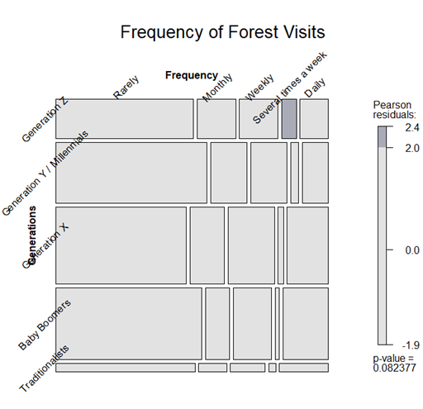 | 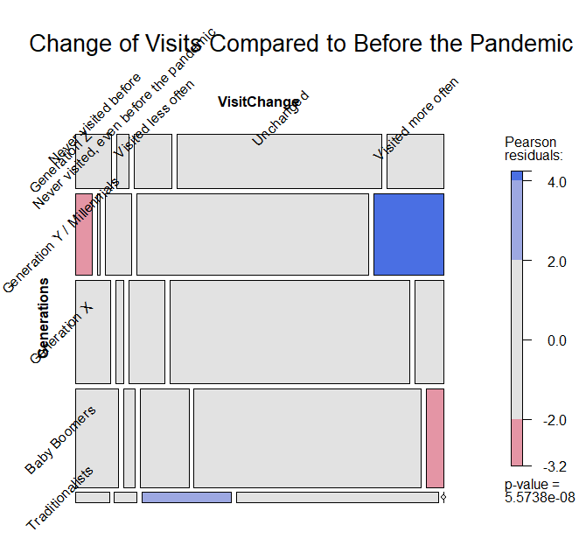
Figure S1. Frequency of Forest Visits (F002)  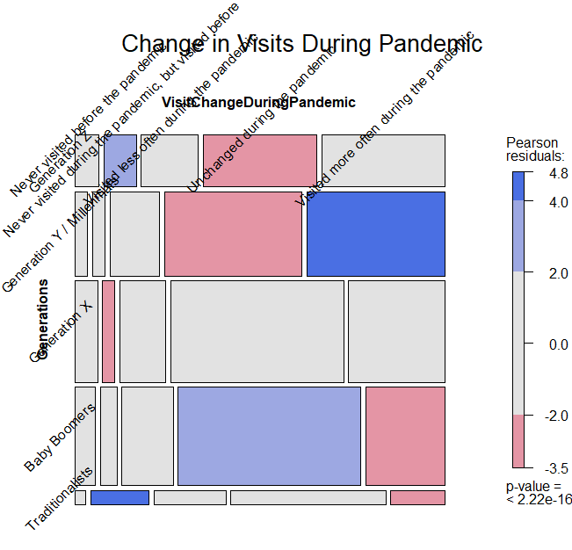  Figure S3. Change in Visits During the Pandemic (F006) | Figure S2. Change in Visit Frequency Compared to Before the Pandemic (F005)  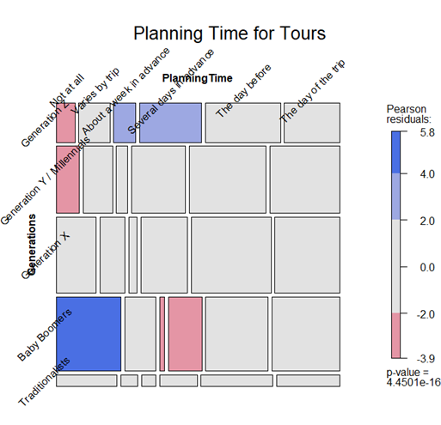  Figure S4. Planning Time for Tours (F015)
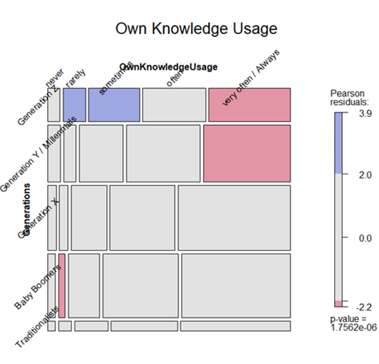  Figure S5. Own Knowledge Usage (F016a) | 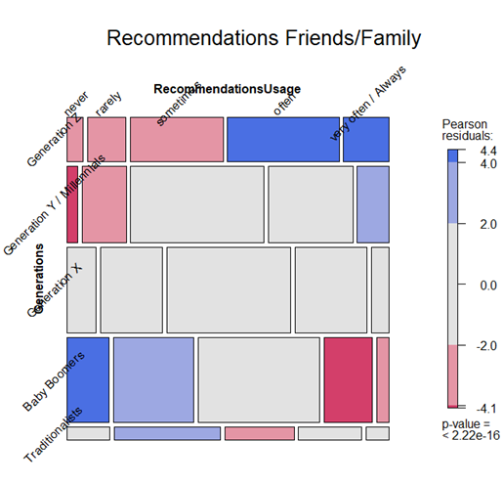  Figure S6. Recommendations from Friends/Family (F016b)
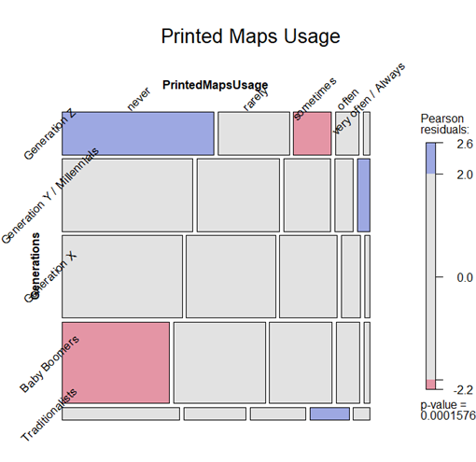 | 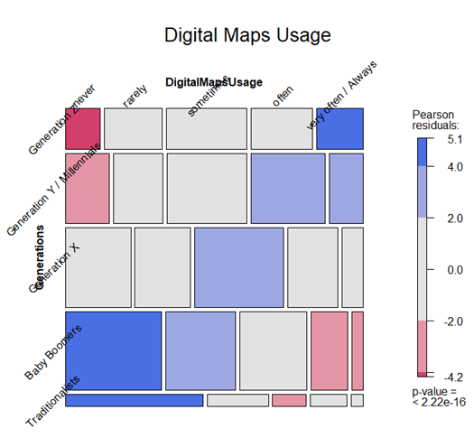
Figure S7. Printed Maps Usage (F016c)  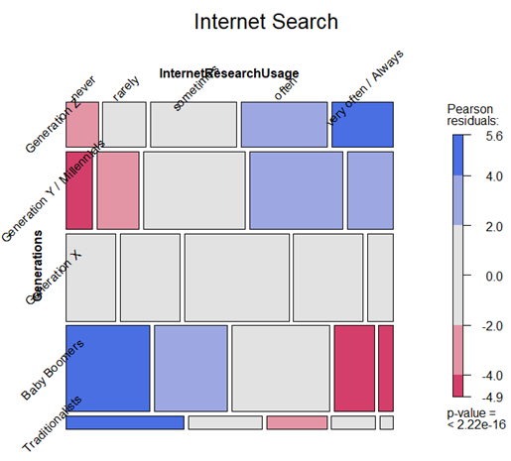 | Figure S8. Digital Maps Usage (F016d)  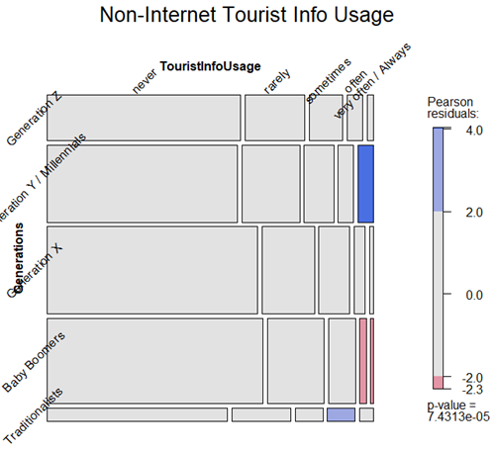
Figure S9. Internet Search (F016e) Figure S10. Non-Internet Tourist Info Usage (F016f)
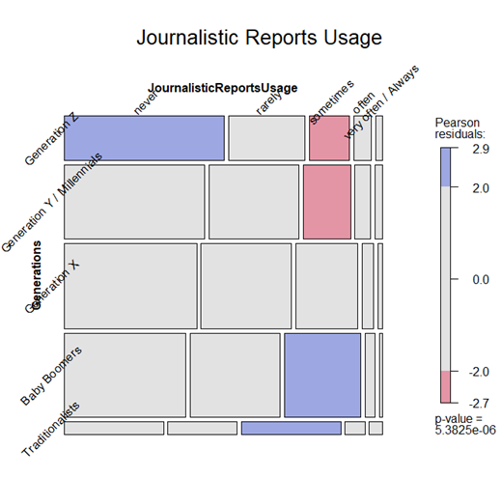 |  | 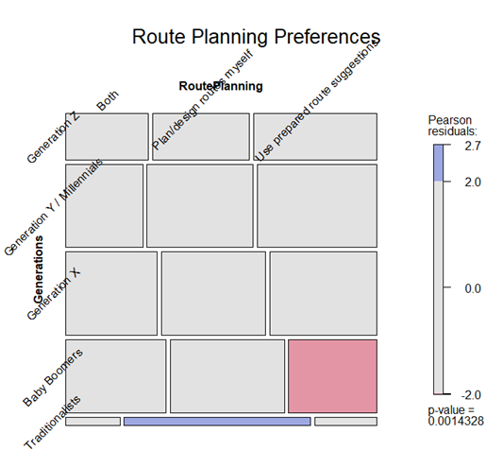
Figure S11. Journalistic Reports Usage (F016g) |  | Figure S12. Route Planning Preferences (F028)
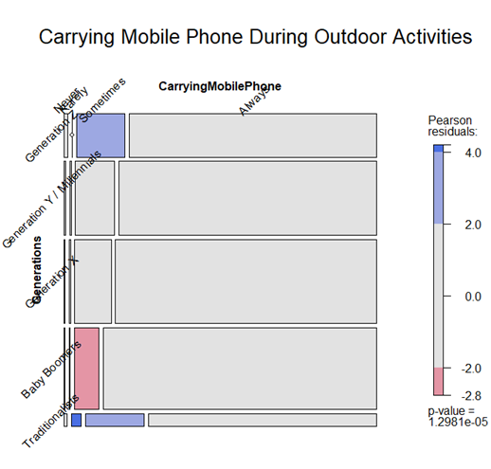  Figure S13. Carrying Mobile Phone During Outdoor Activities (F020) |  | 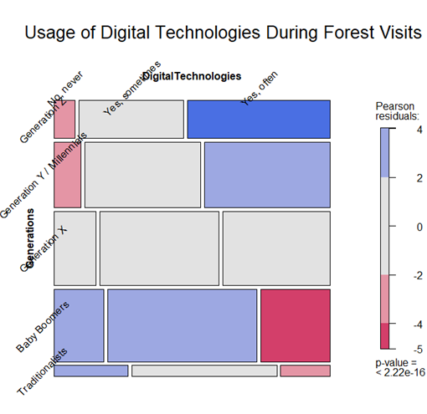  Figure S14. Usage of Digital Technologies During Forest Visits (F022)
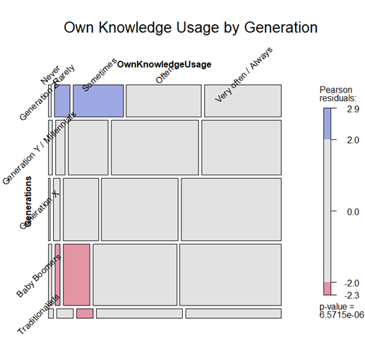  Figure S15. Own Knowledge Usage by Generation (F019a) |  | 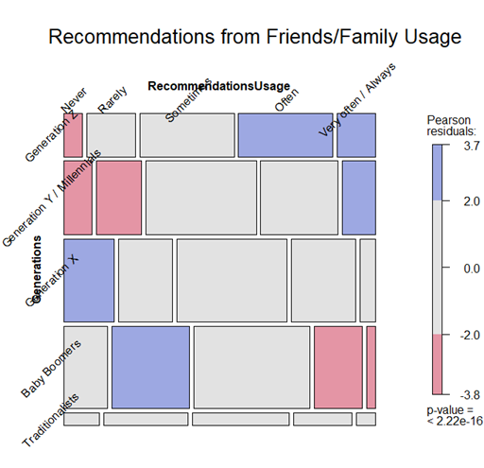  Figure S16. Recommendations from Friends/Family Usage (F019b)
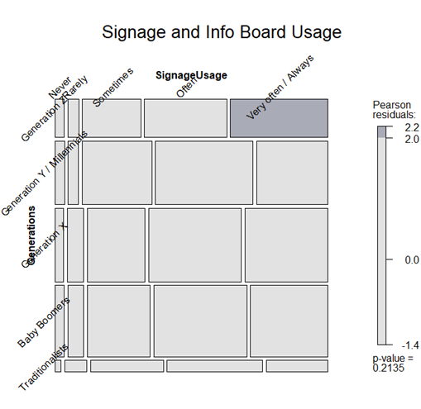  Figure S17: Signage and Info Board Usage (F019c) |  | 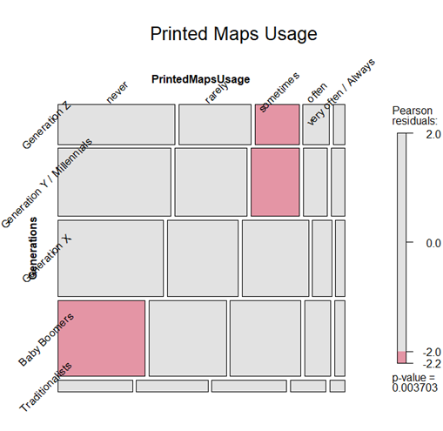  Figure S18: Printed Maps Usage (F019d)
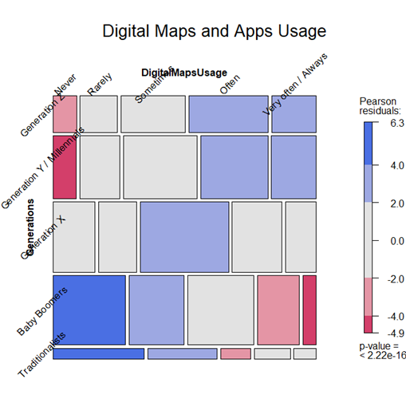 |  | 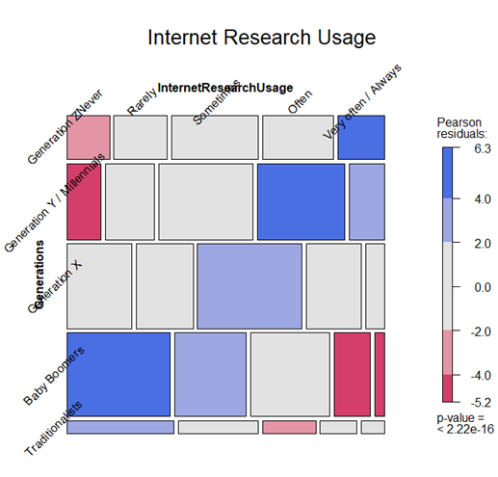
Figure S19. Digital Maps and Apps Usage (F019e) |  | Figure S20. Internet Research Usage (F019f)
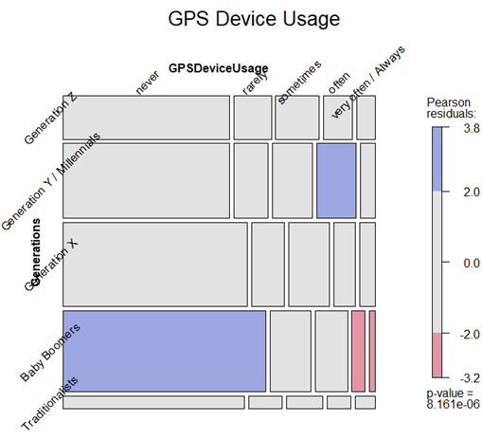 |  | 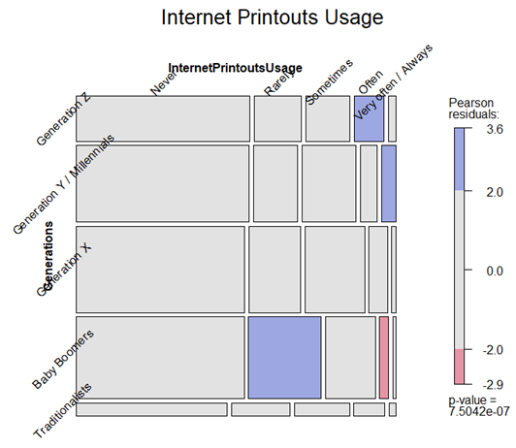
Figure S21. GPS Device Usage (F019g)  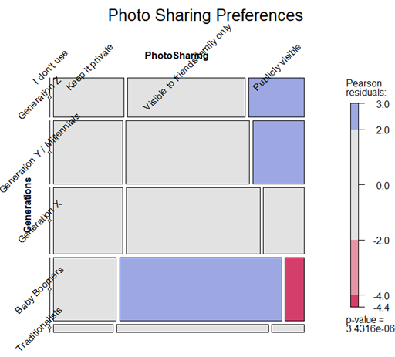  Figure S23. Photo Sharing Preferences (F030a)  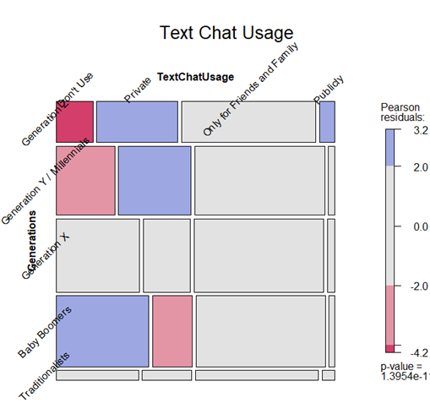Figure S25. Text Chat Usage (F030c)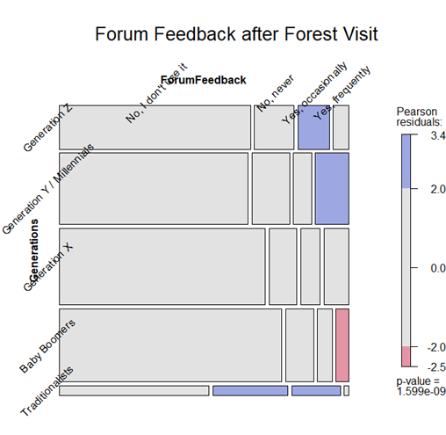  Figure S27. Forum Feedback after Forest Visit (F030e)  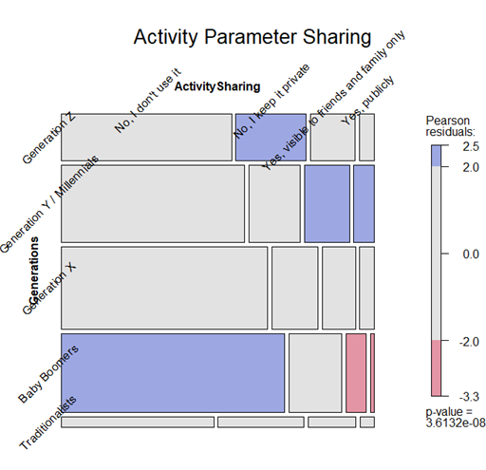  Figure S29. Activity Parameter Sharing (F030j)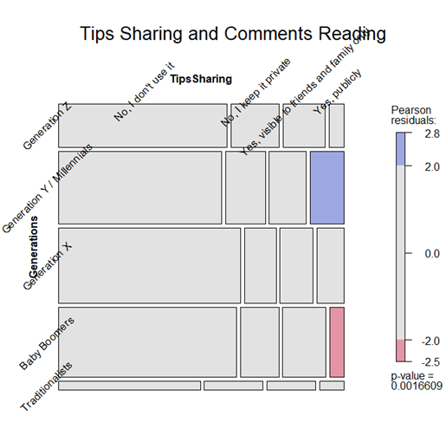  Figure S31. Tips Sharing and Comments Reading (F030l)
  Figure S22. Internet Printouts Usage (F019h)
  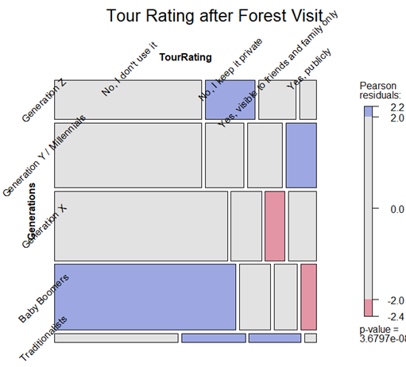
  Figure S24. Tour Rating after Forest Visit (F030b)
  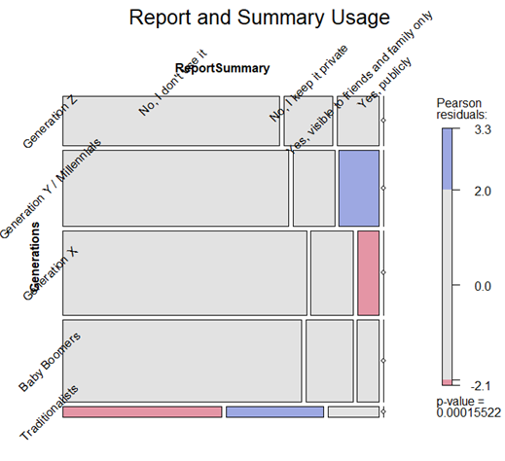
  Figure S26. Report and Summary Usage (F030d)
  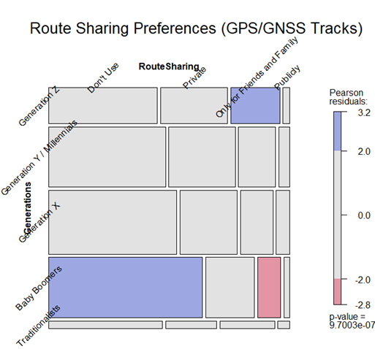
  Figure S28. Route Sharing Preferences (GPS/GNSS Tracks) (F030b)
  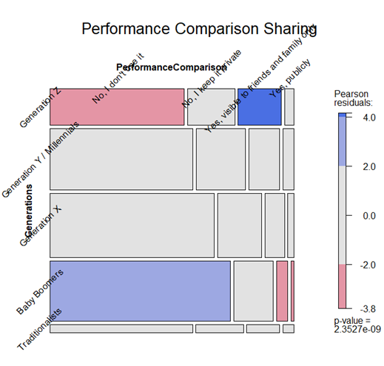
  Figure S30. Performance Comparison Sharing (F030k)
  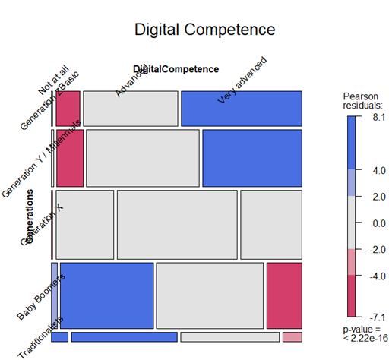
  Figure S32. Digital Competence (F053)

