Supplementary Material

Article title: Linking male reproductive success to effort within and among nests in a co-breeding stream fish

Journal name: Oecologia

Author names: Seoghyun Kim^{1,2}, Mevin B. Hooten^{3,1,4}, Tanya L. Darden⁵, and Yoichiro Kanno*^{1,2,4}

*Correspondence author

Affiliation:
¹ Department of Fish, Wildlife, and Conservation Biology, Colorado State University, Fort Collins, CO 80523-1474, USA
² Department of Forestry and Environmental Conservation, Clemson University, Clemson, SC 29634-0317, USA
³ U.S. Geological Survey, Colorado Cooperative Fish and Wildlife Research Unit, Fort Collins, CO 80523-1484, USA
⁴ Graduate Degree Program in Ecology, Colorado State University, Fort Collins, CO 80523-1474, USA
⁵ South Carolina Department of Natural Resources, Hollings Marine Laboratory, 331 Fort Johnson Road, Charleston, SC 29412, USA

E-mail address of the corresponding author: yoichiro.kanno@colostate.edu

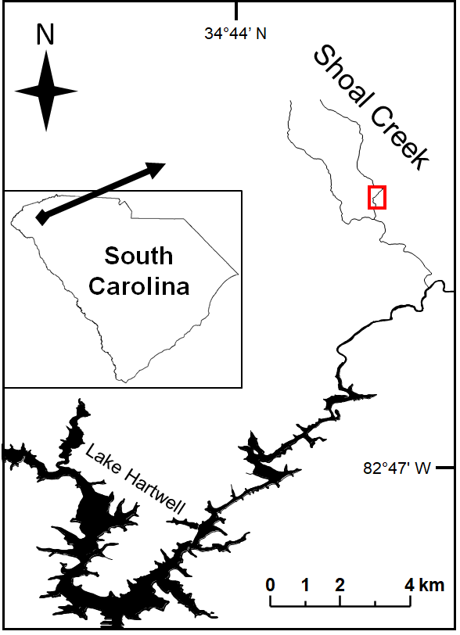
Appendix S1. Location of Shoal Creek in the Savannah River Basin in the upper Piedmont region of South Carolina, USA. The red rectangle indicates the study reach.

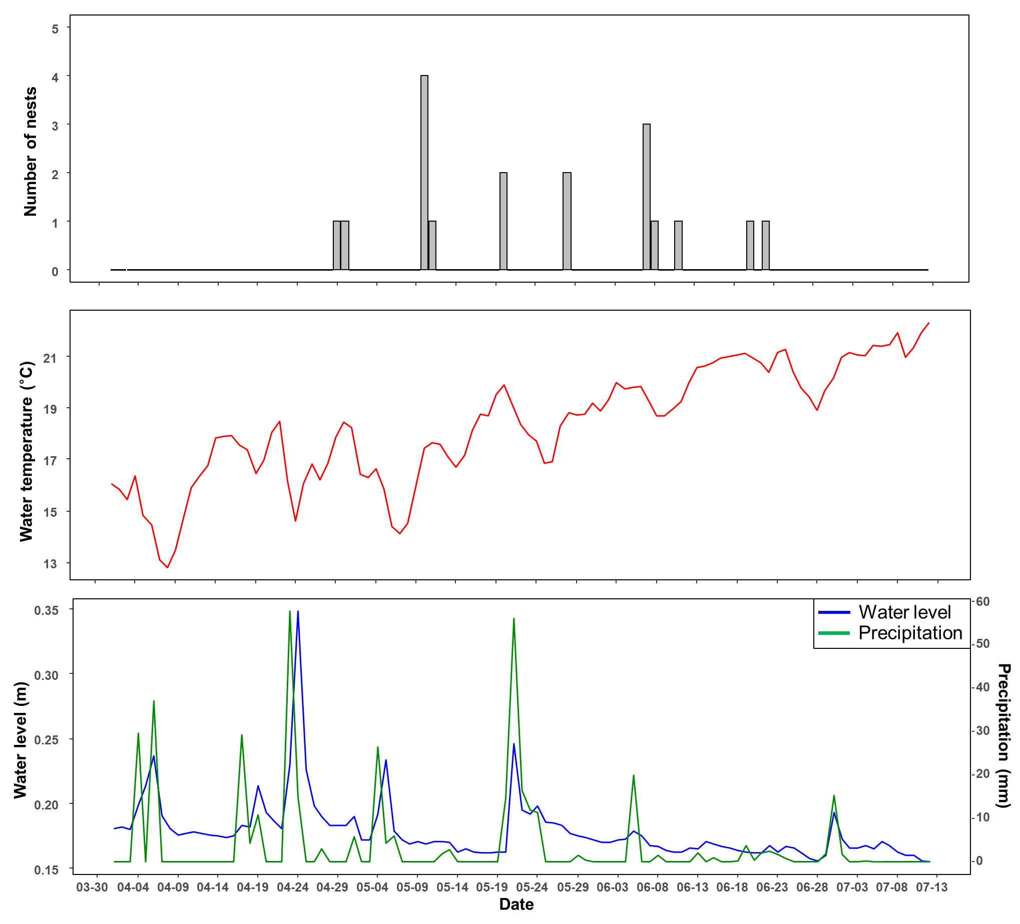
Appendix S2. Dates when each of 18 nests was first recorded (top), water temperature (middle), and water level and precipitation (bottom) from 1 April to 12 July 2017. Water temperature (°C) and level (m) were recorded using a logger (Model U20L‐004, HOBO Onset Computer Corp.), and daily precipitation (mm) was measured at the nearest weather station (Clemson‐Oconee County Airport Weather Station by the National Weather Service, approximately 12 km from the study area).

