Supplementary figure 1. Flow chart of the study population
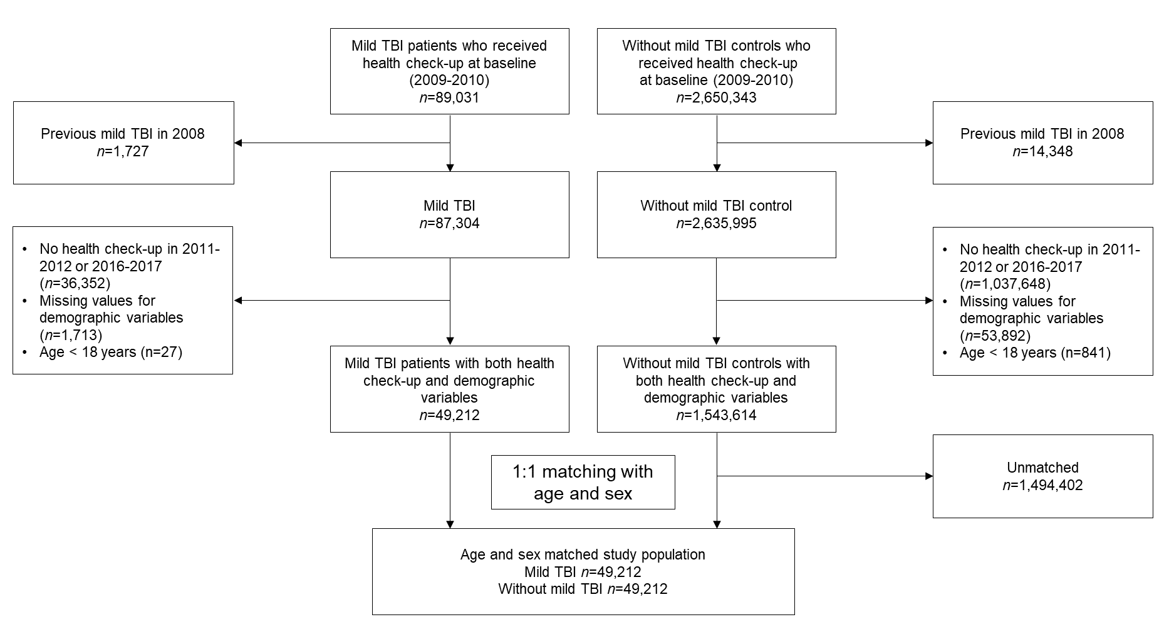

Supplementary Table 1. Sensitivity analysis for the associations between mild TBI and insufficient physical activity using the modified definition of sufficient physical activity ª
 | Short-term follow-up  (2011-2012) |  |  | Long-term follow-up  (2016-2017)
 | OR (95% CI) |  | p-value | OR (95% CI) |  |  | p-value
Mild TBI (Model 1) | 1.05 (1.02−1.08) |  | <0.001 | 1.07 (1.04−1.10) |  |  | < 0.001
Mild TBI (Model 2) | 1.05 (1.02−1.09) |  | <0.001 | 1.07 (1.04−1.10) |  |  | < 0.001
Mild TBI (Model 3) | 1.04 (1.01−1.08) |  | 0.004 | 1.06 (1.03−1.09) |  |  | < 0.001
Mild TBI (Model 4) | 1.04 (1.01−1.08) |  | 0.005 | 1.06 (1.03−1.09) |  |  | < 0.001
Age (years) | 0.99 (0.99−0.99) |  | <0.001 | 1.00 (1.00−1.00) |  |  | 0.183
Sex
Male | 1.0 |  |  | 1.0
Female | 1.23 (1.19−1.27) |  | <0.001 | 1.22 (1.19−1.26) |  |  | < 0.001
Baseline sufficient PA (revised)
No | 1.0 |  |  | 1.0
Yes | 0.28 (0.27−0.29) |  | <0.001 | 0.38 (0.36−0.39) |  |  | < 0.001
Residence
Rural | 1.0 |  |  | 1.0
Urban | 0.87 (0.85−0.90) |  | <0.001 | 0.82 (0.80−0.85) |  |  | < 0.001
Household income level
Quartile 1 (lowest) | 1.0 |  |  | 1.0
Quartile 2 | 1.10 (1.04−1.15) |  | <0.001 | 1.10 (1.05−1.16) |  |  | < 0.001
Quartile 3 | 1.08 (1.03−1.13) |  | 0.001 | 1.05 (1.00−1.10) |  |  | 0.026
Quartile 4 (highest) | 0.91 (0.87−0.95) |  | <0.001 | 0.91 (0.87−0.95) |  |  | <0.001
Comorbidities
Diabetes mellitus | 0.93 (0.88−0.98) |  | 0.016 | 0.98 (0.93−1.04) |  |  | 0.655
Hypertension | 0.93 (0.88−0.97) |  | 0.006 | 0.97 (0.93−1.02) |  |  | 0.347
Dyslipidemia | 0.92 (0.87−0.97) |  | 0.003 | 0.99 (0.95−1.04) |  |  | 0.942
CVD | 0.89 (0.83−0.95) |  | 0.001 | 0.99 (0.92−1.05) |  |  | 0.782
Depression | 0.91 (0.85−0.98) |  | 0.012 | 0.98 (0.91−1.05) |  |  | 0.597
CCI score
≤ 2 | 1.0 |  |  | 1.0
3–4 | 1.01 (0.97−1.06) |  | 0.470 | 1.04 (1.00−1.09) |  |  | 0.053
≥ 5 | 1.01 (0.97−1.06) |  | 0.427 | 1.02 (0.98−1.06) |  |  | 0.316
Abbreviations: TBI, traumatic brain injury; PA, physical activity; OR, odds ratio; CI, confidence interval; CVD, cardiovascular diseases; CCI, Charlson Comorbidity Index.
ª The definition of sufficient physical activity was modified as (1) performing vigorous physical activity at least 3 days/week; or (2) performing moderate physical activity at least 5 days/week.
Model 1: Crude model.
Model 2: Adjusted for age, sex, and baseline physical activity.
Model 3: Adjusted for age, sex, baseline physical activity, region of residence, and household income.
Model 4: Adjusted for age, sex, baseline physical activity, region of residence, household income, comorbidities (diabetes mellitus, hypertension, dyslipidemia, cardiovascular diseases, and depression), and CCI score.

